Supplementary material
Soft EHL based friction mechanism of unreinforced and GF-reinforced PA66 in contact with steel under PAO8 oil lubrication
Takeshi Kunishima ^{a, b, *}, Gaëtan Bouvard ^{b}, Jean-Christophe Abry ^{b}, Vincent Fridrici ^{b}, Philippe Kapsa ^{b}
ª JTEKT CORPORATION, 333 Toichi-cho, Kashihara, Nara 634-8555, Japan
^{b} Laboratoire de Tribologie et Dynamique des Systèmes, UMR CNRS 5513, École Centrale de Lyon, Université de Lyon, 36 Avenue Guy de Collongue, F-69134 Écully CEDEX, France
* Corresponding author: Takeshi Kunishima; E-mail: takeshi_kunishima@jtekt.co.jp

Keywords: polyamide, friction, PAO8, lubrication, soft EHL

1. Effects of sliding speed in wider range on friction coefficient
To investigate the wider effect of the rotational speed on the friction coefficient, a sliding test was conducted using unreinforced PA66, wherein the maximum rotational speed was 1,567 rpm (i.e., double the maximum speed presented in Fig. 7 in main manuscript) when R_{a} = 0.06 μm. Fig. S1 shows the evolution of the friction coefficient obtained at different rotational speeds. Despite the increased rotational speed, no remarkable change in the minimum friction coefficient was observed, whereas the friction coefficient increased when the rotational speed was low.
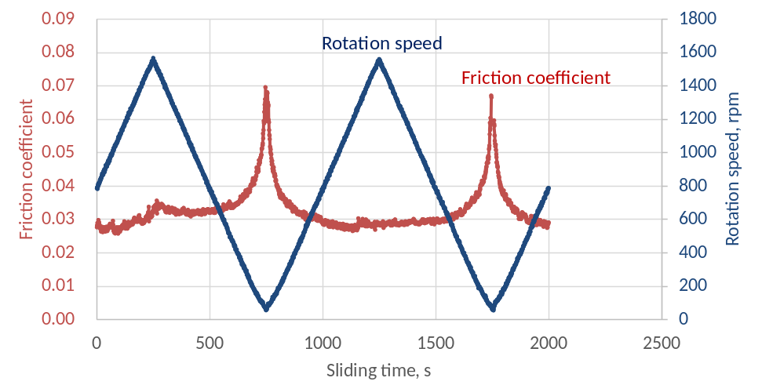
Fig. S1. Evolution of friction coefficient measured at different rotational speeds up to 1,567 rpm.

2. Estimated minimum oil film thickness
By substituting each obtained parameter into the equations for the IE and PE lubrication regimes, the theoretical minimum oil film thicknesses were estimated based on a function of sliding speed under a normal load of 50 N at room temperature, as shown in Fig. S2. The minimum oil film thickness increased with increasing rotational speed, and the differences between the oil film thicknesses estimated based on the equations for the IE and PE regimes were negligible at all the rotational speeds. Therefore, under these sliding conditions, there was no difference between the estimated oil film thicknesses, even without considering the increased oil viscosity, because the lubrication regime was categorized at just the threshold of the IE and PE regimes.
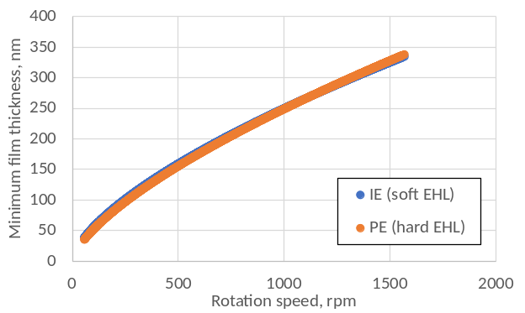
Fig. S2. Theoretical minimum oil film thickness estimated based on equation for IE (soft EHL) or PE (hard EHL) lubrication regime.

Fig. S3 presents the rotational speed and normal load dependences of the theoretical minimum oil film thicknesses estimated using the equation for the IE (i.e., soft EHL) lubrication regime at each temperature. The oil thickness decreased with increasing temperature. Although the viscosity decreased by 82.1 and 92.4% at 80 and 120°C compared to the viscosity at room temperature, respectively, the theoretical minimum oil film thickness remained at 55.4 and 39.0% at 80 and 120°C compared to the counterpart at RT, respectively, under the sliding conditions where the normal load was 50 N and the rotational speed was 790 rpm. This tendency cannot be observed in the sliding of metallic materials because the Young’s modulus decreases at high temperature, thereby preventing the oil film thickness from decreasing.
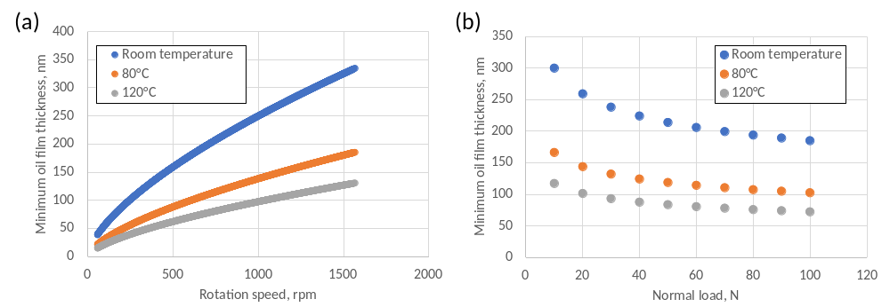
Fig. S3. Estimated theoretical minimum oil film thickness (a) rotational speed and (b) normal load dependences.

In addition, Fig. S4 compares the theoretical minimum oil film thicknesses obtained for the unreinforced PA66 and the GF composite at room temperature and under a normal load of 50 N at various rotational speeds and the temperature dependence of the oil film thickness obtained for only the GF composite. At room temperature, the theoretical oil film thickness obtained using the GF composite was 21.5% lower than that obtained using the unreinforced PA66 at 790 rpm because the fiber reinforcement had increased the Young’s modulus. As observed for the unreinforced PA66, the oil film thickness decreased with increasing temperature or decreasing rotational speed. Then, the effect of each parameter on the GF composite friction coefficient was investigated using the obtained oil film thicknesses.

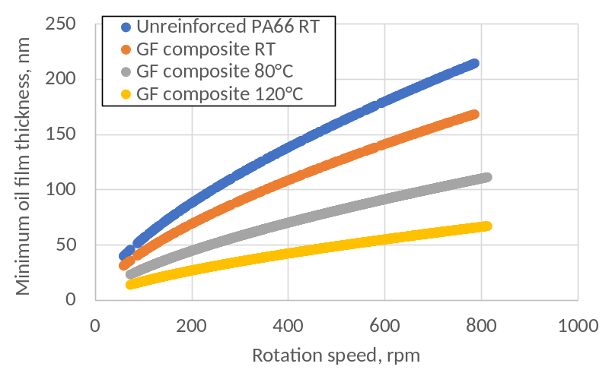
Fig. S4. Evolutions of theoretical minimum oil film thickness vs. rotational speed at room temperature for both unreinforced PA66 and GF composite and at various temperatures only for GF composite (for normal load of 50 N).
3. Sliding surface of the GF composite before sliding test polished using #800 polishing paper
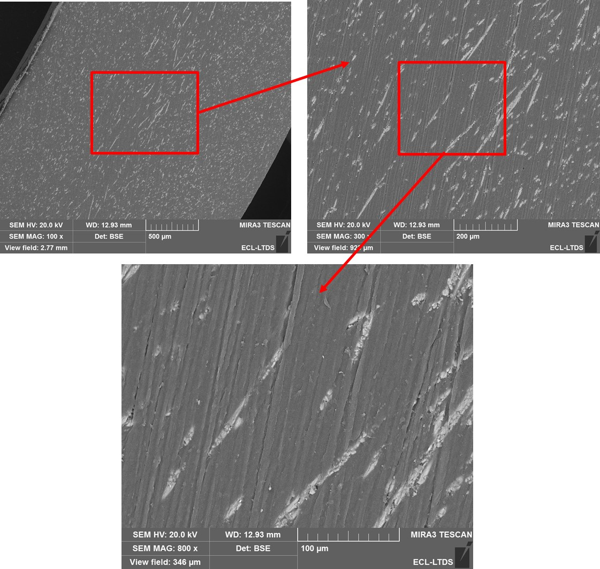
Fig. S5. SEM observations of the sliding surface of the GF composite before sliding test polished using #800 polishing paper.

