Towards automatically verifying chemical structures: The powerful combination of Proton NMR and infrared spectroscopy

Benji Rowlands, Lina Jonsson, Jonathan M Goodman, Peter Howe, Werngard Czechtizky, Tomas Leek, Richard J Lewis*

Benji Rowlands – Centre for Molecular Informatics, 685 The Yusuf Hamied Department of Chemistry, University of 686 Cambridge, Cambridge CB2 1EW, U.K
Lina Jonsson – Department of Medicinal Chemistry, Research and Early Development, Respiratory and Immunology (R&I), BioPharmaceuticals R&D, AstraZeneca,43183 Mölndal, Sweden
Jonathan M Goodman – Centre for Molecular Informatics, 685 The Yusuf Hamied Department of Chemistry, University of 686 Cambridge, Cambridge CB2 1EW, U.K.; orcid.org/0000- 687 0002-8693-9136
Peter Howe – Oncology Chemistry, AstraZeneca, 1 Francis Crick Avenue, Cambridge Biomedical Campus, Cambridge, CB2 0AA.
Werngard Czechtizky – Department of Medicinal Chemistry, Research and Early Development, Respiratory and Immunology (R&I), BioPharmaceuticals R&D, AstraZeneca,43183Mölndal, Sweden;
Tomas Leek – Department of Medicinal Chemistry, Research and Early Development, Respiratory and Immunology (R&I), BioPharmaceuticals R&D, AstraZeneca,43183Mölndal, Sweden;
Richard J. Lewis – Department of Medicinal Chemistry, Research and Early Development, Respiratory and Immunology (R&I), BioPharmaceuticals R&D, AstraZeneca,43183 Mölndal, Sweden; https://orcid.org/0000-0001-9404-8520

Table of Contents
1. Additional Experimental Details 3
1.1 Experimental data acquisition conditions 3
1.2 Table S1: Complete test set 3
2 IR.Cai algorithm details 7
2.1 Outline of algorithm 7
2.2 Sensitivity of IR.Cai algorithm to different line broadening widths 8
3 DP4 calculations with labile protons (DP4*) 8
4 Softmax procedure for score combination 11
5 Combining low-level IR with DP4* and ACD 13
6 Combining scores derived from the same data 14
6.1 ACD and DP4* 14
6.2 High and low-level IR.Cai 14
7 Classification performance of automatic and manual peak picking (ACD) 15
8 Combining scores without softmax scaling 16
8.1 IR.Cai and DP4* 16
8.2 IR.Cai and ACD 16
9 Calculation results 17
9.1 Table S3: Full unscaled DP4* scores 17
9.2 Table S4: Full unscaled IR.Cai (high) results: 18
9.3 Table S5: Full unscaled IR.Cai (low) results: 19
9.4 Table S6: Full unscaled ACD (automatic peak picking) results: 20
9.5 Table S7: Full unscaled ACD (manual peak picking) results: 21
10 ¹H NMR manual peak picking results 22
References 27

Additional Experimental Details

Experimental data acquisition conditions

IR measurements were performed on a solution of the compounds in DMSO-d₆ at a concentration of ca. 40 mg/ml. Approximately 100 µl was transferred to a 0.1 mm BaF₂ cell and an IR spectrum acquired on a Biotools ChiralIR2X instrument (Bio Tools Inc., Jupiter, Florida, USA). NMR data was acquired on a solution of the compounds at approximately 1 mg/ml in DMSO-d6 on a Bruker 600 MHz Avance Neo instrument fitted with a 5mm {H/F}CN PFG cryoprobe. Compounds were taken from the AstraZeneca compound collection. Where appropriate, the free base was liberated and the compound purified.

Table S1: Complete test set

Table S1 shows all of the molecules in the test set and their incorrect “decoy” isomers.

Compound | Correct structure | Incorrect isomer 1 | Incorrect isomer 2 | Incorrect isomer 3
1 | 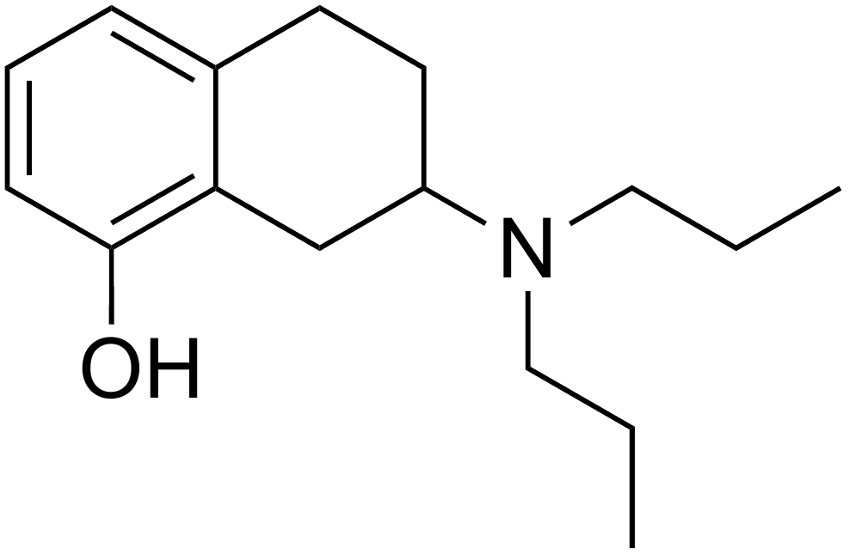 | 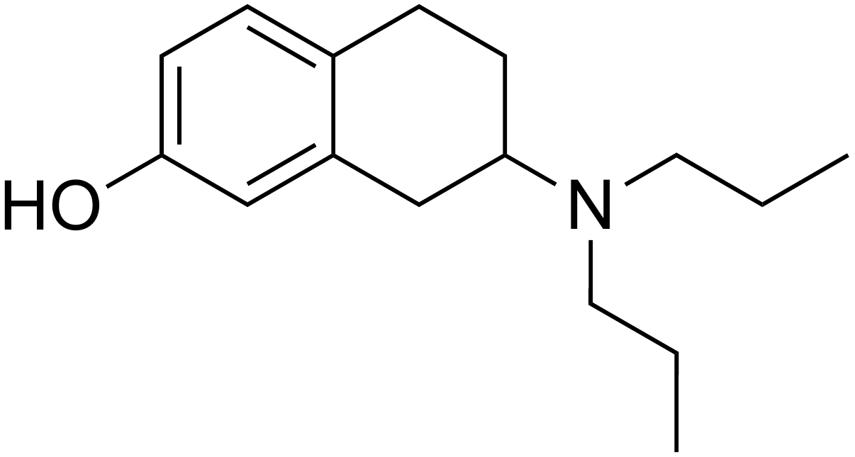 | 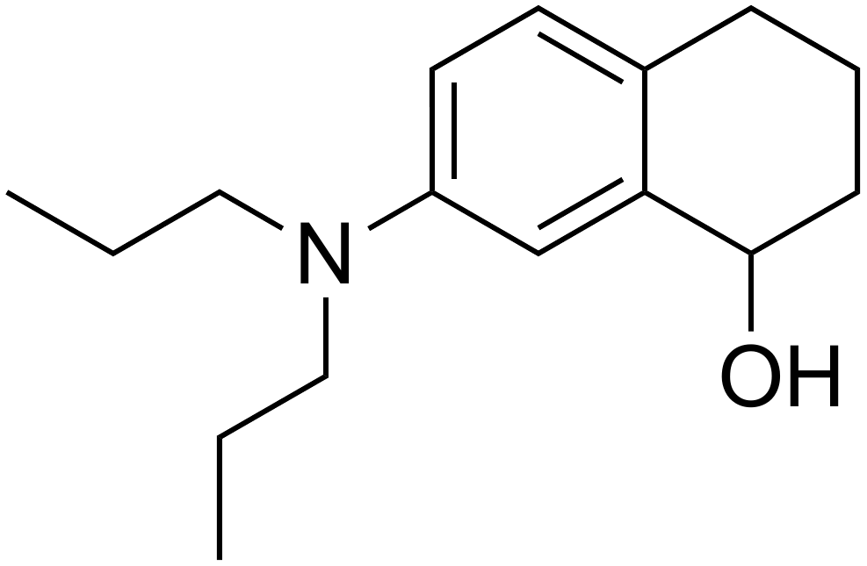 | 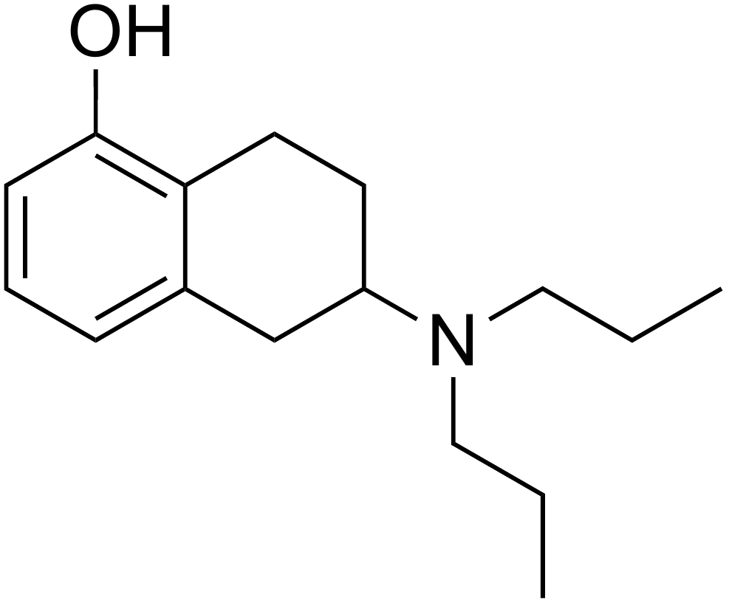
2 | 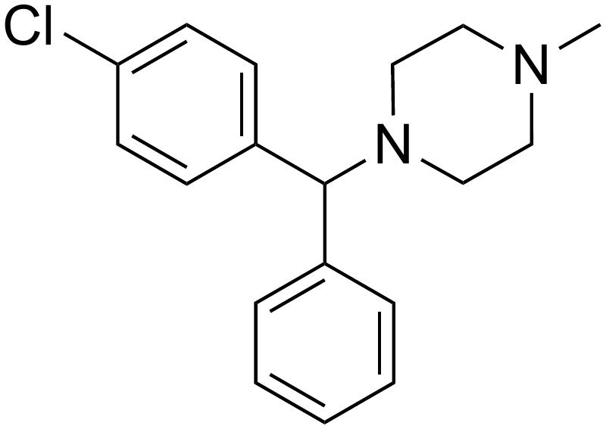 | 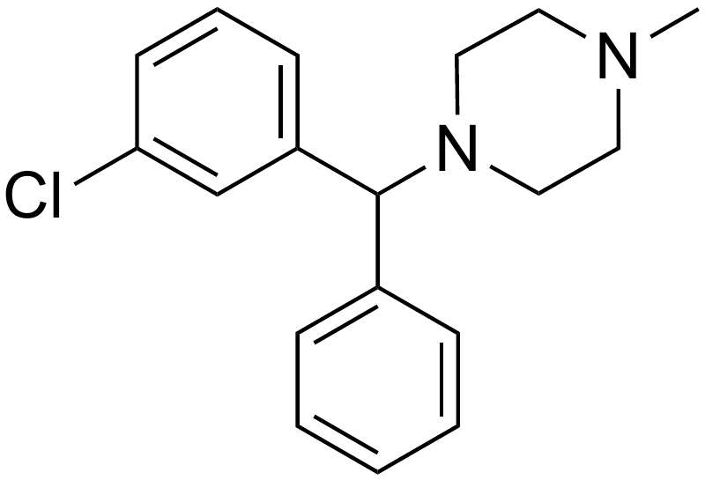 | 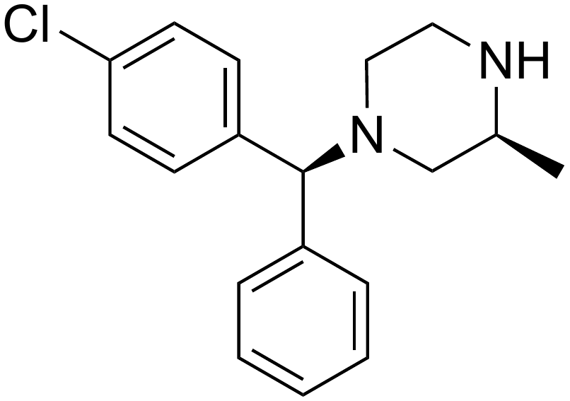 | N/A
3 | 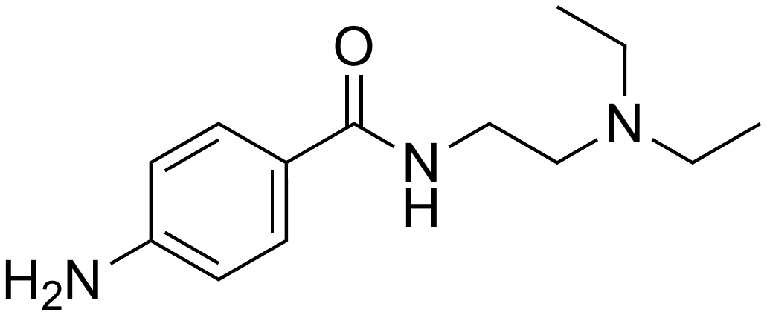 | 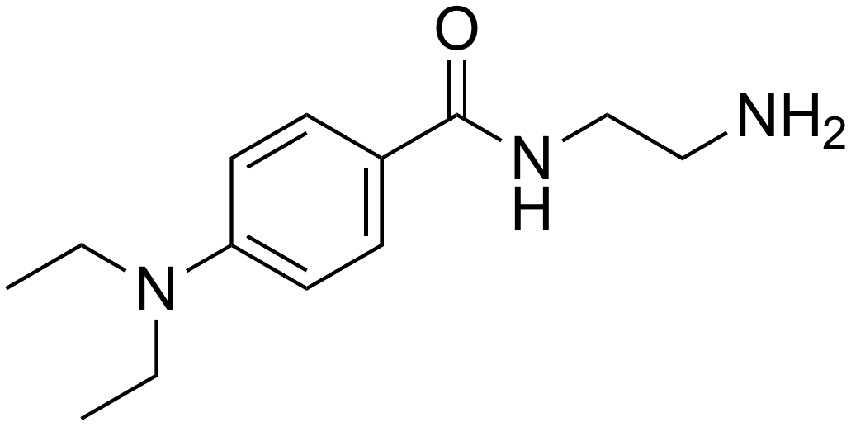 | 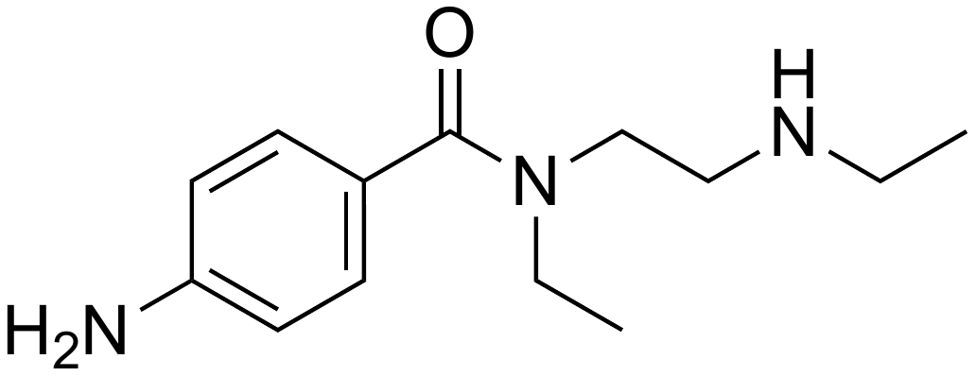 | 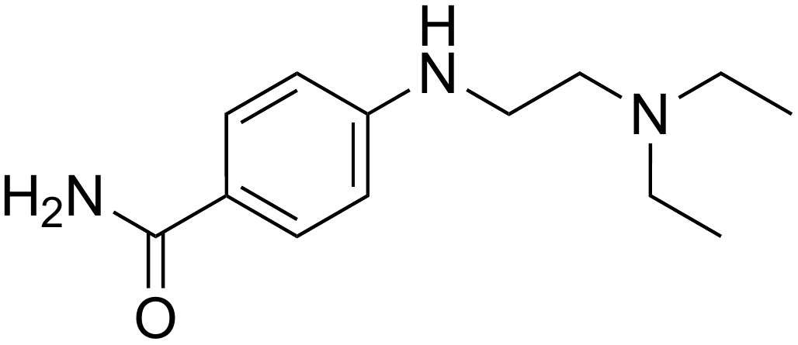
4 | 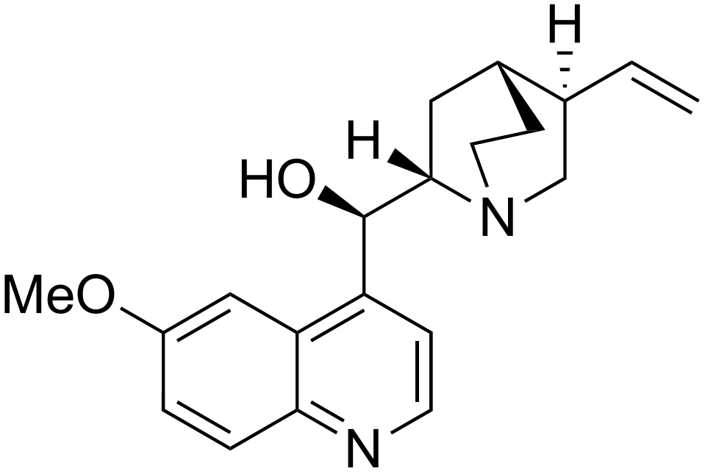 | 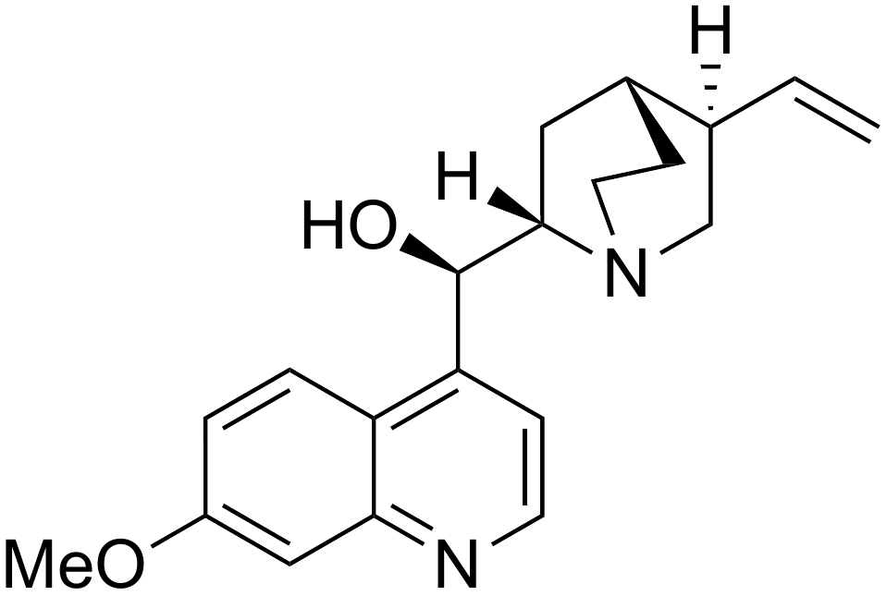 | 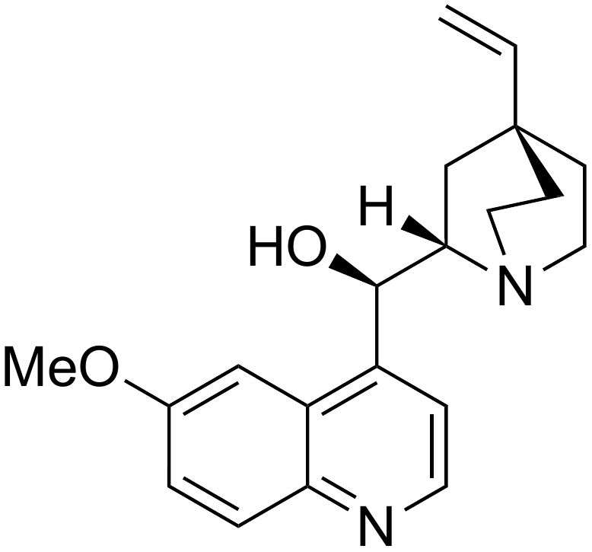 | 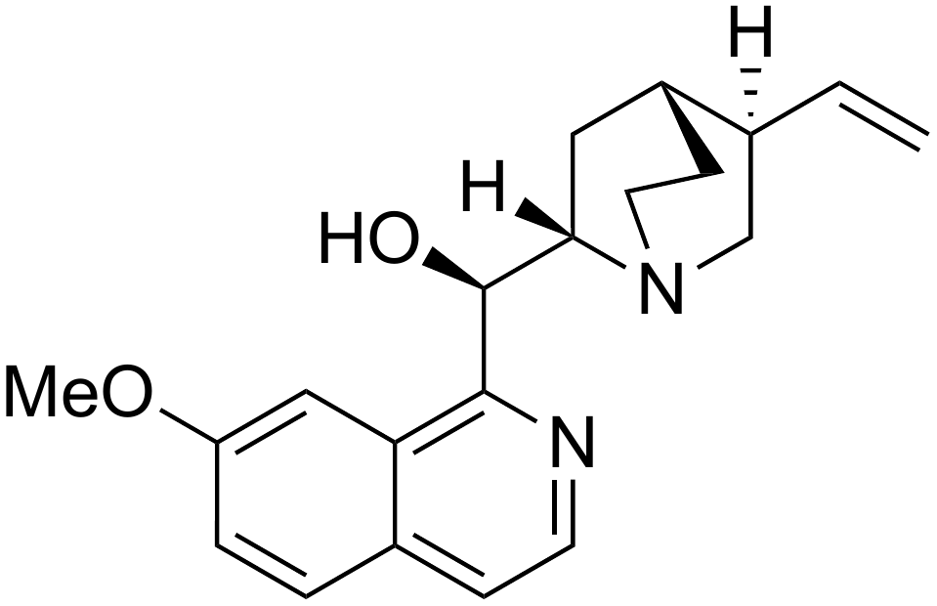
5 | 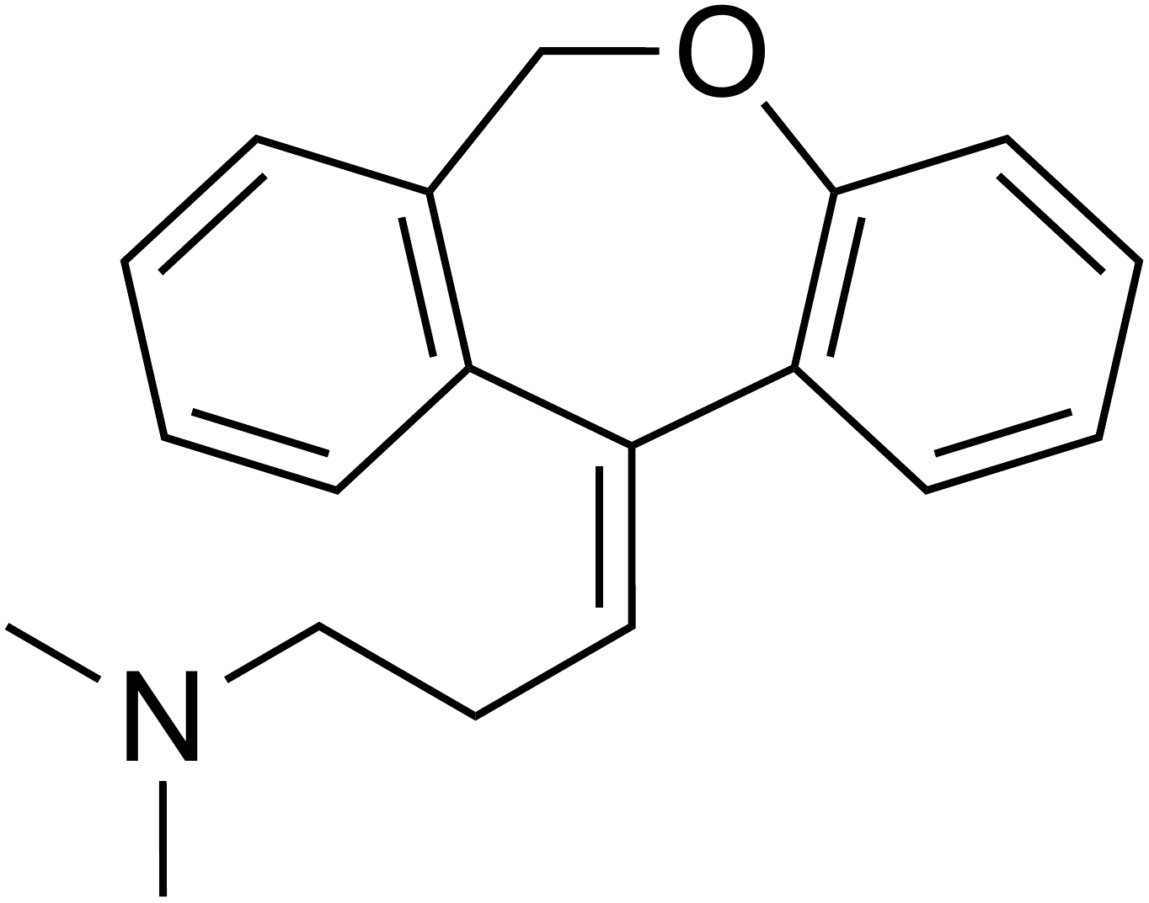 | 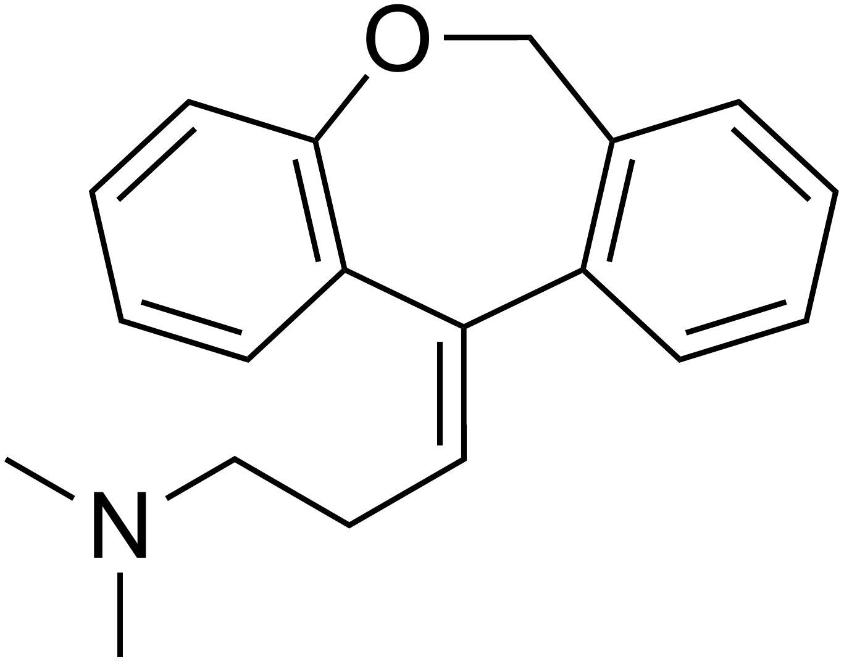 | 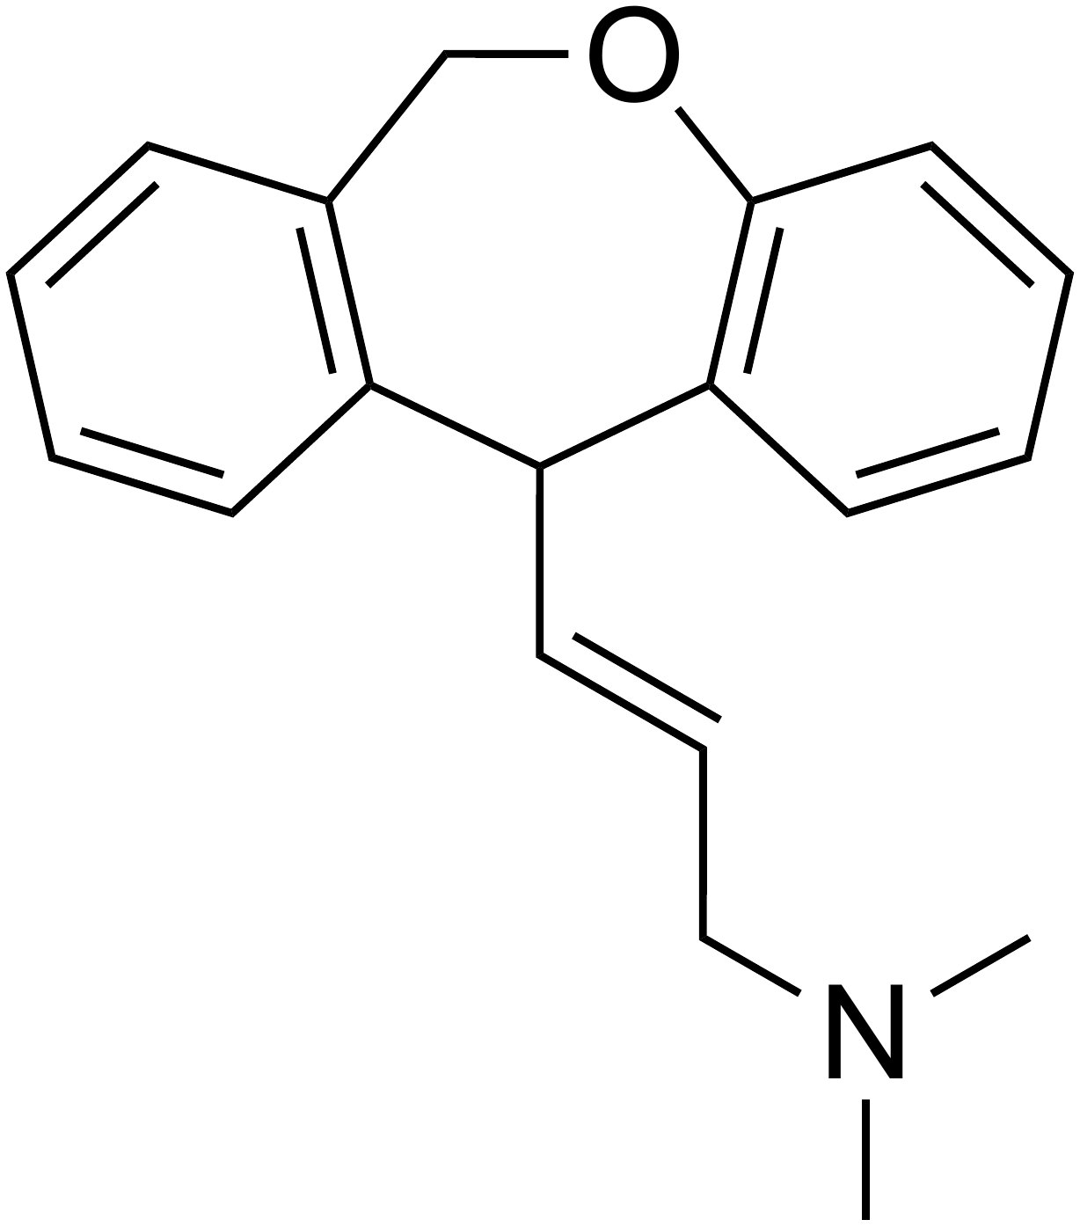 | N/A
6 | 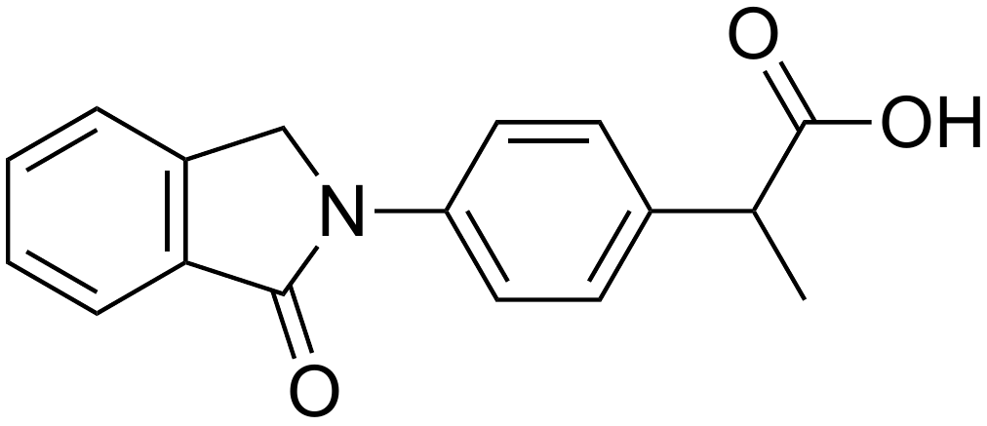 | 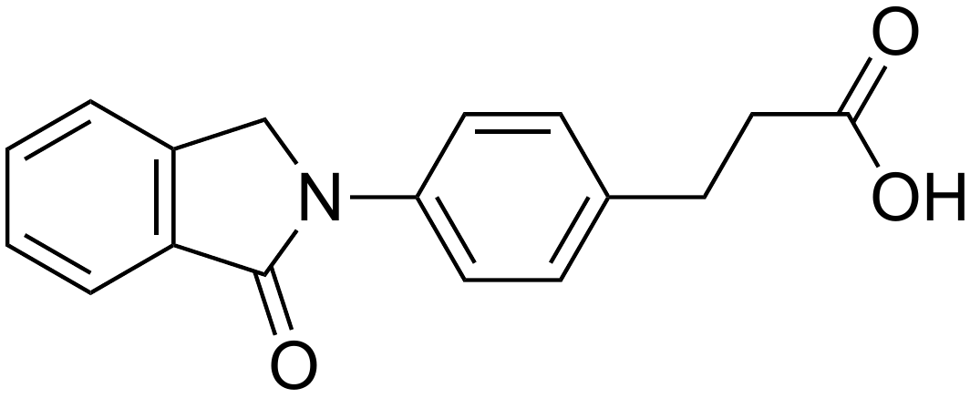 | 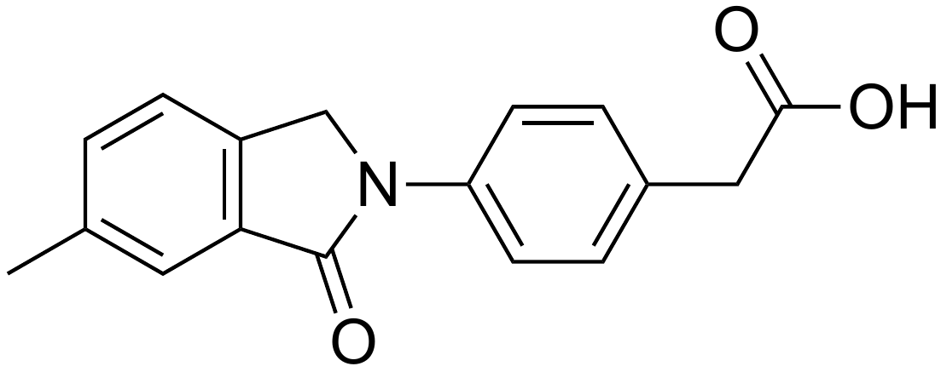 | 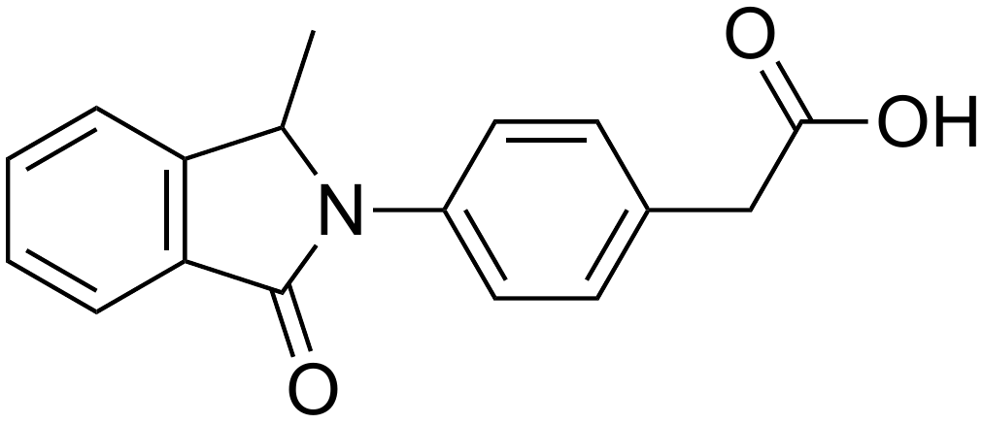
7 | 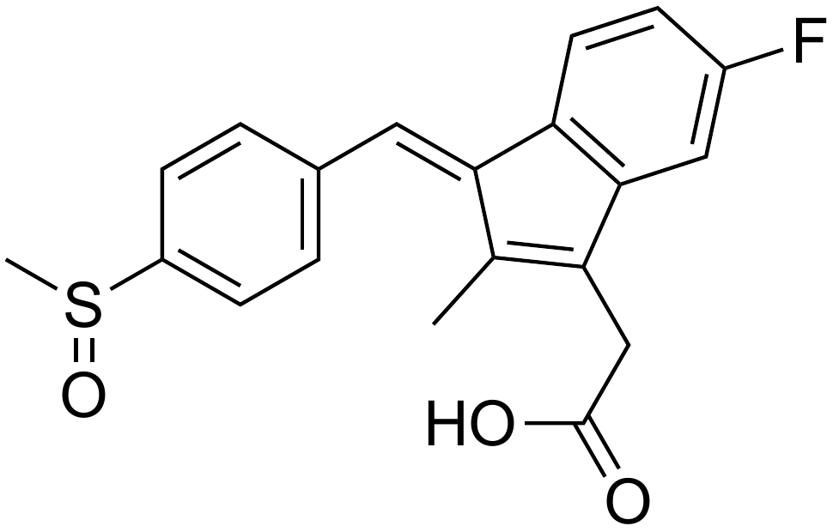 | 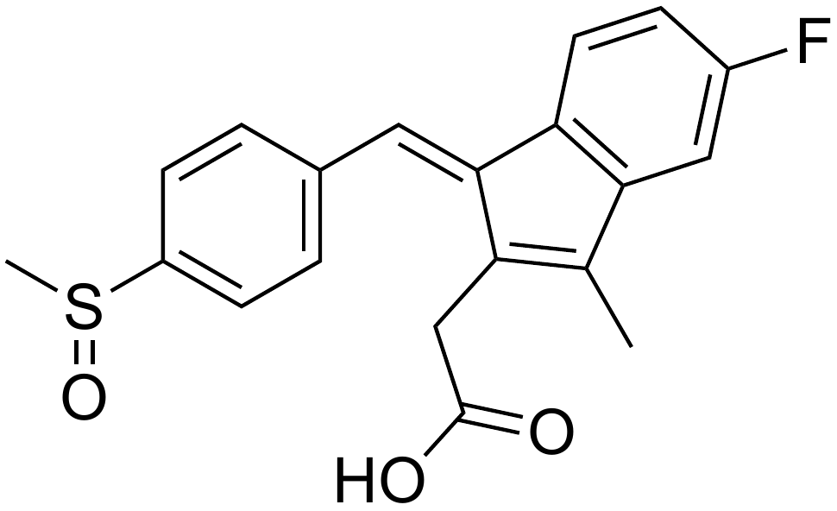 | 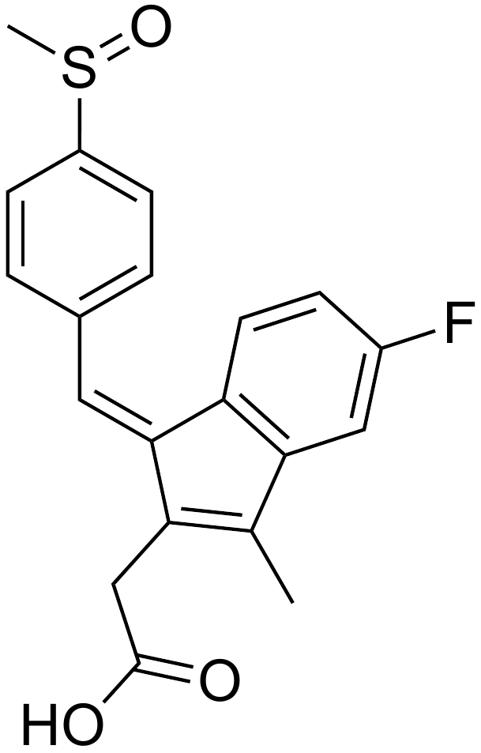 | N/A
8 | 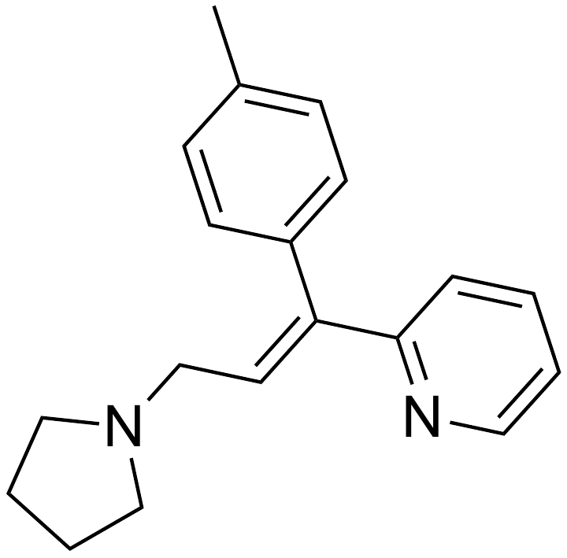 | 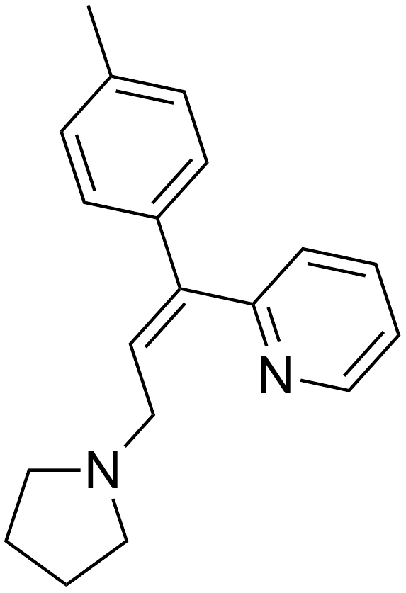 | 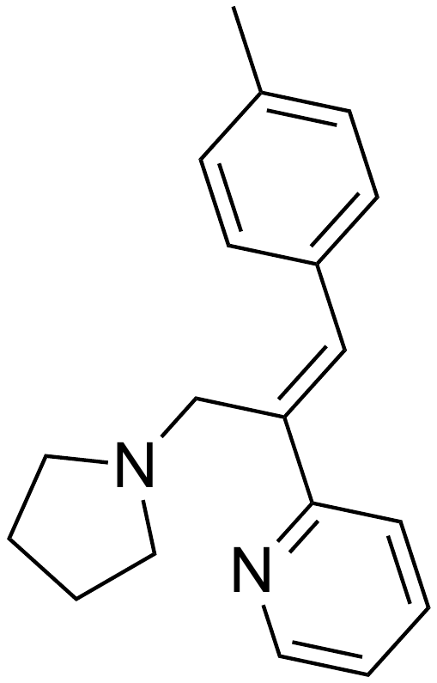 | N/A
9 | 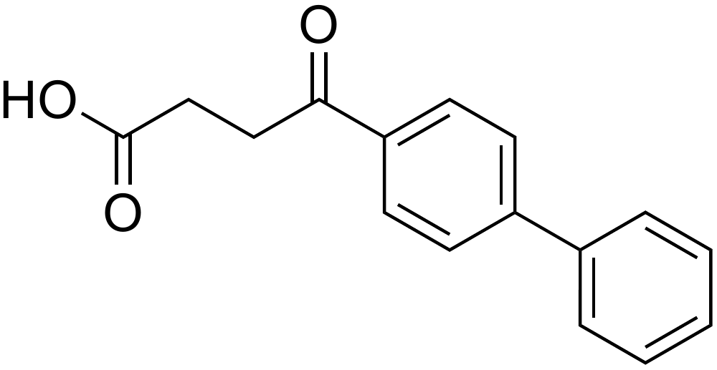 | 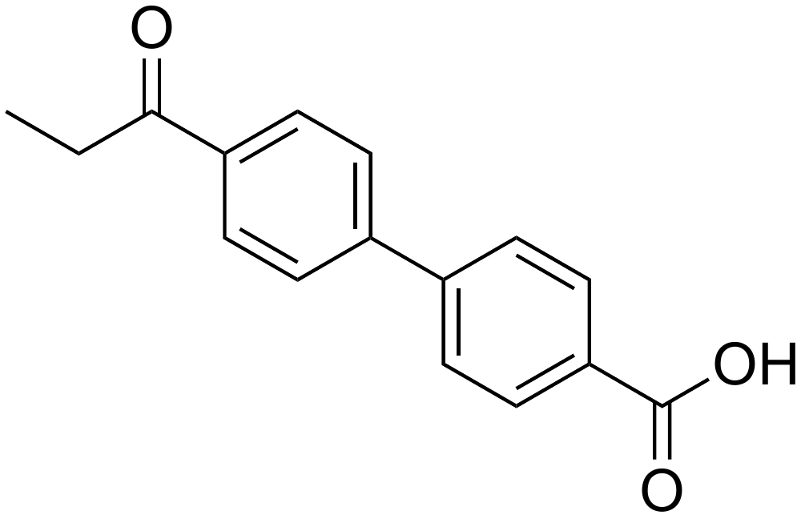 | 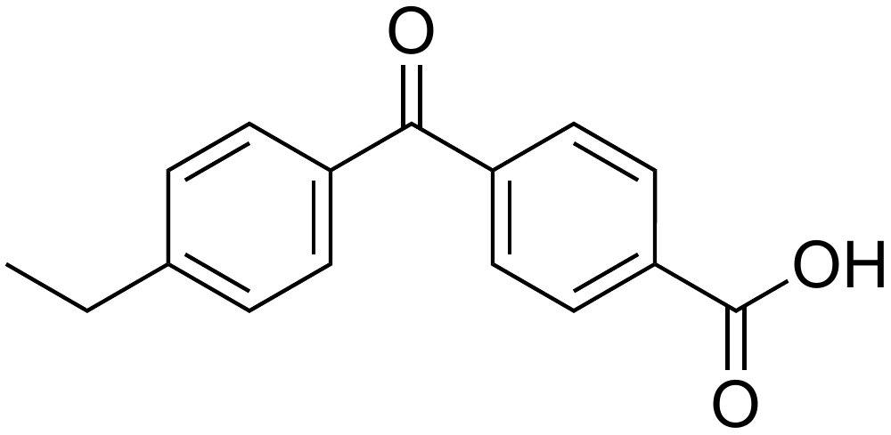 | N/A
10 | 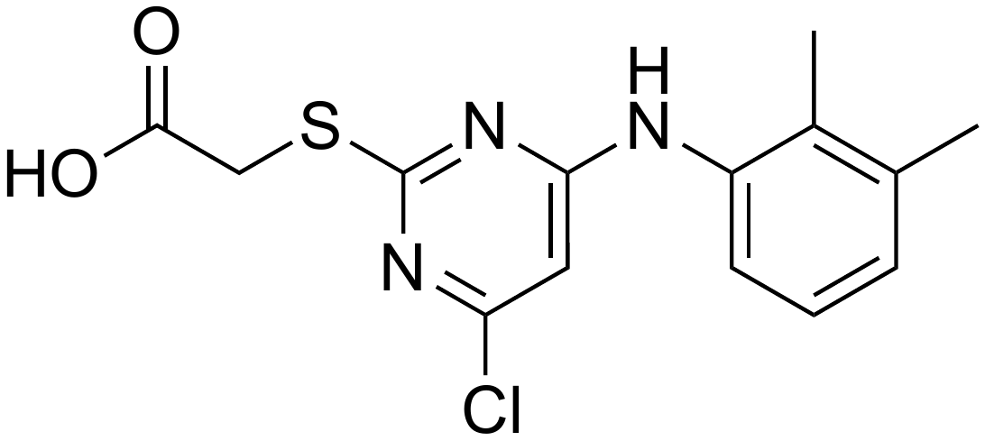 | 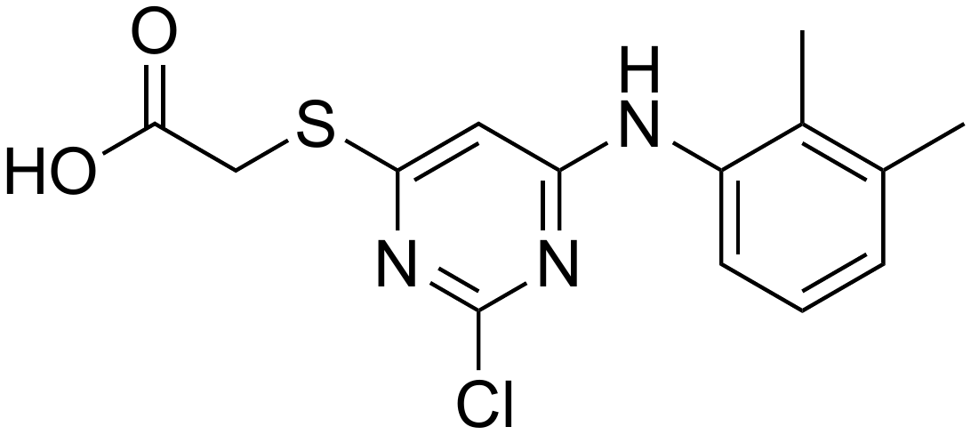 | 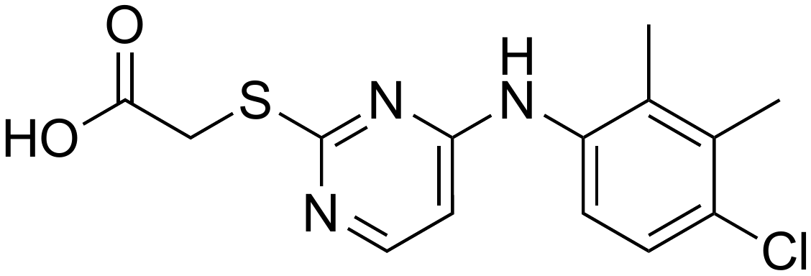 | 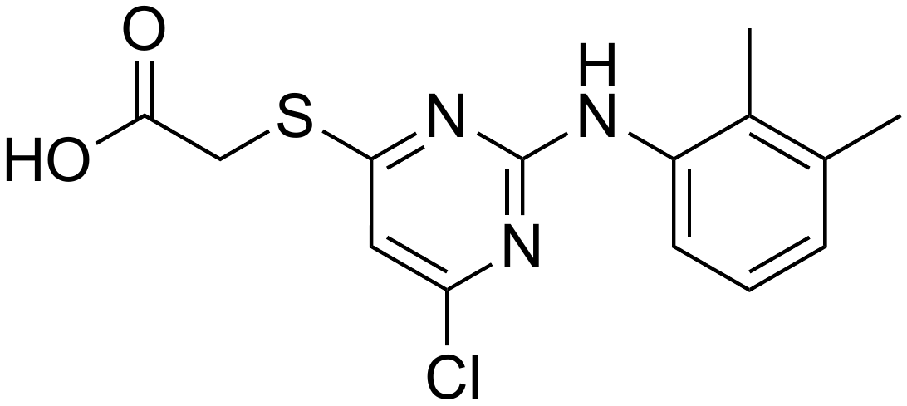
11 | 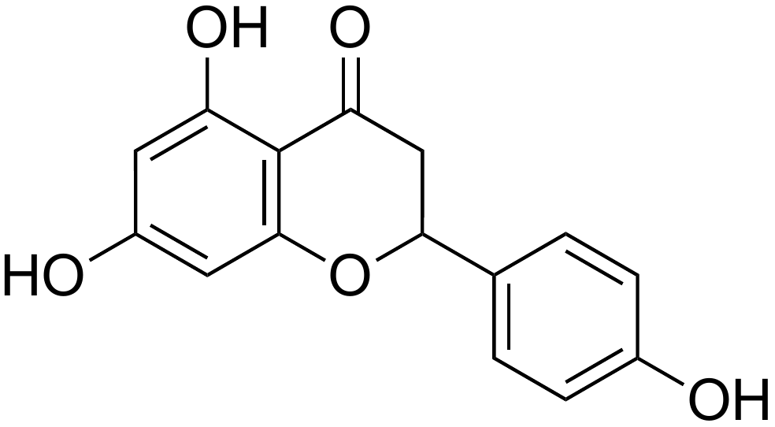 | 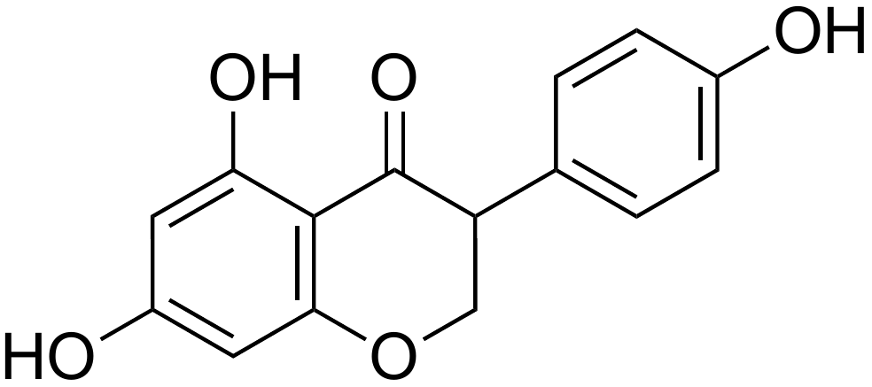 | 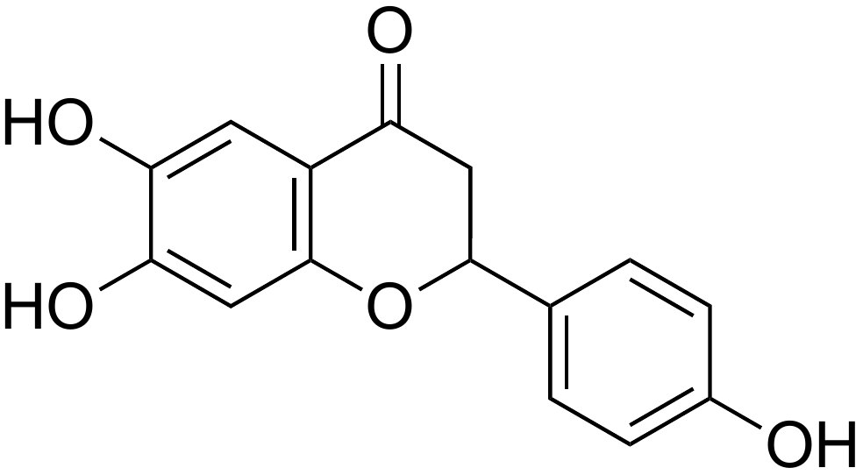 | 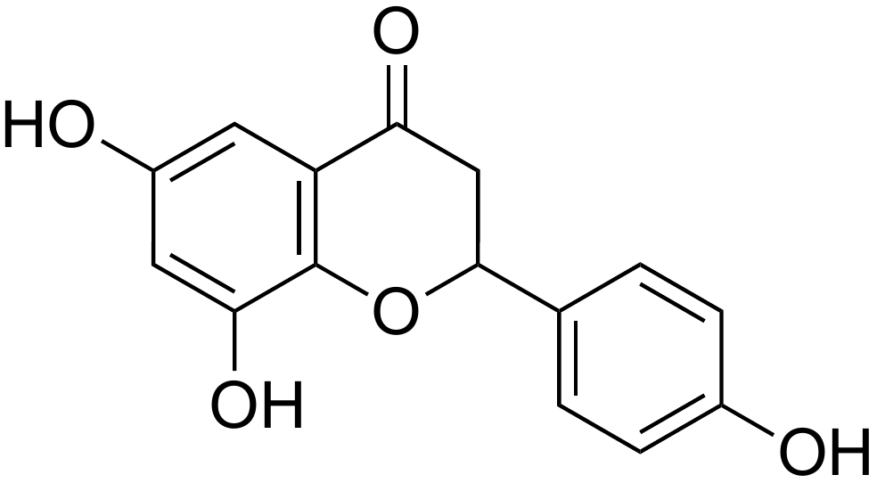
12 | 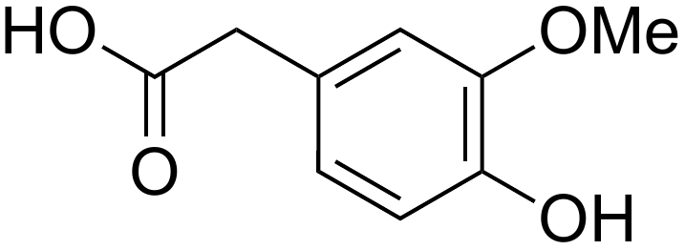 | 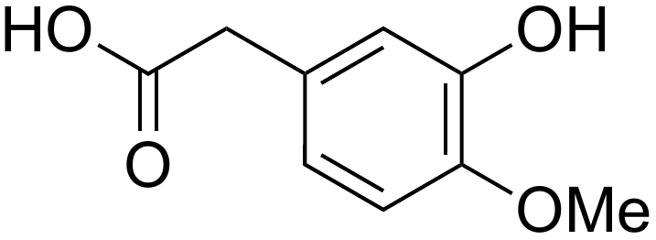 | 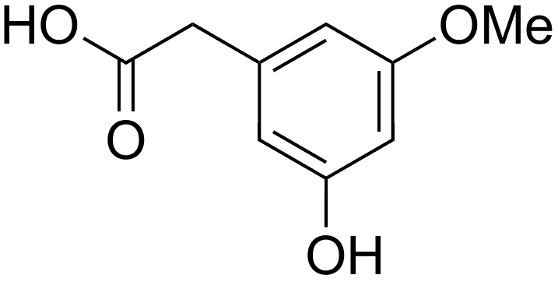 | 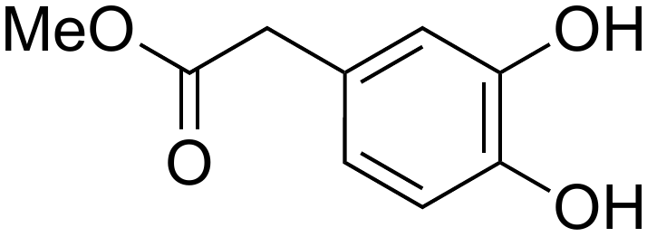
13 | 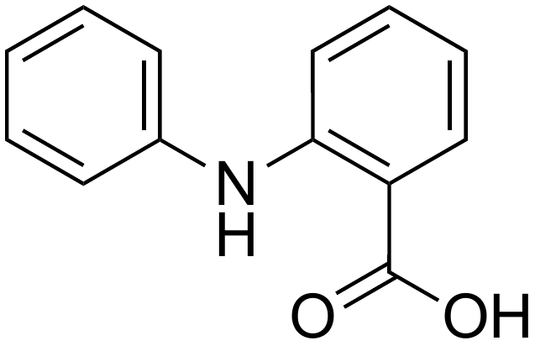 | 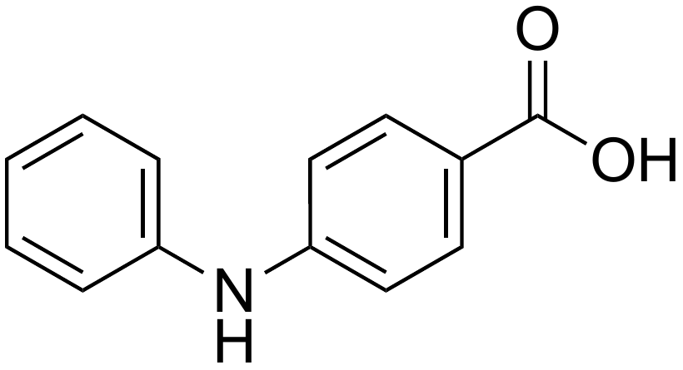 | 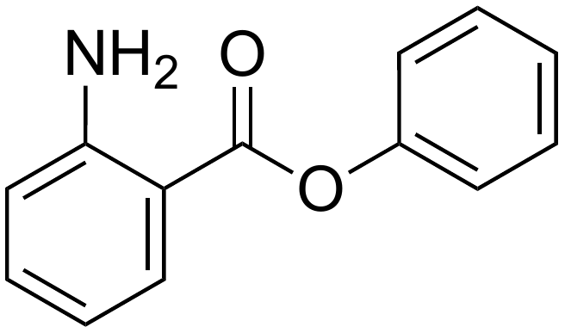 | N/A
14 | 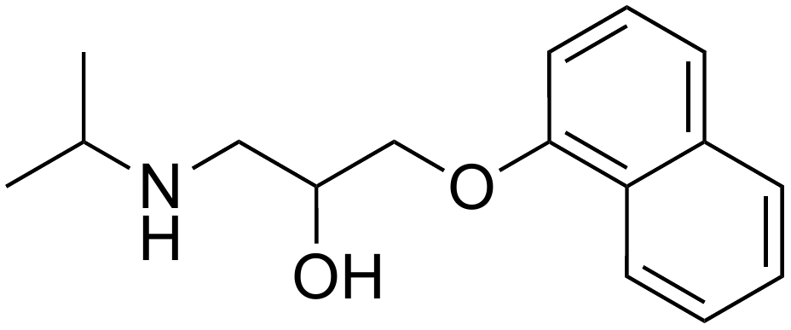 | 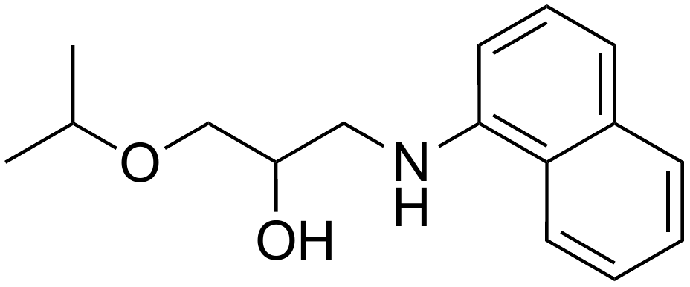 | 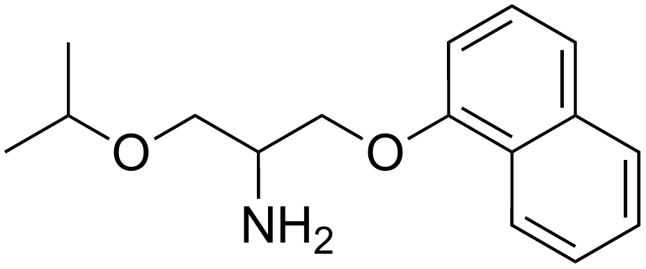 | N/A
15 | 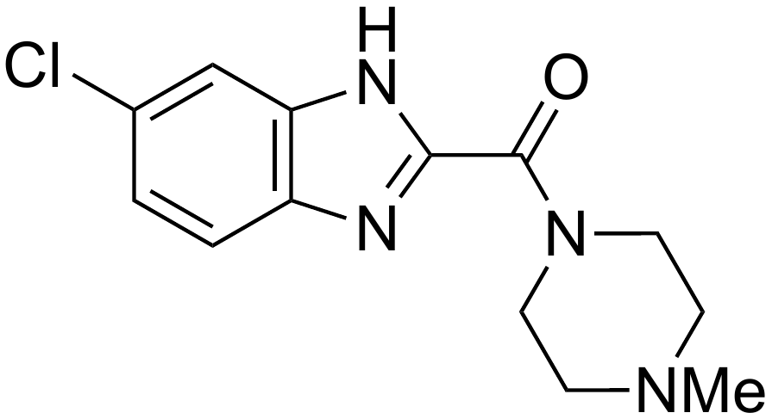 | 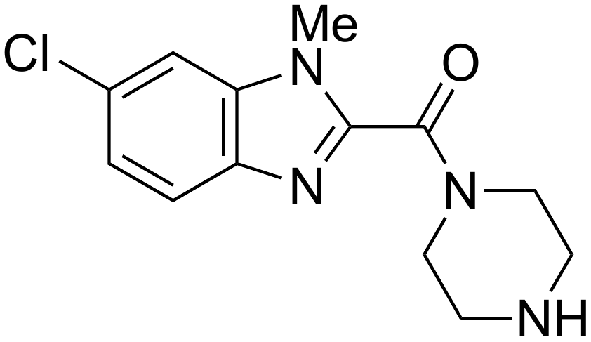 | 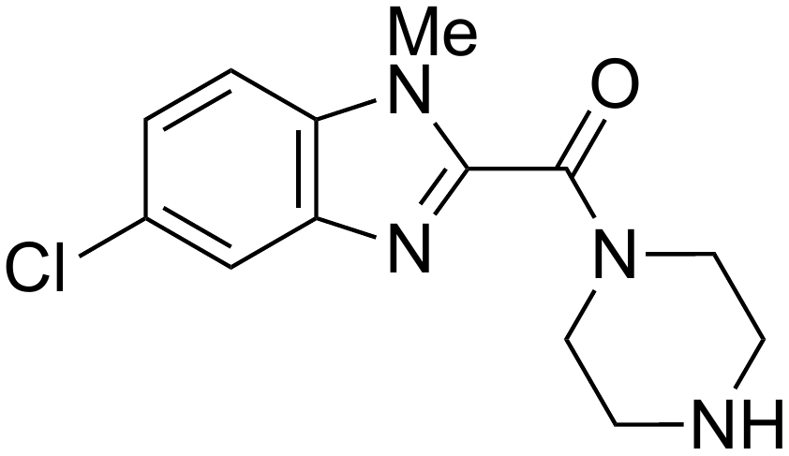 | N/A
16 | 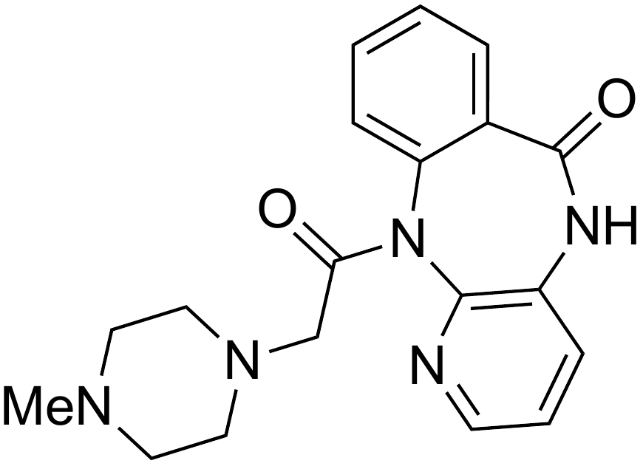 | 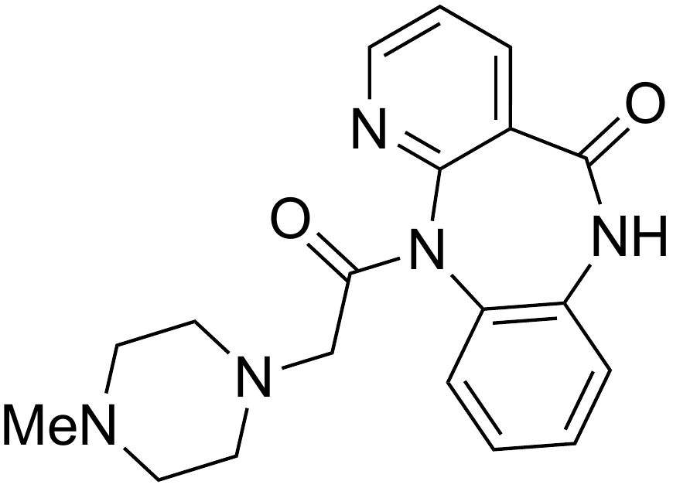 | 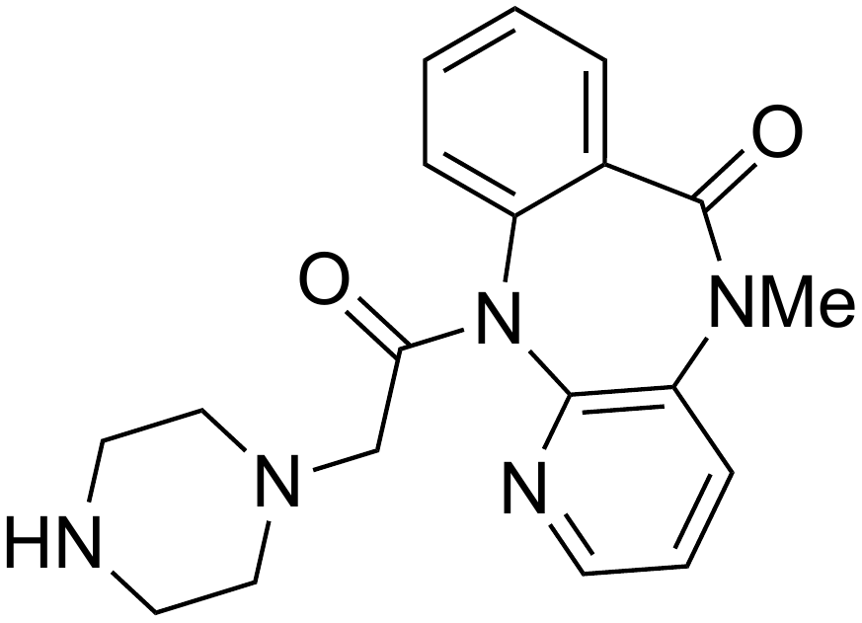 | 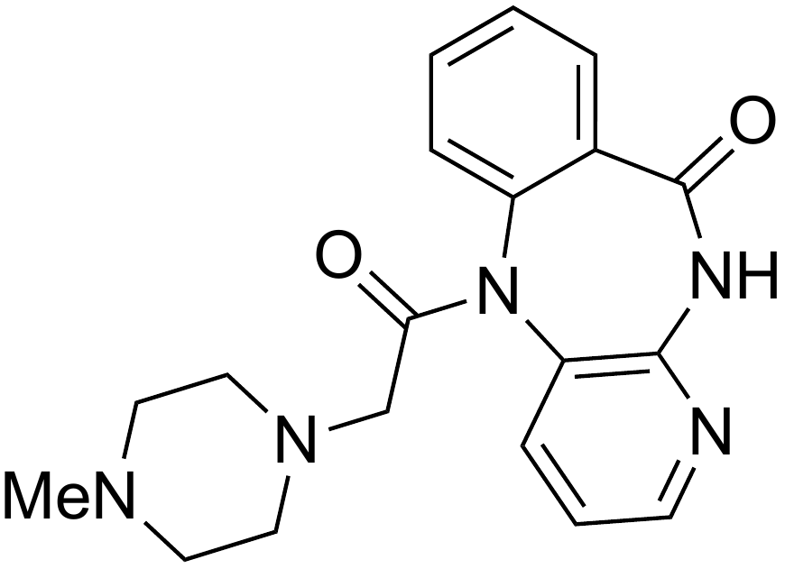
17 | 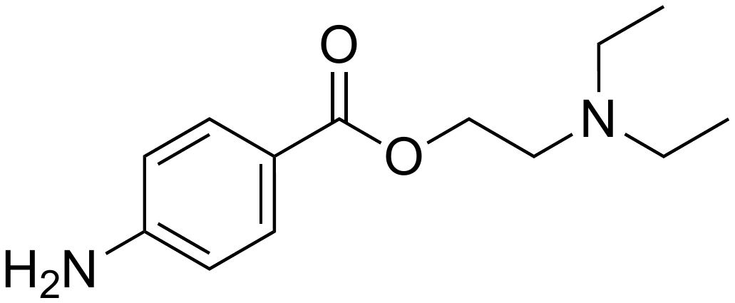 | 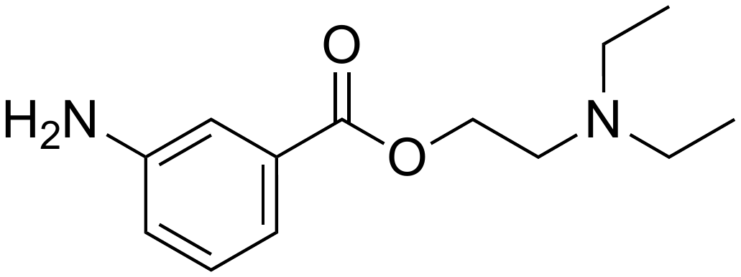 | 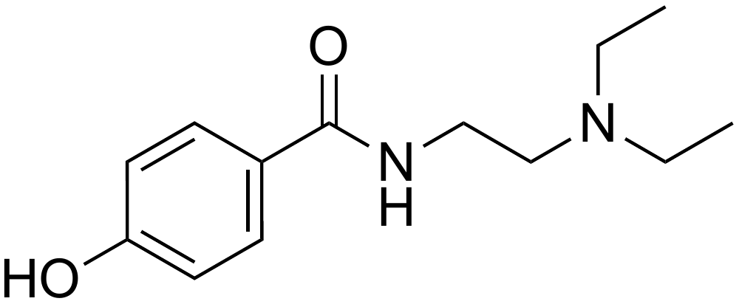 | N/A
18 | 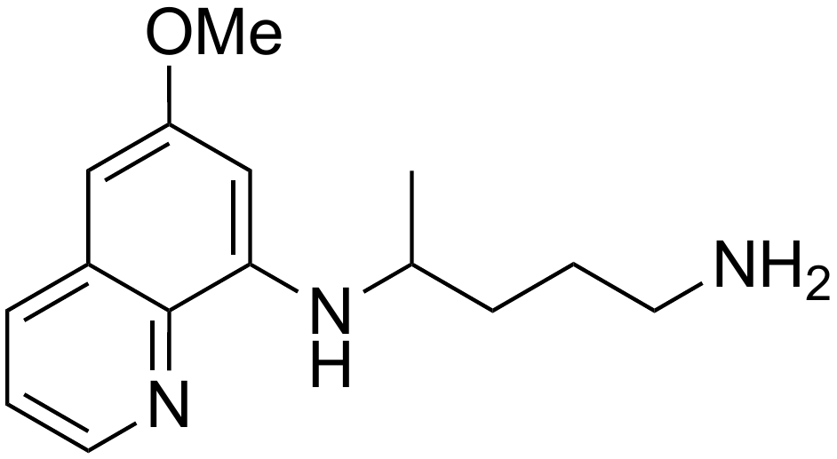 | 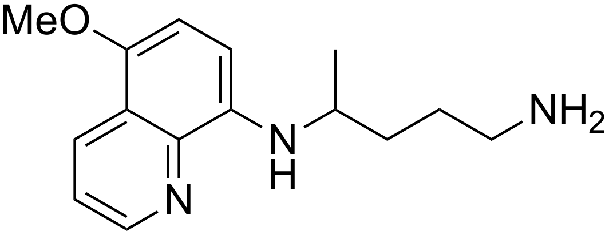 | 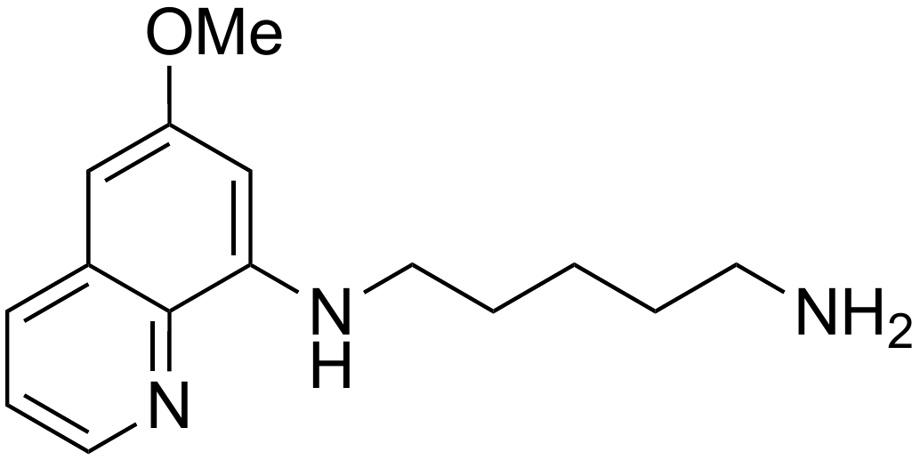 | 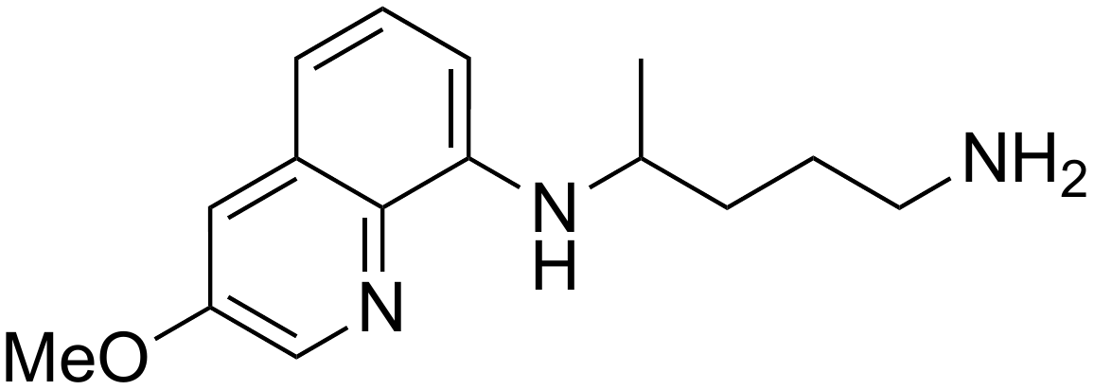
19 | 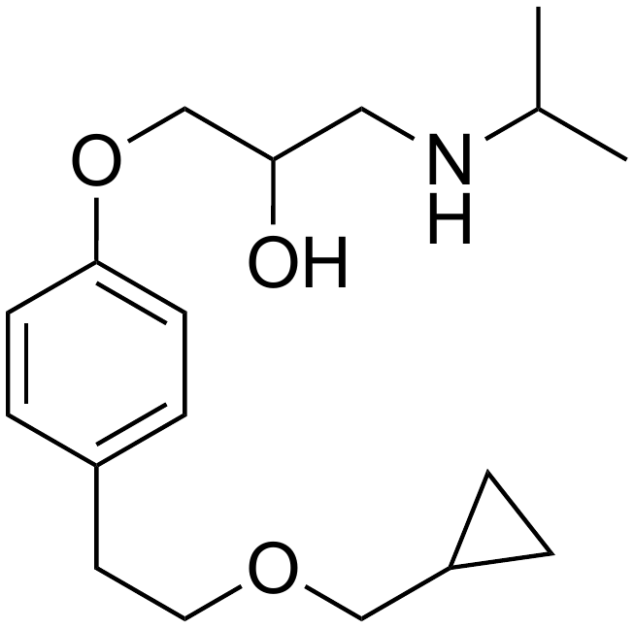 | 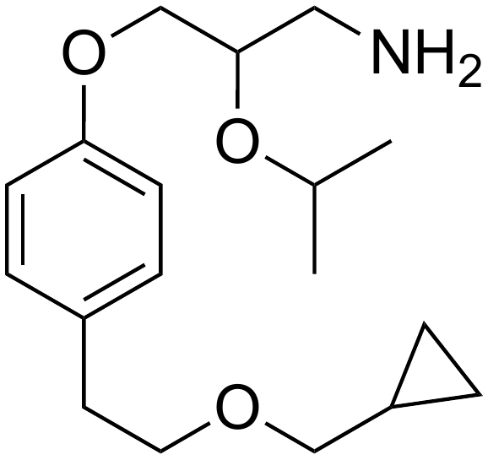 | 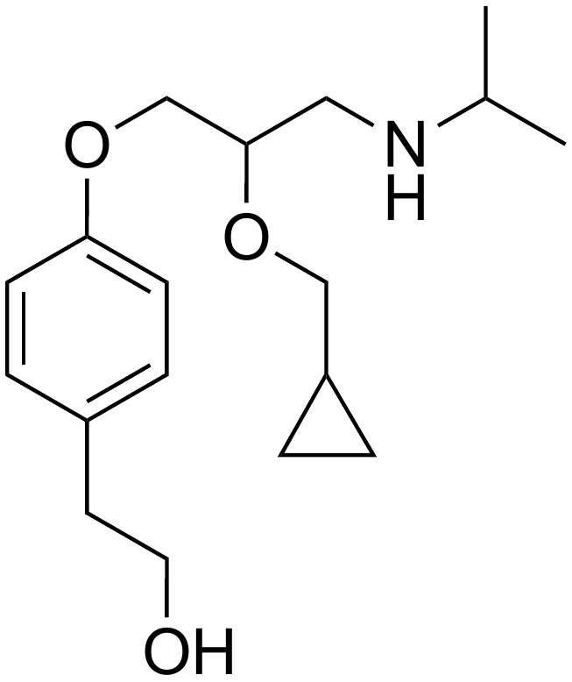 | N/A
20 | 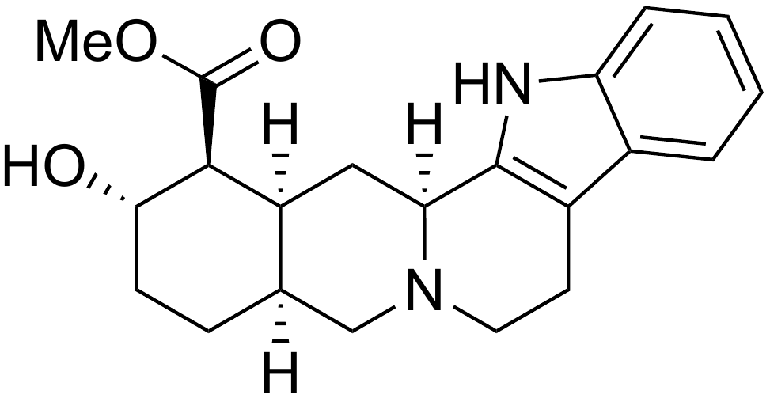 | 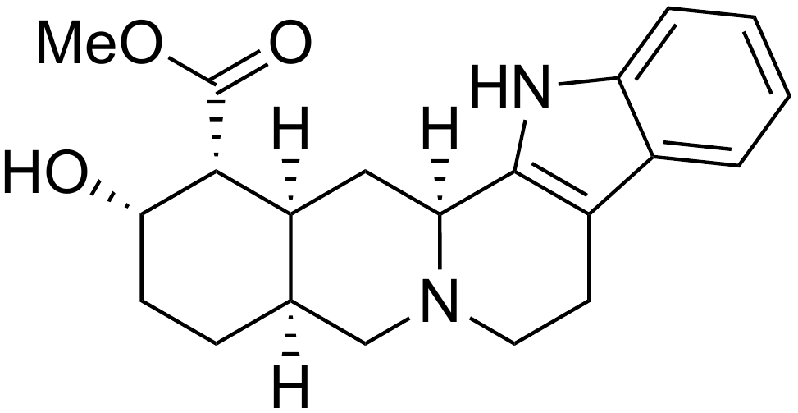 | 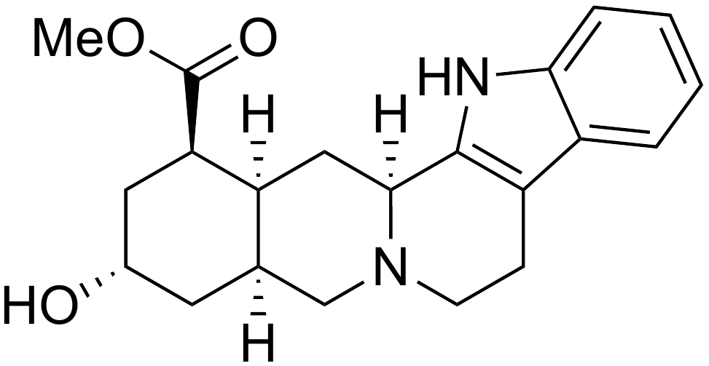 | N/A
21 | 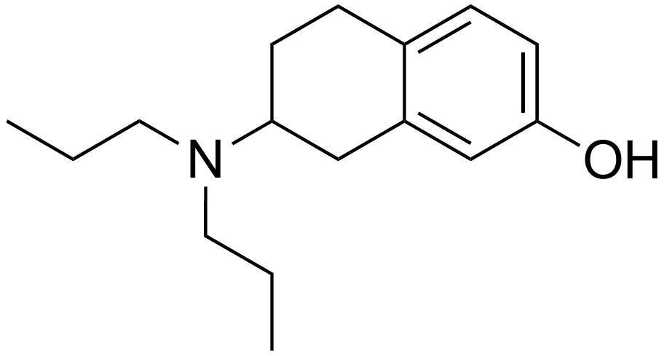 | 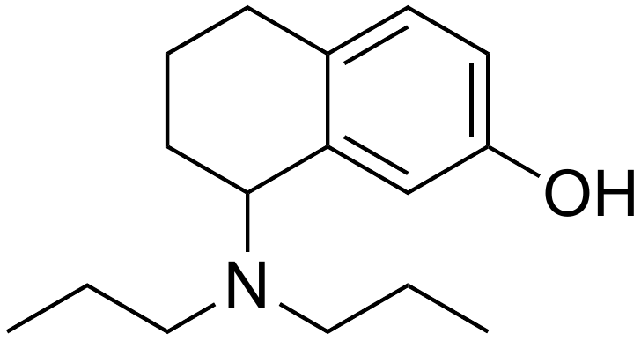 | 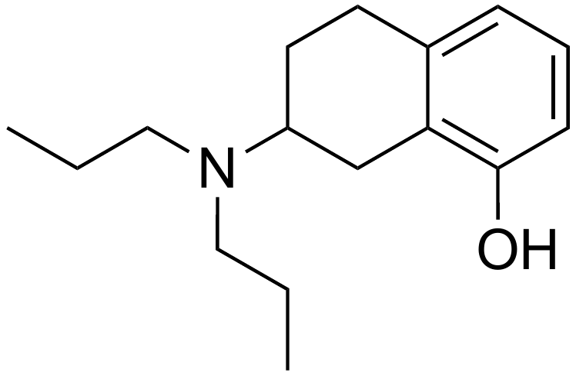 | 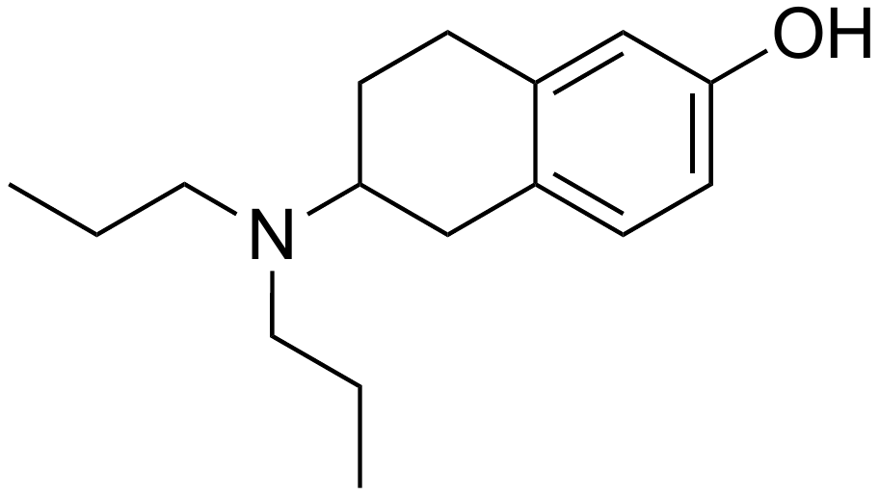
22 | 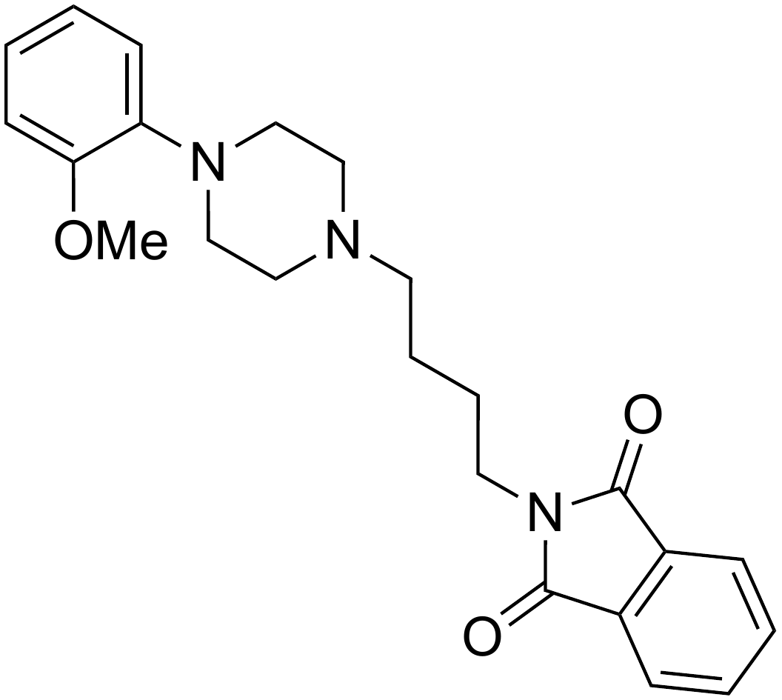 | 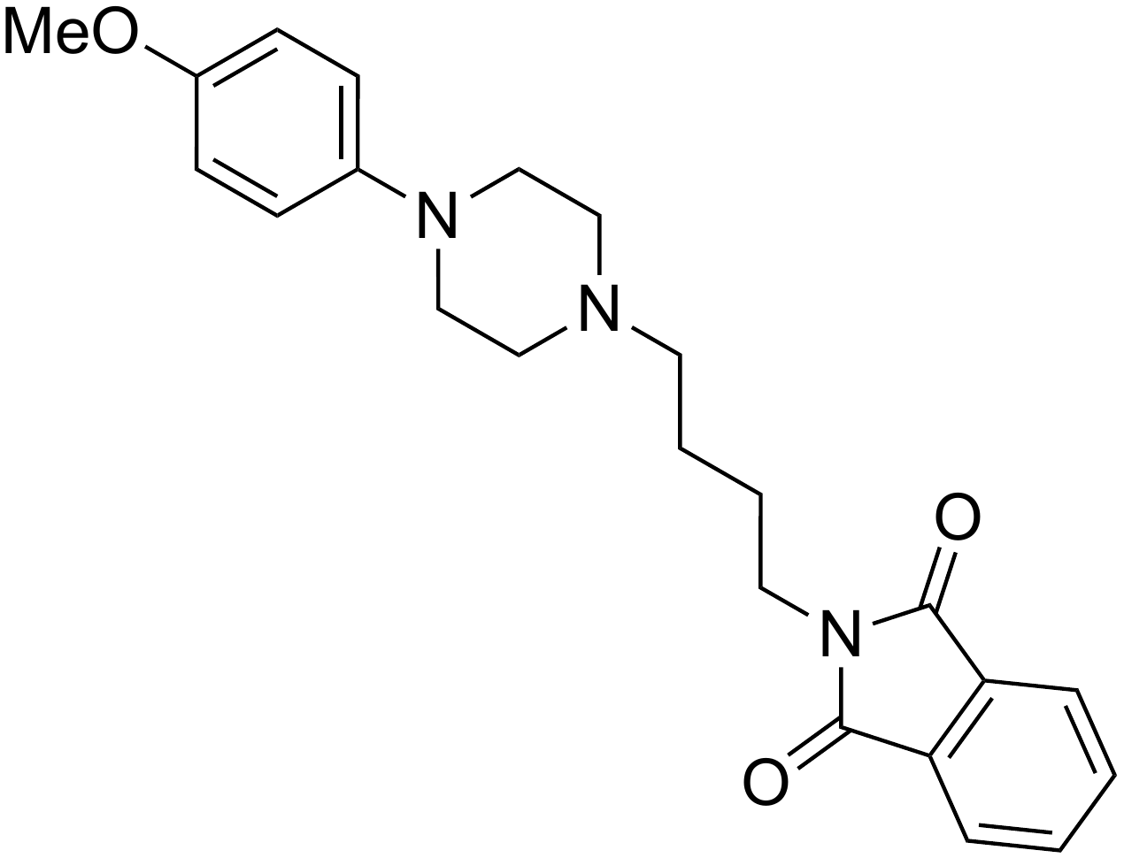 | 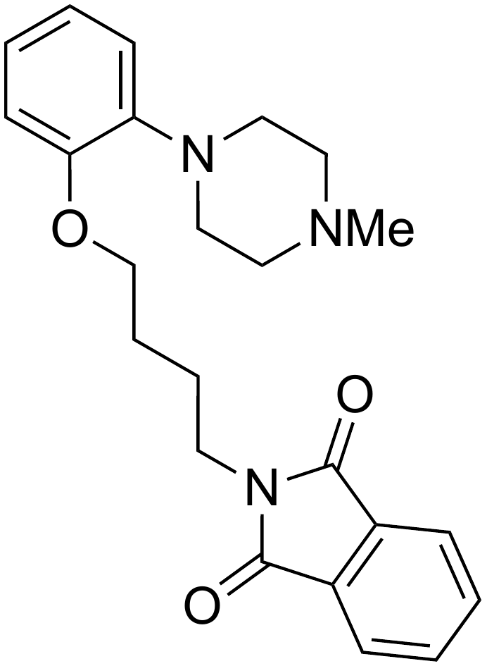 | N/A
23 | 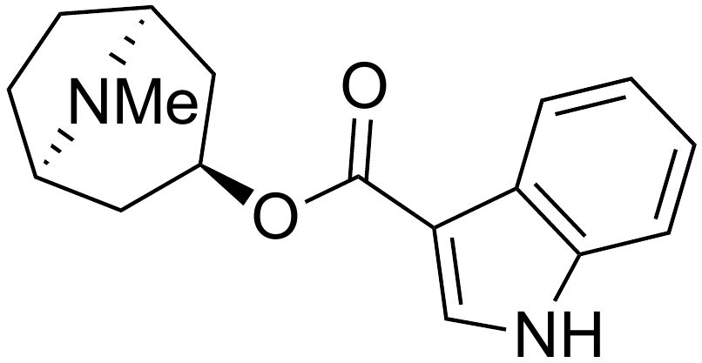 | 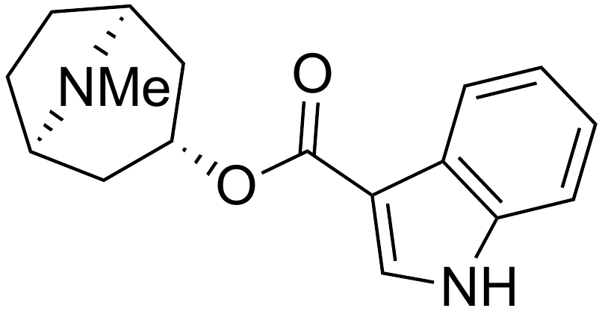 | 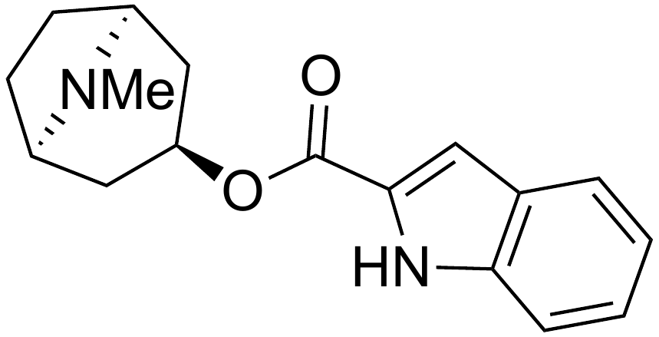 | N/A
24 |  |  | 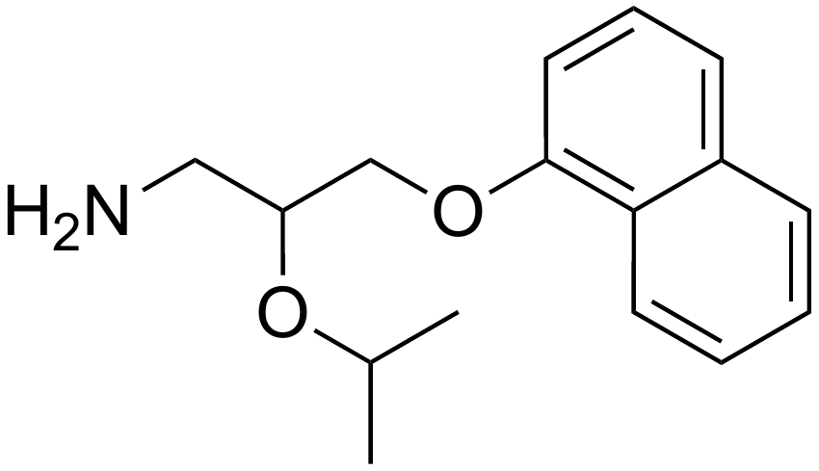 | N/A
25 | 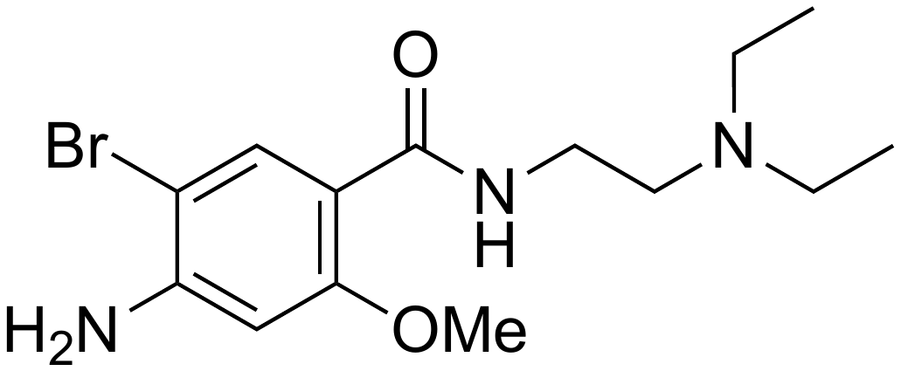 | 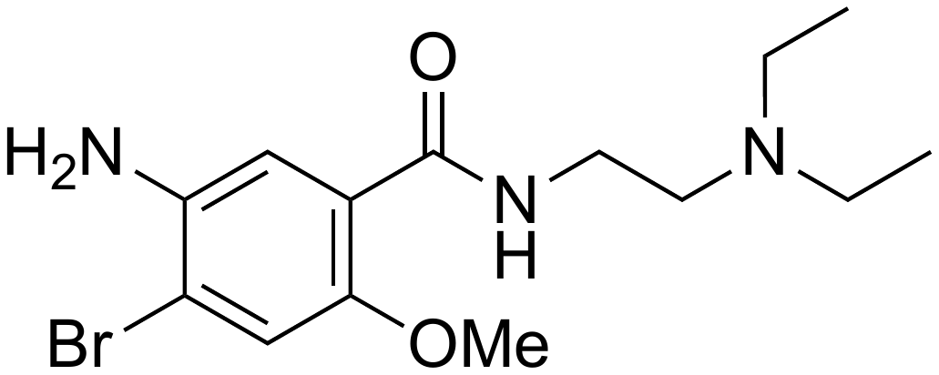 | 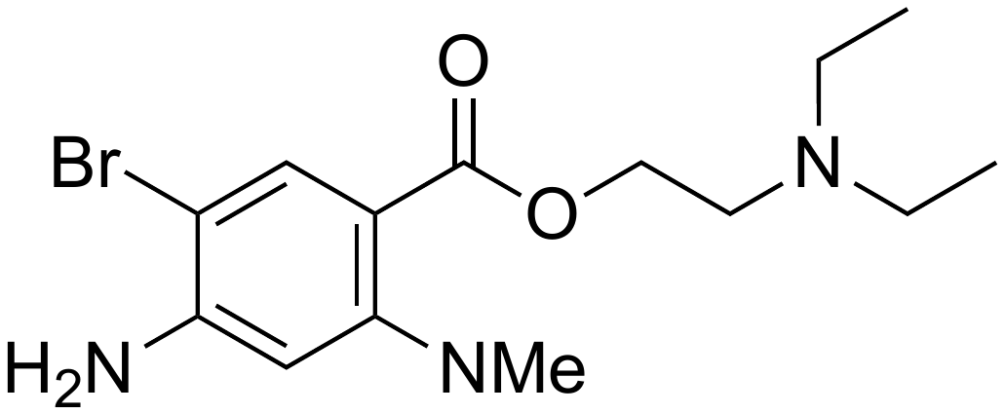 | 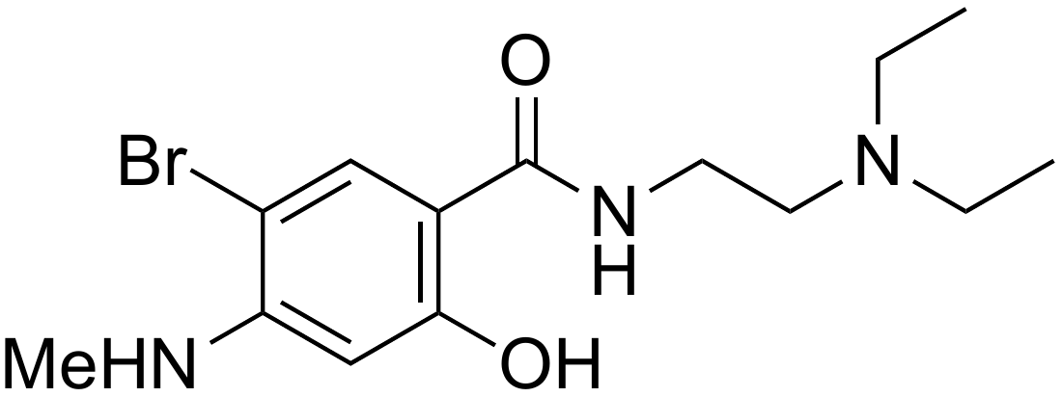
26 | 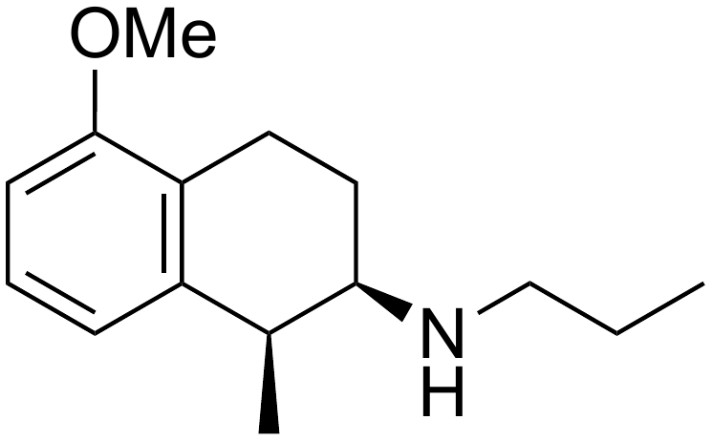 | 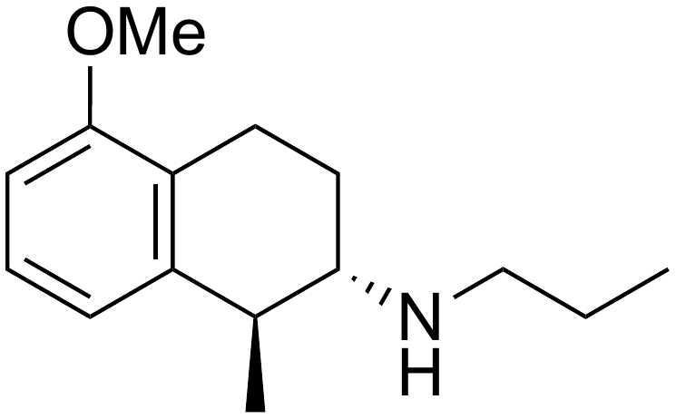 | 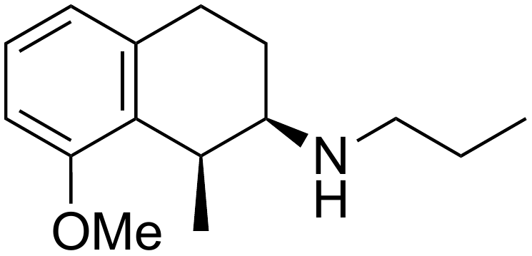 | N/A
27 | 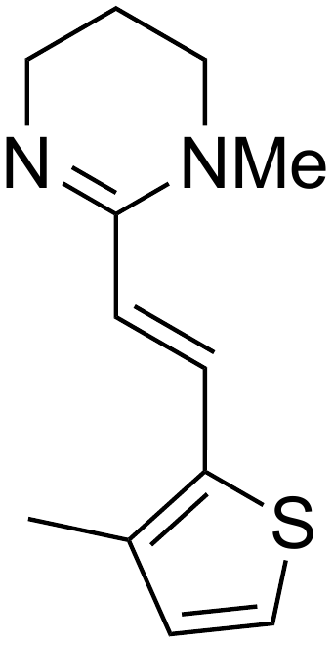 | 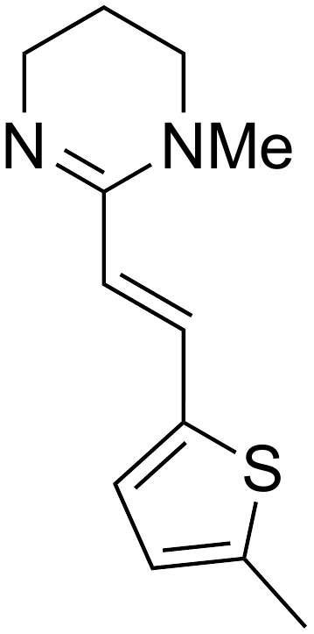 | 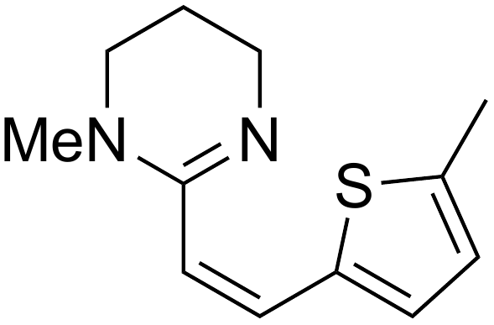 | N/A
28 | 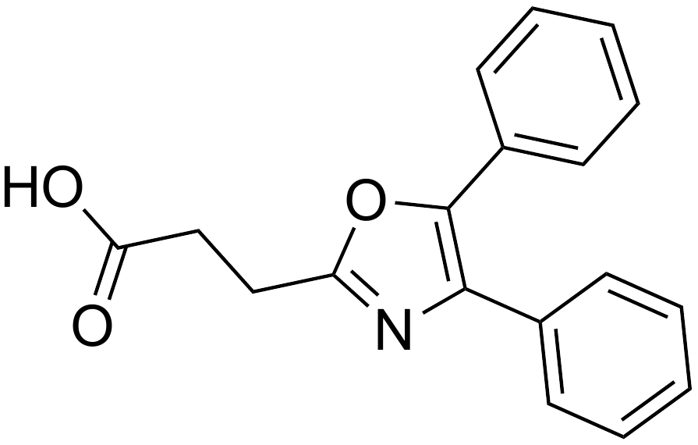 | 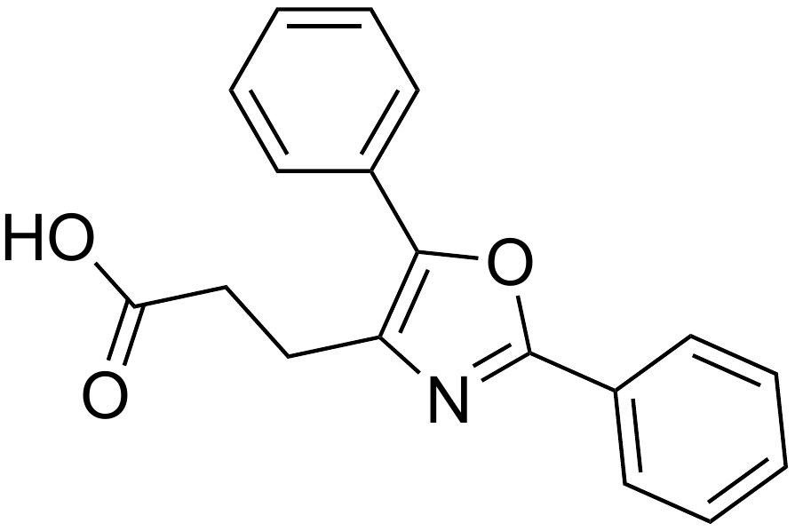 | 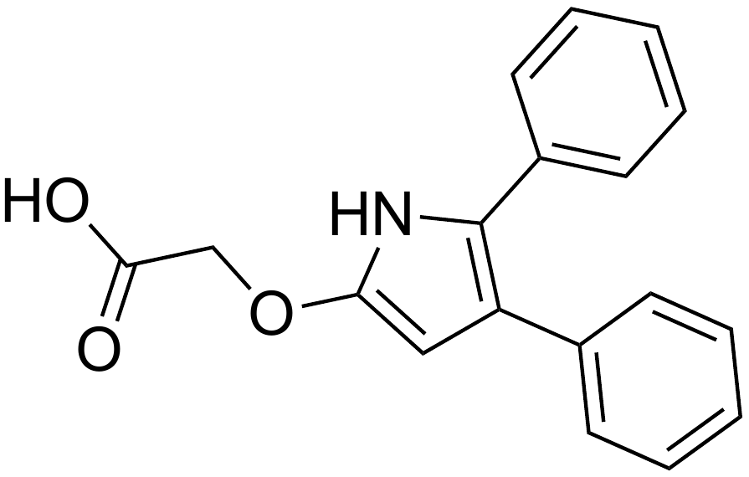 | N/A
29 | 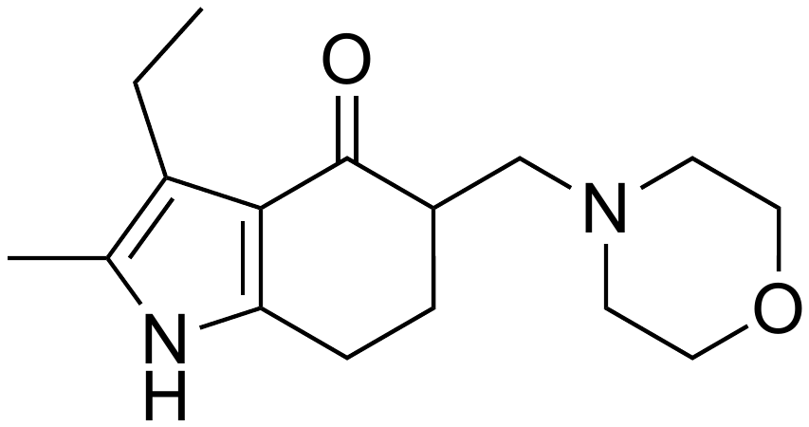 | 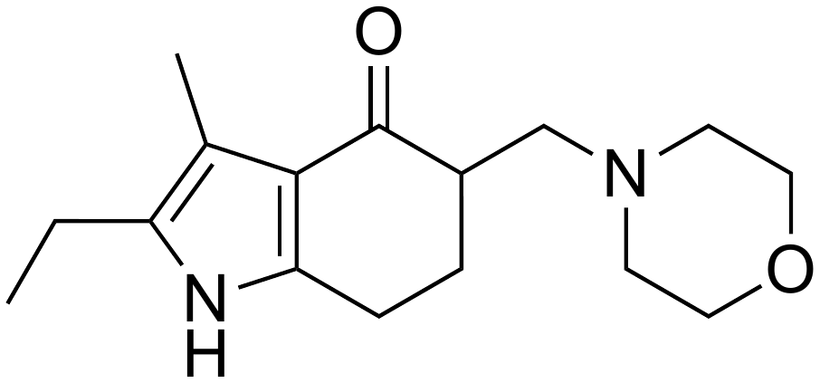 | 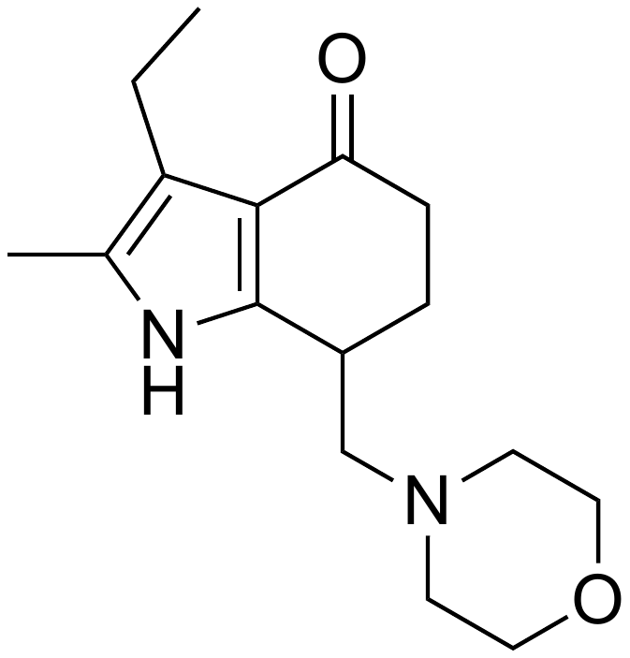 | N/A
30 | 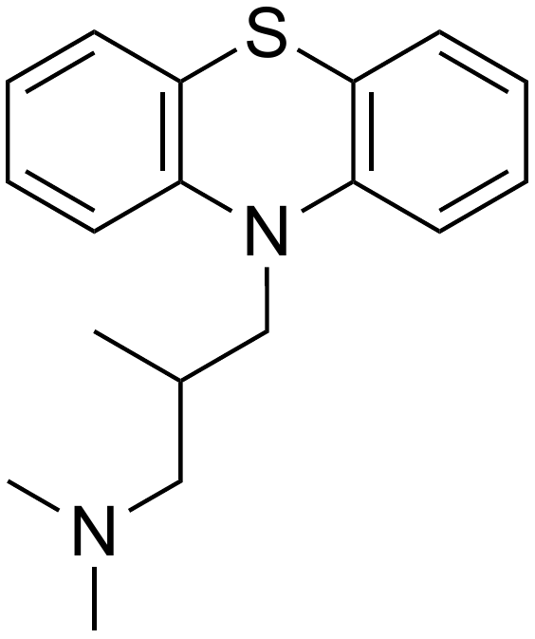 | 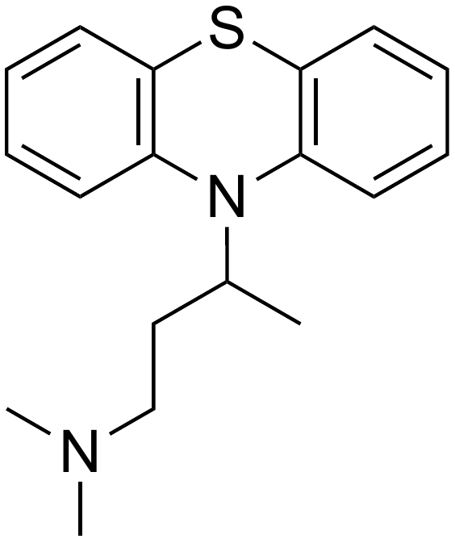 | 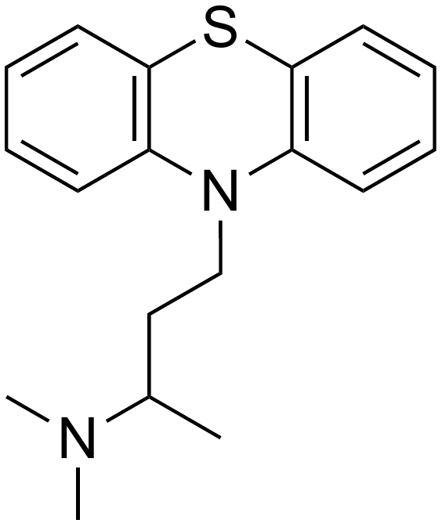 | N/A
31 | 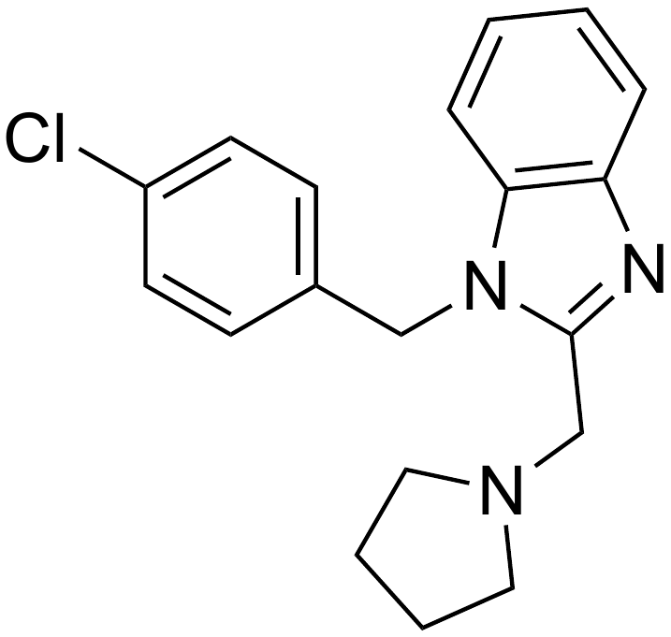 | 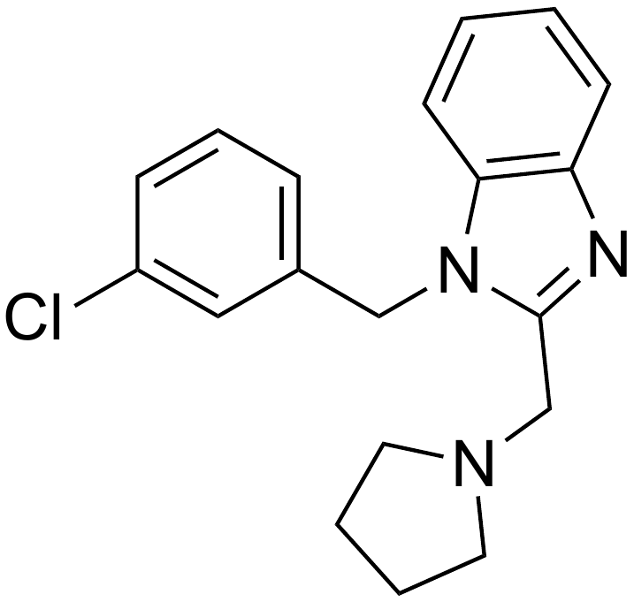 | 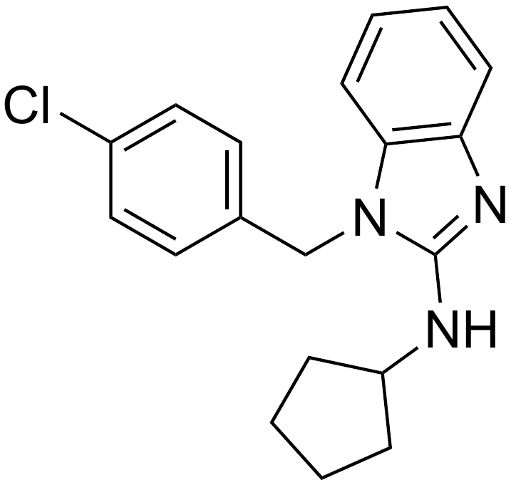 | 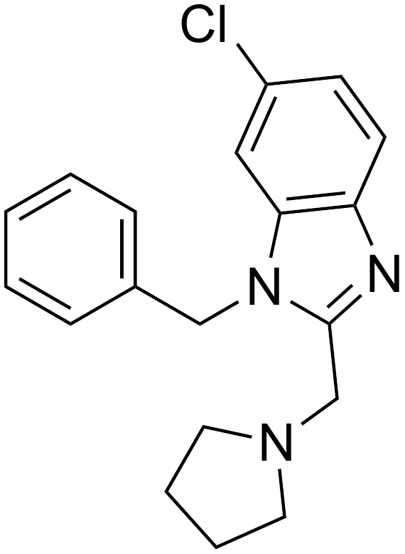
32 | 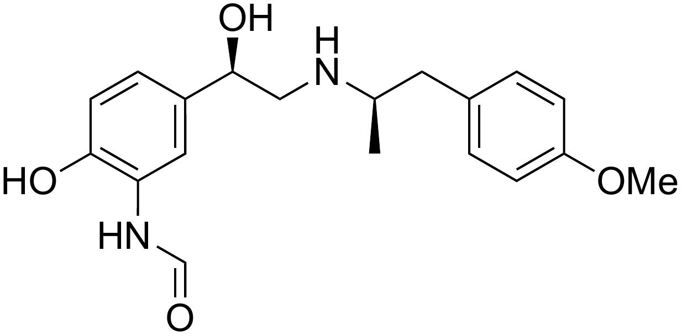 | 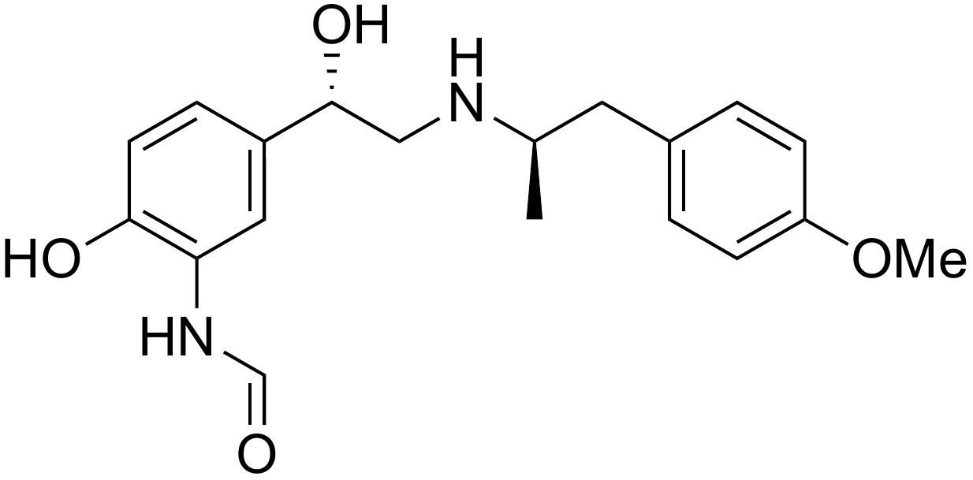 | 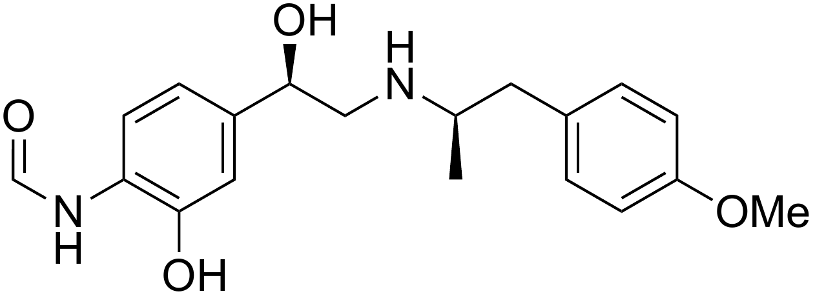 | N/A
33 | 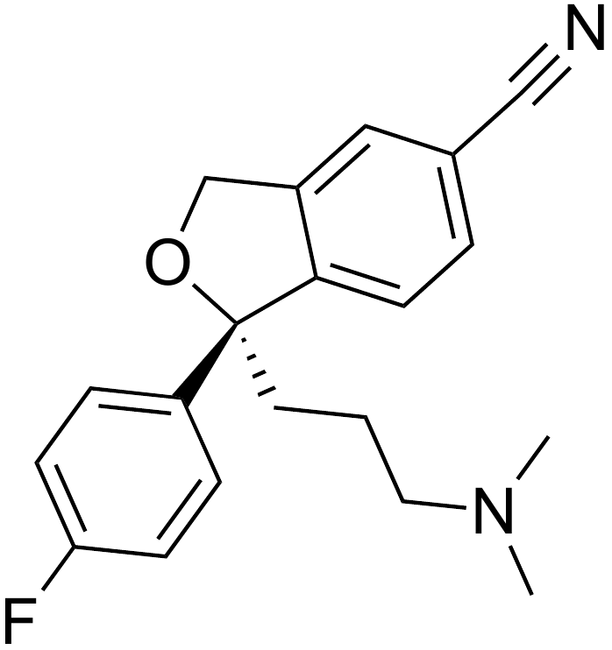 | 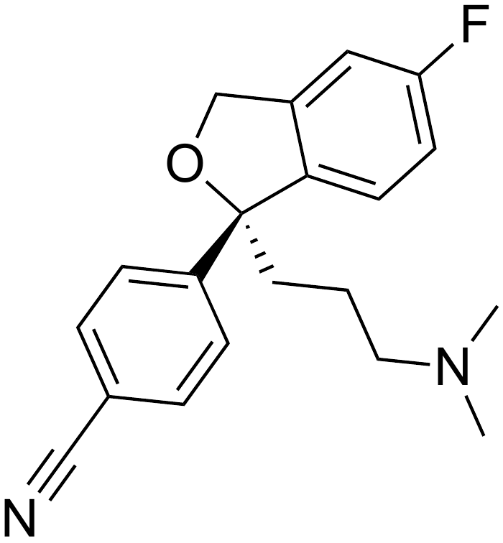 | 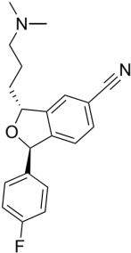 | N/A
34 | 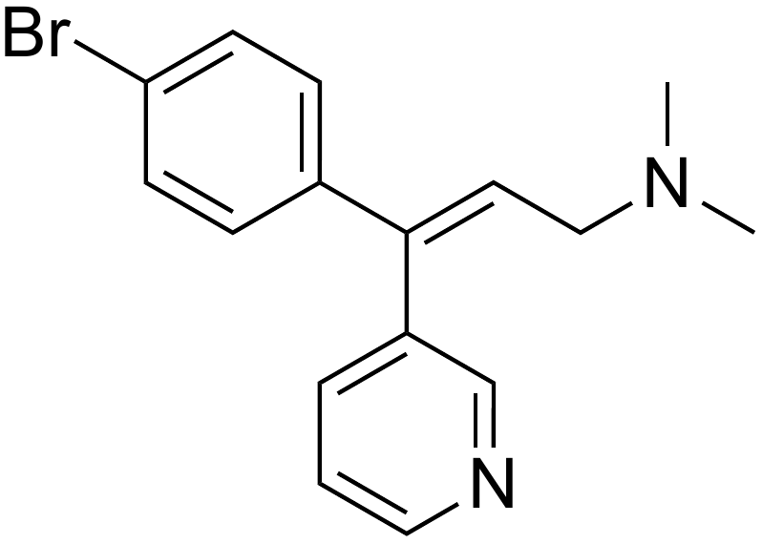 | 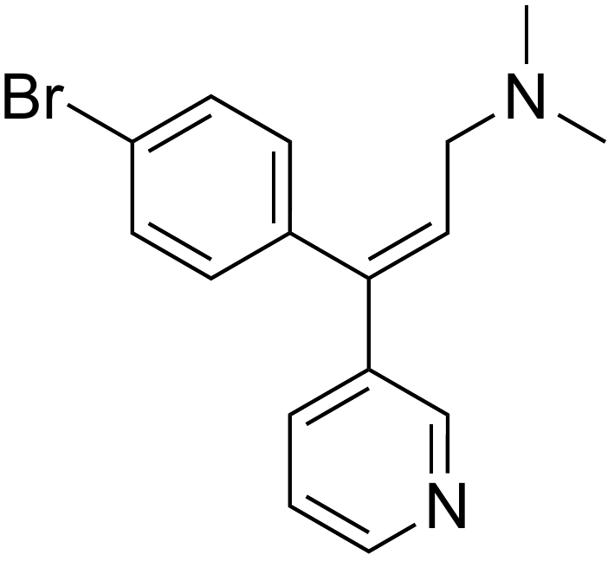 | 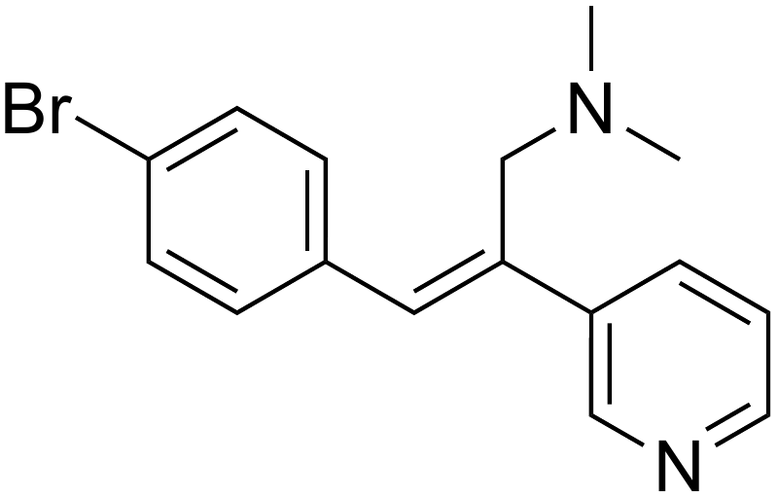 | N/A
35 | 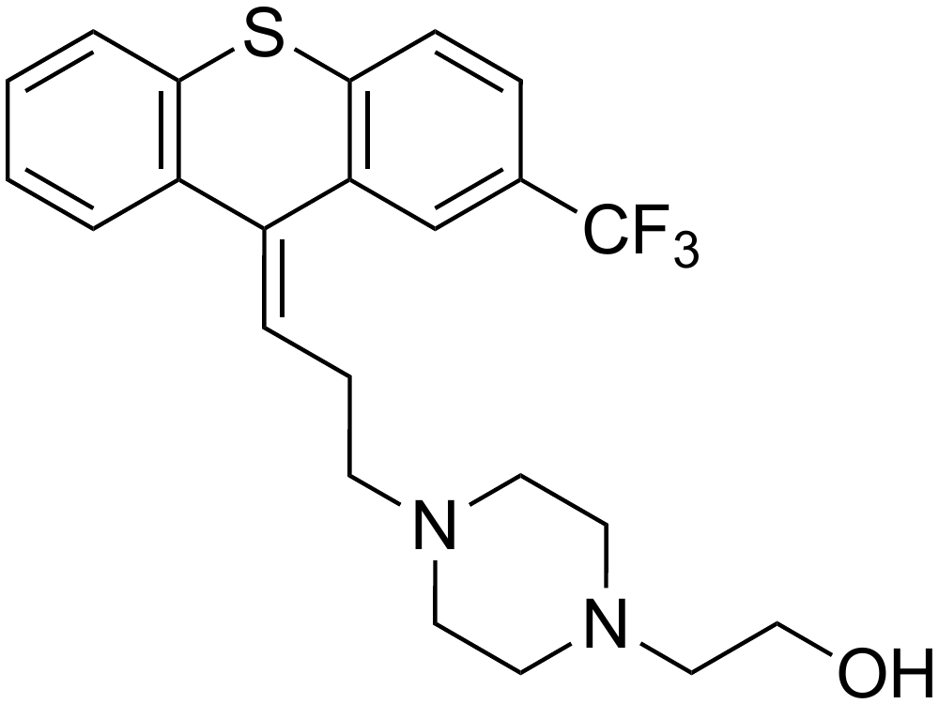 | 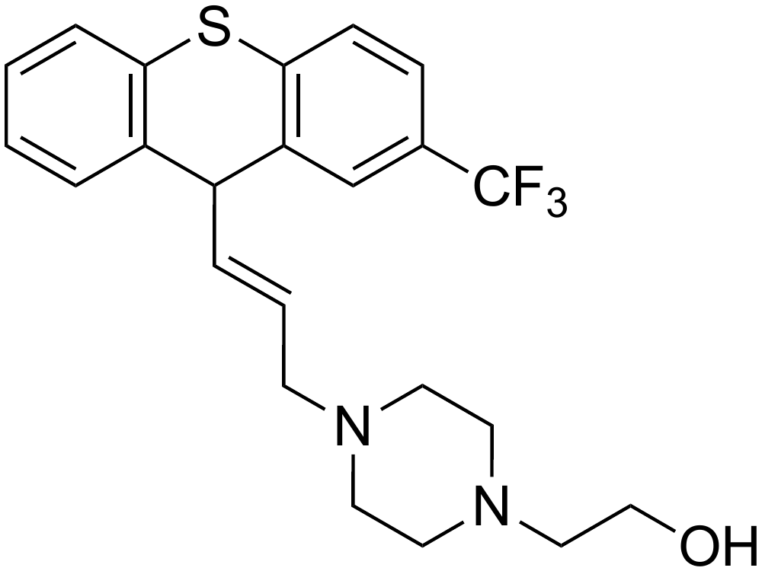 | 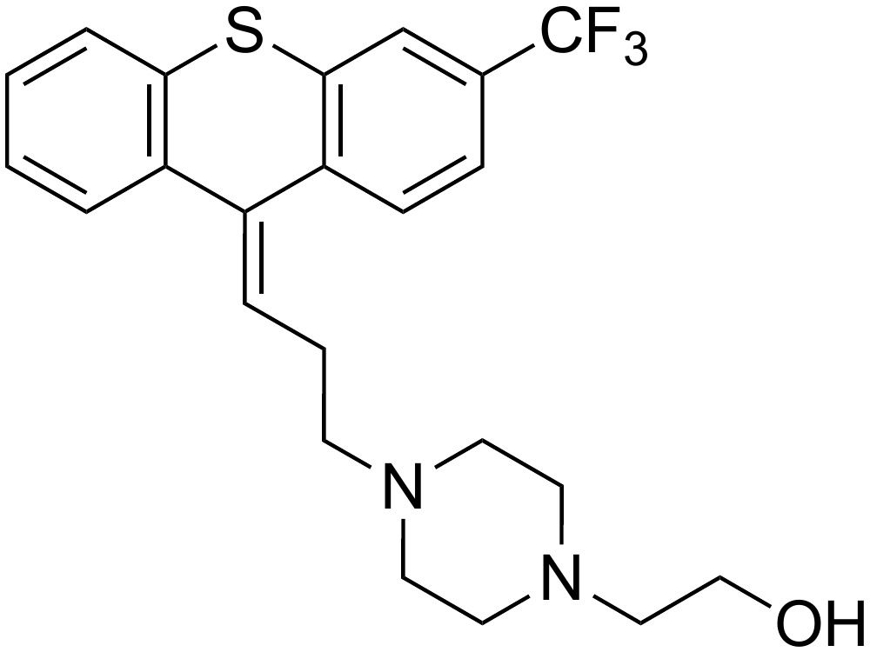 | N/A
36 | 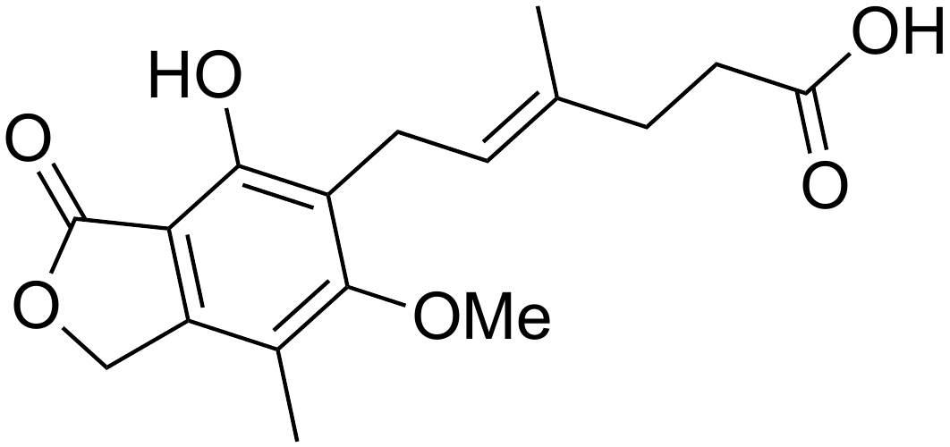 | 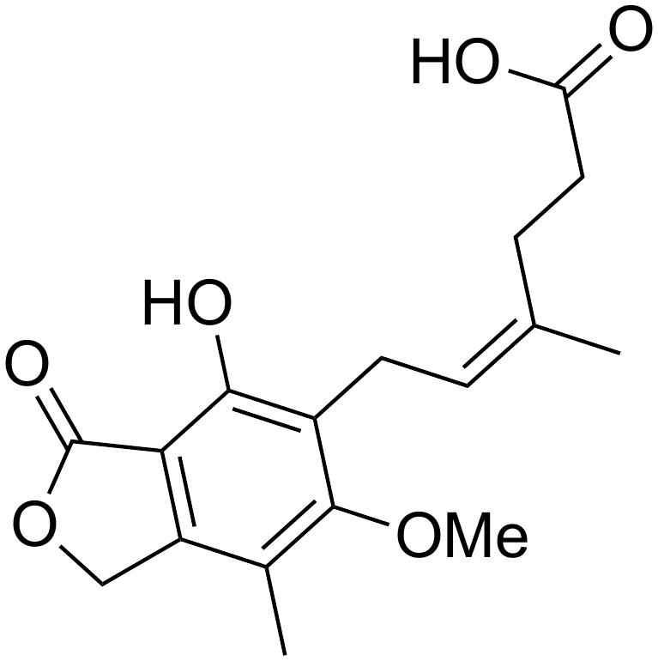 | 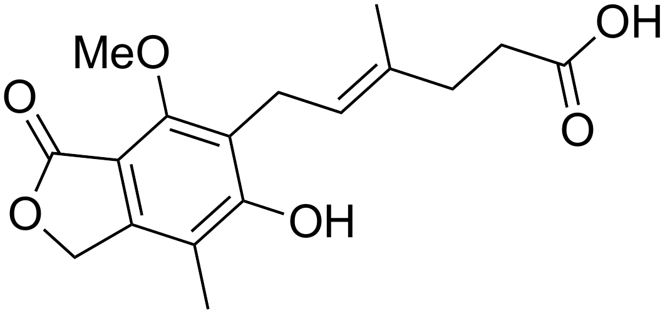 | 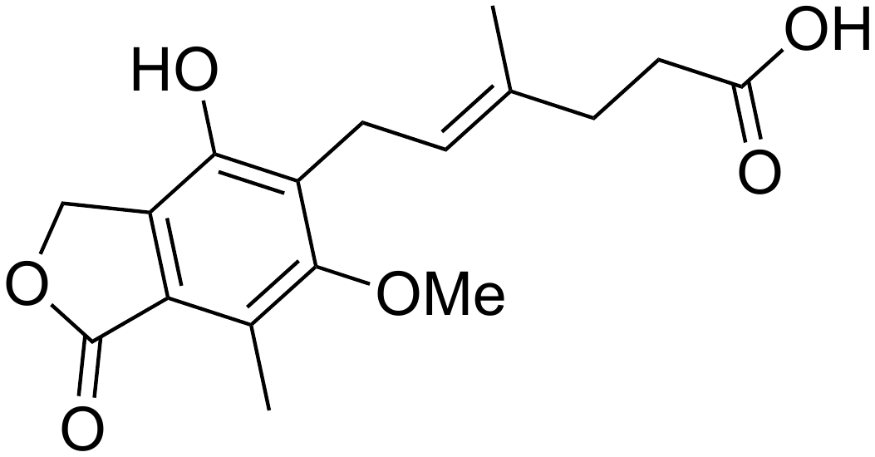
37 | 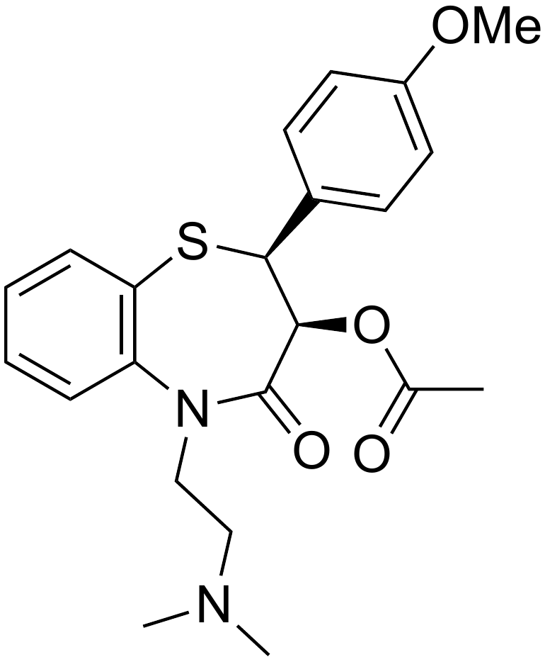 | 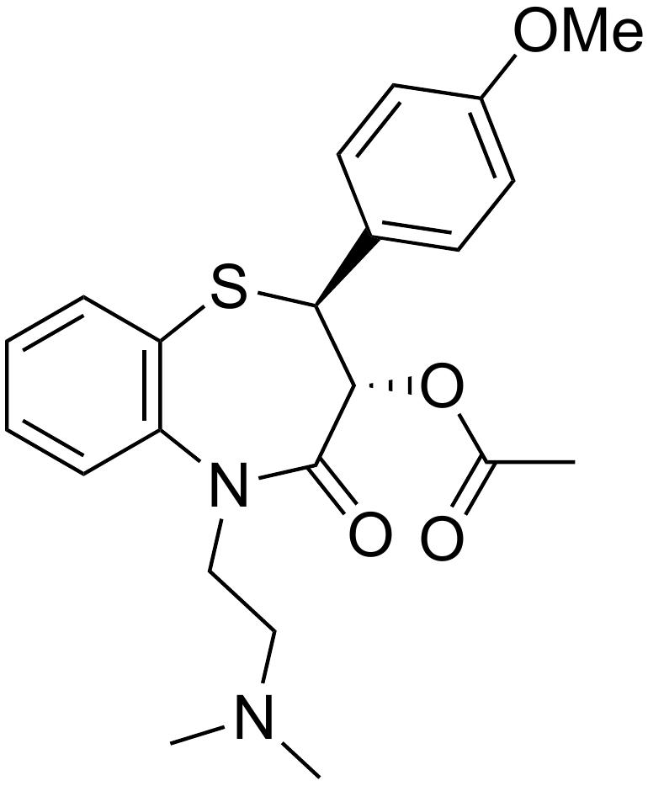 | 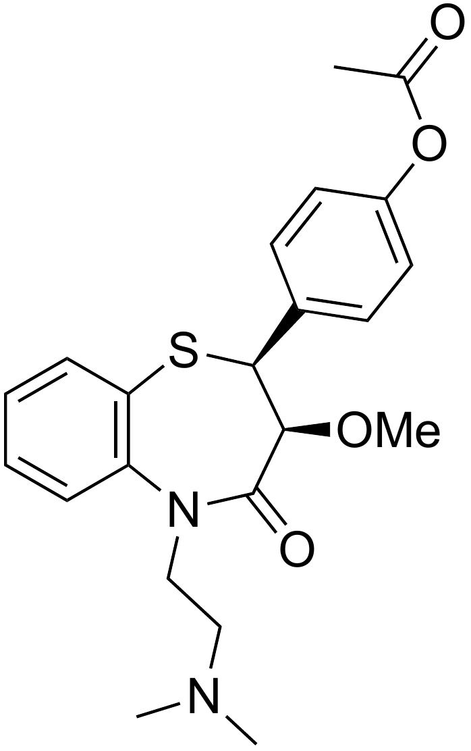 | N/A
38 | 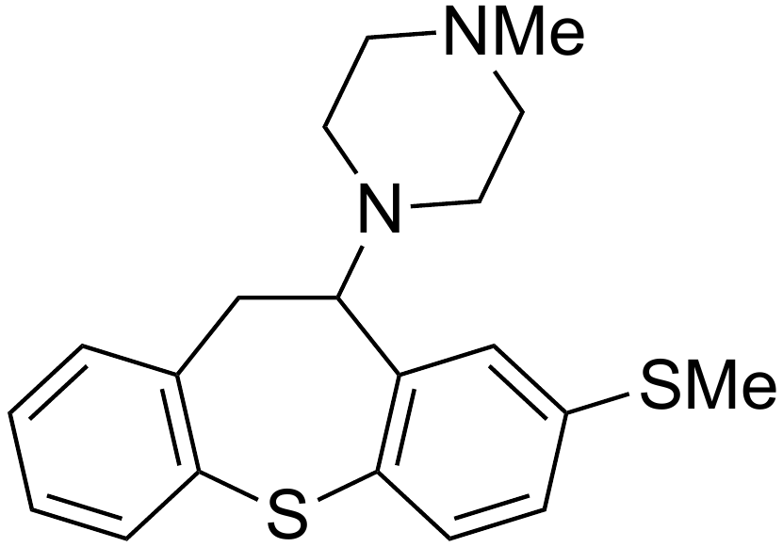 | 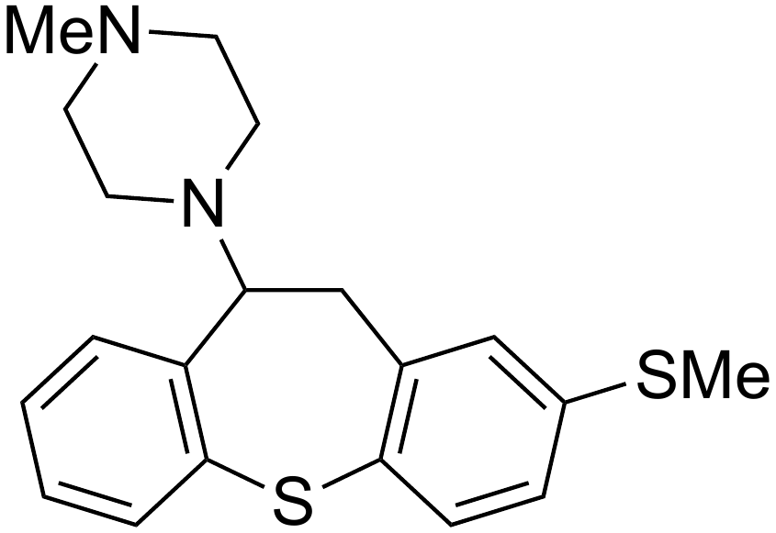 | 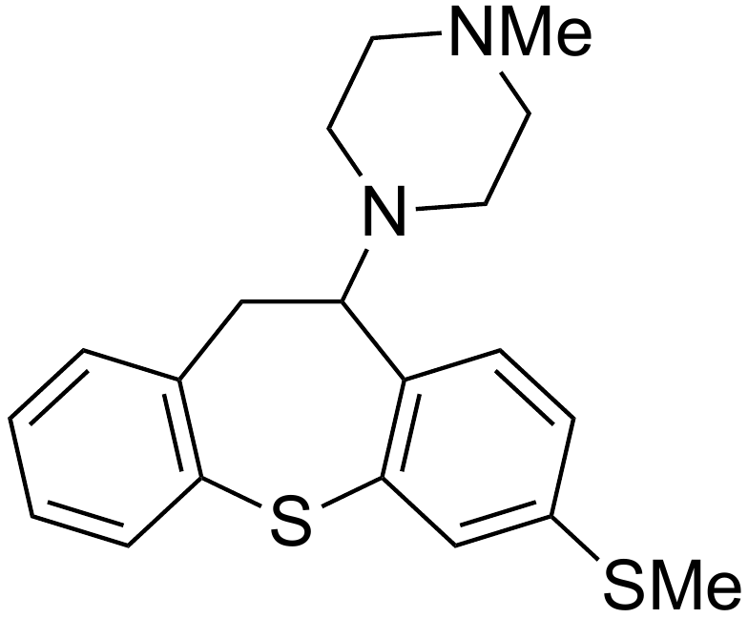 | N/A
39 | 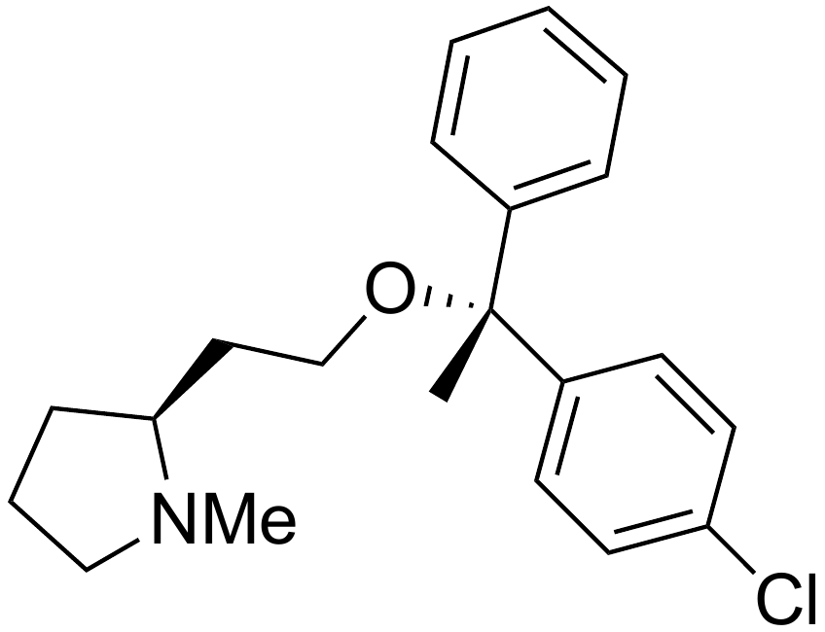 | 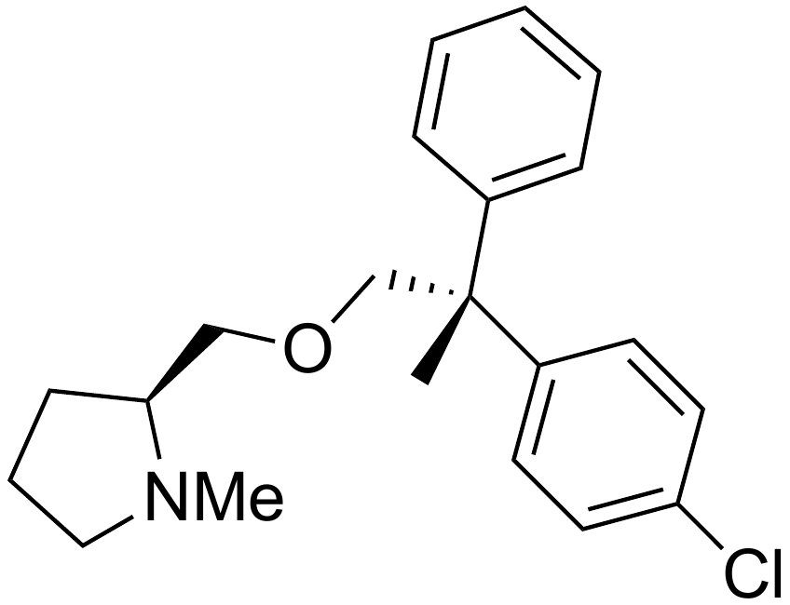 | 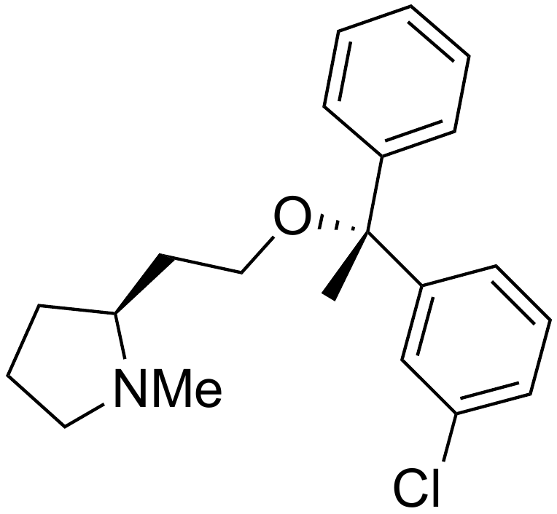 | N/A
40 | 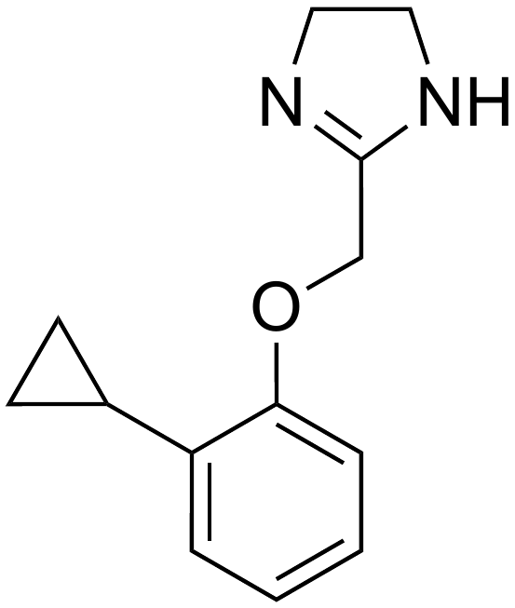 | 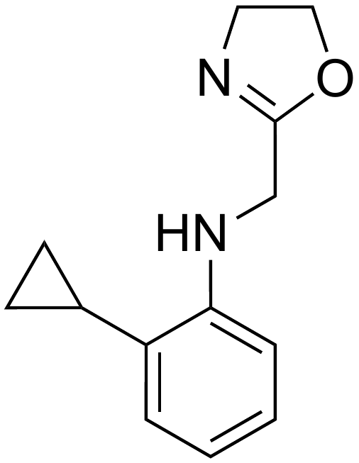 | 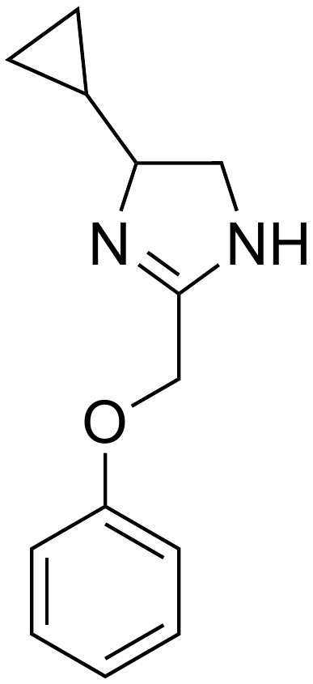 | N/A
41 | 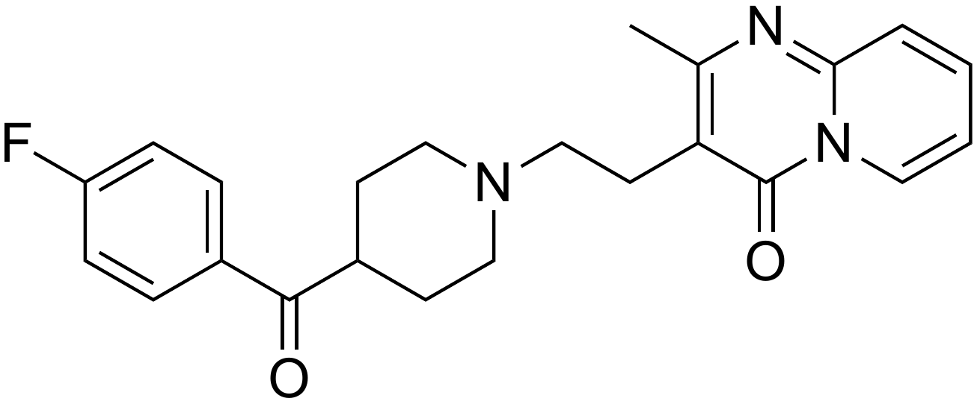 | 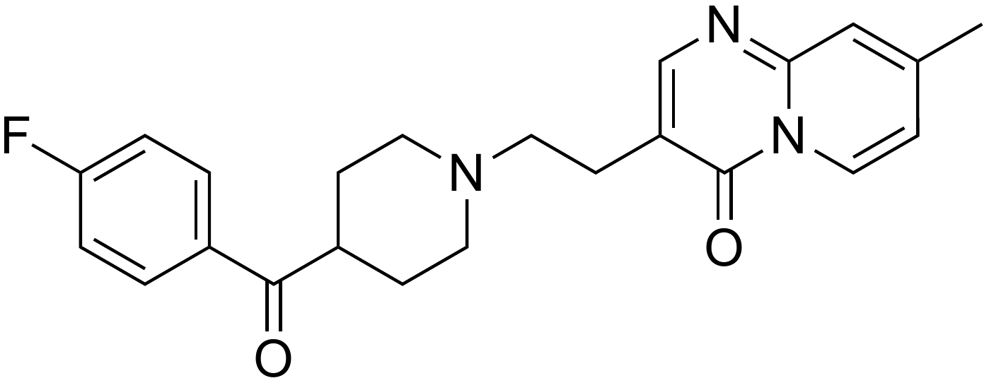 | 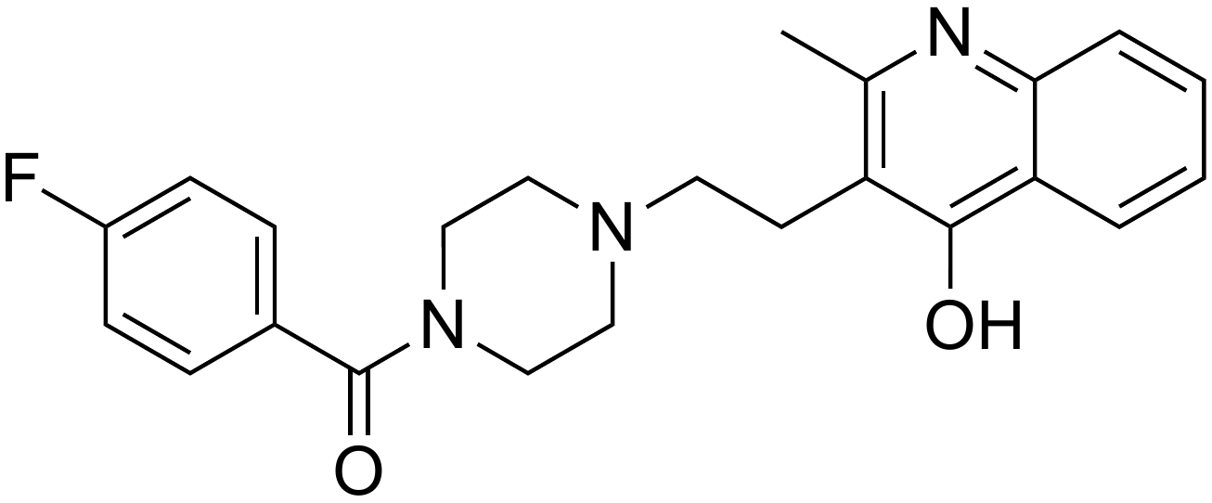 | N/A
42 | 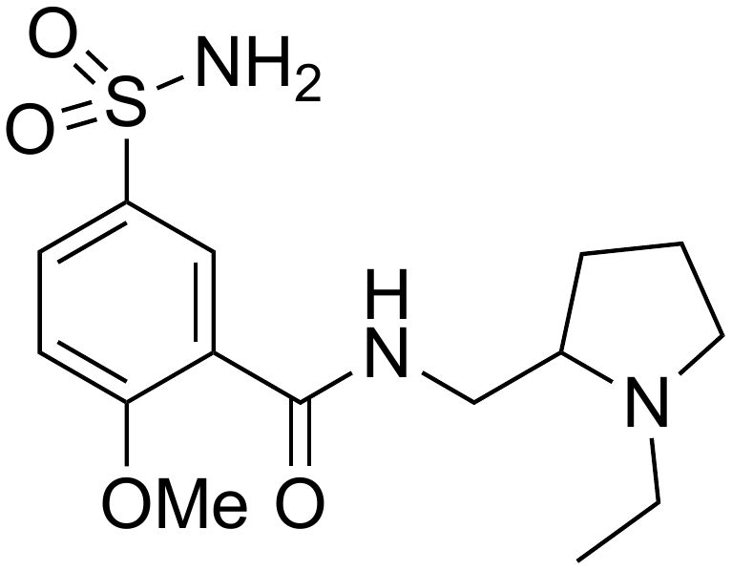 | 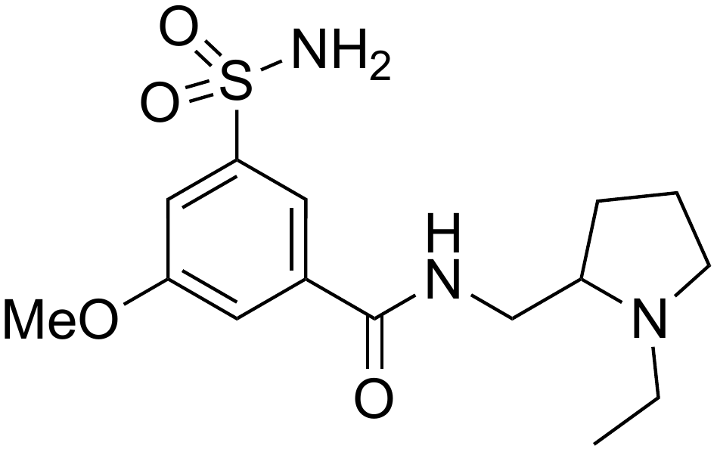 | 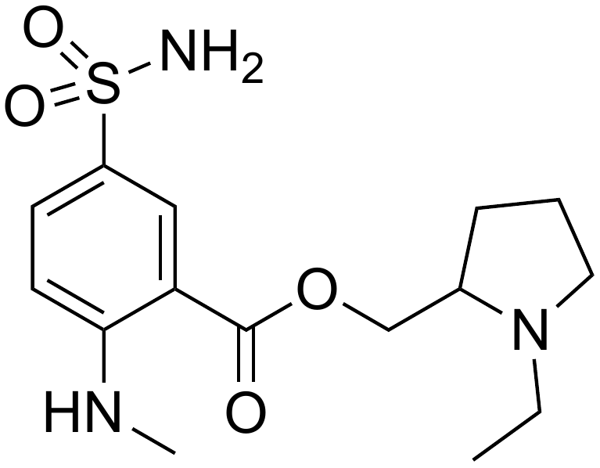 | N/A
43 | 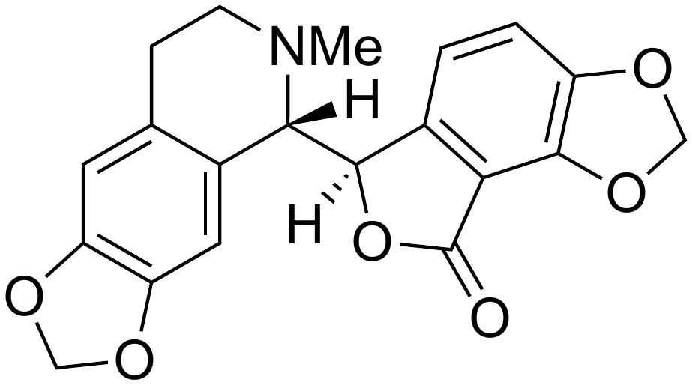 | 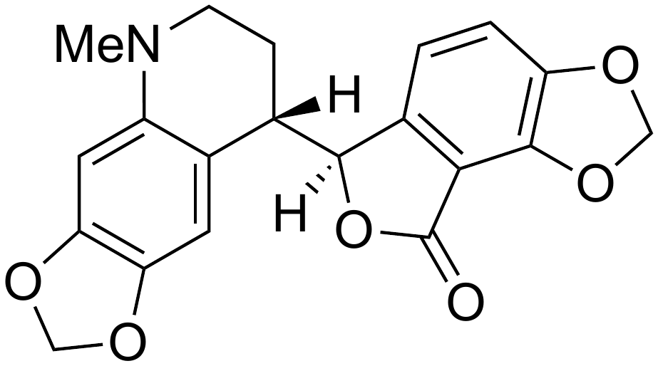 | 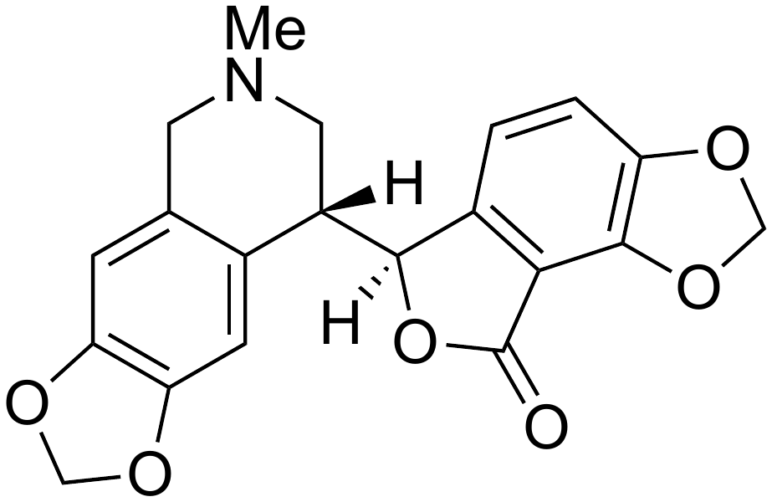 | 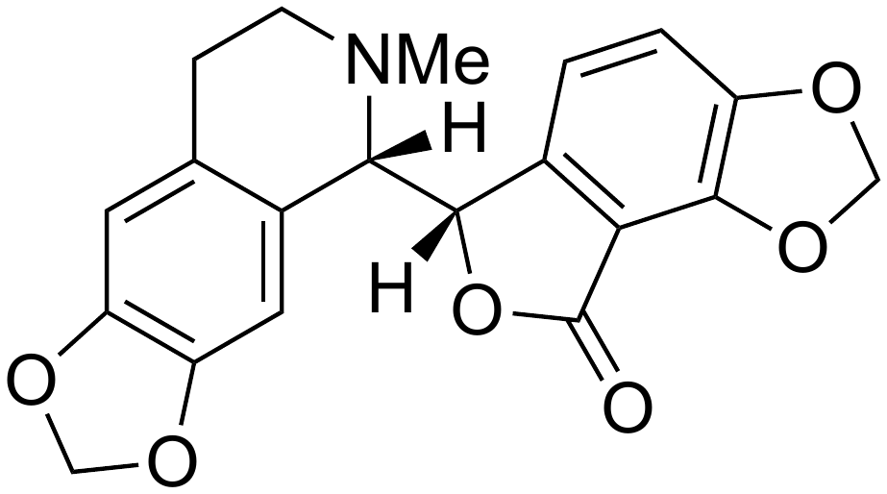

Table S1: Complete list of molecules with incorrect isomers, from the test set used to evaluate the use of infrared and NMR in ASV

IR.Cai algorithm details

Outline of algorithm

Conformational search and DFT geometry optimization are carried out as described in the main text. For each conformer, the infrared frequencies, their corresponding intensities, and the energy of the conformer are obtained. Conformers with energies more than 10 kJ mol⁻¹ above the lowest energy conformer are not considered in the analysis. Each conformer is checked for uniqueness by examining whether the energy and IR frequencies are the same as any of the other conformers; if so, only the lowest energy of the non-unique conformers is considered. The IR intensities for each conformer are weighted according to the Boltzmann distribution, using the energy of each conformer. The calculated frequencies are scaled using a constant scaling factor of 0.97 for B3LYP/6-31G* and 0.98 for B3PW91/cc-pVTZ. The final spectrum is calculated by broadening the sharp calculated frequencies with a Lorentzian distribution, of band width 12 cm⁻¹. The IR.Cai score is then given by:
$$\text{IR.Cai}=\frac{\sum_{i}{c_{i}e_{i}}}{\sqrt{\sum_{i}{c_{i}^{2}\sum_{i}{e_{i}^{2}}}}}$$

Where $c_{i}$ are the calculated intensities and $e_{i}$ are the experimental intensities, and the sum runs over all of the wavenumbers for which the intensity is recorded in the experimental spectrum. This expression is equivalent to the overlap integral of the two spectra, accounting for the discrete nature of the spectra (the intensity is recorded at intervals of around 2 cm⁻¹ for the experimental spectrum and the calculated spectrum is formatted accordingly). The denominator of the fraction is required for normalisation, to give a score between 0 and 1.

Sensitivity of IR.Cai algorithm to different line broadening widths

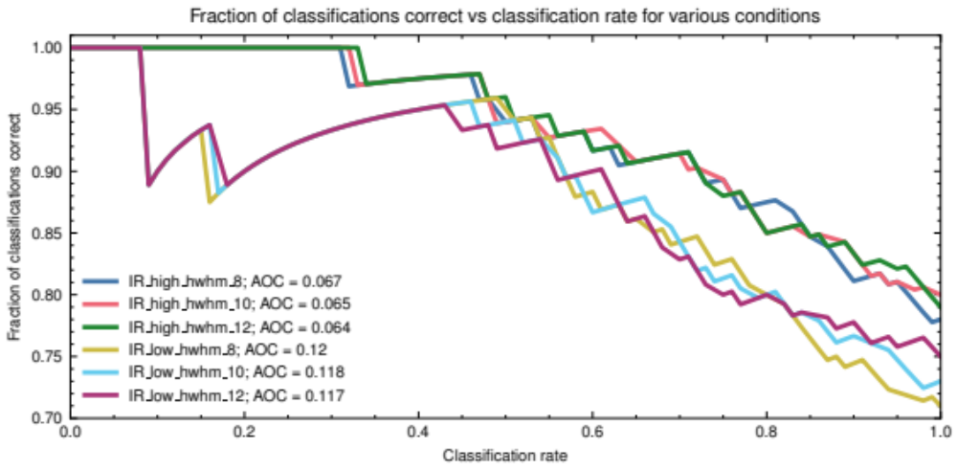

Figure S1: SCC curve showing the sensitivity of the IR.Cai algorithm to the line broadening width used. Values of 8 cm⁻¹, 10 cm⁻¹ and 12 cm⁻¹ were used. ‘Low’ refers to IR.Cai scores obtained by calculating the spectra at the B3LYP/6-31G* level of theory; ‘high’ refers to IR.Cai scores obtained using the B3PW91/cc-pVTZ level of theory.

Figure S1 shows SCC curves for IR.Cai scores obtained from IR spectra calculated at low (B3LYP/6-31G*) and high (B3PW91/cc-pVTZ) levels of theory, using different half-widths at half maximum (HWHM) for the Lorentzian line broadening. The results shown use HWHM values of 8 cm⁻¹, 10 cm⁻¹ and 12 cm⁻¹. The appearance of the SCC curve is not sensitive to the precise value of the HWHM used, and all 3 values of the parameter give similar AOC scores. We took 12 cm⁻¹ as the value to use for the IR.Cai scores used elsewhere in this work, but we anticipate that using slightly different values would not have a material impact on the results or conclusions.

DP4 calculations with labile protons (DP4*)

A DP4 probability calculation relies on assigning the calculated NMR shifts to the experimental shifts. In the case of ¹³C NMR, or ¹H NMR for a molecule with no labile protons, this is achieved by simply matching the highest calculated shift with the highest experimental shift, and so on until all the shifts are assigned. This process of “pairwise assignment” is illustrated in Figure S2 for one of the molecules in our test set. In this case, the pairwise algorithm gives a reasonable assignment, where each calculated shift is assigned to a relatively close experimental shift. This is consistent with the molecule containing no labile protons, and so having a fairly good experimental match for each calculated shift. However, in the case of a molecule containing labile protons, solvent effects can result in large deviations of experimental shifts from calculated values, especially for polar solvents such as DMSO where protic hydrogens can form hydrogen bonds with the solvent [1]. This presents significant difficulties as DMSO is often the preferred solvent for pharmaceuticals, due to its excellent solubility properties, non-toxicity, and miscibility with water. Figure S3 illustrates the limitations of the pairwise assignment algorithm when applied to a molecule with labile protons, using DMSO as the solvent: the resulting assignment is often chemically unreasonable due to the large error in the calculated shift of the protic hydrogens. In this specific case, the experimental peak due to the carboxylic acid proton at 12.33 ppm does not have a closely matching calculated peak. The pairwise algorithm nevertheless assigns it to the highest calculated shift, which then has consequences for the rest of the assignment. The calculated peak at 5.61 ppm ends up being assigned to one of the aromatic peaks at 7.36 ppm, when a more reasonable assignment might have been to the experimental peak at 5.00 ppm.

The issue of assignment is key for the calculation of the DP4 probability, because it is these errors between calculated and experimental shifts which are used to calculate the probability of the structure being correct. Hence, if some of the errors are very large due to an unreasonable assignment, the resulting DP4 probabilities cannot be expected to be useful for structure verification. To resolve this issue, it is necessary to find a way of generating a reasonable assignment, even in the case of molecules containing protic hydrogens. One approach would simply be to exclude protic hydrogens from the DP4 analysis, and calculate probabilities based on the other shifts. The issue with this approach is that it requires manual identification of the experimental peaks which are due to protic hydrogens. In many cases this is reasonable, for example when peaks are broad, or in characteristic chemical shift ranges such as the carboxylic acid proton at 12.33 ppm. However, not all broad signals are due to protic hydrogens (broadness also commonly results from unresolved couplings and chemical exchange) and many protic signals appear in ranges which would also be consistent with non-protic signals. This means that manual exclusion of protic hydrogens is subject to a large amount of guesswork and subjectivity. Without previous knowledge of the structure of the molecule which gave the spectrum, this process becomes even more difficult.

A different, algorithmic, approach was therefore explored, in the hope of finding a solution that would not require subjective judgements as to whether to exclude a peak observed in the experimental spectrum. The final algorithm treats the experimental and calculated shifts as a bipartite graph, where each shift is a node, and there are edges between each experimental and calculated shift that match within a certain threshold, adjustable by the user and taken to be 0.6 ppm throughout this work. Then, the assignment is determined by finding a maximum cardinality matching (i.e. pairing up as many of the calculated shifts as possible) with minimum mean absolute error (MAE). Only having edges between shifts within a certain threshold of each other means that if there are large outliers, such as the 12.33 ppm carboxylic acid proton discussed previously, no match will be possible, and so the peak is simply not matched. In this way, any peaks that were not used in the matching are excluded from the DP4 analysis. This gives rise to an assignment that contains no large errors. This assignment is used in the rest of the DP4 calculation, and we term the resulting scores DP4*.

In the case of an incorrect structure (a molecule that is not the one which gave rise to the spectrum under consideration), this approach excludes many shifts because the calculated spectrum simply does not fit the experimental spectrum very well. This process of excluding peaks which are outliers means that even if a molecule is not correct, it can give rise to a set of small errors for the remaining shifts after the exclusions have been made. This would give a high DP4* score despite the structure clearly not fitting the spectrum. Hence, we need to account for the number of exclusions made in obtaining any given assignment. A simple scaling factor for the raw molecular probabilities is proposed:

$$\text{scaling factor}=\exp\left(-12n_{\text{excl}}\right)$$

where $n_{\text{excl}}$ is the number of protons excluded for a given molecule. The final DP4* scores are then found by normalisation of the scaled probabilities. This is an aggressive scaling, which is necessary due to the tendency of the exclusion process to give a low MAE regardless of whether the structure is correct. Structures which are a poor match for the experimental spectrum tend to be discriminated by a large $n_{\text{excl}}$ in such cases. However, probabilities for structures which result in the same number of exclusions are scaled by the same scaling factor, and so it remains the nature of the differences between the calculated and experimental NMR shifts which discriminate between the possibilities where both structures are a reasonable fit.

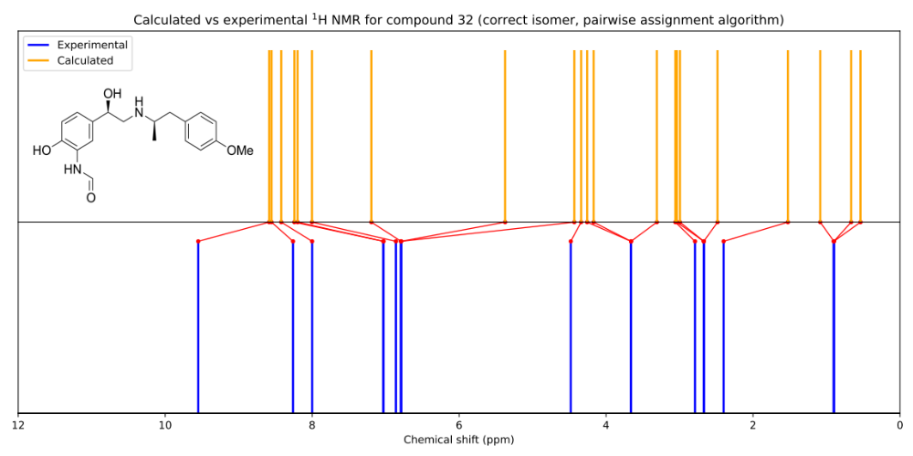
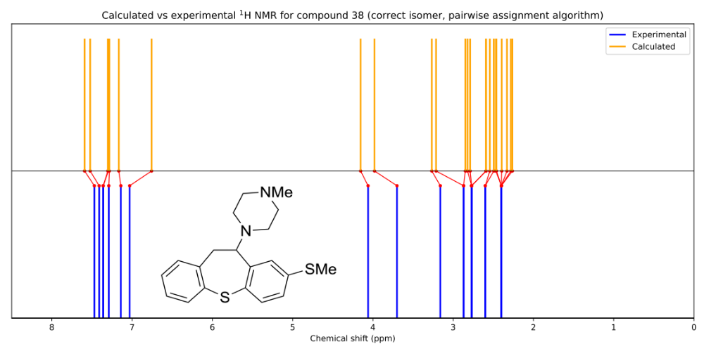
As extensively discussed in the literature [2], [3], DFT calculated NMR shifts are subject to systematic errors that are a complicated function of the specific environment and the computational conditions used. The original DP4 probability alleviated this difficulty by performing an internal scaling process [4]. However, this internal scaling process relies on having an assignment of the experimental to calculated shifts. In this context, where an assignment must be found, we can initially scale the calculated shifts using known external scaling factors [5]. Then, the previously mentioned matching process is performed with the externally scaled shifts, and the corresponding unscaled calculated shifts assigned to the experimental shifts. This then makes the conventional DP4 approach of internal scaling possible using the unscaled calculated shifts and the experimental shifts.
Figure S3: The experimental and calculated NMR spectra of molecule 32 from our test set. The assignments are shown by lines linking the experimental and calculated peaks. These assignments are determined by a simple pairwise assignment algorithm, where the highest calculated shift is assigned to the highest experimental shift and so on. The calculated spectrum shown has been internally scaled according to these assignments, as is standard in a DP4 calculation. As a DP4 calculation does not take into account line shape or coupling patterns, all the peaks are shown as sharp lines. The integration of each peak is considered by allowing relevant experimental peaks to be assigned to more than one calculated peak. The experimental peak at 9.55 ppm does not have a “matching” calculated peak, so the pairwise assignment gives an unreasonable assignment containing some large errors.
Figure S2: The experimental and calculated NMR spectra of molecule 38 from our test set. The assignments are shown by lines linking the experimental and calculated peaks. These assignments are determined by a simple pairwise assignment algorithm, where the highest calculated shift is assigned to the highest experimental shift and so on. The calculated spectrum shown has been internally scaled according to these assignments, as is standard in a DP4 calculation. As a DP4 calculation does not take into account line shape or coupling patterns, all the peaks are shown as sharp lines. The integration of each peak is considered by allowing relevant experimental peaks to be assigned to more than one calculated peak. This molecule contains no protic hydrogens, so the pairwise assignment algorithm gives a reasonable assignment with no large errors.

Softmax procedure for score combination

The steps in the softmax algorithm are as follows:

- Apply the softmax function to the IR.Cai scores (the ‘scaling target’), on a molecule-wise basis:

$$q_{i}=\frac{\exp\left(x_{i}\right)}{\sum_{j}{\exp\left(x_{j}\right)}}$$

where $x_{i}$ is the IR.Cai score for isomer $i$ of the molecule, and the sum runs over all the isomers of the molecule. The resulting softmaxed scores, $q_{i}$ behave like probabilities in that they sum to 1.
- Find the standard deviation of the softmaxed IR.Cai scores, $q$, for each molecule, and find the average standard deviation by finding the mean over all molecules.
- Apply the softmax function to the ACD scores, this time using a temperature parameter:

$$r_{i}=\frac{\exp\left(y_{i}/T\right)}{\sum_{j}{\exp\left(y_{j}/T\right)}}$$

where $y_{i}$ is the ACD score for isomer $i$ of a given molecule, the sum runs over all the isomers of each molecule, and $r_{i}$ are the resulting softmaxed scores. The initial value of $T$ is set to 1.
- Find the mean standard deviation for the softmaxed ACD scores, $r.$ If the mean standard deviation over all molecules of $r$ and $q$ are the same, the process is finished. Otherwise, increment T appropriately and go back to step 2.

The result of this algorithm is two sets of scores for each molecule which sum to 1, and which have the same average standard deviation. This means that when combining the methods, it is less likely that one method will “overpower” the other simply due to the overconfidence in its predictions. In a sense, the methods are now calibrated to one another.

A very similar process is equally possible using DP4* instead of ACD scores. However, as briefly discussed in the main text, the raw DP4* scores tend to be sharply peaked in favour of one structure. This means that applying the same algorithm without modifications results in scores that do not differentiate between the isomers which had very small, but different, DP4* scores. This issue is illustrated in Table S2. A possible way of thinking about the DP4* scores is as the output of a softmax function acting on some latent logits, $z_{i}$:
$${\text{DP4*}}_{i}=\frac{\exp\left(z_{i}\right)}{\sum_{j}{\exp\left(z_{j}\right)}}$$

Applying softmax to the DP4* scores would therefore essentially be equivalent to applying softmax twice to these latent logits, which is a possible explanation for why the distinction between low scores shown in Table S2 is “smoothed over”.

 | Correct isomer | Incorrect isomer 1 | Incorrect isomer 2 | Incorrect isomer 3
DP4* | 2.4×10⁻⁵ | 5.83×10⁻¹⁰ | 2.72×10⁻¹⁴ | 1.00
Softmax(DP4*) | 0.175 | 0.175 | 0.175 | 0.475
Softmax(ln(DP4*)) | 0.251 | 0.123 | 0.108 | 0.519
IR.Cai | 0.865 | 0.827 | 0.668 | 0.842
Softmax(IR.Cai) | 0.475 | 0.218 | 0.00919 | 0.298
Table S2: DP4*, IR and softmax scaled DP4* and IR.Cai scores for compound 43 in the test set. The softmax(DP4*) and softmax(ln(DP4*)) scores have been temperature scaled with the IR.Cai scores as the scaling target. The softmaxed DP4* scores smooth over the differences between the small DP4* scores for the correct isomer and incorrect isomers 1 and 2. First taking the logarithm of the DP4* scores maintains this distinction following application of the softmax function.
To obtain DP4* scores that are well calibrated to the IR.Cai scores, one approach is to determine these latent logits, and use these in the algorithm as previously described. These logits can be obtained by inverting the softmax function:
$$z_{i}=\ln\left(\text{DP4}{\text{*}}_{\text{i}}\right)+\ln\left(\sum_{j}{\exp\left(z_{j}\right)}\right)=\ln\left(\text{DP4}{\text{*}}_{\text{i}}\right)+\ln\left(P\right)$$
As $P=\sum_{j}{\exp\left(z_{j}\right)}$ is a constant for a given molecule, and the softmax algorithm involves scaling the $z_{i}$ by the temperature parameter, we can just take $z_{i}=\ln\left({\text{DP4*}}_{i}\right)$ as the latent logits; the choice of $P$ affects only the value of $T$ required for alignment with the softmaxed IR.Cai scores.

Figure S4a shows the distribution of the subtracted scores used to obtain the SCC curves for ACD, DP4* and IR.Cai. We denote these subtracted scores as ∆IR.Cai, ∆ACD and ∆DP4*. Each of the datapoints on these plots represents a comparison of scores between a correct isomer and one of its incorrect isomers from the test set. While the distributions of the ∆IR.Cai and ∆ACD scores appear similar, the ∆DP4* scores are somewhat bimodal. There are many comparisons for which ∆DP4* is close to 1; however, there are also a significant number of comparisons for which ∆DP4* is close to -1, in cases where the DP4* score for the correct isomer is close to 1 and that for the correct isomer is close to 0. This helps to explain why the ∆DP4* scores cannot be immediately combined with the ∆IR.Cai scores to improve the AOC on the SCC curve, as the distributions of the scores have very different shapes. In order to combine the two methods in a way that considers the information provided by each, the scaling process described above was performed, resulting in scaled scores plotted in Figure S4b. The ∆DP4* scores now have a distribution similar to the ∆IR.Cai scores and combining the two does indeed improve the ability of the scores to classify correctly as described in the main text.

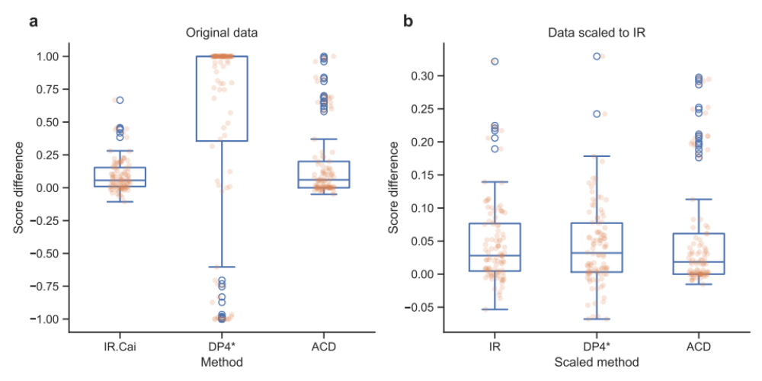
Figure S4: Plots showing the distribution of subtracted scores for high-level IR.Cai, DP4* and ACD with manual peak picking. Each datapoint plotted on these plots is the score of a correct isomer minus the score of one of its incorrect alternatives. a Plot showing the distribution of the raw, unscaled scores for the three methods. b Plot showing the distribution of the scores scaled using the softmax scaling procedure, using the IR.Cai scores as the scaling target.

Combining low-level IR with DP4* and ACD
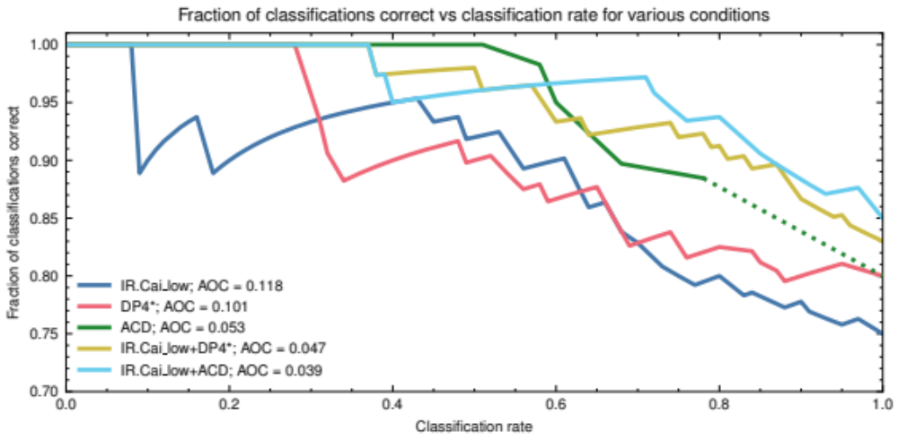

Figure S5: SCC curve showing low level IR.Cai, DP4*, ACD, and the combinations of DP4* and ACD with low-level IR. The DP4* and ACD scores are appropriately scaled to the low level IR.Cai scores using the softmax scaling procedure.

Figure S5 shows the SCC curve for IR.Cai scores obtained from IR spectra calculated at the low (B3LYP/6-31G*) level of theory, DP4* and ACD scores. The combinations of IR.Cai with DP4* and IR.Cai with ACD are also shown. For both ACD and DP4*, the combination with IR.Cai improves the performance, lowering the AOC from 0.053 to 0.039 and 0.101 to 0.047 respectively. Although the low level IR.Cai scores are less effective at differentiating the correct from incorrect isomers compared to the high level IR.Cai scores, the combination of the low level scores with DP4* shows a similar improvement in performance.

Combining scores derived from the same data

ACD and DP4*
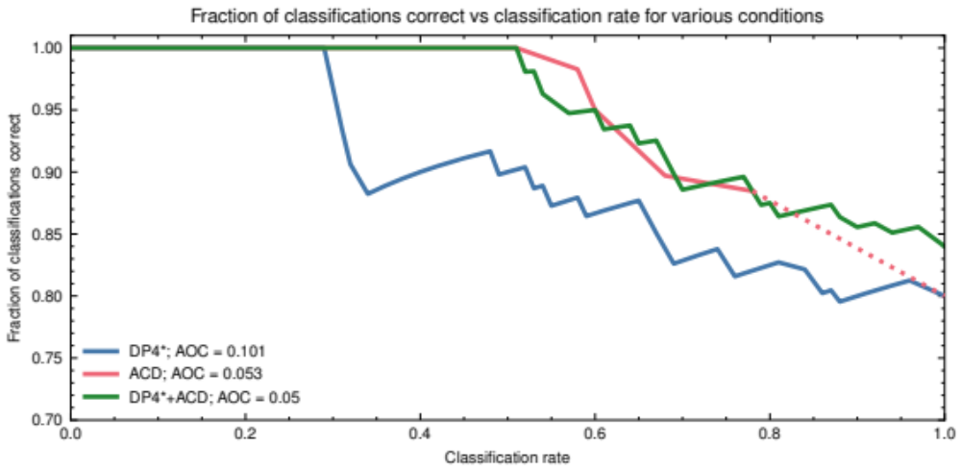

Figure S6: SCC curve showing the effect of combining ACD and DP4* scores. The DP4* scores are scaled to the ACD scores using the softmax scaling procedure.

Figure S6 shows the SCC curve for DP4*, ACD and the combination of DP4* with ACD. Combining DP4* with ACD does not improve the AOC of ACD; ACD alone gives an AOC of 0.053, similar to the result for the combination. This is likely to be because the ACD and DP4* scores are generated from analysis of the same data, namely by comparison of experimental and predicted proton NMR spectra of the isomers. Hence we would expect the scores to encode the same information, meaning that combining the two methods would not provide any new information that could improve the classification performance.

High and low-level IR.Cai

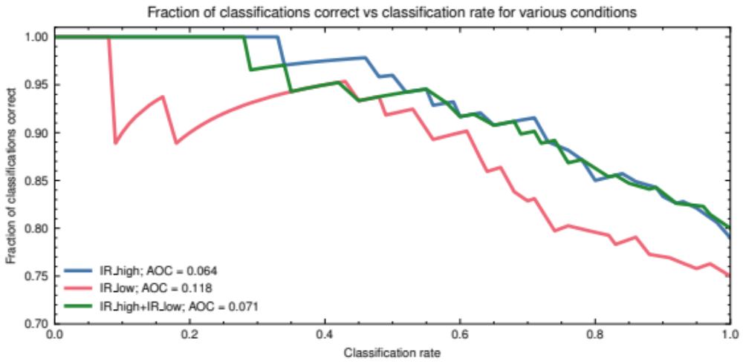

Figure S7: SCC curve showing the effect of combining IR.Cai scores determined using low-level and high-level calculated IR spectra.

Figure S7 shows the SCC curves for low level IR.Cai, high level IR.Cai, and the combination of the two. Similarly to the result shown in Figure S6, the combination of high and low level IR.Cai scores does not improve the appearance of the SCC curve. This is likely for similar reasons: both sets of scores are obtained by analysis of the same experimental data.

Classification performance of automatic and manual peak picking (ACD)
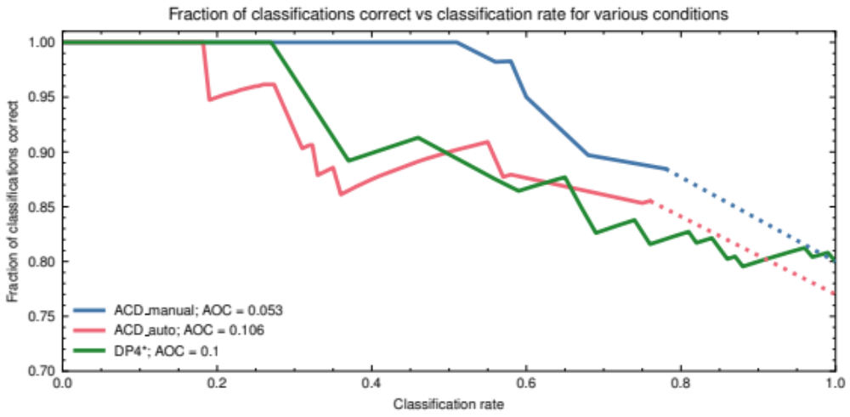

Figure S8: SCC curve comparing results obtained using ACD's automatic peak-picking routine to ACD and DP4* results obtained using manually peak-picked spectra

Figure S8 shows the SCC curves for DP4* and ACD with manual and automatic peak-picking. The performance improves when the ACD scores are calculated with the manually peak-picked NMR data, halving the AOC from 0.106 to 0.053. This is because the automatic peak-picking routine occasionally incorrectly picks solvent peaks, or peaks due to minor impurities and may fail to peak peaks close to solvent.

Combining scores without softmax scaling

IR.Cai and DP4*
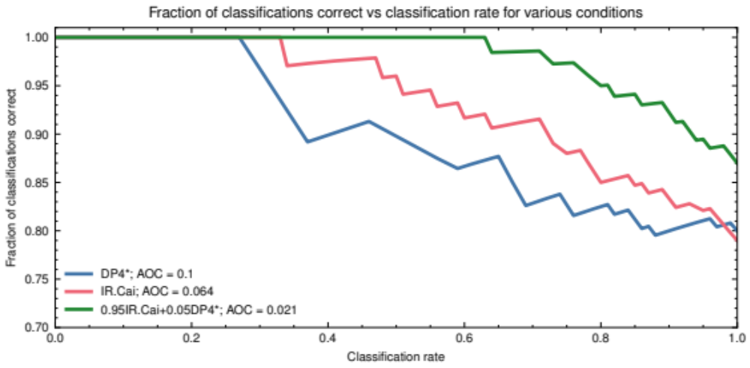

Figure S9: SCC curves showing unscaled DP4*, high level IR.Cai and the weighted combination of IR.Cai with DP4*. The weighting used was 95:5 IR.Cai:DP4*.

Figure S9 shows the SCC curves for unscaled DP4* and IR.Cai scores. The combination of DP4* and IR.Cai is also shown. The combination is weighted 95:5 in favour of IR.Cai, which is necessary to account for the different shapes of the score distributions as shown in Figure S4. We can see from the plot that 95:5 combination of IR.Cai and DP4* decreases the AOC to 0.021, from 0.064 for IR.Cai alone. This is consistent with the increase in performance seen when the two methods are combined using the softmax scaling procedure.

IR.Cai and ACD

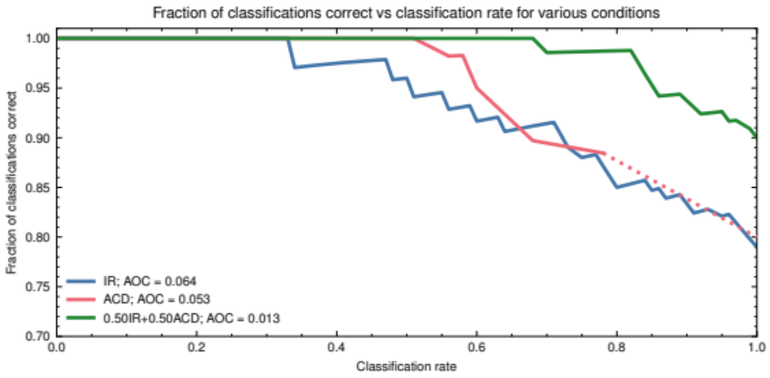
Figure S10: SCC curves showing unscaled ACD (manual peak-picking), IR.Cai and the combination of IR.Cai with ACD. The combination uses an equal weighting.

Figure S10 shows the SCC curves for unscaled ACD and IR.Cai scores. The combination of ACD and IR.Cai is also shown. As the IR.Cai and ACD scores have similar distributions even without scaling, an equal weighting is used to combine the two methods. The combination decreases the AOC to 0.013, from 0.053 for ACD alone. Similarly to DP4*, this is fully consistent with the result outlined earlier showing an improvement in performance when combining IR.Cai and ACD using the softmax scaling procedure.

Calculation results

Table S3: Full unscaled DP4* scores

Compound | Correct structure | Incorrect isomer 1 | Incorrect isomer 2 | Incorrect isomer 3
1 | 0.364153 | 0.351154 | 1.3642e-15 | 0.284693
2 | 0.525723 | 0.474277 | 1.8795e-36 | N/A
3 | 1 | 7.07971e-13 | 3.0915e-07 | 1.02401e-08
4 | 2.32765e-07 | 0.994821 | 2.45308e-07 | 0.00517876
5 | 0.998916 | 0.00108416 | 1.56877e-14 | N/A
6 | 1 | 7.86914e-11 | 2.46301e-26 | 1.05444e-13
7 | 0.687077 | 0.296048 | 0.0168752 | N/A
8 | 0.00907386 | 0.0522214 | 0.938705 | N/A
9 | 1 | 2.02253e-12 | 8.31174e-13 | N/A
10 | 8.80707e-08 | 0.999999 | 2.3369e-09 | 5.69742e-07
11 | 0.999995 | 1.54393e-06 | 2.59096e-06 | 7.24309e-07
12 | 0.639813 | 0.121468 | 1.011e-05 | 0.238709
13 | 0.745867 | 3.671e-05 | 0.254096 | N/A
14 | 0.99998 | 1.98076e-05 | 2.19738e-10 | N/A
15 | 0.998323 | 0.00167196 | 4.6781e-06 | N/A
16 | 0.503986 | 1.3244e-07 | 1.86359e-12 | 0.496014
17 | 0.19394 | 0.0223456 | 0.783715 | N/A
18 | 0.00546246 | 0.994537 | 1.27053e-08 | 5.21164e-07
19 | 0.977845 | 4.74857e-07 | 0.022155 | N/A
20 | 0.0776247 | 0.0777689 | 0.844606 | N/A
21 | 0.851339 | 3.46125e-15 | 0.0954465 | 0.0532147
22 | 0.00517968 | 0.99482 | 1.06328e-07 | N/A
23 | 0.000196313 | 0.00139484 | 0.998409 | N/A
24 | 0.999999 | 6.22961e-09 | 8.17732e-07 | N/A
25 | 0.907222 | 0.0927776 | 1.06501e-11 | 4.84489e-08
26 | 0.960421 | 0.03898 | 0.000599074 | N/A
27 | 1 | 8.7675e-08 | 1.2527e-11 | N/A
28 | 1 | 1.7481e-10 | 7.25027e-16 | N/A
29 | 0.879514 | 0.119702 | 0.00078386 | N/A
30 | 0.0637344 | 4.99286e-11 | 0.936266 | N/A
31 | 2.16306e-07 | 1 | 3.13212e-25 | 1.12558e-07
32 | 0.999088 | 2.34758e-07 | 0.000911948 | N/A
33 | 0.873457 | 0.126543 | 1.81787e-19 | N/A
34 | 1.32743e-05 | 0.999987 | 5.00332e-09 | N/A
35 | 9.11197e-08 | 1.32257e-08 | 1 | N/A
36 | 0.999993 | 4.82289e-06 | 7.78122e-09 | 2.60613e-06
37 | 0.99999 | 5.11403e-06 | 5.25964e-06 | N/A
38 | 0.634439 | 0.0733469 | 0.292215 | N/A
39 | 0.785443 | 1.34418e-11 | 0.214557 | N/A
40 | 1 | 1.59941e-12 | 1.80149e-09 | N/A
41 | 0.999943 | 5.70152e-05 | 6.98247e-16 | N/A
42 | 0.0173907 | 0.982609 | 3.65303e-08 | N/A
43 | 2.40068e-05 | 5.82899e-10 | 2.71876e-14 | 0.999976
Table S3: Full unscaled DP4* results

Table S4: Full unscaled IR.Cai (high) results:

Compound | Correct structure | Incorrect isomer 1 | Incorrect isomer 2 | Incorrect isomer 3
1 | 0.815039 | 0.585732 | 0.357794 | 0.804552
2 | 0.735387 | 0.650608 | 0.618671 | N/A
3 | 0.593196 | 0.700185 | 0.608383 | 0.444809
4 | 0.748457 | 0.692152 | 0.74899 | 0.562237
5 | 0.7982 | 0.721637 | 0.626384 | N/A
6 | 0.865766 | 0.881049 | 0.764738 | 0.587506
7 | 0.614535 | 0.63055 | 0.668973 | N/A
8 | 0.766973 | 0.72697 | 0.645825 | N/A
9 | 0.790007 | 0.564172 | 0.596984 | N/A
10 | 0.889778 | 0.742542 | 0.68831 | 0.758461
11 | 0.911375 | 0.884223 | 0.846261 | 0.720414
12 | 0.842584 | 0.886989 | 0.424974 | 0.791485
13 | 0.615821 | 0.464008 | 0.572219 | N/A
14 | 0.870817 | 0.647765 | 0.874001 | N/A
15 | 0.817571 | 0.657198 | 0.62528 | N/A
16 | 0.778082 | 0.804415 | 0.840909 | 0.761205
17 | 0.815026 | 0.593768 | 0.43163 | N/A
18 | 0.796676 | 0.593199 | 0.711853 | 0.83738
19 | 0.789557 | 0.783505 | 0.796204 | N/A
20 | 0.924599 | 0.893719 | 0.913236 | N/A
21 | 0.850357 | 0.806649 | 0.761154 | 0.773056
22 | 0.919611 | 0.761066 | 0.927299 | N/A
23 | 0.796037 | 0.783118 | 0.708693 | N/A
24 | 0.833854 | 0.392708 | 0.853144 | N/A
25 | 0.855683 | 0.801889 | 0.647549 | 0.751867
26 | 0.845882 | 0.841394 | 0.850196 | N/A
27 | 0.764285 | 0.753921 | 0.654558 | N/A
28 | 0.802932 | 0.601272 | 0.789307 | N/A
29 | 0.934815 | 0.937653 | 0.872568 | N/A
30 | 0.951775 | 0.895783 | 0.946772 | N/A
31 | 0.851854 | 0.800099 | 0.184826 | 0.837072
32 | 0.840327 | 0.843397 | 0.852247 | N/A
33 | 0.703149 | 0.664029 | 0.684265 | N/A
34 | 0.753336 | 0.716578 | 0.648734 | N/A
35 | 0.75072 | 0.824014 | 0.669235 | N/A
36 | 0.885785 | 0.882157 | 0.845349 | 0.829898
37 | 0.835707 | 0.821046 | 0.734428 | N/A
38 | 0.875624 | 0.809726 | 0.80204 | N/A
39 | 0.743883 | 0.6401 | 0.593167 | N/A
40 | 0.895516 | 0.446698 | 0.906451 | N/A
41 | 0.788854 | 0.508212 | 0.598284 | N/A
42 | 0.710716 | 0.674731 | 0.729539 | N/A
43 | 0.873891 | 0.83174 | 0.690116 | 0.855558
Table S4: Full unscaled high-level IR.Cai results

Table S5: Full unscaled IR.Cai (low) results:

Compound | Correct structure | Incorrect isomer 1 | Incorrect isomer 2 | Incorrect isomer 3
1 | 0.808606 | 0.612337 | 0.403774 | 0.794623
2 | 0.685327 | 0.616221 | 0.555081 | N/A
3 | 0.475991 | 0.533277 | 0.697192 | 0.543397
4 | 0.791398 | 0.709922 | 0.794434 | 0.595124
5 | 0.786183 | 0.733406 | 0.6804 | N/A
6 | 0.745728 | 0.790114 | 0.741463 | 0.588849
7 | 0.681686 | 0.686311 | 0.644113 | N/A
8 | 0.740311 | 0.654727 | 0.626211 | N/A
9 | 0.651086 | 0.558595 | 0.658323 | N/A
10 | 0.873064 | 0.855329 | 0.653528 | 0.856997
11 | 0.909976 | 0.895431 | 0.826426 | 0.722931
12 | 0.868471 | 0.825217 | 0.399264 | 0.841356
13 | 0.618949 | 0.513951 | 0.798563 | N/A
14 | 0.885603 | 0.647956 | 0.88332 | N/A
15 | 0.809366 | 0.629715 | 0.624908 | N/A
16 | 0.670901 | 0.657118 | 0.715393 | 0.687319
17 | 0.808618 | 0.589832 | 0.381474 | N/A
18 | 0.709277 | 0.659457 | 0.729197 | 0.744766
19 | 0.733408 | 0.722242 | 0.734752 | N/A
20 | 0.896282 | 0.906979 | 0.897671 | N/A
21 | 0.842572 | 0.757238 | 0.804181 | 0.762395
22 | 0.849793 | 0.763177 | 0.868444 | N/A
23 | 0.640641 | 0.632852 | 0.672737 | N/A
24 | 0.839444 | 0.421111 | 0.864403 | N/A
25 | 0.834693 | 0.765501 | 0.69705 | 0.611963
26 | 0.85008 | 0.843868 | 0.855955 | N/A
27 | 0.762602 | 0.759906 | 0.654291 | N/A
28 | 0.850146 | 0.697242 | 0.848266 | N/A
29 | 0.84016 | 0.857246 | 0.79552 | N/A
30 | 0.918185 | 0.850731 | 0.914438 | N/A
31 | 0.826919 | 0.784779 | 0.27351 | 0.820389
32 | 0.782216 | 0.796244 | 0.799271 | N/A
33 | 0.744906 | 0.644786 | 0.689774 | N/A
34 | 0.797084 | 0.770799 | 0.643406 | N/A
35 | 0.768008 | 0.79769 | 0.689777 | N/A
36 | 0.89039 | 0.879723 | 0.812143 | 0.764176
37 | 0.805151 | 0.795891 | 0.797239 | N/A
38 | 0.791108 | 0.730491 | 0.729782 | N/A
39 | 0.73274 | 0.693394 | 0.623327 | N/A
40 | 0.864077 | 0.411314 | 0.845306 | N/A
41 | 0.714129 | 0.515944 | 0.541737 | N/A
42 | 0.77491 | 0.664857 | 0.711913 | N/A
43 | 0.913796 | 0.924019 | 0.921316 | 0.86512
Table S5: Full unscaled low-level IR.Cai results

Table S6: Full unscaled ACD (automatic peak picking) results:

Compound | Correct structure | Incorrect isomer 1 | Incorrect isomer 2 | Incorrect isomer 3
1 | 0.97 | 0.29 | 0.12 | 0.96
2 | 0.12 | 0.12 | 0 | N/A
3 | 0.98 | 0.8 | 0.92 | 0.89
4 | 0.95 | 0.94 | 0.91 | 0.94
5 | 0.13 | 0.13 | 0 | N/A
6 | 0.88 | 0.18 | 0.19 | 0.19
7 | 0.18 | 0.18 | 0.18 | N/A
8 | 0.64 | 0.64 | 0.72 | N/A
9 | 0.2 | 0 | 0 | N/A
10 | 0.35 | 0.34 | 0.19 | 0.35
11 | 1 | 0 | 0.19 | 0.17
12 | 0.91 | 0.88 | 0 | 0.91
13 | 0.17 | 0 | 0.17 | N/A
14 | 0.25 | 0.24 | 0.25 | N/A
15 | 0.37 | 0.37 | 0.36 | N/A
16 | 0.89 | 0.88 | 0.72 | 0.88
17 | 0.84 | 0.72 | 0.73 | N/A
18 | 0.86 | 0.25 | 0.88 | 0.24
19 | 0.95 | 0.89 | 0.96 | N/A
20 | 0.63 | 0.63 | 0.62 | N/A
21 | 0.94 | 0.87 | 0.29 | 0.95
22 | 0.9 | 0.89 | 0.87 | N/A
23 | 0.93 | 0.92 | 0.86 | N/A
24 | 0.25 | 0.25 | 0.24 | N/A
25 | 0.97 | 0.85 | 0.79 | 0.91
26 | 0.96 | 0.91 | 0.96 | N/A
27 | 0.13 | 0.13 | 0.12 | N/A
28 | 0.96 | 0.89 | 0 | N/A
29 | 0.87 | 0.88 | 0.87 | N/A
30 | 0.95 | 0.89 | 0.9 | N/A
31 | 0.89 | 0.89 | 0.84 | 0.89
32 | 0.42 | 0.42 | 0.4 | N/A
33 | 0 | 0.1 | 0 | N/A
34 | 0.96 | 0.96 | 0.81 | N/A
35 | 0.89 | 0.29 | 0.85 | N/A
36 | 0.96 | 0.96 | 0.93 | 0.9
37 | 0.86 | 0.86 | 0.83 | N/A
38 | 0.9 | 0.92 | 0.91 | N/A
39 | 0.94 | 0.19 | 0.94 | N/A
40 | 0 | 0.19 | 0.12 | N/A
41 | 0.89 | 0.82 | 0.59 | N/A
42 | 0.93 | 0.85 | 0.87 | N/A
43 | 0.13 | 0.25 | 0.12 | 0.13
Table S6: Full unscaled ACD automatic peak picking results

Table S7: Full unscaled ACD (manual peak picking) results:

Compound | Correct structure | Incorrect isomer 1 | Incorrect isomer 2 | Incorrect isomer 3
1 | 0.97 | 0.29 | 0.13 | 0.97
2 | 0.26 | 0.25 | 0.12 | N/A
3 | 0.98 | 0.83 | 0.87 | 0.93
4 | 0.93 | 0.93 | 0.83 | 0.92
5 | 0.13 | 0.13 | 0 | N/A
6 | 0.88 | 0.18 | 0.19 | 0.19
7 | 0 | 0 | 0 | N/A
8 | 0.82 | 0.82 | 0.87 | N/A
9 | 0.2 | 0 | 0 | N/A
10 | 0.84 | 0.84 | 0.19 | 0.74
11 | 1 | 0 | 0.19 | 0.17
12 | 0.98 | 0.96 | 0 | 0.99
13 | 0.91 | 0.81 | 0.86 | N/A
14 | 0.84 | 0.71 | 0.74 | N/A
15 | 0.87 | 0.6 | 0.6 | N/A
16 | 0.89 | 0.88 | 0.24 | 0.89
17 | 0.99 | 0 | 0.88 | N/A
18 | 0.81 | 0.44 | 0.84 | 0.23
19 | 0.96 | 0.89 | 0.98 | N/A
20 | 0.88 | 0.88 | 0.9 | N/A
21 | 0.95 | 0.87 | 0.29 | 0.95
22 | 0.95 | 0.94 | 0.89 | N/A
23 | 0.93 | 0.92 | 0.86 | N/A
24 | 0.25 | 0.25 | 0.26 | N/A
25 | 0.97 | 0.85 | 0.79 | 0.92
26 | 0.9 | 0.9 | 0.92 | N/A
27 | 0.9 | 0.88 | 0.85 | N/A
28 | 0.96 | 0.89 | 0 | N/A
29 | 0.87 | 0.87 | 0.86 | N/A
30 | 0.98 | 0.88 | 0.9 | N/A
31 | 0.89 | 0.89 | 0.84 | 0.89
32 | 0.86 | 0.86 | 0.75 | N/A
33 | 0.87 | 0.25 | 0.87 | N/A
34 | 0.96 | 0.96 | 0.81 | N/A
35 | 0.89 | 0.29 | 0.84 | N/A
36 | 0.96 | 0.96 | 0.94 | 0.9
37 | 0.85 | 0.85 | 0.83 | N/A
38 | 0.88 | 0.91 | 0.9 | N/A
39 | 0.94 | 0.77 | 0.94 | N/A
40 | 0.33 | 0.1 | 0.1 | N/A
41 | 0.89 | 0.25 | 0.65 | N/A
42 | 0.93 | 0.87 | 0.87 | N/A
43 | 0.13 | 0.12 | 0.12 | 0.13
Table S7: Full unscaled ACD manual peak picking results

¹H NMR manual peak picking results
Compound 1
¹H NMR (600 MHz, DMSO-d₆) 0.84 (t, J = 7.3 Hz, 6H), 1.35 - 1.48 (m, 5H), 1.86 (br dd, J = 12.1, 2.3 Hz, 1H), 2.27 (dd, J = 16.6, 11.1 Hz, 1H), 2.39 - 2.45 (m, 4H), 2.64 - 2.83 (m, 4H), 6.50 (d, J = 7.5 Hz, 1H), 6.55 (d, J = 7.8 Hz, 1H), 6.86 (t, J = 7.7 Hz, 1H), 9.30 (br s, 1H).
Compound 2
¹H NMR (600 MHz, DMSO-d₆) 2.12 (s, 3H), 2.16 - 2.48 (br m, 8H), 4.25 (s, 1H), 7.15 - 7.21 (m, 1H), 7.28 (t, J = 7.7 Hz, 2H), 7.31 - 7.34 (m, J = 8.5 Hz, 2H), 7.38 (d, J = 7.1 Hz, 2H), 7.40 - 7.45 (m, J = 8.5 Hz, 2H).
Compound 3
¹H NMR (600 MHz, DMSO-d₆) 0.95 (t, J = 7.1 Hz, 6H), 2.46 - 2.50 (m, 4H), 3.24 - 3.28 (m, 2H), 5.55 (s, 2H), 6.52 - 6.55 (m, 2H), 7.50 - 7.54 (m, J = 8.6 Hz, 2H), 7.95 (t, J = 5.6 Hz, 1H).
One CH₂ completely obscured by DMSO in proton spectrum
Compound 4
¹H NMR (600 MHz, DMSO-d₆) 1.43 (br s, 1H), 1.64 (br d, J = 7.5 Hz, 3H), 1.71 - 1.75 (m, 1H), 2.20 (br s, 1H), 2.42 - 2.50 (m, 2H), 2.87 (dd, J = 13.5, 10.0 Hz, 1H), 2.99 - 3.08 (m, 1H), 3.19 - 3.28 (m, 1H), 3.90 (s, 3H), 4.91 - 4.99 (m, 2H), 5.28 (t, J = 5.5 Hz, 1H), 5.75 (d, J = 5.0 Hz, 1H), 5.83 (ddd, J = 17.4, 10.2, 7.5 Hz, 1H), 7.39 (dd, J = 9.2, 2.7 Hz, 1H), 7.48 (d, J = 2.8 Hz, 1H), 7.51 (d, J = 4.5 Hz, 1H), 7.93 (d, J = 9.1 Hz, 1H), 8.67 (d, J = 4.5 Hz, 1H).
Compound 5
¹H NMR (600 MHz, DMSO-d₆) 2.02 (s, 6H), 2.22 (br s, 2H), 2.32 (br s, 2H), 6.01 (t, J = 7.4 Hz, 1H), 6.70 (dd, J = 8.2, 1.2 Hz, 1H), 6.88 (td, J = 7.5, 1.3 Hz, 1H), 7.12 (ddd, J = 8.3, 7.0, 1.7 Hz, 1H), 7.24 (t, J = 8.2 Hz, 2H), 7.33 - 7.36 (m, 1H), 7.37 - 7.40 (m, 1H), 7.47 (dd, J = 7.4, 1.2 Hz, 1H).
CH₂ missing from spectrum – possibly broad.

Compound 6
¹H NMR (600 MHz, DMSO-d₆) 1.39 (d, J = 7.1 Hz, 3H), 3.65 - 3.74 (m, 1H), 5.00 (s, 2H), 7.33 - 7.38 (m, J = 8.6 Hz, 2H), 7.55 (t, J = 6.8 Hz, 1H), 7.65 - 7.70 (m, 2H), 7.79 (d, J = 7.6 Hz, 1H), 7.83 - 7.88 (m, 2H).
Compound 7
¹H NMR (600 MHz, DMSO-d₆) 2.16 (s, 3H), 2.82 (s, 3H), 3.56 - 3.60 (m, 2H), 6.72 (t, J = 8.9 Hz, 1H), 7.02 (dd, J = 9.1, 2.5 Hz, 1H), 7.18 (dd, J = 8.4, 5.2 Hz, 1H), 7.37 (s, 1H), 7.73 (d, J = 8.0 Hz, 2H), 7.79 (d, J = 7.8 Hz, 2H).
Compound 8
¹H NMR (600 MHz, DMSO-d₆) 1.89 (br s, 4H), 2.38 (s, 3H), 2.93 (br s, 2H), 3.40 - 3.57 (m, 2H), 3.79 (d, J = 7.0 Hz, 2H), 6.94 - 6.99 (m, 2H), 7.14 (d, J = 8.0 Hz, 2H), 7.30 - 7.35 (m, 3H), 7.74 (td, J = 7.8, 1.8 Hz, 1H), 8.62 (d, J = 5.0 Hz, 1H), 11.12 (br s, 1H).
Compound 9
¹H NMR (600 MHz, DMSO-d₆) 2.59 - 2.64 (m, 2H), 3.26 - 3.31 (m, 2H), 7.41 - 7.46 (m, 1H), 7.51 (t, J = 7.5 Hz, 2H), 7.75 (d, J = 7.7 Hz, 2H), 7.81 - 7.85 (m, 2H), 8.05 - 8.08 (m, 2H).
Compound 10
¹H NMR (600 MHz, DMSO-d₆) 2.07 (s, 3H), 2.27 (s, 3H), 3.82 (br s, 2H), 5.91 - 6.39 (br s, 1H), 7.05 - 7.18 (m, 3H), 9.47 (br s, 1H).
Compound 11
¹H NMR (600 MHz, DMSO-d₆) 2.68 (dd, J = 17.1, 3.0 Hz, 1H), 3.23 - 3.30 (m, 1H), 5.44 (dd, J = 12.9, 2.9 Hz, 1H), 5.88 - 5.92 (m, 1H), 5.89 (s, 2H), 6.78 - 6.82 (m, 2H), 7.30 - 7.34 (m, 2H), 9.62 (br s, 1H), 10.47 - 11.18 (m, 1H), 12.15 (s, 1H).
Compound 12

¹H NMR (600 MHz, DMSO-d₆) 3.43 (s, 2H), 3.74 (s, 3H), 6.64 (dd, J = 8.0, 2.0 Hz, 1H), 6.70 (d, J = 7.7 Hz, 1H), 6.81 (d, J = 1.8 Hz, 1H), 8.83 (br s, 1H).

Compound 13
¹H NMR (600 MHz, DMSO-d₆) 6.78 (t, J = 7.3 Hz, 1H), 7.07 (t, J = 7.4 Hz, 1H), 7.22 - 7.26 (m, 3H), 7.34 - 7.40 (m, 3H), 7.91 (dd, J = 8.0, 1.5 Hz, 1H), 9.64 (br s, 1H).
Compound 14
¹H NMR (600 MHz, DMSO-d₆) 0.99 (dd, J = 6.1, 4.3 Hz, 6H), 2.65 - 2.71 (m, 1H), 2.72 - 2.83 (m, 2H), 4.02 - 4.07 (m, 2H), 4.08 - 4.13 (m, 1H), 6.93 (d, J = 7.3 Hz, 1H), 7.37 - 7.41 (m, 1H), 7.43 - 7.46 (m, 1H), 7.46 - 7.53 (m, 2H), 7.84 (d, J = 7.5 Hz, 1H), 8.22 (d, J = 7.7 Hz, 1H).
Compound 15
¹H NMR (600 MHz, DMSO-d₆) 2.20 (s, 3H), 2.40 (t, J = 5.1 Hz, 4H), 3.68 - 3.70 (m, 2H), 4.29 (br s, 2H), 7.31 (br d, J = 8.3 Hz, 1H), 7.67 (br s, 2H).
Compound 16
¹H NMR (600 MHz, DMSO-d₆) 1.97 (br s, 2H), 2.08 (s, 3H), 2.19 (br s, 6H), 2.88 (br d, J = 14.3 Hz, 1H), 3.58 (br d, J = 14.3 Hz, 1H), 7.40 (dd, J = 8.0, 4.6 Hz, 1H), 7.43 - 7.49 (m, 2H), 7.61 - 7.68 (m, 2H), 7.77 (br d, J = 7.6 Hz, 1H), 8.19 (br d, J = 3.8 Hz, 1H), 10.88 (br s, 1H).
Compound 17
¹H NMR (600 MHz, DMSO-d₆) 0.94 (t, J = 7.1 Hz, 6H), 2.50 (q, J = 7.1 Hz, 4H), 2.69 (t, J = 6.0 Hz, 2H), 4.18 (t, J = 6.1 Hz, 2H), 5.91 (s, 2H), 6.57 (d, J = 7.8 Hz, 2H), 7.63 (d, J = 8.4 Hz, 2H).
Compound 18
¹H NMR (600 MHz, DMSO-d₆) 1.21 (br d, J = 6.1 Hz, 3H), 1.39 - 1.57 (m, 3H), 1.60 - 1.73 (m, 1H), 3.55 - 3.64 (m, 1H), 3.82 (s, 3H), 6.12 (br d, J = 8.6 Hz, 1H), 6.25 (d, J = 2.5 Hz, 1H), 6.47 (d, J = 2.5 Hz, 1H), 7.42 (dd, J = 8.3, 4.1 Hz, 1H), 8.07 (dd, J = 8.3, 1.5 Hz, 1H), 8.53 (dd, J = 4.2, 1.6 Hz, 1H).
Compound 19
¹H NMR (600 MHz, DMSO-d₆) -0.01 - 0.02 (m, 2H), 0.27 - 0.35 (m, 2H), 0.84 (m, 7H), 2.39 - 2.43 (m, 1H), 2.51 - 2.63 (m, 4H), 3.05 - 3.12 (m, 2H), 3.37 - 3.43 (m, 2H), 3.66 - 3.73 (m, 2H), 3.73 - 3.81 (m, 1H), 4.83 (br s, 1H), 6.70 (d, J = 8.6 Hz, 2H), 7.00 (d, J = 8.5 Hz, 2H).
Compound 20
¹H NMR (600 MHz, DMSO-d₆) 1.19 - 1.28 (m, 1H), 1.43 (br d, J = 11.6 Hz, 1H), 1.62 (br s, 1H), 1.79 - 1.95 (m, 2H), 2.05 (br s, 2H), 2.36 (br s, 1H), 2.46 - 2.50 (m, 1H), 2.74 (br s, 1H), 2.83 - 3.27 (m, 4H), 3.69 - 3.73 (m, 1H), 3.75 (s, 3H), 3.76 (br s, 1H), 4.75 (br s, 1H), 6.97 - 7.01 (m, 1H), 7.08 (br t, J = 7.0 Hz, 1H), 7.35 (br d, J = 8.0 Hz, 1H), 7.40 (br d, J = 7.5 Hz, 1H), 11.06 (br s, 1H).
NB Broad spectrum in aliphatic region means not all protons can be seen
Compound 21
¹H NMR (600 MHz, DMSO-d₆) 0.82 (t, J = 7.3 Hz, 6H), 1.32 - 1.47 (m, 5H), 1.83 - 1.89 (m, 1H), 2.35 - 2.42 (m, 4H), 2.54 - 2.70 (m, 4H), 2.79 (tdd, J = 11.2, 4.8, 2.9 Hz, 1H), 6.44 (d, J = 2.5 Hz, 1H), 6.47 (dd, J = 8.1, 2.5 Hz, 1H), 6.81 (d, J = 8.1 Hz, 1H), 9.17 (br s, 1H).
Compound 22
¹H NMR (600 MHz, DMSO-d₆) 1.47 (quin, J = 7.4 Hz, 2H), 1.63 (quin, J = 7.3 Hz, 2H), 2.35 (t, J = 7.2 Hz, 2H), 2.43 - 2.50 (m, 4H), 2.93 (br s, 4H), 3.60 (t, J = 7.0 Hz, 2H), 3.75 - 3.77 (m, 3H), 6.84 - 6.87 (m, 2H), 6.89 - 6.94 (m, 2H), 7.82 - 7.85 (m, 2H), 7.86 - 7.89 (m, 2H).
Impurities deselected from peak picking
Compound 23
¹H NMR (600 MHz, DMSO-d₆) 1.71 (br d, J = 14.6 Hz, 2H), 1.98 (s, 4H), 2.10 (dt, J = 14.7, 4.5 Hz, 2H), 2.16 (s, 3H), 3.04 (br s, 2H), 5.07 (t, J = 5.3 Hz, 1H), 7.17 - 7.23 (m, 2H), 7.51 (d, J = 7.5 Hz, 1H), 7.97 (s, 1H), 8.04 (d, J = 7.3 Hz, 1H).
Compound 24
¹H NMR (600 MHz, DMSO-d₆) 0.98 (br d, J = 3.6 Hz, 3H), 0.99 (br d, J = 3.8 Hz, 3H), 2.66 - 2.82 (m, 3H), 4.01 - 4.09 (m, 2H), 4.10 - 4.13 (m, 1H), 6.94 (d, J = 7.5 Hz, 1H), 7.38 - 7.42 (m, 1H), 7.44 - 7.53 (m, 3H), 7.85 (d, J = 7.6 Hz, 1H), 8.23 (d, J = 7.8 Hz, 1H).
Compound 25
¹H NMR (600 MHz, DMSO-d₆) 0.98 (t, J = 7.1 Hz, 6H), 2.47 - 2.51 (m, 6H), 3.27 - 3.33 (m, 2H), 3.83 (s, 3H), 5.88 (s, 2H), 6.49 (s, 1H), 7.88 (s, 1H), 8.12 (t, J = 4.9 Hz, 1H).
Compound 26
¹H NMR (600 MHz, DMSO-d₆) 0.90 (t, J = 7.4 Hz, 3H), 1.06 (d, J = 7.1 Hz, 3H), 1.50 (sxt, J = 7.4 Hz, 2H), 1.63 (qd, J = 12.1, 6.4 Hz, 1H), 1.76 - 1.86 (m, 1H), 2.41 - 2.50 (m, 1H), 2.63 (td, J = 6.9, 3.1 Hz, 2H), 2.72 - 2.81 (m, 1H), 2.87 - 2.96 (m, 1H), 3.00 - 3.08 (m, 1H), 3.74 (s, 3H), 6.72 (d, J = 8.0 Hz, 2H), 7.09 (t, J = 7.9 Hz, 1H).
Compound 27
¹H NMR (600 MHz, DMSO-d₆) 1.98 (qu, J = 5.4 Hz, 2H), 2.35 (s, 3H), 3.21 (s, 3H), 3.38 (t, J = 5.4 Hz, 2H), 3.50 (t, J = 5.4 Hz, 2H), 6.56 (d, J = 16 Hz, 1H), 7.04 (d, J = 4.8 Hz, 1H), 7.69 (d, J = 16 Hz, 1H), 7.69 (d, J = 4.8 Hz, 1H)

Compound 28
¹H NMR (600 MHz, DMSO-d₆) 2.67 (br t, J = 7.1 Hz, 2H), 3.01 (t, J = 7.1 Hz, 2H), 7.32 - 7.42 (m, 6H), 7.48 - 7.54 (m, 4H).
Compound 29
¹H NMR (600 MHz, DMSO-d₆) 0.98 (t, J = 7.4 Hz, 3H), 1.76 - 1.88 (m, 1H), 2.04 (s, 3H), 2.13 - 2.23 (m, 1H), 2.47 - 2.50 (m, 2H), 2.52 - 2.65 (m, 4H), 2.65 - 2.74 (m, 3H), 3.64 (br s, 4H), 10.91 (br s, 1H).
Compound 30
¹H NMR (600 MHz, DMSO-d₆) 0.86 (d, J = 6.1 Hz, 3H), 2.01 - 2.06 (m, 2H), 2.06 (s, 6H), 2.22 - 2.28 (m, 1H), 3.55 - 3.60 (m, 1H), 3.92 (dd, J = 13.7, 4.9 Hz, 1H), 6.93 (t, J = 7.5 Hz, 2H), 7.01 (d, J = 8.0 Hz, 2H), 7.15 (dd, J = 7.6, 1.3 Hz, 2H), 7.19 (ddd, J = 8.3, 7.2, 1.6 Hz, 2H).
Compound 31
¹H NMR (600 MHz, DMSO-d₆) 1.56 - 1.63 (m, 4H), 2.42 - 2.47 (m, 4H), 3.85 (s, 2H), 5.55 (s, 2H), 7.15 - 7.20 (m, 4H), 7.33 - 7.38 (m, 3H), 7.61 (d, J = 6.3 Hz, 1H).
Compound 32
¹H NMR (600 MHz, DMSO-d₆) 0.90 (d, J = 6.3 Hz, 3H), 2.33 - 2.46 (m, 1H), 2.61 - 2.72 (m, 3H), 2.73 - 2.85 (m, 1H), 3.62 - 3.70 (m, 3H), 4.44 - 4.52 (m, 1H), 6.77 - 6.81 (m, 3H), 6.86 (d, J = 7.7 Hz, 1H), 7.01 - 7.04 (m, 2H), 8.00 (s, 1H), 8.26 (s, 1H), 9.55 (br s, 1H).
Compound 33
¹H NMR (600 MHz, DMSO-d₆) 1.36 - 1.54 (m, 2H), 2.17 - 2.26 (m, 2H), 2.61 (s, 6H), 2.88 - 3.02 (m, 2H), 5.14 - 5.18 (m, 1H), 5.21 - 5.25 (m, 1H), 7.17 (t, J = 8.2 Hz, 2H), 7.58 (t, J = 6.6 Hz, 2H), 7.73 (d, J = 8.1 Hz, 1H), 7.78 - 7.82 (m, 2H).
Compound 34
¹H NMR (600 MHz, DMSO-d₆) 2.07 (s, 6H), 2.87 (d, J = 6.8 Hz, 2H), 6.24 (t, J = 6.9 Hz, 1H), 7.11 (d, J = 7.9 Hz, 2H), 7.45 - 7.48 (m, 3H), 7.54 (d, J = 7.5 Hz, 1H), 8.26 (br s, 1H), 8.48 - 8.55 (m, 1H).
Compound 35
¹H NMR (600 MHz, DMSO-d₆) 2.20 - 2.42 (m, 10H), 2.43 - 2.49 (m, 4H), 3.42 - 3.48 (m, 2H), 4.54 (br s, 1H), 6.02 (t, J = 7.1 Hz, 1H), 7.28 - 7.31 (m, 1H), 7.35 (td, J = 7.5, 1.2 Hz, 1H), 7.43 (d, J = 7.4 Hz, 1H), 7.52 (dd, J = 7.6, 1.2 Hz, 1H), 7.63 (d, J = 8.5 Hz, 1H), 7.71 (d, J = 8.1 Hz, 1H), 7.74 - 7.77 (m, 1H).
Compound 36
¹H NMR (600 MHz, DMSO-d₆) 1.55 (s, 3H), 1.89 (s, 3H), 1.94 - 2.01 (m, 2H), 2.05 - 2.10 (m, 2H), 3.11 (br d, J = 6.8 Hz, 2H), 3.51 (s, 3H), 4.94 (td, J = 6.8, 1.0 Hz, 1H), 5.05 (s, 2H).
Compound 37
¹H NMR (600 MHz, DMSO-d₆) 1.81 (s, 3H), 2.13 (s, 6H), 2.25 - 2.32 (m, 1H), 2.52 - 2.55 (m, 1H), 3.67 - 3.73 (m, 1H), 3.76 (s, 3H), 4.27 (ddd, J = 14.1, 7.8, 6.8 Hz, 1H), 4.98 (d, J = 7.5 Hz, 1H), 5.11 (d, J = 7.3 Hz, 1H), 6.88 - 6.93 (m, 2H), 7.32 - 7.37 (m, 1H), 7.41 - 7.44 (m, 2H), 7.59 (td, J = 7.7, 1.5 Hz, 1H), 7.66 - 7.72 (m, 2H).
Compound 38
¹H NMR (600 MHz, DMSO-d₆) 2.40 (br m, 6H), 2.57 - 2.63 (m, 2H), 2.72 - 2.82 (m, 4H), 2.87 (br s, 2H), 3.16 (br dd, J = 12.9, 4.5 Hz, 1H), 3.67 - 3.72 (m, 1H), 4.06 (br dd, J = 11.0, 4.2 Hz, 1H), 7.01 - 7.05 (m, 1H), 7.12 - 7.17 (m, 1H), 7.29 (br t, J = 7.3 Hz, 1H), 7.33 - 7.38 (m, 2H), 7.41 (br d, J = 7.3 Hz, 1H), 7.47 (br d, J = 7.5 Hz, 1H).
Compound 39
¹H NMR (600 MHz, DMSO-d₆) 1.27 - 1.43 (m, 2H), 1.54 - 1.63 (m, 2H), 1.74 - 1.83 (m, 4H), 1.91 (dtd, J = 13.5, 6.9, 3.5 Hz, 1H), 2.07 (q, J = 9.0 Hz, 1H), 2.15 - 2.19 (m, 1H), 2.19 (s, 3H), 2.91 (dt, J = 9.6, 4.9 Hz, 1H), 3.14 - 3.23 (m, 2H), 7.17 - 7.22 (m, 1H), 7.26 - 7.35 (m, 8H).
Compound 40
¹H NMR (600 MHz, DMSO-d₆) 0.59 - 0.65 (m, 2H), 0.86 - 0.94 (m, 2H), 2.24 (tt, J = 8.5, 5.3 Hz, 1H), 3.46 - 3.50 (m, 4H), 4.63 (s, 2H), 6.81 (d, J = 7.5 Hz, 1H), 6.87 (t, J = 7.6 Hz, 1H), 6.95 (d, J = 8.2 Hz, 1H), 7.09 (ddd, J = 8.1, 7.3, 1.7 Hz, 1H).
Compound 41
¹H NMR (600 MHz, DMSO-d₆) 1.53 - 1.62 (m, 2H), 1.76 (br d, J = 12.3 Hz, 2H), 2.13 - 2.24 (m, 2H), 2.44 (s, 3H), 2.44 - 2.46 (m, 2H), 2.73 - 2.83 (m, 2H), 2.99 (br d, J = 11.4 Hz, 2H), 3.33 - 3.39 (m, 1H), 7.26 - 7.35 (m, 3H), 7.55 (d, J = 8.9 Hz, 1H), 7.84 (ddd, J = 8.8, 6.8, 1.7 Hz, 1H), 8.04 (t, J = 6.1 Hz, 2H), 8.86 (d, J = 7.0 Hz, 1H).
Compound 42
¹H NMR (600 MHz, DMSO-d₆) 1.06 (t, J = 7.2 Hz, 3H), 1.47 - 1.57 (m, 1H), 1.58 - 1.70 (m, 2H), 1.76 - 1.88 (m, 1H), 2.13 (td, J = 9.2, 7.5 Hz, 1H), 2.19 - 2.26 (m, 1H), 2.54 - 2.64 (m, 1H), 2.82 (dq, J = 11.9, 7.4 Hz, 1H), 3.08 - 3.20 (m, 2H), 3.49 - 3.55 (m, 1H), 3.97 (s, 3H), 7.27 - 7.38 (m, 3H), 7.90 (dd, J = 8.7, 2.6 Hz, 1H), 8.28 (d, J = 2.5 Hz, 1H), 8.37 (br dd, J = 6.3, 4.0 Hz, 1H).
Compound 43
¹H NMR (600 MHz, DMSO-d₆) 2.06 - 2.12 (m, 1H), 2.40 - 2.44 (m, 1H), 2.45 (s, 3H), 2.52 - 2.57 (m, 1H), 2.65 (ddd, J = 11.7, 7.0, 4.4 Hz, 1H), 4.09 (d, J = 4.0 Hz, 1H), 5.77 (d, J = 4.0 Hz, 1H), 5.95 - 5.97 (m, 1H), 5.98 (d, J = 1.0 Hz, 1H), 6.13 (d, J = 8.0 Hz, 1H), 6.21 (d, J = 1.0 Hz, 1H), 6.23 (d, J = 0.8 Hz, 1H), 6.70 (d, J = 2.3 Hz, 2H), 7.14 (d, J = 7.8 Hz, 1H).

References

[1] | S. Smith and J. Goodman, "Assigning Stereochemistry to Single Diastereoisomers by GIAO NMR Calculation: The DP4 Probability," J. Am. Chem. Soc., vol. 132, no. 37, pp. 12946-12959, 2010.
[2] | K. Nicolaou and S. Snyder, "Chasing Molecules That Were Never There: Misassigned Natural Products and the Role of Chemical Synthesis in Modern Structure Elucidation," Angew. Chem. Int. Ed., vol. 44, no. 7, pp. 1012-1044, 2005.
[3] | A. Howarth and J. Goodman, "The DP5 probability, quantification and visualisation of structural uncertainty in single molecules," Chem. Sci., vol. 13, no. 12, pp. 3507-3518, 2022.
[4] | A. Buevich and M. Elyashberg, "Synergistic Combination of CASE Algorithms and DFT Chemical Shift Predictions: A Powerful Approach for Structure Elucidation, Verification, and Revision," J. Nat. Prod., vol. 79, no. 12, pp. 3105-3116, 2016.
[5] | G. Bifulco, P. Dambruoso, L. Gomez-Paloma and R. Riccio, "Determination of Relative Configuration in Organic Compounds by NMR Spectroscopy and Computational Methods," Chem. Rev., vol. 107, no. 9, pp. 3744-3779, 2007.

