Table 1 shows a sample of molecules and their incorrect isomers from the dataset. The full list can be found in the Supporting Information (Table S1).

Compound | Correct structure | Incorrect isomer 1 | Incorrect isomer 2
5 | 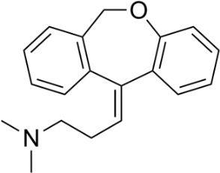 | 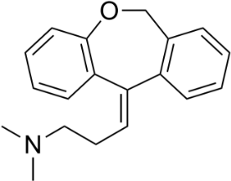  Double bond stereoisomer | 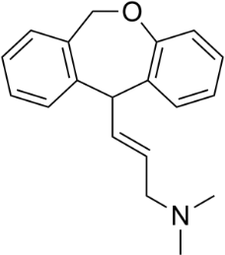  Double bond regioisomer
12 | 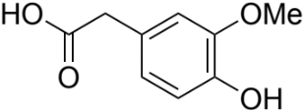 | 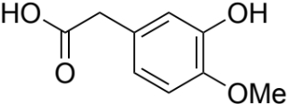  Aromatic regioisomer | 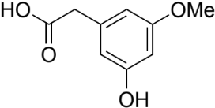  Aromatic regioisomer
32 | 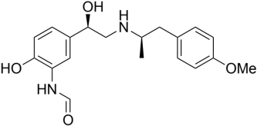 | 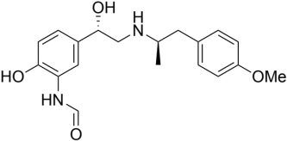  Stereoisomer | 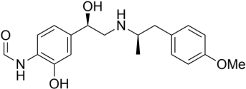  Aromatic regioisomer
37 | 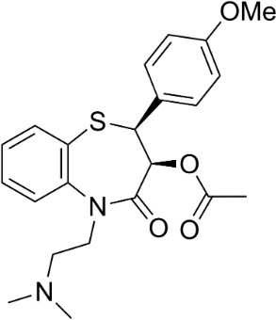 | 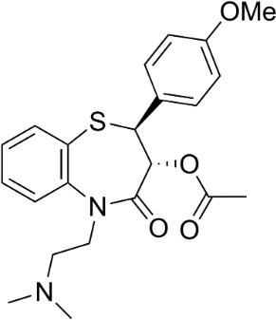  Stereoisomer | 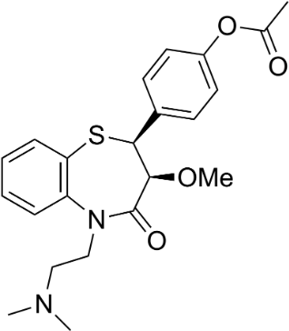  Unclassified regioisomer

Table 1: A sample of 4 molecules, with incorrect isomers, from the test set used to evaluate the use of IR and NMR in ASV. Differentiating the correct and incorrect isomers presents a significant challenge due to the high similarity between the structures.

