Group | Body weight (gm) | Liver weight (gm) | Liver Index
Saline control | 25.8 ± 2.154 | 0.958 ± 0.083 | 0.0403 ± 0.001
Paracetamol | 26.6 ± 2.562*** | 1.4933 ± 0.255*** | 0.0532 ± 0.004***
Carmina (0.5 ml/kg) | 26.75 ± 0.853*** | 1.3445 ± 0.015 | 0.0528 ± 0.001***
Carmina (2.5 ml/kg) | 27.6 ± 1.692### | 1.257 ± 0.081 | 0.0448 ± 0.002###
Maxpro | 25.25 ± 0.853*** | 1.0345 ± 0.109### | 0.0421 ± 0.001###
Table S1. Effects of Carmina (ml/kg/day) on body weight, liver weight and liver index of swiss albino mice.
The data is presented as Mean ± SEM. ***p < 0.05 and ###p < 0.05, compared with saline control and paracetamol group, respectively.

Table S2. Effects of Carmina (ml/kg/day) on body weight, kidney weight and kidney index of swiss albino mice.
Group | Body weight (gm) | Kidney weight (gm) | Kidney Index
Saline control | 25.8 ± 2.154 | 0.1347 ± 0.004 | 0.57 ± 0.0001
Paracetamol | 22.3333 ± 0.802 | 0.1267 ± 0.004 | 0.56 ± 0.0001
Carmina (0.5 ml/kg) | 24.5 ± 0.763 | 0.128 ± 0.014 | 0.55 ± 0.0004
Carmina (2.5 ml/kg) | 27.6667 ± 0.614### | 0.1273 ± 0.024 | 0.46 ± 0.0007
Maxpro | 25.25 ± 0.853 | 0.123 ± 0.014 | 0.50 ± 0.0002
The data is presented as Mean ± SEM. ***p < 0.05 and ###p < 0.05, compared with saline control and paracetamol group, respectively.

Table S3. Influences of different doses of carmina (ml/kg/day) on serum biochemical parameters (liver functions) in swiss albino mice
Group | ALT (U/L) | AST (U/L) | ALP (U/L) | TP (g/dL) | Bilirubin (mg/dL) | TG (mg/dL)
Saline control | 79.2 ± 7.625 | 67.8 ± 7.638 | 112 ± 19.768 | 7.78 ± 0.208 | 2.92 ± 0.425 | 83.8 ± 6.807
Paracetamol | 87.6 ± 3.234*** | 75 ± 4.037*** | 136.4 ± 10.269*** | 9.54 ± 0.529*** | 3.52 ± 0.557*** | 90 ± 3.872***
Carmina (0.5 ml/kg) | 60 ± 4.416***### | 48.75 ± 5.265***### | 124.25 ± 11.397### | 8.025 ± 1.104 | 3.7 ± 0.897 | 80.25 ± 8.158###
Carmina (2.5 ml/kg) | 55.4 ± 4.226***### | 52.8 ± 5.817***### | 98.2 ± 11.659### | 8.32 ± 0.515 | 3.34 ± 0.650### | 70.4 ± 8.447###
Maxpro | 55.25 ± 4.661***### | 69.25 ± 7.685### | 108.5 ± 22.250### | 6.975 ± 0.495 | 4.35 ± 0.340 | 70.75 ± 6.663###
The data is presented as Mean ± SEM. ***p < 0.05 and ###p < 0.05, compared with saline control and paracetamol group, respectively. ALT: alanine aminotransferase, AST: aspartate aminotransferase, and ALP: alkaline phosphatase, TP: total protein, TG: triglyceride.

Table S4. Influences of different doses of carmina (ml/kg/day) on serum biochemical parameters (kidney functions) in swiss albino mice
Group | Creatinine (g/dL) | Urea (g/dL) | BUN (mg/dL) | ALB (g/dL)
Saline control | 0.25 ± 0.029 | 116 ± 12.712 | 54.16 ± 5.943 | 4.32 ± 0.261
Paracetamol | 0.31 ± 0.018*** | 132.6667 ± 12.079*** | 60.9167 ± 2.022*** | 4.65 ± 0.465***
Carmina (0.5 ml/kg) | 0.2967 ± 0.029 | 70.3333 ± 10.065***### | 32.8333 ± 4.707***### | 4.8 ± 0.491###
Carmina (2.5 ml/kg) | 0.2567 ± 0.030### | 69.1667 ± 7.538***### | 32.2833 ± 3.511***### | 5.45 ± 0.392###
Maxpro | 0.3925 ± 0.072 | 63.75 ± 11.397***### | 29.775 ± 5.318***### | 5.325 ± 0.475###
The data is presented as Mean ± SEM. ***p < 0.05 and ###p < 0.05, compared with saline control and paracetamol group, respectively. BUN: blood urea nitrogen, ALB: albumin.

Table S5: The effect of carmina (ml/kg/day) on oxidative stress parameters of mice for hepatotoxicity condition.
Group (H) | Reduced GSH (uM/mg) | MDA (uM/mg) | CAT (U/ml)
Saline control | 0.4686 ± 0.0686 | 10.4559 ± 1.151 | 151.9890±31.41575
Paracetamol | 0.4228 ± 0.102*** | 24.4322 ± 0.635*** | 99.7542±9.03488***
Carmina (0.5 ml/kg) | 0.4101 ± 0.119 | 16.1338 ± 3.097 | 187.5630±10.09874###
Carmina (2.5 ml/kg) | 0.4438 ± 0.039### | 17.9801 ± 3.950 | 162.8417±18.73521###
Maxpro | 0.5666 ± 0.011### | 15.9551 ± 4.228 | 178.0583±5.34639###
The data is presented as Mean ± SEM. ***p < 0.05 and ###p < 0.05, compared with saline control and paracetamol group, respectively. GSH: glutathione, MDA: malondialdehyde, CAT: catalase.
Table S6: The effect of carmina (ml/kg/day) on oxidative stress parameters of mice for nephrotoxicity condition
Group (R) | Reduced GSH (uM/mg) | MDA (uM/mg) | CAT (U/ml)
Saline control | 0.4220 ± 0.008 | 15.2404 ± 2.640 | 151.9890±31.41575
Paracetamol | 0.2663 ± 0.058*** | 19.4691 ± 1.871 | 100.4619±9.50102***
Carmina (0.5 ml/kg) | 0.3319 ± 0.063 | 15.2735 ± 1.938 | 175.7050±9.52754###
Carmina (2.5 ml/kg) | 0.2853 ± 0.069 | 15.3132 ± 1.364 | 152.7201±11.21828###
Maxpro | 0.2895± 0.048 | 22.6653 ± 3.712 | 178.0583±5.34639###
The data is presented as Mean ± SEM. ***p < 0.05 and ###p < 0.05, compared with saline control and paracetamol group, respectively. GSH: glutathione, MDA: malondialdehyde, CAT: catalase.

Figure S1: Calibration Curve of Reduced Glutathione (GSH) Contents
Figure S2: Calibration Curve of malondialdehyde (MDA) Contents
y = 0.0403x - 0.0587
R² = 0.9979

y = 0.0109x - 0.0673
R² = 0.9926

Figure S3: Calibration Curve of catalase activity
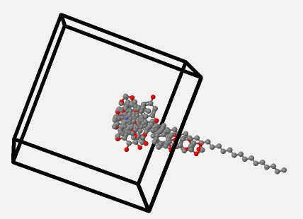
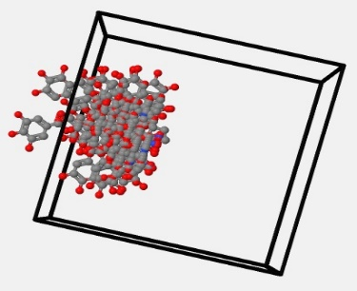
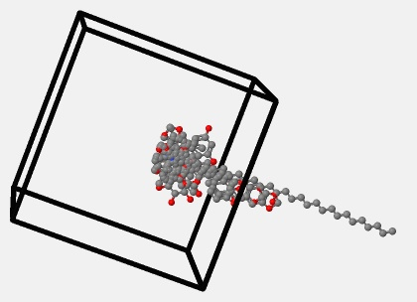
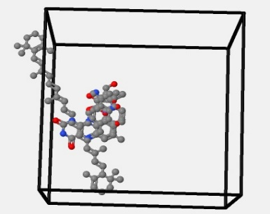
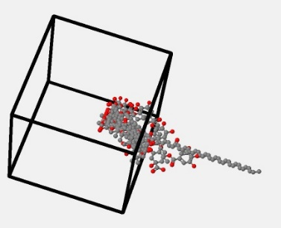
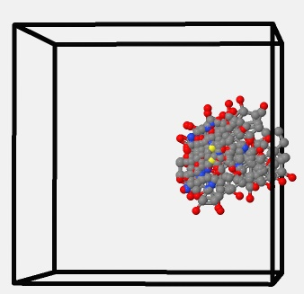
(a)
(b)
(c)
(d)
(e)
(f)
Figure S4: Contour maps of CoMFA for steric condition (a)Phyllanthus emblica (r²=1, q²=1), (b) Zingiber-officinale (r²=0.225, q²=-0.110), (c) Piper nigrum (r²=1, q²=1), (d) Terminalia bellirica (r²=1, q²=1), (e) Trachyspermum ammi (r²=1, q²=1), (f) Terminalia chebula (r²=1, q²=1).

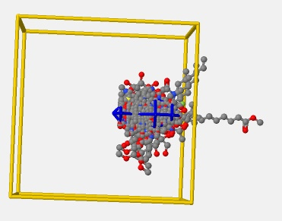
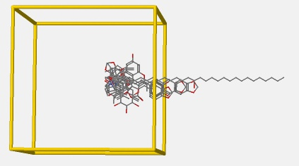
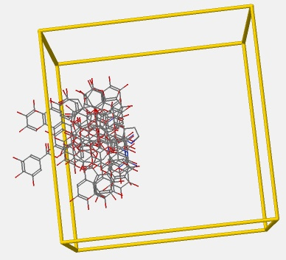
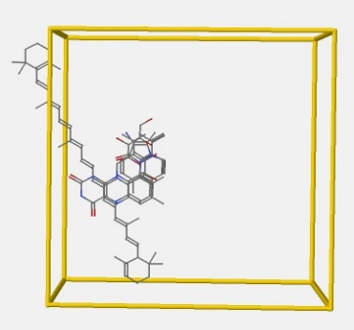
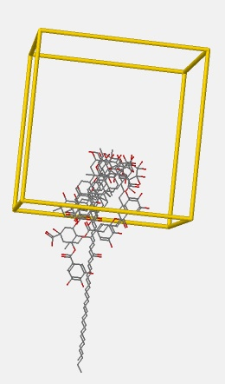
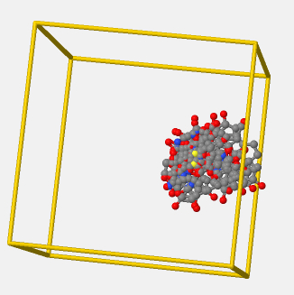
(a)
(b)
(c)
(d)
(e)
(f)
Figure S5: Contour maps of CoMFA for electrostatic condition (a) Phyllanthus emblica r²=1, q²=1), (b) Zingiber-officinale (r²=0.303, q²=-0.035), (c) Piper nigrum (r²=1, q²=1, (d) Terminalia bellirica (r²=1, q²=1), (e) Trachyspermum ammi (r²=1, q²=1), (f) Terminalia chebula (r²=1, q²=1).

