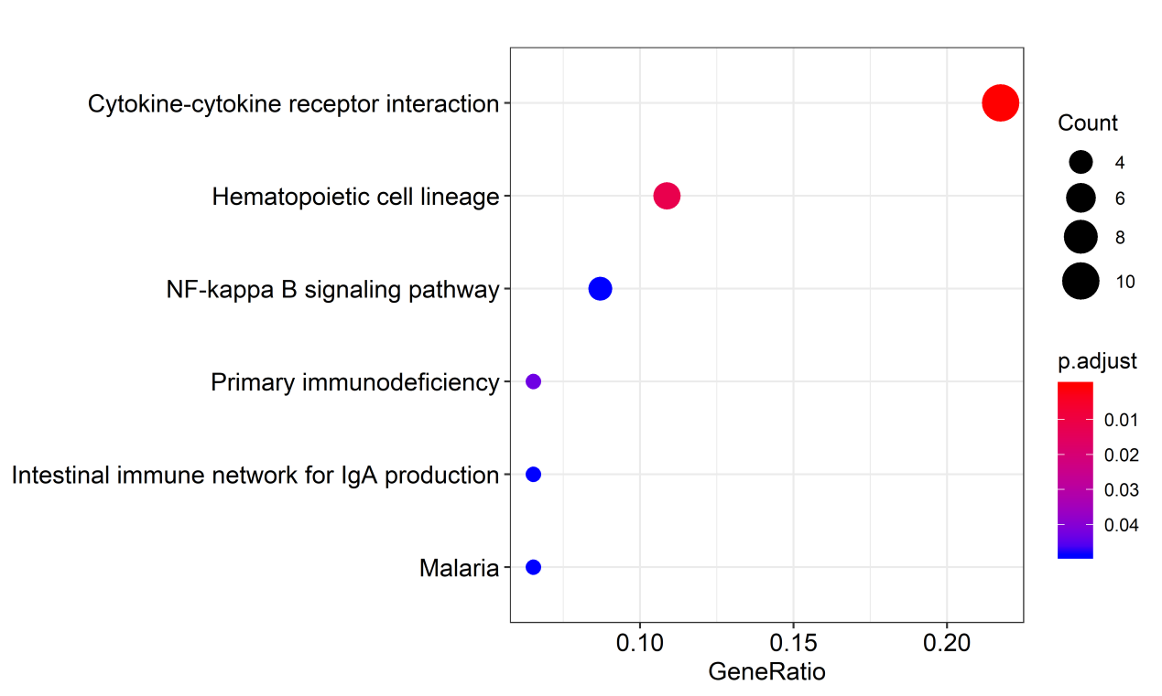
Figure S1. Top 6 significantly enriched KEGG pathways of DEGs. The Node size represents the number of selected genes, and color represents the p-value of the enrichment analysis.
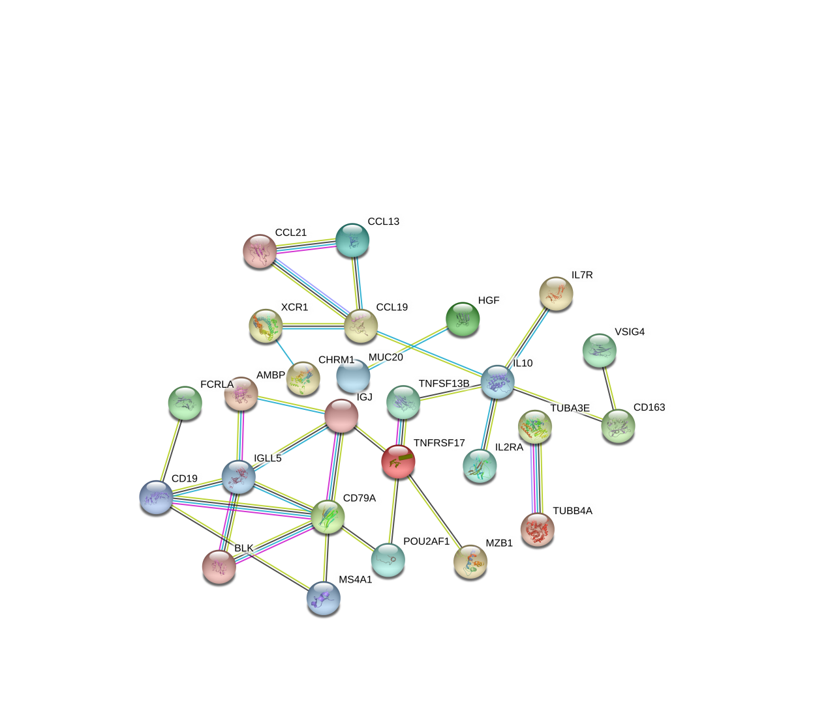
Figure S2. Protein-protein interaction (PPI) network of related genes.

