The unveiling role of South Tropical Atlantic in winter Atlantic Niño inducing La Niña

Supplementary Information

Guangli Zhang¹, Jiepeng Chen^{2,3}, Hanjie Fan⁴, Lei Zhang^{2,3}, Mengyan Chen^{2,3}, Xin Wang^{2,3}, Dongxiao Wang¹
1 School of Marine Sciences, Sun–Yat Sen University; Southern Marine Science and Engineering Guangdong Laboratory (Zhuhai), Zhuhai, China.
2 State Key Laboratory of Tropical Oceanography, South China Sea Institute of Oceanology, Chinese Academy of Sciences, Guangzhou, China.
3 Global Ocean and Climate Research Center, South China Sea Institute of Oceanology, Chinese Academy of Sciences, Guangzhou, China.
4 School of Atmospheric Sciences, Sun Yat-sen University, Southern Marine Science and Engineering Guangdong Laboratory (Zhuhai), Zhuhai, China.

*Corresponding authors:
Dongxiao Wang: dxwang@mail.sysu.edu.cn
Xin Wang: wangxin@scsio.ac.cn

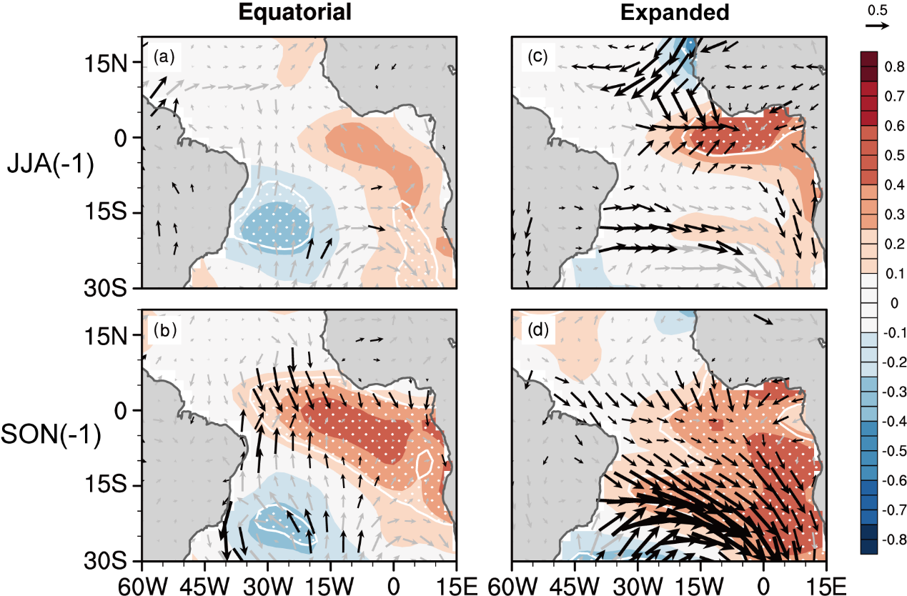
Supplementary Figure 1. Evolutions of Equatorial and Expanded Atlantic Niño events during their developing stages. Seasonal averaged SST (shading, ℃) and 10m wind (vector, m/s) of composited anomalies from Equatorial Atlantic Niño events during a JJA₋₁ and b SON₋₁. c-d are similar to a-b, but for Expanded Atlantic Niño events. The dotted regions and black vectors exceed 95% confidence level.

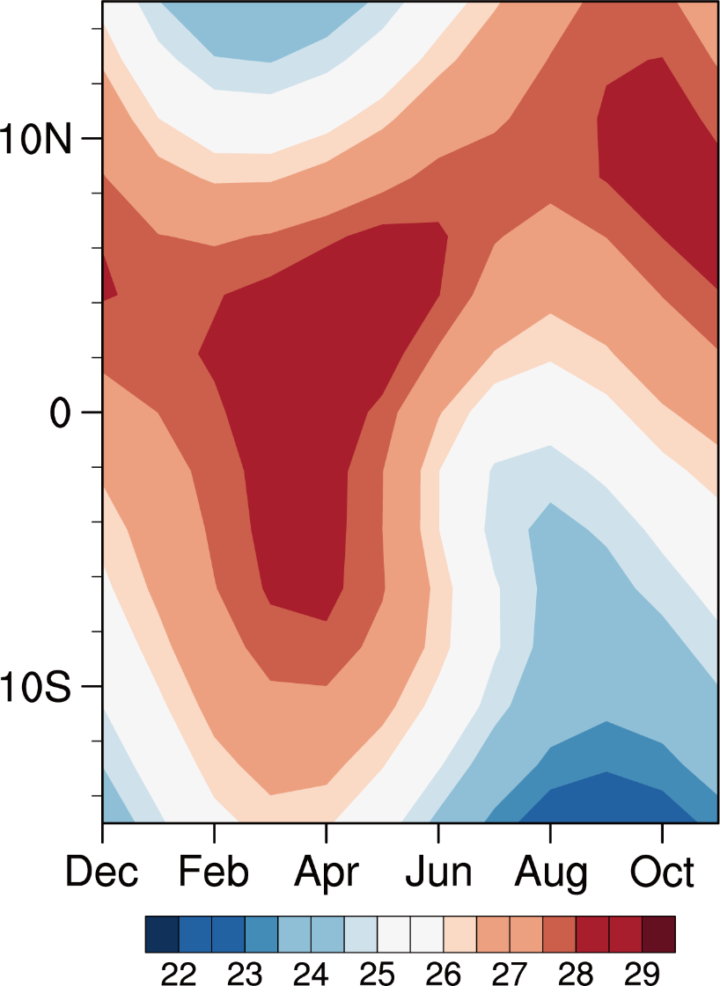
Supplementary Figure 2. Annual cycle of SST mean state over the tropical Atlantic. Variations of observed 50°W-10°W averaged climatological SST (℃) during 1950-2022.

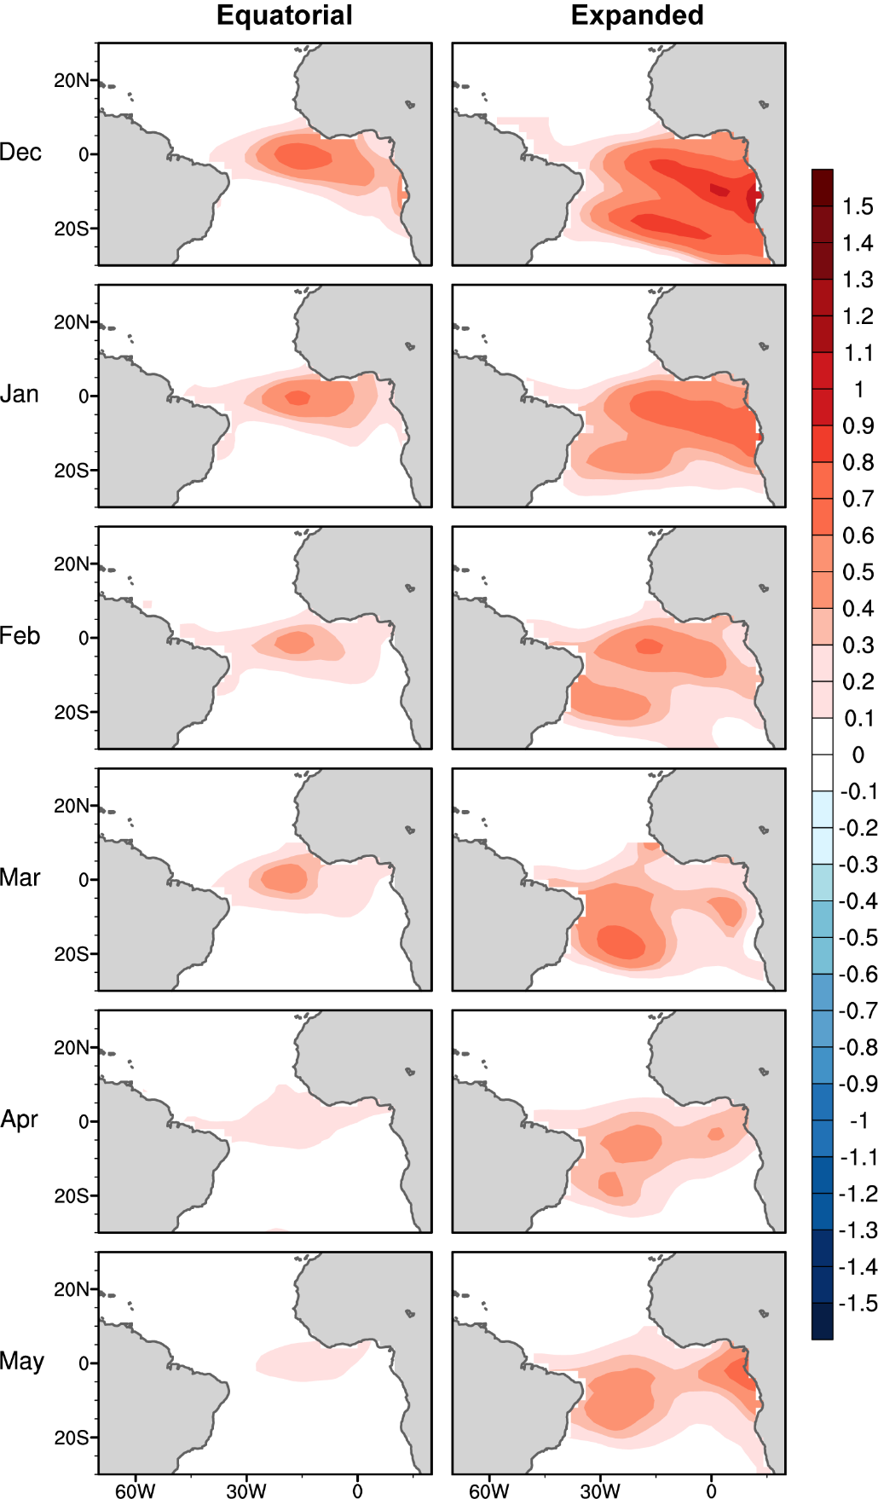
Supplementary Figure 3. The prescribed SST anomalies used in three CAM-sensitive experiments. These SST anomalies are observed as composite SST anomalies from three groups from December₋₁ to May₀ during 1950-2022.

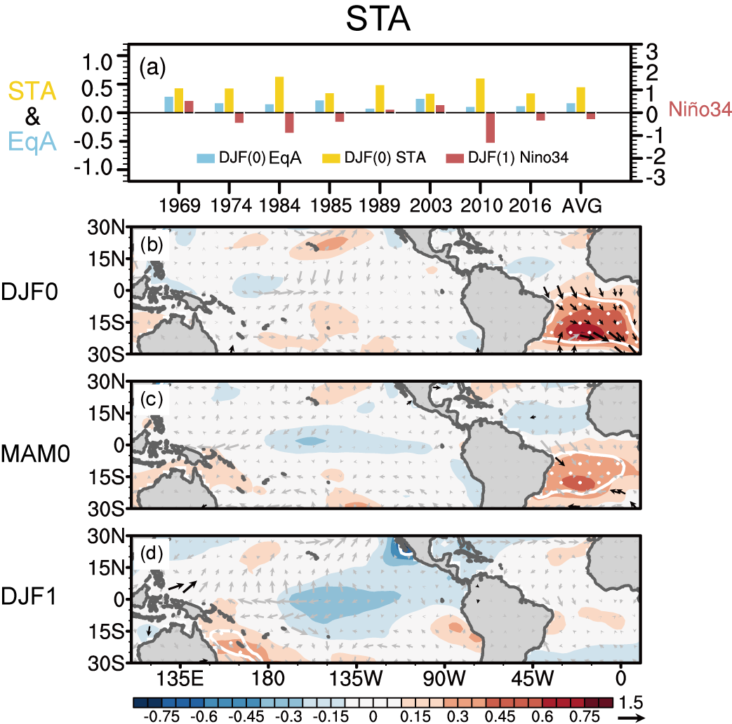
Supplementary Figure 4. Results of “pure” STA events. a Individual values and their average for EqA index (DJF₀, blue bar), STA index (DJF₀, golden bar), and Niño 3.4 index (DJF₁, red bar) for 8 STA events. b-d Composite anomalies of SST (shading, ℃) and 10m wind anomalies (vectors, m/s). The white dots and black vectors in b-d exceed 95% significance level.
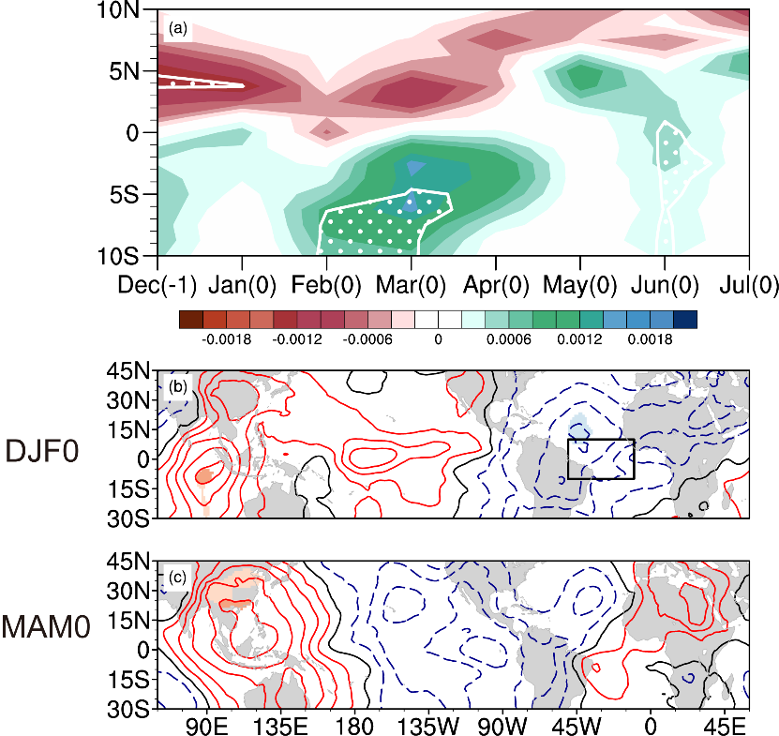
Supplementary Figure 5. Mechanism of STA warm SST anomalies. a Evolutions of composited zonal averaged precipitation anomalies (m) over the Amazon-eastern tropical Atlantic region for STA events. White dotes exceed 90% significance level. b-c Composited 850hPa velocity potential (contour, m²/s, interval is 10⁻⁷) and divergent wind (vectors, m/s) anomalies for STA events. Shading and black vectors exceed 95% confidence level. The black boxes in b and e indicate the location of the Amazon-eastern tropical Atlantic region (10°S-10°N, 60°W-10°W). The influences of DJF₀ ENSO have been removed before the composite analysis.
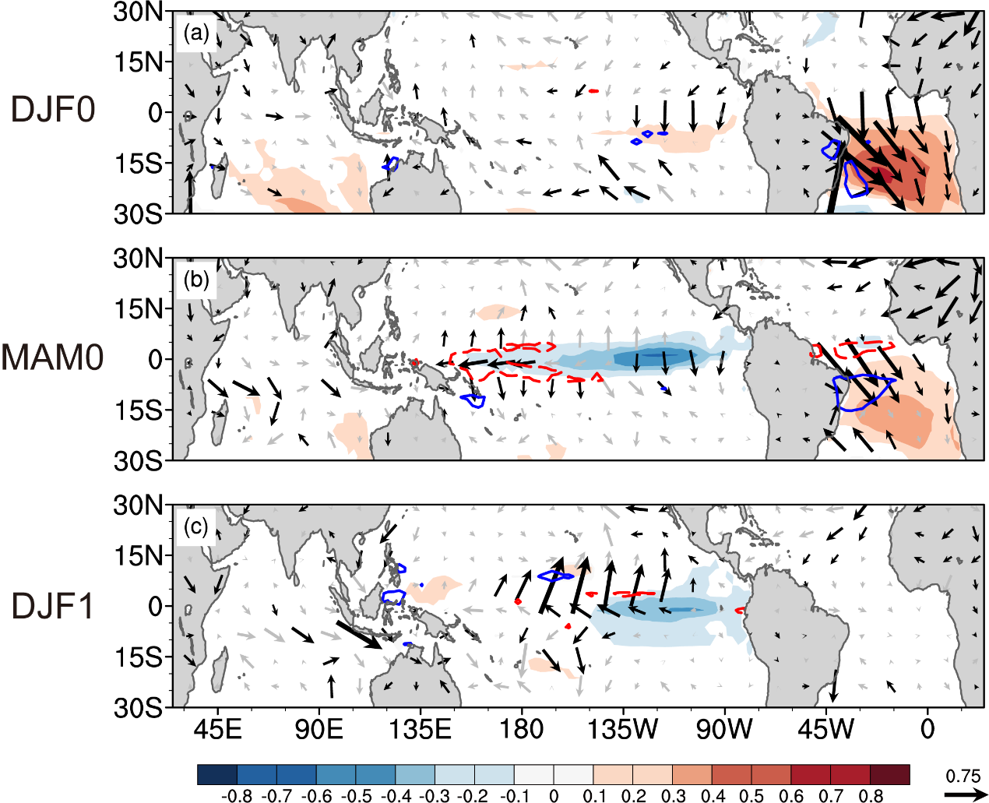
Supplementary Figure 6. Impacts of STA events in 15 CMIP6 historical simulations. Ensemble mean of composited SST (shading, only values exceed 95% significance level are given), surface wind (vector, black vectors exceed 95% significance level) and precipitation (contour, interval is 0.5, red solid and blue dashed lines for positive and negative) for STA events from 15 CMIP6 historical simulations for STA events in DJF₀, MAM₀ and DJF₁ seasons. The influences of DJF₀ ENSO have been removed before the composite analysis.

Supplementary Table 1. A list of the AGCM and CGCM sensitive experiments conducted in the present study.
AGCM | Forcing
CTRL_AGCM_run | global monthly climatological SST
Equatorial_AGCM_run | Observed warm SST anomalies from Equatorial Atlantic Niño events from December₋₁ to May₀
Expanded_AGCM_run | Observed warm SST anomalies from Expanded Atlantic Niño events from December₋₁ to May₀
CGCM | Forcing
CTRL_CGCM_run | integrated freely with global monthly climatological SST
Expanded_CGCM_run | zonal wind from the difference of Expanded_AGCM_run and CTRL_AGCM_run in 15°S-15°N,115°E-140°W region from December₋₁ to May₀

Supplementary Table 2. Historical simulations of CMIP6 climate models used in this study. The first column is model names. The second and third columns are correlation coefficients between the DJF₀ EqA SST anomalies and STA SST anomalies with the DJF₁ Niño 3.4 indices during 1950-2014 from the historical simulations. * indicates that the correlation coefficient exceeds 95% significance level. Bold texts denote the 15 models which could capture the negative relationship between the tropical Atlantic SST anomalies in DJF₀ and the ENSO in DJF₁.

Model name | cor <EqA, Niño 3.4> | cor <STA, Niño 3.4>
ACCESS-CM2 | -0.381* | -0.342*
ACCESS-ESM1-5 | -0.117 | -0.295*
BCC-CSM2-MR | -0.237 | -0.084
CAMS-CSM1-0 | -0.382* | -0.507 *
CanESM5 | -0.017 | -0.291*
CESM2 | -0.400* | -0.442*
CIESM | -0.202 | -0.239
CMCC-CM2-SR5 | -0.109 | 0.120
CMCC-ESM2 | -0.223 | 0.047
CNRM-CM6-1 | -0.286* | -0.260*
CNRM-ESM2-1 | -0.068 | 0.108
E3SM-1-1 | -0.155 | -0.171
EC-Earth3 | -0.184 | -0.273*
FGOALS-f3-L | -0.300* | -0.261*
FGOALS-g3 | -0.361* | -0.377*
GFDL-CM4 | -0.045 | -0.232
GFDL-ESM4 | 0.086 | -0.071
GISS-E2-1-G | -0.419* | -0.339*
HadGEM3-GC31-LL | -0.211 | -0.224
IPSL-CM6A-LR | -0.160 | -0.185
MIROC6 | -0.266* | -0.254*
MIROC-ES2L | -0.134 | -0.333*
MPI-ESM1-2-HR | 0.117 | 0.137
MPI-ESM1-2-LR | 0.171 | 0.322*
MRI-ESM2-0 | -0.293* | -0.314*
NESM3 | -0.039 | -0.096
NorESM2-LM | -0.375* | -0.287*
UKESM1-0-LL | -0.165 | -0.148

