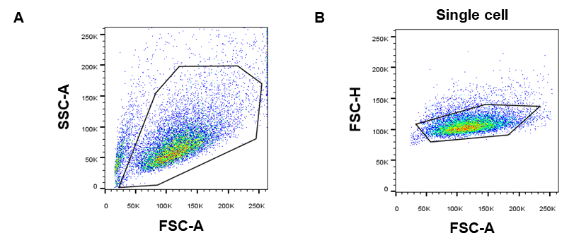
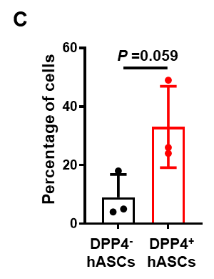

Figure S1. Analytical method of flow cytometry. Related to figure 1. A. Remove cell debris and dead cells. B. Single cell selection. C. The percentage of DPP4⁻ and DPP4⁺ cells from three individual donors were analyzed. Data are presented as mean ± SEM. Significant differences were determined by unpaired two-tailed Student's t tests.
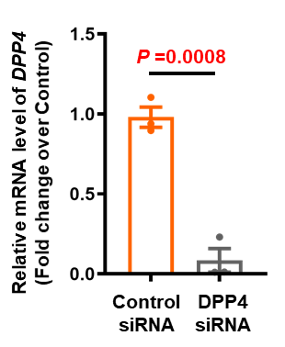
Figure S2. The expression of DPP4 was knocked down in DPP4⁺ hASCs using DPP4 siRNA and control siRNA. Related to Figure 3. Relative mRNA level of DPP4 in DPP4 siRNA-treated and control siRNA treated DPP4⁺ hASCs determined by quantitative RT-PCR. The relative expression of the gene was normalized against 18S rRNA. Data are presented as mean ± SEM. Significant differences were determined by unpaired two-tailed Student's t tests.

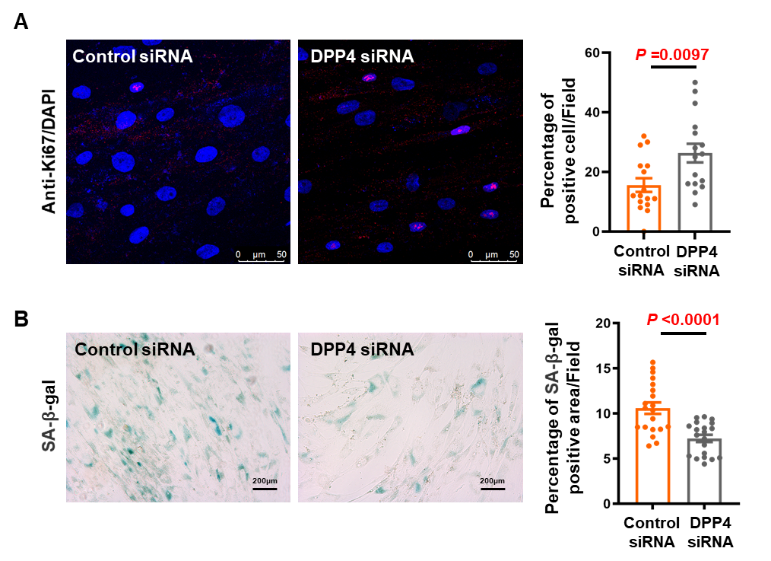
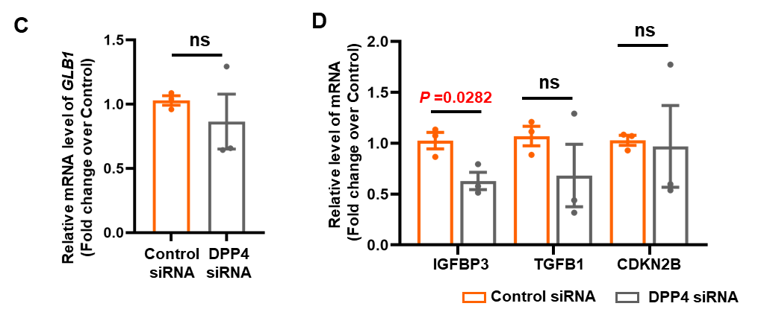
Figure S3. The regulation proliferation of DPP4 on hASCs. Related to Figure 2. A. Representative image of hASCs in the two groups immunoassayed with antibody against Ki-67. Histogram showing the difference of the positive cell percentage of Ki-67 of DPP4 siRNA-treated and control siRNA treated DPP4⁺ hASCs. The number of fields was 20 in each group respectively. Data are presented as the mean ± SEM. Scale bars, 50 μm. B. Representative images of hASCs in the two groups for SA-β-Gal staining. Histogram showing the difference of the positive area percentage of SA-β-Gal of DPP4 siRNA-treated and control siRNA treated DPP4⁺ hASCs. The number of fields was 16 in each group respectively. Data are presented as the mean ± SEM. Scale bars, 50 μm. C. Relative mRNA levels of GLB1 DPP4 siRNA-treated and control siRNA treated DPP4⁺ hASCs determined by quantitative RT-PCR. The relative expression of the gene was normalized against 18S rRNA. Data are presented as the means ± SEM. D. Relative mRNA levels of IGFBP3, IGFB1 and CDKN2B in DPP4 siRNA-treated and control siRNA treated DPP4⁺ hASCs determined by quantitative RT-PCR. The relative expression of the gene was normalized against 18S rRNA. Data are presented as the mean ± SEM. Significant difference by unpaired two-tailed Student’s t test.

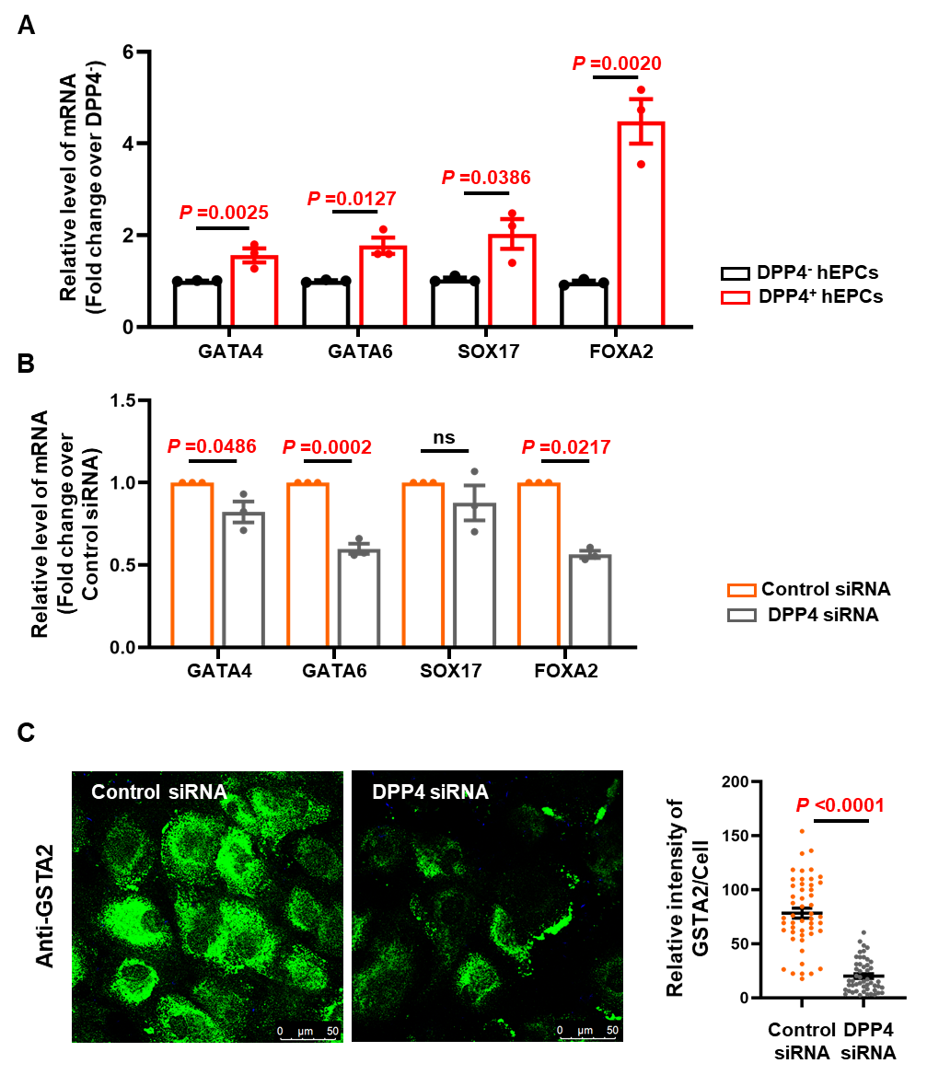
Figure S4. The properties of differentiation level in DPP4⁻ hASCs and DPP4⁺ hASCs were determined. Related to Figure 3. A. Relative mRNA levels of characteristic transcription factors in hEPCs in DPP4⁻ hEPCs and DPP4⁺ hEPCs determined by quantitative RT-PCR. B. Relative mRNA levels of characteristic transcription factors in hEPCs in DPP4 siRNA-treated and control siRNA treated DPP4⁺ hEPCs determined by quantitative RT-PCR. The relative expression of the genes was normalized against 18S rRNA. Data are presented as the mean ± SEM. C. Representative images of the expression of GSTA2 in DPP4 siRNA-treated and control siRNA treated DPP4⁺ hHLCs determined by immunofluorescence. Scatter diagram showing the difference of relative intensity of GSTA2 in cells. The number of cells was 50 in each group respectively. Data are presented as the mean ± SEM. Scale bars, 50 μm. Significant difference by unpaired two-tailed Student’s t test.

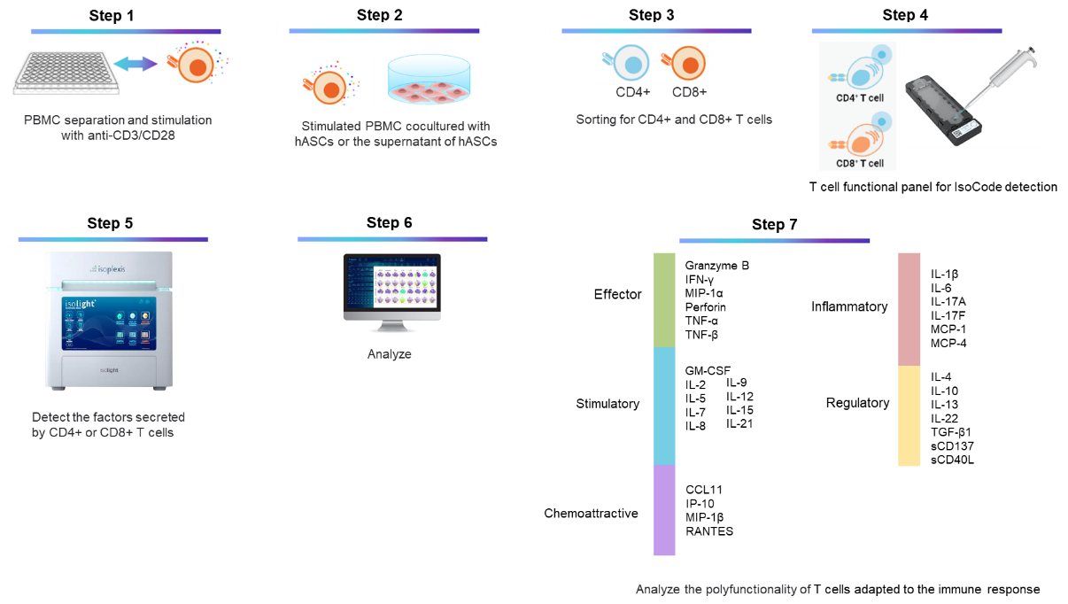

Figure S5. Schematic of the single-cell IsoCode chip to analyze T-cell polyfunctionality.
The color bars denote cytokines with effector (green), stimulatory (blue), chemoattractive (purple), inflammatory (red), and regulatory (yellow) functions.

Groups | Experiment content
1 | PBMC/hASCs vs Activated PBMC/hASCs
2 | PBMC/hASCs vs Activated PBMC/hASCs
3 | Activated PBMC vs Activated PBMC/supernatant of hASCs
4 | Activated PBMC/supernatant of DPP4⁻hASCs vs Activated PBMC/supernatant of DPP4⁺hASCs
5 | Activated PBMC/ DPP4⁻hASCs vs Activated PBMC/DPP4⁺hASCs
6 | Activated PBMC/supernatant of control siRNA treated-hASCs vs Activated PBMC/DPP4 siRNA treated-hASCs
7 | Activated PBMC/control siRNA treated-hASCs vs Activated PBMC/DPP4 siRNA treated-hASCs

Figure S6. Experimental grouping for analyzing the T-cell polyfunctionality using single-cell IsoCode chip. Related with Figure 6,7,8

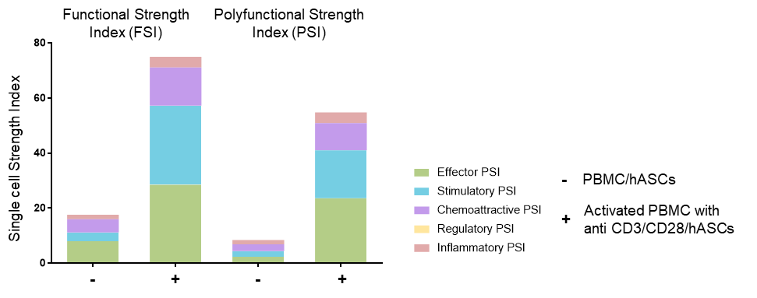
Figure S7. Analyzing the T-cell polyfunctionality in PBMC or activated PBMC co-cultured with hASCs. Related with Figure 6,7,8. Stacked bar charts showing the single-cell functionality and polyfunctionality of PBMCs and activated PBMCs with anti CD3/CD28 cocultured with hASCs; Each colour corresponds to a specific cytokine or combination of cytokines.

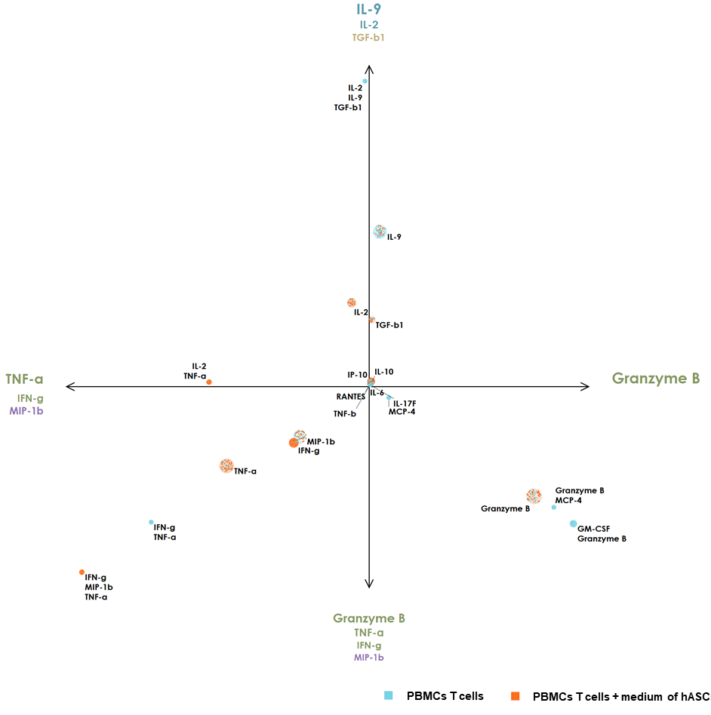
Figure S8. Polyfunctional landscaping of single cell PAT principal component analysis (PCA) of PBMC T cells with or without medium of hASCs. Related with Figure 6.

