Supplementary Information for
Trade coupled with aquaculture is sustaining growth and improving stability in global aquatic food supply
Kangshun Zhao^{1,2}, Steven D. Gaines², Jorge García Molinos³, Min Zhang^{4*}, Jun Xu^{1,5,6*}
¹ Key Laboratory of Breeding Biotechnology and Sustainable Aquaculture, Key Laboratory of Lake and Watershed Science for Water Security, Institute of Hydrobiology, Chinese Academy of Sciences, Wuhan, China
² Bren School of Environmental Science & Management, University of California, Santa Barbara, CA, USA
³ Arctic Research Center, Hokkaido University, Sapporo, Japan
⁴ Hubei Provincial Engineering Laboratory for Pond Aquaculture, Engineering Research Center of Green Development for Conventional Aquatic Biological Industry in the Yangtze River Economic Belt, College of Fisheries, Huazhong Agricultural University, Wuhan, China
⁵ State Key Laboratory of Marine Resource Utilization in South China Sea, Hainan University, Haikou, China
⁶ Laboratory for Marine Fisheries Science and Food Production Processes, Qingdao National Laboratory for Marine Science and Technology, Qingdao, China
* Corresponding author: JX (xujun@ihb.ac.cn) and MZ (zhm7875@mail.hzau.edu.cn)

Supplementary Tables and Figures
Supplementary Tables
Table 1 Countries with the highest and lowest AFPS and AFCS from 1968 to 1990
AFPS = 4 | Continent | AFCS = 4 | Continent | AFPS = -4 | Continent | AFCS = -4 | Continent
Central African Republic | Africa | Central African Republic | Africa | Cameroon | Africa | Saint Helena | Africa
Ghana | Africa | Comoros | Africa | Ivory Coast | Africa | Singapore | Asia
Republic of Congo | Africa | Equatorial Guinea | Africa | Mali | Africa | Jamaica | North America
Swaziland | Africa | Guinea | Africa | Reunion | Africa | Puerto Rico | North America
Tanzania | Africa | Mayotte | Africa | South Africa | Africa | Virgin Islands | North America
Tunisia | Africa | Tanzania | Africa | Bhutan | Asia | Northern Mariana Islands | Oceania
Bahrain | Asia | Togo | Africa | Israel | Asia | Suriname | South America
Malaysia | Asia | Tunisia | Africa | Kuwait | Asia
Pakistan | Asia | Bahrain | Asia | Mongolia | Asia
Philippines | Asia | Japan | Asia | United Arab Emirates | Asia
South Korea | Asia | Malaysia | Asia | Germany | Europe
Thailand | Asia | Maldives | Asia | Portugal | Europe
Denmark | Europe | Oman | Asia | UK | Europe
Finland | Europe | South Korea | Asia | Jamaica | North America
Hungary | Europe | Finland | Europe | Puerto Rico | North America
Ireland | Europe | France | Europe | Virgin Islands | North America
Italy | Europe | Hungary | Europe | Northern Mariana Islands | Oceania
Switzerland | Europe | Iceland | Europe
Anguilla | North America | Ireland | Europe
Cuba | North America | Romania | Europe
Guadeloupe | North America | Anguilla | North America
Australia | Oceania | Bermuda | North America
Solomon Islands | Oceania | Cuba | North America
Guyana | South America | Australia | Oceania
 |  | Cook Islands | Oceania
 |  | Kiribati | Oceania
 |  | Papua New Guinea | Oceania
 |  | Chile | South America
Note: AFPS = aquatic food production score; AFCS = aquatic food consumption score. Countries with slope confidence intervals not covering the median threshold are in bold, indicating that the slopes of their data are statistically significantly lower or higher than the median threshold.
Table 2 Countries with the highest and lowest AFPS and AFCS from 1991 to 2019
AFPS = 4 | Continent | AFCS = 4 | Continent | AFPS = -4 | Continent | AFCS = -4 | Continent
Cameroon | Africa | Cameroon | Africa | Ghana | Africa | Comoros | Africa
Egypt | Africa | Djibouti | Africa | Guinea-Bissau | Africa | Democratic Republic of the Congo | Africa
Guinea | Africa | Egypt | Africa | Kenya | Africa | Madagascar | Africa
Morocco | Africa | Libya | Africa | Madagascar | Africa | Senegal | Africa
Mozambique | Africa | Mauritius | Africa | Namibia | Africa | Seychelles | Africa
Nigeria | Africa | Morocco | Africa | Senegal | Africa | Somalia | Africa
Rwanda | Africa | Mozambique | Africa | Somalia | Africa | Japan | Asia
Sierra Leone | Africa | Tunisia | Africa | Tanzania | Africa | Pakistan | Asia
Bangladesh | Asia | Bangladesh | Asia | Bahrain | Asia | Cuba | North America
Cambodia | Asia | Cambodia | Asia | Pakistan | Asia | Virgin Islands | North America
China | Asia | China | Asia | Philippines | Asia | Guam | Oceania
India | Asia | India | Asia | South Korea | Asia | French Guiana | South America
Indonesia | Asia | Indonesia | Asia | Thailand | Asia | Guyana | South America
Iran | Asia | Iran | Asia | Denmark | Europe
Jordan | Asia | Jordan | Asia | Ireland | Europe
Laos | Asia | Kuwait | Asia | Italy | Europe
Myanmar | Asia | Laos | Asia | Bahamas | North America
Nepal | Asia | Lebanon | Asia | Guadeloupe | North America
Sri Lanka | Asia | Myanmar | Asia | Martinique | North America
Vietnam | Asia | Nepal | Asia | USA | North America
Albania | Europe | Oman | Asia | Virgin Islands | North America
Faroe Islands | Europe | Saudi Arabia | Asia | Australia | Oceania
El Salvador | North America | Singapore | Asia | Chile | South America
Greenland | North America | Sri Lanka | Asia | French Guiana | South America
Guatemala | North America | United Arab Emirates | Asia | Peru | South America
Haiti | North America | Vietnam | Asia | Uruguay | South America
Nicaragua | North America | Albania | Europe
Fiji | Oceania | Austria | Europe
Marshall Islands | Oceania | Bulgaria | Europe
Brazil | South America | Hungary | Europe
Suriname | South America | Malta | Europe
 |  | Romania | Europe
 |  | Sweden | Europe
 |  | Antigua | North America
 |  | Barbados | North America
 |  | Costa Rica | North America
 |  | El Salvador | North America
 |  | Greenland | North America
 |  | Grenadines | North America
 |  | Guatemala | North America
 |  | Haiti | North America
 |  | Jamaica | North America
 |  | Nicaragua | North America
 |  | Trinidad | North America
 |  | French Polynesia | Oceania
 |  | Marshall Islands | Oceania
 |  | Bolivia | South America
 |  | Brazil | South America
 |  | Colombia | South America
Note: AFPS = aquatic food production score; AFCS = aquatic food consumption score. Countries with slope confidence intervals not covering the median threshold are in bold, indicating that the slopes of their data are statistically significantly lower or higher than the median threshold.
Table 3 Results of comparison of trend scores between 1961-1990 and 1991-2019
 |  |  | AFPS |  |  |  | AFCS |  |  |  | AFCS-AFPS
 | n | V |  | p-value |  | V |  | p-value |  | V or t |  | p-value
Global | 177 | 7263.5 |  | 0.043 |  | 5963.5 |  | 0.68 |  | 3736 |  | < 0.01
Africa | 51 | 636.5 |  | 0.45 |  | 663.5 |  | 0.049 |  | 564 |  | 0.42
Asia | 38 | 237 |  | 0.44 |  | 174 |  | 0.058 |  | 91.5 |  | 0.16
Europe | 23 | 130 |  | 0.16 |  | 92.5 |  | 0.43 |  | 53.5 |  | 0.032
North America | 32 | 235 |  | 0.13 |  | 164 |  | 0.16 |  | 46.5 |  | < 0.01
Oceania | 19 | 95 |  | 0.39 |  | 96.5 |  | 0.35 |  | 0.08ª |  | 0.94ª
South America | 14 | 83.5 |  | 0.055 |  | 38 |  | 0.97 |  | -2.53ª |  | 0.025ª
Note: AFPS = aquatic food production score; AFCS = aquatic food consumption score. ªThe significant difference tests were done with t-test and the remaining unlabeled p values are the result of Wilcoxon rank-sum tests. P values lower than 0.05 are in bold.

Table 4 Countries with significant changes in AFPS and AFCS (change in AFPS ≤ -4)
Country | Continent | Changes in AFPS |  |  | Country | Continent
Ghana | Africa | -8 |  | Botswana | Africa | -6
Guinea-Bissau | Africa | -7 |  | Comoros | Africa | -8
Kenya | Africa | -7 |  | Democratic Republic of the Congo | Africa | -4.5
Madagascar | Africa | -4.5 |  | Kenya | Africa | -6
Namibia | Africa | -5 |  | Madagascar | Africa | -4.5
Senegal | Africa | -7 |  | Mayotte | Africa | -4.5
Somalia | Africa | -7 |  | Senegal | Africa | -5
Swaziland | Africa | -4.5 |  | Somalia | Africa | -7
Tanzania | Africa | -8 |  | Tanzania | Africa | -7
Bahrain | Asia | -8 |  | Togo | Africa | -4.5
Pakistan | Asia | -8 |  | Bahrain | Asia | -4.5
Philippines | Asia | -8 |  | Japan | Asia | -8
South Korea | Asia | -8 |  | Bermuda | North America | -4.5
Thailand | Asia | -8 |  | Cuba | North America | -8
Denmark | Europe | -8 |  | Guadeloupe | North America | -5
Hungary | Europe | -4.5 |  | Guam | Oceania | -7
Ireland | Europe | -8 |  | French Guiana | South America | -4.5
Italy | Europe | -8 |  | Guyana | South America | -7
Romania | Europe | -6
Switzerland | Europe | -4.5 |  | Cameroon | Africa | 4.5
Bahamas | North America | -7 |  | Djibouti | Africa | 7
Cuba | North America | -7 |  | Mozambique | Africa | 6
Guadeloupe | North America | -8 |  | Bangladesh | Asia | 4.5
Martinique | North America | -4.5 |  | Bhutan | Asia | 5
Panama | North America | -5 |  | Cambodia | Asia | 4.5
USA | North America | -7 |  | Jordan | Asia | 4.5
Australia | Oceania | -8 |  | Lebanon | Asia | 7
New Zealand | Oceania | -5 |  | Saudi Arabia | Asia | 4.5
Solomon Islands | Oceania | -4.5 |  | Singapore | Asia | 8
Chile | South America | -7 |  | Sri Lanka | Asia | 4.5
French Guiana | South America | -7 |  | Vietnam | Asia | 4.5
Uruguay | South America | -7 |  | Austria | Europe | 4.5
Venezuela | South America | -5 |  | Bulgaria | Europe | 4.5
 |  |  |  | Sweden | Europe | 4.5
Angola | Africa | 4 |  | Antigua | North America | 4.5
Cameroon | Africa | 8 |  | Costa Rica | North America | 4.5
Djibouti | Africa | 5 |  | El Salvador | North America | 4.5
Egypt | Africa | 4.5 |  | Greenland | North America | 6
Nigeria | Africa | 4.5 |  | Grenadines | North America | 7
Rwanda | Africa | 4.5 |  | Guatemala | North America | 4.5
Sierra Leone | Africa | 4.5 |  | Jamaica | North America | 8
Bangladesh | Asia | 4.5 |  | Nicaragua | North America | 7
Cambodia | Asia | 4.5 |  | French Polynesia | Oceania | 7
Jordan | Asia | 4.5 |  | Northern Mariana Islands | Oceania | 5
Saudi Arabia | Asia | 6 |  | Bolivia | South America | 4.5
Vietnam | Asia | 4.5 |  | Brazil | South America | 4.5
El Salvador | North America | 4.5 |  | Colombia | South America | 4.5
Guatemala | North America | 4.5 |  | Suriname | South America | 6
Haiti | North America | 4.5
Nicaragua | North America | 4.5
Northern Mariana Islands | Oceania | 7
Brazil | South America | 4.5
Suriname | South America | 4.5
Note: AFPS = aquatic food production score; AFCS = aquatic food consumption score.

Table 5 Countries with current AFCS ≤ -1 and declining or unchanged trend between two periods
Country | Continent | AFCS (1991-2019) | Change in AFCS | Per capita consumption (1991-2019)
Botswana | Africa | -3 | -6 | 3.42
Comoros | Africa | -4 | -8 | 21.31
Democratic Republic of the Congo | Africa | -4 | -4.5 | 5.84
Guinea-Bissau | Africa | -3 | -2.5 | 2.60
Kenya | Africa | -3 | -6 | 4.30
Madagascar | Africa | -4 | -4.5 | 5.93
Reunion | Africa | -3 | -3.5 | 6.93
Senegal | Africa | -4 | -5 | 26.02
Seychelles | Africa | -4 | -3.5 | 57.48
Somalia | Africa | -4 | -7 | 2.75
Tanzania | Africa | -3 | -7 | 7.84
Japan | Asia | -4 | -8 | 50.12
Pakistan | Asia | -4 | -3.5 | 1.88
Portugal | Europe | -2 | -1.5 | 53.30
Cuba | North America | -4 | -8 | 8.67
Guadeloupe | North America | -3 | -5 | 19.64
Martinique | North America | -3 | -3.5 | 17.25
Virgin Islands | North America | -4 | 0 | 6.59
Guam | Oceania | -4 | -7 | 3.56
French Guiana | South America | -4 | -4.5 | 23.83
Guyana | South America | -4 | -7 | 36.88
Venezuela | South America | -3 | -3.5 | 13.25
Note: AFPS = aquatic food production score; AFCS = aquatic food consumption score. Countries with per capita consumption below the global per capita apparent consumption level of 20.2 kg/capita in 2020 (FAO, 2022) are in bold.

Supplementary Figures
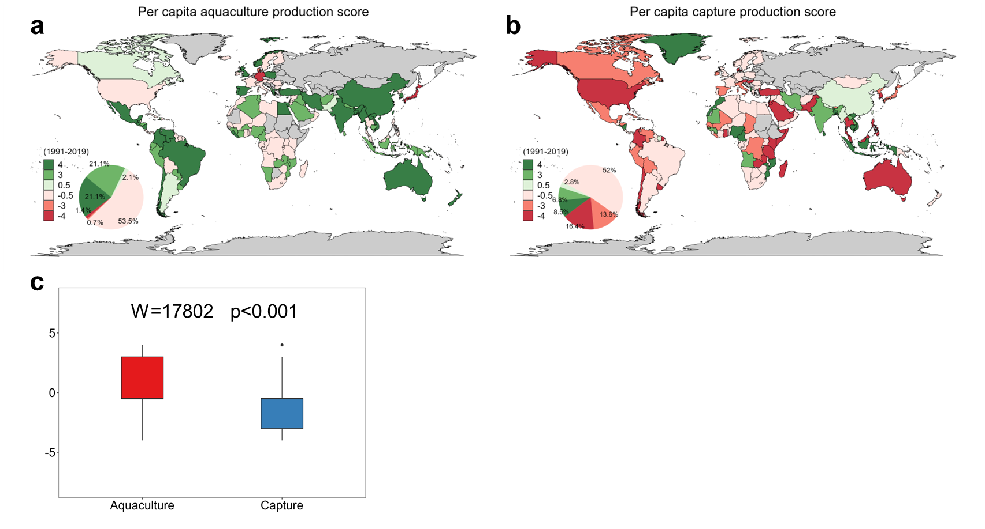
Fig. 1 Global trends in per capita aquaculture and capture fisheries production from 1991 to 2019. a, Map of the per capita aquaculture production trend scores for 142 countries. b, Map of the per capita capture fisheries production trend scores for 177 countries. c, Box plots provide the comparison of (a) aquaculture production trend scores and (b) capture fisheries production trend scores at the global scales from 1991 to 2019. Countries in grey: No data available. We retained 142 countries with zero values for less than one-third of the period (1991-2019). Percentages may not add up exactly to 100% due to rounding. The original global aquaculture and capture fisheries statistic datasets were taken from the FishStatJ software (FAO, 2023).

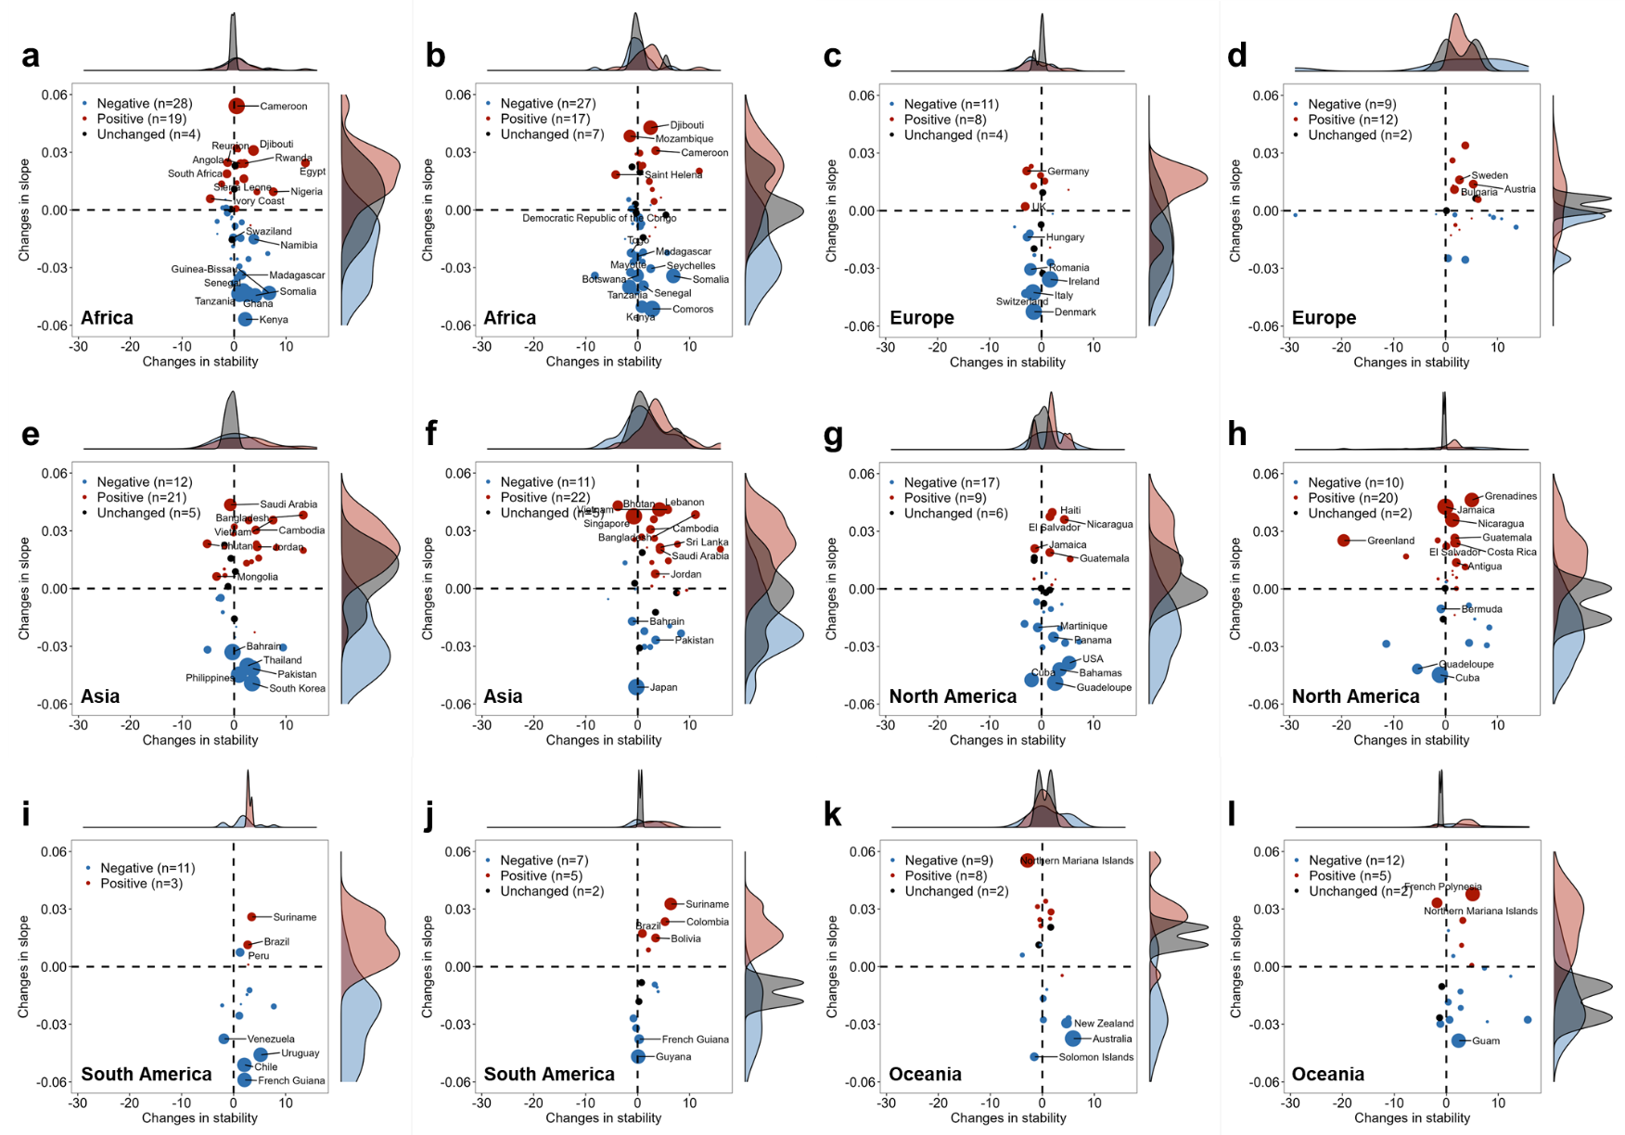
Fig. 2 Changes in continental per capita production and consumption trends and accompanying changes in stability and slope from 1961-1990 to 1991-2019. Scatter plots shows the changes in (a, c, e, g, i, k) AFPS and (b, d, f, h, j, i) AFCS at the continental scale between the two periods. Each point represents a country, with size indicating the absolute value of the score change. Red indicates positive change, blue indicates negative change, and black represents unchanged. Numbers denote the count of countries in each change category, while marginal density plots illustrate the distribution of countries in corresponding change categories. Countries whose scores changed by more than 4 points were labeled.

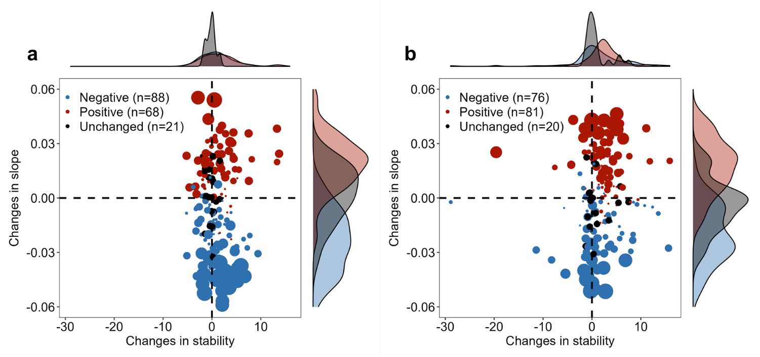
Fig. 3 Changes in global per capita production and consumption trends and accompanying changes in stability and slope from 1961-1990 to 1991-2019. Scatter plots shows the changes in (a) AFPS and (b) AFCS at the global scale between the two periods. Each point represents a country, with size indicating the absolute value of the score change. Red indicates positive change, blue indicates negative change, and black represents unchanged. Numbers denote the count of countries in each change category (Total = 177), while marginal density plots illustrate the distribution of countries in corresponding change categories.
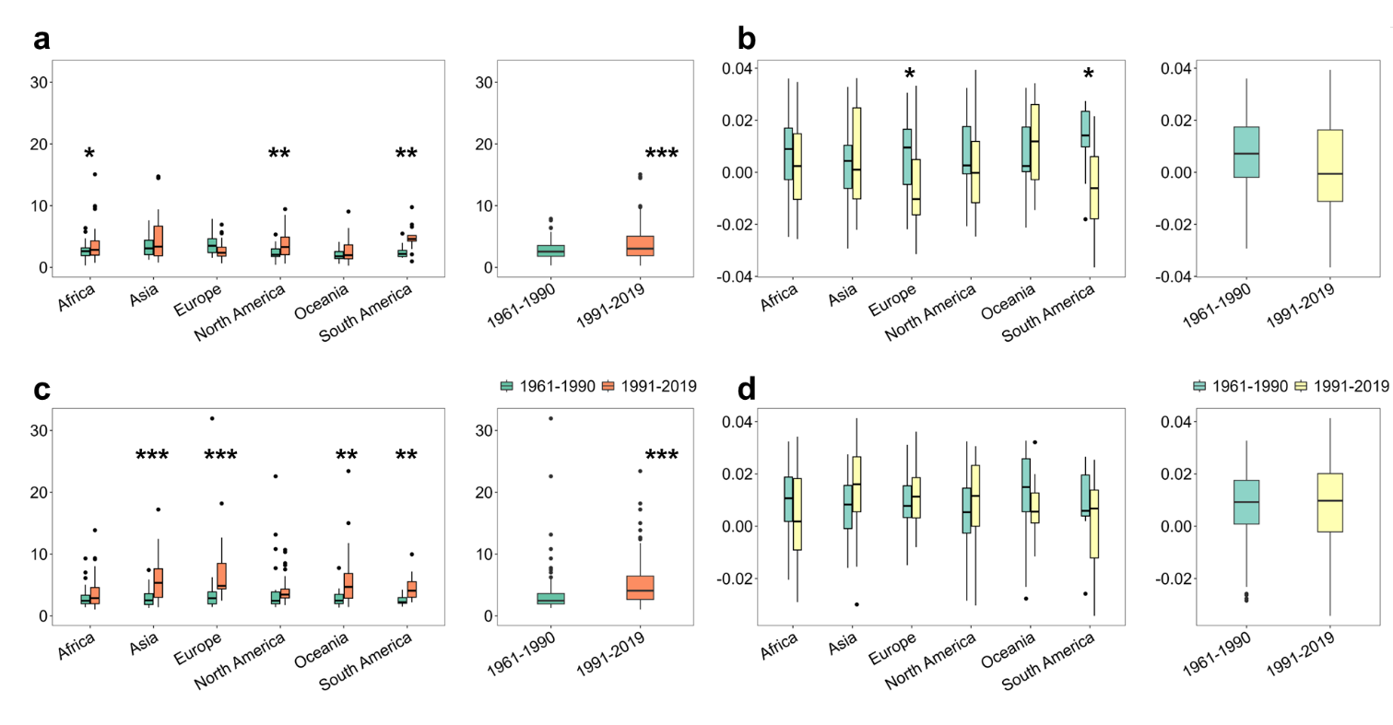
Fig. 4 Comparison of stability and slope of per capita production and consumption trend at the continental and global scales between the two periods. Box plots provide the comparison of (a) stability and (b) slope of per capita production trend; and the comparison of (c) stability and (d) slope of per capita consumption trend between the two periods. Asterisks indicate the significance level of statistical differences from the Wilcoxon rank-sum test or t-test comparing the country scores between the two periods (* p < 0.05; **p < 0.01; ***p < 0.001).

