Supplementary Information

Ethyle 6-amino-5-cyano-2-methyl-4-phenyl-4H-pyran-3-carboxylate 5a :
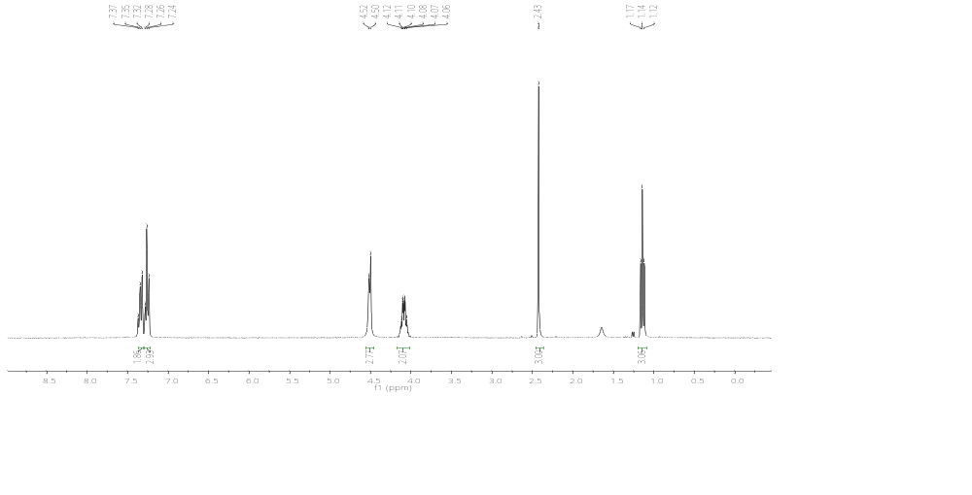

¹H NMR spectrum of ethyl 6-amino-5-cyano-2-methyl-4-phenyl-4H-pyran-3-carboxylate.
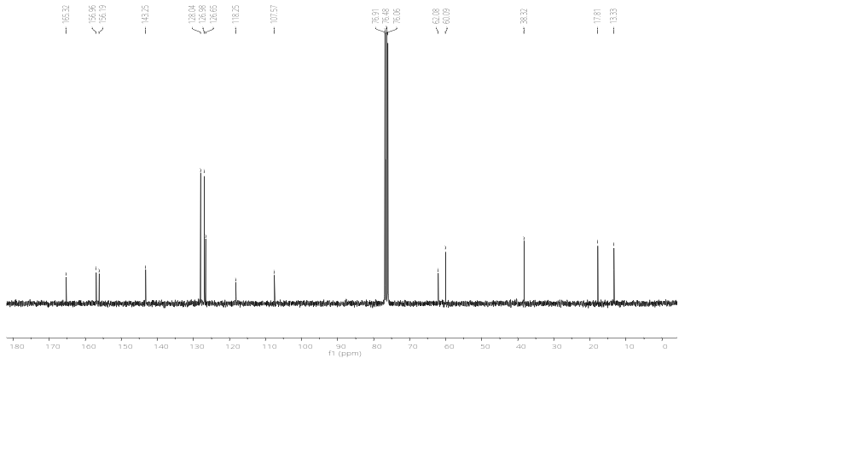

¹³C NMR spectrum of ethyl 6-amino-5-cyano-2-methyl-4-phenyl-4H-pyran-3-carboxylate.

Ethyle 6-amino-5-cyano-4-(4-methoxyphenyl) -2-methyl-4H-pyran-3-carboxylate 5b :

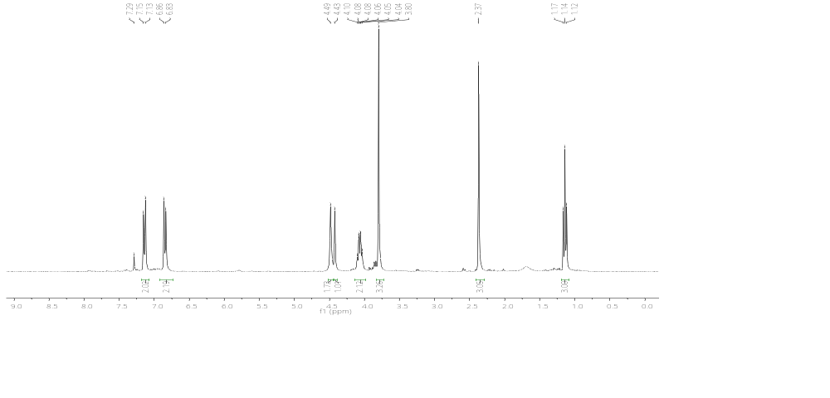

¹H NMR spectrum of ethyl 6-amino-5-cyano-4-(4-methoxyphenyl) -2-methyl-4H-pyran-3-carboxylate.

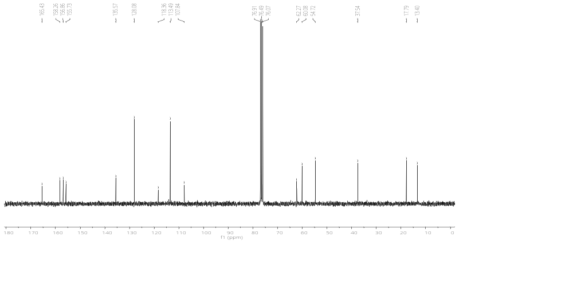

¹³C NMR spectrum of ethyl 6-amino-5-cyano-4-(4-methoxyphenyl) -2-methyl-4H-pyran-3-carboxylate.

Ethyle 6-amino-4-(4-chlorophenyl) -5-cyano-2-methyl-4H-pyran-3-carboxylate 5c :

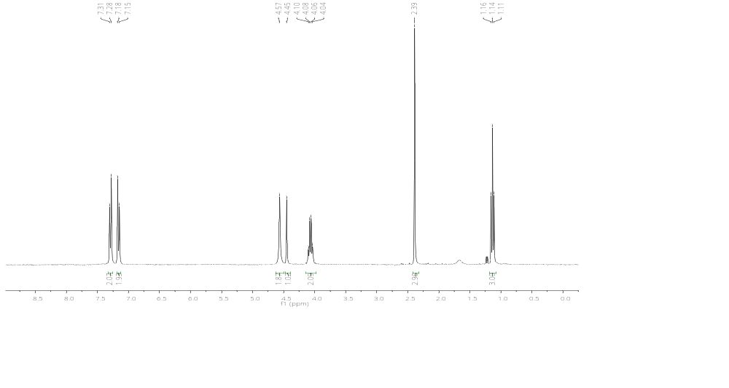

¹H NMR spectrum of ethyl 6-amino-4-(4-chlorophenyl) -5-cyano-2-methyl-4H-pyran-3-carboxylate.

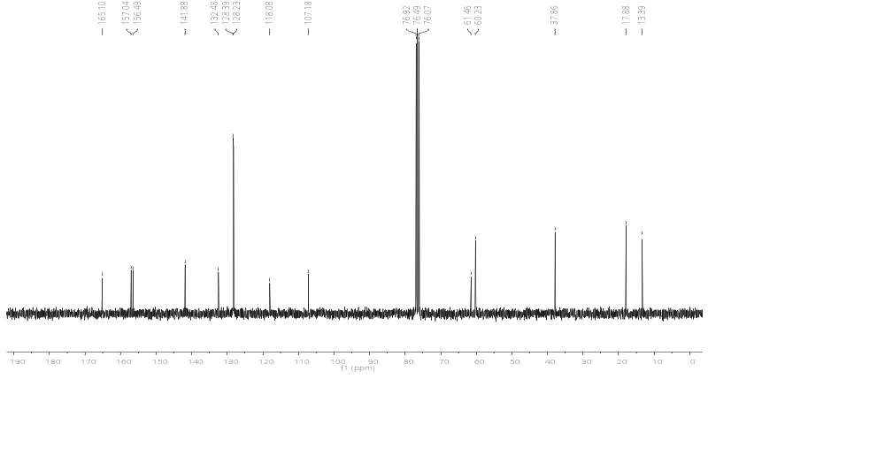

¹³C NMR spectrum of ethyl 6-amino-4-(4-chlorophenyl) -5-cyano-2-methyl-4H-pyran-3-carboxylate.

Ethyle 6-amino-4-(2-chlorophenyl) -5-cyano-2-methyl-4H-pyran-3-carboxylate 5d :

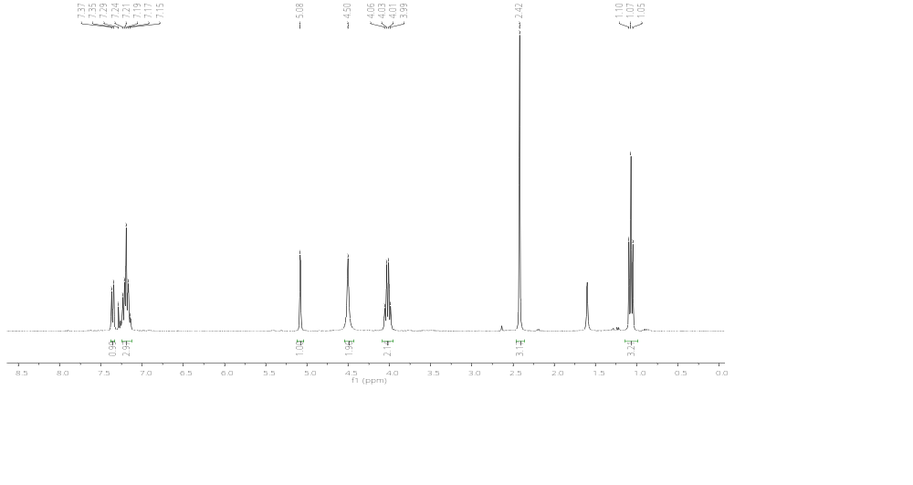

¹H NMR spectrum of ethyl 6-amino-4-(2-chlorophenyl) -5-cyano-2-methyl-4H-pyran-3-carboxylate.

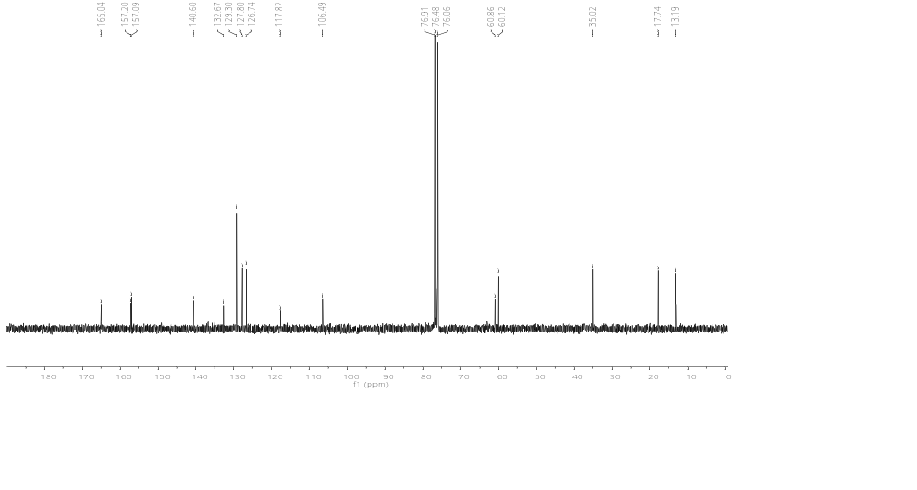

¹³C NMR spectrum of ethyl 6-amino-4-(2-chlorophenyl) -5-cyano-2-methyl-4H-pyran-3-carboxylate.
Ethyle 6-amino-5-cyano-4-(3,4-dimethoxyphenyl) -2-methyl-4H-pyran-3carboxylate 5e :

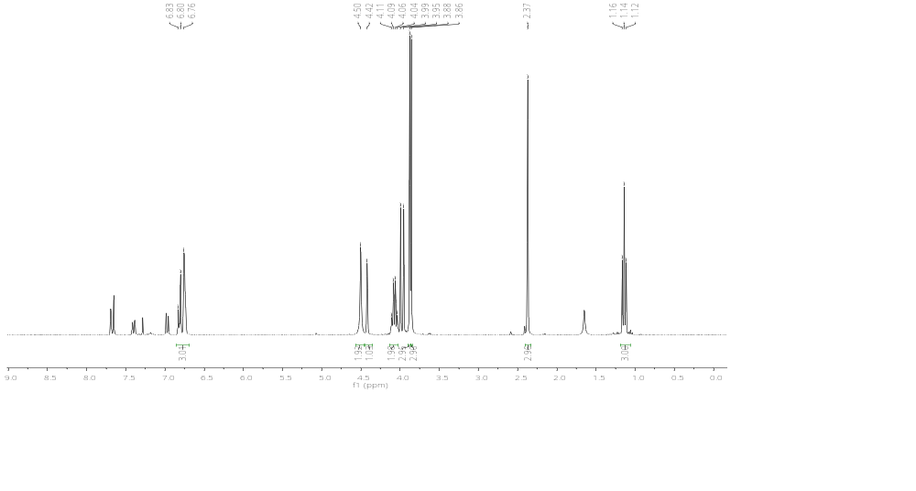

¹H NMR spectrum of ethyl 6-amino-5-cyano-4-(3,4-dimethoxyphenyl) -2-methyl-4H-pyran-3-carboxylate.

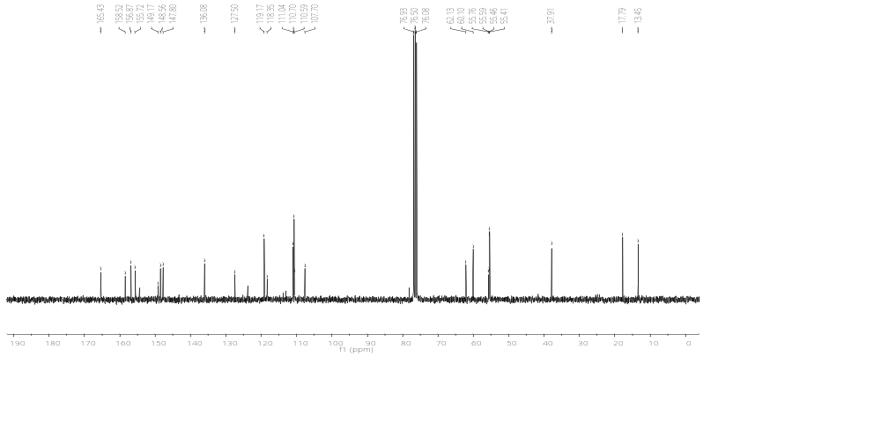

¹³C NMR spectrum of ethyl 6-amino-5-cyano-4-(3,4-dimethoxyphenyl) -2-methyl-4H-pyran-3-carboxylate.

Ethyle 6-amino-5-cyano-2-methyl-4-(3,4,5-trimethoxyphenyl) -4H-pyran-3 carboxylate 5f :

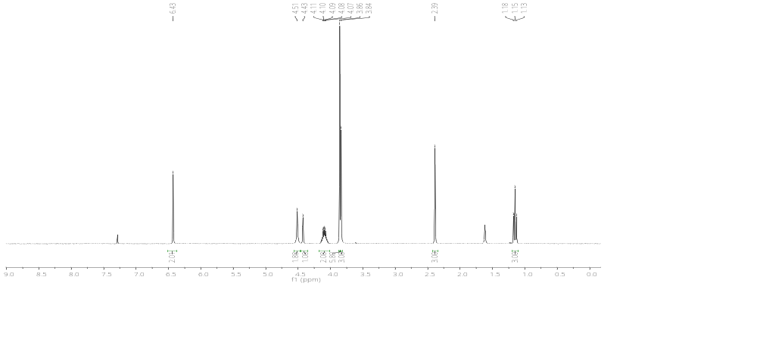

¹H NMR spectrum of ethyl 6-amino-5-cyano-2-methyl-4-(3,4,5-trimethoxyphenyl) -4H-pyran-3-carboxylate.
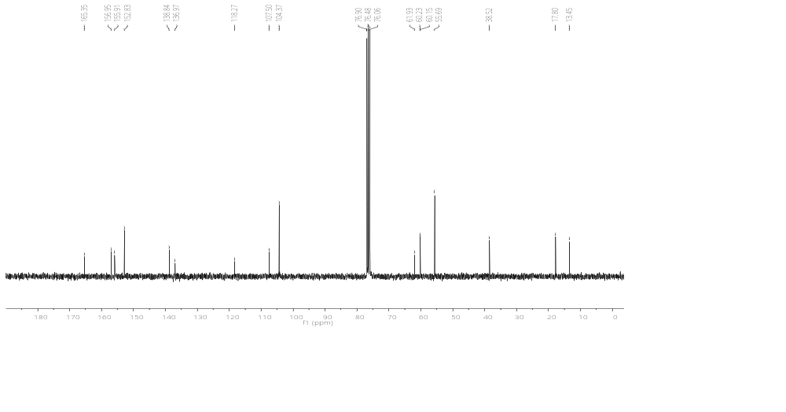

¹³C NMR spectrum of ethyl 6-amino-5-cyano-2-methyl-4-(3,4,5-trimethoxyphenyl) -4H-pyran-3-carboxylate.

Ethyle 6-amino-5-cyano-2-methyl-4-(4-nitrophenyl) -4H-pyran-3-carboxylate 5g :

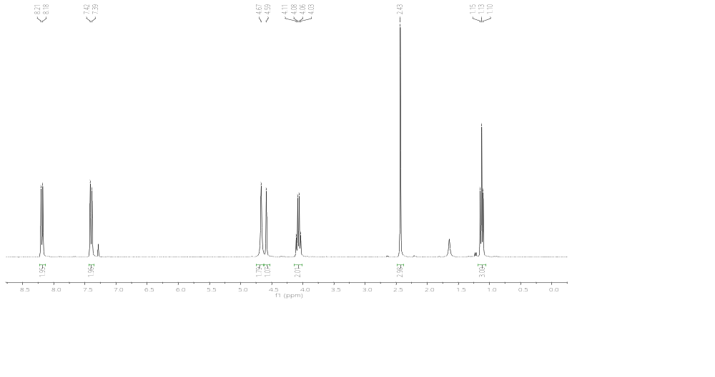

¹H NMR spectrum of ethyl 6-amino-5-cyano-2-methyl-4-(4-nitrophenyl) -4H-pyran-3-carboxylate.

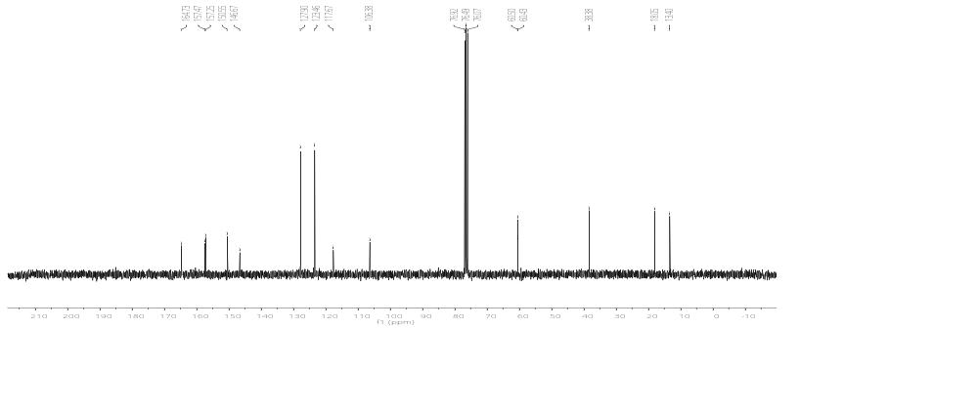

¹³C NMR spectrum of ethyl 6-amino-5-cyano-2-methyl-4-(4-nitrophenyl) -4H-pyran-3-carboxylate.

Ethyle 6-amino-5-cyano-4-(3-hydroxy-4-methoxyphenyl) -2-methyl-4H-pyran-3 carboxylate 5h :
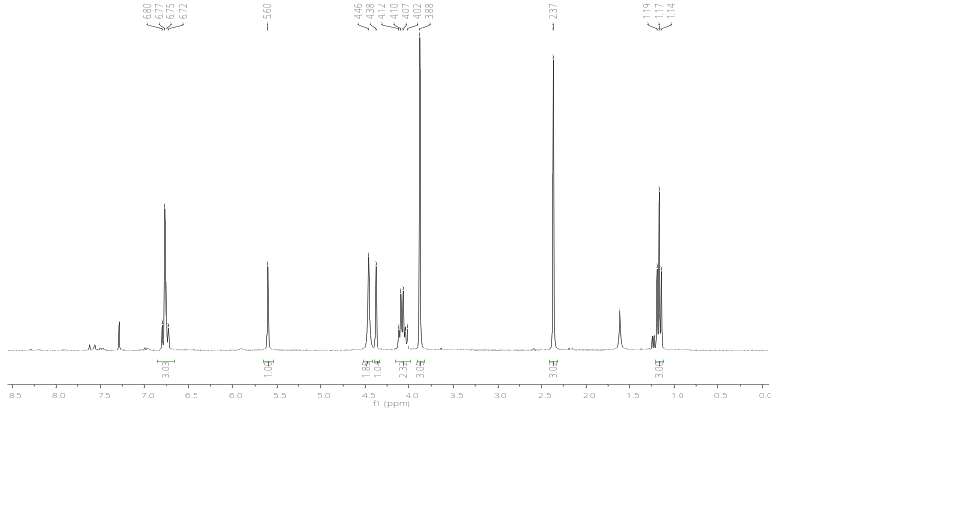

¹H NMR spectrum of ethyl 6-amino-5-cyano-4-(3-hydroxy-4-methoxyphenyl) -2-methyl-4H- pyran-3-carboxylate.

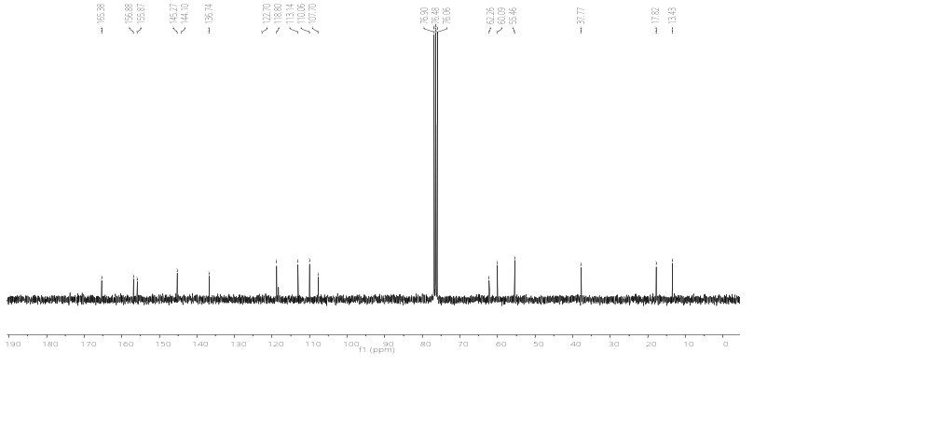

¹³C NMR spectrum of ethyl 6-amino-5-cyano-4-(3-hydroxy-4-methoxyphenyl) -2-methyl-4H- pyran-3-carboxylate.

