Supplementary information

Future weakening of the Atlantic Meridional Overturning Circulation shaped by reduced Labrador Sea winds and salt transport feedback
Won-Il Lim¹, Hyo-Seok Park^{1*} and Andrew Stewart²
¹Department of Ocean Science and Technology, Hanyang University, Ansan, South Korea
²Department of Atmospheric and Oceanic Sciences, University of California, Los Angeles, USA

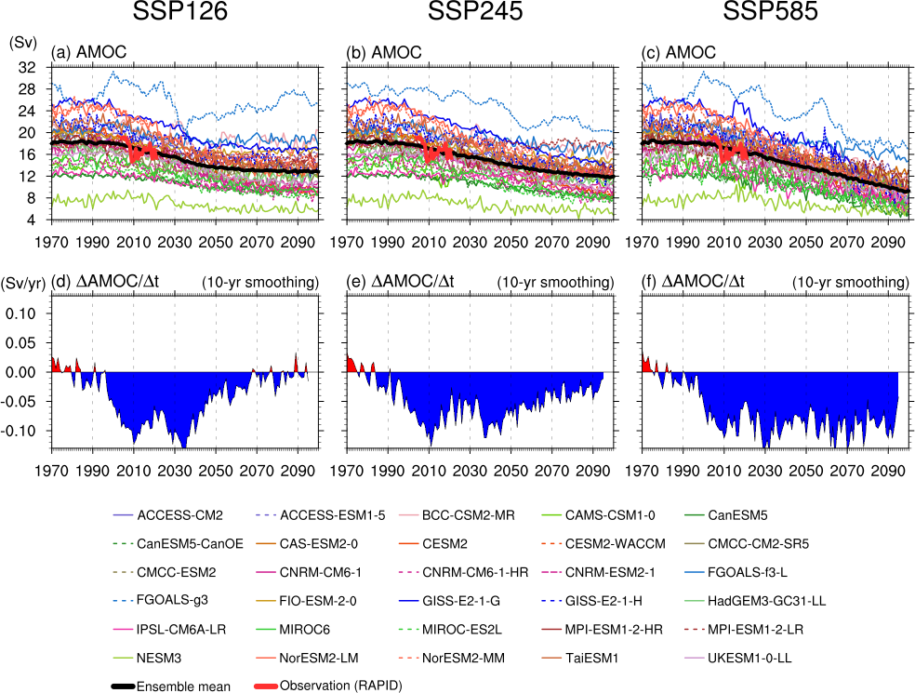

Supplementary Figure 1: AMOC strength and interannual change rate.
The annual-mean AMOC strength and the rate of AMOC change spanning 1850 to 2100. The top panel shows the AMOC strength derived from CMIP6 simulations under three scenarios: (a) Historical + SSP-126, (b) Historical + SSP-245, and (c) Historical + SSP-585, alongside RAPID observations from 2004 to 2021 (red line). The bottom panel shows the AMOC change rate (ΔAMOC/year) from CMIP6 simulations under the same scenarios: (d) Historical + SSP-126, (e) Historical + SSP-245, and (f) Historical + SSP-585. In the bottom panel, red (blue) shading indicates a positive (negative) AMOC change rate.

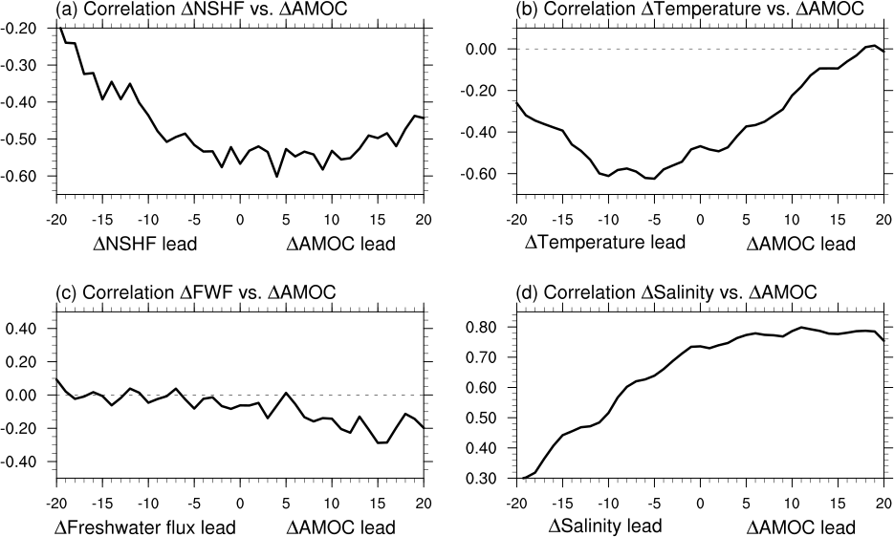

Supplementary Figure 2: Lagged correlation between AMOC changes and net surface heat flux, freshwater flux, ocen tempearture, and salinity.
Lagged correlation AMOC changes from 1990 to 2050 (ΔAMOC) verse (a) net surface heat flux changes (ΔNSHF), (b) ocean temperature (vertical averaged from 0 to 1000 m ) changes (ΔTemperature), (c) freshwater flux changes (ΔFWF), and (d) salinity (vertical averaged from 0 to 1000 m) changes (ΔSalinity), over the Labrador Sea. A positive lag indicates that AMOC changes lead NSHF changes, ocean temperature changes, freshwater flux changes, and salinity changes.

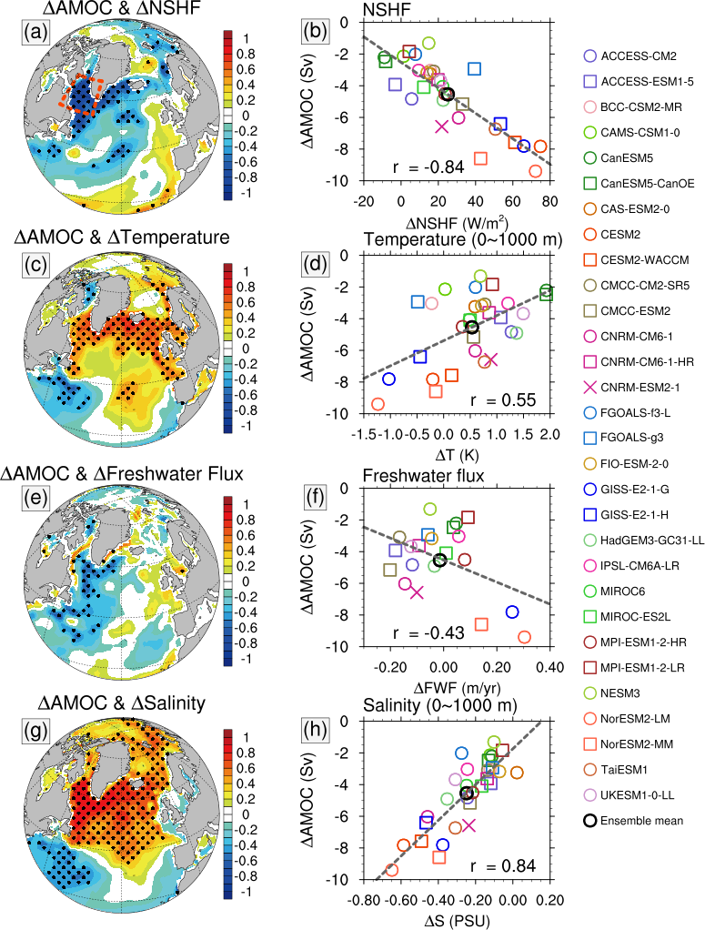
Supplementary Figure 3: Multi-model relationship between AMOC changes and surface flux changes Historical and SSP-585 scenario simulations
(a, c, e, g) Correlation map: inter-model correlations between (a) ΔAMOC and ΔNSHF, (c) ΔAMOC and ΔT (0–1000m temperature average), (e) ΔAMOC and ΔFWF (freshwater flux), and (g) ΔAMOC and ΔS (0–1000m salinity average), at each grid cell. Here, Δ implies the temporal change from 1990 to 2050. It correlates the differences in ΔAMOC across models with the inter-model differences in ΔNSHF, ΔFreshwater flux, ΔTemperature, and ΔSalinity at each grid cell. (b, d, f, h) Multi-model correlation between (b) ΔAMOC and ΔNSHF, (d) ΔAMOC and ΔT, (f) ΔAMOC and ΔFWF, and (h) ΔAMOC and ΔS, averaged over the Labrador Sea (ornage dotted line in (a)) in Historical and SSP-126 scenario simulations. The gray-dashed lines in (b, d, f, h) indicate the regression lines of the multi-models.

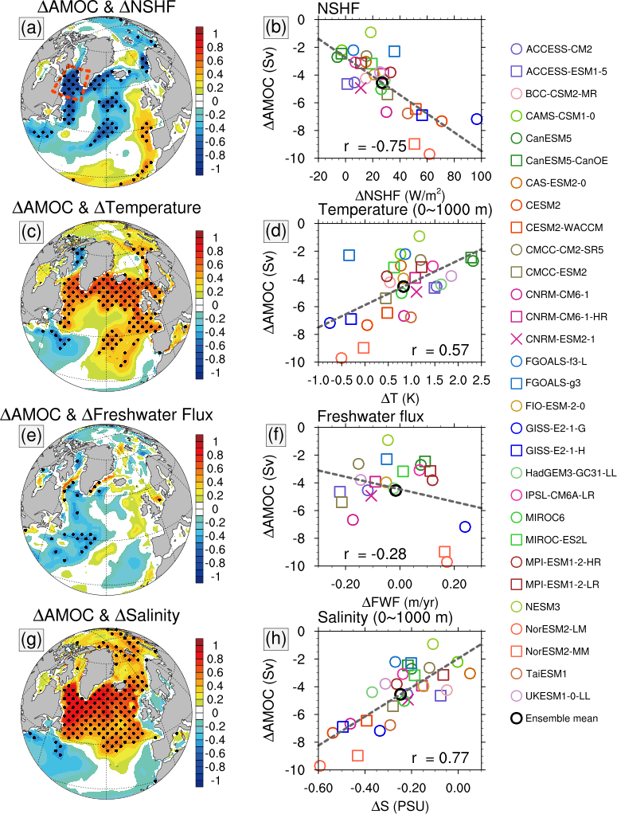

Supplementary Figure 4: Multi-model relationship between AMOC changes and surface flux changes in Historical and SSP-585 scenario simulations
Same as Supplementary Fig. 3 except for Historical and SSP-585 scenario simulations.

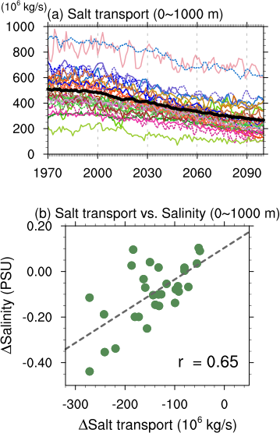
Supplementary Figure 5: Changes in meridional salt transport
(a) The CMIP6 annual-mean meridional salt transport at 50°N spanning 1970 to 2100 from CMIP6 simulations under Historical and SSP-245 scenarios. (b) Multi-model correlations between ΔSalt transport and ΔSalinity (0–1000 m average), averaged in the Labrador Sea in Historical and SSP-245 scenario simulations. Here, Δ implies the temporal change from 1990 to 2050. The gray-dashed lines in (b) indicate the regression lines of the multi-models.

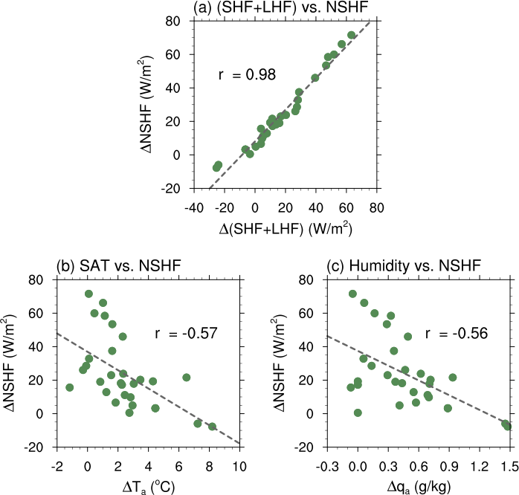

Supplementary Figure 6: Multi-model relationship between surface turbulent heat flux changes and NSHF cahnges
Multi-model correlation between (a) Δturbulenta heat flux (sensible + latent heat flux) and ΔNSHF, (b) Δ(surface air temperature) and ΔNSHF, and (c) Δ(surface specific humidity) and ΔNSHF, averaged over the Labrador Sea in Historical and SSP-245 scenario simulations. The gray-dashed lines indicate the regression lines of the multi-models.

Table S1. Information of CMIP6 list and member used in this study.
Model | Member | Reference
ACCESS-CM2 | r1i1p1f1, r2i1p1f1, r3i1p1f1, r4i1p1f1, r5i1p1f1 | ref. ¹
ACCESS-ESM1-5 | r1i1p1f1, r2i1p1f1, r3i1p1f1, r4i1p1f1, r5i1p1f1 | ref. ^{2,3}
BCC-CSM2-MR | r1i1p1f1 | ref. ⁴
CAMS-CSM1-0 | r1i1p1f1 | ref. ⁵
CanESM5 | r1i1p2f1, r2i1p2f1, r3i1p2f1, r4i1p2f1, r5i1p2f1 | ref. ⁶
CanESM5-CanOE | r1i1p2f1, r2i1p2f1, r3i1p2f1 | ref. ⁶
CAS-ESM2-0 | r1i1p1f1, r3i1p1f1 | ref. ⁷
CESM2 | r4i1p1f1, r10i1p1f1, r11i1p1f1 | ref. ⁸
CESM2-WACCM | r1i1p1f1 | ref. ⁸
CMCC-CM2-SR5 | r1i1p1f1 | ref. ⁹
CMCC-ESM2 | r1i1p1f1 | ref. ¹⁰
CNRM-CM6-1 | r1i1p1f2, r2i1p1f2, r3i1p1f2, r4i1p1f2, r5i1p1f2 | ref. ¹¹
CNRM-CM6-1-HR | r1i1p1f2 | ref. ¹¹
CNRM-ESM2-1 | r1i1p1f2 | ref. ¹²
FGOALS-f3-L | r1i1p1f1 | ref. ¹³
FGOALS-g3 | r1i1p1f1 | ref. ¹⁴
FIO-ESM-2-0 | r1i1p1f1, r2i1p1f1, r3i1p1f1 | ref. ¹⁵
GISS-E2-1-G | r1i1p1f2, r2i1p1f2, r3i1p1f2, r4i1p1f2, r5i1p1f2 | ref. ¹⁶
GISS-E2-1-H | r1i1p1f2, r2i1p1f2, r3i1p1f2, r4i1p1f2, r5i1p1f2 | ref. ¹⁷
HadGEM3-GC31-LL | r1i1p1f3 | ref. ¹⁸
IPSL-CM6A-LR | r1i1p1f1, r2i1p1f1, r3i1p1f1, r4i1p1f1, r6i1p1f1 | ref. ¹⁹
MIROC6 | r1i1p1f1, r2i1p1f1, r3i1p1f1, r4i1p1f1, r5i1p1f1 | ref. ²⁰
MIROC-ES2L | r1i1p1f2, r2i1p1f2, r3i1p1f2, r4i1p1f2, r5i1p1f2 | ref. ²¹
MPI-ESM1-2-HR | r1i1p1f1, r2i1p1f1 | ref. ²²
MPI-ESM1-2-LR | r1i1p1f1, r2i1p1f1, r3i1p1f1, r4i1p1f1, r5i1p1f1 | ref. ²³
NESM3 | r1i1p1f1, r2i1p1f1 | ref. ²⁴
NorESM2-LM | r1i1p1f1 | ref. ²⁵
NorESM2-MM | r1i1p1f1 | ref. ²⁵
TaiESM1 | r1i1p1f1 | ref. ²⁶
UKESM1-0-LL | r1i1p1f2, r2i1p1f2, r3i1p1f2, r4i1p1f2, r8i1p1f2 | ref. ²⁷

References
1. Bi, D. et al. The ACCESS coupled model: description, control climate and evaluation. Aust. Meteorol. Oceanogr. J. 63, 41–64 (2013).
2. Law, R. M. et al. The carbon cycle in the Australian Community Climate and Earth System Simulator (ACCESS-ESM1) – Part 1: Model description and pre-industrial simulation. Geosci. Model Dev. 10, 2567–2590 (2017).
3. Ziehn, T., Lenton, A., Law, R. M., Matear, R. J. & Chamberlain, M. A. The carbon cycle in the Australian Community Climate and Earth System Simulator (ACCESS-ESM1) – Part 2: Historical simulations. Geosci. Model Dev. 10, 2591–2614 (2017).
4. Wu, T. et al. The Beijing Climate Center Climate System Model (BCC-CSM): the main progress from CMIP5 to CMIP6. Geosci. Model Dev. 12, 1573–1600 (2019).
5. Rong, X. et al. The CMIP6 Historical Simulation Datasets Produced by the Climate System Model CAMS-CSM. Adv. Atmospheric Sci. 38, 285–295 (2021).
6. Swart, N. C. et al. The Canadian Earth System Model version 5 (CanESM5.0.3). Geosci. Model Dev. 12, 4823–4873 (2019).
7. Zhang, H. et al. Description and Climate Simulation Performance of CAS-ESM Version 2. J. Adv. Model. Earth Syst. 12, e2020MS002210 (2020).
8. Danabasoglu, G. et al. The Community Earth System Model Version 2 (CESM2). J. Adv. Model. Earth Syst. 12, e2019MS001916 (2020).
9. Cherchi, A. et al. Global Mean Climate and Main Patterns of Variability in the CMCC-CM2 Coupled Model. J. Adv. Model. Earth Syst. 11, 185–209 (2019).
10. Lovato, T. et al. CMIP6 Simulations With the CMCC Earth System Model (CMCC-ESM2). J. Adv. Model. Earth Syst. 14, e2021MS002814 (2022).
11. Voldoire, A. et al. Evaluation of CMIP6 DECK Experiments With CNRM-CM6-1. J. Adv. Model. Earth Syst. 11, 2177–2213 (2019).
12. Séférian, R. et al. Evaluation of CNRM Earth System Model, CNRM-ESM2-1: Role of Earth System Processes in Present-Day and Future Climate. J. Adv. Model. Earth Syst. 11, 4182–4227 (2019).
13. He, B. et al. CAS FGOALS-f3-L Model Datasets for CMIP6 Historical Atmospheric Model Intercomparison Project Simulation. Adv. Atmospheric Sci. 36, 771–778 (2019).
14. Li, L. et al. The Flexible Global Ocean-Atmosphere-Land System Model Grid-Point Version 3 (FGOALS-g3): Description and Evaluation. J. Adv. Model. Earth Syst. 12, e2019MS002012 (2020).
15. Bao, Y., Song, Z. & Qiao, F. FIO-ESM Version 2.0: Model Description and Evaluation. J. Geophys. Res. Oceans 125, e2019JC016036 (2020).
16. Schmidt, G. A. et al. Configuration and assessment of the GISS ModelE2 contributions to the CMIP5 archive. J. Adv. Model. Earth Syst. 6, 141–184 (2014).
17. Kelley, M. et al. GISS-E2.1: Configurations and Climatology. J. Adv. Model. Earth Syst. 12, e2019MS002025 (2020).
18. Kuhlbrodt, T. et al. The Low-Resolution Version of HadGEM3 GC3.1: Development and Evaluation for Global Climate. J. Adv. Model. Earth Syst. 10, 2865–2888 (2018).
19. Dufresne, J.-L. et al. Climate change projections using the IPSL-CM5 Earth System Model: from CMIP3 to CMIP5. Clim. Dyn. 40, 2123–2165 (2013).
20. Tatebe, H. et al. Description and basic evaluation of simulated mean state, internal variability, and climate sensitivity in MIROC6. Geosci. Model Dev. 12, 2727–2765 (2019).
21. Hajima, T. et al. Development of the MIROC-ES2L Earth system model and the evaluation of biogeochemical processes and feedbacks. Geosci. Model Dev. 13, 2197–2244 (2020).
22. Müller, W. A. et al. A Higher-resolution Version of the Max Planck Institute Earth System Model (MPI-ESM1.2-HR). J. Adv. Model. Earth Syst. 10, 1383–1413 (2018).
23. Mauritsen, T. et al. Developments in the MPI‐M Earth System Model version 1.2 (MPI‐ESM1.2) and Its Response to Increasing CO2. J. Adv. Model. Earth Syst. 11, 998–1038 (2019).
24. Cao, J. et al. The NUIST Earth System Model (NESM) version 3: description and preliminary evaluation. Geosci. Model Dev. 11, 2975–2993 (2018).
25. Seland, Ø. et al. Overview of the Norwegian Earth System Model (NorESM2) and key climate response of CMIP6 DECK, historical, and scenario simulations. Geosci. Model Dev. 13, 6165–6200 (2020).
26. Lee, W.-L. et al. Taiwan Earth System Model Version 1: description and evaluation of mean state. Geosci. Model Dev. 13, 3887–3904 (2020).
27. Sellar, A. A. et al. UKESM1: Description and Evaluation of the U.K. Earth System Model. J. Adv. Model. Earth Syst. 11, 4513–4558 (2019).

