Supporting Information

Efficient Detection of Pancreatic-Cancer Biomarkers using Functionalized Titanium Carbide (Ti₃C₂T_{x}) MXenes
Narender Kumar^{1,4}, Tanveer Hussain², Shen Lei³, Nacir Tit^{1,4,*}
¹ Department of Physics, College of Science, UAE University, P.O. Box 15551, Al-Ain, United Arab Emirates
² School of Science and Technology, University of New England, Armidale, New South Wales 2351, Australia
³ Department of Mechanical Engineering, National University of Singapore, 9 Engineering Drive 1, Singapore 117575, Singapore
⁴ National Water and Energy Center, UAE University, P.O. Box 15551, Al-Ain, United Arab Emirates

Corresponding Author: ntit@uaeu.ac.ae (N. Tit)

S1
- Ti₃C₂O₂ MXene | 2-pentanone (2p-none)
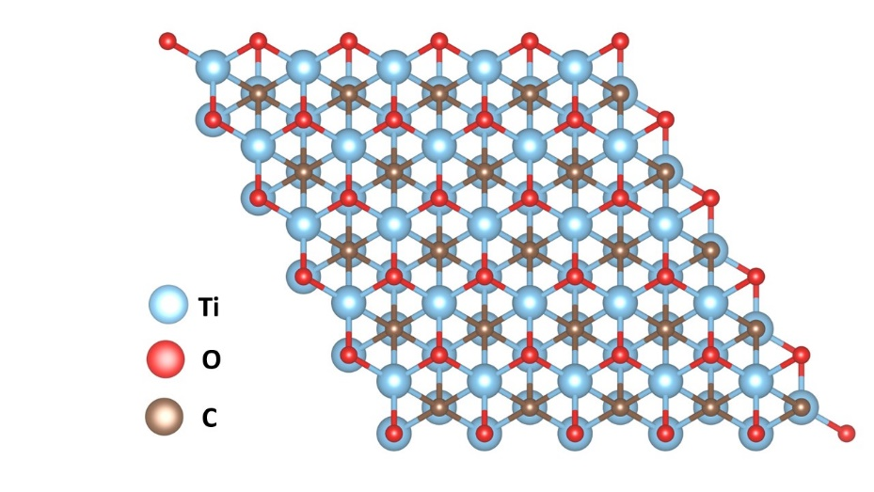 | 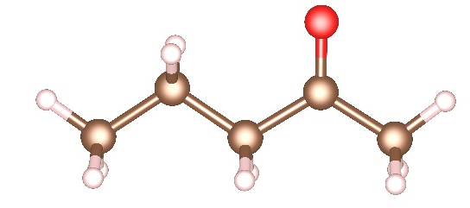
 | 4-ethyl-1-2-dimethylbenzene (4E12DMB)
 | 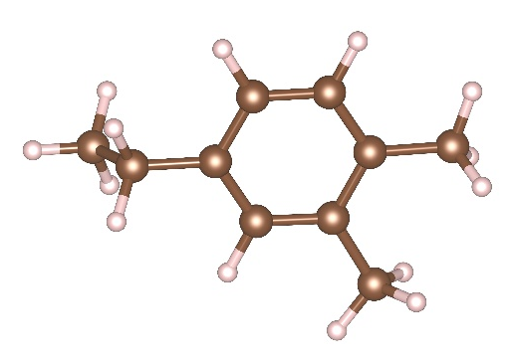
- X@Ti₃C₂O₂ (X = Co/Cu/Fe/Ni)
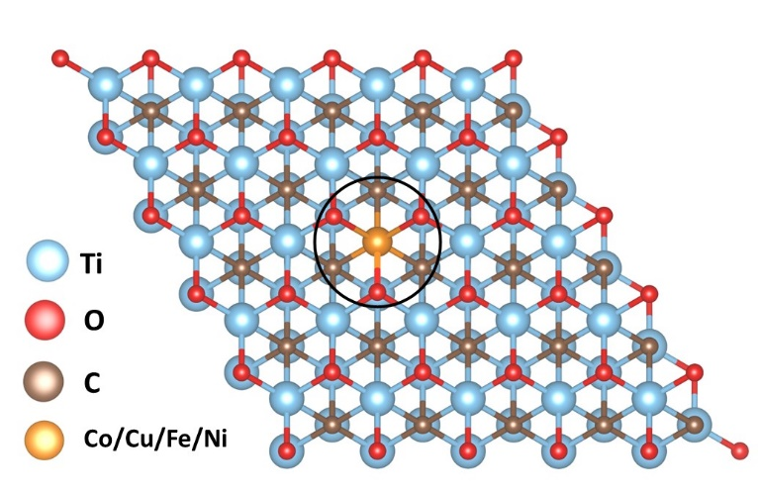
 | n-nonanal (n-nonal)
 | 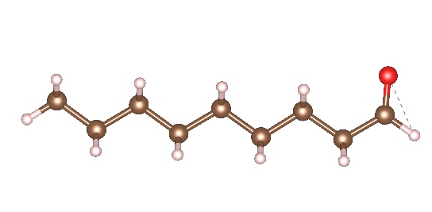
Figure S1: The optimized structures of Ti₃C₂O₂ MXene and VOCs, related to pancreatic cancer biomarkers. (a) Pristine Ti₃C₂O₂ MXene, (b) TM doped Ti₃C₂O₂ MXene (with TM = Co, Cu, Fe, Ni).

S2

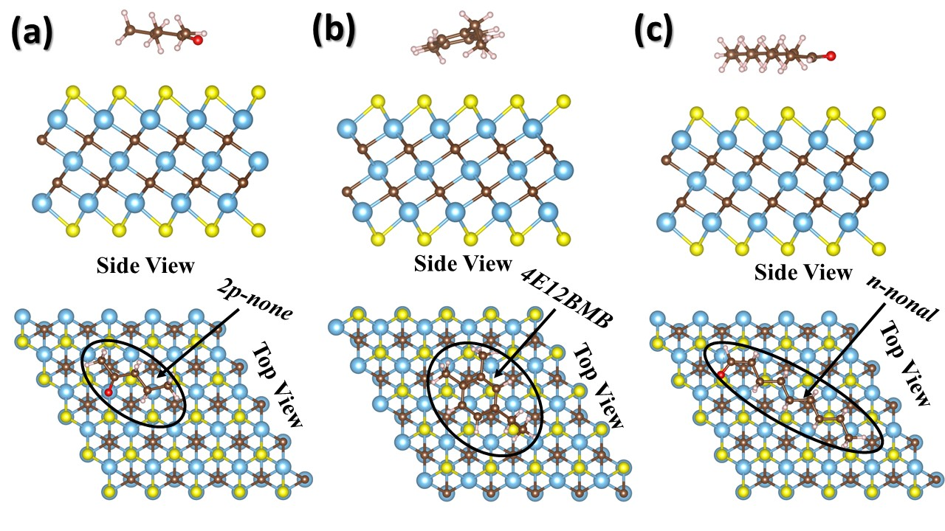
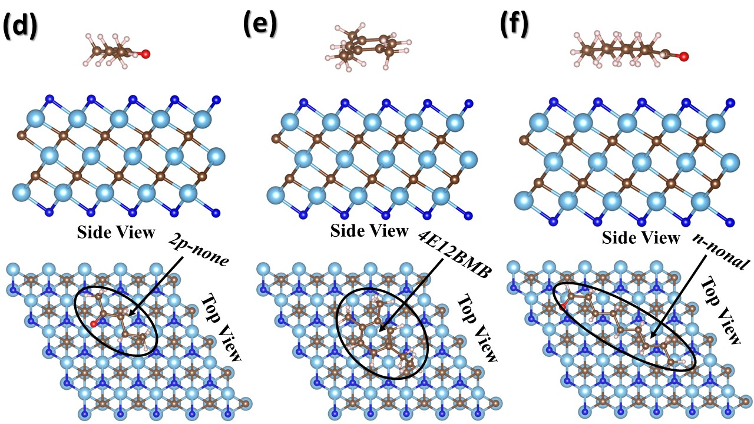

Figure S2: Relaxed structures of three VOCs, related to pancreatic cancer biomarkers, on Ti₃C₂S₂ MXene (a-c) and on Ti₃C₂F₂ MXene (d-f). Both top and side views are shown.

S3
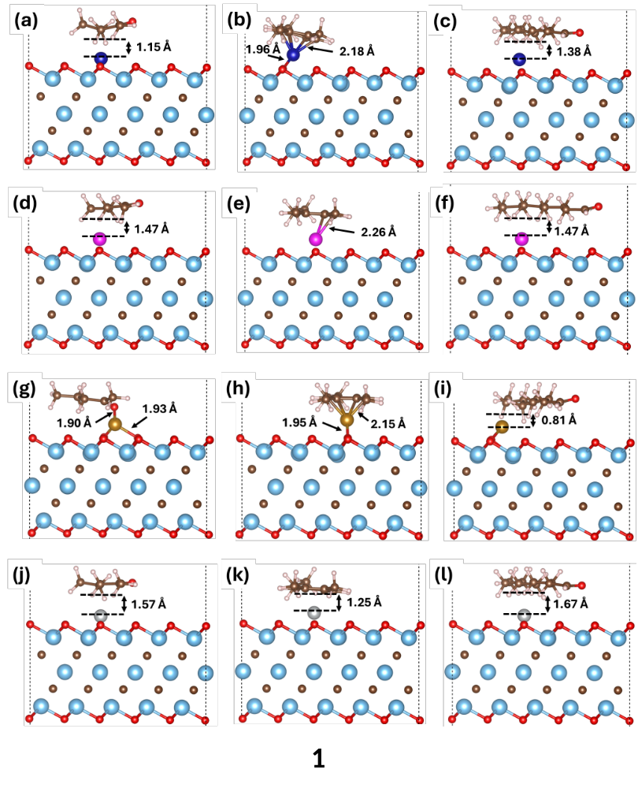

Figure S3: The relaxed structures of three VOCs, related to pancreatic cancer biomarkers, after their absorptions on TM-doped O site of Ti₃C₂O₂ MXenes (with TM = Co, Cu, Fe, Ni).

S4

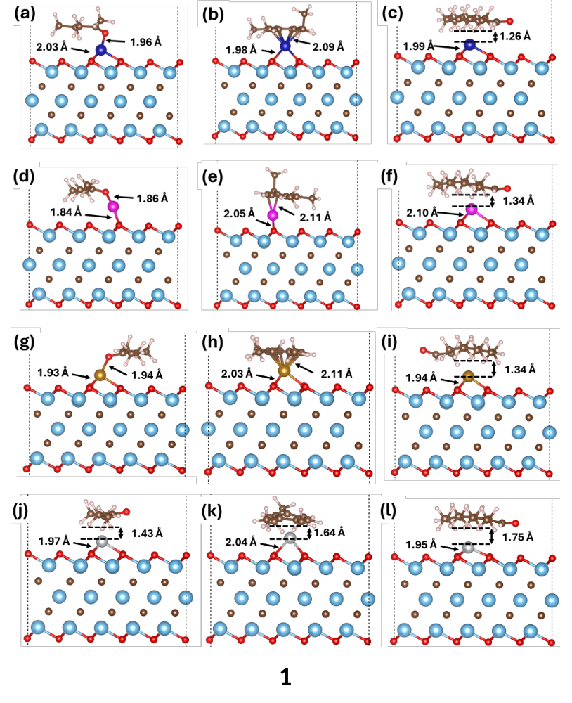
Figure S4: The relaxed structures of three VOCs, related to pancreatic cancer biomarkers, after their absorptions on TM-deposited as ad-atom on Ti₃C₂O₂ MXenes (with TM = Co, Cu, Fe, Ni).

S5

 | - 2p-none | - 4E1-2DMB | (c) n-nonal
(i) Co | 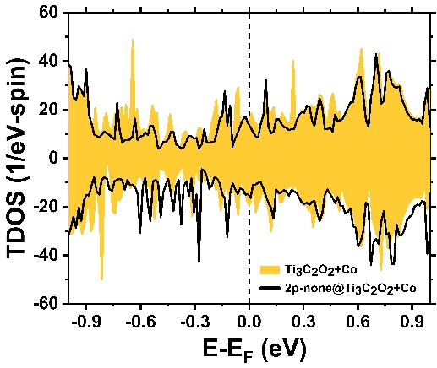 | 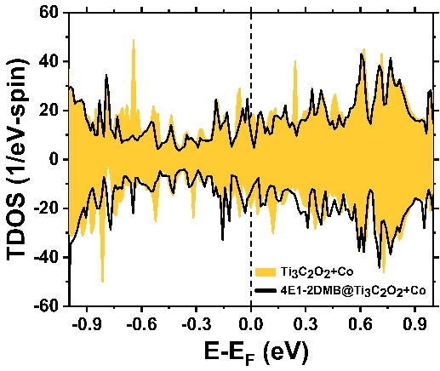 | 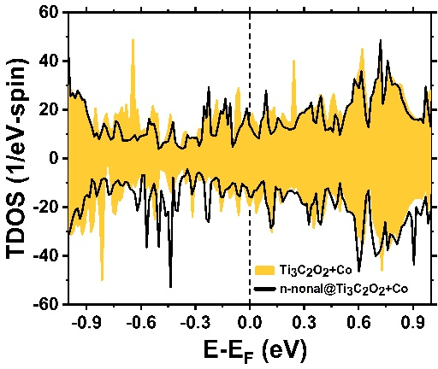
(ii) Cu | 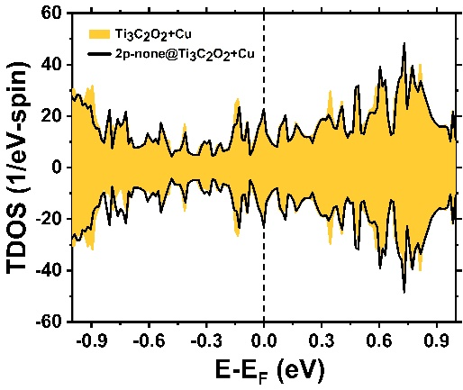 | 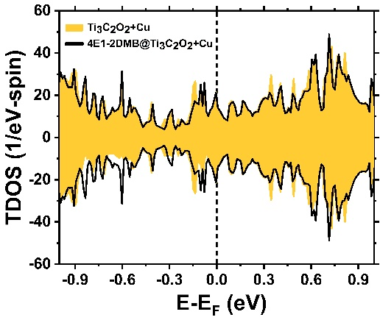 | 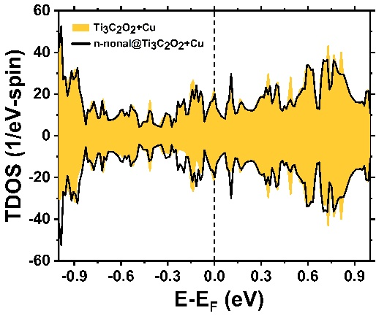
(iii) Fe | 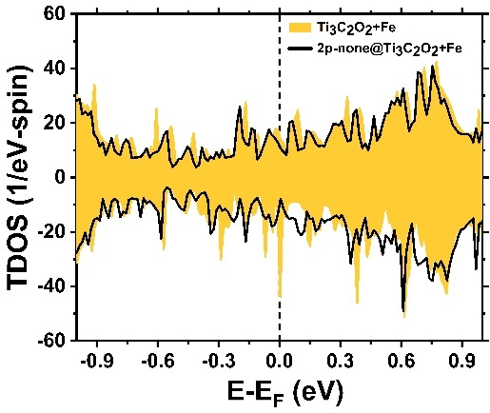 | 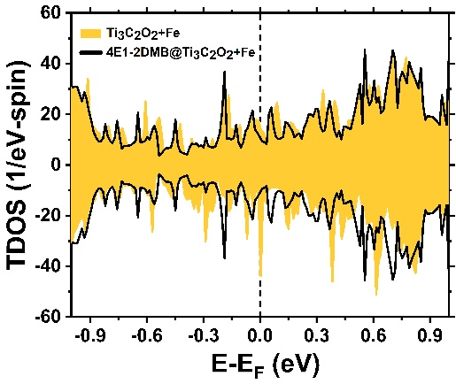 | 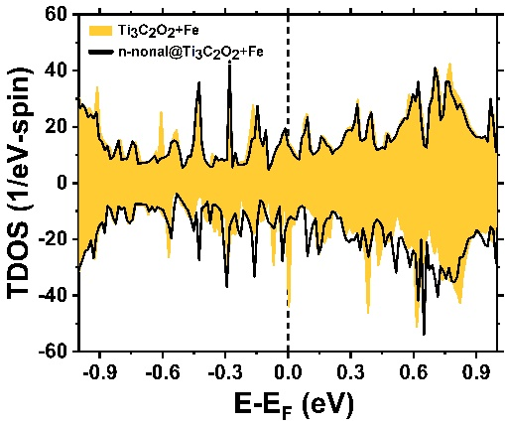
(iv) Ni | 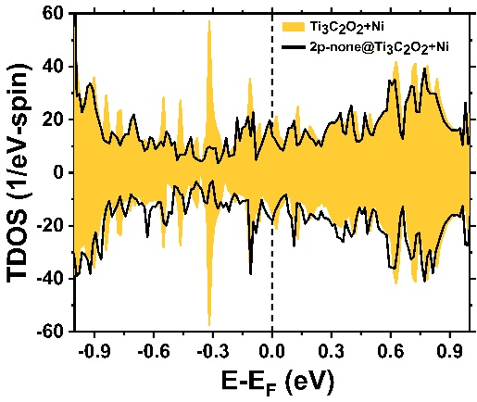 | 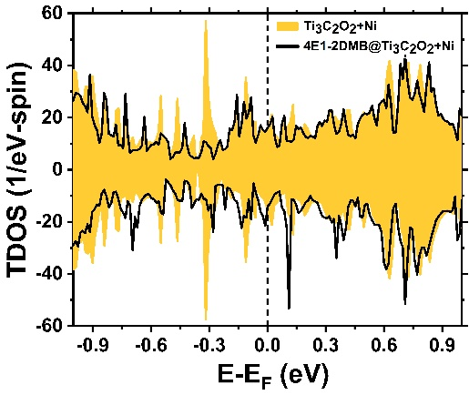 | 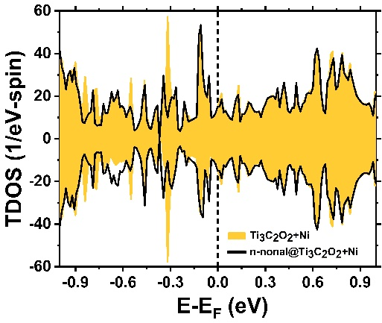
S6
Figure S5: Spin-polarized TDOS of TM decorated as ad-atom on the surface of Ti₃C₂O₂ MXenes (with TM = Co, Cu, Fe, Ni). Filled orange and black-solid curves correspond to pristine and TM ad-atom on surfaces of Ti₃C₂O₂ MXenes. Fermi level is taken as an energy reference (E_{F}=0).

S7

