Electronic supplementary material

Associations between anion gap-to-calcium ratio and mortality in septic patients with diabetes: a retrospective cohort study

Jing Cai; Lin Pu; Ken Lin; Meng Liu; Nanbing Yuan; Jie Gao; Jingjing Li

2024-05-26

Contents
Table S1. Detailed inclusion and exclusion criteria ......…………..........………...........………..3
Table S2. The definition of Sepsis-3.0 and primary outcome………….……..…...........…....….4
Table S3. Missing values analysis……………………………………………….........……........5
Table S4. Propensity score matching ……………………….……………………….......…........7
Figure S1. Absolute standard difference of covariates ……………..….………..........……........ 8
Figure S2. Standardized differences in covariates…………………………..….........……….......9
Table S5. Subgroup analyses………………………………………………….….......…….…....10

Table S1. Detailed inclusion and exclusion criteria
Category | Specific content
Inclusion criteria | (1) patients with the diagnosis of sepsis or septic shock; (2) with diabetes mellitus; (3) older than 18 years; (4) admitted directly to the ICU .
Exclusion criteria | (1) patients who were not admitted to ICU; (2) Multiple ICU admissions; (3)who did not have comprehensive anion gap and blood calcium data.

Table S2. The definition of Sepsis-3.0 and primary outcome
Category | Definition
Sepsis-3.0 | patients with a diagnosis of sepsis or septic shock
30-day mortality | 30-day mortality was defined as the status of patient survival within 30 days from admission

Table S3. Missing values analysis of included variables
Univariate Statistics
Variables | No. | Mean | Std. Deviation | Missing |  | No. of Extremesª
 |  |  |  | Count | Percent | Low | High
BMI, kg/m² | 943 | 31.34 | 9.20462 | 673 | 41.6 | 2 | 37
Lactate, mmol/l | 1308 | 3.094 | 2.6670 | 308 | 19.1 | 0 | 121
Neutrophil | 1456 | 82.999 | 11.0814 | 160 | 10.0 | 59 | 0
INR | 1522 | 1.748 | 1.4899 | 94 | 5.8 | 0 | 179
Temperature | 1584 | 36.816 | 0.7312 | 32 | 2.0 | 24 | 21
Hemoglobin, g/L | 1613 | 11.647 | 2.0680 | 3 | 0.2 | 0 | 12
Platelet ×10⁹ /L | 1613 | 242.47 | 115.202 | 3 | 0.2 | 0 | 45
WBC ×10⁹ /L | 1613 | 14.860 | 10.4860 | 3 | 0.2 | 0 | 49
Respiratory rate | 1614 | 19.77 | 4.204 | 2 | 0.1 | 0 | 41
SpO2 | 1614 | 96.8577 | 2.38388 | 2 | 0.1 | 29 | 0
Age, years | 1616 | 69.25 | 13.76 | 0 | 0.0 | 7 | 0
Anion gap, mmol/L | 1616 | 17.11 | 4.991 | 0 | 0.0 | 3 | 80
Calcium, mg/dL | 1616 | 8.373 | 0.9558 | 0 | 0.0 | 22 | 30
Glucose, mg/dL | 1616 | 233.66 | 132.239 | 0 | 0.0 | 0 | 74
BUN, mg/dL | 1616 | 37.90 | 25.772 | 0 | 0.0 | 0 | 89
Creatinine, mg/dL | 1616 | 1.817 | 1.5447 | 0 | 0.0 | 0 | 150
RDW | 1616 | 15.606 | 2.0934 | 0 | 0.0 | 0 | 55
RBC ×10¹² /L | 1616 | 3.9217 | 0.69102 | 0 | 0.0 | 0 | 15
Heart rate | 1616 | 86.10 | 16.037 | 0 | 0.0 | 3 | 8
Mean blood pressure | 1616 | 75.49 | 10.215 | 0 | 0.0 | 4 | 44
SOFA score | 1616 | 5.68 | 3.232 | 0 | 0.0 | 0 | 69
SAPA II score | 1616 | 41.65 | 14.305 | 0 | 0.0 | 0 | 52
Gender | 1616 | NA | NA | 0 | 0.0 | NA | NA
Septic shock | 1616 | NA | NA | 0 | 0.0 | NA | NA
Ventilation | 1616 | NA | NA | 0 | 0.0 | NA | NA
Coronary artery disease | 1616 | NA | NA | 0 | 0.0 | NA | NA
Congestive heart failure | 1616 | NA | NA | 0 | 0.0 | NA | NA
Valvular disease | 1616 | NA | NA | 0 | 0.0 | NA | NA
Hypertension | 1616 | NA | NA | 0 | 0.0 | NA | NA
COPD | 1616 | NA | NA | 0 | 0.0 | NA | NA
Metastatic cancer | 1616 | NA | NA | 0 | 0.0 | NA | NA
Renal failure | 1616 | NA | NA | 0 | 0.0 | NA | NA
Liver disease | 1616 | NA | NA | 0 | 0.0 | NA | NA
Lymphoma | 1616 | NA | NA | 0 | 0.0 | NA | NA
Solid tumor | 1616 | NA | NA | 0 | 0.0 | NA | NA
Rheumatoid arthritis | 1616 | NA | NA | 0 | 0.0 | NA | NA
a. Number of cases outside the range (Mean - 2*SD, Mean + 2*SD).
Abbreviations: No., number; Std., standard; NA, not applicable; BMI, body mass index; INR, international normalized ratio; WBC, white blood cell; SpO2, blood oxygen saturation; BUN, blood urea nitrogen; RDW, red blood cell distribution width; RBC, red blood cell; SOFA, Sequential Organ Failure Assessment; SPSA II,Simplified Acute Physiology Score; COPD, chronic obstructive pulmonary disease; IQR, inter-quartile range.

Table S4. Propensity score matching
Sample Sizes
Subsamples | All |  | Matched |  | Unmatched |  | Discarded
Subsamples | Control | Treated | Control | Treated | Control | Treated | Control | Treated
(all cases) | 1159 | 457 | 532 | 340 | 627 | 117 | 0 | 0
Relative multivariate imbalance L1
All cases | Before matching |  |  |  | After matching
All cases | 1.000 |  |  |  | 1.000
Overall balance test
All cases | Chi square |  |  | df |  | p. value
All cases | 9.773 |  |  | 25.000 |  | 0.997

Patients treated with high ACR and low ACR groups were matched in a ratio of 1:2. The total number after matching was 872. After matching, the number of participants in high ACR group was 340,and the number of low ACR group was 532.

Figure S1. Absolute standard difference of covariates between the high ACR and low ACR groups.
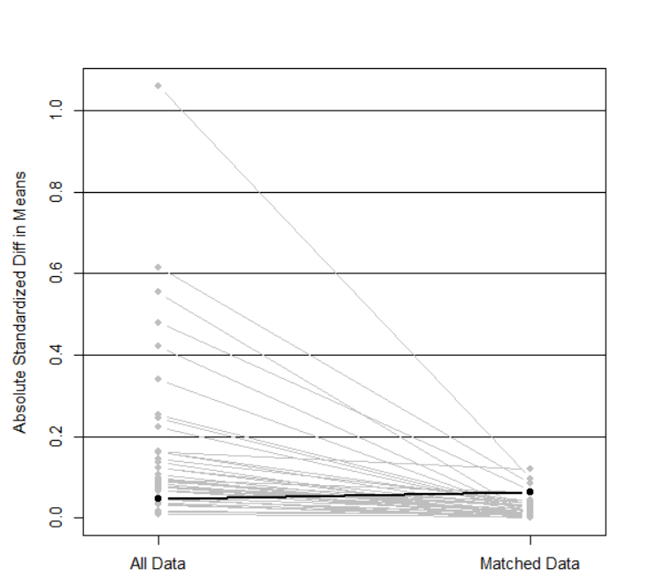

In the original cohort, large absolute standard differences (>0.2) were detected in the covariates between the high ACR and low ACR groups. However, the differences between high ACR and low ACR groups were all reduced to be below 0.2 after balancing with the PSM.

Figure S2. Standardized differences in covariates between the original and matching cohort.

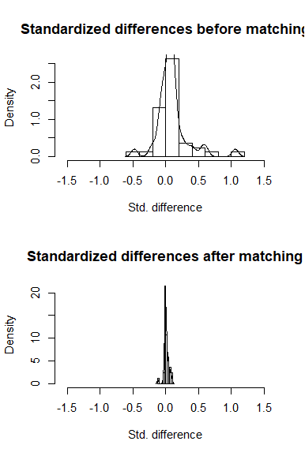

Table S5. Efficacy of ACR lever on 30-day mortality from any cause in septic patients with diabetes mullitus
Subgroup | Number of patients | High ACR group, N% | Low ACR group, N% | OR (95% CI) | P-value | Interaction  P-value
Age of patients |  |  |  |  |  | 0.051
≤ 65 years | 1041 | 106/285 (37.1%) | 111/756 (14.6%) | 2.477 (1.929, 3.181) | 0.000
> 65 years | 575 | 38/172 (22.0%) | 28/403 (6.9%) | 1.917 (1.424, 2.583) | 0.000
Gender |  |  |  |  |  | 0.524
Male | 924 | 86/264 (32.5%) | 71/660 (10.7%) | 2.334 (1.816, 3.000) | 0.000
Female | 692 | 58/193 (30.0%) | 68/499 (13.6%) | 1.862 (1.405, 2.467) | 0.000
Ventilation |  |  |  |  |  | 0.062
No | 860 | 44/241 (18.2%) | 59/619 (9.5%) | 2.120 (1.389, 3.236) | 0.000
Yes | 756 | 100/216 (40.2%) | 80/540 (14.8%) | 1.787 (1.228, 2.599) | 0.002
Septic shock |  |  |  |  |  | 0.054
No | 1375 | 94/340 (27.6%) | 114/1035 (11.0%) | 2.020 (1.621, 2.518) | 0.000
Yes | 241 | 50/117 (42.7%) | 25/124 (20.1%) | 2.955 (1.669, 5.234) | 0.000
Coronary artery disease |  |  |  |  |  | 0.276
No | 1083 | 101/321 (31.4%) | 101/762 (13.2%) | 3.005 (2.192, 4.118) | 0.000
Yes | 533 | 43/136 (31.6%) | 38/397 (9.5%) | 1.954 (1.579, 2.419) | 0.000
Congestive heart failure |  |  |  |  |  | 0.206
No | 1220 | 105/340 (30.8%) | 94/880 (10.6%) | 2.316 (1.862, 2.882) | 0.000
Yes | 396 | 39/117 (33.3%) | 45/279 (16.1%) | 1.632 (1.120, 2.377) | 0.011
Hypertension |  |  |  |  |  | 0.609
No | 1184 | 91/295 (30.8%) | 107/889 (12%) | 2.072 (1.672, 2.567) | 0.000
Yes | 432 | 53/162 (32.7%) | 32/270 (11.8%) | 2.208 (1.505, 3.240) | 0.000
COPD |  |  |  |  |  | 0.669
No | 1272 | 112/370 (30.2%) | 105/902 (11.6%) | 2.033 (1.655, 2.497) | 0.000
Yes | 344 | 32/87 (36.7%) | 34/257 (13.2%) | 2.851 (1.756, 4.630) | 0.000
Renal failure |  |  |  |  |  | 0.668
No | 1139 | 87/283 (30.7%) | 105/856 (12.2%) | 2.043 (1.645, 2.536) | 0.000
Yes | 477 | 57/174 (32.7%) | 34/303 (11.2%) | 2.310 (1.594, 3.347) | 0.000
Liver disease |  |  |  |  |  | 0.532
No | 1437 | 117/401 (29.1%) | 125/1036 (12.0%) | 1.882 (1.532, 2.311) | 0.000
Yes | 179 | 27/56 (48.2%) | 14/123 (14.3%) | 3.722 (2.192, 6.321) | 0.000
Solid tumor |  |  |  |  |  | 0.775
No | 1540 | 138/435 (31.7%) | 133/1105 (12.0%) | 2.088 (1.727, 2.524) | 0.000
Yes | 76 | 6/22 (27.2%) | 6/54 (11.1%) | 3.050 (1.059, 8.783) | 0.039
Rheumatoid arthritis |  |  |  |  |  | 0.052
No | 1562 | 136/443 (30.6%) | 132/1119 (11.7%) | 2.107 (1.743, 2.547) | 0.000
Yes | 54 | 8/14 (57.1%) | 7/40 (17.5%) | 3.336 (1.003, 11.093) | 0.049
Abbreviations: ACR, anion gap-to-calcium ratio; High ACR group, ACR ≥ 2.25; Low ACR group, ACR < 2.25; OR, odds ratio; CI, confidence interval; Ventilation, the patient needs assisted ventilation on the first day; COPD, chronic obstructive pulmonary disease.

