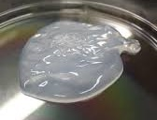
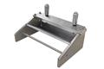

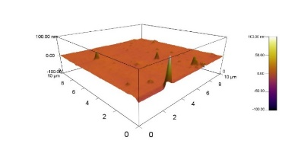
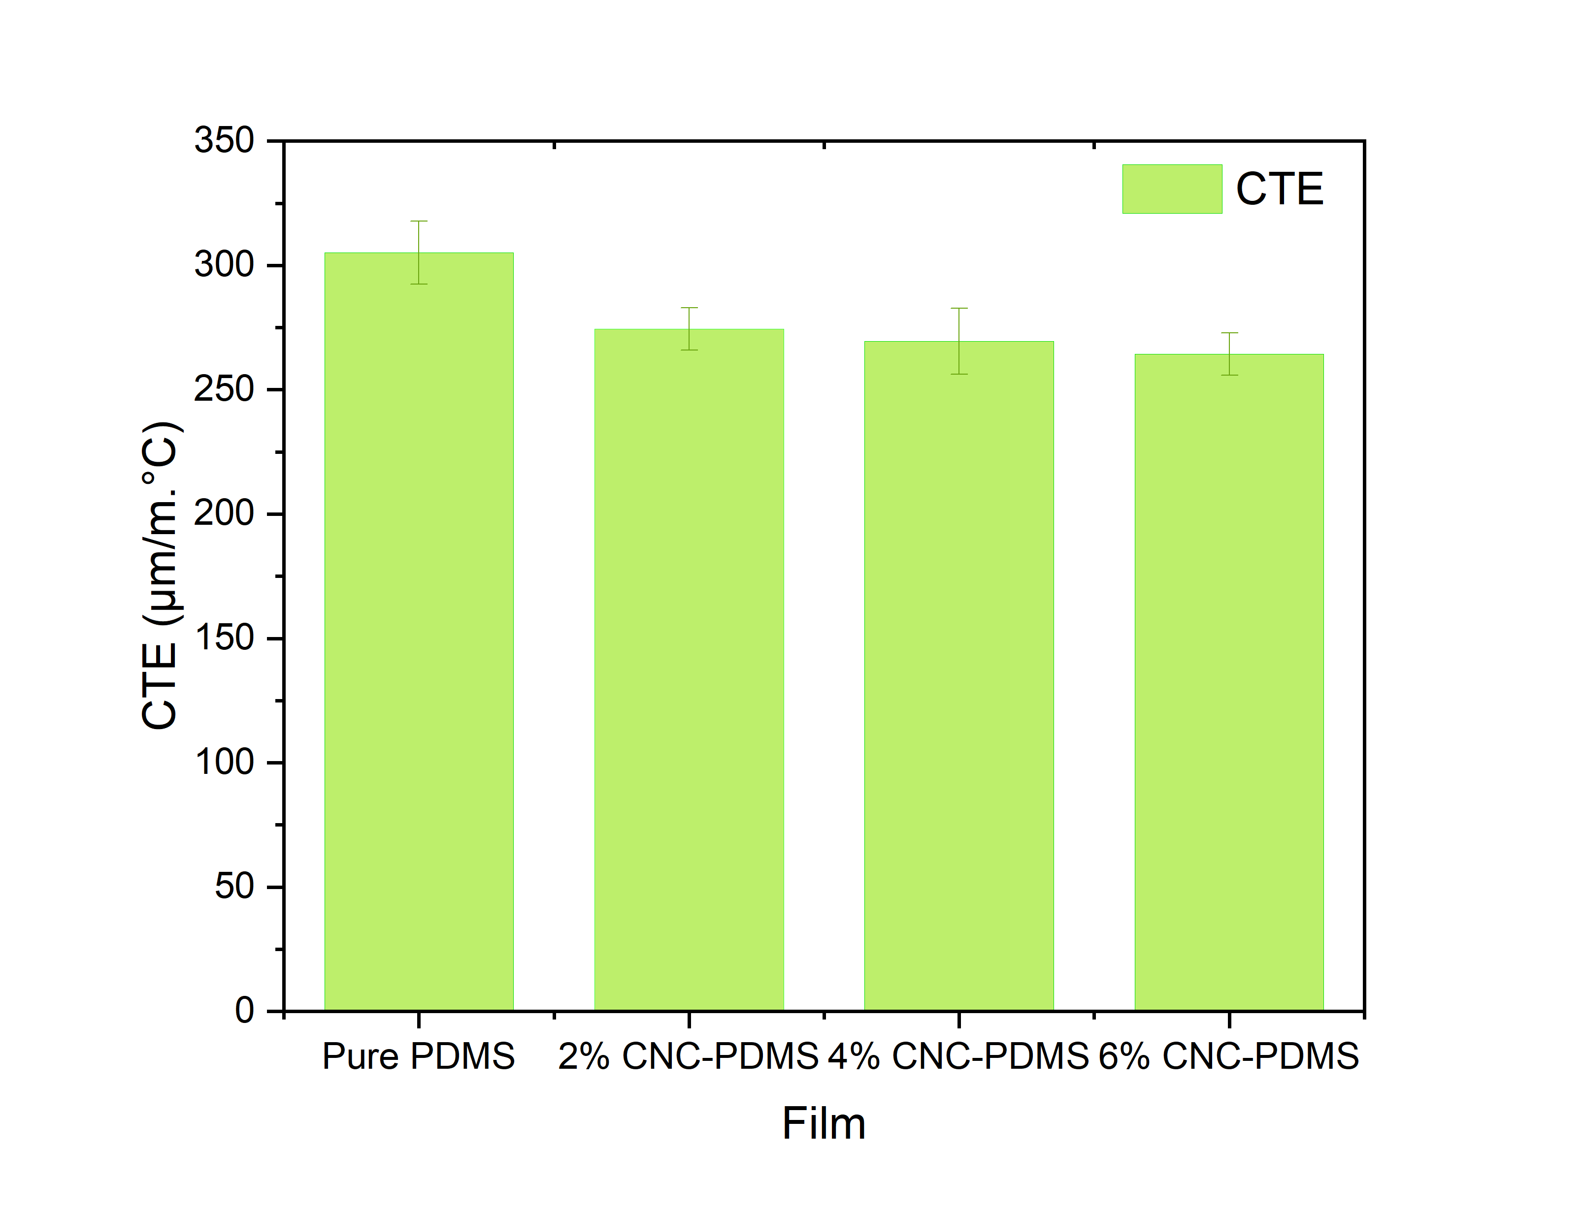
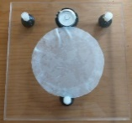
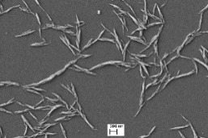
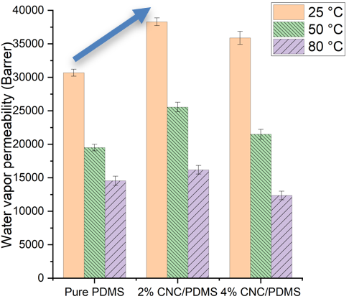
Graphical abstract: CNC as a sustainable material was added to PDMS and CNC/PDMS membrane was synthesized for air/water vapor separation at elevated temperatures and for increasing the water vapor permeability and reducing the coefficient of thermal expansion.
CNC suspension
PDMS
CNC/PDMS
CNC/PDMS hybrid membrane

