Appendix 1. Z-scores of latent profiles

Appendix 2. Raincloud plots of latent profiles
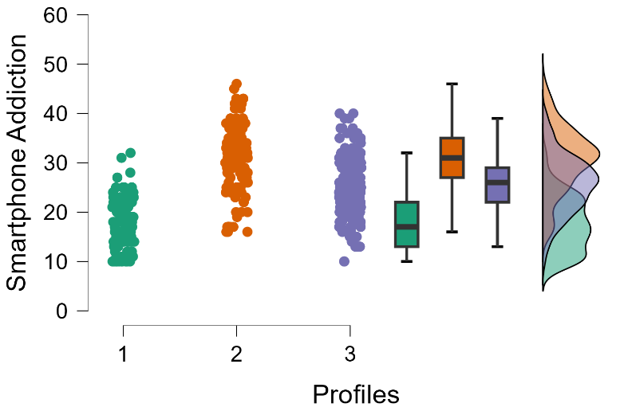
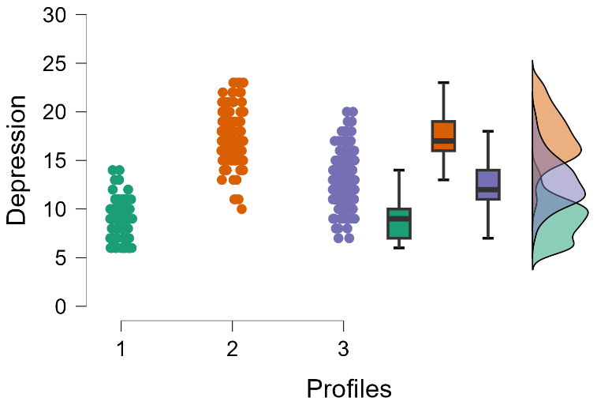
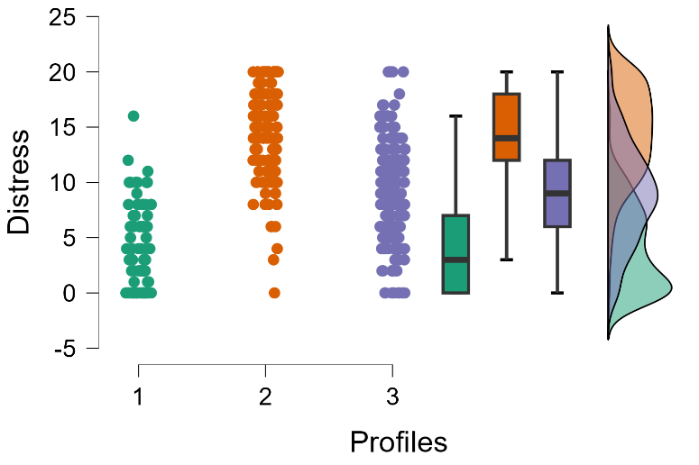
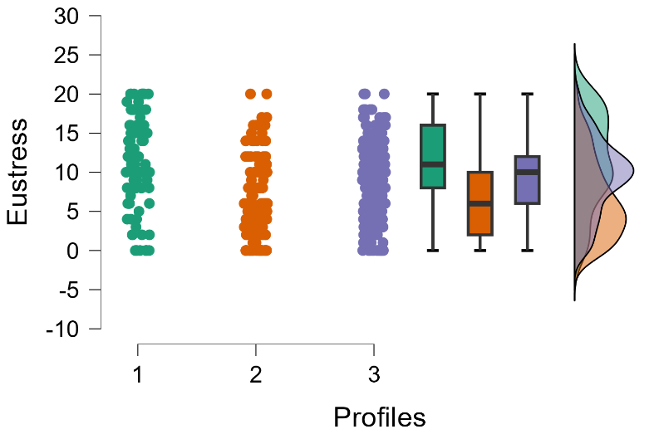
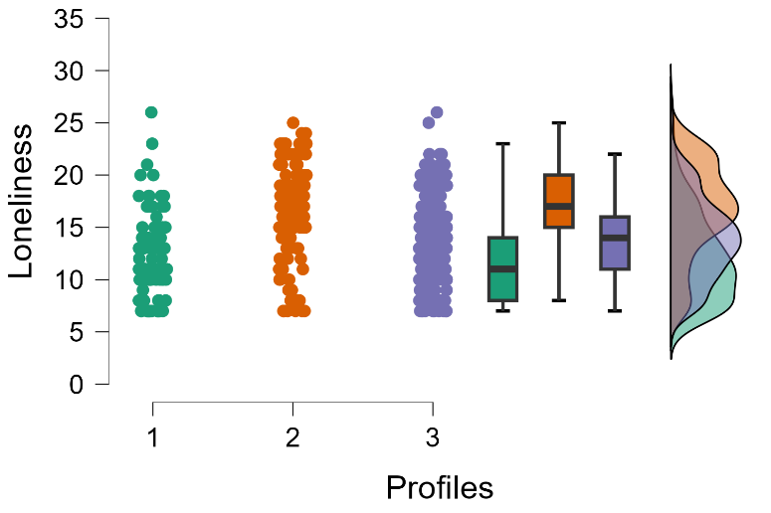
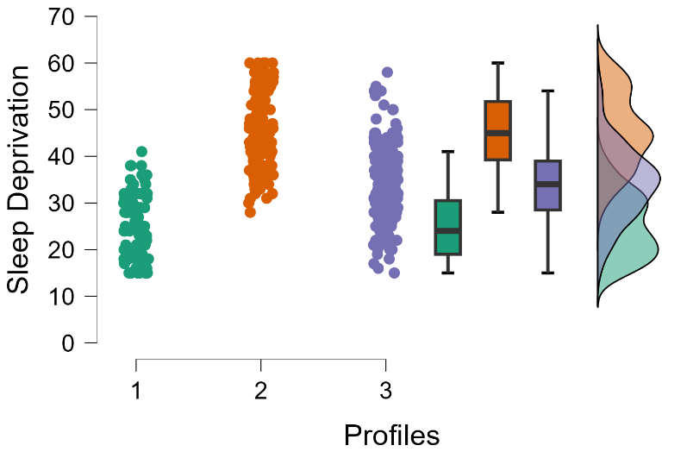

Appendix 3. Weights matrix of general profile
Variable | Smartphone Addiction | Depression | Distress | Eustress | Loneliness | Sleep Deprivation
Smartphone Addiction | .00
Depression | .07 | .00
Distress | .12 | .41 | .00
Eustress | .00 | -.17 | .00 | .00
Loneliness | .10 | .12 | .12 | .00 | .00
Sleep Deprivation | .35 | .26 | .08 | -.14 | .00 | .00

Appendix 4. Edge weight matrix of the variables network among latent profiles
 | 1 |  |  |  |  |  | 2 |  |  |  |  |  | 3
 | S_A | D | Distress | Eustress | L | S_D | S_A | D | Distress | Eustress | L | S_D | S_A | D | Distress | Eustress | L | S_D
S_A | 0.000 | -0.080 | -0.164 | 0.017 | 0.014 | 0.131 | 0.000 | -0.205 | -0.001 | 0.105 | 0.095 | 0.109 | 0.000 | -0.245 | -0.087 | 0.020 | -0.049 | 0.194
D | -0.080 | 0.000 | 0.250 | -0.005 | 0.152 | -0.008 | -0.205 | 0.000 | 0.167 | -0.193 | -0.108 | -0.060 | -0.245 | 0.000 | 0.085 | -0.093 | -0.009 | -0.152
Distress | -0.164 | 0.250 | 0.000 | 0.112 | 0.065 | -0.085 | -0.001 | 0.167 | 0.000 | 0.008 | -0.029 | -0.040 | -0.087 | 0.085 | 0.000 | 0.229 | 0.092 | -0.184
Eustress | 0.017 | -0.005 | 0.112 | 0.000 | 0.013 | -0.196 | 0.105 | -0.193 | 0.008 | 0.000 | 0.050 | -0.113 | 0.020 | -0.093 | 0.229 | 0.000 | 0.011 | -0.048
L | 0.014 | 0.152 | 0.065 | 0.013 | 0.000 | -0.188 | 0.095 | -0.108 | -0.029 | 0.050 | 0.000 | 0.046 | -0.049 | -0.009 | 0.092 | 0.011 | 0.000 | -0.176
S_D | 0.131 | -0.008 | -0.085 | -0.196 | -0.188 | 0.000 | 0.109 | -0.060 | -0.040 | -0.113 | 0.046 | 0.000 | 0.194 | -0.152 | -0.184 | -0.048 | -0.176 | 0.000
Note 1. 1 = Profile 1, 2 = Profile 2, 3 = Profile 3
Note 2. S_A = Smartphone Addiction, D = Depression, L = Loneliness, S_D = Sleep Deprivation

Appendix 5 Edge weight matrix of the variables network among general profile
Variable | Network
Variable | 1 | 2 | 3 | 4 | 5 | 6
1 Smartphone Addiction | 0.000 | 0.375 | 0.358 | -0.168 | 0.239 | 0.505
2 Depression | 0.375 | 0.000 | 0.583 | -0.328 | 0.295 | 0.501
3 Distress | 0.358 | 0.583 | 0.000 | -0.126 | 0.289 | 0.392
4 Eustress | -0.168 | -0.328 | -0.126 | 0.000 | -0.111 | -0.302
5 Loneliness | 0.239 | 0.295 | 0.289 | -0.111 | 0.000 | 0.200
6 Sleep Deprivation | 0.505 | 0.501 | 0.392 | -0.302 | 0.200 | 0.000

Appendix 6. Centrality measures per variable
Variable | 1 |  |  | 2 |  |  |  | 3
Variable | Betweenness | Closeness | Strength |  | Betweenness | Closeness | Strength | Betweenness | Closeness | Strength
Smartphone Addiction | -0.998 | -1.021 | -0.685 |  | -0.170 | 0.758 | 0.421 | -0.791 | -0.084 | 0.228
Depression | -0.143 | -0.012 | 0.016 |  | 1.865 | 1.437 | 1.684 | 0.000 | -0.075 | 0.170
Distress | 0.713 | 1.210 | 1.441 |  | -0.678 | -0.621 | -1.152 | 0.791 | 0.184 | 0.743
Eustress | -0.998 | -1.143 | -1.188 |  | 0.339 | 0.347 | 0.151 | -0.791 | -0.914 | -0.978
Loneliness | -0.143 | -0.118 | -0.484 |  | -0.678 | -0.907 | -0.670 | -0.791 | -0.920 | -1.384
Sleep Deprivation | 1.568 | 1.083 | 0.899 |  | -0.678 | -1.014 | -0.434 | 1.581 | 1.809 | 1.222

Appendix 7. Centrality plot of latent profiles
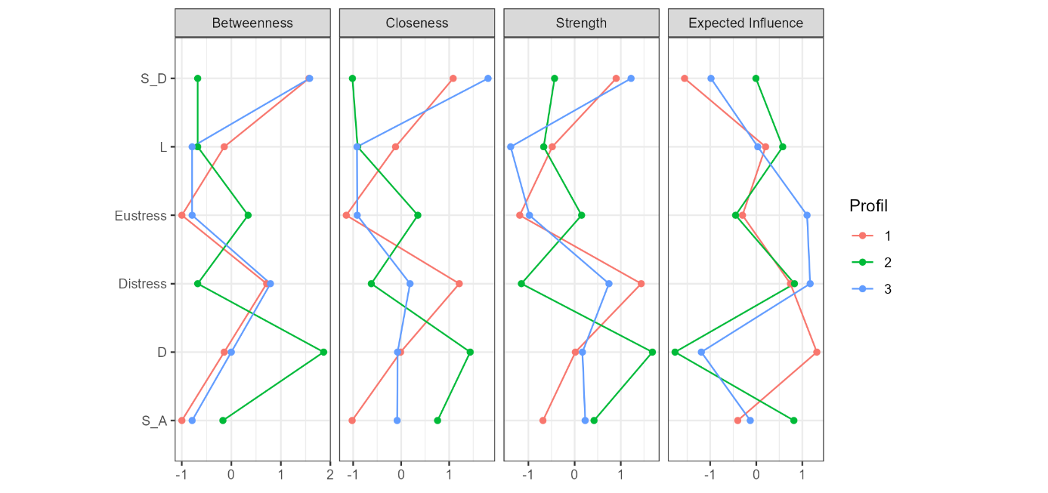
Note 1. S_D = Sleep Deprivation, L = Loneliness, D = Depression, S_A = Smartphone Addiction
Note 2. Red line = non-addicted , green line = addicted , blue line = risky

Appendix 8. Centrality measures per variable of general profile
 | Network
Variable | Betweenness | Closeness | Strength
Smartphone Addiction | -0.598 | -0.041 | 0.131
Depression | 1.793 | 1.355 | 1.169
Distress | -0.598 | 0.420 | 0.372
Eustress | -0.598 | -1.181 | -1.322
Loneliness | -0.598 | -1.125 | -1.088
Sleep Deprivation | 0.598 | 0.572 | 0.738

Appendix 9. Centrality plot of general profile
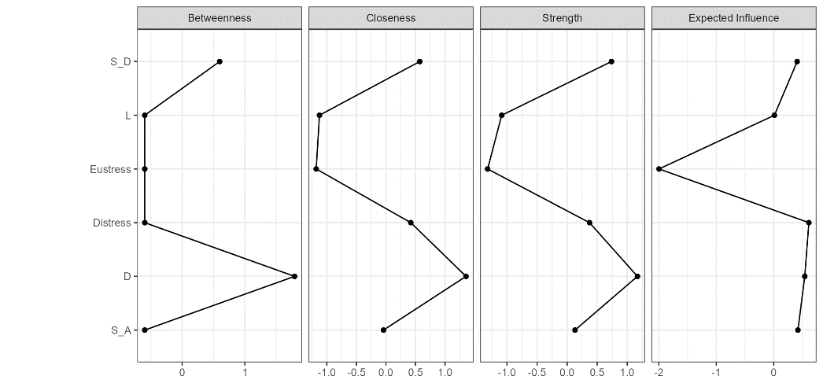
Note 1. S_D = Sleep Deprivation, L = Loneliness, D = Depression, S_A = Smartphone Addiction

Appendix 10. Centrality stability of profiles
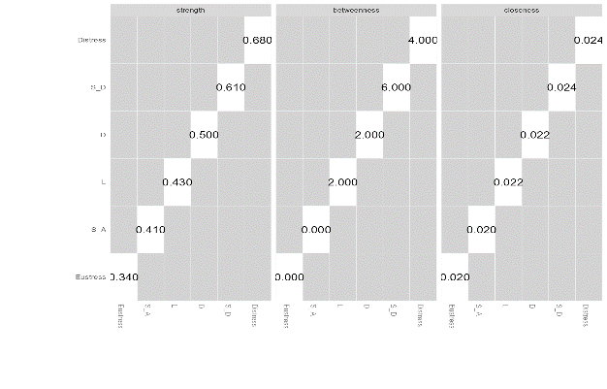
Profile 1
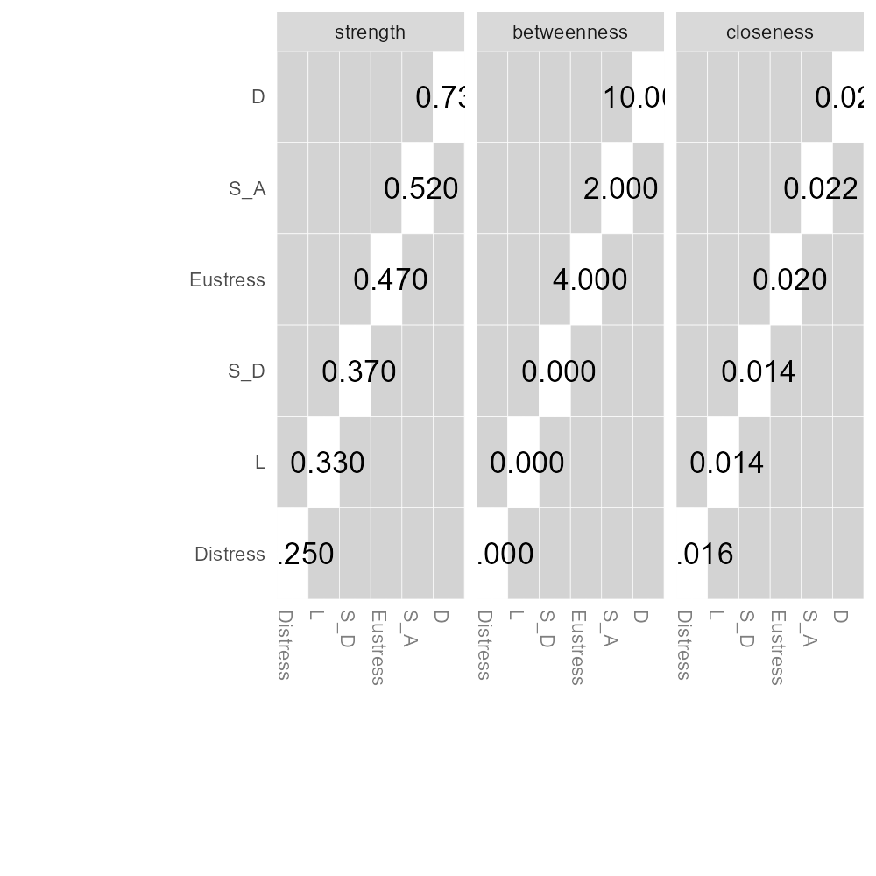
Profile 2
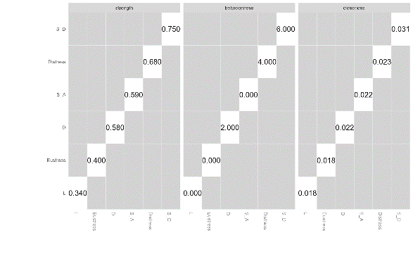
Profile 3
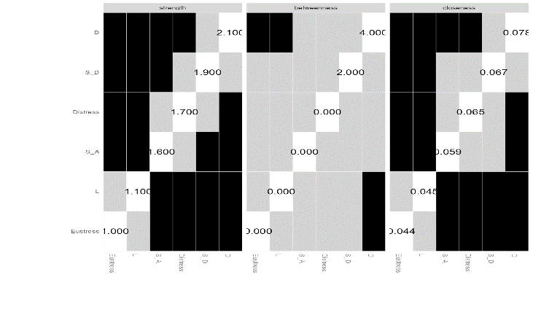

General Profile

