Supplementary Information of
Transforming de novo peptide sequencing by explainable AI
Zhendong Liang^{1,3}, Tianze Ling^{4,2}, Tingpeng Yang^{1,3}, Linhai Xie², Yonghong He^{1,3}, Cheng Chang^{2*}, Yu Wang^{1*}

1 Peng Cheng Laboratory, Shenzhen, 518055, China.
2 State Key Laboratory of Medical Proteomics, Beijing Proteome Research Center, National Center for Protein Sciences (Beijing), Beijing Institute of Lifeomics, Beijing, 102206, China
3 Tsinghua Shenzhen International Graduate School, Shenzhen, 518055, China.
4 School of Life Sciences, Tsinghua University, Beijing, 100084, China.

* To whom correspondence should be addressed:
Cheng Chang, Email: changcheng@ncpsb.org.cn
Yu Wang, Email: wangy20@pcl.ac.cn

TOC
Supplementary Figures 2
Supplementary Tables 15

Supplementary Figures
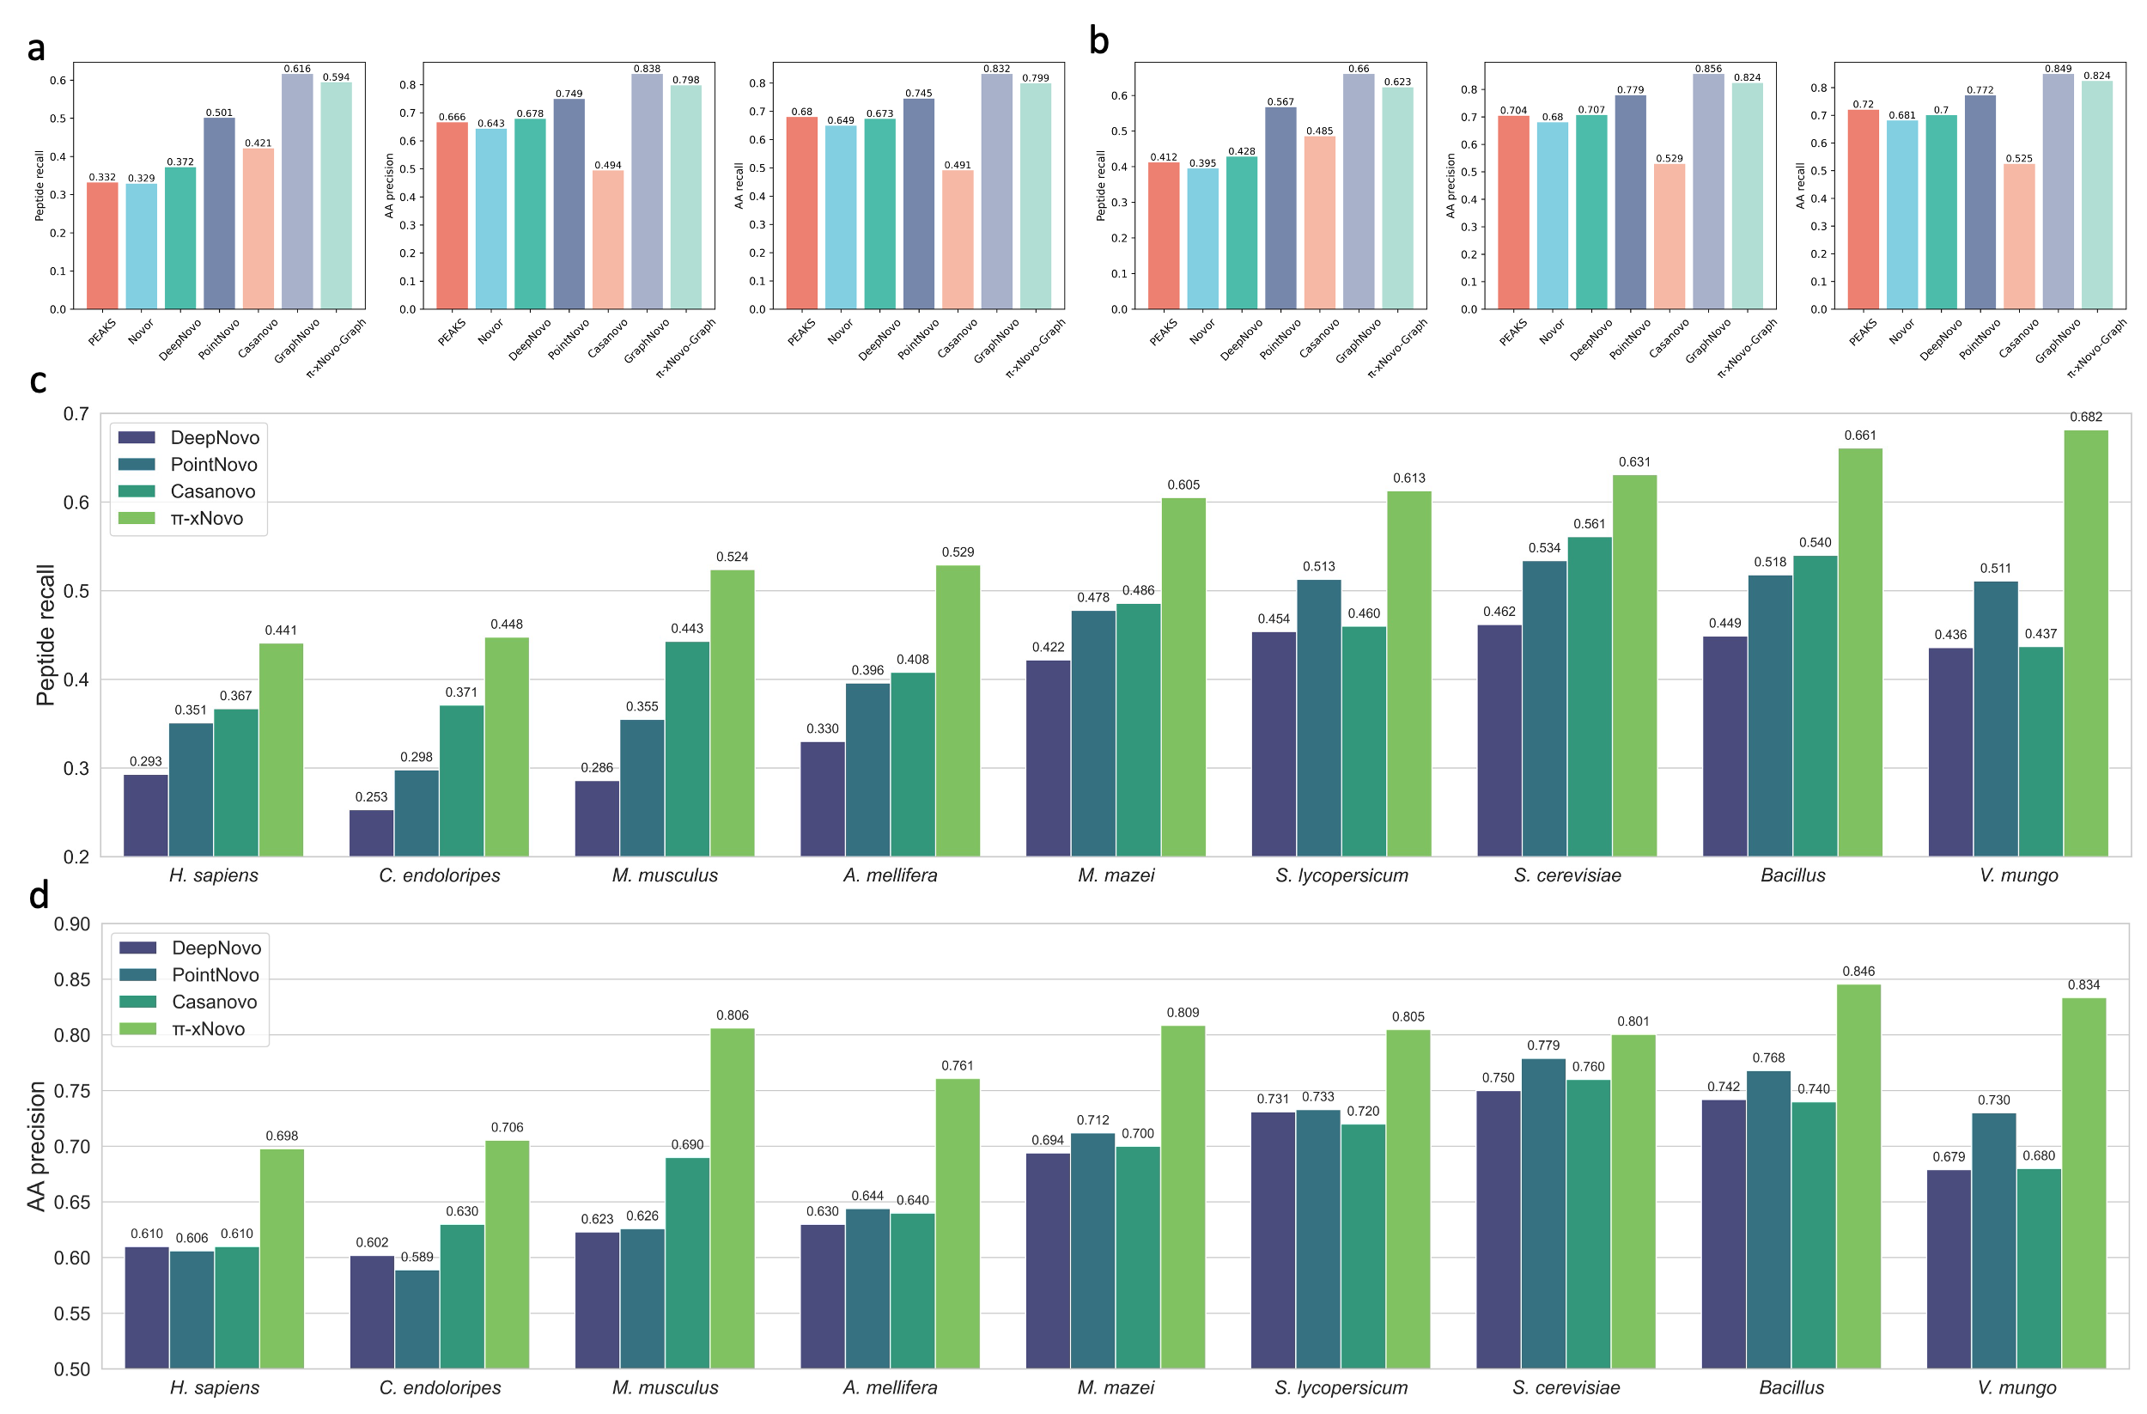
Figure S1: Performance comparison of $π$-xNovo with other de novo peptide sequencing models. a-b, Results in A. thaliana and C. elegans. c-d, Results in the nine-species dataset.
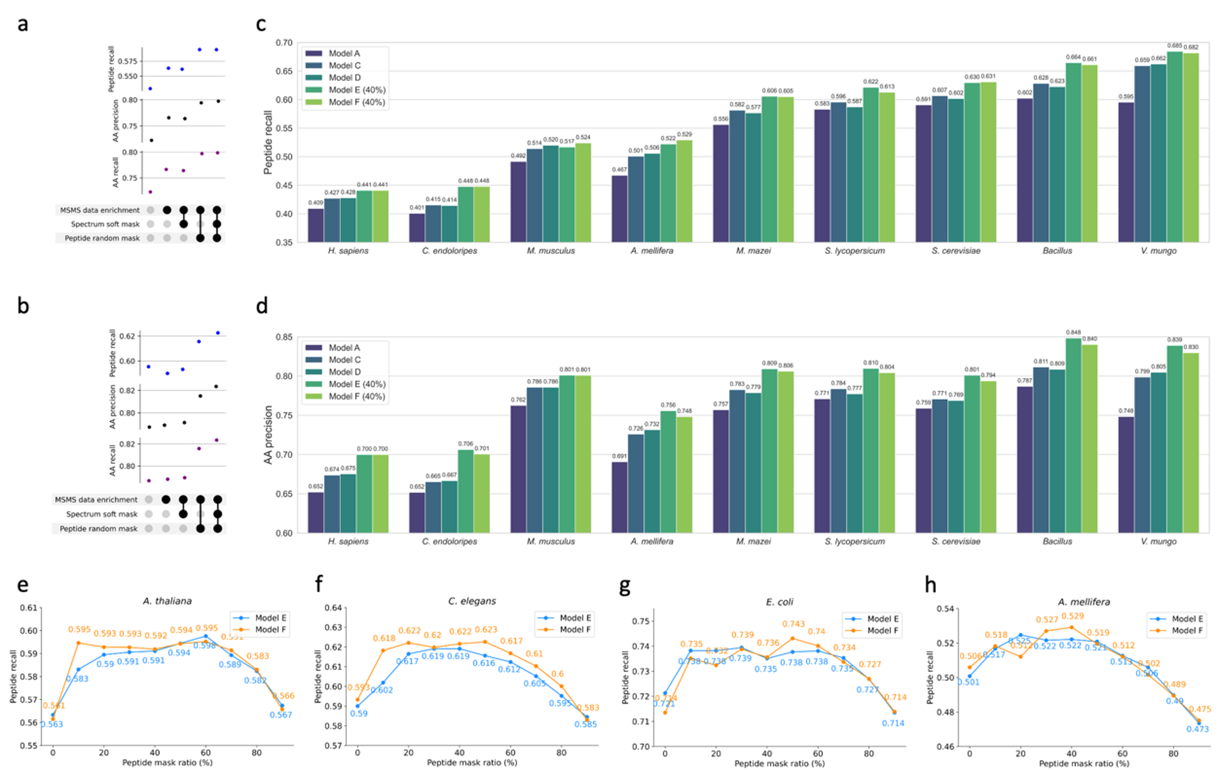
Figure S2: Ablation studies of training strategies on model performance. a-b, Results in A. thaliana and C. elegans. c-d, Results in the nine-species dataset. e-h, Effect of optimal masking rate for peptide random mask on model performance.
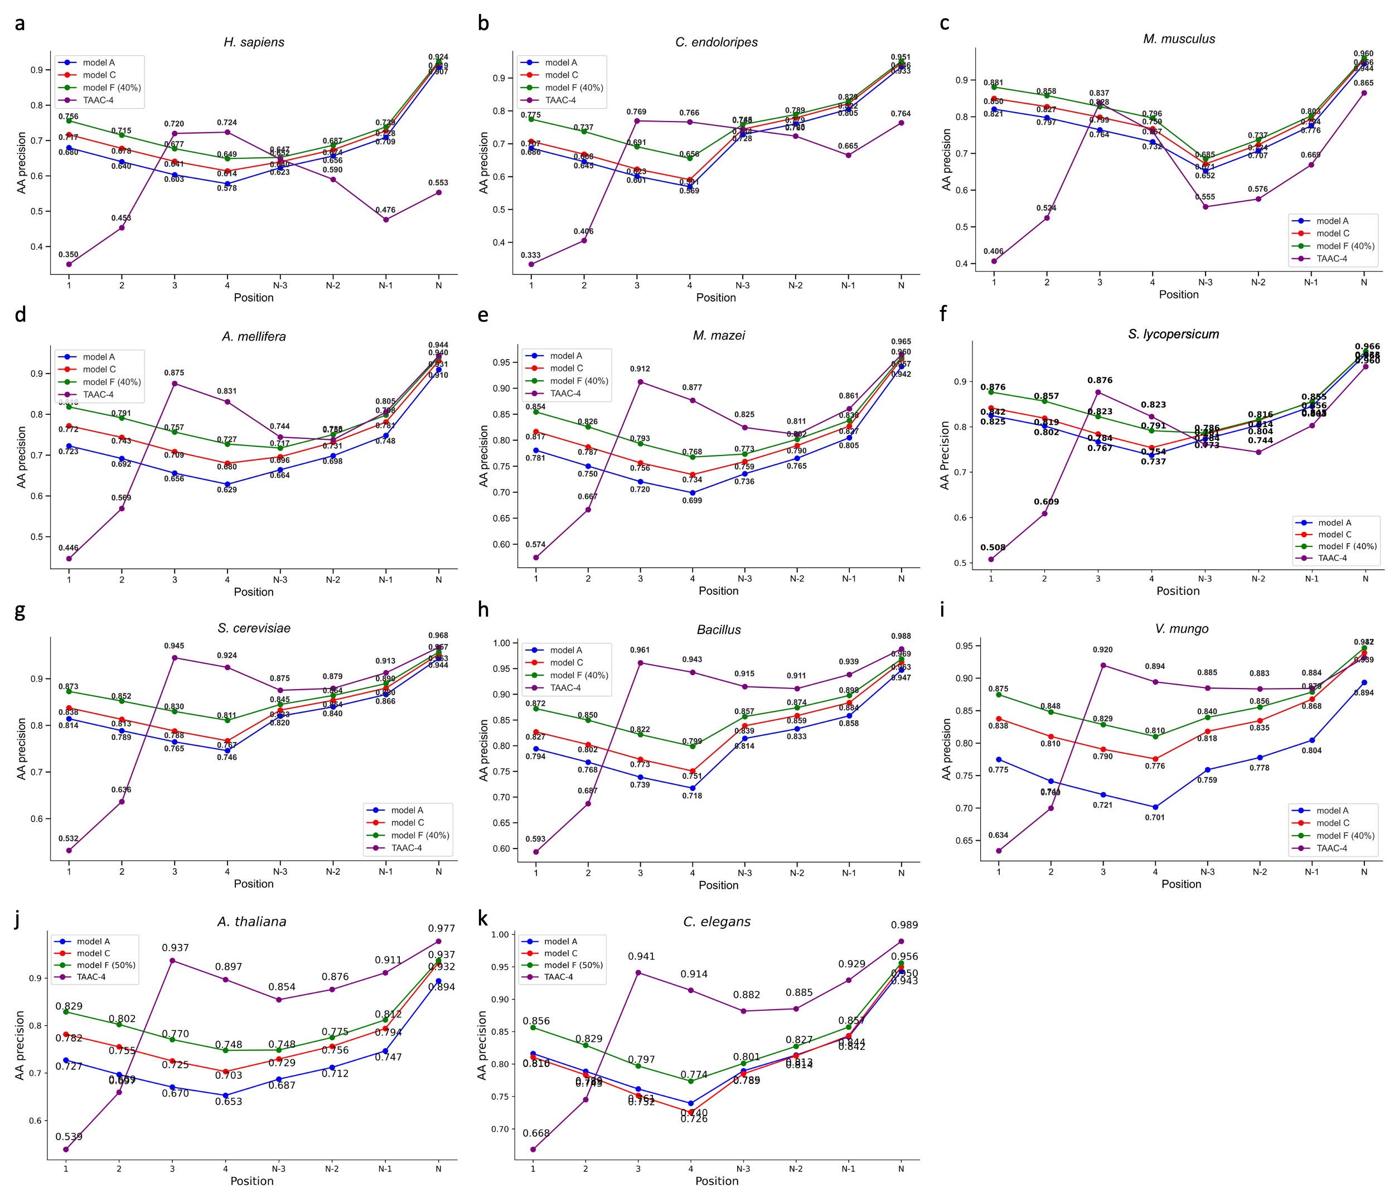
Figure S3: Accuracy of N/C-terminal amino acid predictions among different model settings in a-i, the nine-species dataset, and j-k, A. thaliana and C. elegans. TAAC-4, representing the amino acid coverage in the spectra. Model settings are detailed in Supplementary Table 1.
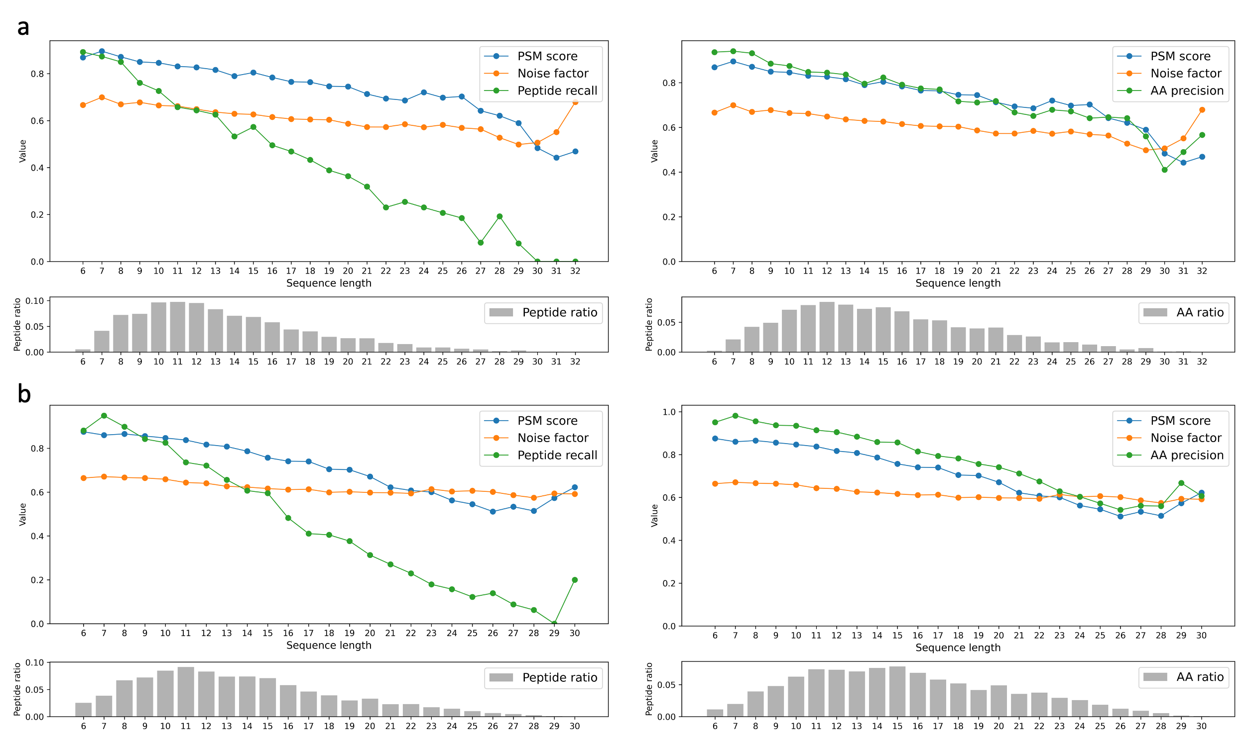
Figure S4: Effect of peptide length on $π$-xNovo-Graph performance and PSM score in (a) A. thaliana and (b) C. elegans.
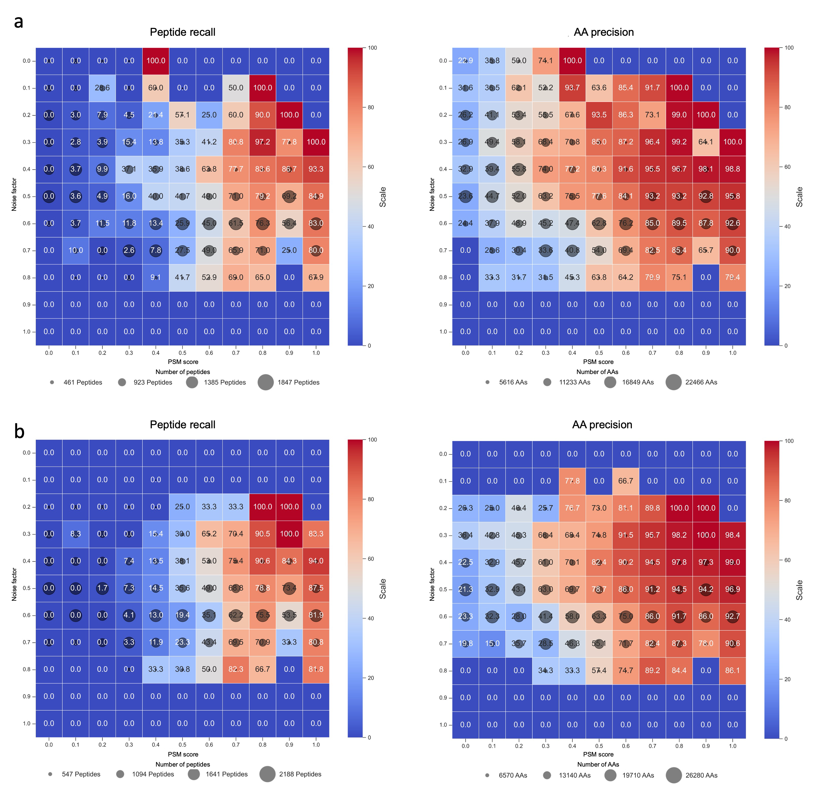
Figure S5: Analysis of $π$-xNovo-Graph performance with varying PSM scores and noise factors in (a) A. thaliana and (b) C. elegans.
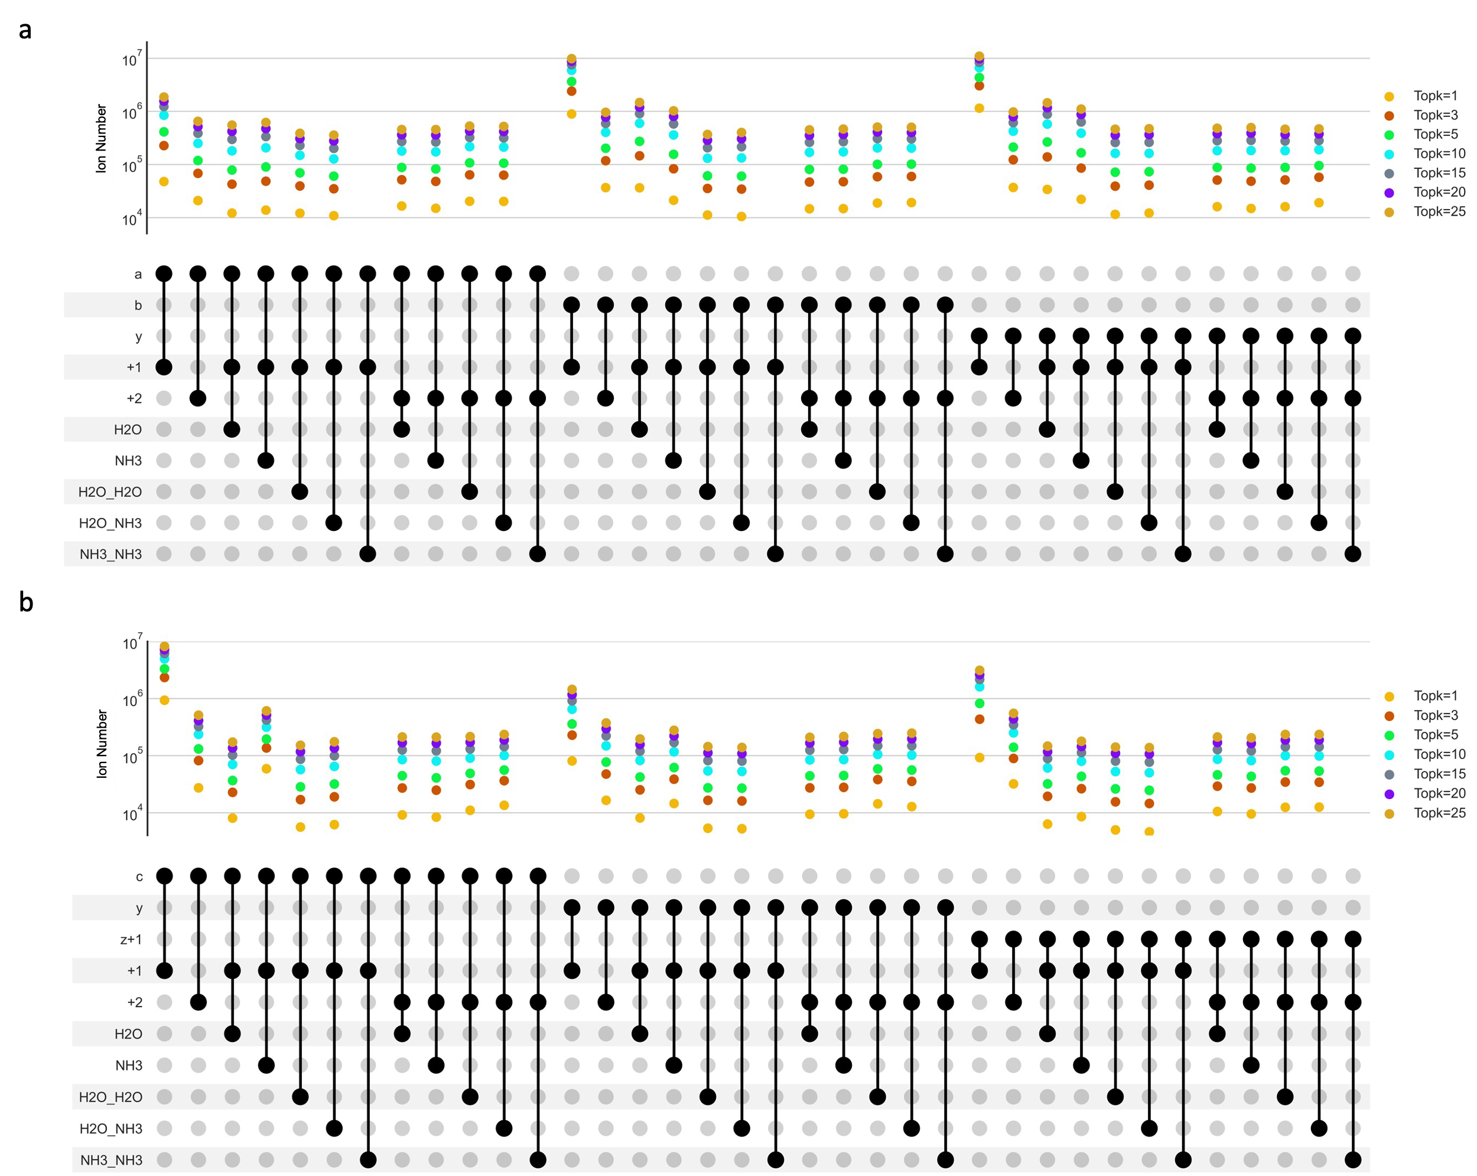
Figure S6: Statistical analysis of amino acid-related peak types and Top-k distribution for spectra generated by (a) HCD and (b) ETD in the DHP dataset.
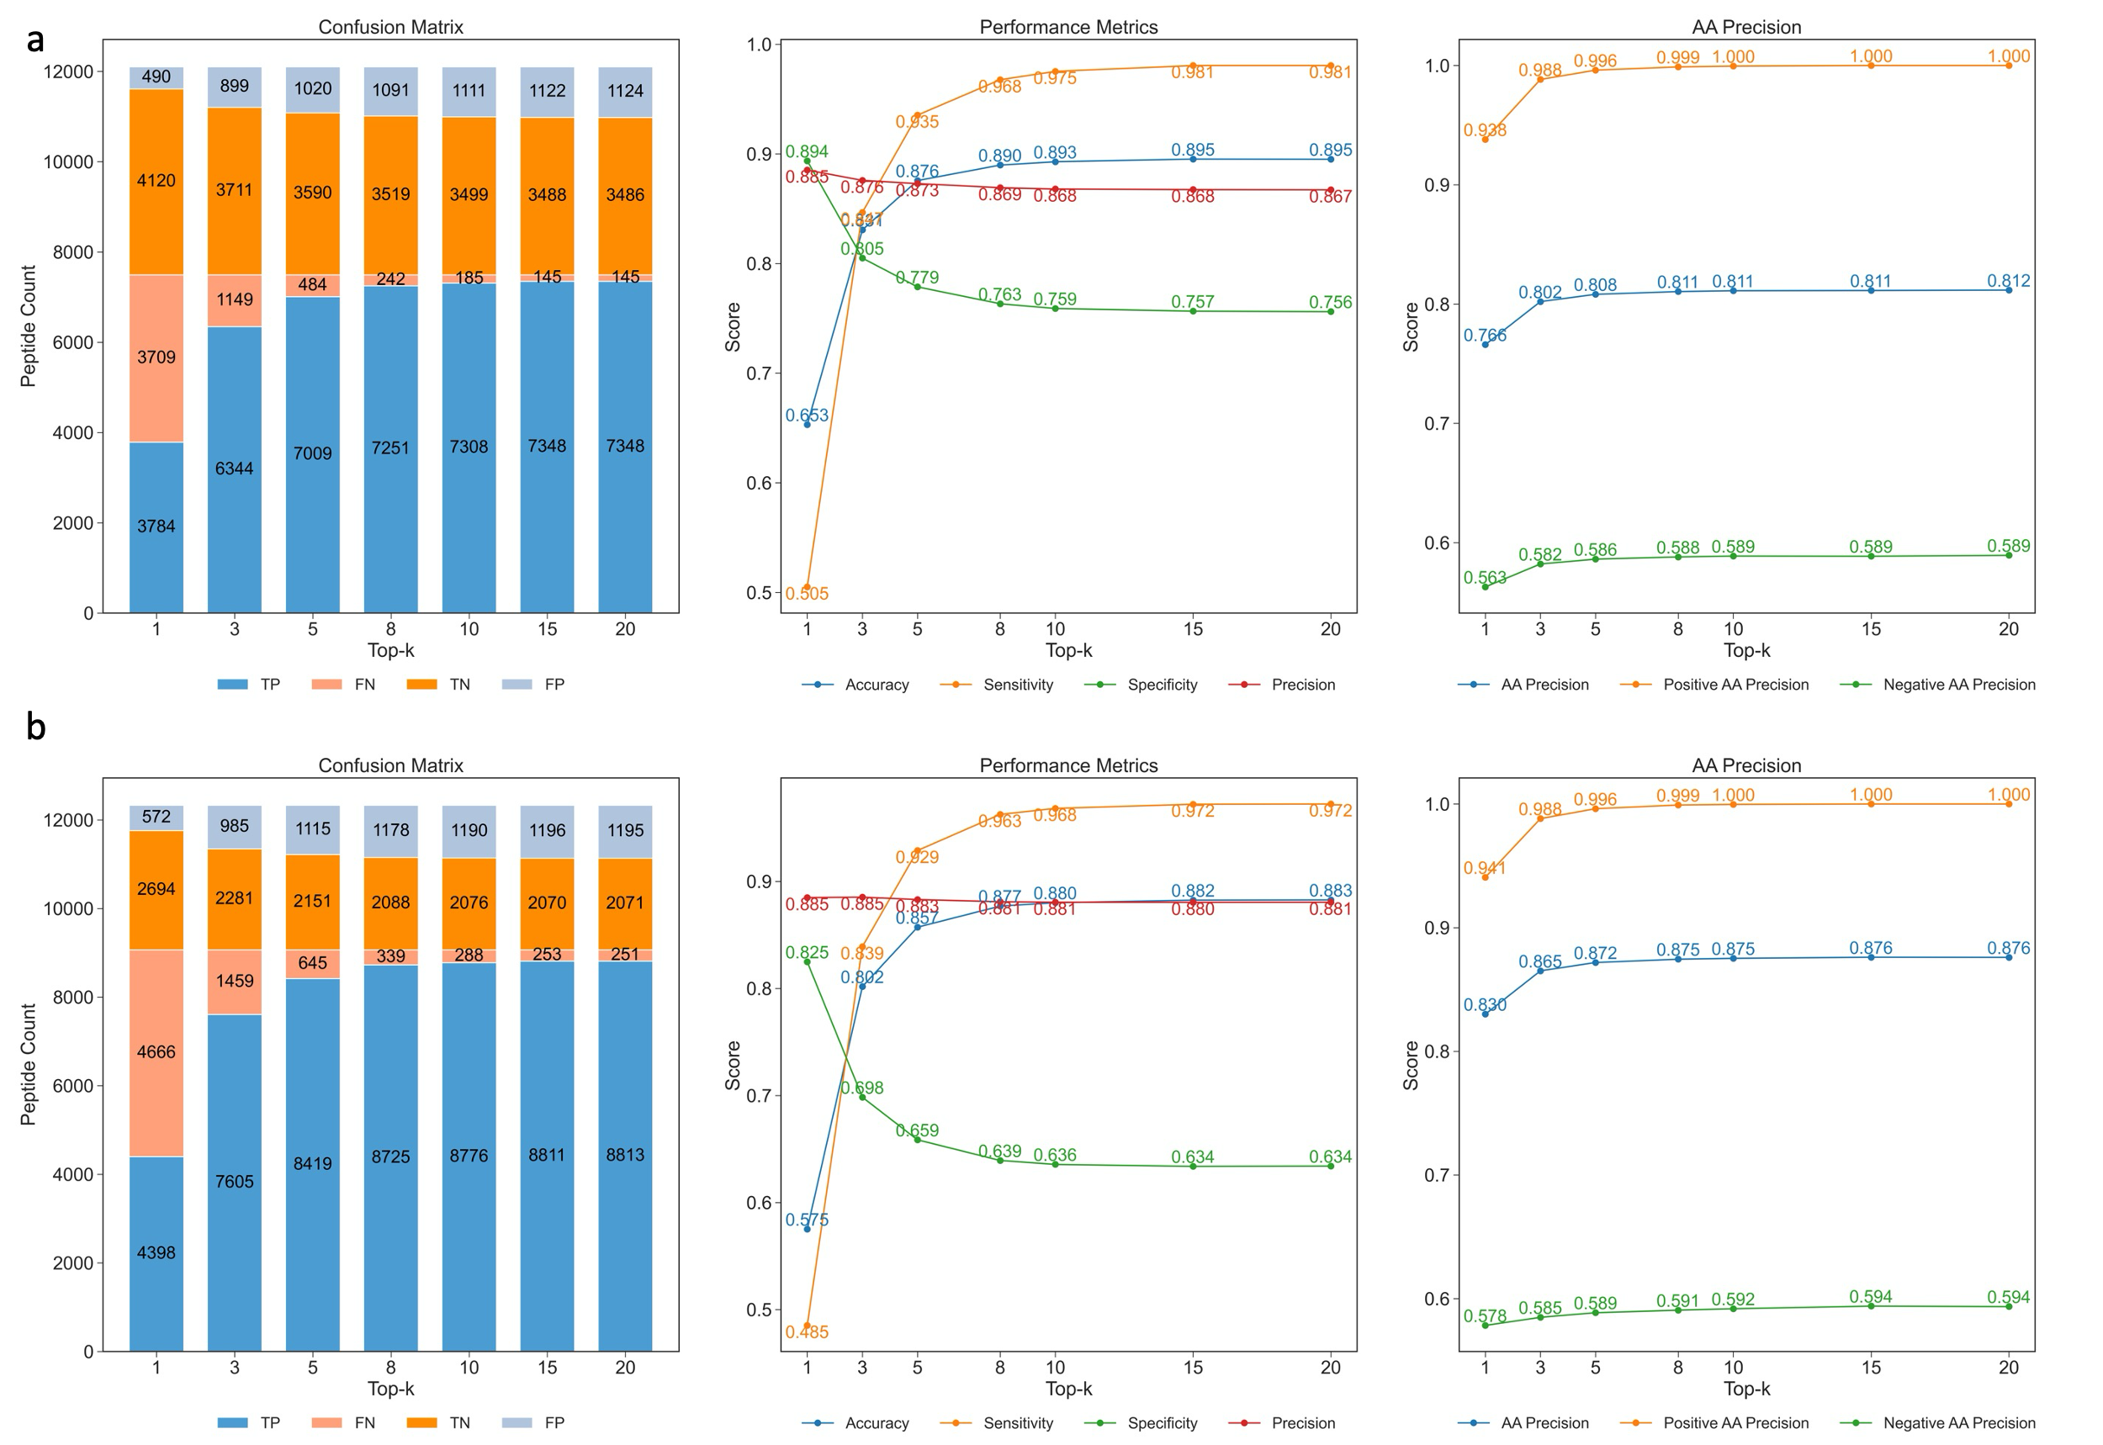
Figure S7: Effect of the number of Top-k peaks on $π$-xNovo-Graph-QC performance in (a) C. elegans and (b) E. coli.
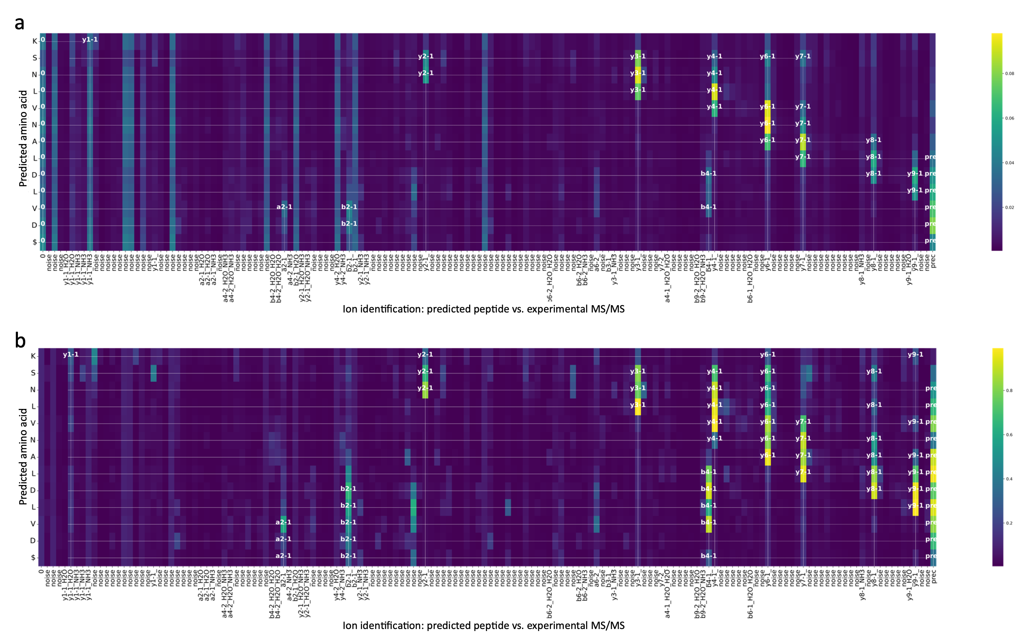
Figure S8: Schematic of interpretable matrices generated by applying (a) average value and (b) maximum value aggregation methods to the cross-correlation matrix.
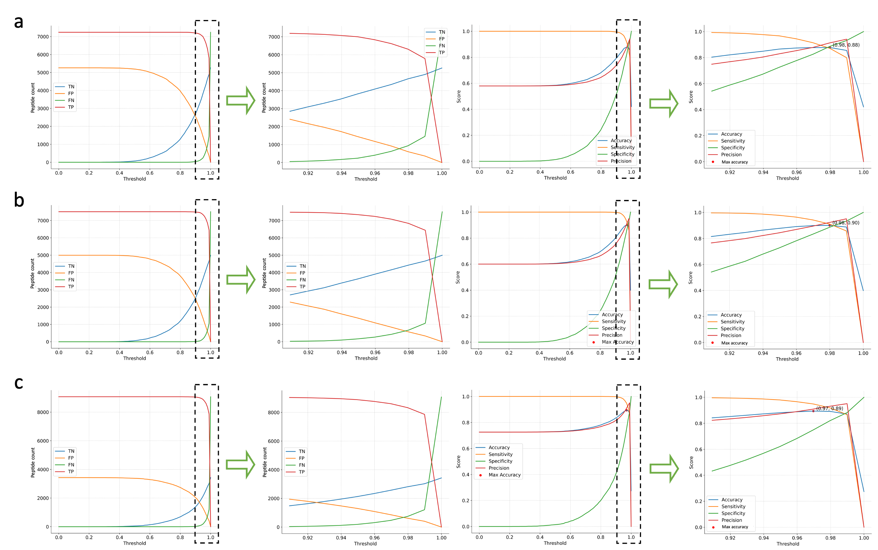
Figure S9: Effect of thresholds on the robustness of the amino acid probability-based π-xNovo-Graph-prob in (a) A. thaliana, (b) C. elegans, (c) E. coli. The implementation of π-xNovo-Graph-prob is detailed in the Methods section.
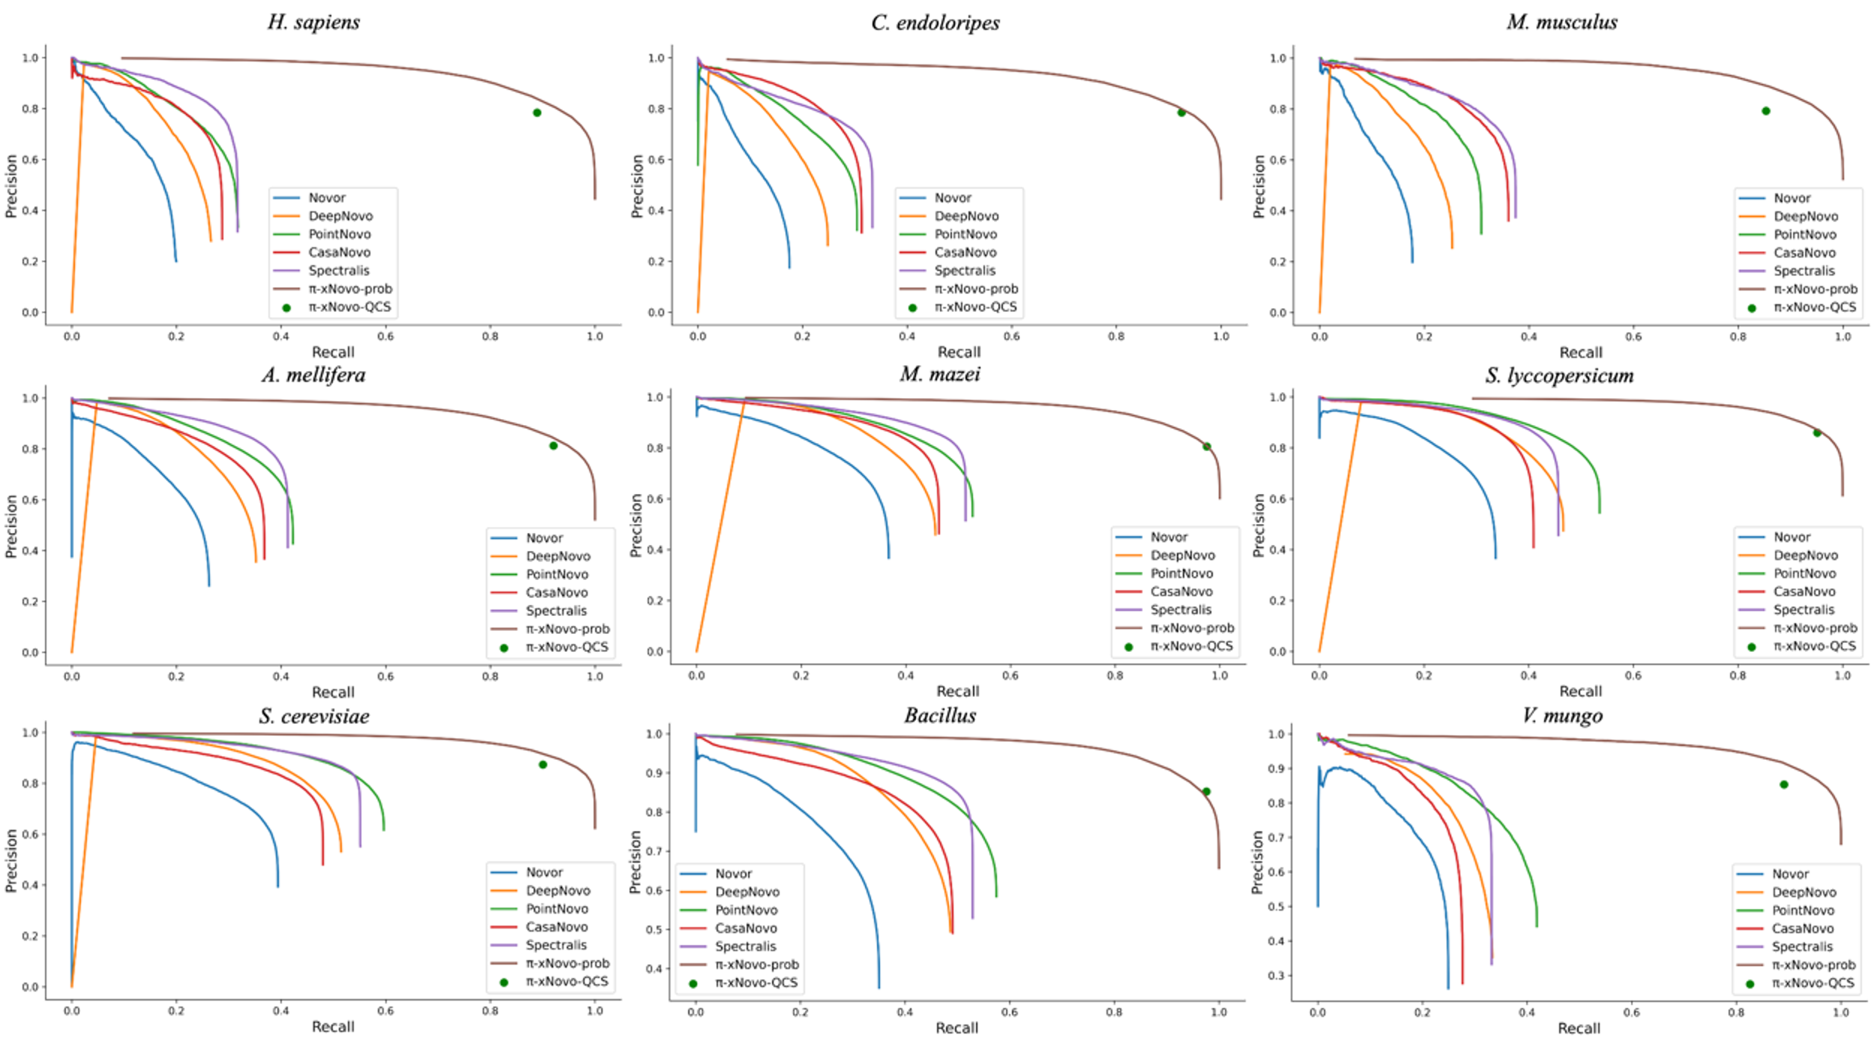
Figure S10: A comparative analysis of the classification performance between the feature-based quality control systems (π-xNovo-prob and π-xNovo-QC) and Levenshtein distance estimators on the nine-species dataset. π-xNovo-prob and π-xNovo-QC represents system derived from π-xNovo trained in the nine-species dataset. The methodologies of Novor, DeepNovo, PointNovo, Casanovo, and Spectralis are all grounded in Levenshtein distance estimators.

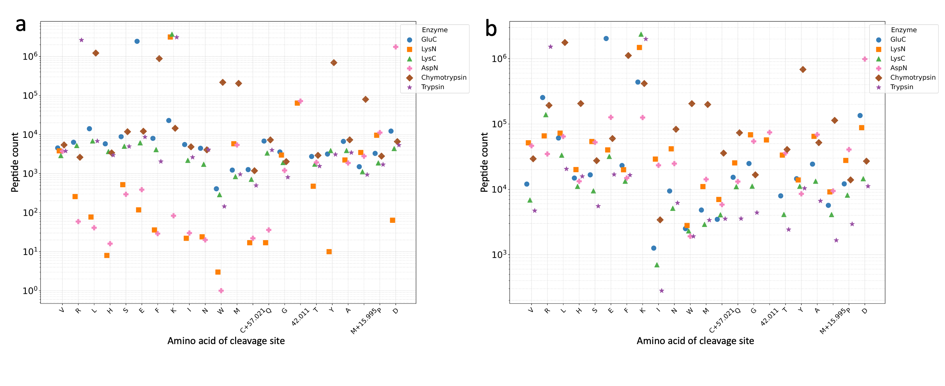
Figure S11: Analysis of peptide fragmentation site distribution in the DHP dataset. a, Distribution of fragmentation sites of proteases for peptides identified by database search. b, Distribution of fragmentation sites of proteases for de novo sequencing peptides screened by $π$-xNovo-QC. The fragmentation sites for the proteases AspN and LysN are at the first amino acid of the N-terminal, while the fragmentation sites for other proteases are at the first amino acid of the C-terminal.

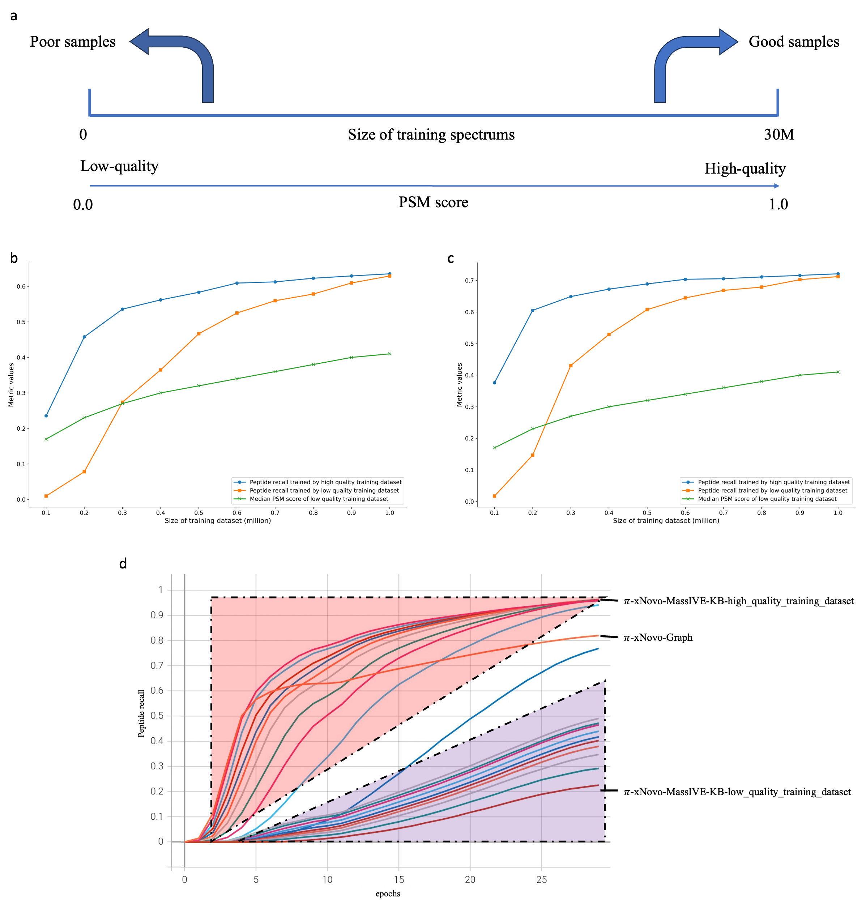
Figure S12: Effect of training set quality and size on model performance ($π$-xNovo-MassIVE-KB). a, Sampling method for high/low-quality spectra. The PSM scores of high-quality spectra are consistently at 1.0. b-c, Effect of training set quality and size on model performance in (b) C. elegans and (c) E. coli. d, Peptide recall of $π$-xNovo-MassIVE-KB on the training set.
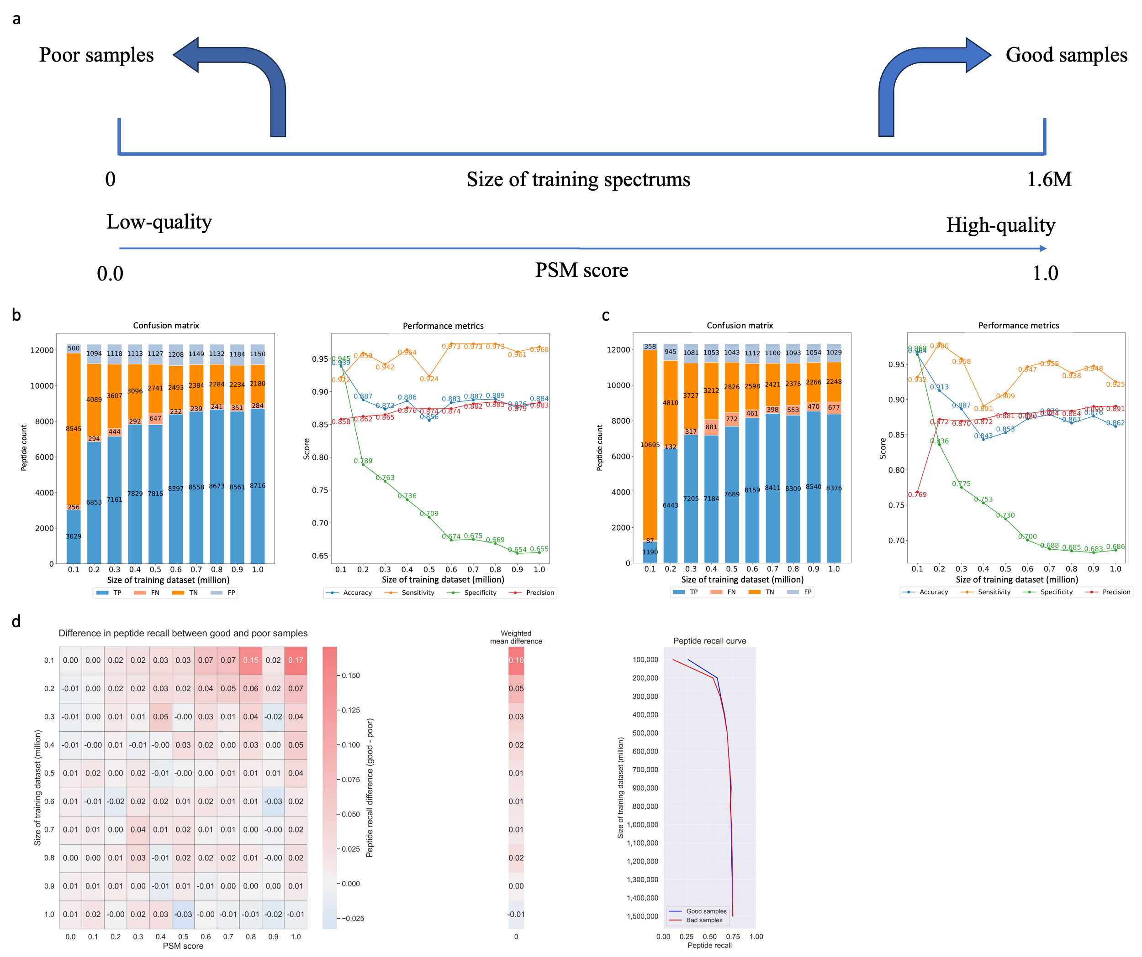
Figure S13: Effect of training set quality and size on model performance ($π$-xNovo-Graph). a, Sampling method for high/low-quality spectra. b, Effect of high-quality training set on $π$-xNovo-Graph-QC metrics in E. coli. c, Effect of low-quality training set on $π$-xNovo-Graph-QC metrics in E. coli. d, Variation in peptide recall differences at different PSM scores with changes in the training set quality in E. coli.

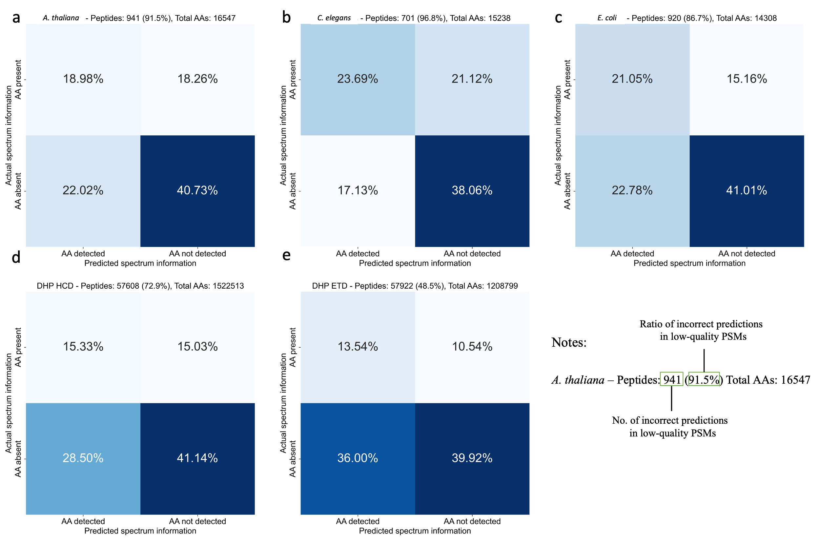
Figure S14: Amino acid prediction results in erroneous samples of low-quality spectra from test sets. a-c, Results by $π$-xNovo-MassIVE-KB-30M-3epochs in (a) A. thaliana, (b) C. elegans, and (c) E. coli, with low-quality spectra having a PSM score below 0.4. d-e, Results by $π$-xNovo in the (d) HCD and (e) ETD test sets of the DHP dataset, with low-quality spectra having a PSM score below 0.2.
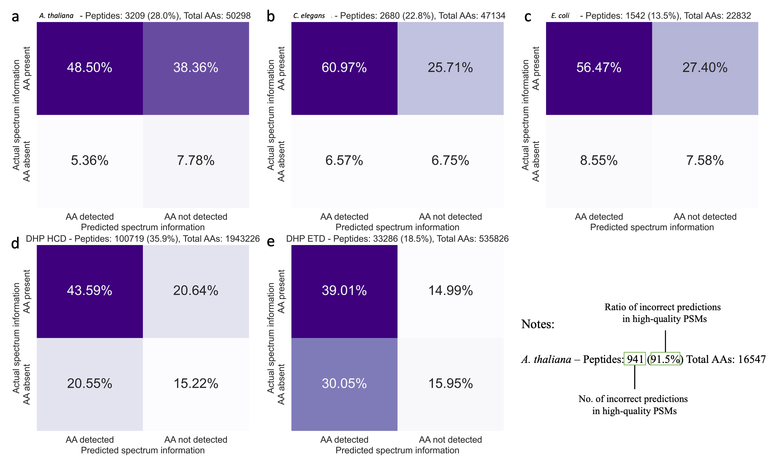
Figure S15: Amino acid prediction results in erroneous samples of high-quality spectra from test sets. a-c, Results by $π$-xNovo-MassIVE-KB-30M-3epochs in (a) A. thaliana, (b) C. elegans, and (c) E. coli, with high-quality spectra having a PSM score above 0.4. d-e, Results by $π$-xNovo in the (d) HCD and (e) ETD test sets of the DHP dataset, with high-quality spectra having a PSM score above 0.2.
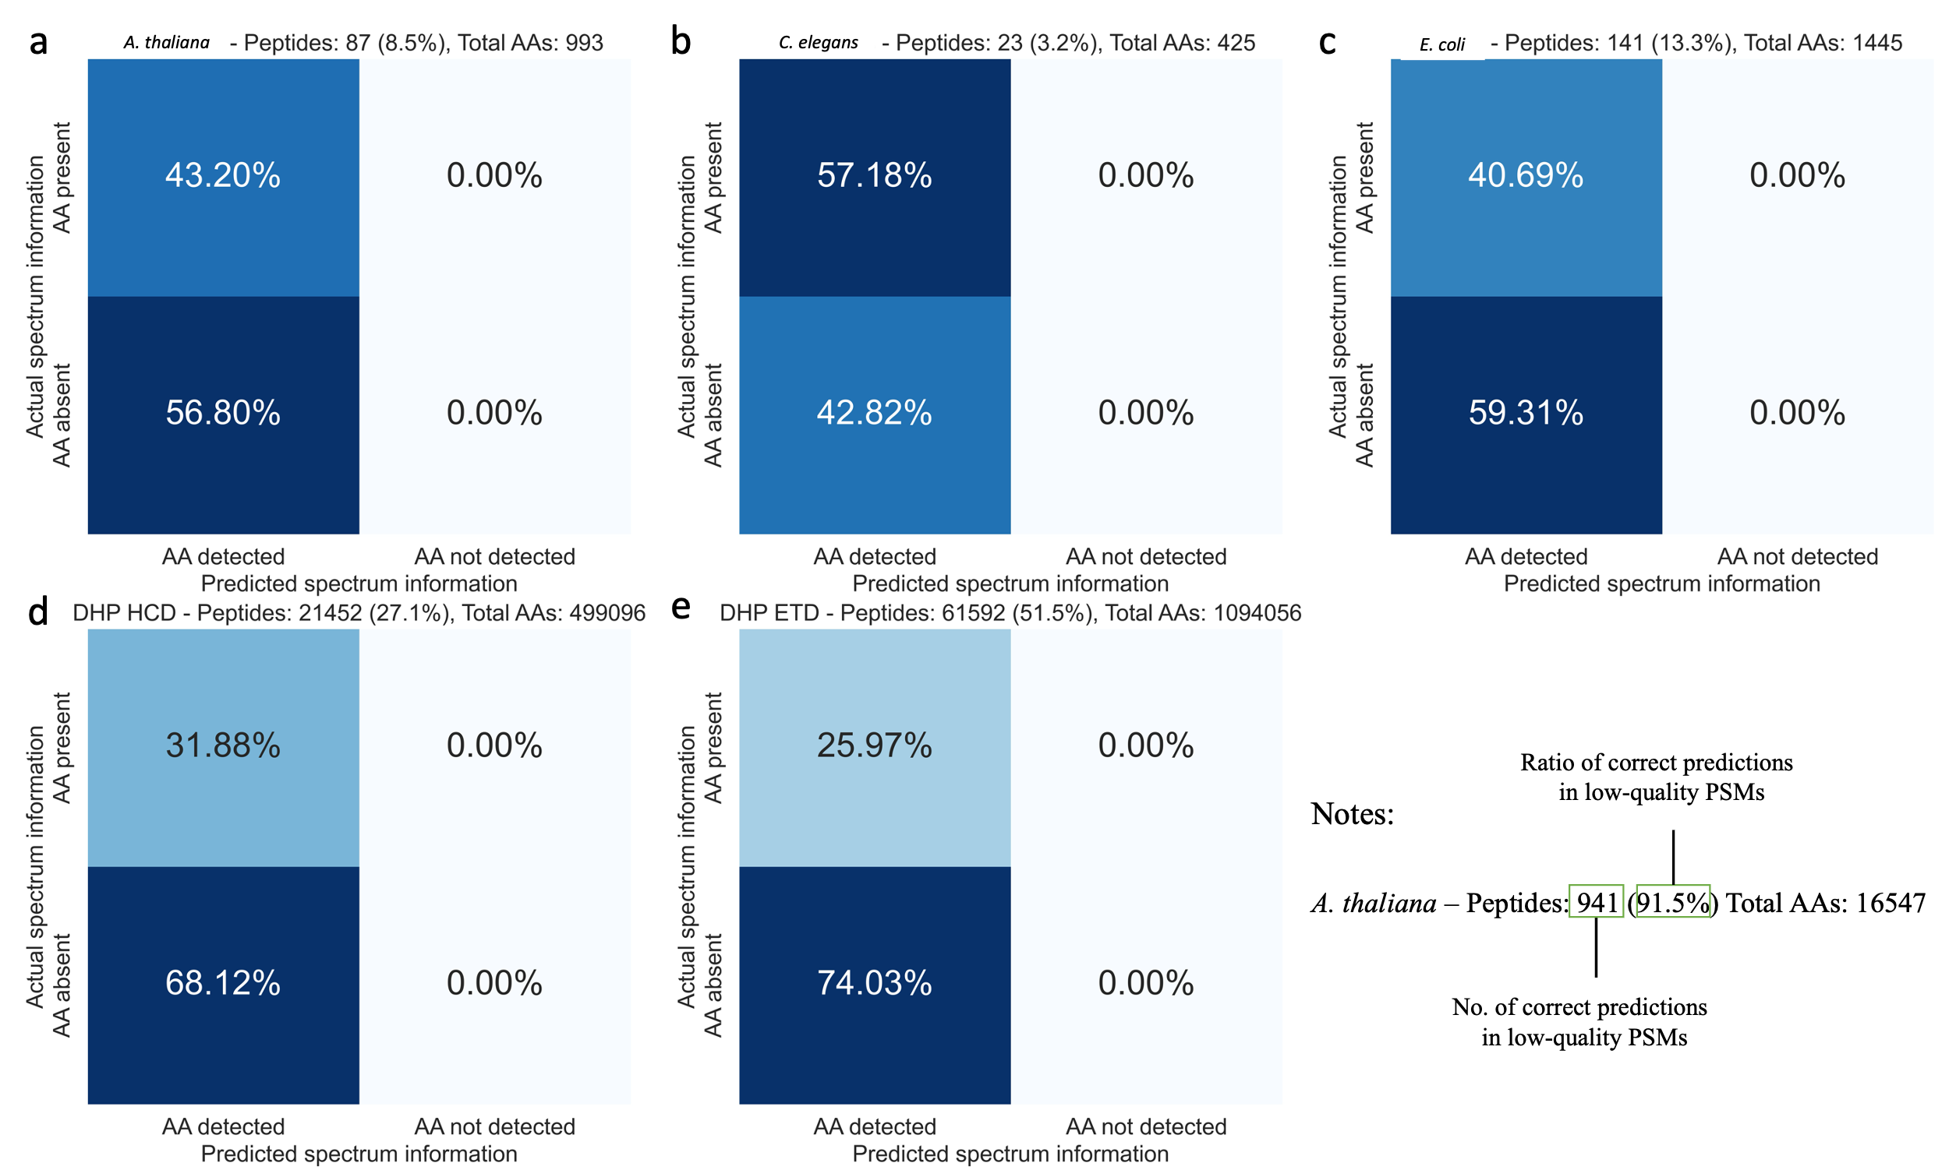
Figure S16: Amino acid prediction results in correct samples of low-quality spectra from test sets. a-c, Results by $π$-xNovo-MassIVE-KB-30M-3epochs in (a) A. thaliana, (b) C. elegans, and (c) E. coli, with low-quality spectra having a PSM score below 0.4. d-e, Results by $π$-xNovo in the (d) HCD and (e) ETD test sets of the DHP dataset, with low-quality spectra having a PSM score below 0.2.
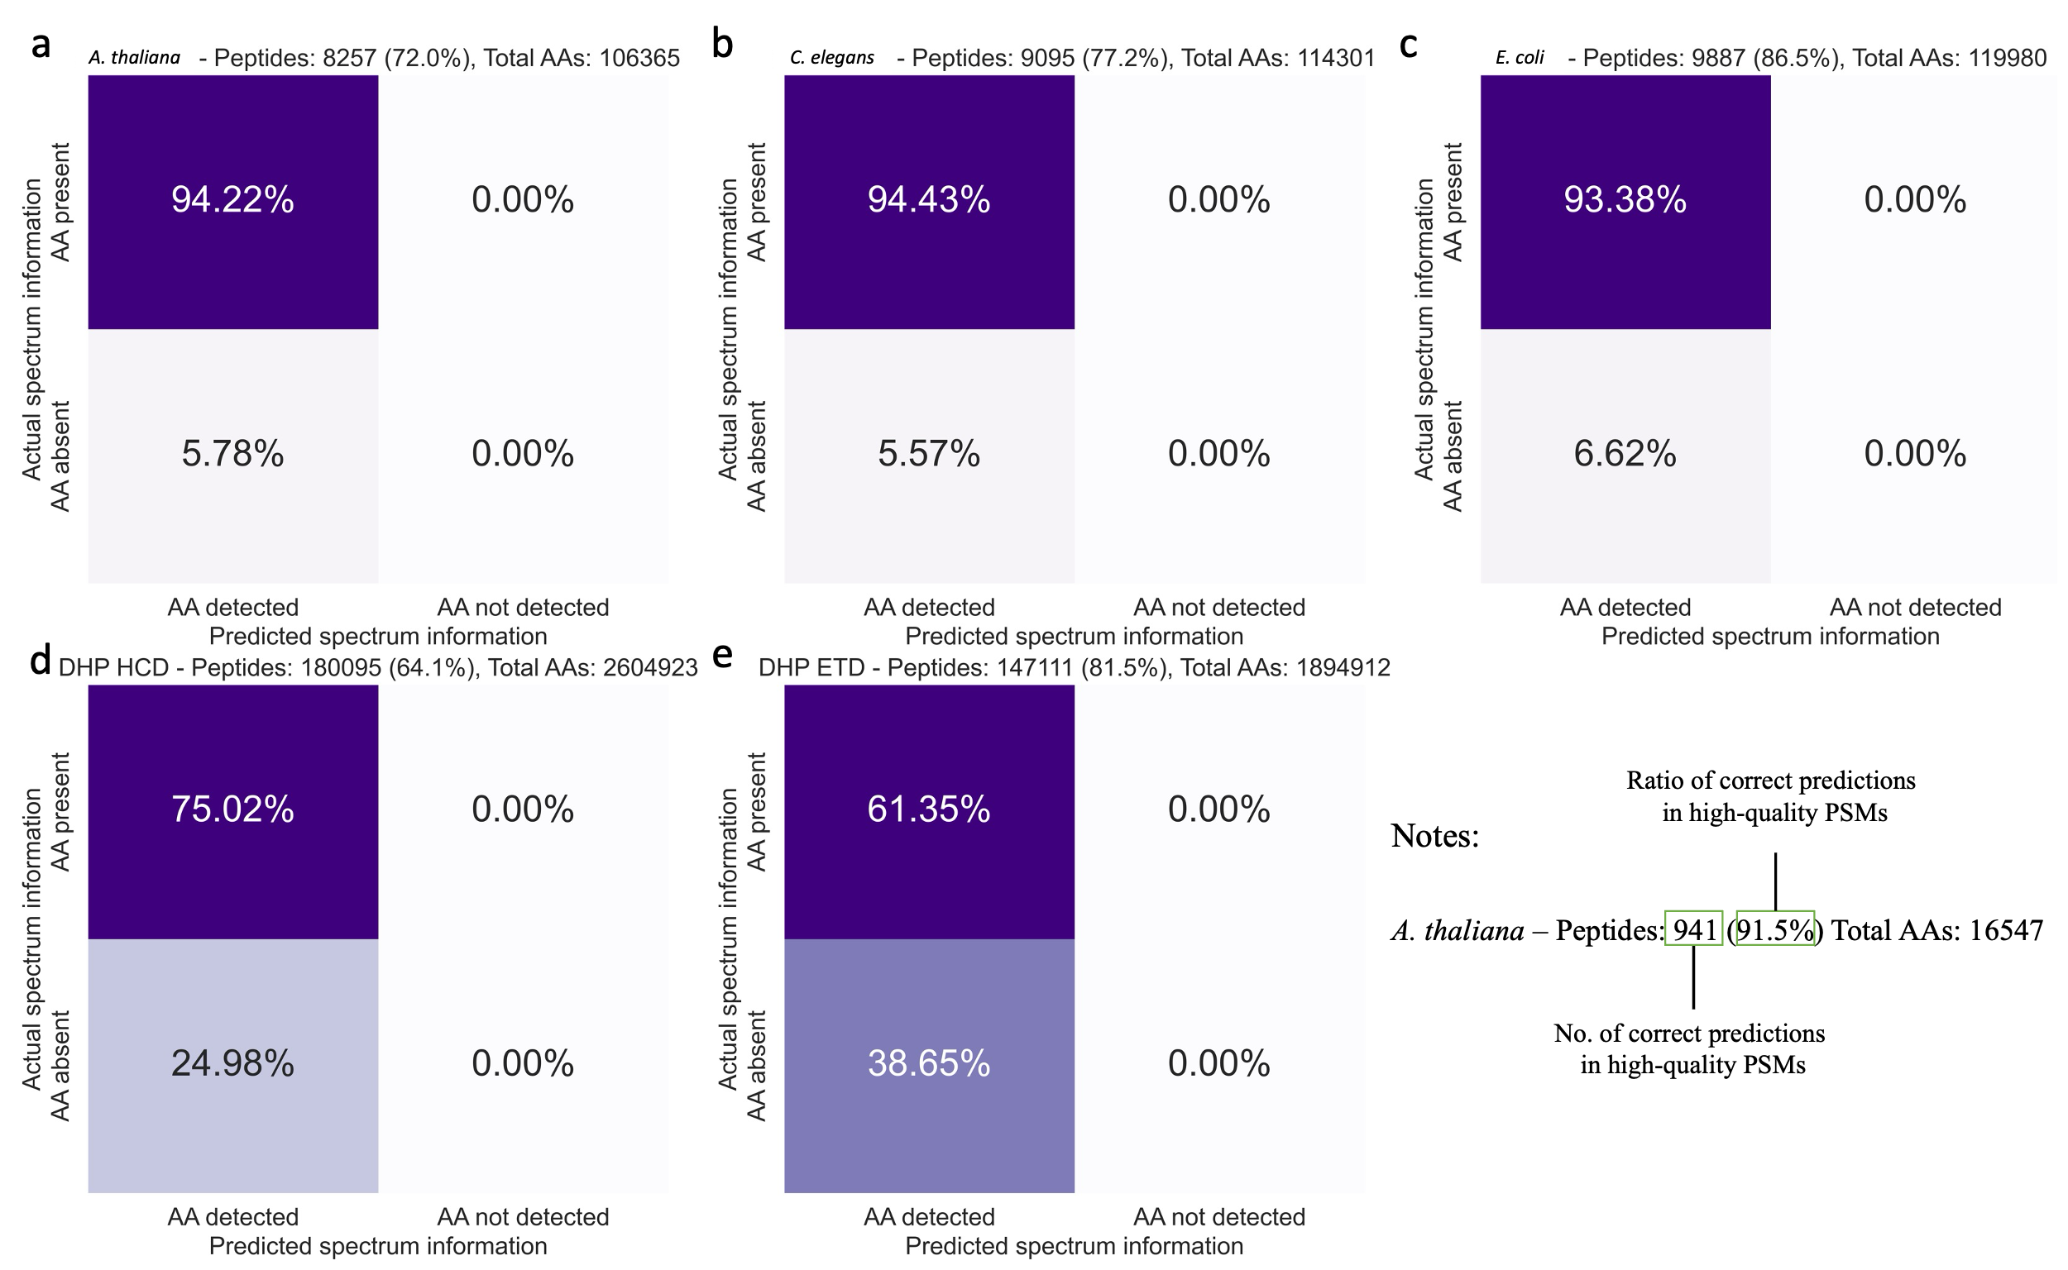
Figure S17: Amino acid prediction results in correct samples of high-quality spectra from test sets. a-c, Results by $π$-xNovo-MassIVE-KB-30M-3epochs in (a) A. thaliana, (b) C. elegans, and (c) E. coli, with high-quality spectra having a PSM score above 0.4. d-e, Results by $π$-xNovo in the HCD and ETD test sets of the DHP dataset, with high-quality spectra having a PSM score above 0.2.
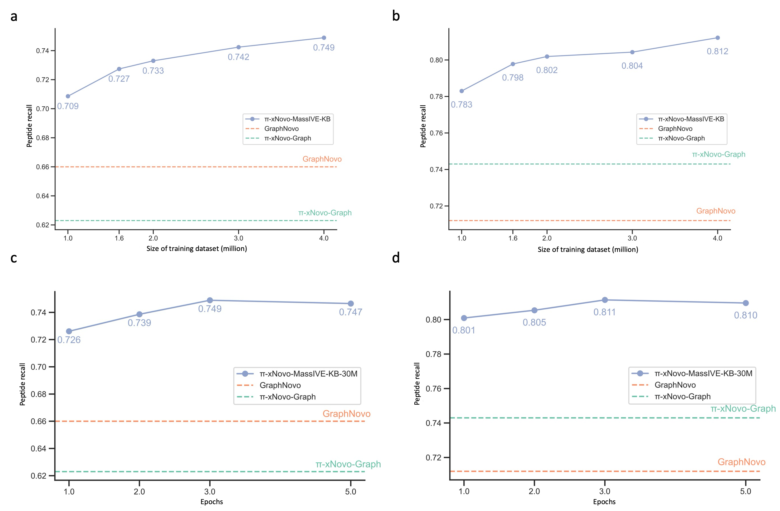
Figure S18: Effect of training set size and number of iterations on peptide recall of $π$-xNovo-MassIVE-KB. a-b, Effect of training set size on peptide recall in (a) C. elegans and (b) E. coli. c-d, Effect of training iterations on peptide recall in (c) C. elegans and (d) E. coli.
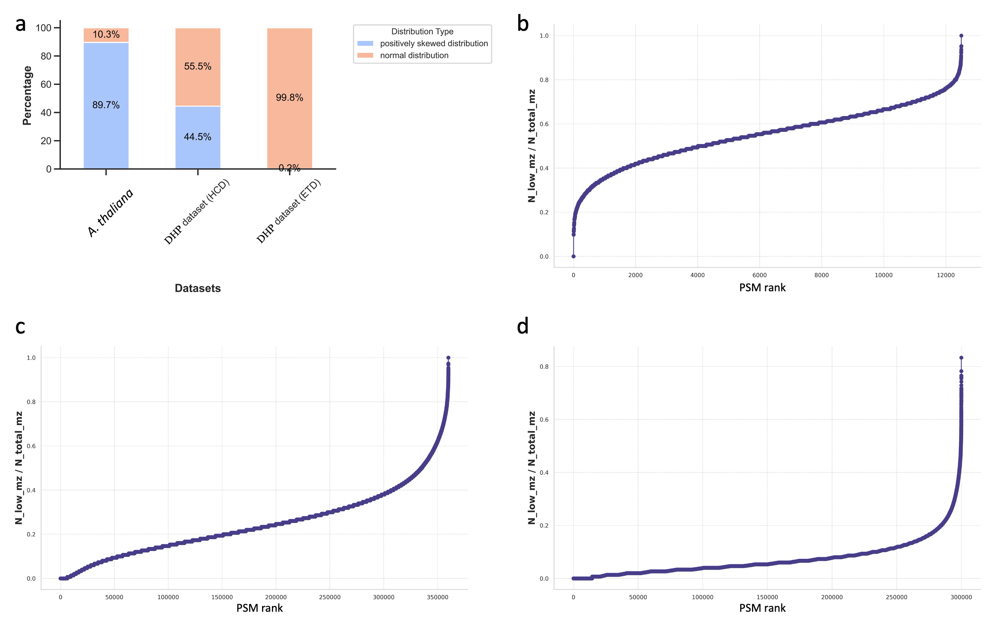
Figure S19: Spectrum types in test sets of GraphNovo and DHP datasets. a, Distribution of spectrum types across datasets. b, Proportion distribution of low m/z peak in A. thaliana spectra. c-d, Proportion distribution of low m/z peak in (c) HCD and (d) ETD spectra in the DHP dataset.
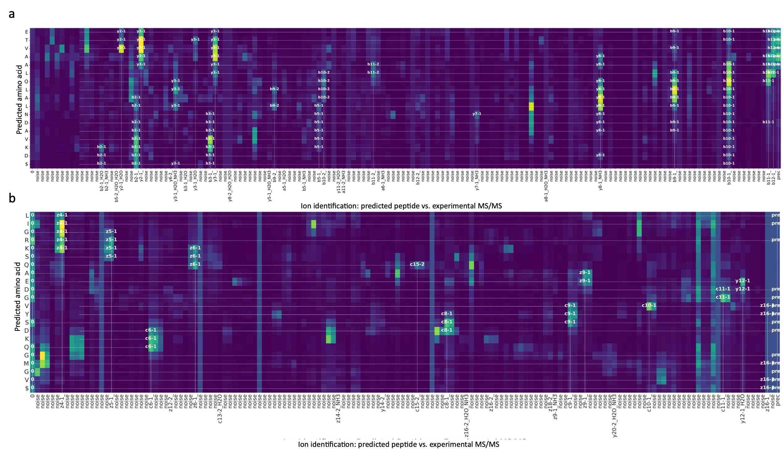
Figure S20: a-b, Schematic diagrams of the interpretable matrices for (a) HCD and (b) ETD spectra in the DHP dataset.
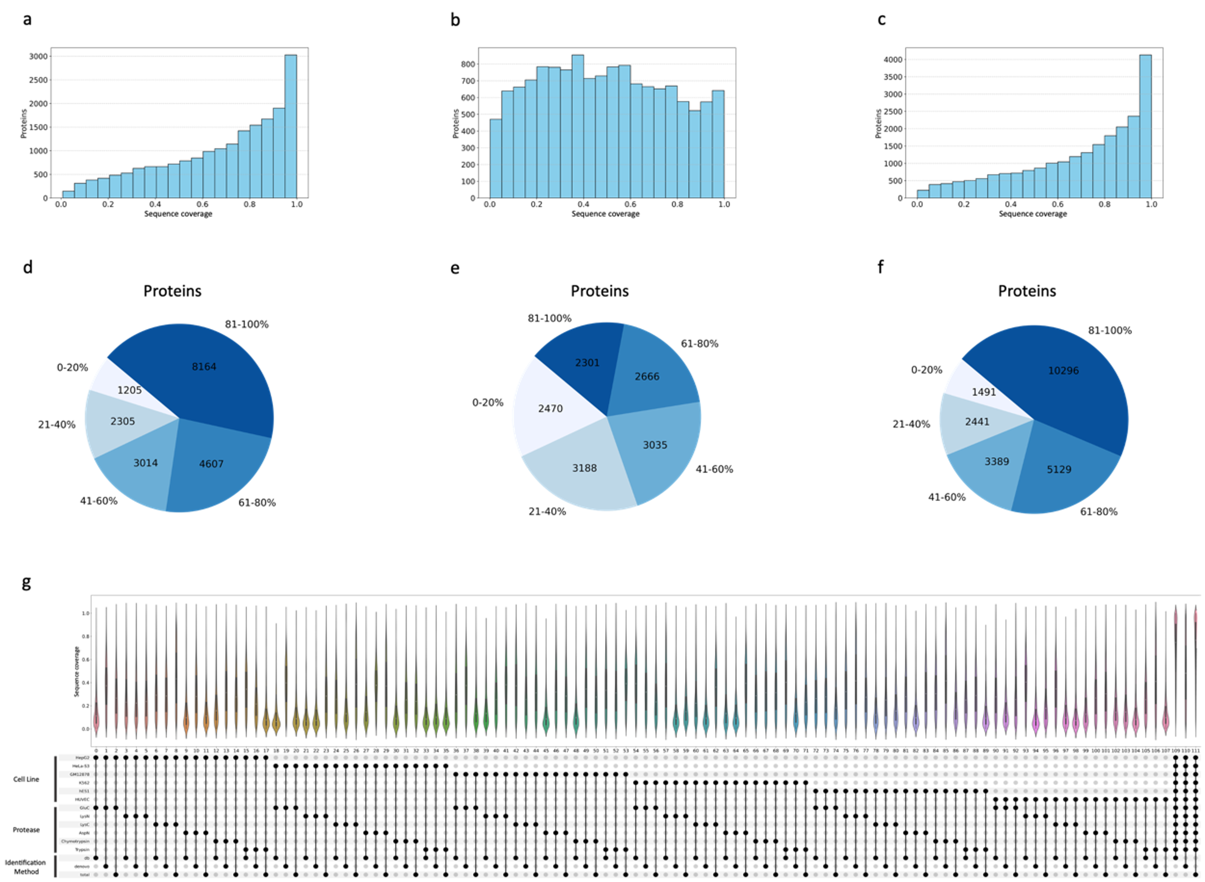
Figure S21: Sequence coverage of proteins identified by different methods. a-c, Histograms of protein counts by observed sequence coverage from (a) database search, (b) π-xNovo-QC screening, and (c) all identifications. d-f, Pie charts of protein counts in 20% sequence coverage intervals from (d) database search, (e) π-xNovo-QC screening, and (f) all identifications. g, Violin plots showing the combination of all cell lines, proteases, and identification methods.
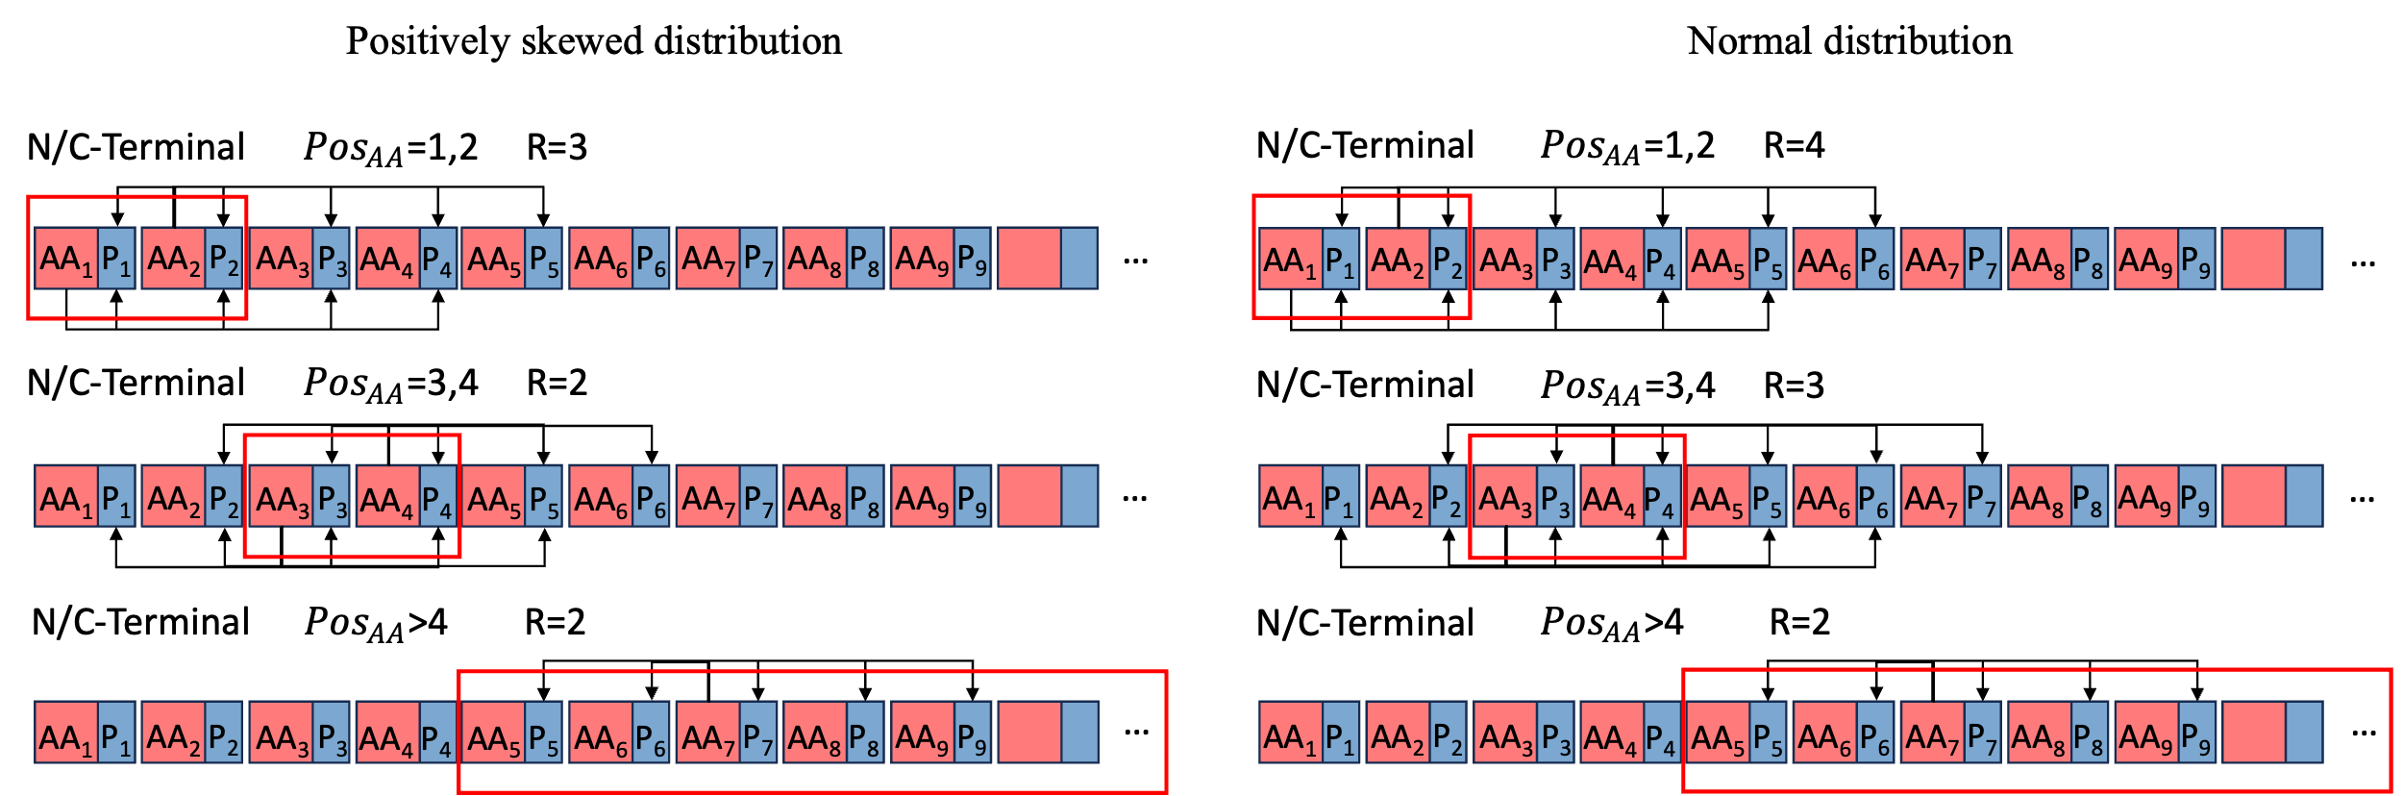
Figure S22: Schematic diagram of the generation rules for the theoretical backbone ion set.

Supplementary Tables
Table S1: Model settings for ablation experiments.
Model | MS/MS data enrichment |  | Joint masking mechanism
Model | Precursors | C-terminal | Spectrum soft mask | Peptide random mask (mask ratio)
Model A
Model B | $$√$$
Model C | $$√$$ | $$√$$
Model D | $$√$$ | $$√$$ | $$√$$
Model E | $$√$$ | $$√$$ |  | $$√$$
Model F | $$√$$ | $$√$$ | $$√$$ | $$√$$
Model F (40%) | $$√$$ | $$√$$ | $$√$$ | $√$ (40%)
Model F (50%) | $$√$$ | $$√$$ | $$√$$ | $√$ (50%)

Table S2: Results of A. mellifera in different random masking ratio of spectrum encoder when the masking ratio of peptide decoder is 40%.
Mask ratio | 0% | 10% | 20% | 30% | 40%
Peptide recall | 0.5221 | 0.4246 | 0.3557 | 0.2881 | 0.2190

Table S3: A comprehensive summary of datasets.
Species | Accession no. | No. of PSM | PSM score | a-ions ratio | b-ions ratio | y-ions ratio | Noise factor | Total ions
Nine-species datasets
H. sapiens | PXD004424 | 130,049 | 0.5534 | 0.0702 | 0.1173 | 0.1974 | 0.6152 | 10,277,011
C. endoloripes | PXD004536 | 150,117 | 0.5802 | 0.0855 | 0.1353 | 0.2134 | 0.5657 | 10,834,099
M. musculus | PXD004948 | 37,019 | 0.5501 | 0.0778 | 0.1219 | 0.2390 | 0.5613 | 2,251,691
A. mellifera | PXD004467 | 313,844 | 0.6701 | 0.0692 | 0.1040 | 0.1749 | 0.6518 | 32,771,085
M. mazei | PXD004325 | 164,412 | 0.7306 | 0.0755 | 0.1069 | 0.1771 | 0.6405 | 17,180,159
S. lycopersicum | PXD004947 | 290,000 | 0.6793 | 0.0839 | 0.1305 | 0.2371 | 0.5484 | 22,956,333
S. cerevisiae | PXD003868 | 111,298 | 0.7509 | 0.0805 | 0.1284 | 0.1907 | 0.6004 | 13,268,631
Bacillus | PXD004565 | 291,769 | 0.7788 | 0.0807 | 0.1179 | 0.1851 | 0.6163 | 34,803,648
V. mungo | PXD005025 | 37,774 | 0.7692 | 0.0784 | 0.1178 | 0.1526 | 0.6512 | 4,347,456
GraphNovo dataset
Cerebellum | PXD006109 | 1,249,397 | - | - | - | - | - | -
HeLa | PXD006109 | 410,366 | - | - | - | - | - | -
A. thaliana | PXD016315 | 12,222 | 0.7401 | 0.0771 | 0.0990 | 0.1621 | 0.6618 | 1,603,105
C. elegans | PXD013233 | 12,103 | 0.7785 | 0.0753 | 0.1069 | 0.1725 | 0.6454 | 1,536,647
E. coli | PXD016001 | 12,330 | 0.7442 | 0.0856 | 0.1108 | 0.1933 | 0.6103 | 1,322,615

Table S4: Control condition settings of $π$-xNovo-Graph-QC for ablation studies.
$π$-xNovo-QC steps | Cross-correlation matrix aggregation method |  | Second step | Third step
 | Mean | Max | matching of  backbone ions | PSM score  control | matching of precursor
mean_2 | $$√$$ |  | $$√$$
mean_3.1 | $$√$$ |  | $$√$$ | $$√$$
mean_3.2 | $$√$$ |  | $$√$$ |  | $$√$$
mean_all | $$√$$ |  | $$√$$ | $$√$$ | $$√$$
max_2 |  | $$√$$ | $$√$$
max _3.1 |  | $$√$$ | $$√$$ | $$√$$
max _3.2 |  | $$√$$ | $$√$$ |  | $$√$$
max _all |  | $$√$$ | $$√$$ | $$√$$ | $$√$$

Table S5: The performance comparison of different quality control system of $π$-xNovo-Graph.
 |  | $π$-xNovo-QC | $π$-xNovo-prob
A. thaliana | Accuracy  Sensitivity  Specificity  Precision | 87.6%  97.3%  73.6%  84.2% | 87.74%  87.11%  88.59%  91.31%
C. elegans | Accuracy  Sensitivity  Specificity  Precision | 89.3%  97.5%  75.9%  86.8% | 90.10%  91.10%  88.59%  92.31%
E. coli | Accuracy  Sensitivity  Specificity  Precision | 88.0%  96.8%  63.6%  88.1% | 89.40%  94.86%  74.93%  90.93%

Table S6: The performance comparison of different model.
 |  | GraphNovo | $π$-xNovo-Graph | $π$-xNovo-MassIVE-KB-30M
A. thaliana | Peptide recall  Amino acid recall | 61.6%  83.8% | 59.4%  79.8% | 67.98%  82.32%
C. elegans | Peptide recall  Amino acid recall | 66.0%  85.6% | 62.3%  82.4% | 74.89%  88.01%
E. coli | Peptide recall  Amino acid recall | 71.2%  87.6% | 74.3%  88.4% | 81.14%  90.87%

Table S7: The performance comparison of $π$-xNovo-QC trained by different datasets.
 |  | $π$-xNovo-Graph-QC | $π$-xNovo-MassIVE-KB-30M-QC
A. thaliana | Accuracy  Sensitivity  Specificity  Precision | 87.6%  97.3%  73.6%  84.2% | 89.51%  97.56%  72.43%  88.25%
C. elegans | Accuracy  Sensitivity  Specificity  Precision | 89.3%  97.5%  75.9%  86.8% | 90.51%  97.38%  72.17%  90.33%
E. coli | Accuracy  Sensitivity  Specificity  Precision | 88.0%  96.8%  63.6%  88.1% | 90.45%  96.91%  64.94%  91.60%

Table S8: Detailed information on different models.
Model | Dataset | Size of dataset | epochs | Notes
$π$-xNovo | Nine-species dataset | 1.2M~1.5M | 30 | -
$π$-xNovo-Graph | GraphNovo dataset | 1.65M | 30 | -
$π$-xNovo-Graph | GraphNovo dataset | 0.1M~1M | 30 | High quality
$π$-xNovo-Graph | GraphNovo dataset | 0.1M~1M | 30 | Low quality
$π$-xNovo-MassIVE-KB-K | MassIVE-KB | 1M | 30 | Peptides end with K
$π$-xNovo-MassIVE-KB-KR | MassIVE-KB | 1M | 30 | Peptides end with K and R
$π$-xNovo-MassIVE-KB | MassIVE-KB | 0.1M~1M | 30 | High quality
$π$-xNovo-MassIVE-KB | MassIVE-KB | 0.1M~1M | 30 | Low quality
$π$-xNovo-MassIVE-KB | MassIVE-KB | 1M~4M | 30 | -
$π$-xNovo-MassIVE-KB-30M | MassIVE-KB | 30M | 1/2/3/5 | -
$π$-xNovo-DHP-GM12878 | DHP dataset | - | 15 | -
$π$-xNovo-DHP-GM12878 | DHP dataset | - | 15 | pretrained
$π$-xNovo-DHP-HUVEC | DHP dataset | - | 15 | -
$π$-xNovo-DHP- HUVEC | DHP dataset | - | 15 | pretrained
$π$-xNovo-DHP-Hela-S3 | DHP dataset | - | 15 | -
$π$-xNovo-DHP-Hela-S3 | DHP dataset | - | 15 | pretrained
$π$-xNovo-DHP-HepG2 | DHP dataset | - | 15 | -
$π$-xNovo-DHP- HepG2 | DHP dataset | - | 15 | pretrained
$π$-xNovo-DHP-K562 | DHP dataset | - | 15 | -
$π$-xNovo-DHP- K562 | DHP dataset | - | 15 | pretrained
$π$-xNovo-DHP-hES1 | DHP dataset | - | 15 | -
$π$-xNovo-DHP- hES1 | DHP dataset | - | 15 | pretrained
$π$-xNovo-DHP-all | DHP dataset | - | 3 | -
$π$-xNovo-DHP-all | DHP dataset | - | 3 | pretrained
$π$-xNovo-DHP-ETD | DHP dataset | - | 15 | Generated by ETD

