Atlas of fungal biosynthetic gene clusters reveals the diversification of cyclodipeptide biosynthesis

Bin Wei ^{1,2,*,}†, Ti-Ti Ying ^{1,}†, Hua-Wei Lv ^{1,}†, Zhen-Yi Zhou ¹, Hai Cai ¹, Gang-Ao Hu ¹, Hui-Min Liang ¹, Wen-Chao Yu ¹, Yan-Lei Yu ¹, Ai-Li Fan ³, Kui Hong ⁴, Xing-Nuo Li^{1,*}, Hong Wang ^{1,2,*}

¹ College of Pharmaceutical Science & Collaborative Innovation Center of Yangtze River Delta Region Green Pharmaceuticals, Zhejiang key laboratory of green, low-carbon, and efficient development of Marine Fishery Resources, Zhejiang University of Technology, Hangzhou, 310014, China.
² Binjiang Cyberspace Security Institute of ZJUT, Hangzhou, 310051, China
³ State Key Laboratory of Natural and Biomimetic Drugs, School of Pharmaceutical Sciences, Peking University, Beijing, 100191, China
⁴ Key Laboratory of Combinatorial Biosynthesis and Drug Discovery, Ministry of Education, School of Pharmaceutical Sciences, Wuhan University, Wuhan, 430071, China.

* Correspondence author:
Tel: 86-571-8832-0622; E-mail: binwei@zjut.edu.cn (B. W.); lixingnuo@zjut.edu.cn (X. L.); hongw@zjut.edu.cn (H. W.)
† Bin Wei, Ti-Ti Ying, and Hua-Wei Lv contributed equally to this article.

Table of Contents
Supplementary Methods
Supplementary Results
Supplementary Tables 6-7
Supplementary Figures 1-2
Supplementary Notes (NMR data)

Methods
ECD calculations
Conformational searches were carried out using the torsional sampling (MCMM) method and OPLS_2005 force field in the Macro model 9.9.223 software, applying an energy window of 21 kJ/mol. The Boltzmann populations of conformers were obtained based on the potential energy provided by the OPLS_2005 force field, which afforded 3 and 3 conformers above 5% and 2% population for compounds 1 and 2, respectively, for re-optimization (Table S7-S8). The re-optimization and the following TDDFT calculations of the selected conformers were all performed with Gaussian 09 software (1) at the B3LYP/6-311G (d, p) level with the IEFPCM solvent model for methanol. Finally, the Boltzmann-averaged ECD spectra of compounds 1 and 2 were obtained with SpecDis1.62 software (2).
Derivatization with Marfey’s reagent and HPLC Analysis of aspergillan C
Compound 3 (0.5 mg) was dissolved in 6 N HCl (1 mL) in a sealed container and heated at 105°C for 24 h. After cooling, the reaction mixture was concentrated in vacuo to dryness. The hydrolysate was added to acetone with 40 µL of 1 M NaHCO3 solution and 100 µL of 1% 1-fluoro-2,4-dinitrophenyl-5-L-alaninamide. The solution was reacted at 45°C for 1.5 h. The derivatives obtained were analyzed by co-injection into an HPLC apparatus and compared with Marfey’s derivatives of authentic amino acids (3). The retention times of derivatized amino acids were measured under the condition as follows: Agilent ZORBAX SB-C₁₈ column (4.6 × 250 mm, 5 µm); gradient elution: MeCN (A)-H₂O (0.1% CH₃COOH) (B), A%: 15%-45% 50 min; flow rate 1.0 mL/min; UV detection at 340 nm. Authentic amino acids: 38.56 min (L-Val-L-FDAA) and 44.48 min (D-Val-L-FDAA); the hydrolysate of 1: 38.45 min (L-Val -L-FDAA).
Genome sequencing of Aspergillus sp. WHUF0304
The genomic DNA was extracted from the mycelium of Aspergillus sp. WHUF0304 using cetyltrimethylammonium bromide, and was sequenced on BGISEQ-500 and Nanopore at BGI (Shenzhen, Guangzhou, China). The resulting reads were quality-controlled and assembled using SPAdes 3.6.1 with default parameters (3). The AUGUSTUS gene-finding software has been used for finding coding genes (4).
Results
Structure elucidation
Aspergillan A (1) was obtained as a white amorphous powder. Its molecular formula was deduced to be C₃₈H₃₉N₃O₅ based on HRESIMS data (m/z: 616.2792 [M-H]⁻, calcd for C₃₈H₃₈N₃O₅: m/z 616.2817). The ¹H-NMR spectrum exhibited signals attributed to a hydroxyl proton at δ_{H} 11.73 (s), an aldehyde hydrogen proton at δ_{H} 10.24 (s), three NH groups at δ_{H} 8.30 (s), 7.39 (s), and 6.10 (s), four aromatic H-atoms at δ_{H} 7.33 (d, J = 7.8Hz), 7.17 (dd, J = 7.8, 7.8Hz), 7.10 (dd, J = 7.8, 7.8 Hz), and 7.03 (d, J = 7.8 Hz, 1H), eight olefinic H-atoms at δ_{H} 7.02 (s), 6.88 (s), 6.06 (dt, J = 10.2, 3.0 Hz), 5.96 (dd, J = 17.4, 10.8 Hz), 5.85 (dt, J = 10.2, 1.8 Hz), 5.31 (t, J = 7.2 Hz), 5.15 (d, J = 10.8 Hz), and 5.09 (d, J = 17.4 Hz), five methyl groups at δ_{H} 1.76 (s), 1.69 (s), 1.37 (s), and 1.33 (s), two aliphatic CH₂ groups at δ_{H} 3.39 (d, J = 7.2 Hz), 2.61 (dd, J = 13.8, 8.4 Hz, 1H), 1.99 (m, 1H), and two aliphatic CH groups at δ_{H} 4.38 (m) and 2.70 (m). The ¹³C-NMR spectrum (150 MHz, CDCl₃) showed the presence of 38 C-atoms including twenty-four olefinic or aromatic carbons, three carbonyl carbons, five CH₃ groups, two CH₂ groups, two CH groups, and two quaternary C-atoms by comprehensive analysis of ¹H NMR and HSQC experiments. Detailed analysis of the ¹H- and ¹³C-NMR spectra revealed that 1 was a dioxopiperazine alkaloid derivative containing an indole moiety. The structure was similar to cryptoechinulin D. The dimethylprop-2-enyl dehydrotryptophan moiety was confirmed by the HMBC correlations from H-8 to C-2, C-3a and C-10, from NH-11 to C-8, from H-18 to C-2, and from H-17 to H-15. The spirobicyclic moiety was deduced based on the key HMBC correlation from H-28 to C-13, from H-33 to C-32, from H-31 to C-12, and from NH-11 to C-12. The prenyl benzaldehyde moiety was confirmed by the HMBC correlations from H-35 to C-21, C-37, from H-34 to C-21, from H-23 to C-21. The main differences between 1 and cryptoechinulin D were the presence of a singlet proton signal at δ_{H} 6.88 (s) instead of signals of a hydroxyl proton and two double-bond protons in 1. By comparing unsaturation, compound 1 has one more unsaturation than cryptoechinulin D, which indicates a furan moiety was formed by the connection of C-24 and C-27 via oxygen. The Z-geometry of the Δ⁸ double bond was deduced from the downfield shift of H-8 (δ_{H} 7.39) attributed to the deshielding effect of the carbonyl group on the β-vinyl protons. The relative configuration of 1 was deduced as (12R*, 28S*, 29S*) based on the NOESY correlations of NH-11/H-33 and H-32β, H-28/H-32α. 1 has a zero specific rotation and no cotton effect in its ECD spectrum, which indicate Aspergillan A is a racemate. The enantiomers of Aspergillan A, 1a, and 1b, were separated by chiral HPLC using a Chiralpak IB column. ECD calculations with time-dependent density functional theory (TD-DFT) were performed, and the Boltzmann-averaged ECD spectra of (12S,28R,31R)-1 and (12R,28S,31S)-1 matched well with the experimental ECD spectrum of 1a and 1b, respectively.
Aspergillan B (2) was obtained as a white amorphous powder. The molecular formula was determined to be C₃₈H₄₁N₃O₆ based on an ion at m/z 658.2891 [M+Na]⁺ (calcd. for C₃₈H₄₁N₃O₆Na: m/z 658.2888) by the HRESIMS, indicating twenty degrees of unsaturation. The ¹H- and ¹³C-NMR spectra reveal characteristic dioxopiperazine [(δ_{H} 7.37 (s), 6.33 (s), δ_{C} 161.1, 161.7, 123.3, 82.2], and indole [δ_{H} 8.37 (s), 7.36 (d, J = 7.8 Hz), 7.29 (d, J = 7.8 Hz), 7.18 (dd, J = 7.8, 7.8 Hz), and 7.10 (dd, J = 7.8, 7.8 Hz), δ_{C} 144.9, 103.2, 126.1, 119.1, 121.6, 122.7, 111.5, 134.4)] moieties. The 1D NMR data were similar to those of aspergilline D, except for the appearance of two olefinic protons (δ_{H} 5.92 and 5.66) and two sp2 carbons (δ_{C} 141.9 and 122.4) instead of two CH₂ signals in aspergilline D. This suggested that Aspergillan B was the dehydro analog of aspergilline D. The isochroman moiety with a pentyl side-chain was deduced by the ¹H–¹H COSY correlations (H-21/H-29/H-30/H-31/H-32/H-33/H-34) and HMBC correlations (H-30/C-21). The key NOESY correlations of NH-11/H20β and H-20β (δ_{H} 1.45)/H-29 indicate that these three hydrogens are located on the same side. At the same time, the NOESY correlation of H-20α (δ_{H} 2.45)/H-21 suggested the cis configuration of H-20α and H-21. 2 was also assumed to be a racemate due to its zero specific rotation and baseline ECD curve. The enantiomers of 2a and 2b, were obtained by chiral HPLC using a Chiralpak IB column. The absolute configuration of 2a and 2b was further determined by the time-dependent density functional (TDDFT)-ECD calculation. There is a high coincidence between the calculated and experimental curves, confirming that the absolute configuration of 2a and 2b was assigned as 12S, 21R, 29S, and 12R, 21S, 29R, respectively.
Aspergillan C (3) was obtained as a faint yellow amorphous powder with the molecular formula C₂₁H₂₅N₃O₂ inferred from its HRESIMS (m/z 350.1868 [M-H]⁻, calcd. for C₂₁H₂₄N₃O₂: m/z 350.1874), accounting for eleven degrees of unsaturation. The general features of the ¹H and ¹³C NMR spectra resembled those of aspergilline B. The presence of a singlet olefinic proton signal at δ_{H} 7.20 and two olefinic carbon signals at δ_{C} 111.8 and 124.5 indicate the presence of a C₈=C₉ bond in 3. The absolute configuration of C₁₂ was determined as S by Marfey’s method. Thus, the structure of 3 was established as shown.
The structures of compounds 4-18 were identified as Cryptoechinulin D (4) (5), Eurotinoid B (5) (6), Variecolortide B (6) (7), Variecolortide C (7) (7), Isoechinulin A (8) (8), Variecolorin G (9) (8), Neochinulin D (10) (9), Variecolorin J (11) (8), Cryptoechinulin C (12) (10), Variecolorin O (13) (11), Variecolorin H (14) (8), Aspergilline B (15) (12), Neoechinulin A (16) (13), Neoechinulin B (17) (8), Dihydroneoechinulin B (18) (9) based on comparison of HRESIMS, ¹H NMR, and ¹³C NMR data with previously reported literature.
Spectral data of new compounds
Aspergillan A (1): white amorphous powder; [α]20 D -6.00 (c 0.10, CHCl₃); HRESIMS: m/z 616.2773 [M-H]⁻, (calcd. 616.2817); UV (MeOH) λ_{max} (log ε): 230 (3.84), 310 (4.18) nm; IR (KBr) v_{max}: 3373, 2974, 2926, 1639, 1420, 1383, 1048 cm⁻¹; ECD λ_{max} (Δε) in methanol: 1a: 237 (9.24), 288 (-2.81), 370 (-6.62); 1b: 237 (-7.16), 288 (1.84), 370 (4.48); ¹H NMR (600 MHz) and ¹³C NMR (150 MHz) data were shown in Table S6;
Aspergillan B (2): white amorphous powder; [α]20 D 16.00 (c 0.016, CHCl₃); HRESIMS: m/z 658.2891 [M+Na]⁺; UV (MeOH) λ_{max} (log ε): 242 (4.20), 347 (4.08) nm; IR (KBr) v_{max}: 3324, 2973, 2918, 1620, 1420, 1385, 1126, 1044 cm⁻¹; ECD λ_{max} (Δε) in methanol: 2a: 238 (28.80), 271 (10.77), 362 (-16.25); 2b: 238 (-26.58), 271 (-9.54), 362 (15.20); ¹H NMR (600 MHz) and ¹³C NMR (150 MHz) data were shown in Table S6;
Aspergillan C (3): faint yellow amorphous powder; [α]20 D 160.01 (c 0.03, CHCl₃); HRESIMS: m/z 350.1868 [M-H]⁻, (calcd. 350.1874); UV (CHCl₃) λ_{max} (log ε): 229 (4.45), 338 (4.06) nm; IR (KBr) v_{max}: 3424, 2922, 1590, 1455, 1419, 1122 cm⁻¹; ¹H NMR (600 MHz) and ¹³C NMR (150 MHz) data were shown in Table S6.

Reference
1. Frisch, A. gaussian 09W Reference. Wallingford, USA, 25p 470 (2009).
2. T. Bruhn, A. Schaumlöffel, Y. Hemberger, G. Bringmann, SpecDis: Quantifying the Comparison of Calculated and Experimental Electronic Circular Dichroism Spectra. Chirality 25, 243-249 (2013).
3. A. Bankevich, S. Nurk, D. Antipov, A. A. Gurevich, M. Dvorkin, A. S. Kulikov, V. M. Lesin, S. I. Nikolenko, S. Pham, A. D. Prjibelski, SPAdes: a new genome assembly algorithm and its applications to single-cell sequencing. J. Comput. Biol. 19, 455-477 (2012).
4. O. Keller, M. Kollmar, M. Stanke, S. Waack, A novel hybrid gene prediction method employing protein multiple sequence alignments. Bioinformatics 27, 757-763 (2011).
5. H. Gao, T. Zhu, D. Li, Q. Gu, W. Liu, Prenylated indole diketopiperazine alkaloids from a mangrove rhizosphere soil derived fungus Aspergillus effuses H1-1. Arch. Pharm. Res. 36, 952-956 (2013).
6. W. Zhong, J. Wang, X. Wei, T. Fu, Y. Chen, Q. Zeng, Z. Huang, X. Huang, W. Zhang, S. Zhang, Three pairs of new spirocyclic alkaloid enantiomers from the marine-derived fungus Eurotium sp. SCSIO F452. Front. Chem. 7, 350 (2019).
7. G. D. Chen, Y. R. Bao, Y. F. Huang, D. Hu, X. X. Li, L. D. Guo, J. Li, X. S. Yao, H. Gao, Three pairs of variecolortide enantiomers from Eurotium sp. with caspase-3 inhibitory activity. Fitoterapia 92, 252-259 (2014).
8. W. L. Wang, Z. Y. Lu, H. W. Tao, T. J. Zhu, Y. C. Fang, Q. Q. Gu, W. M. Zhu, Isoechinulin-type alkaloids, variecolorins A–L, from halotolerant Aspergillus variecolor. J. Nat. Prod. 70, 1558-1564 (2007).
9. Elsbaey, M., Sallam, A., El‐Metwally, M., Nagata, M., Tanaka, C., Shimizu, K. and Miyamoto, T. (2019). Melanogenesis inhibitors from the endophytic fungus Aspergillus amstelodami. Chem. Biodivers. 16, e1900237. https://doi.org/10.1002/cbdv.201900237.
10. X. Chen, L. Si, D. Liu, P. Proksch, L. Zhang, D. Zhou, W. Lin, Neoechinulin B and its analogues as potential entry inhibitors of influenza viruses, targeting viral hemagglutinin. Eur. J. Med. Chem. 93, 182-195 (2015).
11. L. N. Zhou, T. J. Zhu, S. X. Cai, Q. Q. Gu, D. H. Li, Three new indole‐containing diketopiperazine alkaloids from a deep‐ocean sediment derived fungus Penicillium griseofulvum. Helv. Chim. Acta. 93, 1758-1763 (2010).
12. M. L. Wang, R. Chen, F. J. Sun, P. R. Cao, X. R. Chen, M. H. Yang, Three alkaloids and one polyketide from Aspergillus cristatus harbored in Pinellia ternate tubers. Tetrahedron. Lett. 68, 152914 (2021).
13. T. Aoki, K. Ohnishi, M. Kimoto, S. Fujieda, K. Kuramochi, T. Takeuchi, A. Nakazaki, N. Watanabe, F. Sugawara, T. Arai, S. Kobayashi, Synthesis and Neuroprotective Action of Optically Pure Neoechinulin A and Its Analogs. Pharmaceuticals 3, 1063-1069 (2010).

Table S6. ¹H (600 MHz) and ¹³C (150 MHz) NMR data of 1-3 (δ in ppm, CDCl₃)
Position | 1 |  |  | 2 |  |  | 3
Position | δ_{H} (J, Hz) | δ_{C} |  | δ_{H} (J, Hz) | δ_{C} |  | δ_{H} (J, Hz) | δ_{C}
1-NH | 8.30, s |  |  | 8.37, s |  |  | 8.29, s
2 |  | 144.0 |  |  | 144.9 |  |  | 143.7
3 |  | 103.0 |  |  | 103.6 |  |  | 103.1
3a |  | 126.1 |  |  | 126.1 |  |  | 126.2
4 | 7.03, d (7.8) | 118.8 |  | 7.29, d (7.8) | 119.1 |  | 7.24, d (7.8) | 118.8
5 | 7.10, dd (7.8, 7.8) | 121.1 |  | 7.10, dd (7.8, 7.8) | 121.6 |  | 7.15, dd (7.8, 7.8) | 121.1
6 | 7.17, dd (7.8, 7.8) | 122.5 |  | 7.18, dd (7.8, 7.8) | 122.7 |  | 7.18, dd (7.8, 7.8) | 122.3
7 | 7.33, d (7.8) | 111.4 |  | 7.36, d (7.8) | 111.5 |  | 7.36, d (7.8) | 111.3
7a |  | 134.4 |  |  | 134.4 |  |  | 134.4
8 | 7.02, s | 111.8 |  | 7.39, s | 114.8 |  | 7.20, s | 111.8
9 |  | 123.9 |  |  | 123.3 |  |  | 124.5
10 |  | 159.4 |  |  | 161.1 |  |  | 160.2
11-NH | 6.10, s |  |  | 6.69, s |  |  | 6.24, s
12 |  | 61.0 |  |  | 82.2 |  | 4.06, brs | 61.4
13 |  | 166.9 |  |  | 161.7 |  |  | 164.9
14-NH | 7.39, s |  |  | 7.37, s |  |  | 7.47, s
15 |  | 39.2 |  |  | 39.4 |  |  | 39.3
16 | 5.96, dd  (17.4, 10.8) | 144.2 |  | 6.08, dd (17.4,10.8) | 144.2 |  | 6.06, dd (17.4, 10.8) | 144.4
17 | 5.15, d (10.8)  5.09, d (17.4) | 113.5 |  | 5.24, d (10.8)  5.20, d (17.4) | 113.8 |  | 5.22, d (10.8)  5.18, d (17.4) | 113.4
18 | 1.36, s | 27.3 |  | 1.56, s | 27.7 |  | 1.52, s | 27.5
19 | 1.37, s | 27.4 |  | 1.56, s | 27.7 |  | 1.52 s | 27.4
20 |  | 110.9 |  | 2.45, dd (13.8, 5.4)  1.45, m | 32.1 |  | 2.43, m | 33.7
21 |  | 158.1 |  | 3.96, dt (17.4, 5.4) | 31.9 |  | 1.03, d (7.2) | 16.4
22 |  | 127.3 |  |  | 117.4 |  | 1.10, d (6.6) | 18.6
23 | 7.52, s | 120.0 |  |  | 142.3
24 |  | 149.1 |  | 6.97, s | 124.1
25 |  | 127.4 |  |  | 131.1
26 | 6.88, s | 102.5 |  |  | 155.1
27 |  | 158.3 |  |  | 105.8
28 | 4.38, m | 42.9 |  |  | 169.3
29 | 5.85, dt (10.2, 1.8) | 122.4 |  | 4.53, dd (11.4, 8.4) | 85.7
30 | 6.06, dt (10.2, 3.0) | 134.8 |  | 5.66, dd (15.4, 8.4) | 125.1
31 | 2.70, m | 27.9 |  | 5.92, dt (15.0, 7.2) | 139.5
32 | 2.61, dd (13.8, 8.4)  1.99, m | 39.5 |  | 2.11, m | 34.4
33 | 1.33, d (7.8) | 22.1 |  | 1.46, m | 22.1
34 | 10.24, s | 193.1 |  | 0.93, t (7.2) | 13.8
35 | 3.39, d (7.2) | 27.6 |  | 3.34, d (7.2) | 27.7
36 | 5.31, br.t (7.2) | 121.1 |  | 5.30, br.t (7.2) | 121.1
37 |  | 134.4 |  |  | 134.2
38 | 1.76, s | 25.9 |  | 1.75, s | 26.0
39 | 1.69, s | 17.9 |  | 1.70, s | 18.0
OH-21 | 11.73, s
OH-26 |  |  |  | 10.64, s

Table S7. Re-optimized conformers above 5% population of 1 and 2 calculated at the B3LYP/6-311G(d, p) level.
1a
Conformer 1  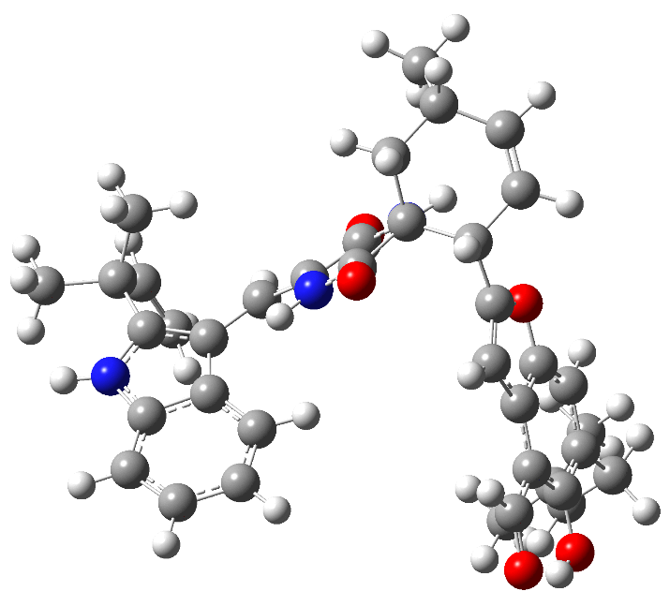  Population=73.11%  Energy=-2012.321344 a. u. | Conformer 2  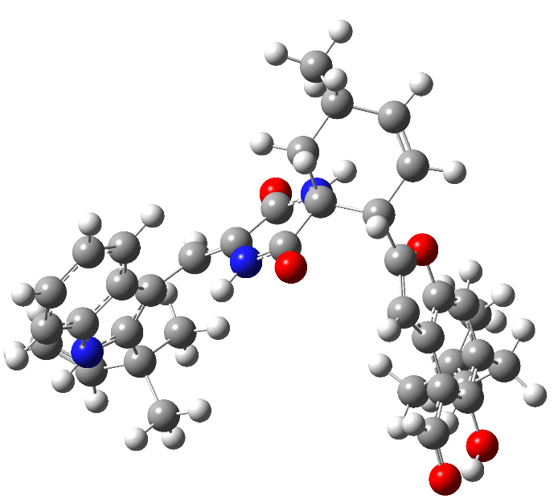  Population=14.00%  Energy=-2012.315539 a. u. | Conformer 3  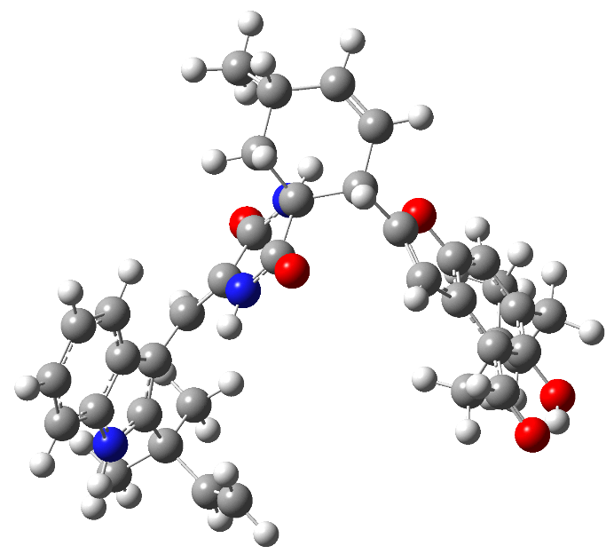  Population=12.89%  Energy=-2012.314854 a. u.
1b
Conformer 1  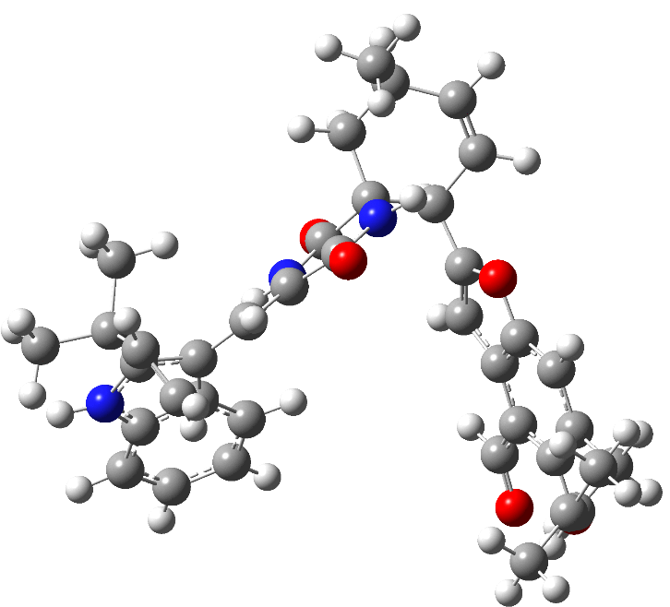  Population=73.44%  Energy=-2012.321344 a. u. | Conformer 2  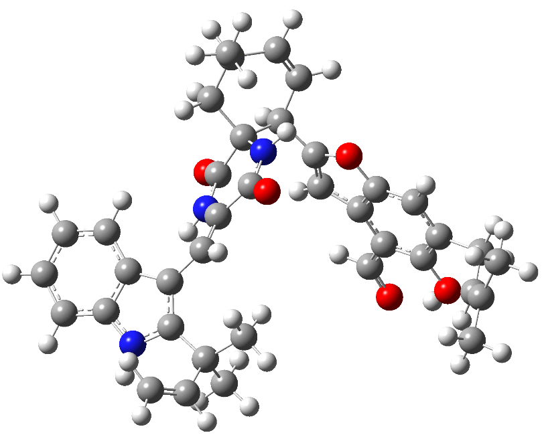  Population=13.61%  Energy=-2012.319462 a. u. | Conformer 3  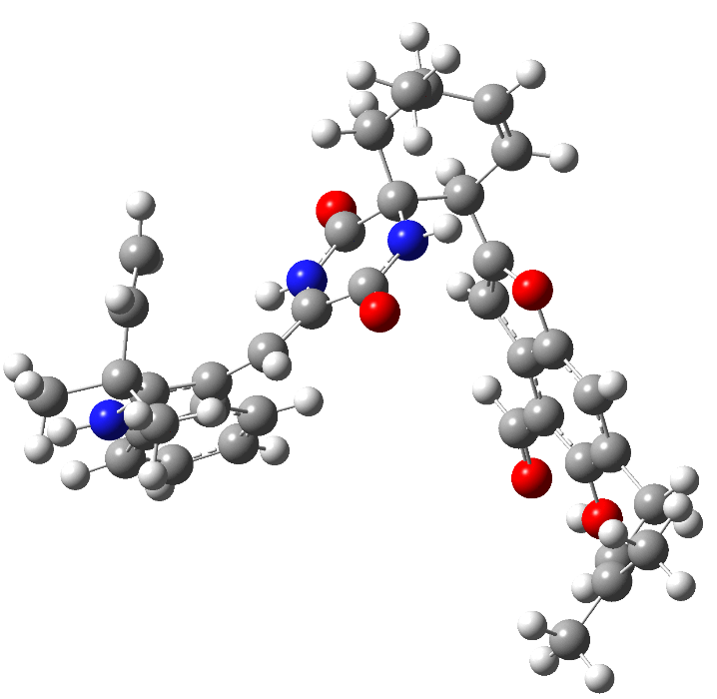  Population=12.95%  Energy=-2012.315537 a. u.
2a
Conformer 1  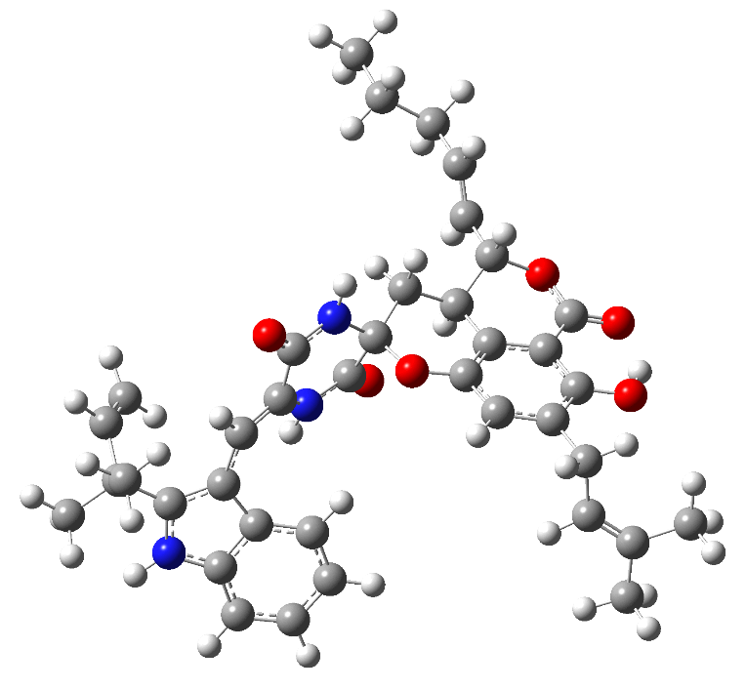  Population=83.06%  Energy=-2088.784667 a. u. | Conformer 2  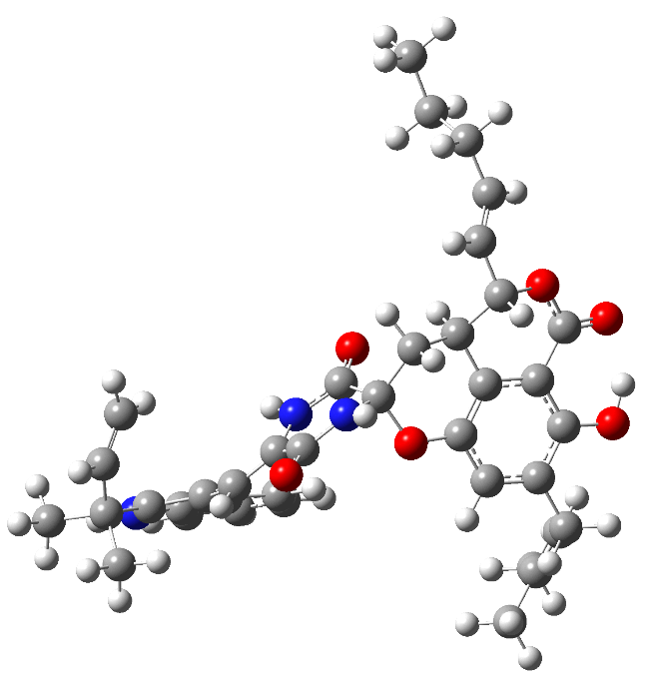  Population=8.59%  Energy=-2088.782622 a. u. | Conformer 3  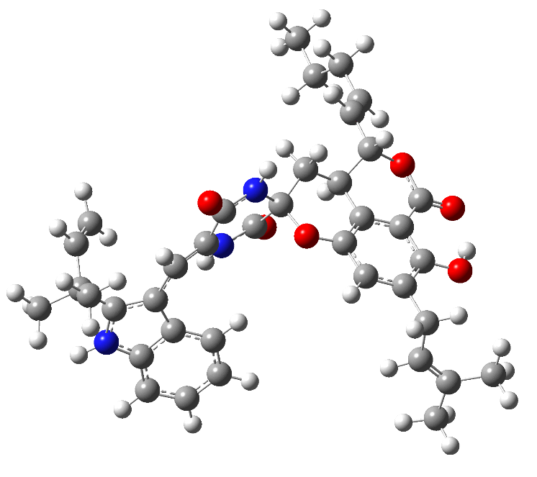  Population=8.36%  Energy=-2088.782608 a. u.
2b
Conformer 1  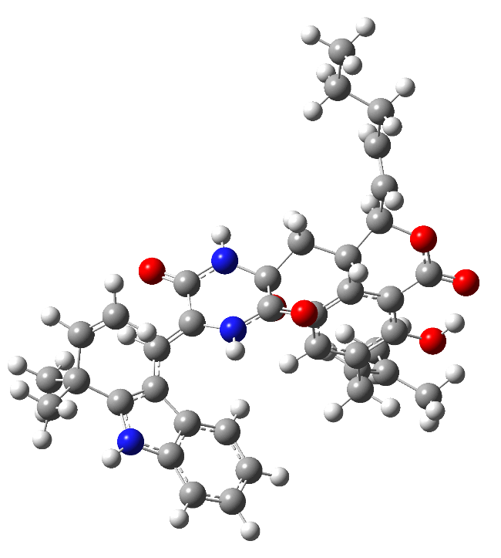  Population=95.66%  Energy=-2088.784673 a. u. | Conformer 2  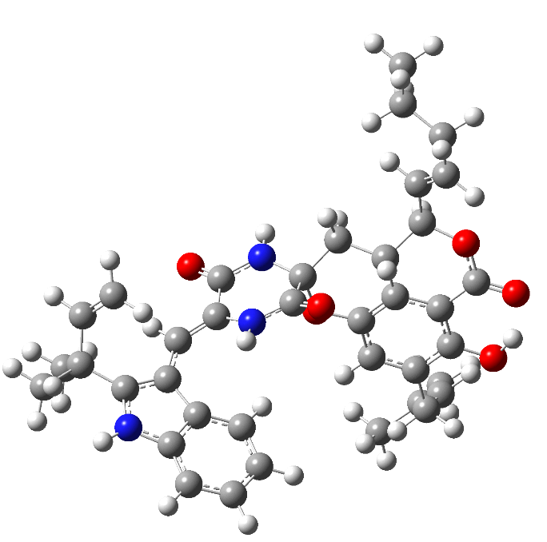  Population=3.11%  Energy=-2088.781565 a. u. | Conformer 3  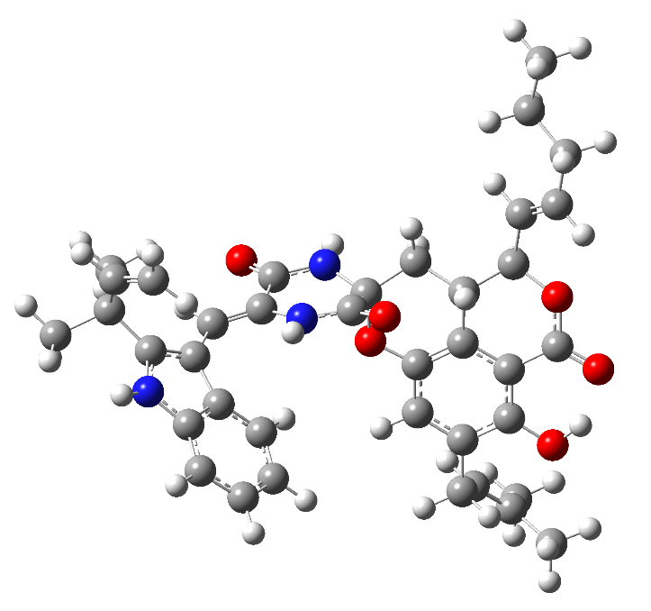  Population=1.23%  Energy=-2088.778959 a. u.

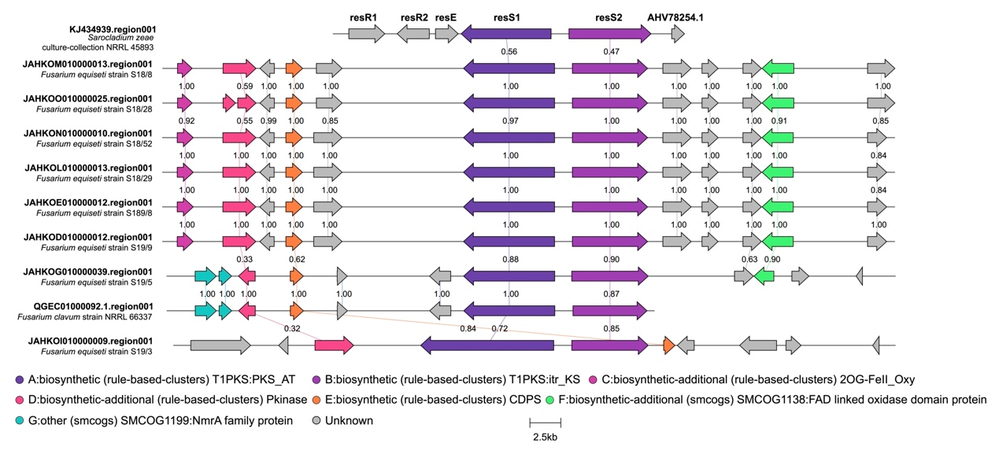
Figure S1 The composition of BGCs containing CDPS from cluster 3.
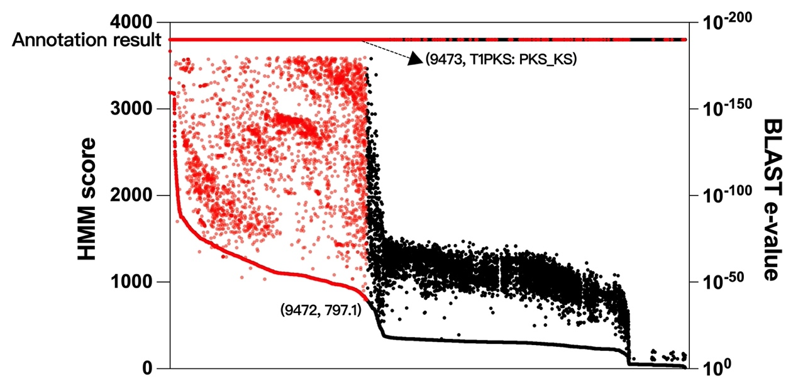
Figure S2 Result of the gene centric-screening approach for genes encoding diketopiperazine-forming NRPSs. Obtained unique proteins are depicted along the horizontal axis where they are sorted according to their hidden Markov chain (HMM) score represented by the primary vertical axis. Annotation result of sequences are indicated by the color code (Red: NRPS; black: others).
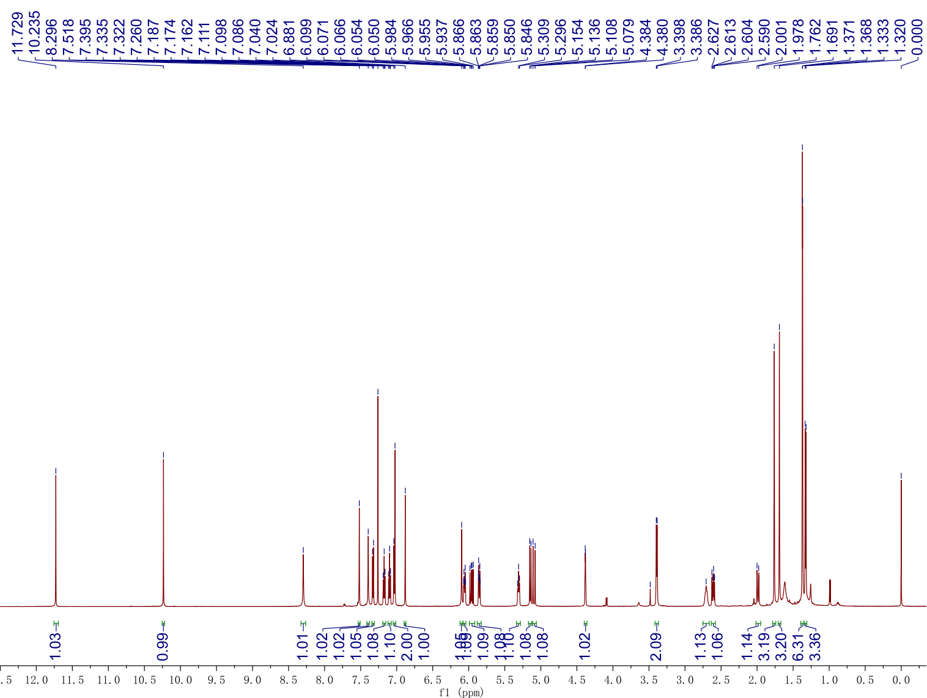
Figure S3 ¹H NMR (600 MHz) spectrum of 1 in CDCl₃.
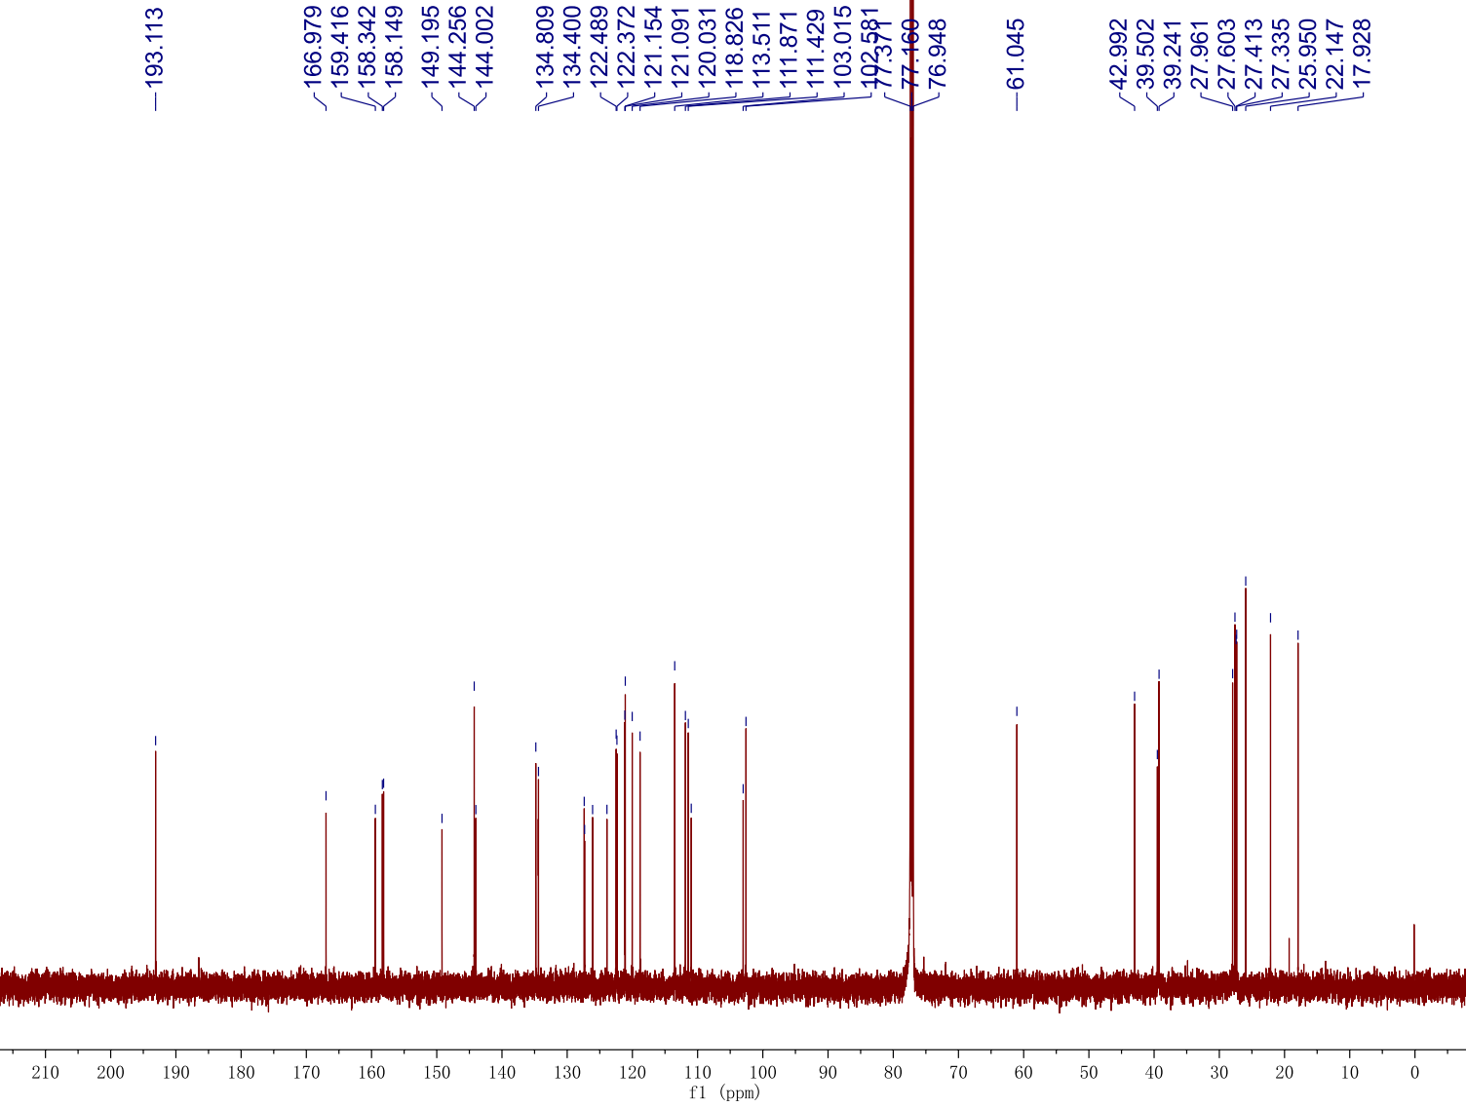Figure S4 ¹³C NMR (150 MHz) spectrum of 1 in CDCl₃.
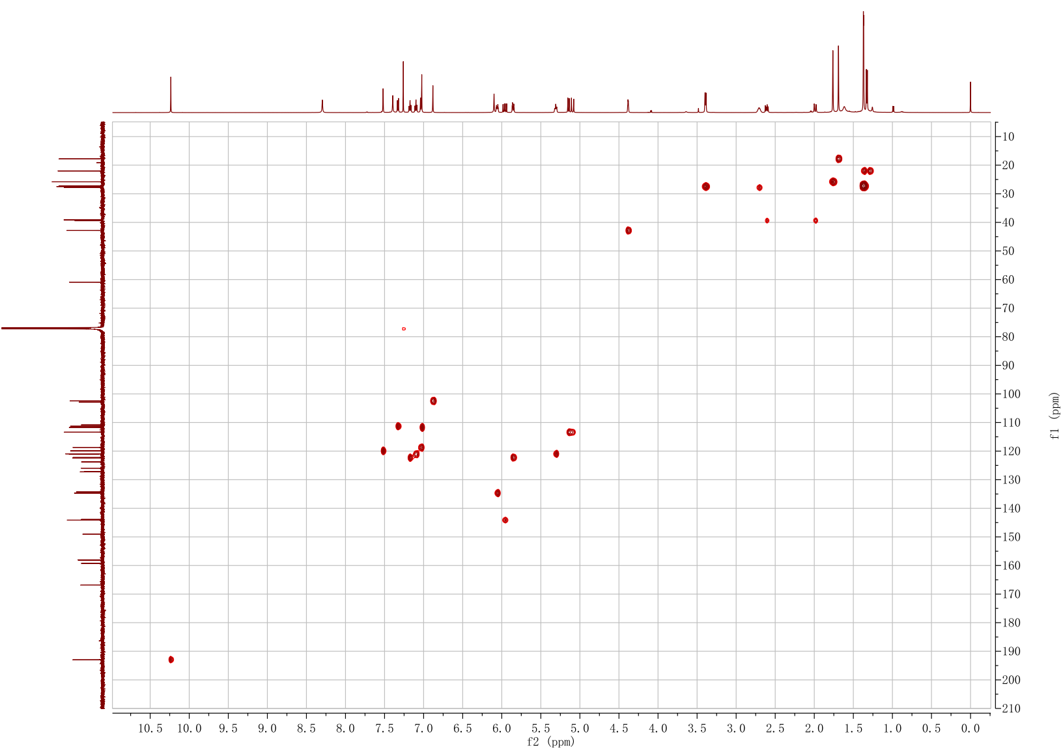Figure S5 HSQC spectrum of 1 in CDCl₃.
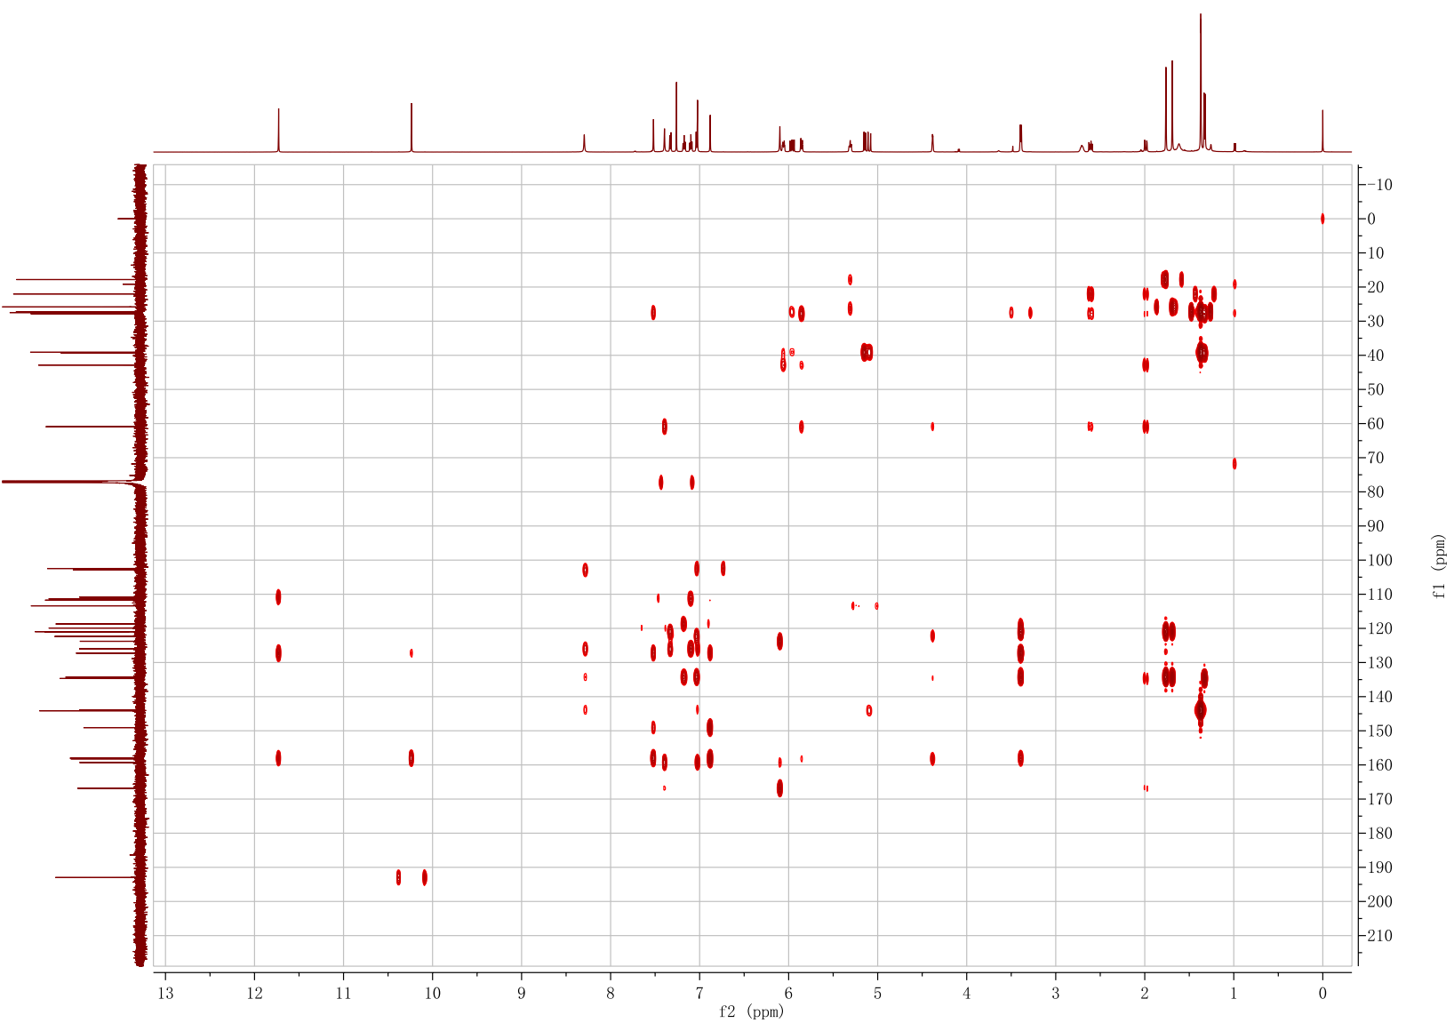Figure S6 HMBC spectrum of 1 in CDCl₃.
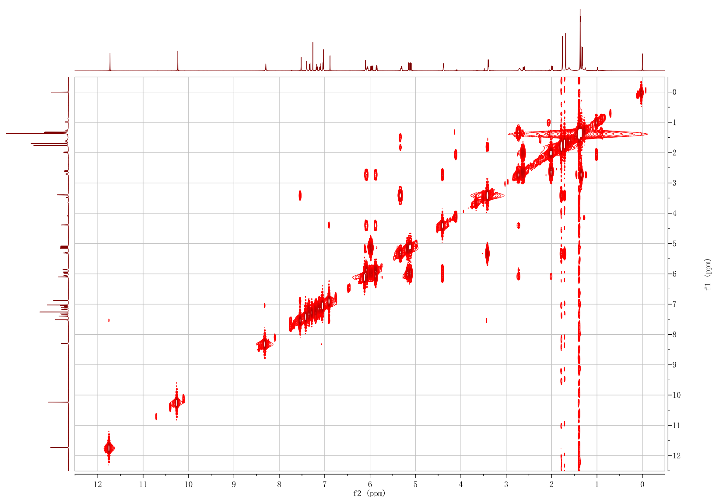
Figure S7 ¹H-¹H COSY spectrum of 1 in CDCl₃.
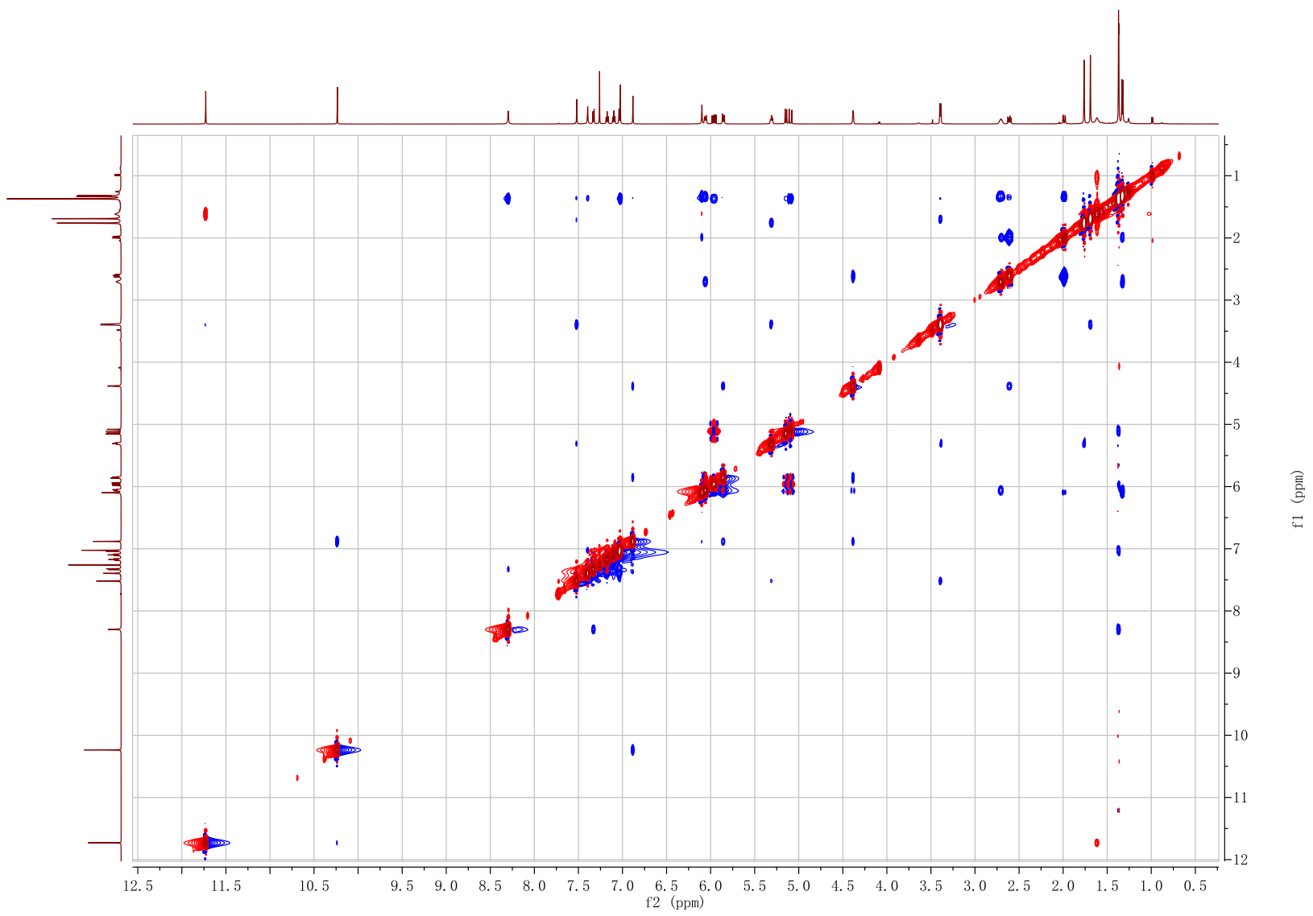Figure S8 NOESY spectrum of 1 in CDCl₃.
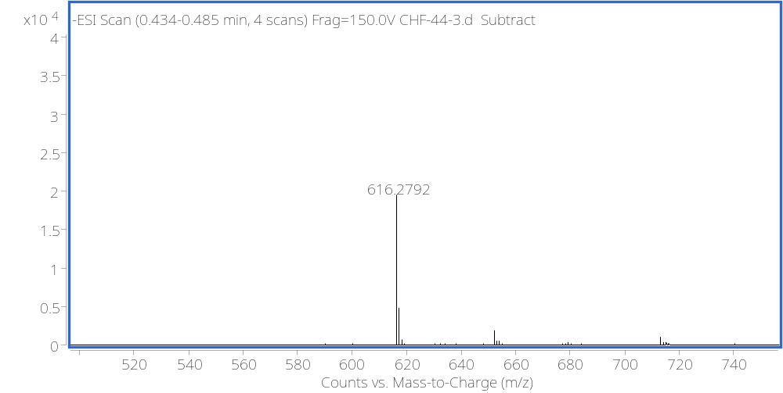Figure S9 HRESIMS spectrum of 1.
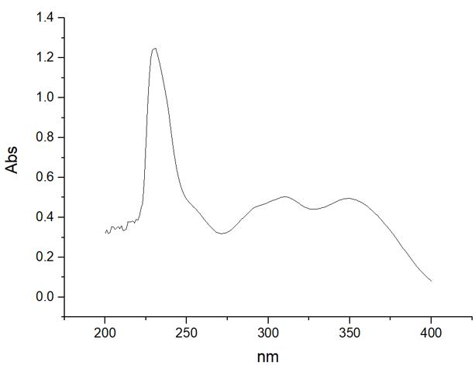
Figure S10 UV spectrum of 1.
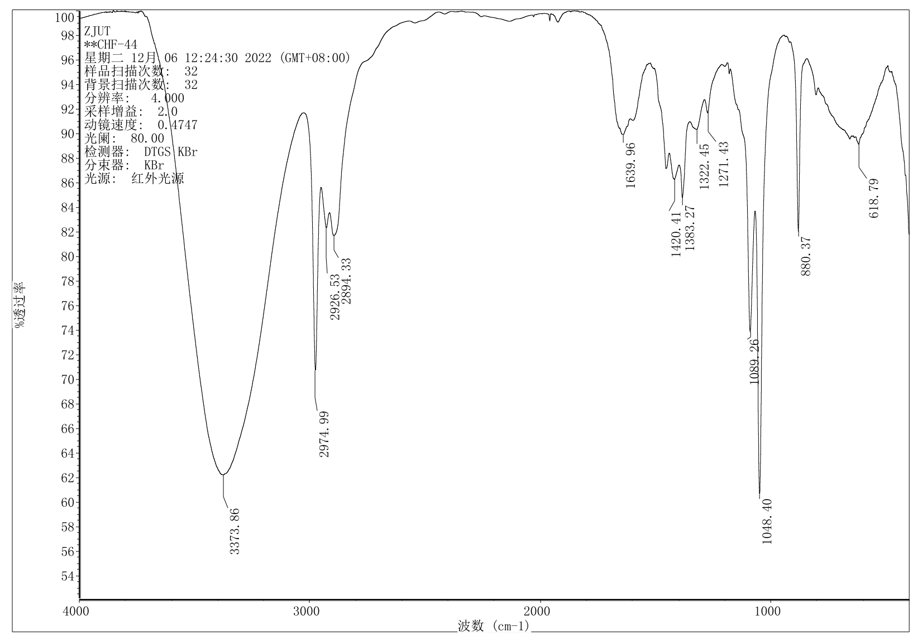Figure S11 IR spectrum of 1.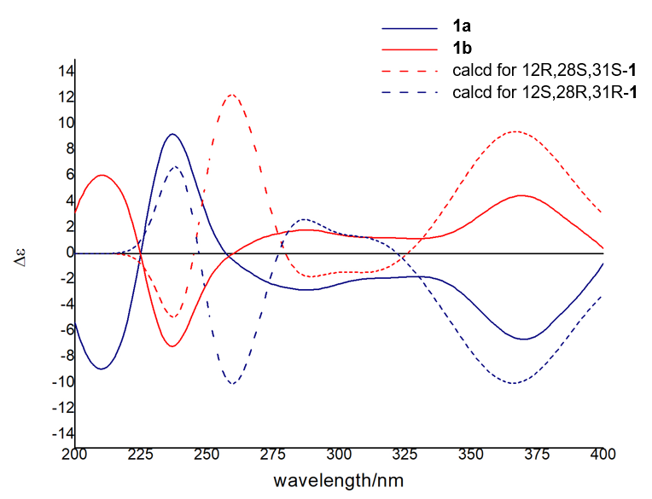
Figure S12 Experimental and calculated ECD spectra of 1a and 1b

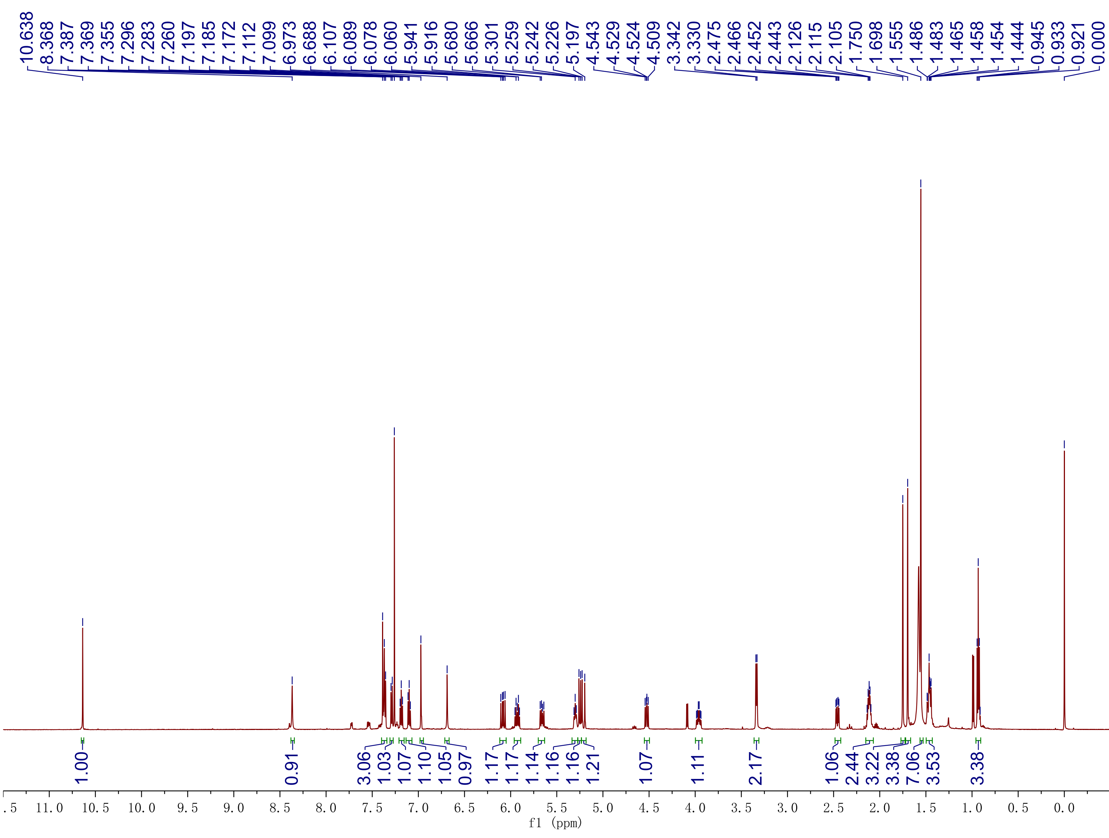
Figure S13 ¹H NMR (600 MHz) spectrum of 2 in CDCl₃.
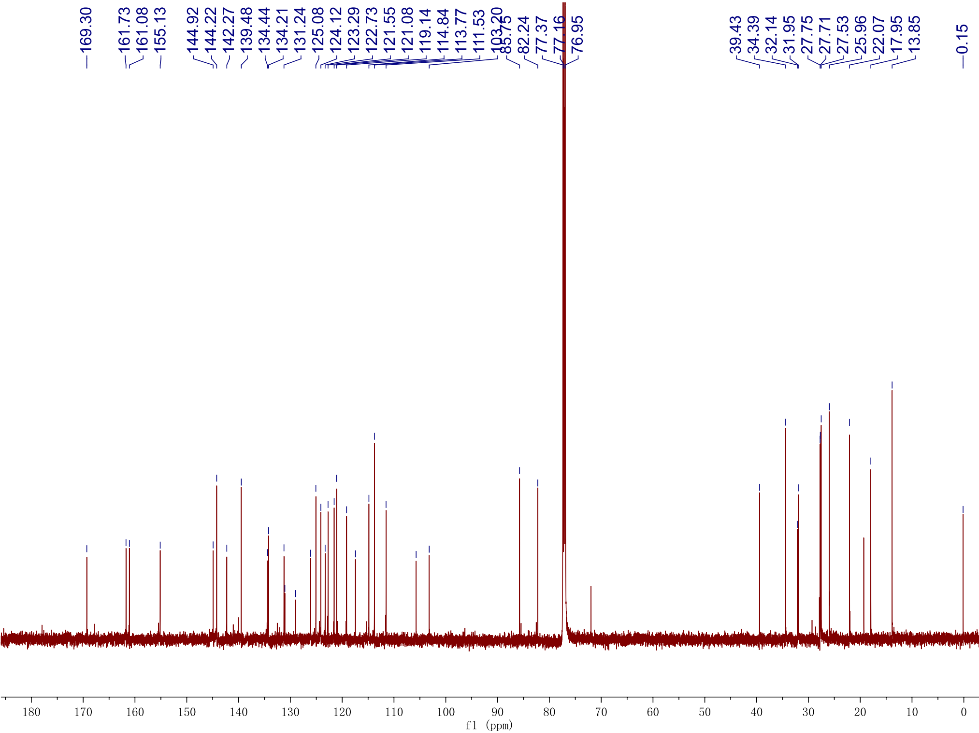
Figure S14 ¹³C NMR (150 MHz) spectrum of 2 in CDCl₃.
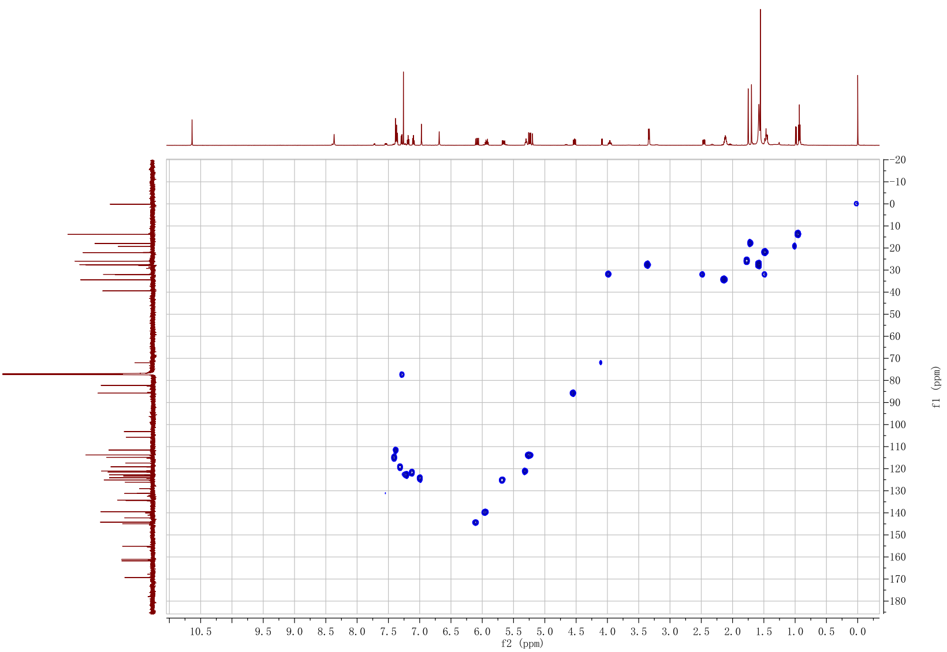
Figure S15 HSQC spectrum of 2 in CDCl₃.
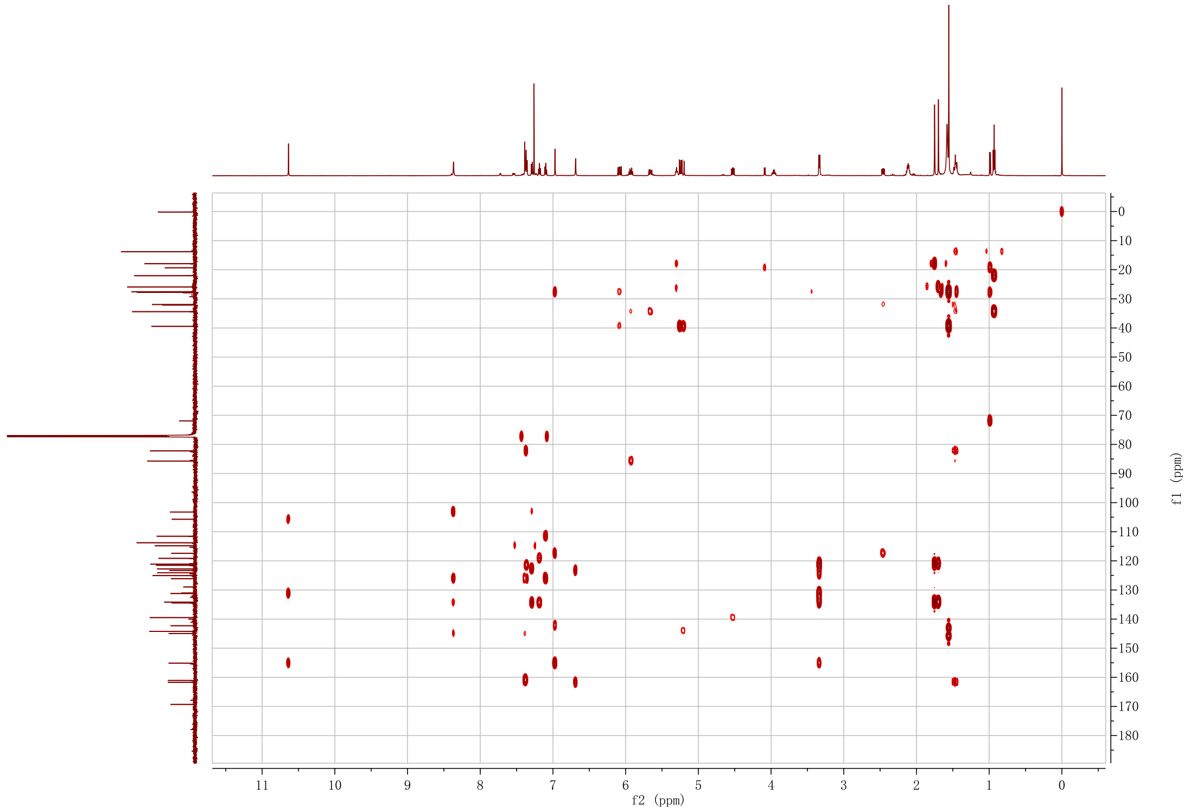
Figure S16 HMBC spectrum of 2 in CDCl₃.
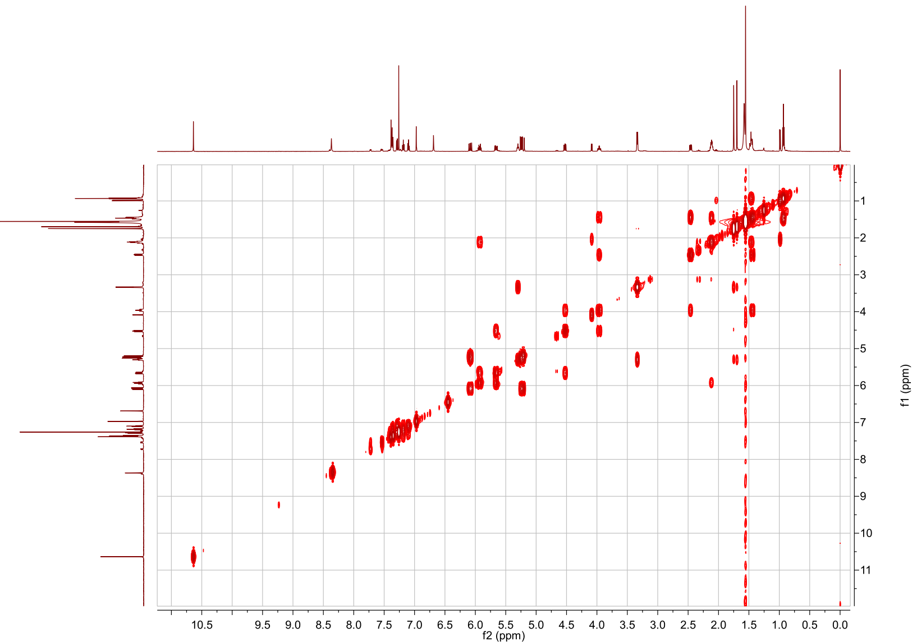Figure S17 ¹H-¹H COSY spectrum of 2 in CDCl₃.
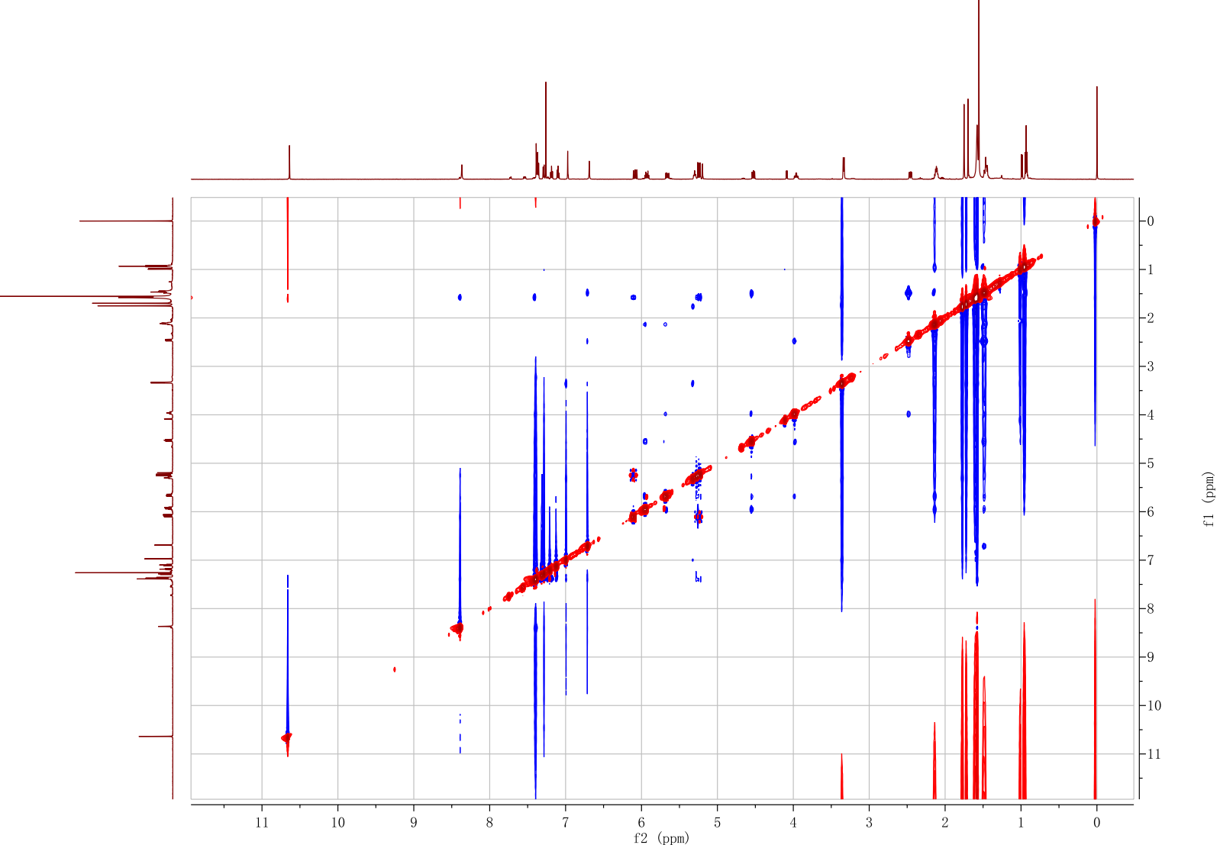Figure S18 NOESY spectrum of 2 in CDCl₃.

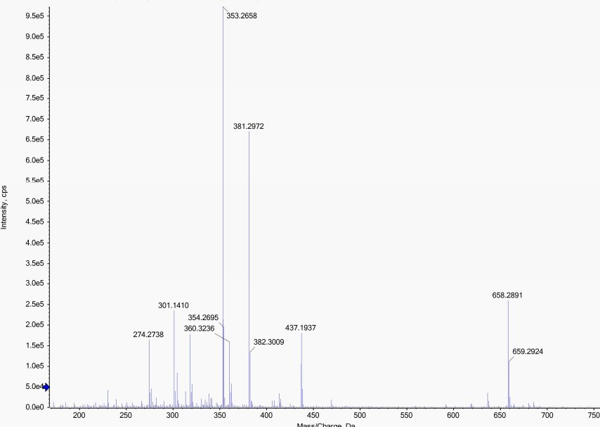Figure S19 HRESIMS spectrum of 2.
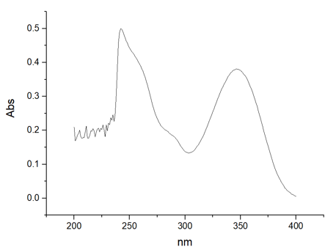
Figure S20 UV spectrum of 2.

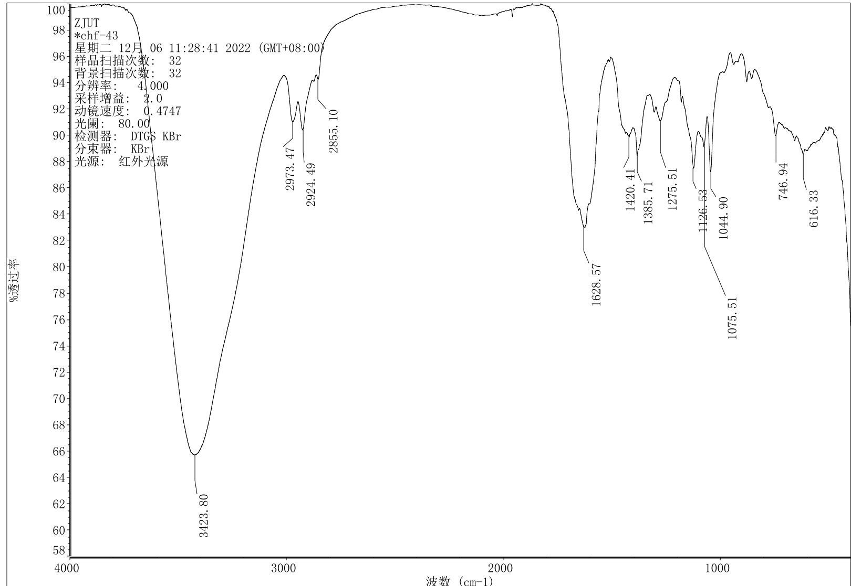Figure S21 IR spectrum of 2.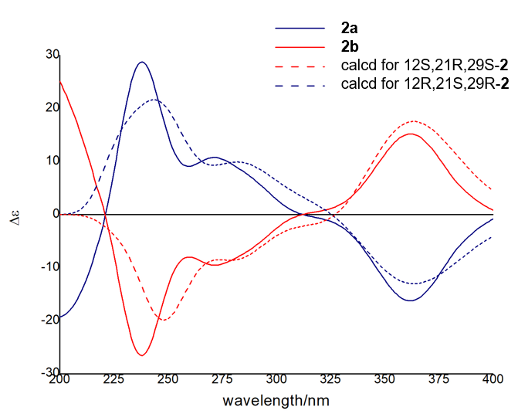
Figure S22 Experimental and calculated ECD spectra of 2a and 2b

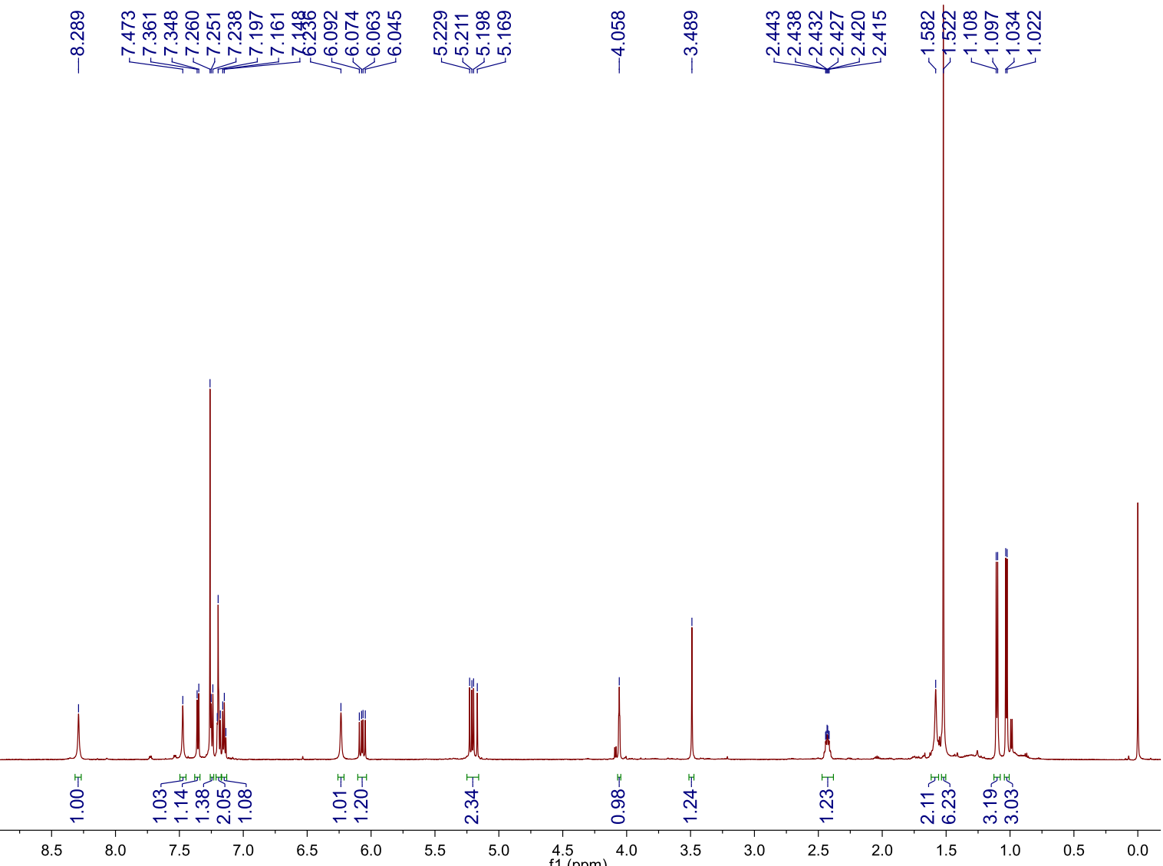
Figure S23 ¹H NMR (600 MHz) spectrum of 3 in CDCl₃.
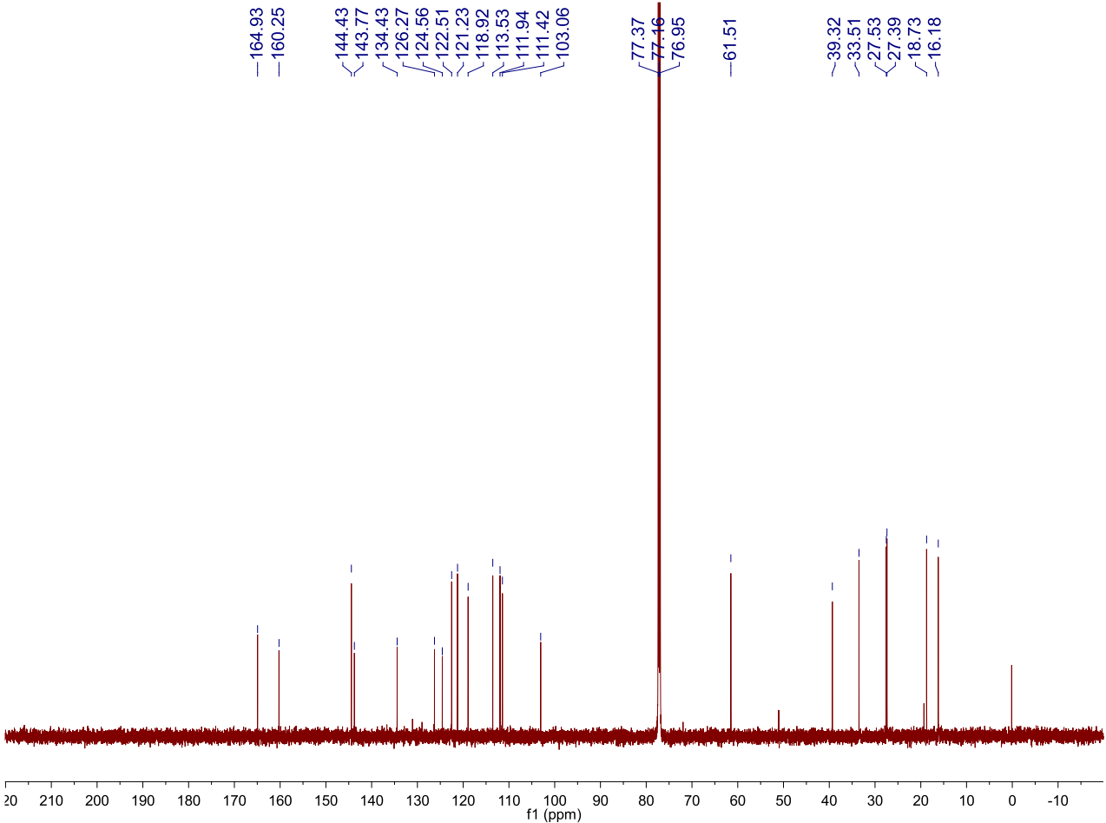Figure S24 ¹³C NMR (150 MHz) spectrum of 3 in CDCl₃.
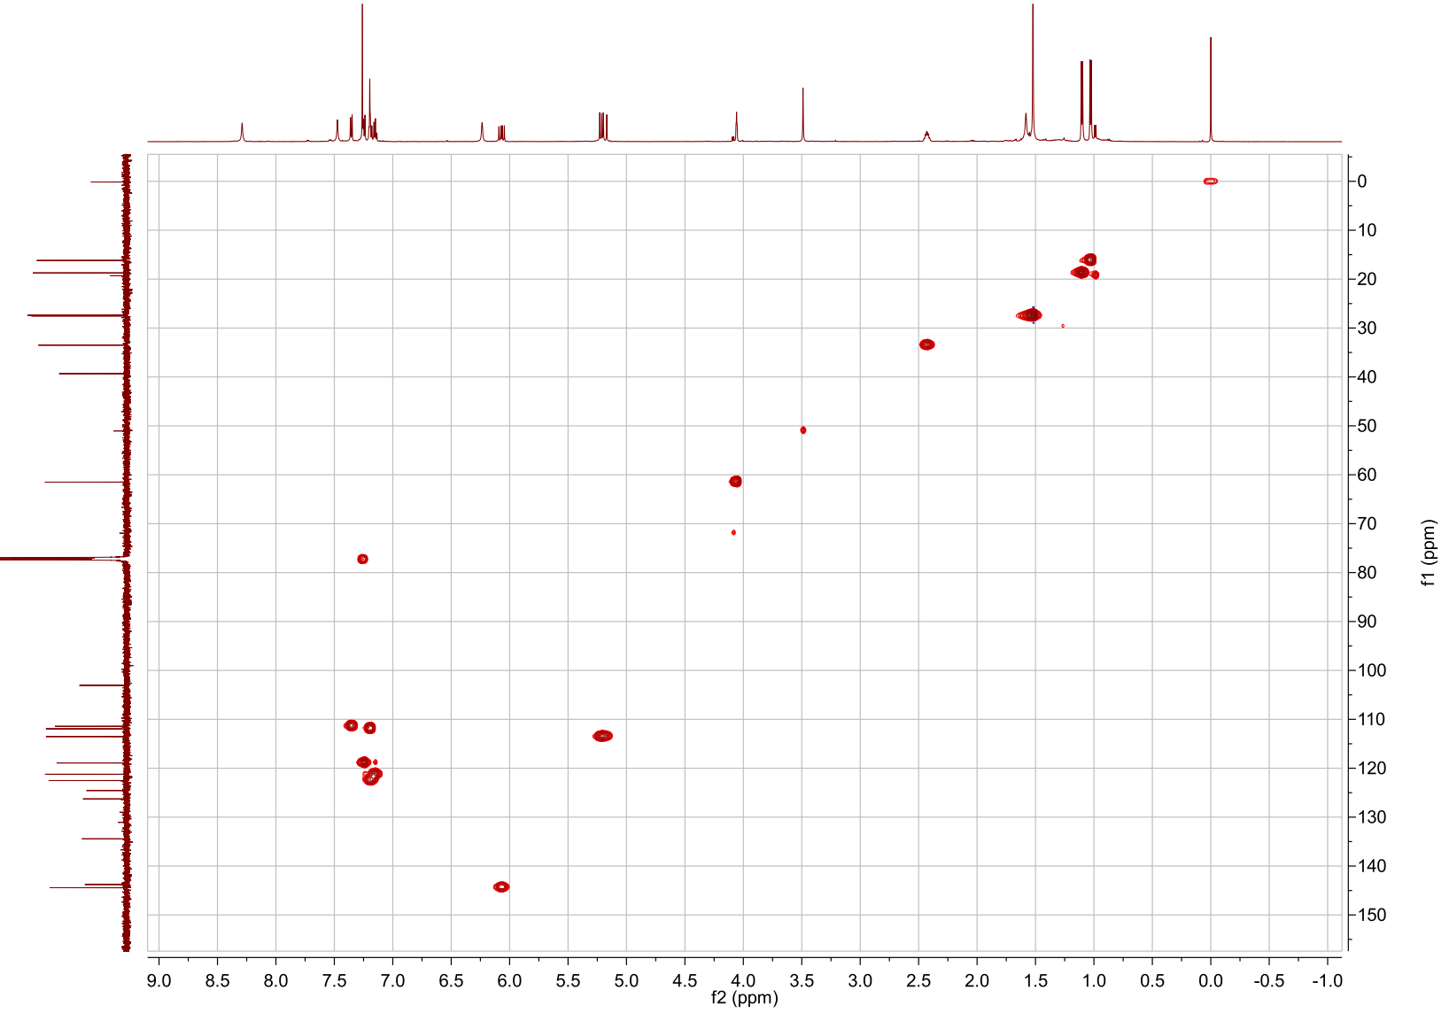Figure S25 HSQC spectrum of 3 in CDCl₃.
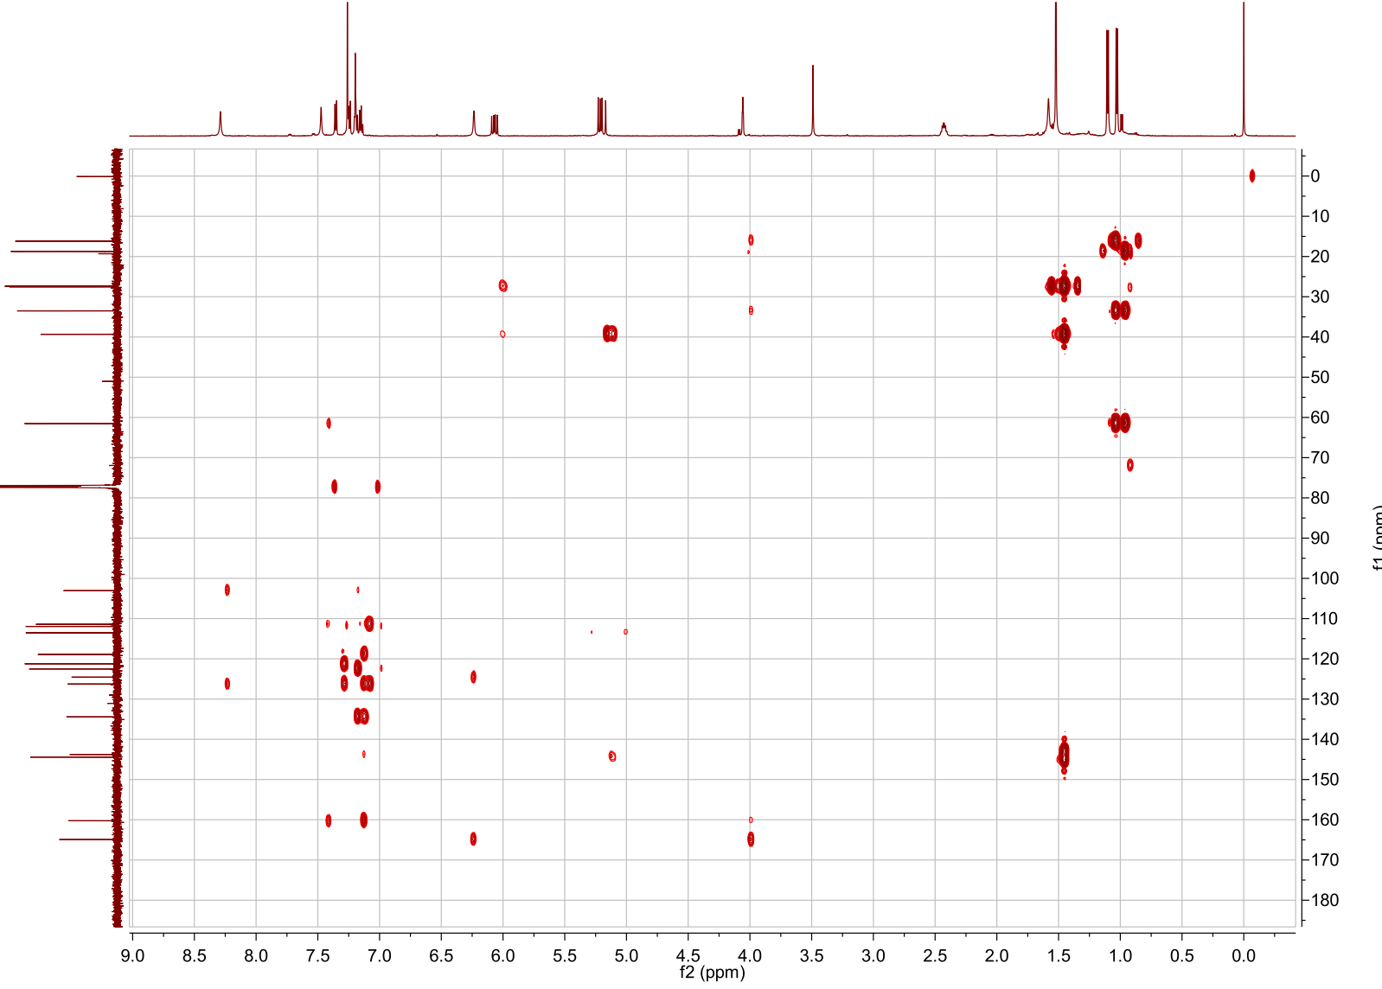Figure S26 HMBC spectrum of 3 in CDCl₃.
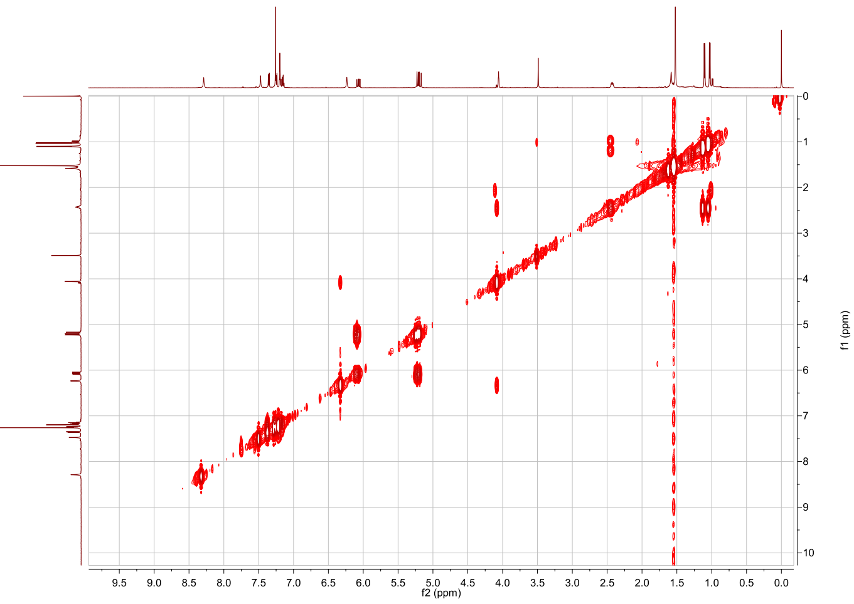Figure S27 ¹H-¹H COSY spectrum of 3 in CDCl₃.
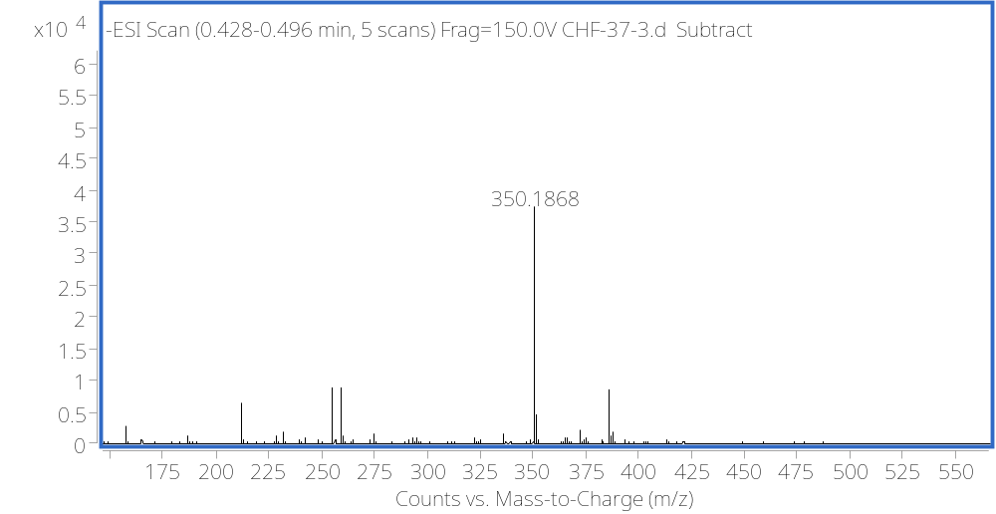Figure S28 HRESIMS spectrum of 3.
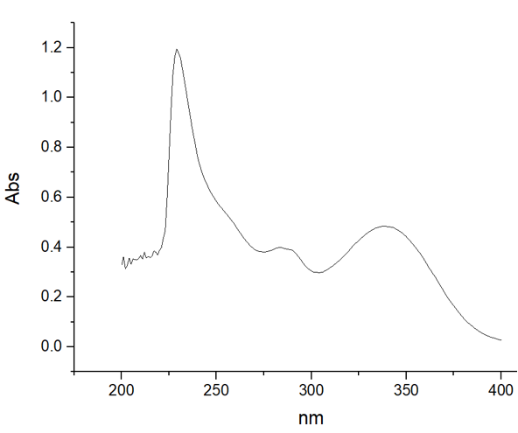
Figure S29 UV spectrum of 3.
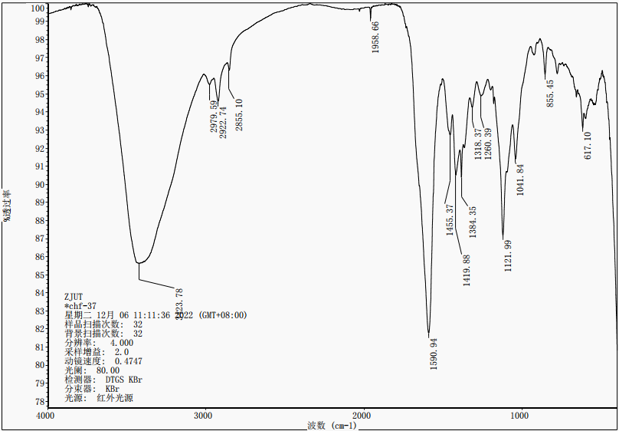Figure S30 IR spectrum of 3.

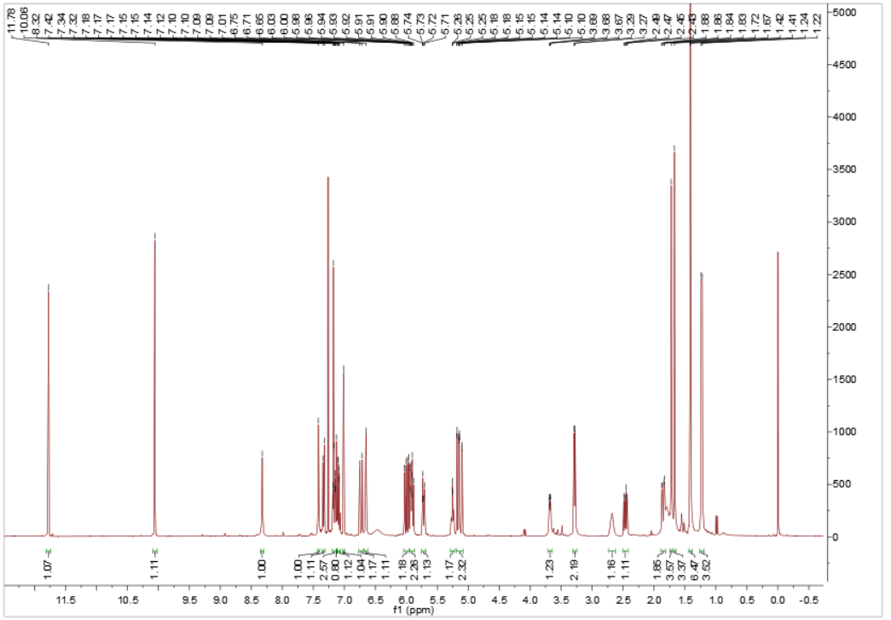
Figure S31 ¹H NMR (600 MHz) spectrum of 4 in CDCl₃.

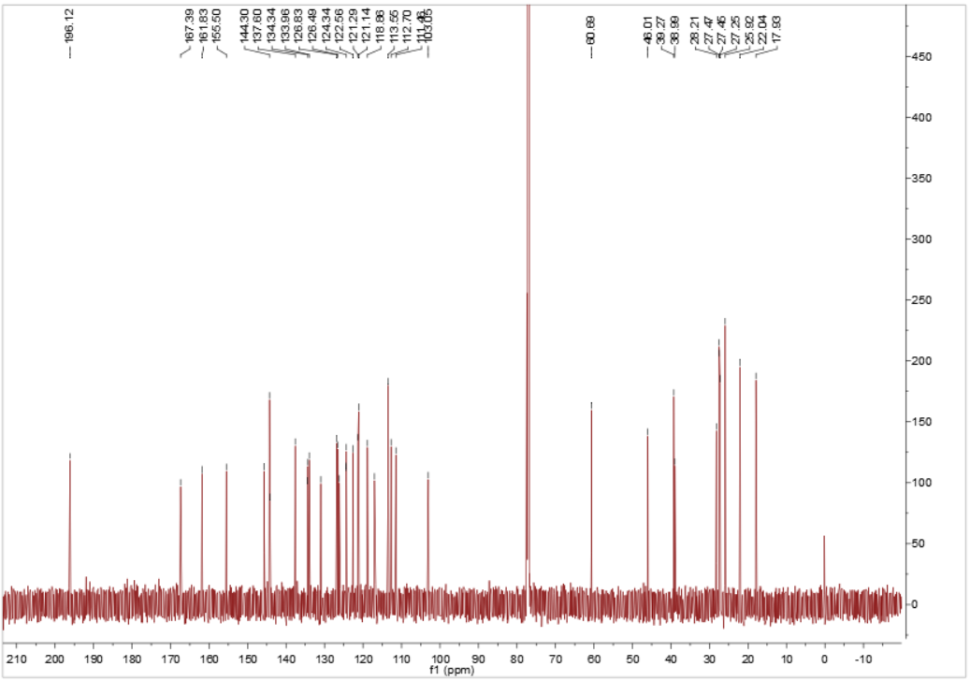
Figure S32 ¹³C NMR (150 MHz) spectrum of 4 in CDCl₃.

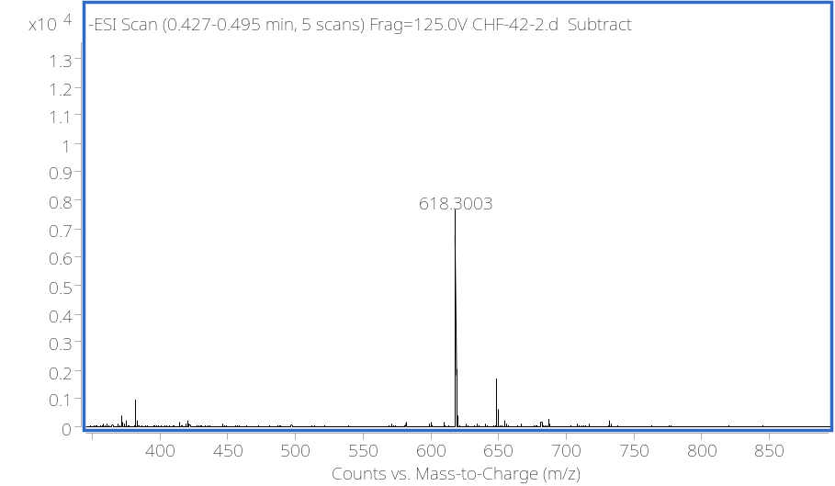
Figure S33 HRESIMS spectrum of 4.

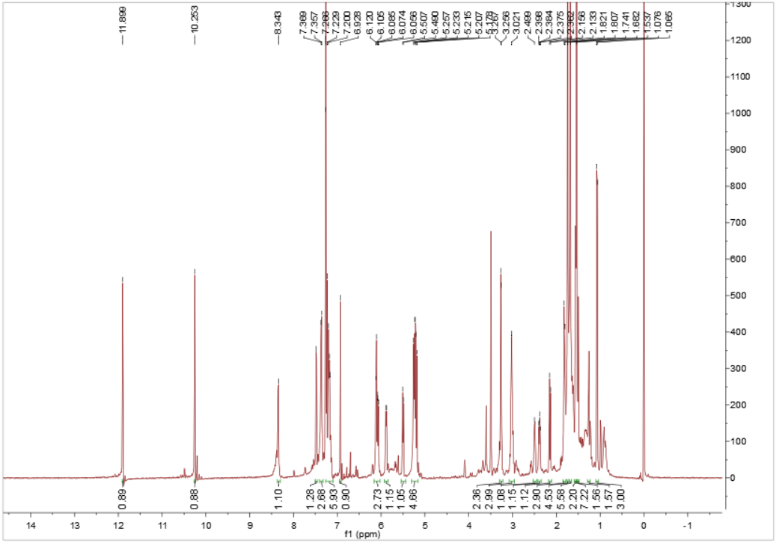
Figure S34 ¹H NMR (600 MHz) spectrum of 5 in CDCl₃.

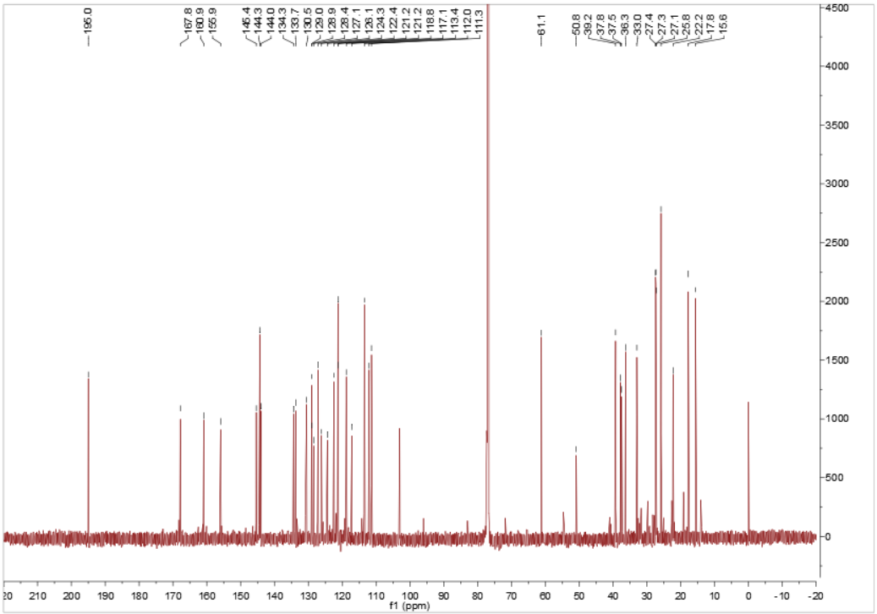
Figure S35 ¹³C NMR (150 MHz) spectrum of 5 in CDCl₃.
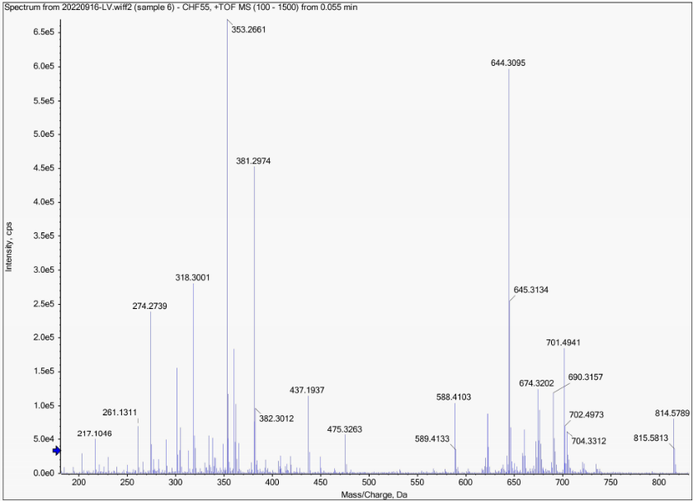
Figure S36 HRESIMS spectrum of 5.

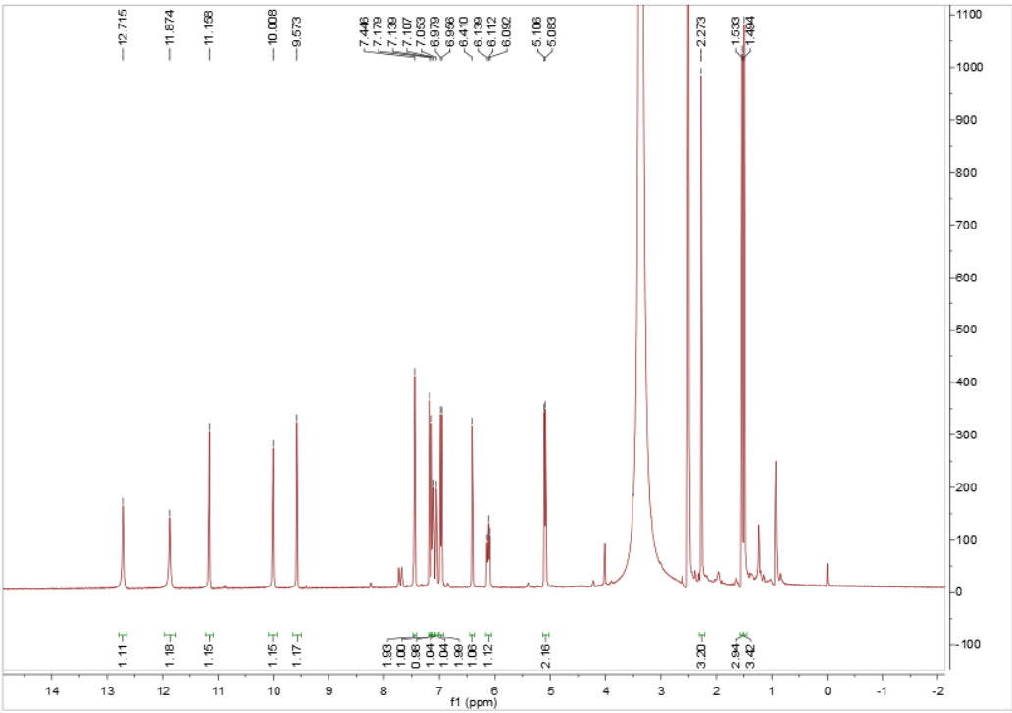
Figure S37 ¹H NMR (600 MHz) spectrum of 6 in DMSO-d₆.

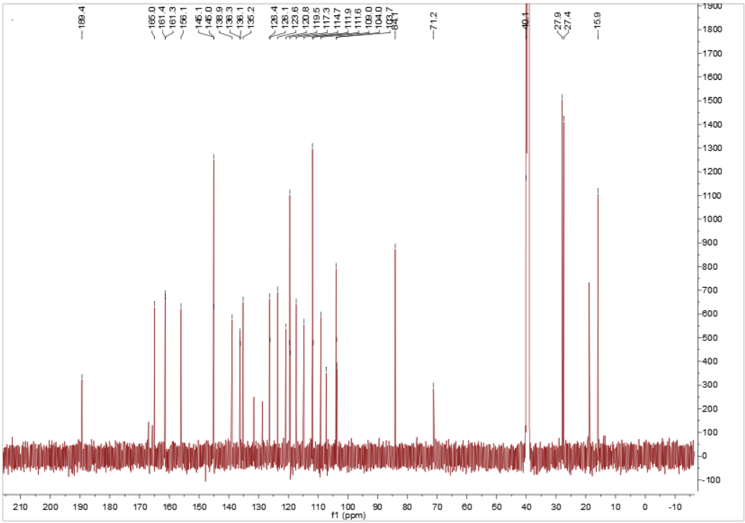
Figure S38 ¹³C NMR (150 MHz) spectrum of 6 in DMSO-d₆.

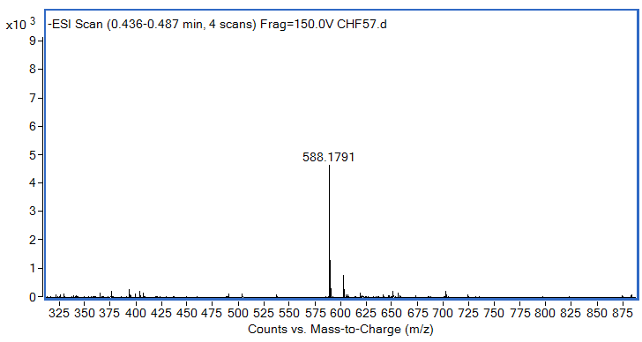
Figure S39 HRESIMS spectrum of 6.

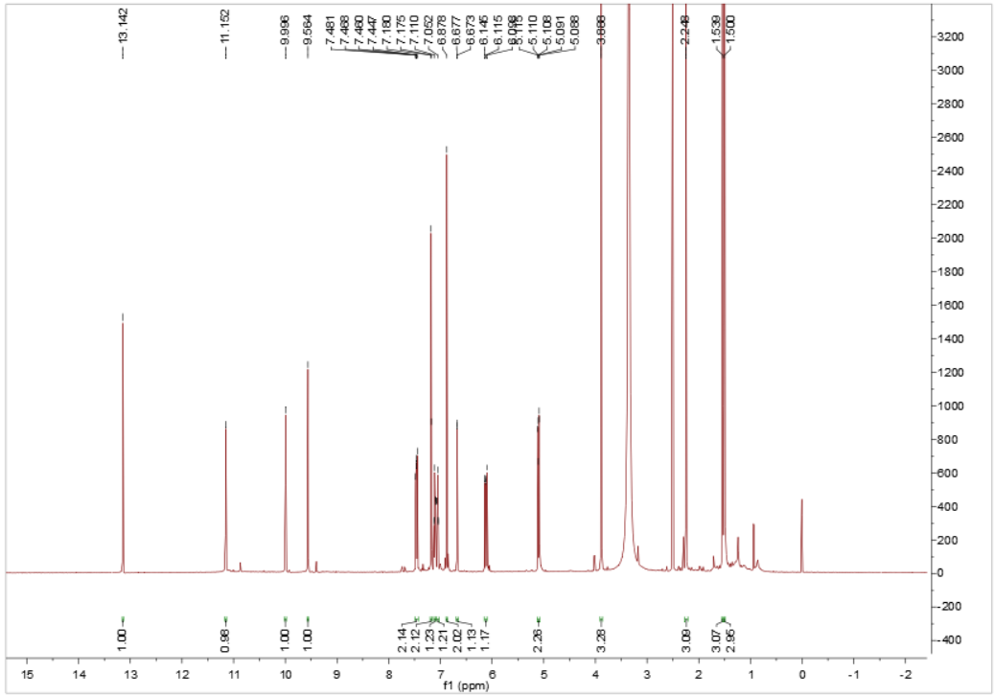
Figure S40 ¹H NMR (600 MHz) spectrum of 7 in DMSO-d₆.

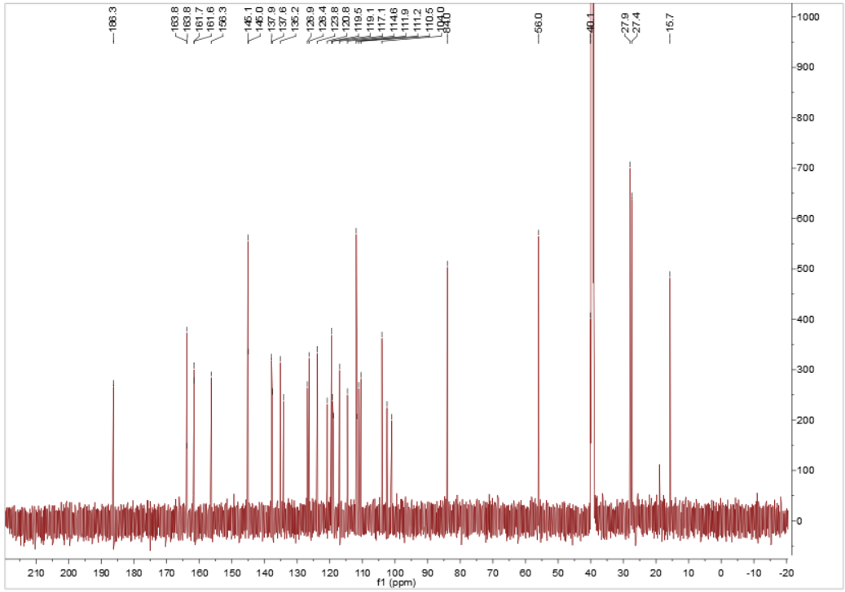
Figure S41 ¹³C NMR (150 MHz) spectrum of 7 in DMSO-d₆.

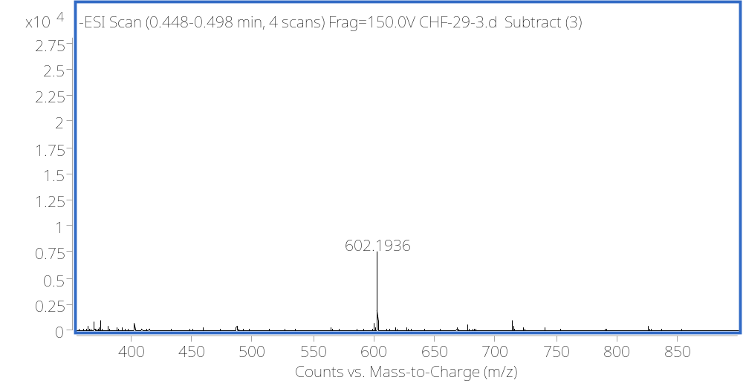
Figure S42 HRESIMS spectrum of 7.

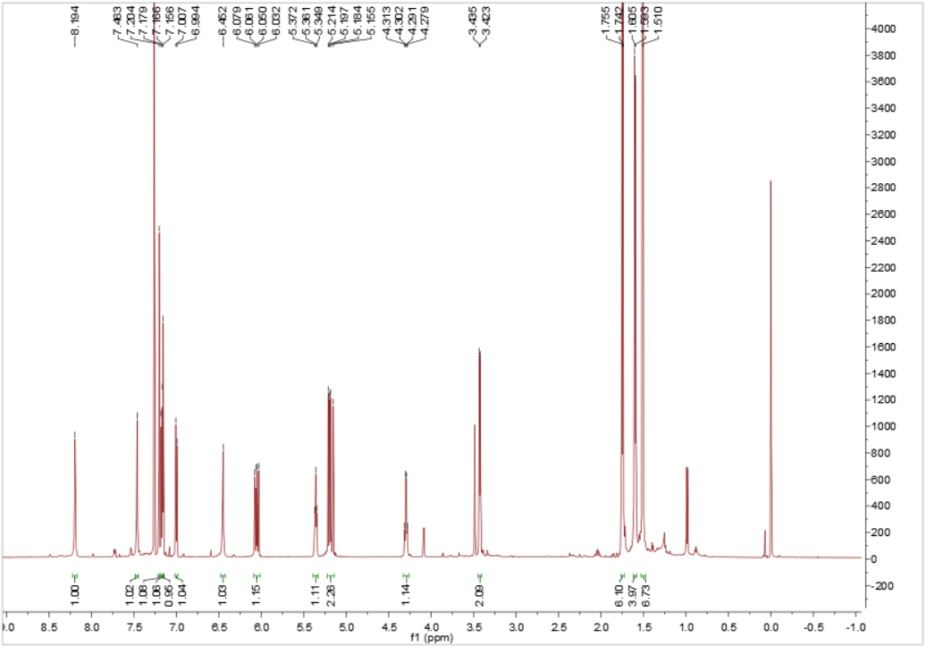
Figure S43 ¹H NMR (600 MHz) spectrum of 8 in CDCl₃.

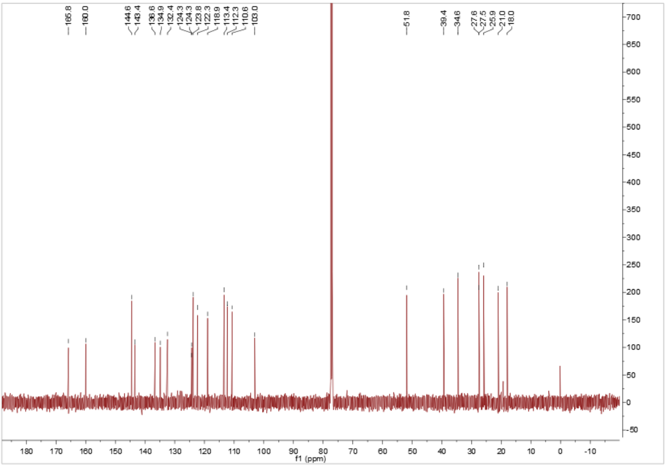
Figure S44 ¹³C NMR (150 MHz) spectrum of 8 in CDCl₃.

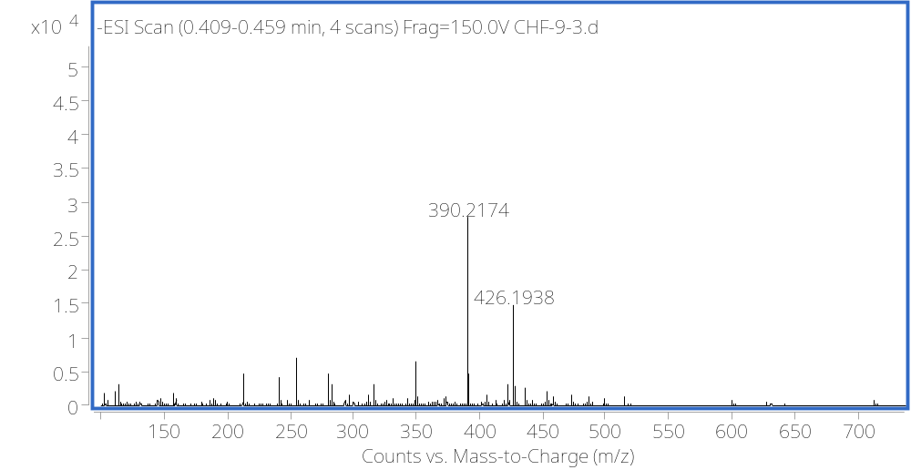
Figure S45 HRESIMS spectrum of 8.

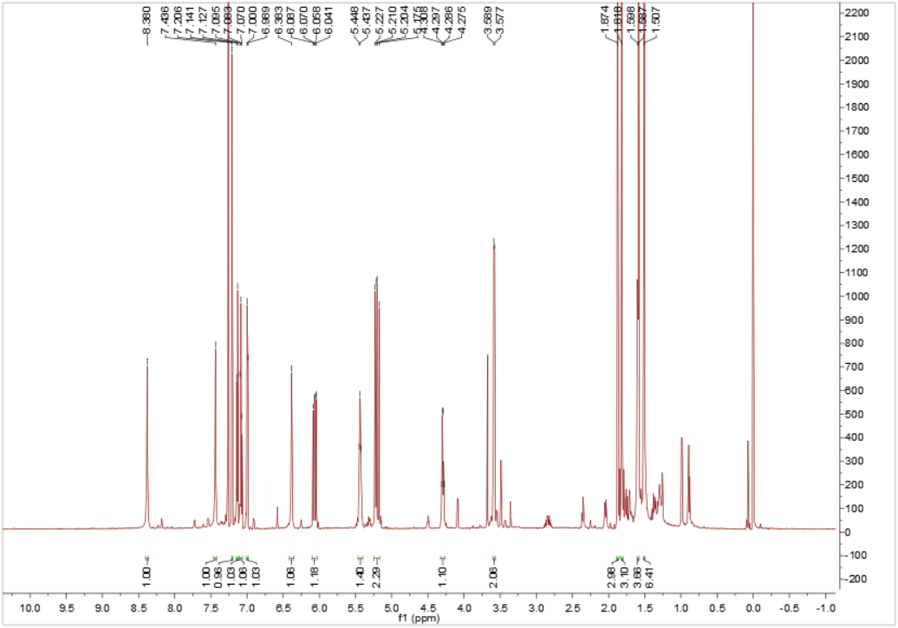
Figure S46 ¹H NMR (600 MHz) spectrum of 9 in CDCl₃.

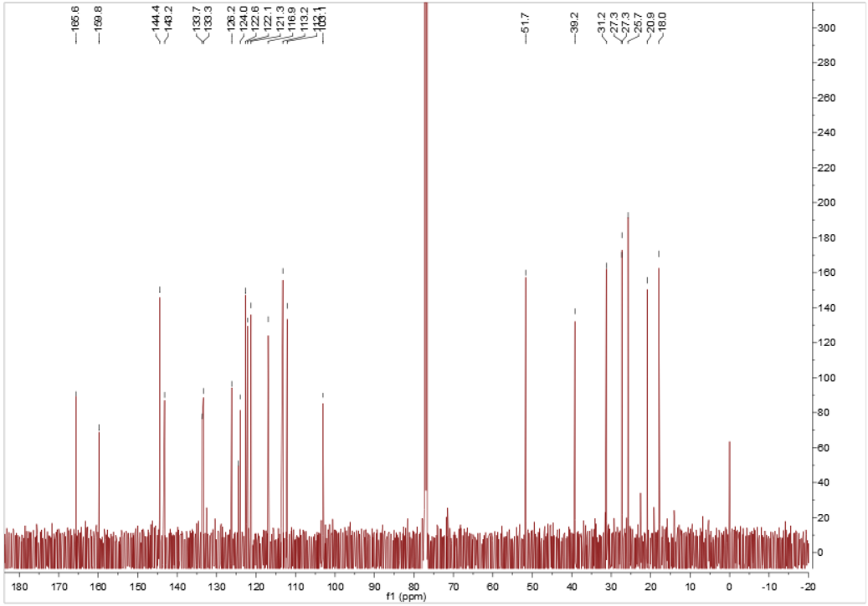
Figure S47 ¹³C NMR (150 MHz) spectrum of 9 in CDCl₃.

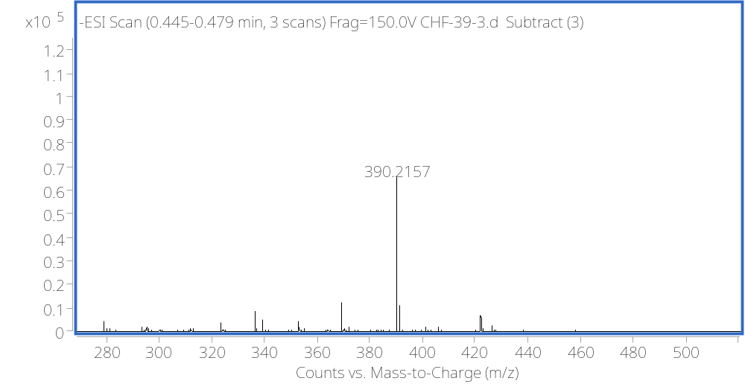
Figure S48 HRESIMS spectrum of 9.

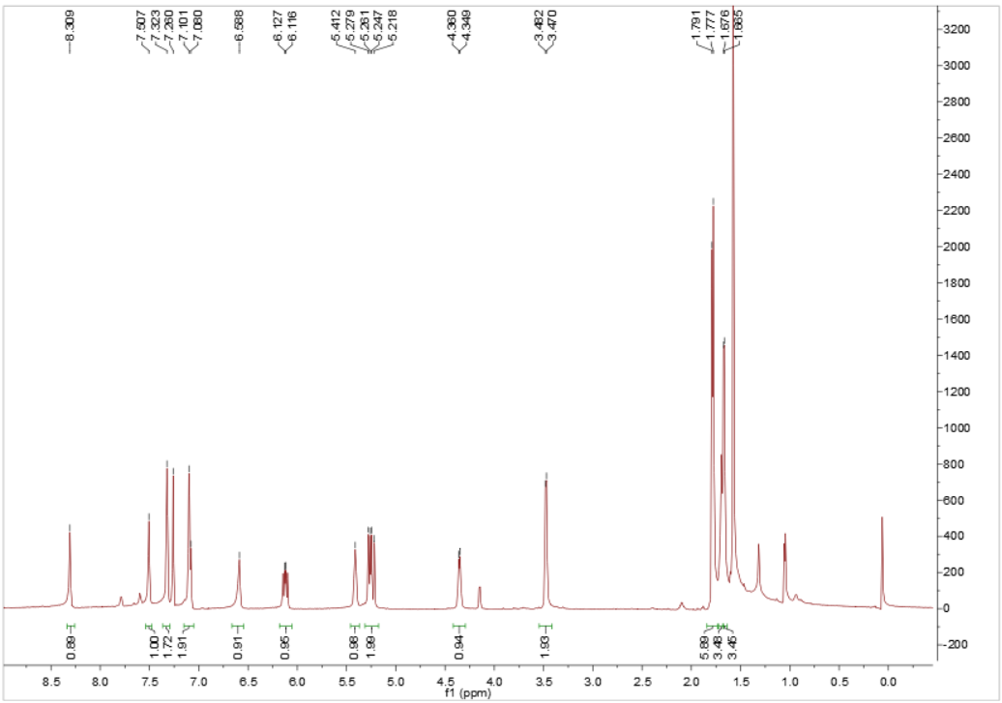
Figure S49 ¹H NMR (600 MHz) spectrum of 10 in CDCl₃.

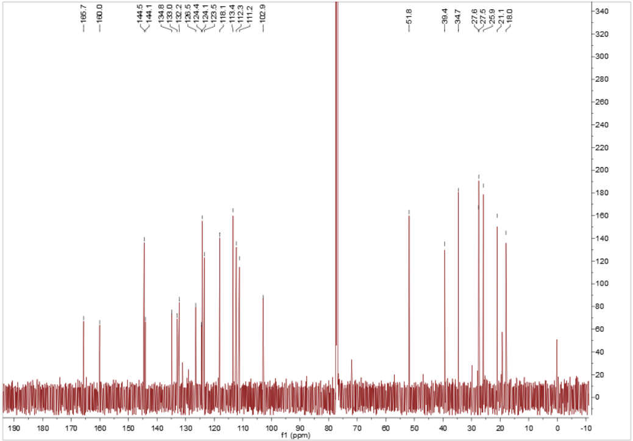
Figure S50 ¹³C NMR (150 MHz) spectrum of 10 in CDCl₃.

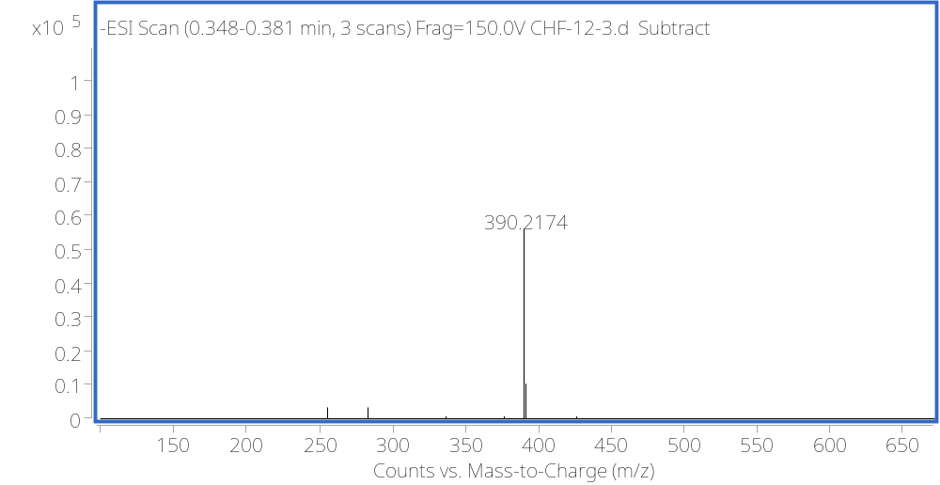
Figure S51 HRESIMS spectrum of 10.

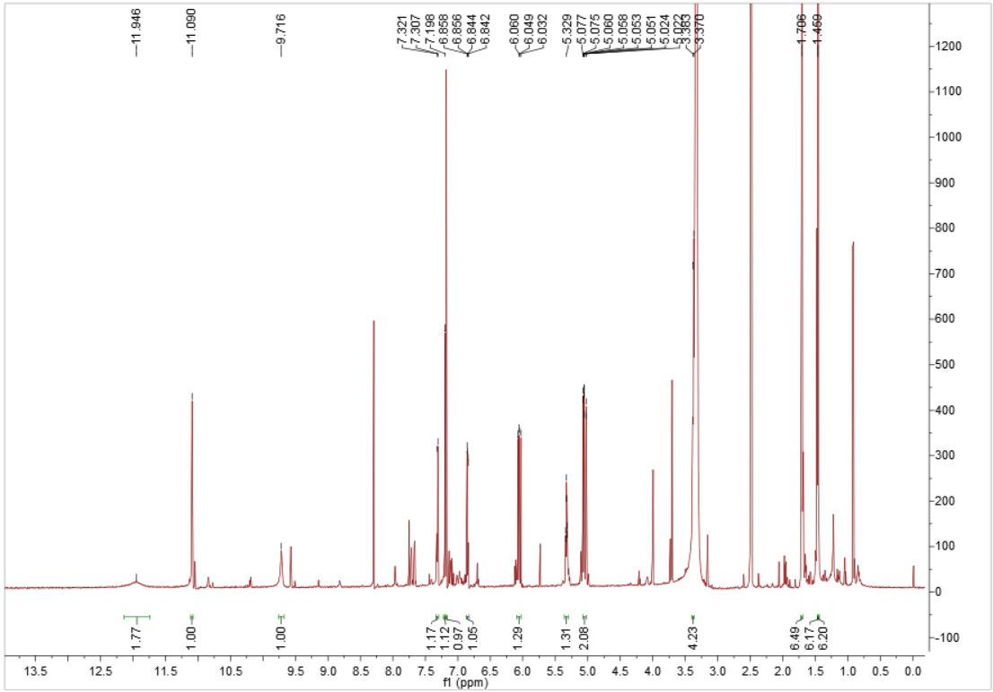
Figure S52 ¹H NMR (600 MHz) spectrum of 11 in CDCl₃.

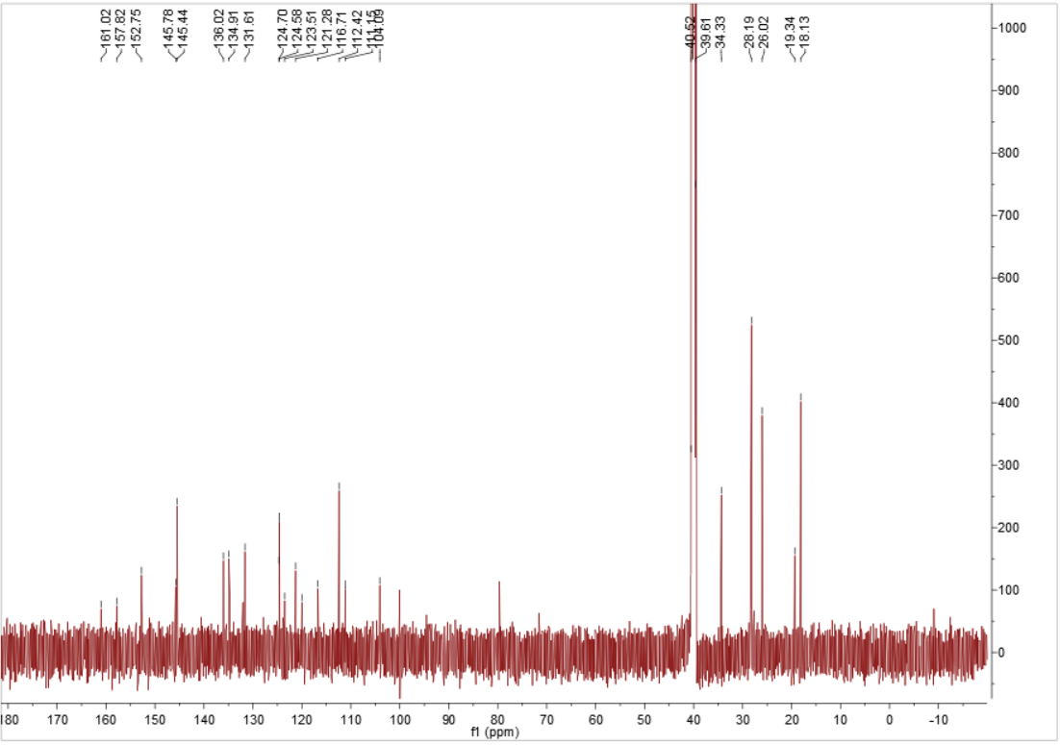
Figure S53 ¹³C NMR (150 MHz) spectrum of 11 in CDCl₃.
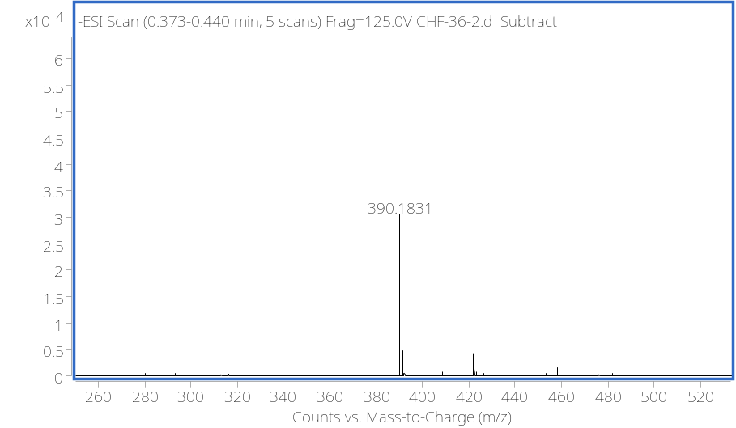
Figure S54 HRESIMS spectrum of 11.

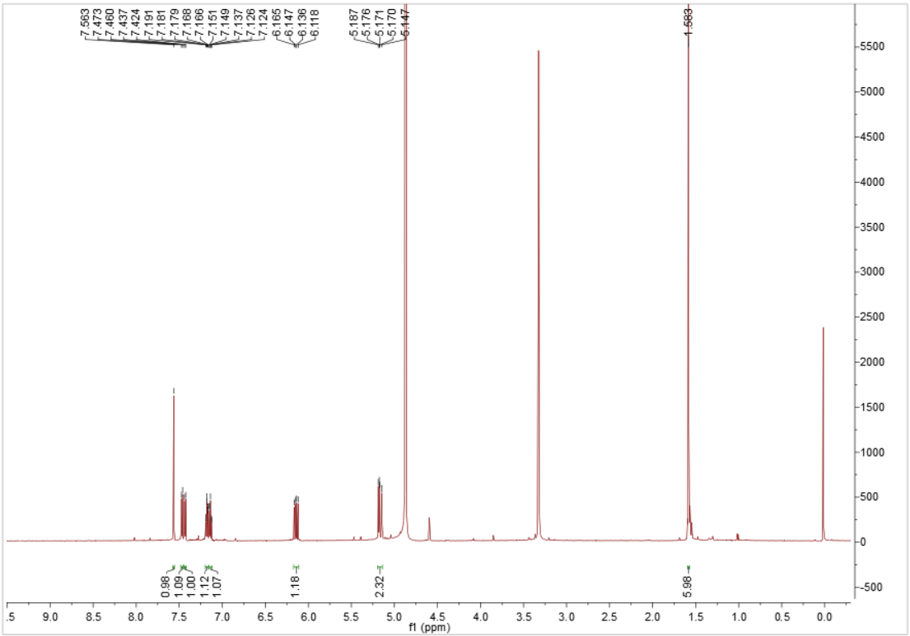
Figure S55 ¹H NMR (600 MHz) spectrum of 12 in methanol-d₄.

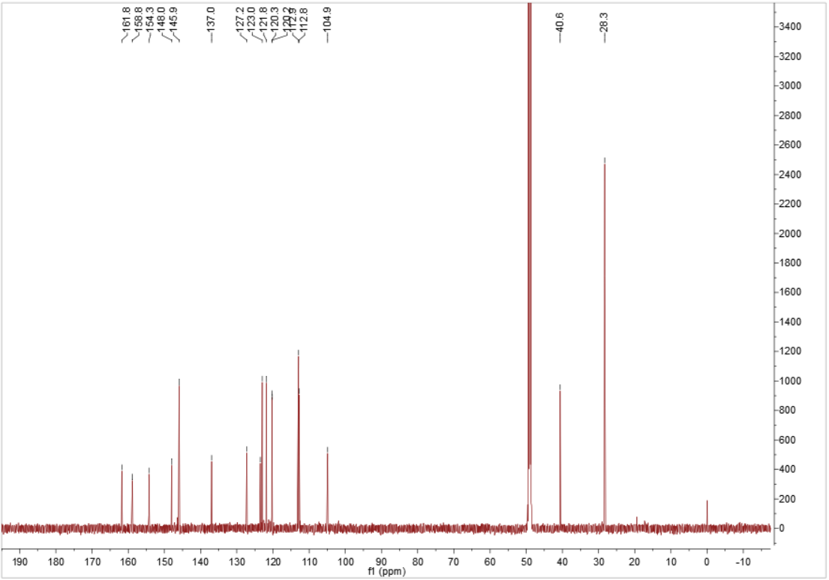
Figure S56 ¹³C NMR (150 MHz) spectrum of 12 in methanol-d₄.
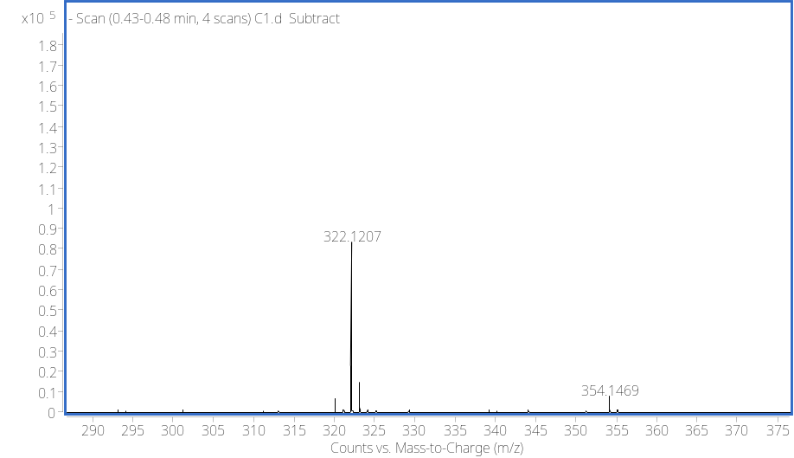
Figure S57 HRESIMS spectrum of 12.

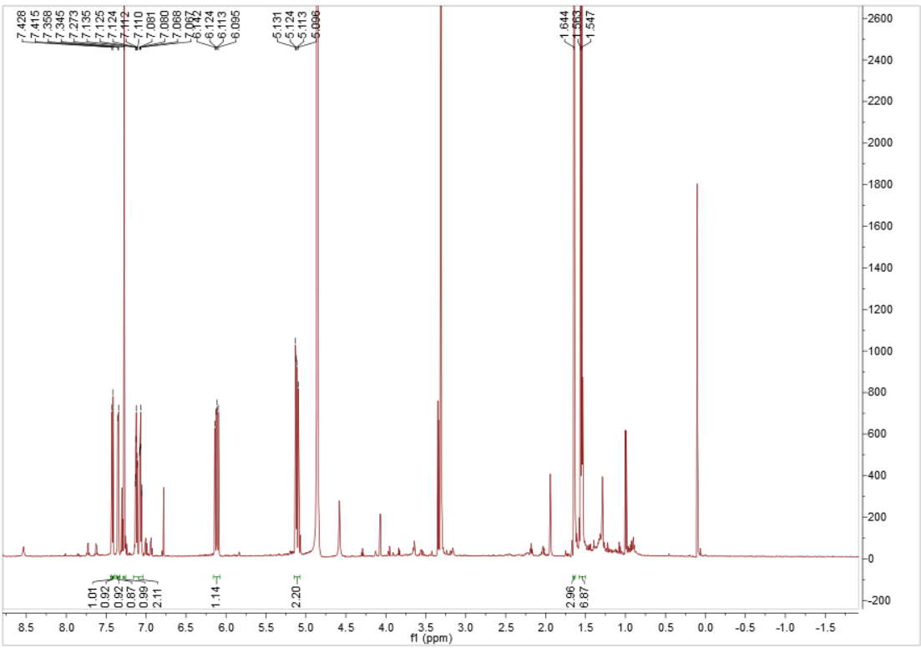
Figure S58 ¹H NMR (600 MHz) spectrum of 13 in methanol-d₄.

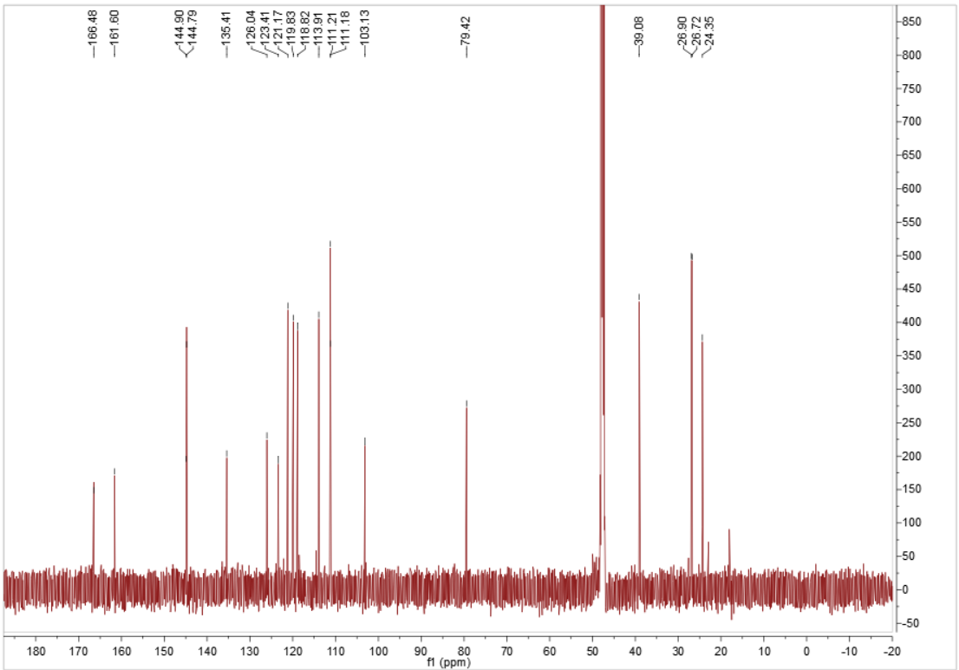
Figure S59 ¹³C NMR (150 MHz) spectrum of 13 in methanol-d₄.
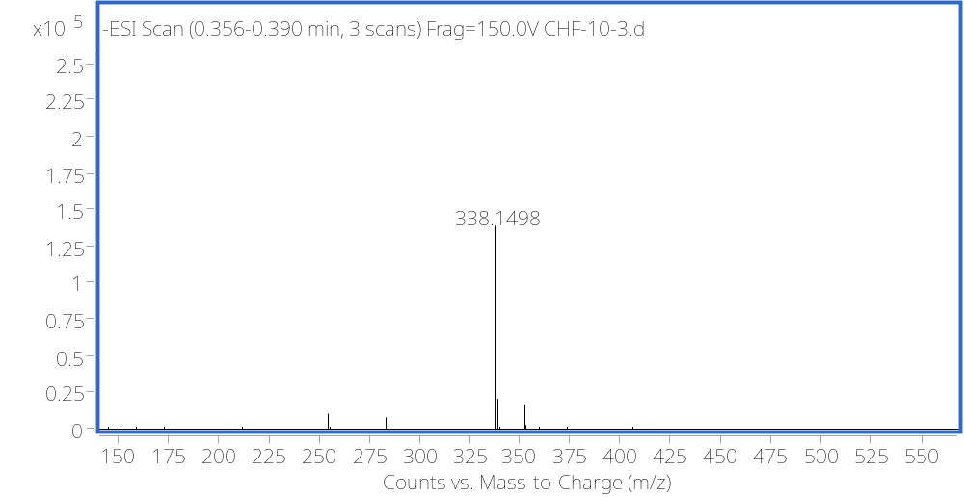
Figure S60 HRESIMS spectrum of 13.

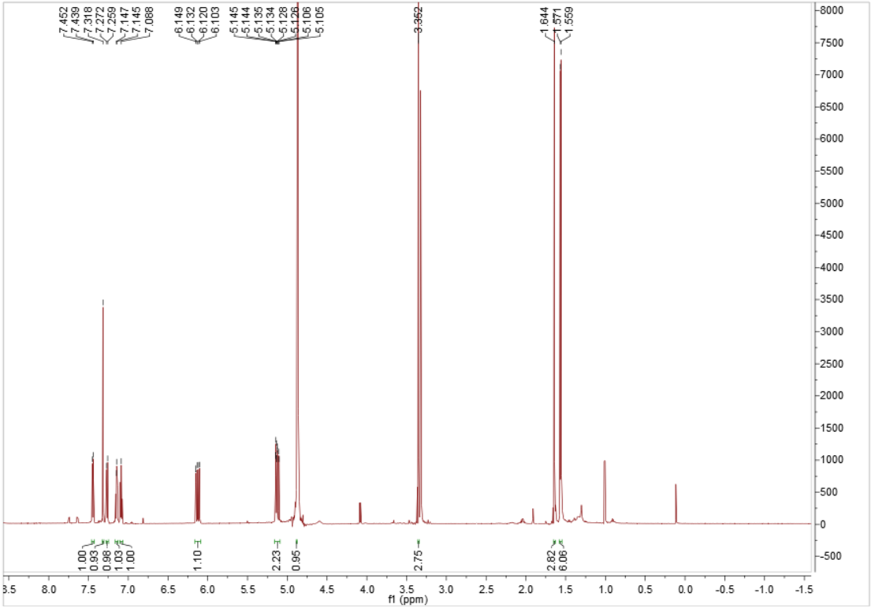
Figure S61 ¹H NMR (600 MHz) spectrum of 14 in methanol-d₄.

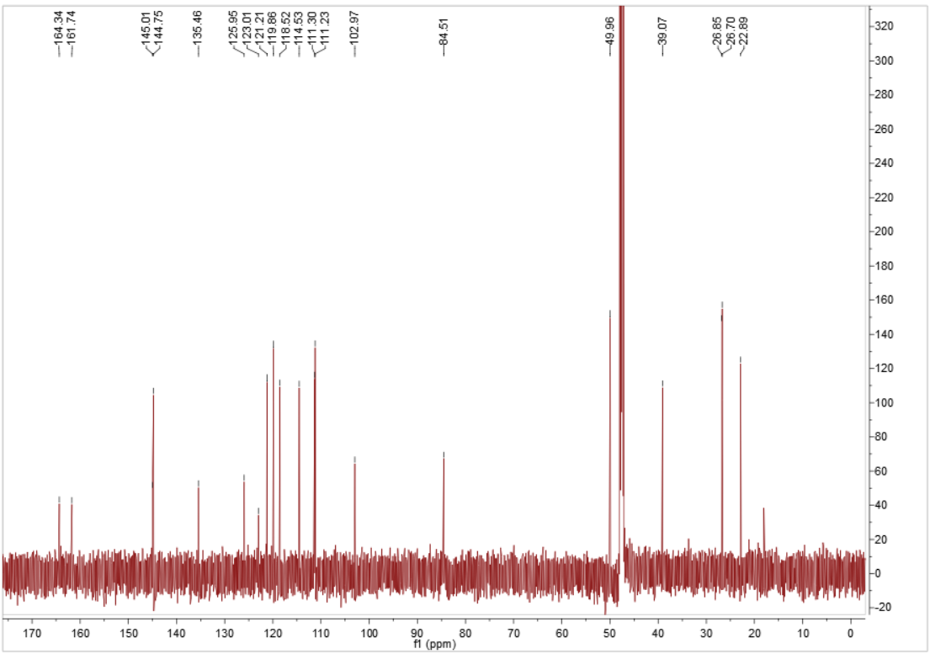
Figure S62 ¹³C NMR (150 MHz) spectrum of 14 in methanol-d₄.

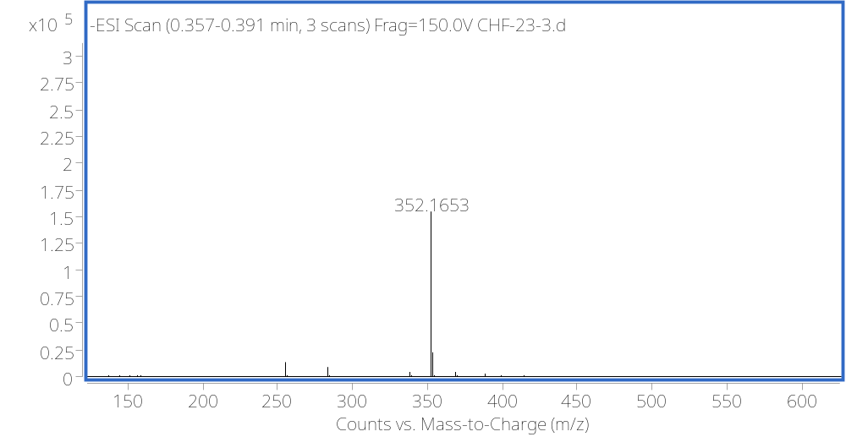
Figure S63 HRESIMS spectrum of 14.

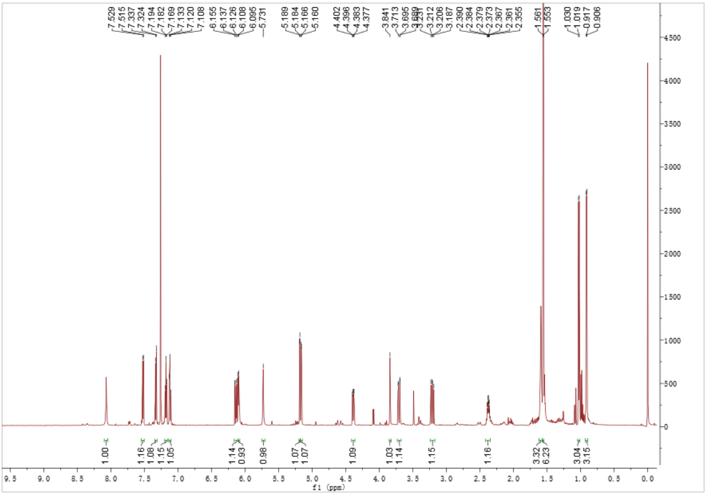
Figure S64 ¹H NMR (600 MHz) spectrum of 15 in CDCl₃.

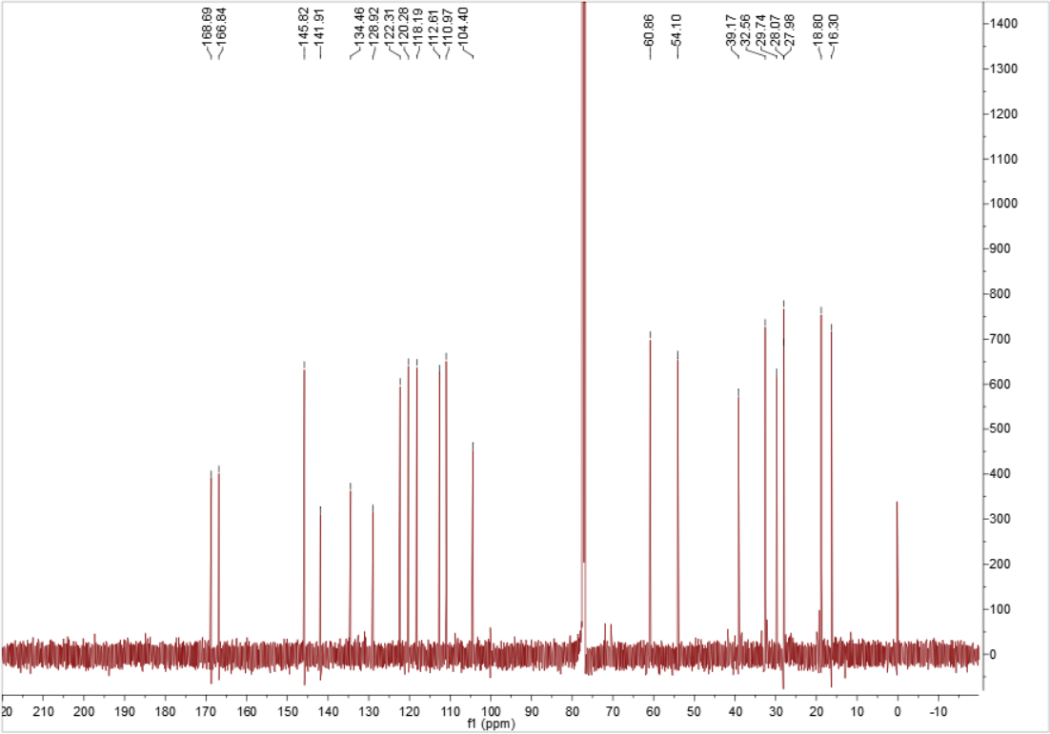
Figure S65 ¹³C NMR (150 MHz) spectrum of 15 in CDCl₃.
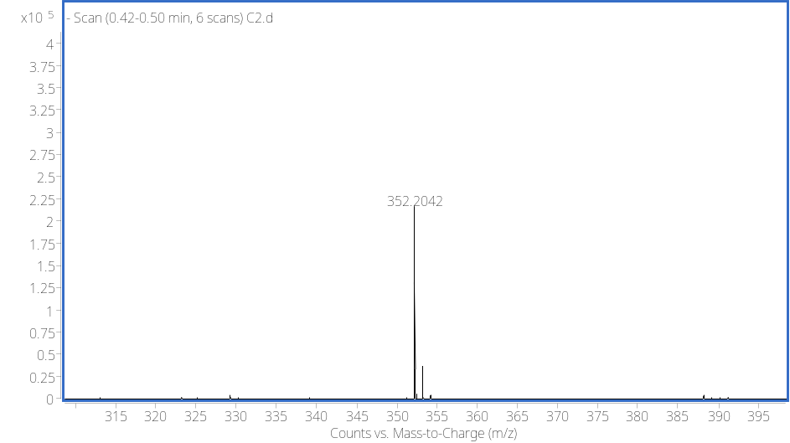
Figure S66 HRESIMS spectrum of 15.

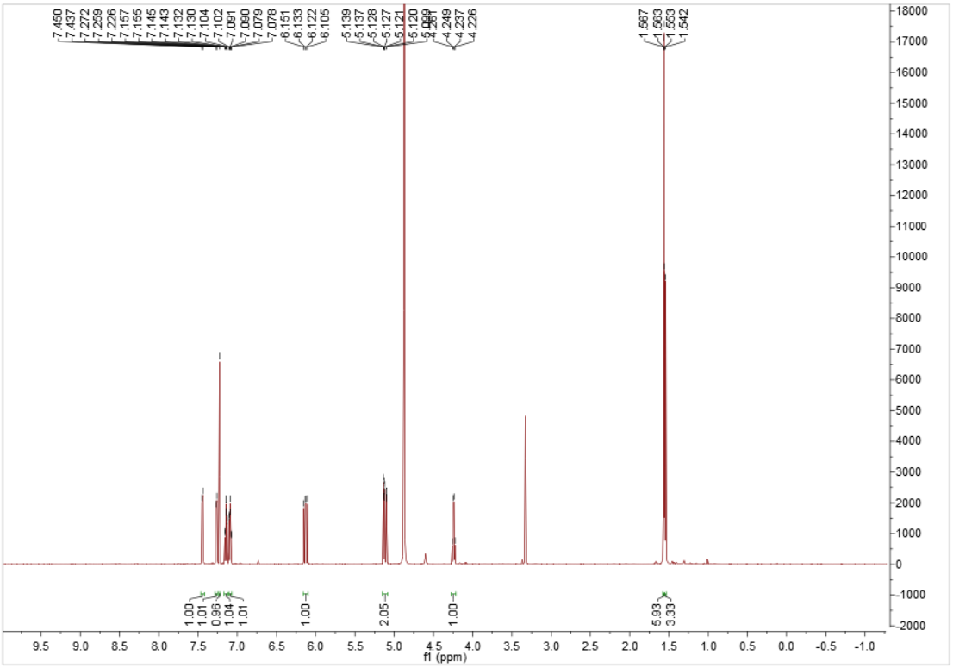
Figure S67 ¹H NMR (600 MHz) spectrum of 16 in methanol-d₄.

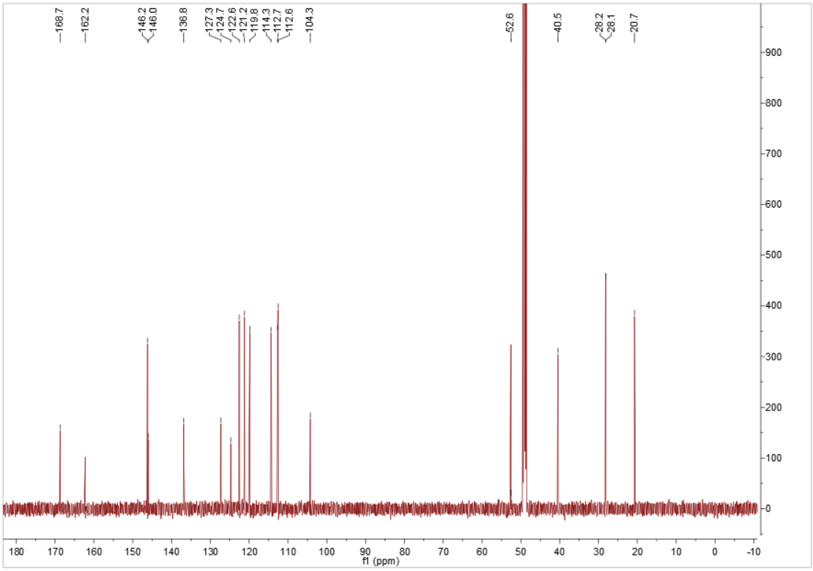
Figure S68 ¹³C NMR (150 MHz) spectrum of 16 in methanol-d₄.
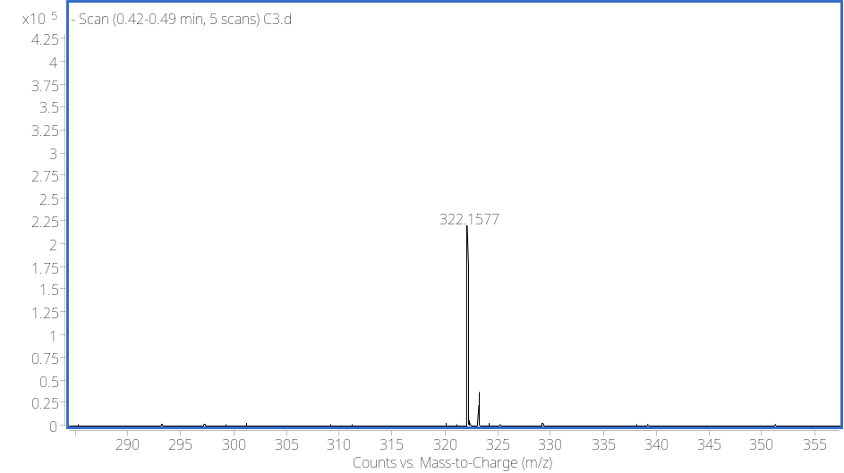
Figure S69 HRESIMS spectrum of 16.

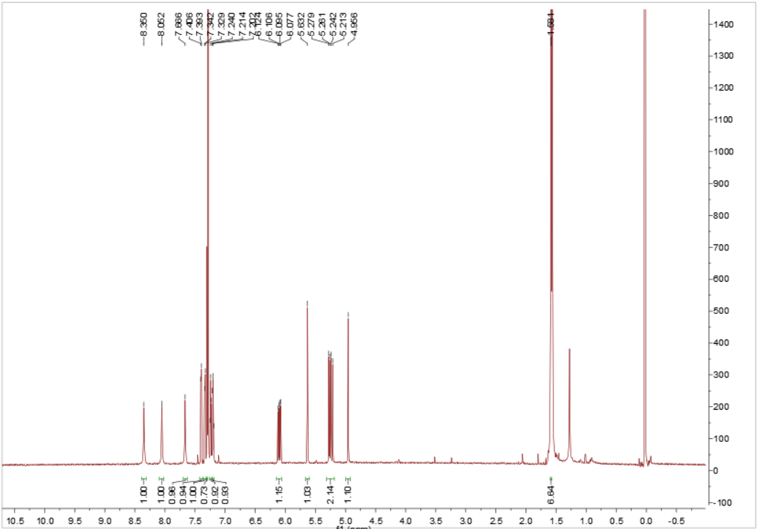
Figure S70 ¹H NMR (600 MHz) spectrum of 17 in CDCl₃.

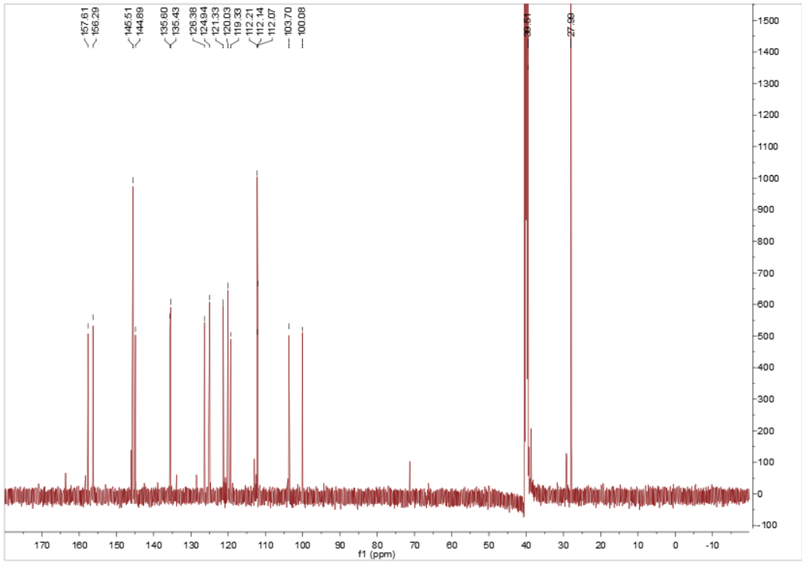
Figure S71 ¹³C NMR (150 MHz) spectrum of 17 in CDCl₃.
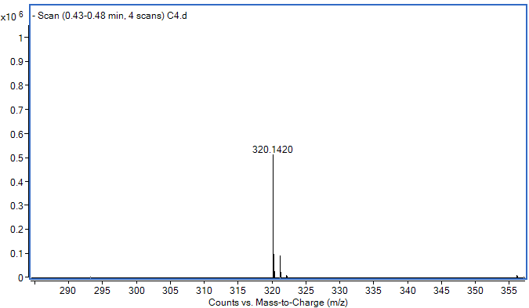
Figure S72 HRESIMS spectrum of 17.

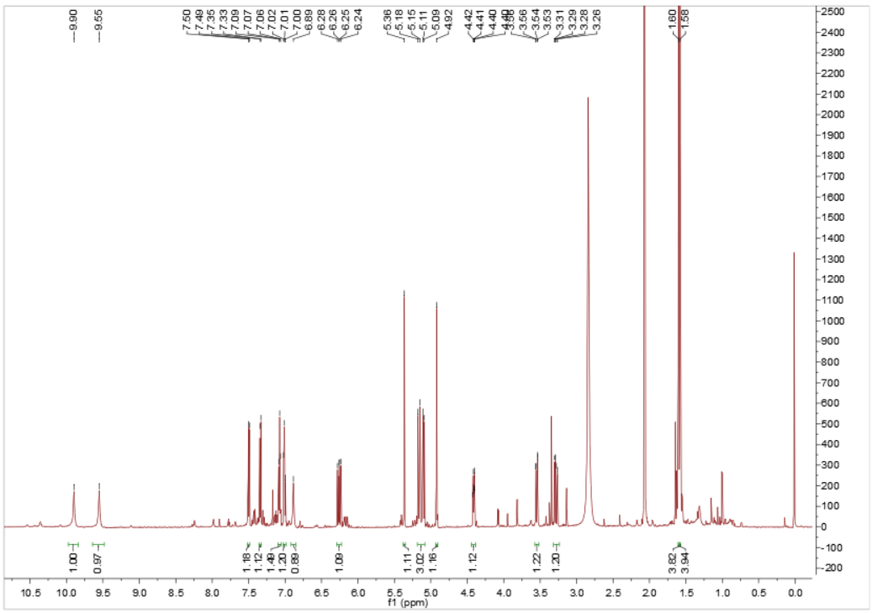
Figure S73 ¹H NMR (600 MHz) spectrum of 18 in acetone-d₆.

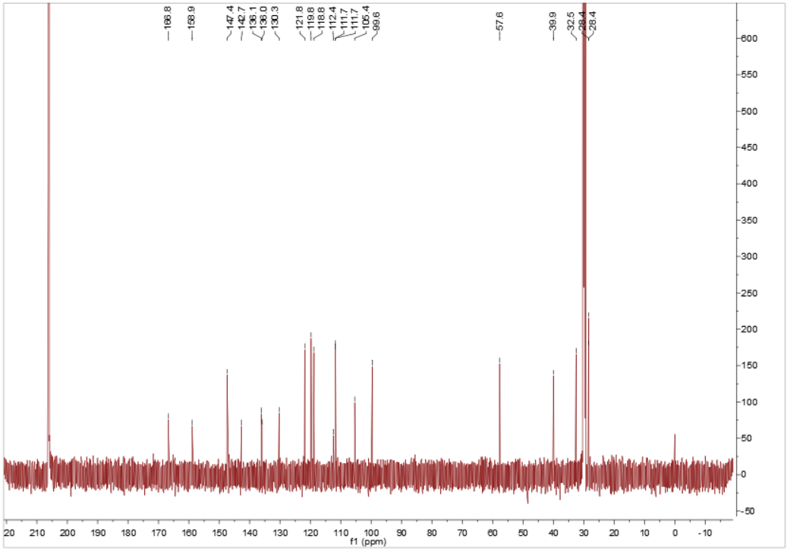
Figure S74 ¹³C NMR (150 MHz) spectrum of 18 in acetone-d₆.

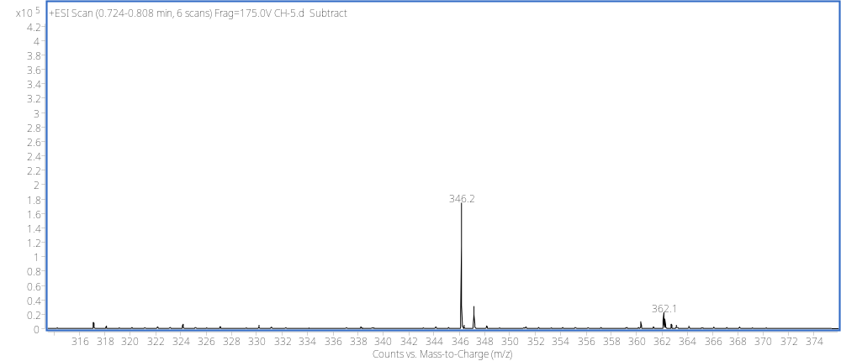
Figure S75 HRESIMS spectrum of 18.

