Treatment of Denervated Muscle Atrophy by Injectable Dual-responsive Hydrogels Loaded with Extracellular Vesicles
Ziheng Bu^{1,5}, Jianxing Jing^{2,5}, Wei Liu^{1,5}, Zhen Fan², Junchao Huang¹, Zheng Zhou¹, Jianhai Hu¹, Jinxi An⁴，Jiachang Hong¹, Jianing Yu⁴, Min Sun¹✉, Jianzhong Du^{1,2,3}✉, &Peng Wu¹✉

Author affiliations:
¹Department of Orthopedics, Shanghai Tenth People's Hospital, School of Medicine, Tongji University, Shanghai 200072, China

²Department of Polymeric Materials, School of Materials Science and Engineering, Tongji University, 4800 Caoan Road, Shanghai 201804, China

³Key Laboratory for Ultrafine Materials of Ministry of Education, School of Materials Science and Engineering, East China University of Science and Technology, Shanghai 200237, China

⁴School of Medicine, Anhui University of Science & Technology, 168 Taifeng Street, Shannan New District, Huainan city, Anhui Province 232000, China.

⁵These authors contributed equally: Ziheng Bu, Jianxing Jing, Wei Liu.

✉ e-mail：1911422@tongji.edu.cn (Min Sun); jzdu@tongji.edu.cn (Jianzhong Du); wupeng03010814@163.com (Peng Wu)

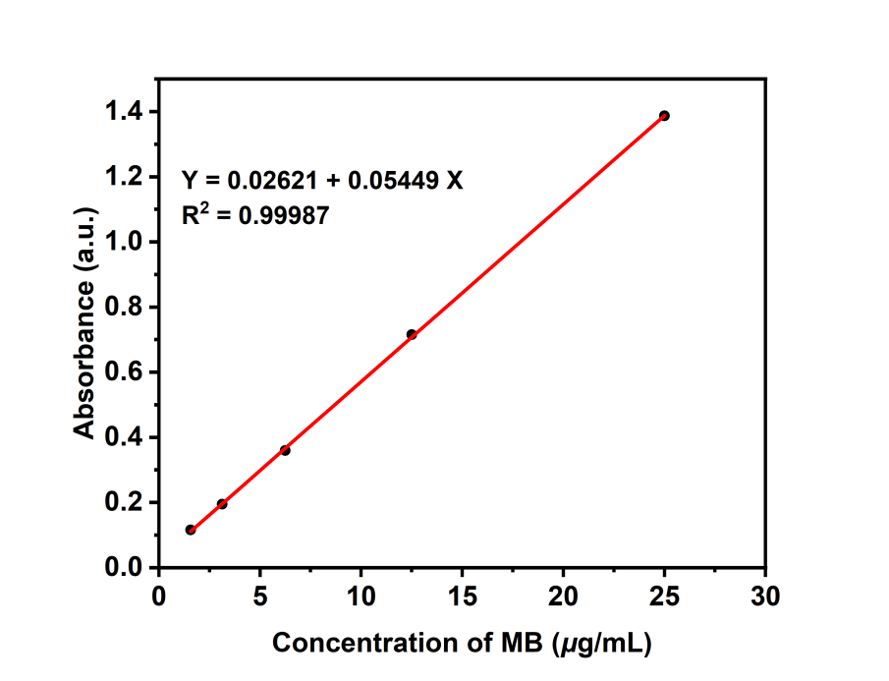
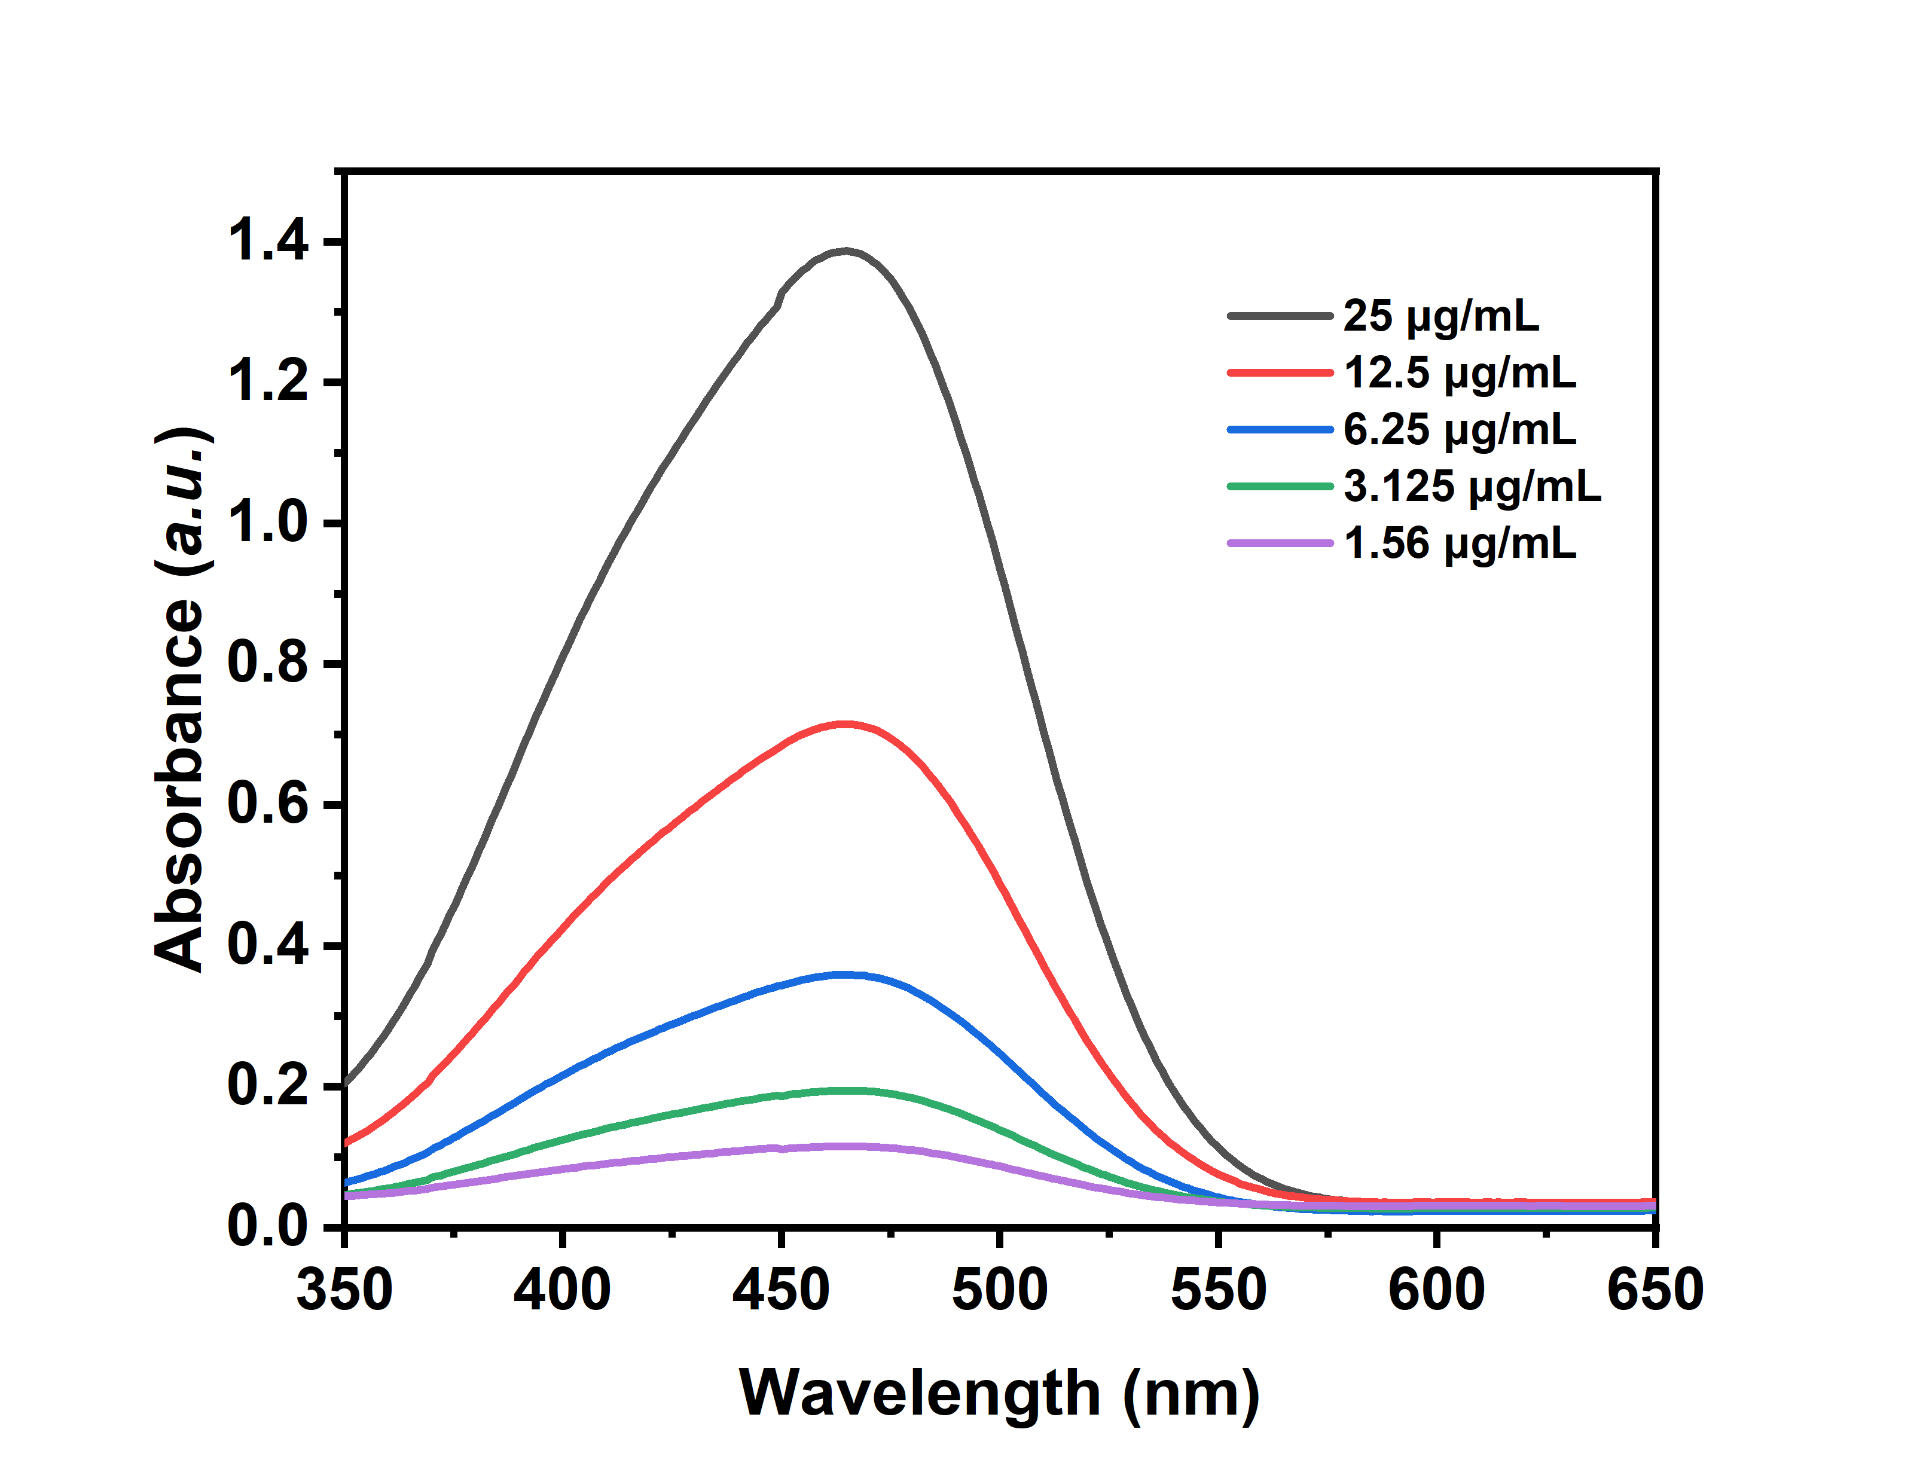
b
a

Fig. S1 | a The absorbance of concentrations of standard methylene blue (MB) samples. b Standard fitting curve between MB concentrations and absorbance
Fig. S2 | a Light field diagram of HUC-MSCs, scale bar=100μm.b Results of osteogenic, chondrogenic and adipogenic differentiation of HUC-MSCs.scale bar=100μm. c Logistic results of surface markers of HUC-MSCs.
a
c
b
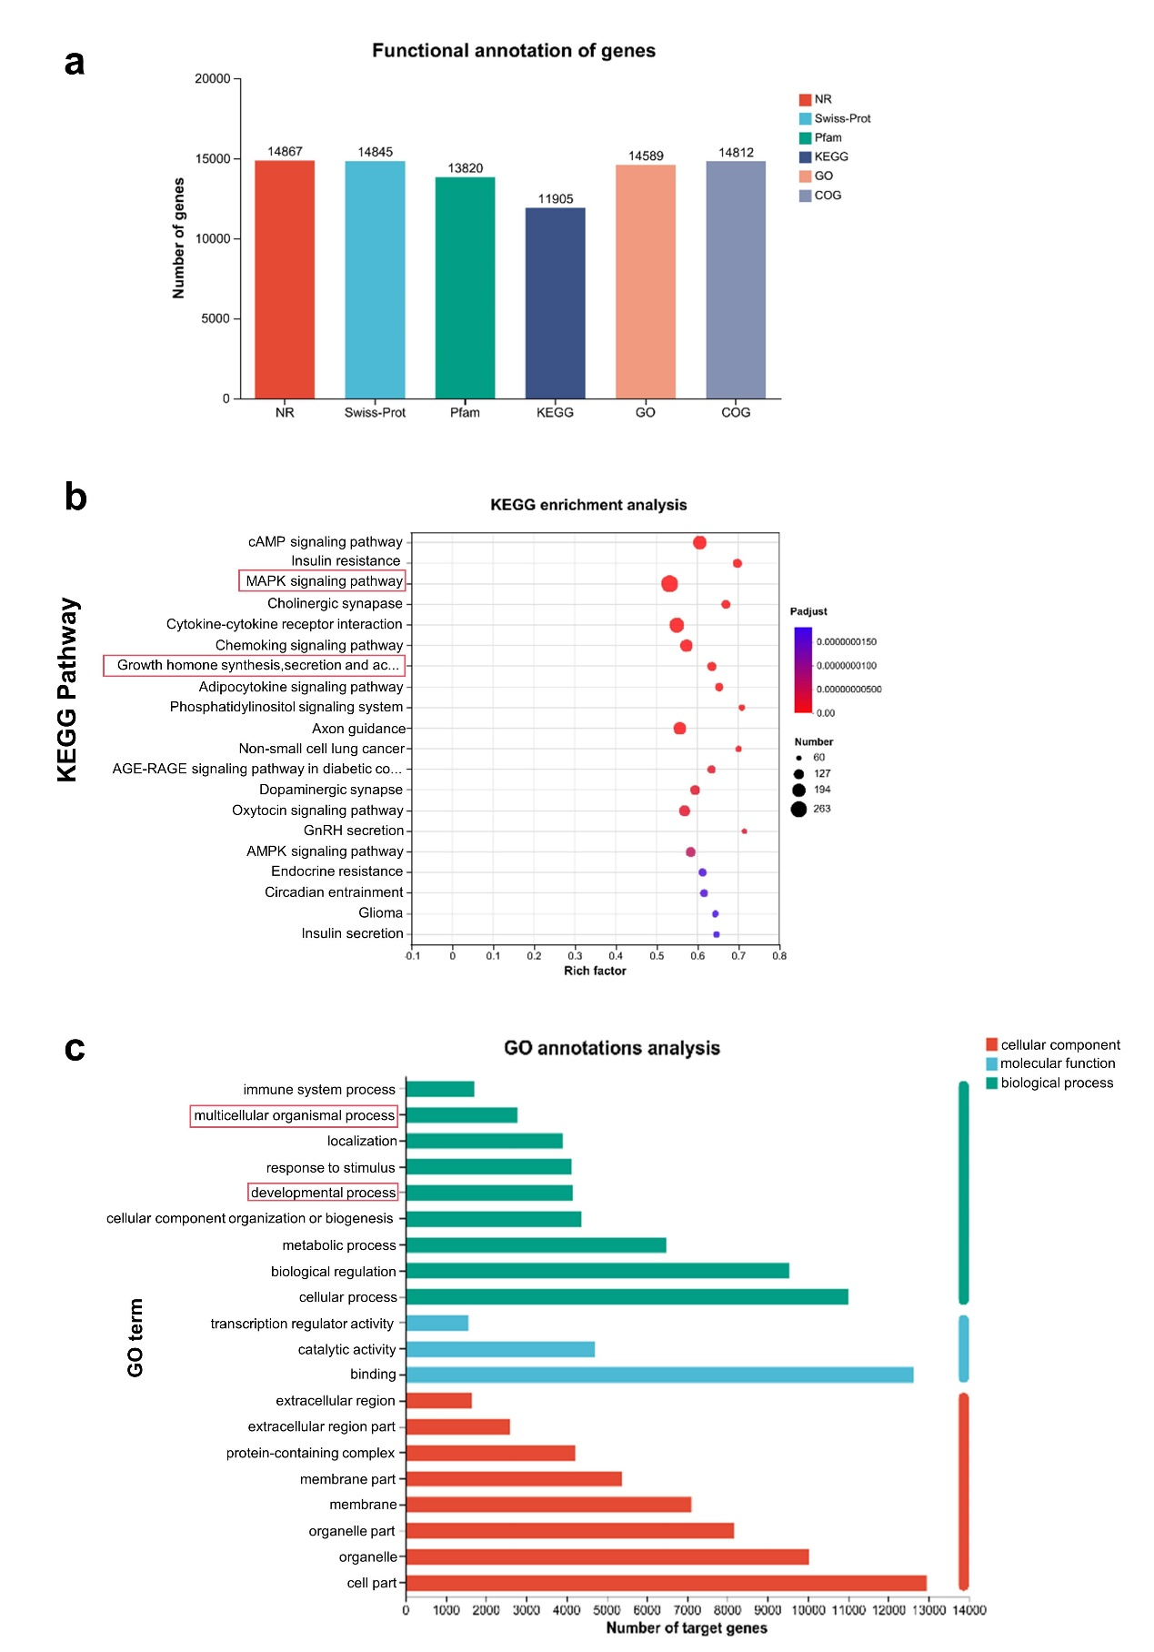 Fig. S3 | a Analysis of miRNA target gene quantity in commonly used databases. b Gene Ontology (GO) analysis of target genes. c Kyoto Encyclopedia of Genes and Genomes (KEGG) analysis of target genes.

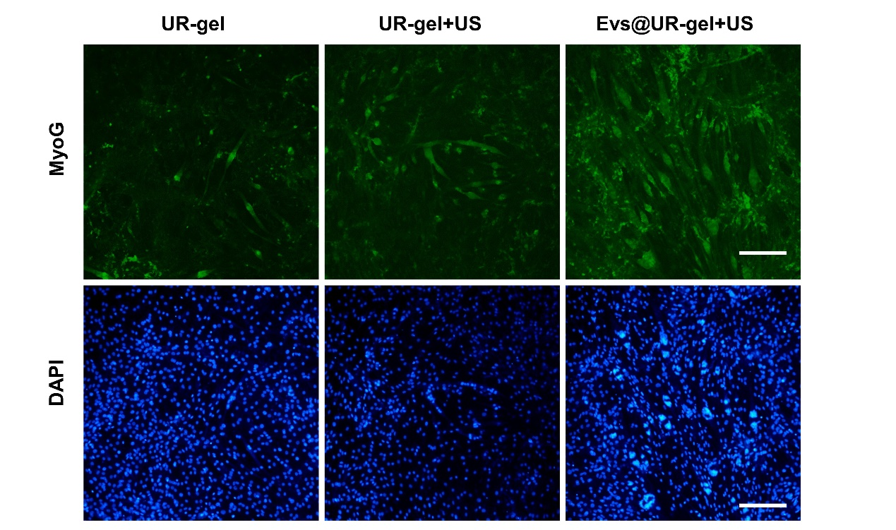

Fig. S4 | C2C12 myogenic differentiation MyoG and DAPI immunofluorescence staining ，scale bar=100μm

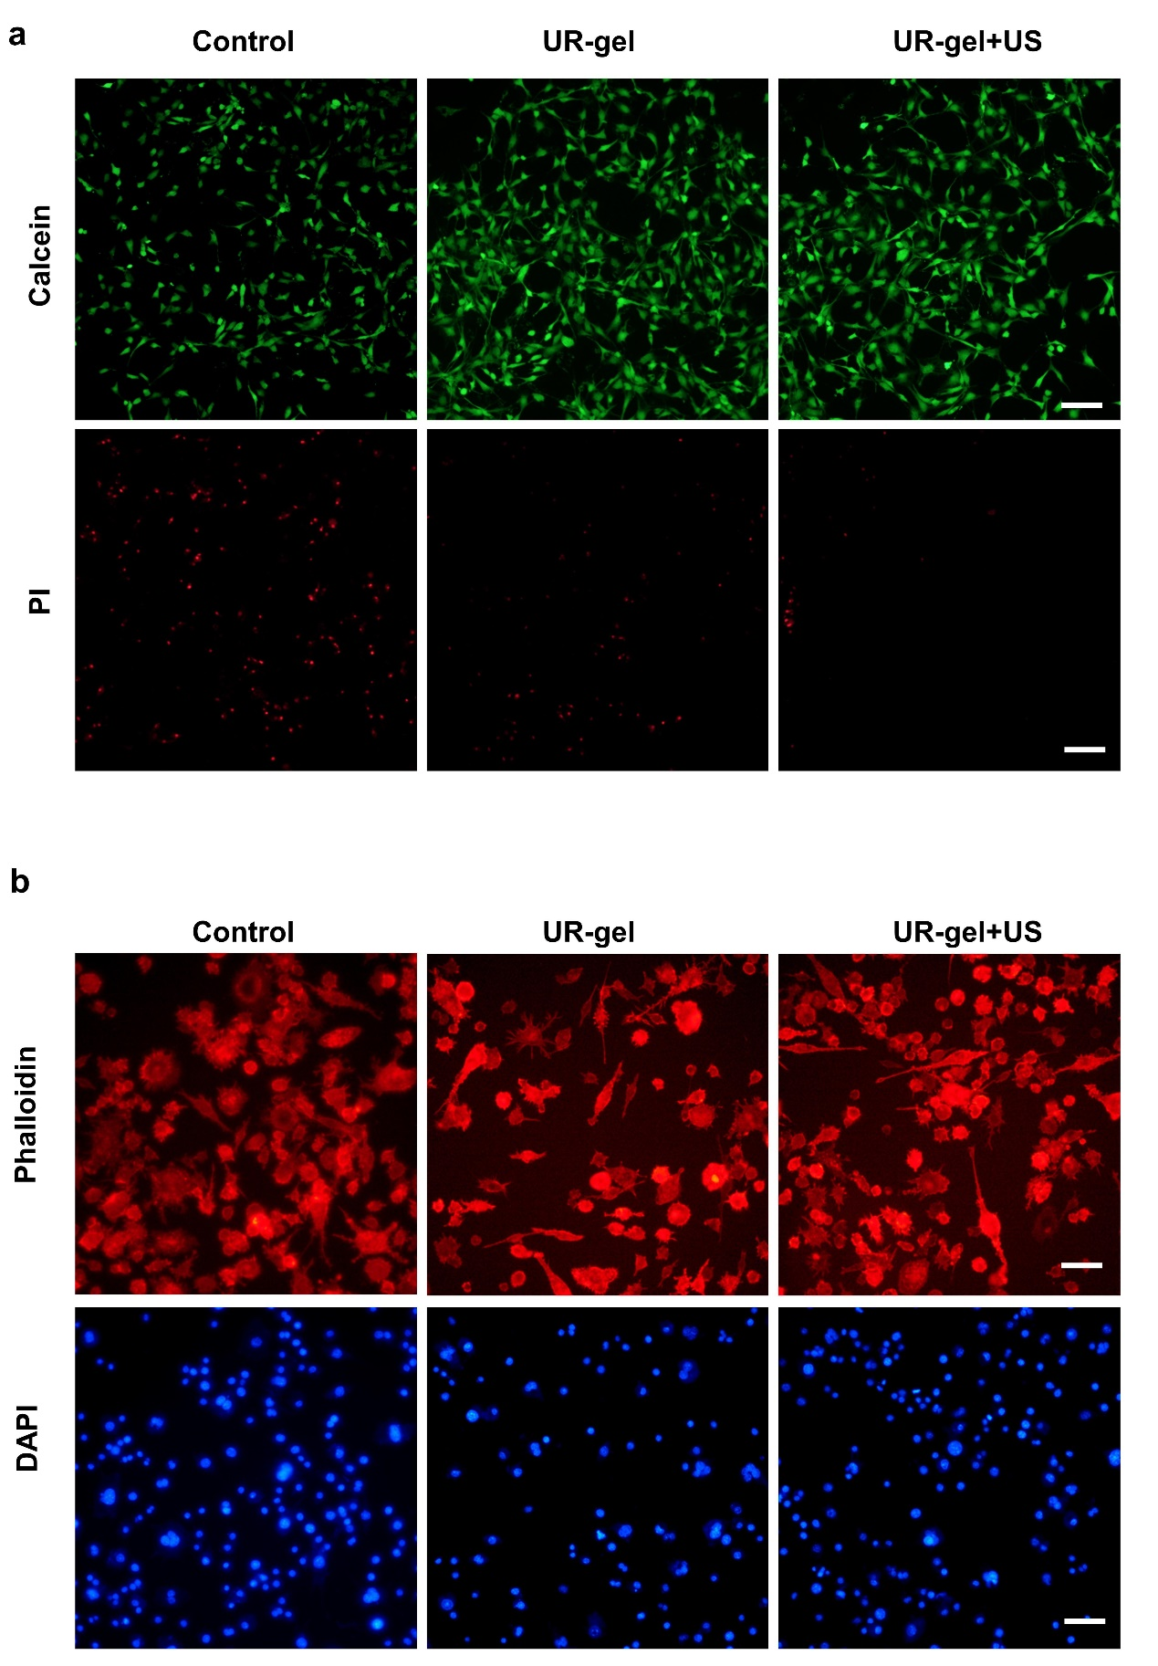 Fig. S5 | a Protective effect of UR-gel against H₂O₂-induced cell death in C2C12，scale bar=100μm. b RAW 264.7 cells immunofluorescent staining of phalloidin(red) and DAPI (blue), scale bar = 100 µm

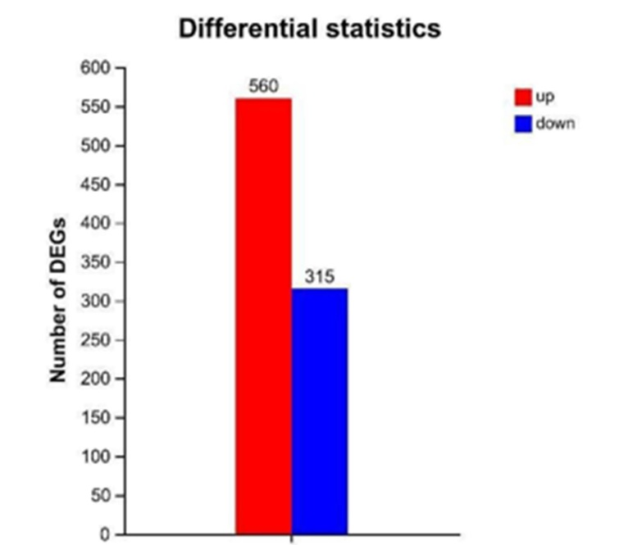

Fig. S6 | Comparison of the number of differentially expressed genes (DEGS) increasing and decreasing in rat tibialis anterior muscle tissue sequencing

