Trophic ecologies and dietary niches of Arctic charr (Salvelinus alpinus) and three coastal forage fishes in Frobisher Bay, Nunavut

SUPPLEMENTARY MATERIAL

Sarah Rauf, Ashley Ehrman, Christopher Lewis, Zoya Martin, Ross Tallman, and Andrea Niemi

Corresponding author: Sarah Rauf
srauf4656@gmail.com

Table S1. Full gut contents data for each fish taxon, including total numerical abundance and weight (g), % number (% N), % weight (% W), frequency of occurrence (% FO), prey-specific abundance (P_{i}), and % index of relative importance (% IRI). Diet items that were identifiable but innumerable were not included in calculations of % N and % IRI. Diet items that were identifiable but below detection weight on laboratory scales were given an arbitrary weight of 0.0001 g and included in calculations. Gut contents indices are reported by prey category (bold) in order of decreasing % IRI, with indices then provided for corresponding prey within each category. In cases where a category contained only one prey item, % IRI is the same for both the category and taxon level. Taxa that could not be enumerated, and therefore have no corresponding %IRI, are arranged by decreasing total weight.
Fish taxa | Category | Prey taxa | %N | %W | %FO | P_{i} | %IRI | Total Abundance | Total Weight (g)
Arctic charr
 | Hyperbenthic Amphipoda |  | 70.40 | 80.40 | 100.00 | 80.40 | 87.68 | 15041 | 331.94
 |  | Themisto libellula | 61.51 | 72.10 | 92.31 | 73.23 | 85.26 | 13143 | 297.65
 |  | Apherusa glacialis | 7.17 | 4.59 | 65.38 | 6.11 | 5.32 | 1533 | 18.97
 |  | Gammarus wilkitzkii | 1.67 | 3.69 | 53.85 | 6.92 | 2.00 | 357 | 15.24
 |  | Weyprechtia heuglini | 0.04 | 0.02 | 3.85 | 0.42 | 0.00 | 8 | 0.09
 | Fish Remains |  | 2.41 | 9.72 | 53.85 | 19.37 | 3.80 | 515 | 40.13
 |  | Cottidae larva | 1.59 | 4.22 | 26.92 | 18.37 | 1.08 | 340 | 17.41
 |  | Myoxocephalus sp. | 0.73 | 1.11 | 11.54 | 25.32 | 0.15 | 157 | 4.58
 |  | Zoarcidae | 0.03 | 3.28 | 3.85 | 66.67 | 0.09 | 6 | 13.55
 |  | Unidentified fish larva | 0.03 | 0.84 | 11.54 | 5.14 | 0.07 | 6 | 3.45
 |  | Unidentified fish | 0.00 | 0.27 | 3.85 | 4.61 | 0.01 | 1 | 1.11
 |  | Fish eggs | 0.02 | 0.01 | 3.85 | 0.14 | 0.00 | 5 | 0.04
 | Copepoda |  | 11.82 | 0.10 | 50.00 | 0.16 | 3.46 | 2525 | 0.41
 |  | Cyclopoida | 7.69 | 0.03 | 26.92 | 0.19 | 1.44 | 1644 | 0.13
 |  | Copepoda | 3.64 | 0.02 | 15.38 | 0.07 | 0.39 | 778 | 0.07
 |  | Calanus sp. | 0.23 | 0.02 | 23.08 | 0.09 | 0.04 | 50 | 0.09
 |  | Calanus hyperboreus | 0.08 | 0.02 | 15.38 | 0.09 | 0.01 | 17 | 0.08
 |  | Metridia longa | 0.16 | 0.01 | 7.69 | 0.26 | 0.01 | 35 | 0.05
 |  | Paraeuchaeta glacialis | 0.00 | 0.00 | 3.85 | 0.01 | 0.00 | 1 | 0.00
 | Benthic Amphipoda |  | 4.03 | 2.33 | 61.54 | 3.49 | 2.28 | 862 | 9.64
 |  | Onisimus sp. | 2.27 | 1.46 | 26.92 | 3.89 | 0.69 | 485 | 6.03
 |  | Onisimus litoralis | 1.73 | 0.84 | 34.62 | 2.88 | 0.62 | 369 | 3.49
 |  | Monoporeia affinis | 0.02 | 0.02 | 11.54 | 0.11 | 0.00 | 5 | 0.08
 |  | Pontogeneia inermis | 0.00 | 0.01 | 3.85 | 0.14 | 0.00 | 1 | 0.03
 |  | Oediceros sp. | 0.00 | 0.00 | 3.85 | 0.16 | 0.00 | 1 | 0.01
 |  | Ischyrocerus sp. | 0.00 | 0.00 | 3.85 | 0.00 | 0.00 | 1 | 0.00
 | Benthic Copepoda |  | 4.24 | 0.02 | 42.31 | 0.07 | 1.05 | 906 | 0.07
 |  | Harpacticoida | 3.32 | 0.01 | 30.77 | 0.07 | 0.71 | 710 | 0.06
 |  | Harpacticus sp. | 0.92 | 0.00 | 15.38 | 0.06 | 0.10 | 196 | 0.01
 | Mysidae | Mysis sp. | 1.76 | 0.93 | 42.31 | 1.77 | 0.66 | 376 | 3.86
 | Crustacea | Crustacea nauplii | 3.32 | 0.01 | 23.08 | 0.05 | 0.45 | 710 | 0.02
 | Cirripedia Larvae | Cirripedia cyprid larva | 1.33 | 0.01 | 34.62 | 0.03 | 0.32 | 285 | 0.02
 | Unidentified Amphipoda |  | 0.06 | 2.08 | 19.23 | 12.34 | 0.24 | 13 | 8.57
 | Other Malacostraca |  | 0.08 | 0.50 | 15.38 | 2.66 | 0.05 | 18 | 2.08
 |  | Thysanoessa raschii | 0.06 | 0.44 | 7.69 | 2.78 | 0.03 | 12 | 1.80
 |  | Euphausiacea | 0.03 | 0.07 | 7.69 | 2.08 | 0.01 | 6 | 0.27
 | Parasitic Isopoda | Dajus mysidis | 0.23 | 0.00 | 15.38 | 0.01 | 0.02 | 49 | 0.01
 | Decapoda larva |  | 0.15 | 0.04 | 11.54 | 0.28 | 0.01 | 32 | 0.17
 | Fish Otoliths | Cottidae | 0.09 | 0.16 | 7.69 | 3.60 | 0.01 | 19 | 0.67
 | Polychaeta |  | 0.01 | 0.07 | 7.69 | 0.95 | 0.00 | 3 | 0.31
 |  | Nereidae | 0.01 | 0.07 | 3.85 | 1.52 | 0.00 | 2 | 0.31
 |  | Eunicidae | 0.00 | 0.00 | 3.85 | 0.00 | 0.00 | 1 | 0.00
 | Decapoda | Decapoda | 0.01 | 0.06 | 7.69 | 0.27 | 0.00 | 3 | 0.25
 | Limacinidae | Limacina sp. | 0.03 | 0.01 | 7.69 | 0.18 | 0.00 | 6 | 0.05
 | Ostracoda |  | 0.01 | 0.01 | 11.54 | 0.03 | 0.00 | 3 | 0.02
 |  | Philomedes sp. | 0.01 | 0.00 | 7.69 | 0.02 | 0.00 | 2 | 0.02
 |  | Ostracoda | 0.00 | 0.00 | 3.85 | 0.15 | 0.00 | 1 | 0.00
 | Digested Remains |  | NA | 3.45 | 53.85 | 7.19 | NA | NA | 14.23
 | Unidentified Fish Remains |  | NA | 0.09 | 15.38 | 0.36 | NA | NA | 0.36
 | Plant Material |  | NA | 0.01 | 11.54 | 0.05 | NA | NA | 0.04
 | Other Material |  | NA | 0.00 | 11.54 | 0.01 | NA | NA | 0.00
 | Gravel/Sand/Rocks |  | NA | 0.00 | 7.69 | 0.01 | NA | NA | 0.00
Arctic cod
 | Copepoda |  | 94.50 | 53.55 | 90.48 | 53.71 | 95.20 | 3247 | 13.01
 |  | Copepoda | 35.04 | 13.65 | 42.86 | 41.01 | 32.89 | 1204 | 3.32
 |  | Calanus hyperboreus | 13.01 | 17.75 | 46.03 | 31.56 | 22.32 | 447 | 4.31
 |  | Calanoida | 11.85 | 8.19 | 49.21 | 19.95 | 15.54 | 407 | 1.99
 |  | Calanus glacialis | 13.77 | 6.80 | 33.33 | 14.81 | 10.81 | 473 | 1.65
 |  | Calanus sp. | 17.69 | 3.64 | 26.98 | 6.26 | 9.08 | 608 | 0.88
 |  | Paraeuchaeta glacialis | 1.14 | 3.39 | 14.29 | 10.09 | 1.02 | 39 | 0.82
 |  | Cyclopoida | 1.80 | 0.05 | 1.59 | 11.70 | 0.05 | 62 | 0.01
 |  | Metridia longa | 0.12 | 0.03 | 6.35 | 0.30 | 0.01 | 4 | 0.01
 |  | Heterorhabdus clausi | 0.06 | 0.05 | 3.17 | 0.71 | 0.01 | 2 | 0.01
 |  | Copepod nauplii | 0.03 | 0.00 | 1.59 | 0.04 | 0.00 | 1 | 0.00
 | Hyperbenthic Amphipoda |  | 1.92 | 38.96 | 14.29 | 66.18 | 4.15 | 66 | 9.47
 |  | Themisto libellula | 1.75 | 38.76 | 11.11 | 73.52 | 7.10 | 60 | 9.42
 |  | Apherusa glacialis | 0.15 | 0.12 | 1.59 | 63.83 | 0.01 | 5 | 0.03
 |  | Hyperoche medusarum | 0.03 | 0.08 | 1.59 | 1.31 | 0.00 | 1 | 0.02
 | Mysidae | Mysis sp. | 1.34 | 1.62 | 17.46 | 8.07 | 0.81 | 46 | 0.39
 | Benthic Copepoda |  | 1.08 | 0.03 | 25.40 | 0.25 | 0.20 | 37 | 0.01
 |  | Harpacticus sp. | 0.73 | 0.02 | 15.87 | 0.18 | 0.19 | 25 | 0.00
 |  | Harpacticoida | 0.12 | 0.00 | 4.76 | 0.61 | 0.01 | 4 | 0.00
 |  | Tisbe furcata | 0.17 | 0.00 | 1.59 | 1.06 | 0.00 | 6 | 0.00
 |  | Harpacticus chelifer | 0.06 | 0.00 | 3.17 | 0.51 | 0.00 | 2 | 0.00
 | Other Malacostraca |  | 0.09 | 0.26 | 7.94 | 14.80 | 0.02 | 3 | 0.06
 | Polychaeta |  | 0.15 | 0.35 | 4.76 | 23.02 | 0.02 | 5 | 0.09
 |  | Polychaeta | 0.12 | 0.34 | 4.76 | 22.48 | 0.03 | 4 | 0.08
 |  | Lumbrineridae | 0.03 | 0.01 | 1.59 | 44.44 | 0.00 | 1 | 0.00
 | Benthic Amphipoda |  | 0.29 | 0.41 | 3.17 | 23.53 | 0.02 | 10 | 0.10
 |  | Onisimus litoralis | 0.12 | 0.25 | 1.59 | 20.13 | 0.01 | 4 | 0.06
 |  | Pontogeneia inermis | 0.12 | 0.12 | 1.59 | 22.95 | 0.01 | 4 | 0.03
 |  | Onisimus sp. | 0.03 | 0.04 | 1.59 | 8.20 | 0.00 | 1 | 0.01
 |  | cf Pseudotanais oculata | 0.03 | 0.00 | 1.59 | 0.33 | 0.00 | 1 | 0.00
 | Fish Remains |  | 0.06 | 0.58 | 3.17 | 1.57 | 0.01 | 2 | 0.14
 |  | Gymnocanthus tricuspis | 0.03 | 0.57 | 1.59 | 1.55 | 0.01 | 1 | 0.14
 |  | Unidentified fish | 0.03 | 0.02 | 1.59 | 3.38 | 0.00 | 1 | 0.00
 | Unidentified Amphipoda |  | 0.17 | 0.03 | 7.94 | 0.99 | 0.01 | 6 | 0.01
 | Cumacea |  | 0.15 | 0.03 | 3.17 | 4.57 | 0.00 | 5 | 0.01
 |  | Cumacea | 0.12 | 0.02 | 1.59 | 4.20 | 0.00 | 4 | 0.01
 |  | Leucon sp. | 0.03 | 0.00 | 1.59 | 9.90 | 0.00 | 1 | 0.00
 | Decapoda | Lebbeus polaris | 0.03 | 0.08 | 1.59 | 3.40 | 0.00 | 1 | 0.02
 | Isopoda |  | 0.09 | 0.02 | 1.59 | 0.60 | 0.00 | 3 | 0.00
 | Parasitic Isopoda | Bopyridae sp. | 0.06 | 0.00 | 1.59 | 2.27 | 0.00 | 2 | 0.00
 | Foraminifera |  | 0.03 | 0.00 | 1.59 | 22.22 | 0.00 | 1 | 0.00
 | Decapoda larva |  | 0.03 | 0.00 | 1.59 | 0.02 | 0.00 | 1 | 0.00
 | Ostracoda |  | 0.03 | 0.00 | 1.59 | 2.22 | 0.00 | 1 | 0.00
 | Digested Remains |  | NA | 2.81 | 22.22 | 40.62 | NA | NA | 0.68
 | Crustacea |  | NA | 0.77 | 11.11 | 16.38 | NA | NA | 0.19
 | Unidentified Invertebrates |  | NA | 0.38 | 6.35 | 20.98 | NA | NA | 0.09
 | Unidentified Fish Remains |  | NA | 0.05 | 7.94 | 2.41 | NA | NA | 0.01
 | Gravel/Sand/Rocks |  | NA | 0.05 | 4.76 | 9.89 | NA | NA | 0.01
 | Other Material |  | NA | 0.01 | 1.59 | 0.66 | NA | NA | 0.00
Fish Doctor
 | Copepoda |  | 47.48 | 2.71 | 33.33 | 19.49 | 39.49 | 132 | 0.02
 |  | Cyclopoida | 42.45 | 2.25 | 28.57 | 16.20 | 50.84 | 118 | 0.02
 |  | Cyclopina sp. | 2.16 | 0.15 | 4.76 | 7.14 | 0.44 | 6 | 0.00
 |  | Euryte longicauda | 1.44 | 0.15 | 4.76 | 7.14 | 0.30 | 4 | 0.00
 |  | Copepoda | 1.08 | 0.15 | 4.76 | 12.50 | 0.23 | 3 | 0.00
 |  | Calanoida | 0.36 | 0.01 | 4.76 | 50.00 | 0.07 | 1 | 0.00
 | Benthic Copepoda |  | 35.61 | 4.46 | 28.57 | 8.36 | 27.03 | 99 | 0.03
 |  | Tisbe furcata | 28.78 | 2.68 | 19.05 | 26.09 | 23.85 | 80 | 0.02
 |  | Harpacticoida | 5.04 | 1.19 | 9.52 | 16.67 | 2.36 | 14 | 0.01
 |  | Harpacticus cf superflexus | 1.80 | 0.59 | 14.29 | 1.23 | 1.36 | 5 | 0.00
 | Polychaeta |  | 3.60 | 15.05 | 33.33 | 60.17 | 14.67 | 10 | 0.10
 |  | Polychaeta | 1.08 | 8.49 | 14.29 | 77.79 | 5.44 | 3 | 0.06
 |  | Polynoidae | 1.44 | 3.57 | 14.29 | 43.01 | 2.85 | 4 | 0.02
 |  | Aphroditiformia | 0.72 | 2.97 | 4.76 | 51.28 | 0.70 | 2 | 0.02
 |  | Lumbrineridae | 0.36 | 0.01 | 4.76 | 0.27 | 0.07 | 1 | 0.00
 | Benthic Amphipoda |  | 5.40 | 10.60 | 28.57 | 18.63 | 10.79 | 15 | 0.07
 |  | Oedicerotidae | 2.52 | 3.00 | 19.05 | 27.01 | 4.19 | 7 | 0.02
 |  | Tryphosidae | 0.36 | 6.69 | 4.76 | 16.07 | 1.34 | 1 | 0.05
 |  | Oediceros borealis | 2.16 | 0.89 | 4.76 | 21.43 | 0.58 | 6 | 0.01
 |  | Anonyx nugax | 0.36 | 0.01 | 4.76 | 1.10 | 0.07 | 1 | 0.00
 | Decapoda |  | 1.44 | 11.30 | 19.05 | 19.57 | 5.73 | 4 | 0.08
 |  | Sclerocrangon boreas | 0.36 | 5.65 | 4.76 | 13.57 | 1.14 | 1 | 0.04
 |  | Sabinea sarsi | 0.36 | 4.31 | 4.76 | 63.04 | 0.89 | 1 | 0.03
 |  | Eualus sp. | 0.36 | 0.89 | 4.76 | 23.08 | 0.24 | 1 | 0.01
 |  | Sabinea sp. | 0.36 | 0.45 | 4.76 | 8.24 | 0.15 | 1 | 0.00
 | Parasitic Isopoda |  | 1.08 | 1.22 | 14.29 | 10.89 | 0.78 | 3 | 0.01
 |  | Gnathia sp. | 0.72 | 1.20 | 9.52 | 13.68 | 0.73 | 2 | 0.01
 |  | Gnathiidae | 0.36 | 0.01 | 4.76 | 0.62 | 0.07 | 1 | 0.00
 | Isopoda |  | 1.80 | 0.59 | 9.52 | 8.33 | 0.54 | 5 | 0.00
 |  | Isopoda | 1.44 | 0.45 | 4.76 | 8.82 | 0.36 | 4 | 0.00
 |  | Pleurogonium sp. | 0.36 | 0.15 | 4.76 | 7.14 | 0.10 | 1 | 0.00
 | Hyperbenthic Amphipoda | Syrrhoe crenulata | 0.72 | 1.34 | 9.52 | 24.93 | 0.78 | 2 | 0.01
 | Mysidae | Mysis sp. | 0.72 | 1.04 | 4.76 | 49.30 | 0.33 | 2 | 0.01
 | Foraminifera |  | 1.44 | 0.01 | 4.76 | 0.27 | 0.16 | 4 | 0.00
 | Simuliidae |  | 0.36 | 0.59 | 4.76 | 11.76 | 0.11 | 1 | 0.00
 | Cumacea | Lamprops fuscatus | 0.36 | 0.01 | 4.76 | 0.70 | 0.07 | 1 | 0.00
 | Other Malacostraca |  | NA | 20.09 | 19.05 | 38.86 | NA | NA | 0.14
 | Digested Remains |  | NA | 11.60 | 4.76 | 27.86 | NA | NA | 0.08
 | Crustacea |  | NA | 6.72 | 38.10 | 27.68 | NA | NA | 0.05
 | Unidentified Amphipoda |  | NA | 7.58 | 14.29 | 54.26 | NA | NA | 0.05
 | Plant Material |  | NA | 2.99 | 23.81 | 5.36 | NA | NA | 0.02
 | Gravel/Sand/Rocks |  | NA | 1.35 | 28.57 | 2.54 | NA | NA | 0.01
 | Other Material |  | NA | 0.15 | 4.76 | 7.14 | NA | NA | 0.00
 | Unidentified Invertebrates | Arthropoda | NA | 0.59 | 4.76 | 11.76 | NA | NA | 0.00
Sculpins
 | Hyperbenthic Amphipoda |  | 34.71 | 19.15 | 36.36 | 35.60 | 54.20 | 59 | 1.33
 |  | Apherusa glacialis | 28.24 | 6.05 | 18.18 | 61.80 | 47.35 | 48 | 0.42
 |  | Hyperiidae | 4.12 | 8.04 | 6.06 | 28.23 | 5.60 | 7 | 0.56
 |  | Gammarus wilkitzkii | 0.59 | 4.88 | 3.03 | 33.90 | 1.26 | 1 | 0.34
 |  | Syrrhoe crenulata | 1.18 | 0.13 | 6.06 | 19.57 | 0.60 | 2 | 0.01
 |  | Calliopius sp. | 0.59 | 0.04 | 3.03 | 10.00 | 0.15 | 1 | 0.00
 | Benthic Amphipoda |  | 10.00 | 5.49 | 33.33 | 11.65 | 14.29 | 17 | 0.38
 |  | Oediceros borealis | 5.29 | 0.75 | 18.18 | 6.10 | 8.34 | 9 | 0.05
 |  | Onisimus nanseni | 1.18 | 3.35 | 3.03 | 58.99 | 1.04 | 2 | 0.23
 |  | Tryphosidae | 1.18 | 0.27 | 3.03 | 16.96 | 0.33 | 2 | 0.02
 |  | Onisimus litoralis | 0.59 | 0.50 | 3.03 | 3.49 | 0.25 | 1 | 0.04
 |  | Anonyx nugax | 0.59 | 0.49 | 3.03 | 4.34 | 0.25 | 1 | 0.03
 |  | Bathymedon obtusifrons | 0.59 | 0.10 | 3.03 | 20.00 | 0.16 | 1 | 0.01
 |  | Oedicerotidae | 0.59 | 0.03 | 3.03 | 1.53 | 0.14 | 1 | 0.00
 | Copepoda |  | 22.35 | 0.27 | 21.21 | 5.38 | 13.29 | 38 | 0.02
 |  | Cyclopoida | 14.12 | 0.11 | 9.09 | 4.68 | 9.83 | 24 | 0.01
 |  | Cyclopina sp. | 5.88 | 0.03 | 3.03 | 6.67 | 1.36 | 10 | 0.00
 |  | Calanoida | 1.18 | 0.09 | 6.06 | 8.57 | 0.58 | 2 | 0.01
 |  | Paraeuchaeta sp. | 0.59 | 0.04 | 3.03 | 3.57 | 0.15 | 1 | 0.00
 |  | Copepoda | 0.59 | 0.00 | 3.03 | 0.09 | 0.14 | 1 | 0.00
 | Benthic Copepoda |  | 18.82 | 0.22 | 21.21 | 2.50 | 11.18 | 32 | 0.02
 |  | Tisbe furcata | 15.88 | 0.19 | 9.09 | 7.47 | 11.10 | 27 | 0.01
 |  | Harpacticus sp. | 1.76 | 0.00 | 6.06 | 0.60 | 0.81 | 3 | 0.00
 |  | Harpacticus cf superflexus | 1.18 | 0.03 | 6.06 | 0.50 | 0.55 | 2 | 0.00
 | Polychaeta |  | 0.59 | 4.76 | 21.21 | 10.78 | 3.14 | 1 | 0.33
 |  | Polynoidae | 0.59 | 0.32 | 3.03 | 73.33 | 0.21 | 1 | 0.02
 |  | Polychaeta | NA | 4.44 | 18.18 | 10.17 | NA | 0 | 0.31
 | Mysidae |  | 5.88 | 2.13 | 9.09 | 13.84 | 2.02 | 10 | 0.15
 | Decapoda |  | 1.18 | 2.74 | 6.06 | 18.51 | 0.66 | 2 | 0.19
 |  | Crangonidae | 0.59 | 2.33 | 3.03 | 16.15 | 0.67 | 1 | 0.16
 |  | Argis dentata | 0.59 | 0.42 | 3.03 | 100.00 | 0.23 | 1 | 0.03
 | Parasitic Isopoda | Gnathia sp. | 2.35 | 0.03 | 9.09 | 0.63 | 1.65 | 4 | 0.00
 | Cumacea |  | 2.94 | 0.20 | 6.06 | 8.80 | 0.53 | 5 | 0.01
 | Bivalvia | Cardiidae | 0.59 | 0.06 | 3.03 | 10.53 | 0.15 | 1 | 0.00
 | Cirripedia Larvae |  | 0.59 | 0.01 | 3.03 | 0.18 | 0.05 | 1 | 0.00
 | Digested Remains |  | NA | 42.62 | 69.70 | 48.20 | NA | NA | 2.97
 | Unidentified Amphipoda |  | NA | 17.88 | 51.52 | 22.76 | NA | NA | 1.25
 | Gravel/Sand/Rocks |  | NA | 1.38 | 9.09 | 8.10 | NA | NA | 0.10
 | Plant Material |  | NA | 1.03 | 15.15 | 2.88 | NA | NA | 0.07
 | Unidentified Fish Remains |  | NA | 1.06 | 9.09 | 62.18 | NA | NA | 0.07
 | Other Malacostraca |  | NA | 0.69 | 9.09 | 7.69 | NA | NA | 0.05
 | Other Material |  | NA | 0.22 | 9.09 | 2.84 | NA | NA | 0.02
 | Crustacea |  | NA | 0.06 | 3.03 | 25.00 | NA | NA | 0.00
Table S2. Full caloric density data for each fish taxon with corresponding metadata, morphological, and isotope data including fish ID, date, station (full information available in Table 1), fork length (FL), standard length (SL), weight, sex (S), maturity (M), percent carbon (C), percent nitrogen (N), δ¹³C, δ¹⁵N, C:N, and caloric density (CD). Caloric density is the average of duplicate samples. Maturity status was evaluated as mature (M), spawning (S), immature (I), ripe (R).
Fish Taxa | Fish ID | Date | Station | FL (mm) | SL (mm) | Weight (g) | S | M | % C | % N | δ¹³C | δ¹⁵N | C:N | CD (cal/g)
Arctic charr
 | SG-19-021 | 2019-07-16 | Isld01 | 365 | NA | 431 | M | I | 46.84 | 13.90 | -19.39 | 10.79 | 3.37 | 4986.39
 | SG-19-035 | NA | PI01 | 320 | NA | 334 | M | I | 46.76 | 14.21 | -19.77 | 8.34 | 3.29 | 5181.16
 | SG-19-048 | 2019-07-28 | PI02 | 530 | NA | 2005 | M | S | 51.20 | 11.86 | -19.47 | 14.46 | 4.32 | 6046.78
 | SG-19-063 | 2019-07-28 | PI02 | 545 | NA | 2076 | M | S | 52.25 | 11.10 | -20.09 | 14.40 | 4.71 | 6039.56
 | SG-19-066 | 2019-07-28 | Isld01 | 395 | NA | 654 | M | M | 47.95 | 13.04 | -18.59 | 13.37 | 3.68 | 5235.14
 | SG-19-073 | 2019-07-28 | Isld01 | 331 | NA | 405 | M | M | 47.43 | 13.93 | -20.33 | 8.55 | 3.40 | 5168.36
 | SG-19-075 | 2019-07-28 | Isld01 | 338 | NA | 286 | F | M | 47.56 | 13.67 | -20.34 | 8.78 | 3.48 | 5344.49
 | SG-19-084 | 2019-07-28 | Isld01 | 480 | NA | 1385 | F | M | 54.73 | 9.38 | -20.69 | 13.76 | 5.83 | 6282.20
 | SG-19-089 | 2019-07-28 | Isld01 | 500 | NA | 1454 | M | S | 50.04 | 12.20 | -19.63 | 13.74 | 4.10 | 5803.02
 | SG-19-091 | 2019-07-28 | Isld01 | 340 | NA | 415 | M | S | 49.39 | 12.73 | -21.09 | 9.80 | 3.88 | 5833.20
 | SG-19-101 | 2019-07-30 | Isld02 | 350 | NA | 450 | F | I | 48.10 | 13.56 | -18.42 | 13.02 | 3.55 | 5416.63
 | SG-19-137 | 2019-07-30 | Isld02 | 340 | NA | 468 | F | I | 50.16 | 11.69 | -20.11 | 10.77 | 4.29 | 5721.70
 | SG-19-140 | 2019-07-30 | Isld02 | 300 | NA | 238 | M | I | 48.00 | 13.05 | -20.99 | 9.40 | 3.68 | 5513.46
 | SG-19-153 | 2019-07-30 | Isld02 | 370 | NA | 563 | M | M | 48.34 | 12.95 | -19.94 | 9.85 | 3.73 | 5008.32
 | SG-19-154 | 2019-08-08 | PI01 | 520 | NA | 1631 | F | R | 52.81 | 10.58 | -19.94 | 14.71 | 4.99 | 6135.95
 | SG-19-156 | 2019-08-08 | PI01 | 491 | NA | 1408 | F | R | 52.65 | 10.74 | -20.03 | 13.85 | 4.90 | 6458.77
 | SG-19-157 | 2019-08-08 | PI01 | 354 | NA | 488 | M | I | 48.78 | 12.88 | -18.75 | 12.97 | 3.79 | 5688.19
 | SG-19-162 | 2019-08-08 | Isld02 | 526 | NA | 1562 | F | R | 55.57 | 9.23 | -20.98 | 13.51 | 6.02 | 5861.99
 | SG-19-163 | 2019-08-08 | Isld02 | 475 | NA | 1296 | F | R | 53.61 | 9.85 | -20.72 | 12.72 | 5.44 | 6108.40
 | SG-19-166 | 2019-08-08 | Isld02 | 420 | NA | 937 | F | R | 51.40 | 11.28 | -20.08 | 13.14 | 4.56 | 6190.90
 | SG-19-170 | 2019-08-08 | Isld02 | 325 | NA | 410 | F | I | 49.00 | 12.84 | -18.95 | 13.60 | 3.82 | 5561.78
 | SG-19-179 | 2019-08-08 | Isld02 | 455 | NA | 1068 | F | R | 48.61 | 13.23 | -18.74 | 13.75 | 3.68 | 5548.35
 | SG-19-185 | 2019-08-22 | MD01 | 440 | NA | 1062 | M | S | 49.36 | 12.48 | -19.40 | 12.84 | 3.96 | 5666.75
Fish Taxa | Fish ID | Date | Station | FL (mm) | SL (mm) | Weight (g) | S | M | % C | % N | δ¹³C | δ¹⁵N | C:N | CD (cal/g)
Arctic cod
 | 18-206 | 2018-09-22 | A1 | 101 | 94 | 6.81 | NA | NA | 44.95 | 12.84 | -20.55 | 11.80 | 3.50 | 5421.16
 | 18-207 | 2018-09-22 | A1 | 156 | 148 | 22.45 | M | IM | 46.00 | 13.08 | -20.46 | 13.16 | 3.52 | 5397.76
 | 18-292 | 2018-09-26 | A5 | 102 | 97 | 8.03 | F | IM | 44.58 | 11.83 | -20.23 | 12.40 | 3.77 | 5252.71
 | 18-293 | 2018-09-26 | A5 | 159 | 152 | 37.64 | M | M | 49.16 | 12.09 | -20.66 | 13.41 | 4.07 | 5130.27
 | 18-295 | 2018-09-26 | A5 | 145 | 135 | 26.76 | F | M | 46.67 | 13.21 | -20.17 | 12.41 | 3.53 | 5037.64
 | 18-401 | 2018-09-26 | B4 | 126 | 124 | 23.5 | F | M | 46.60 | 13.14 | -20.44 | 12.69 | 3.55 | 5162.26
 | 18-407 | 2018-09-26 | B4 | NA | 216 | 118.75 | F | M | 44.42 | 12.98 | -19.99 | 14.67 | 3.42 | 4996.13
 | 19-434 | 2019-09-04 | KI4 | 114 | 106 | 10.61 | M | M | 47.14 | 13.41 | -20.34 | 11.80 | 3.52 | 5190.57
 | 19-464 | 2019-08-28 | B4 | 103 | 98 | 9.424 | M | M | 44.42 | 12.26 | -21.11 | 11.88 | 3.62 | 5354.20
 | 19-468 | 2019-08-28 | B4 | 99 | 94 | 7.852 | M | M | 48.06 | 13.31 | -20.83 | 11.89 | 3.61 | 5413.00
 | 19-469 | 2019-08-28 | B4 | 97 | 92 | 6.558 | M | M | 46.10 | 12.64 | -21.09 | 12.05 | 3.65 | 5402.98
 | 19-475 | 2019-09-02 | B5 | 98 | 93 | 8.308 | M | M | 45.30 | 12.56 | -20.52 | 12.68 | 3.61 | 5128.74
 | 19-519 | 2019-09-18 | P1 | 100 | 95 | 11.196 | M | M | 42.70 | 11.83 | -19.74 | 11.87 | 3.61 | 5618.22
 | 19-522 | 2019-09-18 | P1 | 106 | 101 | 12.644 | M | M | 44.07 | 12.01 | -19.75 | 11.96 | 3.67 | 5610.07
 | 19-523 | 2019-09-18 | P1 | 92 | 88 | 8.298 | M | M | 42.59 | 11.51 | -19.68 | 12.13 | 3.70 | 5614.79
 | 19-540 | 2019-09-18 | P4 | 101 | 99 | 11.846 | M | M | 46.39 | 11.88 | -19.72 | 12.47 | 3.91 | 6063.85
 | 19-541 | 2019-09-18 | P4 | 94 | 89 | 8.331 | M | M | 46.95 | 11.83 | -20.59 | 11.87 | 3.97 | 5753.64
Fish Doctor
 | 18-034 | 2018-09-26 | B4 | NA | 88 | 1.86 | NA | NA | 45.96 | 14.02 | -18.88 | 16.21 | 3.28 | 4727.88
 | 18-035 | 2018-09-26 | B4 | NA | 103 | 3.08 | NA | NA | 45.16 | 13.95 | -19.35 | 16.22 | 3.24 | 4713.78
 | 18-036 | 2018-09-26 | B4 | NA | 80 | 2.16 | NA | NA | 46.21 | 14.08 | -19.44 | 16.01 | 3.28 | 4651.99
 | 18-049 | 2018-09-26 | A5 | NA | 88 | 2.58 | NA | NA | 43.97 | 13.48 | -19.49 | 15.85 | 3.26 | 4581.67
 | 18-051 | 2018-09-26 | A5 | NA | 98 | 3.03 | NA | NA | 45.86 | 14.01 | -18.97 | 15.85 | 3.27 | 4804.30
 | 18-231 | 2018-09-22 | A1 | NA | 129 | 7.2699 | NA | NA | 45.51 | 13.97 | -17.74 | 16.20 | 3.26 | 5218.51
 | 18-232 | 2018-09-22 | A1 | NA | 144 | 9.7796 | NA | NA | 45.73 | 14.10 | -18.88 | 15.68 | 3.24 | 4854.15
 | 18-233 | 2018-09-22 | A1 | NA | 78 | 1.3548 | NA | NA | 43.69 | 13.23 | -18.12 | 14.46 | 3.30 | 4392.88
 | 19-443 | 2019-09-04 | KI4 | NA | 106 | 3.92 | F | M | 45.44 | 13.96 | -18.92 | 16.44 | 3.25 | 4575.77
 | 19-445 | 2019-09-04 | KI4 | NA | 110 | 3.973 | F | M | 47.43 | 13.87 | -19.09 | 16.32 | 3.42 | 4859.14
 | 19-446 | 2019-09-04 | KI4 | NA | 123 | 5.683 | F | M | 50.86 | 14.33 | -19.40 | 16.26 | 3.55 | 4796.86
Fish Taxa | Fish ID | Date | Station | FL (mm) | SL (mm) | Weight (g) | S | M | % C | % N | δ¹³C | δ¹⁵N | C:N | CD (cal/g)
 | 19-450 | 2019-09-04 | KI4 | NA | 118 | 3.189 | F | M | 49.35 | 13.15 | -20.10 | 16.85 | 3.75 | 4757.04
 | 19-451 | 2019-09-04 | KI4 | NA | 111 | 3.689 | M | M | 41.76 | 12.73 | -19.16 | 15.89 | 3.28 | 4874.52
 | 19-470 | 2019-08-28 | B4 | NA | 109 | 3.418 | M | M | 41.50 | 11.54 | -18.88 | 16.53 | 3.60 | 4873.96
 | 19-480 | 2019-09-02 | B5 | NA | 110 | 3.616 | F | M | 43.22 | 12.28 | -18.63 | 16.30 | 3.52 | 5030.16
 | 19-535 | 2019-09-18 | P1 | NA | 159 | 14.876 | M | M | 45.30 | 11.77 | -17.48 | 16.07 | 3.85 | 5124.26
Arctic Staghorn Sculpin
 | 18-234 | 2018-09-22 | A1 | NA | 57 | 3.6167 | NA | NA | 44.33 | 13.70 | -18.82 | 14.59 | 3.24 | 4357.50
 | 18-235 | 2018-09-22 | A1 | NA | 53 | 2.5848 | NA | NA | 45.15 | 13.84 | -18.53 | 14.43 | 3.26 | 4511.38
 | 18-236 | 2018-09-22 | A1 | NA | 48 | 1.9628 | NA | NA | 45.26 | 13.50 | -19.15 | 14.34 | 3.35 | 4820.09
 | 19-549 | 2019-09-18 | P6 | NA | 178 | 107.4 | M | M | 46.20 | 13.39 | -19.20 | 14.96 | 3.45 | 4895.52
Spatulate Sculpin
 | 19-431 | 2019-08-28 | A5 | NA | 75 | 8.553 | F | M | 47.74 | 13.44 | -18.71 | 15.07 | 3.55 | 4552.96
 | 19-432 | 2019-08-28 | A5 | NA | 64 | 4.114 | F | M | 42.24 | 10.46 | -19.42 | 14.63 | 4.04 | 4674.14
 | 19-504 | 2019-09-05 | P5 | NA | 59 | 5.229 | F | M | 46.57 | 12.03 | -19.18 | 15.00 | 3.87 | 5033.86
 | 19-568 | 2019-09-18 | P6 | NA | 82 | 10.415 | F | M | 46.52 | 13.70 | -17.90 | 16.02 | 3.40 | 5012.42
Twohorn Sculpin
 | 18-040 | 2018-09-26 | A5 | NA | 65 | 5.18 | NA | NA | 44.03 | 12.63 | -18.22 | 16.01 | 3.49 | 4155.48
 | 18-246 | 2018-09-25 | A1 | NA | 108 | 25.85 | F | NA | 45.55 | 13.53 | -18.51 | 15.41 | 3.37 | 4799.41
 | 18-247 | 2018-09-25 | A1 | NA | 104 | 31.2 | F | NA | 46.47 | 14.25 | -18.12 | 15.77 | 3.26 | 4444.50
 | 19-499 | 2019-09-05 | P5 | NA | 52 | 2.424 | M | M | 47.85 | 12.63 | -18.75 | 14.90 | 3.79 | 5072.22

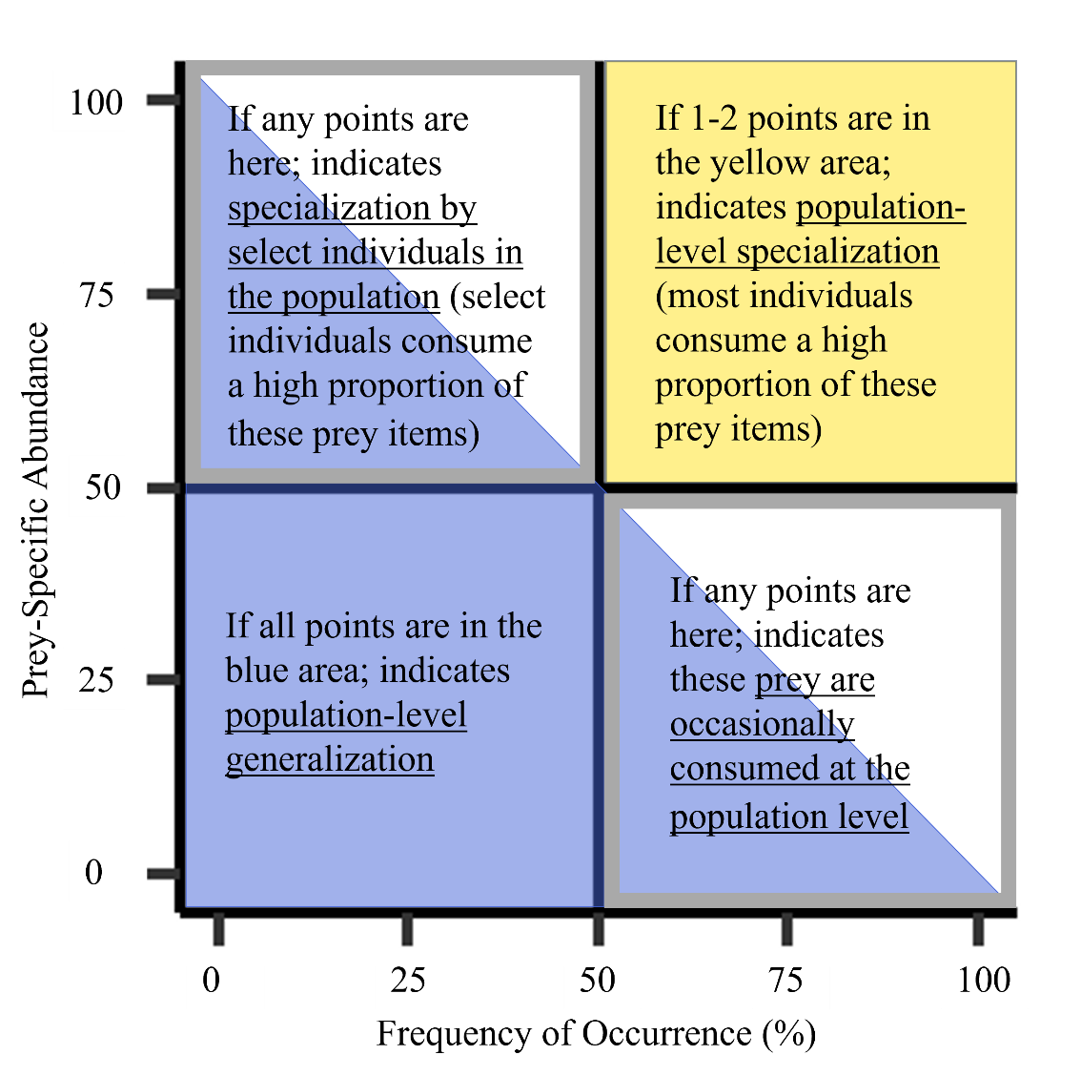

Figure S1. An explanatory diagram for interpreting graphical evaluations of feeding strategies according to the modified Costello method (see full details in Amundsen et al. 1996).

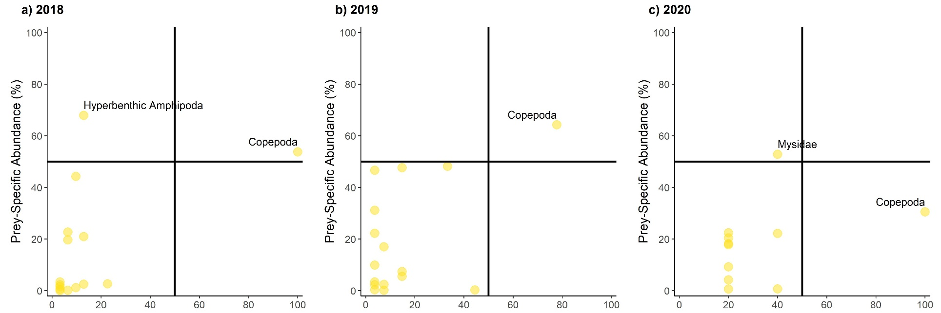

Figure S2. Modified Costello analyses of the diets of Arctic cod sampled from inner Frobisher Bay in (a) 2018 (n = 64), (b) 2019 (n = 29), and (c) 2020 (n = 5). All prey categories with a Frequency of Occurrence > 50% or Prey-Specific Abundance > 50% were labelled. Mysidae and Copepoda were prominent prey in the diets of Arctic cod across all sampling years, with some individual- and population-level specialization on these taxa and hyperbenthic amphipods.

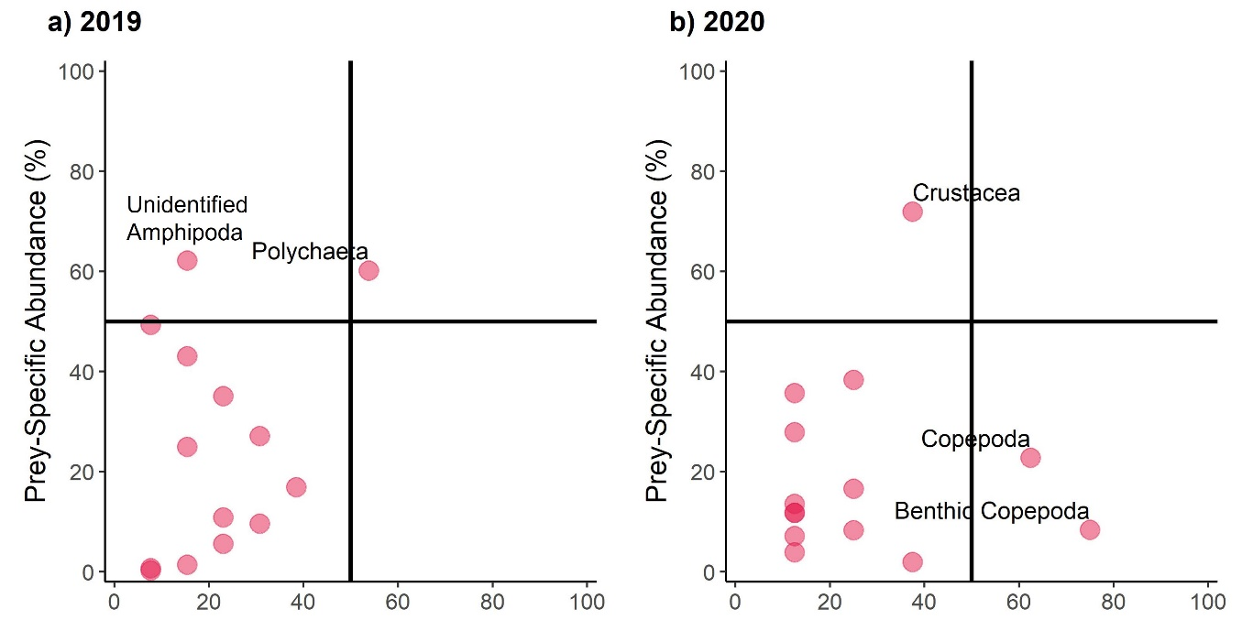

Figure S3. Modified Costello analyses of the diets of Fish Doctor sampled from inner Frobisher Bay in (a) 2019 (n = 13), and (b) 2020 (n = 8). All prey categories with a Frequency of Occurrence > 50% or Prey-Specific Abundance > 50% were labelled. Individual- and population-level specialization on benthic and pelagic prey varied between years.

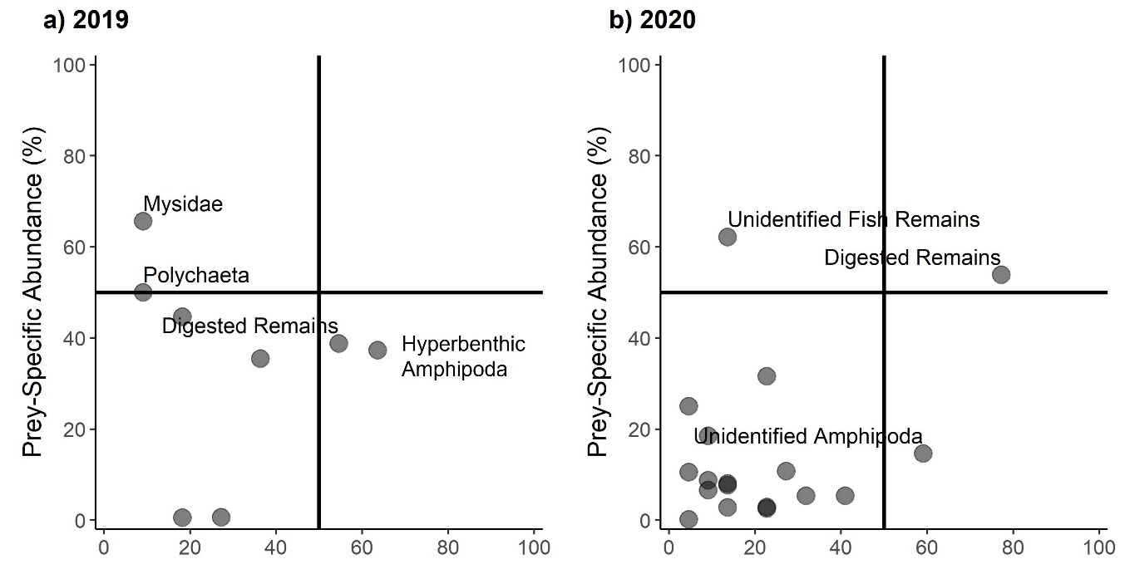

Figure S4. Modified Costello analyses of the diets of sculpins (Gymnocanthus tricuspis, Icelus bicornis, I. spatula) sampled from inner Frobisher Bay in (a) 2019 (n = 11), and (b) 2020 (n = 22). All prey categories with a Frequency of Occurrence > 50% or Prey-Specific Abundance > 50% were labelled. Amphipoda and digested remains were frequently consumed in both years, but specialization on Mysidae, polychaetes, and digested remains varied between years.

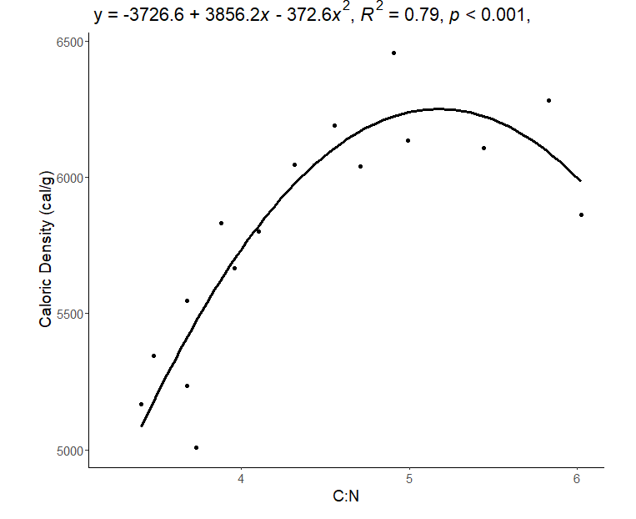

Figure S5. Caloric density as a function of C:N for Arctic charr (Salvelinus alpinus; n = 16) sampled in Frobisher Bay in 2018-2019.

