Supplementary materials

S1. Checklist of the PRISMA extension for network meta-analysis
Section/topic | # | PRISMA-DTA Checklist Item | Reported on page #
TITLE / ABSTRACT
Title | 1 | Identify the report as a systematic review (+/- meta-analysis) of diagnostic test accuracy (DTA) studies. | 1
Abstract | 2 | Abstract: See PRISMA-DTA for abstracts. | 2-3
INTRODUCTION
Rationale | 3 | Describe the rationale for the review in the context of what is already known. | 4
Clinical role of index test | D1 | State the scientific and clinical background, including the intended use and clinical role of the index test, and if applicable, the rationale for minimally acceptable test accuracy (or minimum difference in accuracy for comparative design). | 4
Objectives | 4 | Provide an explicit statement of question(s) being addressed in terms of participants, index test(s), and target condition(s). | 4
METHODS
Protocol and registration | 5 | Indicate if a review protocol exists, if and where it can be accessed (e.g., Web address), and, if available, provide registration information including registration number. | Not registered
Eligibility criteria | 6 | Specify study characteristics (participants, setting, index test(s), reference standard(s), target condition(s), and study design) and report characteristics (e.g., years considered, language, publication status) used as criteria for eligibility, giving rationale. | 5
Information sources | 7 | Describe all information sources (e.g., databases with dates of coverage, contact with study authors to identify additional studies) in the search and date last searched. | 5
Search | 8 | Present full search strategies for all electronic databases and other sources searched, including any limits used, such that they could be repeated. | 5
Study selection | 9 | State the process for selecting studies (i.e., screening, eligibility, included in systematic review, and, if applicable, included in the meta-analysis). | 5-6
Data collection process | 10 | Describe method of data extraction from reports (e.g., piloted forms, independently, in duplicate) and any processes for obtaining and confirming data from investigators. | 6
Definitions for data extraction | 11 | Provide definitions used in data extraction and classifications of target condition(s), index test(s), reference standard(s) and other characteristics (e.g. study design, clinical setting). | 6-7
Risk of bias and applicability | 12 | Describe methods used for assessing risk of bias in individual studies and concerns regarding the applicability to the review question. | 6-7
Diagnostic accuracy measures | 13 | State the principal diagnostic accuracy measure(s) reported (e.g. sensitivity, specificity) and state the unit of assessment (e.g. per-patient, per-lesion). | 6
Synthesis of results | 14 | Describe methods of handling data, combining results of studies and describing variability between studies. This could include, but is not limited to: a) handling of multiple definitions of target condition. b) handling of multiple thresholds of test positivity, c) handling multiple index test readers, d) handling of indeterminate test results, e) grouping and comparing tests, f) handling of different reference standards | 7
Meta-analysis | D2 | Report the statistical methods used for meta-analyses, if performed. | 7
Additional analyses | 16 | Describe methods of additional analyses (e.g., sensitivity or subgroup analyses, meta-regression), if done, indicating which were pre-specified. | 7
RESULTS
Study selection | 17 | Provide numbers of studies screened, assessed for eligibility, included in the review (and included in meta-analysis, if applicable) with reasons for exclusions at each stage, ideally with a flow diagram. | 8
Study characteristics | 18 | For each included study provide citations and present key characteristics including: a) participant characteristics (presentation, prior testing), b) clinical setting, c) study design, d) target condition definition, e) index test, f) reference standard, g) sample size, h) funding sources | 8
Risk of bias and applicability | 19 | Present evaluation of risk of bias and concerns regarding applicability for each study. | 8-9
Results of individual studies | 20 | For each analysis in each study (e.g. unique combination of index test, reference standard, and positivity threshold) report 2x2 data (TP, FP, FN, TN) with estimates of diagnostic accuracy and confidence intervals, ideally with a forest or receiver operator characteristic (ROC) plot. | 9-11
Synthesis of results | 21 | Describe test accuracy, including variability; if meta-analysis was done, include results and confidence intervals. | 9-11
Additional analysis | 23 | Give results of additional analyses, if done (e.g., sensitivity or subgroup analyses, meta-regression; analysis of index test: failure rates, proportion of inconclusive results, adverse events). | 11
DISCUSSION
Summary of evidence | 24 | Summarize the main findings including the strength of evidence. | 11-13
Limitations | 25 | Discuss limitations from included studies (e.g. risk of bias and concerns regarding applicability) and from the review process (e.g. incomplete retrieval of identified research). | 13-14
Conclusions | 26 | Provide a general interpretation of the results in the context of other evidence. Discuss implications for future research and clinical practice (e.g. the intended use and clinical role of the index test). | 14
FUNDING
Funding | 27 | For the systematic review, describe the sources of funding and other support and the role of the funders. | 14

S2. Searching strategies in details for four databases
Pubmed
#1 | ((breast neoplasm) OR breast cancer) OR breast carcinoma
#2 | (ultrasound) OR ultrasonography
#3 | screening
#4 | ((((((((supplemental) OR supplementary) OR adjunct) OR adjunctive) OR combined) OR joint) OR primary) OR single) OR alone
#5 | ((((sensitivity) OR specificity) OR detection rate) OR recall rate) OR biopsy rate
#6 | ((((#1) AND #2) AND #3) AND #4) AND #5 Filters: Clinical Study; Clinical Trial; Comparative Study; Controlled Clinical Trial; English Abstract; Evaluation Studies; Multicenter Study; Observational Study; Randomized Controlled Trial; Publication date from 2003/01/01 to 2017/12/31; Humans; English; Female; Cancer

Scopus
#1 | TITLE-ABS-KEY ( "breast neoplasm" OR "breast cancer" OR "breast carcinoma" ) AND DOCTYPE ( ar ) AND PUBYEAR > 2002
#2 | TITLE-ABS-KEY ( "ultrasound" OR "ultrasonography" ) AND DOCTYPE ( ar ) AND PUBYEAR > 2002
#3 | TITLE-ABS-KEY ( screening ) AND DOCTYPE ( ar ) AND PUBYEAR > 2002
#4 | TITLE-ABS-KEY ( "supplemental" OR "supplementary" OR "adjunct" OR "adjunctive" OR "combined" OR "joint" OR "primary" OR "single" OR "alone" ) AND DOCTYPE ( ar ) AND PUBYEAR > 2002
#5 | TITLE-ABS-KEY ( "sensitivity" OR "specificity" OR "detection rate" OR "recall rate" OR "biopsy rate" ) AND DOCTYPE ( ar ) AND PUBYEAR > 2002
#6 | #1 AND #2 AND #3 AND #4 AND #5

Web of Science
#1 | TOPIC: (breast cancer) OR TOPIC: (breast neoplasm) OR TOPIC: (breast carcinoma)
#2 | TOPIC: (ultrasound) OR TOPIC: (ultrasonography)
#3 | TOPIC: (screening)
#4 | TOPIC: (supplemental) OR TOPIC: (supplementary) OR TOPIC: (adjunct) OR TOPIC: (adjunctive) OR TOPIC: (combined) OR TOPIC: (joint) OR TOPIC: (primary) OR TOPIC: (single) OR TOPIC: (alone)
#5 | TOPIC: (sensitivity) OR TOPIC: (specificity) OR TOPIC: (detection rate) OR TOPIC: (recall rate) OR TOPIC: (biopsy rate)
#6 | #5 AND #4 AND #3 AND #2 AND #1
#7 | #5 AND #4 AND #3 AND #2 AND #1  Refined by: PUBLICATION YEARS: ( 2016 OR 2005 OR 2003 OR 2015 OR 2008 OR 2013 OR 2009 OR 2010 OR 2012 OR 2011 OR 2006 OR 2017 OR 2007 OR 2014 OR 2004 ) AND DOCUMENT TYPES: ( ARTICLE ) AND LANGUAGES: ( ENGLISH )

Embase
('breast neoplasm':ti,ab,kw OR 'breast cancer':ti,ab,kw OR 'breast carcinoma':ti,ab,kw) AND
('ultrasound':ti,ab,kw OR 'ultrasonography':ti,ab,kw) AND
'screening':ti,ab,kw AND
('supplemental':ti,ab,kw OR 'supplementary':ti,ab,kw OR 'adjunct':ti,ab,kw OR 'adjunctive':ti,ab,kw OR 'combined':ti,ab,kw OR 'joint':ti,ab,kw OR 'primary':ti,ab,kw OR 'single':ti,ab,kw OR 'alone':ti,ab,kw) AND
('sensitivity':ti,ab,kw OR 'specificity':ti,ab,kw OR 'detection rate':ti,ab,kw OR 'recall rate':ti,ab,kw OR 'biopsy rate':ti,ab,kw) AND
([controlled clinical trial]/lim OR [randomized controlled trial]/lim) AND [2003-2018]/py

S3. Flowchart of searching strategy.
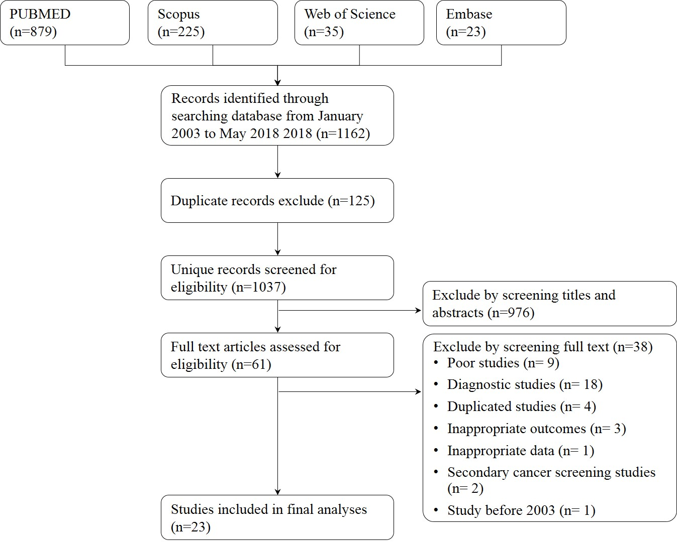

S4. Screening accuracy for supplemental US screening
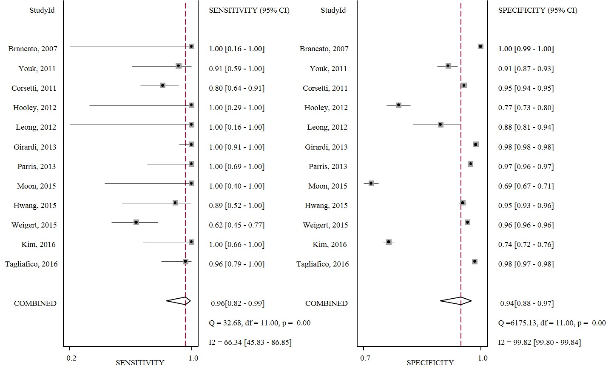
S5. Screening accuracy for primary MAM screening
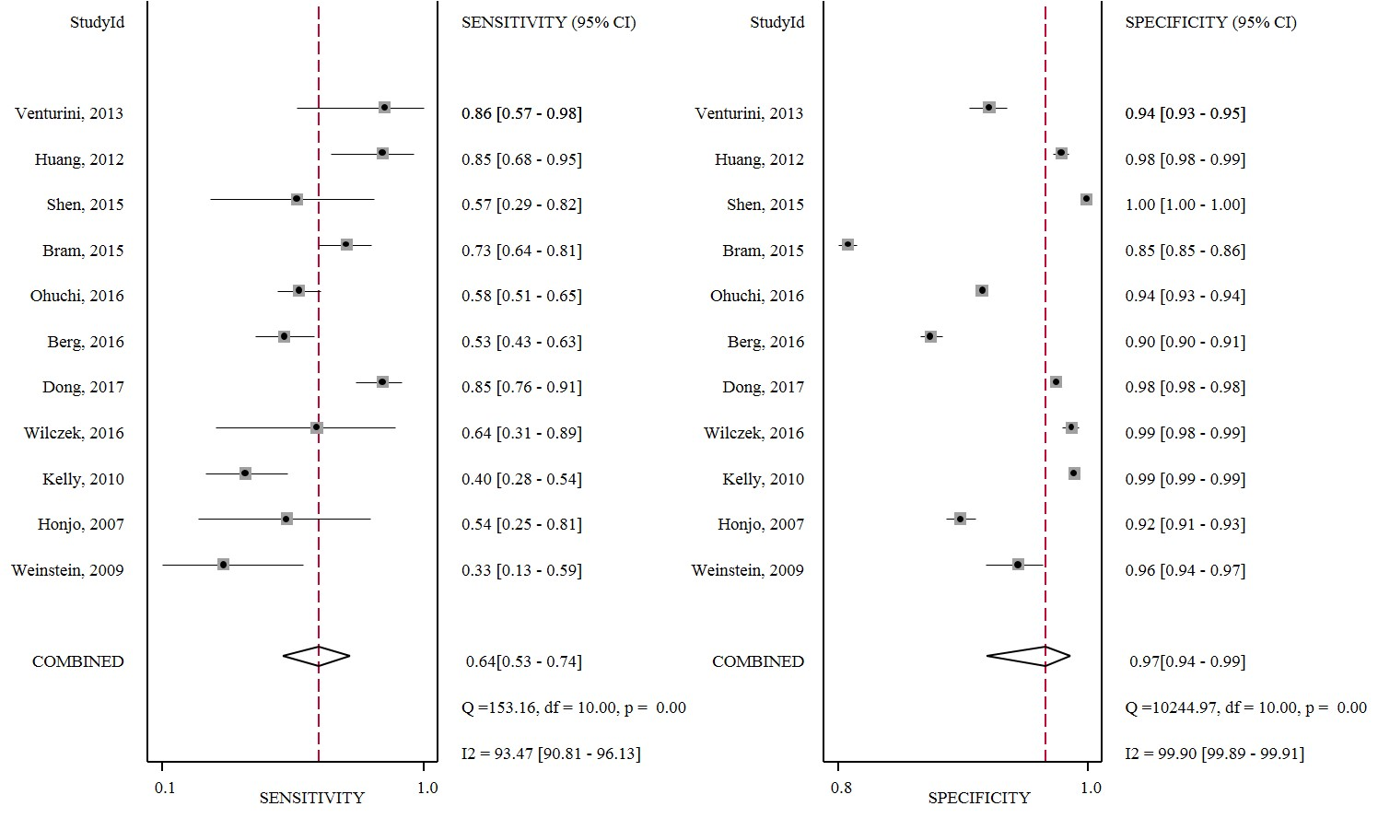

S6. Screening accuracy for primary US screening
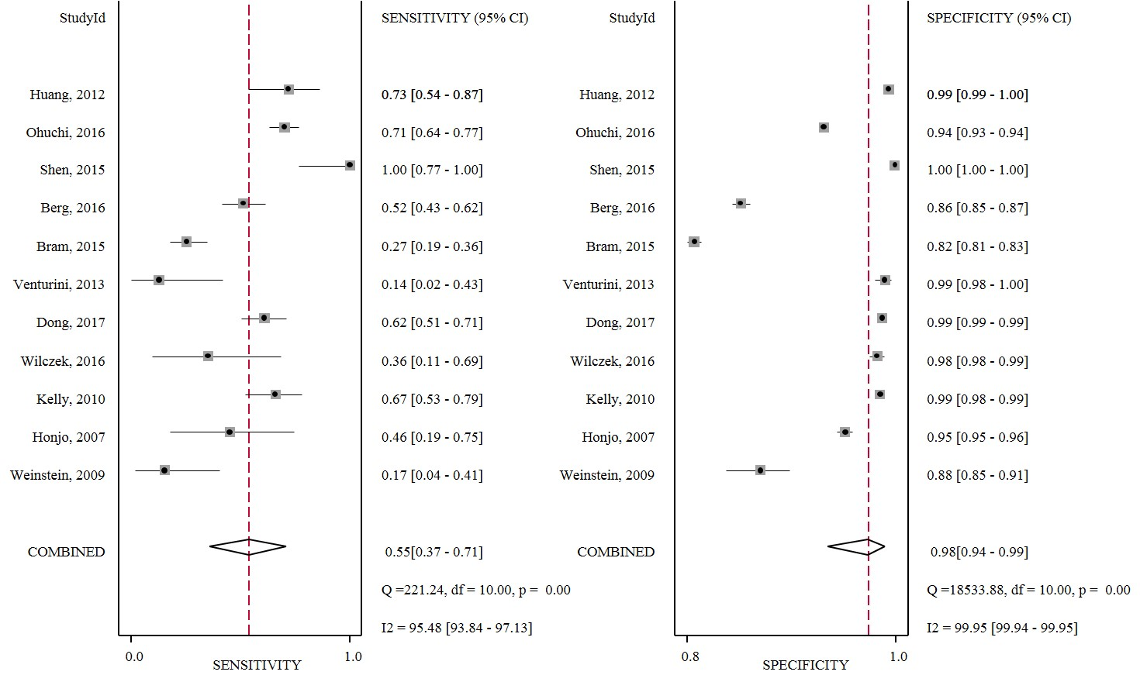

S7. Subgroup analyses on the performance of supplemental ultrasonography screening for breast cancer
Subgroup | Sensitivity, % |  |  | Specificity, % |  |  | Cancer detected rate,  1/1000 |  |  | Recall rate, % |  |  | Biopsy rate, % |  |  | ProIC, % |  |  | ProNPC, %
Subgroup | N | 95%CI |  | N | 95%CI |  | N | 95%CI |  | N | 95%CI |  | N | 95%CI |  | N | 95%CI |  | N | 95%CI
All women with dense breasts
Yes | 9 | 93.4 (80.9, 100) |  | 9 | 92.5 (87.2, 96.5) |  | 9 | 3.4 (1.6, 5.9) |  | 9 | 8.1 (4.0, 13.6) |  | 8 | 4.6 (2.6, 7.2) |  | 5 | 73.4 (40.2, 97.6) |  | 2 | 68.6 (44.1, 89.6)
No | 3 | 99.9 (89.2, 100) |  | 3 | 90.2 (68.7, 99.8) |  | 3 | 2.4 (1.1, 4.1) |  | 3 | 10.2 (0.3, 31.5) |  | 2 | 1.9 (1.7, 2.1) |  | 2 | 77.2 (46.5, 98.4) |  | 2 | 81.2 (43.3, 100)
Sample size
≥ 1000 | 9 | 94.9 (81.9, 100) |  | 9 | 93.6 (88.6, 97.2) |  | 9 | 2.6 (1.6, 3.9) |  | 9 | 6.8 (3.1, 11.8) |  | 7 | 2.4 (1.3, 3.9) |  | 5 | 75.3 (47.3, 96.0) |  | 3 | 69.0 (48.3, 87.1)
< 1000 | 3 | 97.8 (76.9, 100) |  | 3 | 85.6 (74.4, 94.0) |  | 3 | 12.6 (1.7, 31.2) |  | 3 | 15.9 (8.2, 25.6) |  | 3 | 9.7 (6.4, 13.6) |  | 2 | 60.3 (10.3, 99.7) |  | 1 | 100 (15.8, 100)
Screening mode
Opportunistic screening | 10 | 95.0 (82.0, 100) |  | 10 | 91.4 (85.8, 95.7) |  | 10 | 2.7 (1.6, 4.1) |  | 10 | 9.0 (4.6, 14.7) |  | 8 | 3.8 (2.3, 5.6) |  | 5 | 64.7 (44.4, 83.1) |  | 3 | 86.9 (53.2, 100)
Community women | 2 | 100 (89.0, 100) |  | 2 | 98.0 (97.5, 98.5) |  | 2 | 5.4 (2.9, 8.6) |  | 2 | 2.7 (2.2, 33.4) |  | 2 | 1.4 (1.0, 1.9) |  | 2 | 98.5 (83.9, 100) |  | 1 | 61.9 (38.4, 81.9)
Exclusion of BC
Yes | 3 | 92.2 (77.4, 100) |  | 3 | 91.2 (76.0, 99.2) |  | 3 | 3.6 (2.7, 7.0) |  | 3 | 9.5 (1.2, 24.3) |  | 3 | 3.5 (1.4, 6.4) |  | 2 | 93.4 (79.2, 99.8) |  | 1 | 61.9 (38.4, 81.9)
No or NR | 9 | 96.8 (80.5, 100) |  | 9 | 92.2 (87.2, 96.1) |  | 9 | 2.2 (1.0, 3.9) |  | 9 | 8.3 (4.3, 13.5) |  | 7 | 4.1 (2.4, 6.1) |  | 5 | 58.9 (38.5, 78.1) |  | 3 | 86.9 (53.2, 100)
Complete data
Yes | 11 | 96.5 (85.1, 100) |  | 11 | 91.7 (86.5, 95.7) |  | 11 | 2.8 (1.5, 4.4) |  | 11 | 8.9 (4.8, 14.2) |  | 9 | 4.1 (2.6, 6.0) |  | 6 | 70.6 (40.8, 94.2) |  | 3 | 67.7 (43.2, 88.9)
No | 1 | 88.9 (51.8, 99.7) |  | 1 | 94.6 (94.5, 95.7) |  | 1 | 4.6 (2.0, 9.1) |  | 1 | 5.8 (4.7, 7.0) |  | 1 | 2.1 (1.5, 2.9) |  | 1 | 87.5 (47.4, 99.7) |  | 1 | 85.7 (42.1, 99.6)
BIRADS criteria
Yes | 8 | 95.0 (82.1, 100) |  | 8 | 92.6 (87.6, 96.5) |  | 8 | 3.9 (1.8, 6.7) |  | 8 | 7.9 (3.8, 13.2) |  | 6 | 3.4 (1.9, 5.3) |  | 4 | 61.0 (36.6, 83.3) |  | 3 | 86.9 (53.2, 100)
No | 4 | 96.0 (78.5, 100) |  | 4 | 90.6 (77.4, 98.4) |  | 4 | 2.4 (1.3, 4.0) |  | 4 | 10.3 (2.2, 23.2) |  | 4 | 4.7 (2.3, 7.8) |  | 3 | 88.9 (60.3, 100) |  | 1 | 61.9 (38.4, 81.9)
Follow-up
≥ 12 months | 7 | 92.0 (82.6, 98.6) |  | 7 | 85.3 (74.3, 93.7) |  | 7 | 4.4 (2.1, 7.3) |  | 7 | 15.5 (7.1, 26.5) |  | 6 | 6.0 (4.1, 8.3) |  | 5 | 75.6 (53.8, 93.1) |  | 3 | 86.9 (53.2, 100)
<12 months or NR | 5 | 96.2 (73.3, 100) |  | 5 | 97.9 (96.5, 99.0) |  | 5 | 2.2 (1.0, 3.8) |  | 5 | 2.3 (1.2, 3.8) |  | 4 | 1.6 (0.7, 2.9) |  | 2 | 75.3 (61.2, 87.2) |  | 1 | 61.9 (38.4, 81.9)

S8. Subgroup analyses on the performances of primary MAM screening compared to primary US screening for breast cancer
Subgroup | Sensitivity, % |  |  | Specificity, % |  |  | Cancer detected rate,  1/1000 |  |  | Recall rate, % |  |  | Biopsy rate, % |  |  | ProIC, % |  |  | ProNPC, %
Subgroup | N | 95%CI |  | N | 95%CI |  | N | 95%CI |  | N | 95%CI |  | N | 95%CI |  | N | 95%CI |  | N | 95%CI
All women with dense breasts
Yes | 3 | 24.7 (-10.7, 60.1) |  | 3 | 2.7 (0.6, 4.9) |  | 3 | 2.0 (-0.0, 4.0) |  | 3 | -1.4 (-2.9, 0.1) |  | 3 | -0.7 (-2.3, 0.9) |  | 3 | -26.6 (-36.1, -17.1) |  | 2 | -4.6 (-13.3, 4.1)
No or NR | 8 | 5.7 (-15.1, 26.5) |  | 8 | -0.7 (-1.3, -0.1) |  | 8 | -0.0 (-1.0, 1.0) |  | 8 | -1.0 (-1.9, 0.2) |  | 4 | -0.4 (-0.9, 0.1) |  | 6 | -16.6 (-33.8, 0.5) |  | 5 | -0.4 (-23.1, 22.4)
Type of ultrasound
HHUS | 8 | 9.2 (-9.3, 27.6) |  | 8 | -0.3 (-1.0, -0.4) |  | 8 | 0.0 (-1.0, -1.0) |  | 8 | -1.0 (-1.9, -0.1) |  | 4 | -0.8 (-2.1, 0.5) |  | 6 | -17.6 (-34.5, -0.7) |  | 6 | -1.6 (-17.3, 14.1)
ABUS | 3 | 15.5 (-38.4, 69.3) |  | 3 | 1.5 (-0.1, 3.1) |  | 3 | 1.0 (-3.0, 5.0) |  | 3 | -1.4 (-2.8, -0.1) |  | 3 | -0.2 (-0.9, 0.4) |  | 3 | -27.1 (-38.0, -16.1) |  | 1 | -3.2 (-14.6, 8.1)
Sample size
≥ 1000 | 10 | 10.3 (-9.0, 29.6) |  | 10 | -0.0 (-0.6, 0.6) |  | 10 | 1.0 (-1.0, 2.0) |  | 10 | -1.1 (-1.9, -0.3) |  | 6 | -0.6 (-1.3, 0.1) |  | 8 | -18.5 (-31.7, -5.4) |  | 6 | -2.1 (-14.5, 10.2)
< 1000 | 1 | 16.7 (-11.1, 44.4) |  | 1 | 7.8 (4.6, 11.0) |  | 1 | 5.0 (-5.0, 14.0) |  | 1 | -1.8 (-4.5, 0.9) |  | 1 | -0.1 (-2.2, 2.0) |  | 1 | -50.0 (-12.6, 12.6) |  | 1 | 0.0 (-6.1, 6.1)
Screening mode
Community/high-risk screening | 10 | 12.1 (-7.4, 31.6) |  | 10 | -1.0 (-1.5, -0.4) |  | 10 | 1.0(-1.0, 2.0) |  | 10 | -0.5 (-1.2, 0.1) |  | 7 | -0.6 (-1.2, 0.1) |  | 9 | -20.2 (-33.1, -7.2) |  | 7 | -2.0 (-13.5, 9.4)
Opportunistic women | 1 | 10.8 (-9.0, 30.5) |  | 1 | 0.4 (-0.3, 1.0) |  | 1 | 1.0 (-3.0, 6.0) |  | 1 | -7.0 (-8.3, -5.8) |  | 0 |  |  | 0 |  |  | 0
Exclusion of BC
Yes | 8 | 15.3 (-6.0, 36.6) |  | 8 | 0.2 (-0.4, 0.9) |  | 8 | 1.0 (-0.0, 2.0) |  | 8 | -1.7 (-2.5, -0.8) |  | 5 | -0.5 (-1.3, 0.3) |  | 6 | -17.3 (-32.9, -1.7) |  | 5 | -2.3 (-15.7, 11.2)
No or NR | 3 | -2.9 (-33.4, 27.6) |  | 3 | 1.3 (-2.4, 5.0) |  | 3 | -1.0 (-4.0, 3.0) |  | 3 | 3.0 (-2.9, 3.5) |  | 2 | -0.9 (-1.4, -0.3) |  | 3 | -25.0 (-42.2, -7.8) |  | 2 | 0.0 (-30.9, 30.9)
Blinding
Yes | 8 | -2.6 (-17.5, 12.3) |  | 8 | 0.2 (-0.4, 0.8) |  | 8 | -0.0 (-1.0, 1.0) |  | 8 | -0.6 (-1.4, 0.2) |  | 4 | -0.9 (-2.1, 0.3) |  | 6 | -16.2 (-31.3, -1.1) |  | 5 | -0.5 (-16.9, 16.0)
No | 3 | 50.7 (20.8, 70.6) |  | 3 | -0.3 (-4.3, 3.7) |  | 3 | 3.0 (2.0, 5.0) |  | 3 | -2.9 (-5.3, -0.5) |  | 3 | 0.1 (-0.3, 0.4) |  | 3 | -31.0 (-43.7, -18.4) |  | 2 | -3.8 (-15.1, 7.5)
Complete data
Yes | 8 | 9.3 (-9.8, 28.3) |  | 8 | 0.5 (-0.5, 1.4) |  | 8 | 1.0 (-1.0, 2.0) |  | 8 | -1.0 (-2.2, 0.2) |  | 4 | -0.8 (-1.9, 0.4) |  | 7 | -17.8 (-31.4, -4.1) |  | 5 | -0.5 (-16.9, 16.0)
No | 3 | 15.1 (-50.7, 81.0) |  | 3 | 0.6 (-3.9, 5.2) |  | 3 | 2.0 (-3.0, 6.0) |  | 3 | -2.5 (-6.1, 1.2) |  | 3 | -0.1 (-0.3, -0.0) |  | 2 | -41.7 (-76.6, -6.8) |  | 2 | -3.8 (-15.1, 7.5)
BIRADS criteria
Yes | 8 | 8.0 (-15.0, 31.1) |  | 8 | 0.8 (-0.2, 1.7) |  | 8 | 1.0 (-1.0, 2.0) |  | 8 | -2.2 (-3.2, -1.1) |  | 6 | -0.6 (-1.4, 0.1) |  | 6 | -22.4 (-29.1, -15.6) |  | 5 | -8.2 (-15.2, -1.2)
No | 3 | 22.3 (11.3, 33.2) |  | 3 | -1.0 (-2.5, 0.5) |  | 3 | 1.0 (0.0, 1.0) |  | 3 | 1.1 (-0.4, 2.6) |  | 1 | -0.1 (-0.6, 0.5) |  | 3 | -14.2 (-48.2, 19.7) |  | 2 | 19.2 (4.3, 34.2)
Follow-up
≥ 12 months | 10 | 5.1 (-12.5, 22.7) |  | 10 | 0.6 (-0.0, 1.2) |  | 10 | 0.0 (-1.0, 2.0) |  | 10 | -0.9 (-1.6, -0.1) |  | 6 | -0.6 (-1.3, 0.1) |  | 8 | -19.6 (-33.0, -6.1) |  | 6 | -1.4 (-13.3, 10.5)
<12 months or NR | 1 | 71.4 (45.5, 97.4) |  | 1 | -5.0 (-6.3, -3.7) |  | 1 | 5.0 (-0.0, 10.0) |  | 1 | -5.9 (-8.2, -3.6) |  | 1 | -0.4 (-1.2, 0.5) |  | 1 | -33.3 (-3.7, 37.0) |  | 1 | -30.0 (-7.7, 47.7)
Quality
Good | 7 | 1.2 (-20.0, 22.4) |  | 7 | 0.7 (0.1, 1.4) |  | 7 | 0.0 (-1.0, 2.0) |  | 7 | -1.4 (-2.2, -0.5) |  | 4 | -0.8 (-1.7, 0.2) |  | 5 | -15.3 (-30.3, -0.3) |  | 4 | -1.4 (-15.5, 12.6)
Fair | 4 | 32.3 (0.9, 63.6) |  | 4 | -0.2 (-3.8, 3.4) |  | 4 | 1.0 (-1.0, 3.0) |  | 4 | -1.1 (-4.3, 2.1) |  | 3 | -0.1 (-0.6, 0.3) |  | 4 | -37.3 (-60.5, -14.0) |  | 3 | -4.1 (-32.8, 24.6)

