Supplementary Information

Whole-Body Human Ultrasound Tomography

David C. Garrett†, Jinhua Xu†, Yousuf Aborahama, Geng Ku,
Konstantin Maslov, and Lihong V. Wang*

Caltech Optical Imaging Laboratory, Andrew and Peggy Cherng Department of Medical Engineering, Department of Electrical Engineering, California Institute of Technology, Pasadena, CA 91125 USA

† These authors contributed equally.
* Corresponding author: lvw@caltech.edu

Array construction

Steps of the array construction are shown in Supplementary Fig. 1. The 1 mm thick, gold-coated PVDF-TrFE piezoelectric was diced into elements 3 mm in width and 10 mm in height using an excimer UV laser. The elements were then aligned with copper-clad polyimide electrodes and bonded using high-strength epoxy, leading to capacitive coupling. A short trace is extended from each electrode for connection to the preamplifier circuits. A continuous piece of copper-clad polyimide was then bonded on the opposite surface of the piezoelectric.

Strips of 128 channels were then mounted into the plastic supports and positioned around a 60 cm diameter lathwed disc of high-density polyethylene to provide a precise template surface geometry. The backing was then filled with casting epoxy. Next, the preamplifier printed circuit boards (PCBs) were mounted, and each electrode trace was soldered to its amplifier channel. Every ~10 channels, a short wire was also soldered to the reference (front) electrode. Signal coaxial cables for each channel and DC power cables extend down the supporting tubes and connect to the PCBs. The top stainless-steel plate was then lowered, and the front electrode was trimmed to the plate height. Finally, a stainless-steel shim was glued with silver epoxy to the exterior surface of the array to provide electrical shielding.

Supplementary Fig. 1. Steps of the acoustic receiver array construction. a Diced PVDF-TrFE is glued to polyimide electrodes and a continuous common electrode. b Sections of channels are mounted to a circular template. A casting epoxy backing is poured. c Annular preamplifier PCBs are mounted on top of each section, and the electrodes are soldered to them. d A grounding wire is soldered every ~10 channels. e The outer electrode is trimmed, the array is filled with casting epoxy, and the top stainless steel plate is screwed in.

Receiver characterization

The bandwidth of the array elements was evaluated using a photoacoustic point source made from carbon powder-epoxy mixture on the tip of an optical fiber (Thorlabs FT600EMT) of 600 $μm$ core size. A sampling rate of 20 megasamples per second was used to record the bandwidth up to 10 MHz. The frequency response of the array elements is given in Supplementary Fig. 2. The average –3 dB bandwidth across the array is approximately 0.81 MHz (corresponding to 81% fractional bandwidth).

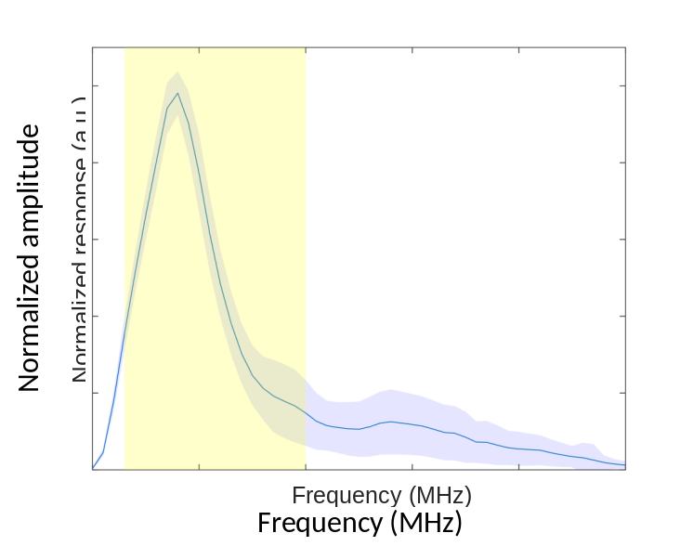
Supplementary Fig. 2. Normalized frequency response the receiver array. The solid curve indicates the mean response across 512 elements. The blue shaded area indicates one standard deviation from the mean response. The yellow shaded area indicates the frequency range of 0.3 – 2 MHz of the imaging chirp signal.

Additional human images

The female subject from Fig. 2 was also imaged at various heights from the ribcage toward the pelvis, shown in Supplementary Fig. 3. This subject had her left kidney removed during childhood but is now healthy.

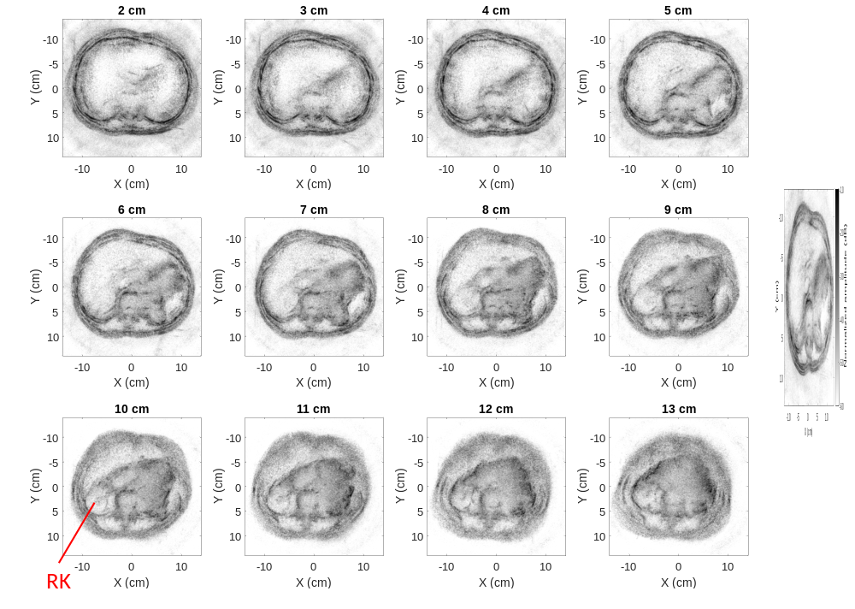
Supplementary Fig. 3. Example of elevational scans of a female subject from approximately the ribcage to the pelvis. RK: right kidney (left kidney was removed).

Straight-ray transmission-mode reconstruction algorithms

Along the straight ray $L_{i}$ between the i^{th} transmitter-receiver pair, the total delay $τ_{i}$ can be modeled as $\int_{L_{i}}^{ }{\frac{dl}{c(\overset{⃑}{r})}}=τ_{i}$, where $c(\overset{⃑}{r})$ represents the location-dependent speed of sound. This equation can be discretized as $\sum_{j∈\{L_{i}\}}{Δl_{ij}}∙x_{j}=τ_{i}$, where $x_{j}=\frac{1}{c_{j}}$ is the inverse of the speed of sound at the j^{th} pixel along ray $L_{i}$ and $Δl_{ij}$ represents the length of ray $L_{i}$ crossing the j^{th} pixel. The linear equation can be arranged into the matrix form $AX=T$, where $X$ and $T$ are the vectorized $x_{j}$ and $τ_{i}$.

One technical issue with solving the linear equation is with the memory required for matrix $A$ which is of the size $(N_{t}∙N_{r})×(N_{x}∙N_{y})$ (>10¹¹ in our implementation). Rather than saving and inverting the matrix directly, we take advantage of the fact that $A^{'}=A^{T}A$ is close to diagonal (as neighboring rays go through neighboring pixels), and therefore $X^{'}≈A^{T}AX$ can be estimated as a vector with elements $x_{j}^{'}≈A_{jj}^{'}x_{j}=\left(\sum_{i}{Δl_{ij}^{2}}\right)∙x_{j}$. The right-hand side of the equation is then converted to $B=A^{T}T$, with elements $b_{j}=\sum_{i}{τ_{i}}Δl_{ij}$. Thereby, simple element-wise division of $B$ by $\sum_{i}{Δl_{ij}^{2}}$ solves for $X$.

The attenuation coefficient map can be rearranged as $\int_{L_{i}}^{ }{μ_{a}\left(\overset{⃑}{r}\right)dl}=a_{i}⇒\sum_{j∈\{L_{i}\}}{Δl_{ij}}∙{μ_{a}}_{j}=a_{i}$ and solved concurrently.

To robustly determine signal arrival time, we cross-correlate the subject and water-only time traces, then derive the arrival time difference using various methods.

We tried using the first-break method [1]. For a given cross-correlated target signal $χ_{s}\left(i\right)$ at discrete time samples $i$, an energy ratio $er$ is defined for a window size $N_{e}$ as:

 | $$er\left(i\right)=\frac{\sum_{j=i}^{i+N_{e}}{{χ_{s}}^{2}\left(j\right)}}{\sum_{j=i-N_{e}}^{i}{{χ_{s}}^{2}\left(j\right)}}.$$ | (1)

We use a window $N_{e}$ of 4 μs as a compromise between robustness and precision. The modified energy ratio ($mer$) is then calculated as:

 | $$mer\left(i\right)={\left(\left|χ_{s}\left(i\right)\right|×\text{er}\right)}^{3}.$$ | (2)

The signal arrival time is determined from the maximum value of $mer$. As an example, the calculated transmission-mode arrival times through water and a human abdomen are shown in Supplementary Fig. 4.

We also tested methods such as global path tracing [2], an adapted algorithm of dynamic time warping used in seismology field, to enforce the smoothness prior between neighboring frames, and matched filtering which requires accurate knowledge of the transmitted waveform. In practice, we found these methods to perform similarly given the SNR of the time traces collected.
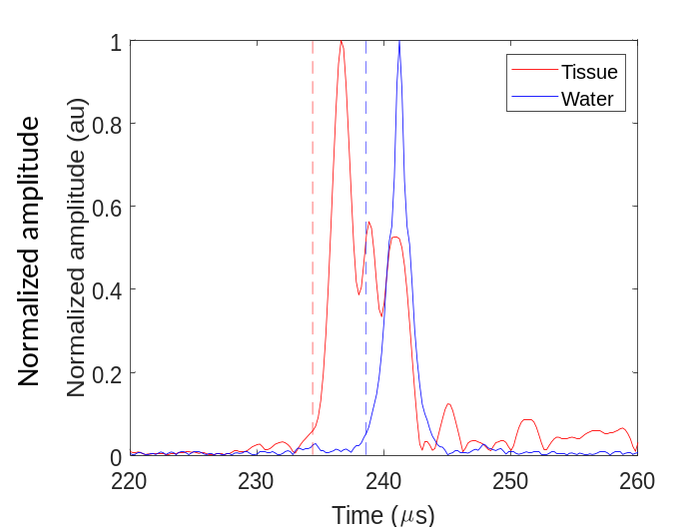
Supplementary Fig. 4. Example cross-correlated transmission signals for water-only and the human abdomen. The vertical dashed lines show the estimated arrival times using the first-break method.

Transmission-mode reconstruction accuracy

To assess the accuracy of our speed of sound profiles, we imaged ethanol-water mixtures with speed of sound ranging from approximately 1510 to 1610 m/s. Note that the speed of sound increases with ethanol content until ~50%, but decreases at higher content [3]. The reference speed of sound was determined using a single-element transducer immersed in the mixture and by varying the distance to an acoustic reflector to record the time-of-flight using an ultrasonic pulser (Olympus 5072PR). Measurements were recorded over 21 distances at 1 mm intervals. The speed of sound was then calculated as $v=Δd/2Δt$, where $Δd$ is the difference in position, and $Δt$ is the difference in arrival time. The arrival time is determined using the first-break approach. Table 1 shows the mean and standard error of the speed of sound estimations for each mixture.

The five mixtures were then held in thin membranes of ~3 cm diameter and imaged together in the same session. For transmission-mode reconstruction, we used both the unmasked and masked approaches, where the masked method uses the reflection-mode image to segment each mixture during reconstruction. The resulting speed of sound estimations are given in Supplementary Table 1. We find typical errors of less than 1%, but a maximum error of 1.52% and 2.84% for the unmasked and masked approaches, respectively.

Supplementary Table 1. Estimated speed of sound in m/s for ethanol-water mixtures. Reference values were determined using a single-element transducer at varying distances in the mixtures. Percent error from the reconstructed values is shown in parentheses.

Method | Ethanol content
 | 5% | 10% | 20% | 50% | 60%
Reference  (Standard error) | 1508.6  (0.18) | 1532.4  (0.24) | 1578.9  (0.26) | 1609.5  (0.50) | 1531.4  (0.18)
Unmasked  (% error) | 1511.0  (0.15%) | 1524.5  (-0.52%) | 1580.2  (0.08%) | 1604.2  (-0.33%) | 1508.1  (-1.52%)
Masked  (% error) | 1509.39  (0.04%) | 1542.04  (0.63%) | 1578.83  (0.00%) | 1563.77  (-2.84%) | 1520.03  (-0.74%)

From our human images, we then compared our estimates of several tissue’s speed of sound (from the subject in Fig. 2) with literature values [4], as shown in Supplementary Fig. 5. Our estimates for the liver and stomach speed of sound match closely with literature values, but there is less agreement for other organs like the spleen. This is likely because these regions are smaller and therefore undergo less temporal shift from their speed of sound variations.

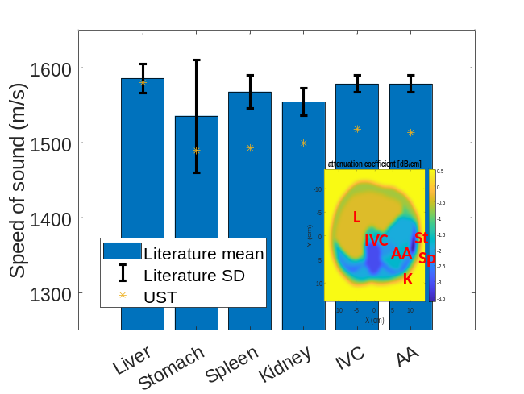
Supplementary Fig. 5. Comparison of literature [4] and UST estimations of tissue speed of sound. L: liver. St: stomach. Sp: spleen. K: kidney. IVC: inferior vena cava. AA: abdominal aorta. The inset shows the segmented tissue regions used for speed of sound reconstruction.

Since liver health assessment is a potential application of whole-body UST, we compared our estimated properties with reported values in various diseased states. Supplementary Fig. 6 shows the reported speed of sound [5] and attenuation coefficient [6] of the healthy and diseased liver. These values are shown alongside our estimations (from the subject in Fig. 2) across six image slices spaced by 1 cm vertically. As expected, our estimated values fall within the expected range for healthy subjects.

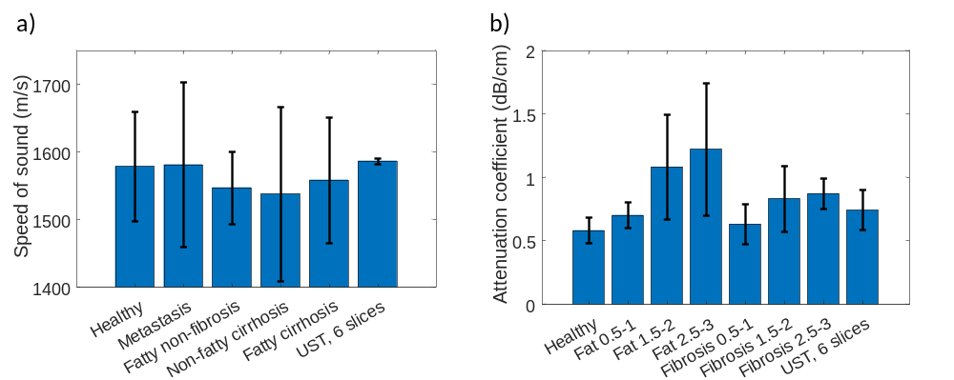
Supplementary Fig. 6. Comparison of UST transmission-mode estimations for a healthy subject’s liver acoustic properties. a Literature speed of sound values for the liver under various diseased conditions [5]. b Literature attenuation coefficient values for the liver at varying pathological stages of disease [6]. Error bars show the standard deviation of literature values and UST estimations across six images.

Transmitter lens correction

For manufacturing simplicity, we used a cylindrical TPX lens to diverge the transmitter beam, shown in Supplementary Fig. 7a. If uncorrected, this geometry causes cylindrical aberration where different emission angles correspond to varying effective focal lengths. We correct for this aberration during reconstruction. For each transmitter position, we determine the angle to each pixel and assign an appropriate focal length. We consider a plane wave emitted from the flat transducer surface as shown in Supplementary Fig. 7b. Wavefronts emerging at position $x$ along the transducer surface arrive at the lens interface at depth $y=\sqrt{r_{lens}^{2}-x^{2}}$. The angle normal to the lens surface at this position is:

 | $$θ_{norm}=\tan^{-1}{(x/y)}.$$ | (3)

The wavefront refracts at an angle relative to the normal angle as:

 | $$θ_{ref}=\sin^{-1}\left[\sin{(θ_{norm})\frac{c_{water}}{c_{lens}}}\right],$$ | (4)

where $c_{water}\sim 1500$ m/s and $c_{lens}\sim 2090$ m/s are the water and TPX lens speed of sound, respectively. The angle into the imaging plane is therefore $θ_{pix}=θ_{norm}-θ_{ref}.$ This line intersects with the centerline of the transducer at distance $f$ behind the emitting surface:

 | $$f=\frac{x}{\tan{θ_{pix}}}-y.$$ | (5)

During reconstruction, from a given $θ_{pix}$, we can therefore calculate the appropriate focal length $f$. Example calculated values are shown in Supplementary Fig. 7c. This is incorporated in our GPU-based reconstruction.

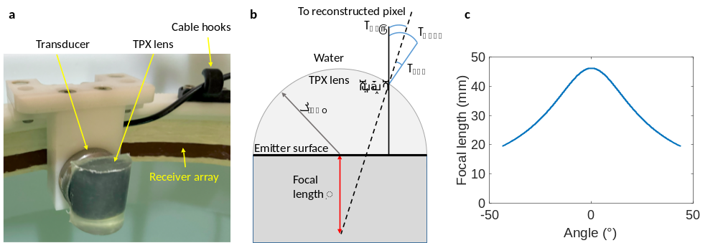
Supplementary Fig. 7. Determining the effective focal length for various pixel angles using a cylindrical TPX lens on the acoustic transmitter. a Photograph of TPX lens mounted on the transmitting transducer. b Diagram of TPX lens and transmitter surface. c Calculated focal length for varying angles to reconstructed pixels ($θ_{pix}$).

Biopsy needle acoustic modes

The biopsy needle acts as an acoustic waveguide where different modes are supported depending on the frequency and form of excitation. These modes can be longitudinal, torsional, or flexural. We expect the dominant mode to be the longitudinal L(0,1) mode which, fortunately, has approximately uniform phase velocity and low attenuation over our frequency range for this needle diameter (~1.5 mm), as shown in Supplementary Fig. 8a and b [7]. The phase velocity is close to the bulk longitudinal velocity of stainless steel (~5790 m/s). During reconstruction, we therefore consider a constant propagation delay down the needle length of ~50 μs.

An example received waveform spectrogram is shown in Supplementary Fig. 8c, showing that the linear chirp is maintained after propagation along the needle and emission at the tip. There is some reverberation after the dominant chirp signal due to other acoustic modes. A weak second-order chirp (at twice the dominant frequencies) is also visible due to nonlinearities in the power amplifier.

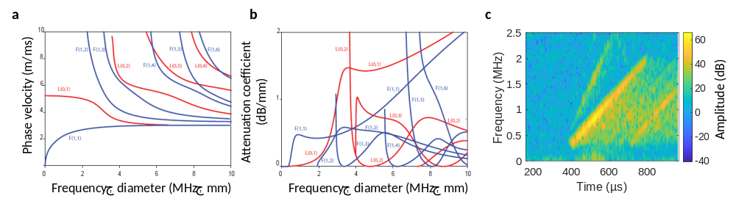
Supplementary Fig. 8. Expected acoustic modes in an unmodified biopsy needle. a and b: Phase velocity and attenuation coefficient, respectively, for acoustic modes supported by a stainless steel rod immersed in water, adapted from [7]. c Example waveform received from the scattered emission from the biopsy needle.

References

[1] J. I. Sabbione and D. Velis, “Automatic first-breaks picking: New strategies and algorithms,” GEOPHYSICS, vol. 75, no. 4, pp. V67–V76, Jul. 2010, doi: 10.1190/1.3463703.
[2] D. Zhang, T. W. Fei, S. Han, C. Tsingas, Y. Luo, and H. Liu, “Automatic first-arrival picking workflow by global path tracing,” Geophysics, Nov. 2021, doi: 10.1190/geo2021-0162.1.
[3] J. Tong, M. J. W. Povey, X. Zou, B. Ward, and C. P. Oates, “Speed of sound and density of ethanol-water mixture across the temperature range 10 to 50 degrees Celsius,” J. Phys. Conf. Ser., vol. 279, no. 1, p. 012023, Feb. 2011, doi: 10.1088/1742-6596/279/1/012023.
[4] IT’IS Foundation, “Tissue Properties Database V4.2.” IT’IS Foundation, 2024. doi: 10.13099/VIP21000-04-2.
[5] C. F. Chen, D. E. Robinson, L. S. Wilson, K. A. Griffiths, A. Manoharan, and B. D. Doust, “Clinical sound speed measurement in liver and spleen in vivo<math><mtext>in vivo</mtext></math>,” Ultrason. Imaging, vol. 9, no. 4, pp. 221–235, Oct. 1987, doi: 10.1016/0161-7346(87)90075-7.
[6] T. Lin, J. Ophir, and G. Potter, “Correlation of ultrasonic attenuation with pathologic fat and fibrosis in liver disease,” Ultrasound Med. Biol., vol. 14, no. 8, pp. 729–734, Jan. 1988, doi: 10.1016/0301-5629(88)90028-2.
[7] F. Simonetti, “A guided wave technique for needle biopsy under ultrasound guidance,” in Medical Imaging 2009: Visualization, Image-Guided Procedures, and Modeling, SPIE, Mar. 2009, pp. 405–412. doi: 10.1117/12.811482.

