Supplementary Information

Glacio-hydrological changes along the Andes throughout the 21st Century

Alexis Caro^{1,2*}, Thomas Condom¹, Antoine Rabatel¹, Rodrigo Aguayo³, Nicolas Champollion¹

¹Univ. Grenoble Alpes, CNRS, IRD, INRAE, Grenoble-INP, Institut des Géosciences de l’Environnement, Grenoble, France
²Department of Civil Engineering, Universidad de La Frontera, Temuco, Chile
³Department of Water and Climate, Vrije Universiteit Brussel, Brussels, Belgium
*alexis.caro.paredes@gmail.com

A | B | C | D | E
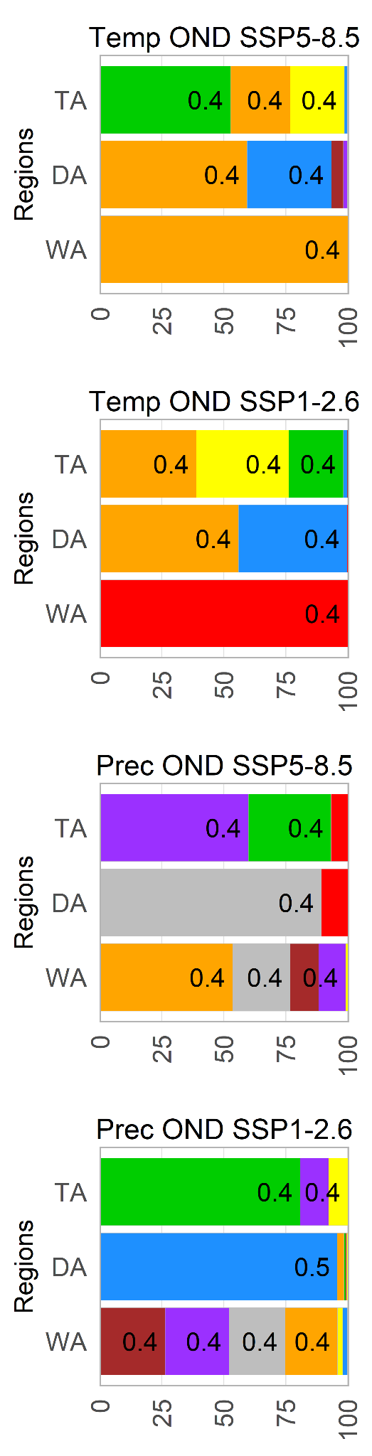 | 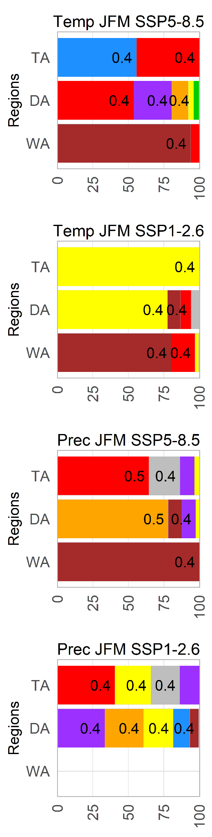 | 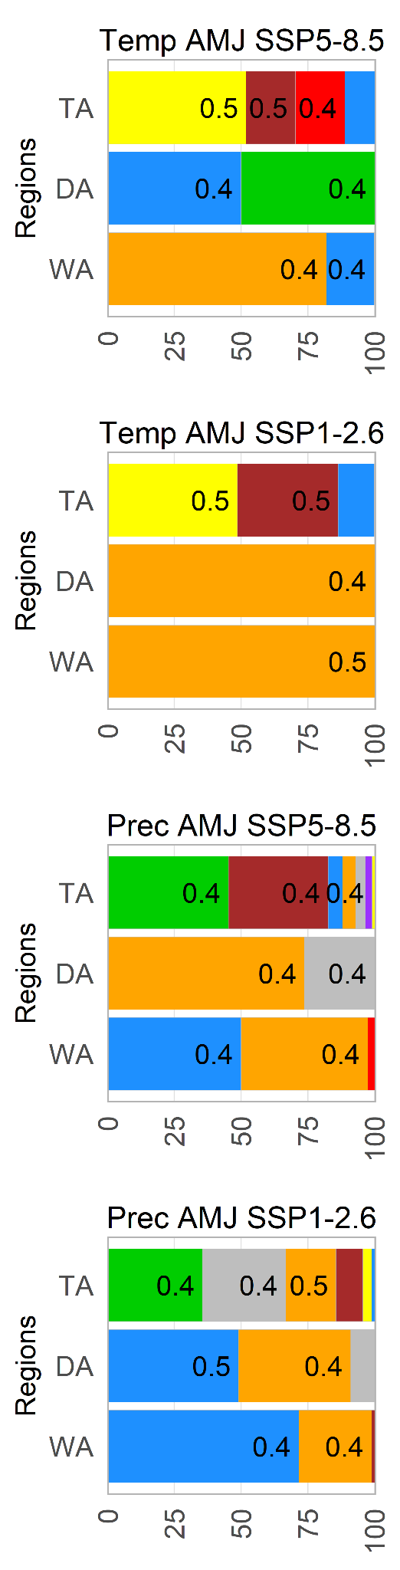 | 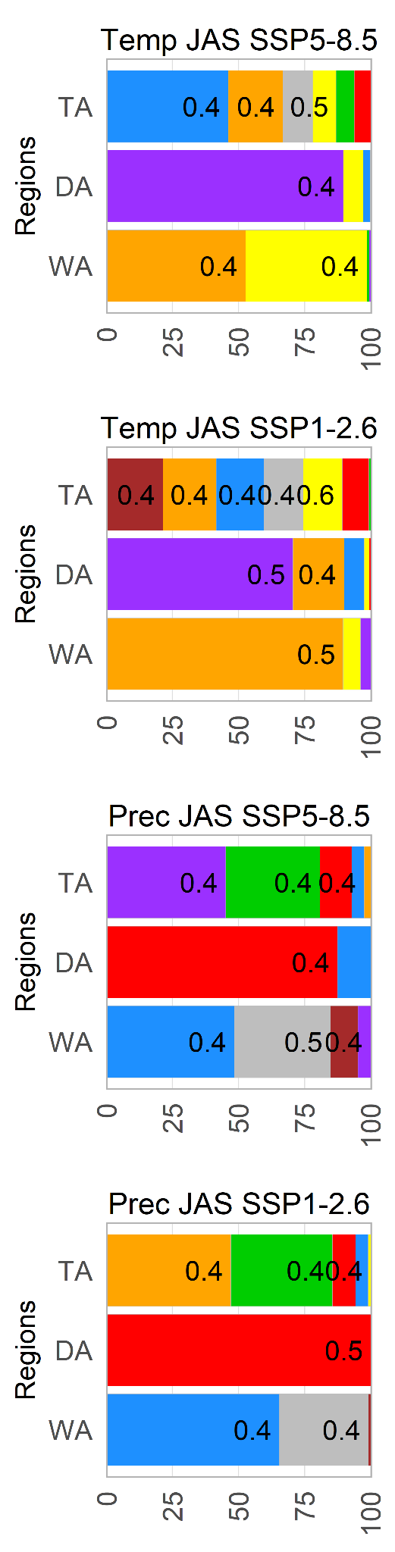 | 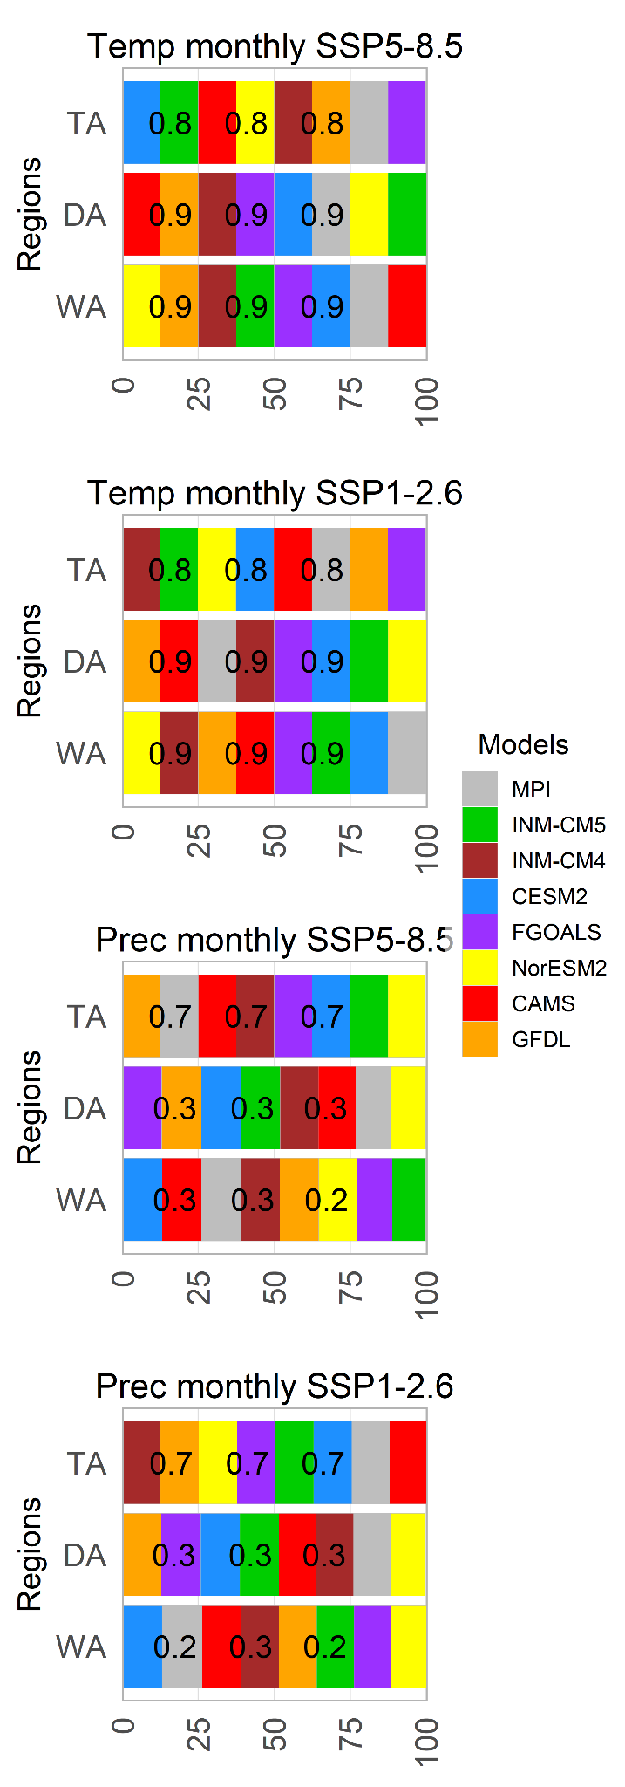
Figure S1. Percentage of glaciers that show significant correlations (p-value < 0.05) between each GCM and corrected TerraClimate variables in the period 1990-2019. Correlations were performed by seasons (A, B, C and D) and months (E), and grouped by glaciological regions. The first two rows of plots represent the temperature correlation whereas the last two rows of plots the precipitation correlation in both climate change scenarios. Considering that one glacier can show at least one significant correlation between any GCM with corrected TerraClimate, axis x represents the percentage of glaciers with CGM significative correlations (see Table S1). The number inside each bar represents Pearson’s correlation value.

Table S1. Summary of seasonal correlation of 8 GCMs with cTC considering temperature and precipitation between 1990-2019. Results are present at a glaciological region scale.
Region | Season | N° of glaciers tested | % of significative glaciers | p-value | r | RMSE | % of significative glaciers | p-value | r | RMSE
Region | Season | N° of glaciers tested | Precipitation
Region | Season | N° of glaciers tested | SSP1-2.6 |  |  |  | SSP5-8.5
TA | OND | 598  (1750 km²) | 4 | 0.02±0.01 | 0.4±0 | 212±75 | 3 | 0.02±0.01 | 0.4±0 | 99±67
TA | JFM | 598  (1750 km²) | 38 | 0.03±0.01 | 0.4±0 | 242±107 | 24 | 0.03±0.02 | 0.4±0.1 | 252±101
TA | AMJ | 598  (1750 km²) | 12 | 0.03±0.02 | 0.4±0.1 | 98±46 | 57 | 0.02±0.01 | 0.4±0.1 | 88±55
TA | JAS | 598  (1750 km²) | 17 | 0.03±0.01 | 0.4±0 | 39±47 | 7 | 0.03±0.01 | 0.4±0 | 715±762
DA | OND | 370  (1519 km²) | 70 | 0.01±0.01 | 0.5±0 | 101±41 | 5 | 0.03±0.01 | 0.4±0 | 38±24
DA | JFM | 370  (1519 km²) | 50 | 0.03±0.02 | 0.4±0.1 | 57±18 | 63 | 0.02±0.02 | 0.5±0.1 | 58±23
DA | AMJ | 370  (1519 km²) | 31 | 0.02±0.01 | 0.4±0.1 | 125±36 | 14 | 0.03±0.01 | 0.4±0 | 104±41
DA | JAS | 370  (1519 km²) | 30 | 0.01±0.01 | 0.5±0.1 | 120±77 | 2 | 0.04±0.01 | 0.4±0 | 76±22
WA | OND | 2245  (24399 km²) | 26 | 0.03±0.01 | 0.4±0 | 272±100 | 49 | 0.03±0.01 | 0.4±0 | 248±99
WA | JFM | 2245  (24399 km²) | 0 | - | - | - | 12 | 0.04±0 | 0.4±0 | 188±71
WA | AMJ | 2245  (24399 km²) | 8 | 0.04±0.01 | 0.4±0 | 109±54 | 2 | 0.04±0.01 | 0.4±0 | 91±20
WA | JAS | 2245  (24399 km²) | 34 | 0.03±0.01 | 0.4±0 | 281±127 | 34 | 0.02±0.01 | 0.4±0.1 | 234±123
 |  |  | Temperature
 |  |  | SSP1-2.6 |  |  |  | SSP5-8.5
TA | OND | 598 | 42 | 0.03±0.01 | 0.4±0 | 0.4±0 | 53 | 0.03±0.02 | 0.4±0.1 | 0.4±0
TA | JFM | 598 | 1 | 0.04±0.01 | 0.4±0 | 0.5±0 | 8 | 0.04±0.01 | 0.4±0 | 0.5±0
TA | AMJ | 598 | 3 | 0.01±0.01 | 0.5±0.1 | 0.3±0 | 2 | 0.02±0.01 | 0.5±0 | 0.3±0
TA | JAS | 598 | 17 | 0.03±0.02 | 0.4±0.1 | 0.4±0.1 | 25 | 0.03±0.02 | 0.4±0.1 | 0.4±0.1
DA | OND | 370 | 98 | 0.03±0.01 | 0.4±0 | 0.6±0 | 85 | 0.03±0.01 | 0.4±0 | 0.6±0
DA | JFM | 370 | 75 | 0.03±0.01 | 0.4±0 | 0.5±0.1 | 14 | 0.03±0.02 | 0.4±0.1 | 0.5±0
DA | AMJ | 370 | 2 | 0.05±0 | 0.4±0 | 0.8±0.1 | 14 | 0.04±0 | 0.4±0 | 0.7±0.1
DA | JAS | 370 | 98 | 0.02±0.02 | 0.5±0.1 | 0.6±0.1 | 75 | 0.03±0.01 | 0.4±0 | 0.6±0.1
WA | OND | 2245 | 0.1 | 0.05±0.01 | 0.4±0 | 0.5±0 | 1 | 0.04±0.01 | 0.4±0 | 0.5±0.1
WA | JFM | 2245 | 16 | 0.03±0.01 | 0.4±0 | 0.6±0 | 53 | 0.02±0.01 | 0.5±0.1 | 0.6±0
WA | AMJ | 2245 | 49 | 0.01±0.01 | 0.5±0.1 | 0.6±0 | 65 | 0.02±0.01 | 0.4±0 | 0.6±0
WA | JAS | 2245 | 23 | 0.02±0.02 | 0.5±0.1 | 0.6±0.1 | 19 | 0.03±0.01 | 0.4±0 | 0.6±0.1

A B
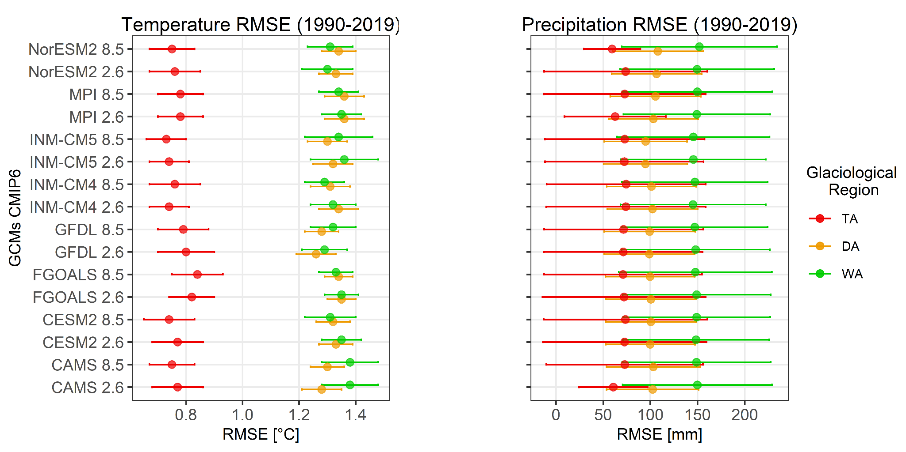
Figure S2. Error estimated for temperature (A) and precipitation (B) between monthly time series of GCM and corrected TerraClimate. Are considered the SSP1-2.6 (2.6) and SSP5-8.5 (8.5) scenarios by GCM, in the glaciological regions of the Andes (TA = Tropical Andes, DA = Dry Andes, WA = Wet Andes).

Table S2. Climate change likely ranges results from the mean comparison between the periods 1990-2019 y 2020-2049 for eight GCMs and corrected TerraClimate. The percentiles 10, 50 y 90 of precipitation and temperature differences are considered using the SSP1-2.6 and SSP5-8.5 scenarios.
Region | Season | SSP1-2.6 |  |  |  |  |  | SSP5-8.5
Region | Season | Delta temp (°C) |  |  | Delta prec (%) |  |  | Delta temp (°C) |  |  | Delta prec (%)
Region | Season | P 10 | P 50 | P 90 | P 10 | P 50 | P 90 | P 10 | P 50 | P 90 | P 10 | P 50 | P 90
TA | OND | 0.5 | 0.7 | 1.1 | -7.0 | -0.8 | 5.9 | 0.7 | 0.9 | 1.3 | -8.7 | -0.9 | 7.1
TA | JFM | 0.5 | 0.7 | 1.0 | -6.1 | 1.7 | 7.8 | 0.7 | 0.9 | 1.2 | -6.8 | 1.4 | 10.4
TA | AMJ | 0.5 | 0.7 | 1.2 | -9.5 | 1.0 | 10.1 | 0.6 | 0.9 | 1.4 | -10.7 | -0.7 | 8.1
TA | JAS | 0.5 | 0.8 | 1.2 | -14.4 | -1.8 | 8.6 | 0.7 | 1.1 | 1.5 | -27.1 | -4.7 | 4.6
DA | OND | 0.3 | 0.6 | 1.1 | -27.8 | 1.2 | 20.6 | 0.8 | 1.0 | 1.5 | -27.2 | -8.8 | 17.3
DA | JFM | 0.4 | 0.7 | 0.9 | -15.1 | -2.7 | 14.3 | 0.8 | 1.0 | 1.2 | -16.3 | 0.0 | 24.7
DA | AMJ | 0.4 | 0.7 | 1.0 | -17.9 | -4.6 | 20.9 | 0.6 | 0.8 | 1.1 | -19.7 | -2.6 | 19.7
DA | JAS | 0.4 | 0.6 | 1.3 | -12.8 | -6.1 | 17.3 | 0.5 | 0.9 | 1.4 | -14.2 | -0.6 | 19.6
WA | OND | 0.2 | 0.4 | 0.8 | -9.3 | -1.9 | 3.8 | 0.3 | 0.5 | 1.0 | -13.2 | -4.0 | 2.8
WA | JFM | 0.3 | 0.5 | 0.8 | -15.4 | -2.4 | 8.4 | 0.3 | 0.7 | 1.0 | -15.7 | -4.5 | 1.4
WA | AMJ | 0.1 | 0.4 | 0.7 | -7.3 | -1.0 | 4.0 | 0.4 | 0.6 | 1.0 | -6.3 | -1.5 | 3.5
WA | JAS | 0.2 | 0.4 | 0.9 | -4.7 | 1.5 | 6.1 | 0.3 | 0.5 | 1.1 | -6.9 | 0.2 | 7.3

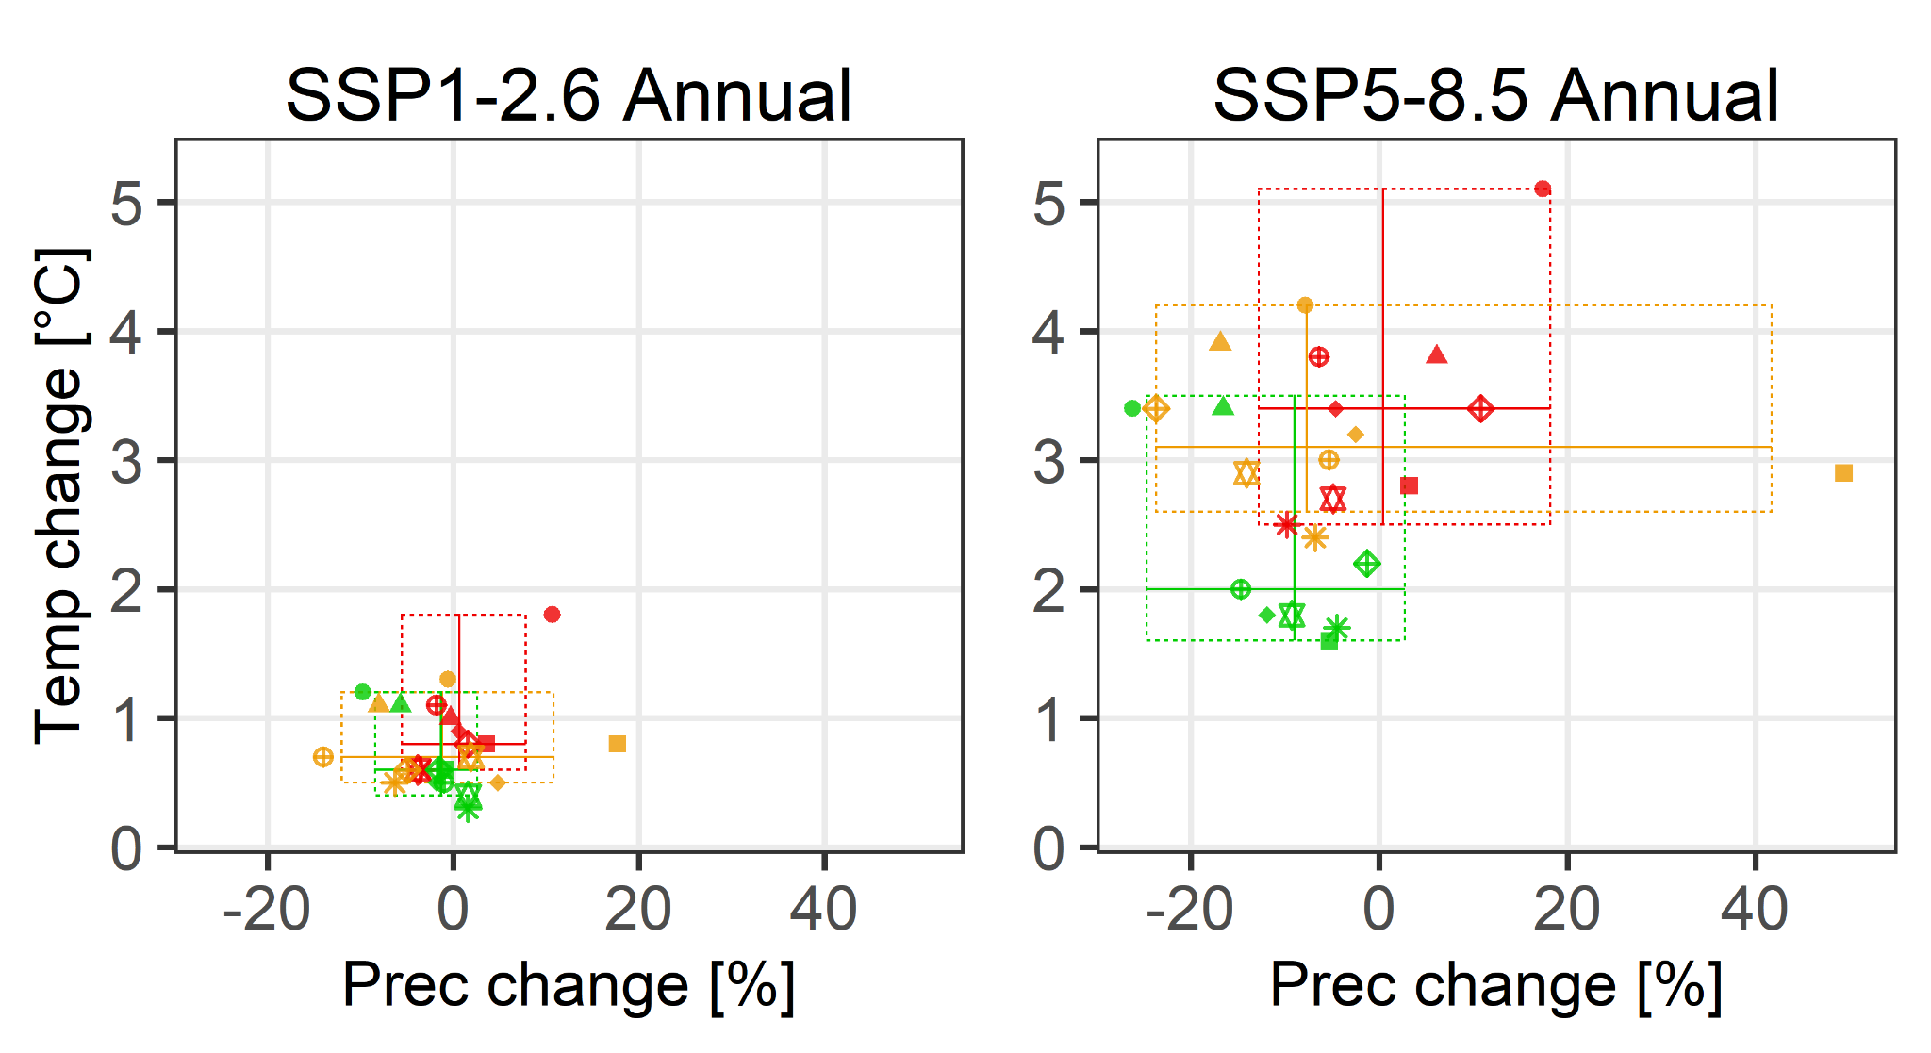 | 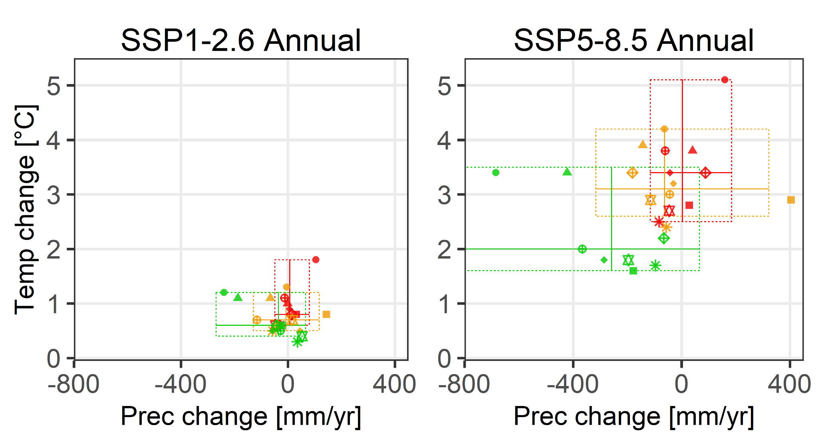
Figure S3. Mean changes between periods 1990-2019 and 2070-2099 per GCM considering percentage (left) and absolute (right) changes in precipitation. Differences from mean annual for temperature and mean total annual for precipitation.

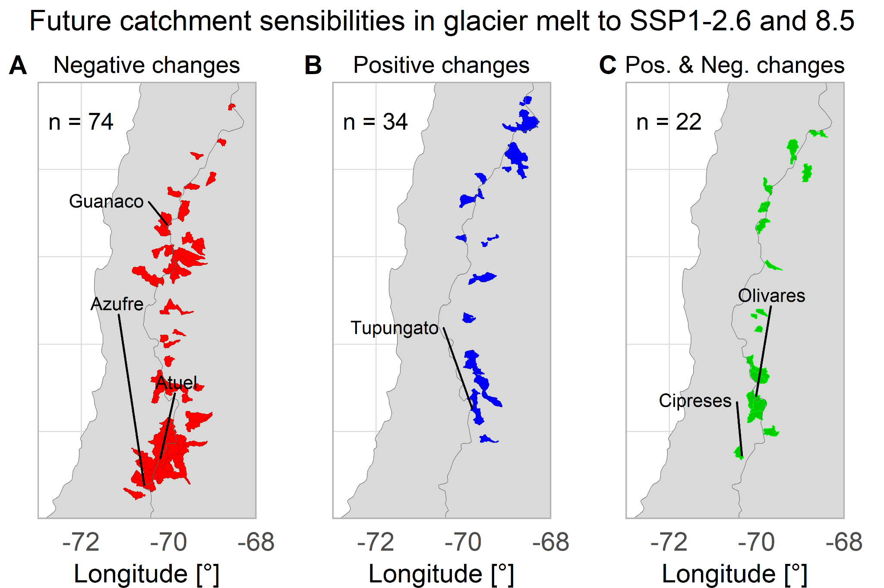
Figure S4. Response of glacier runoff changes between 2000-2019 and 2030-2049 by catchments to the SSP1-2.6 and SSP5-8.5 scenarios in the Dry Andes region. (A) Catchments with negative changes of glacier runoff using both scenarios are exhibited, as well as, (B) catchments where both scenarios show positive changes, and lastly (C) catchments to show a negative change of glacier runoff in SSP1-2.6 and positive changes in SSP5-8.5 scenarios.

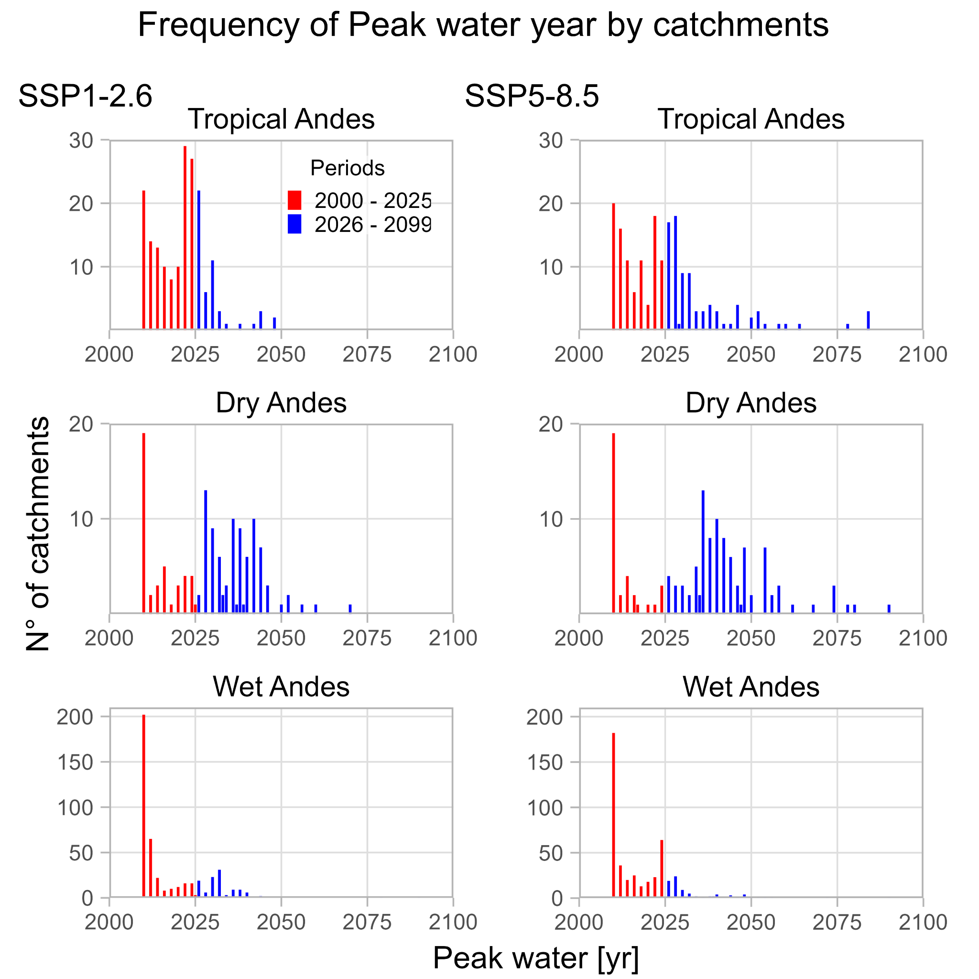
Figure S5. Peak water year frequency by catchment, considering the glaciological regions of the Andes.
Example of figures in each of the 778 catchments in available data

SSP5-8.5 | SSP1-2.6
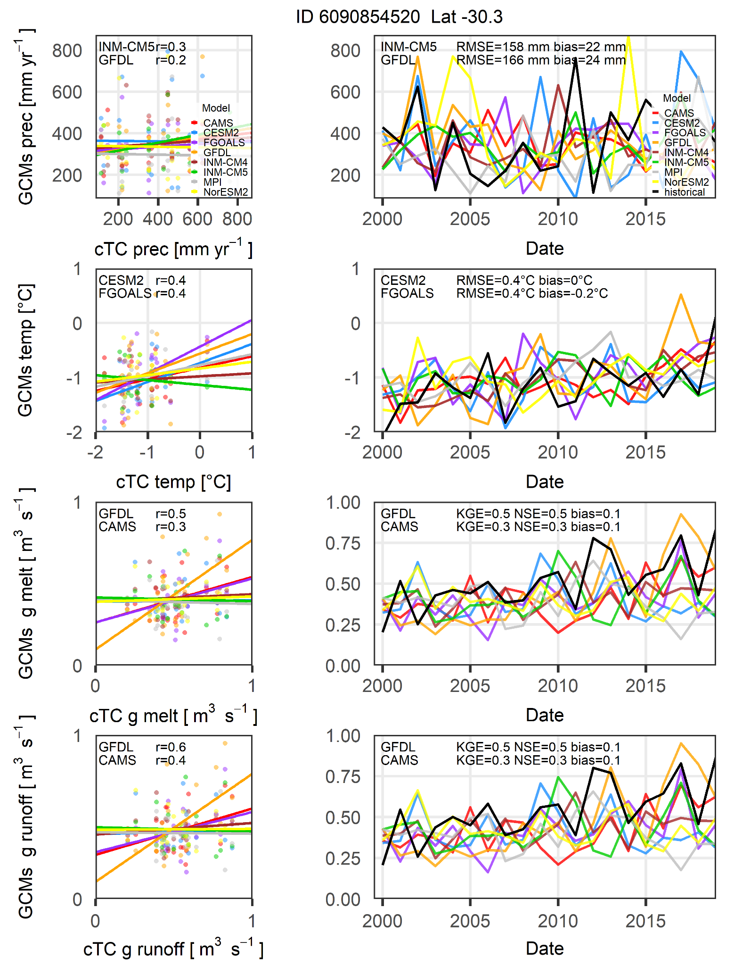 | 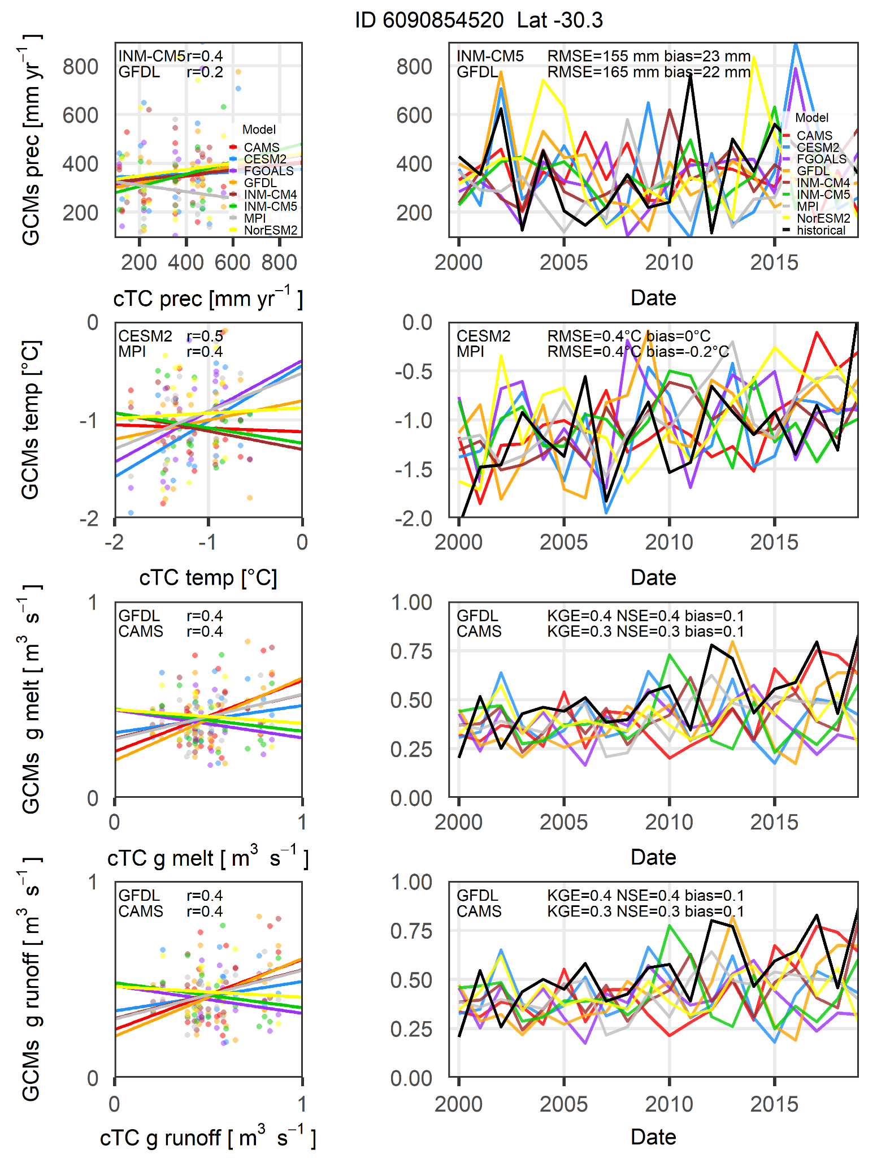
Figure S6. Annual variations using GCMs in any catchment (left correlations, right temporal series).
1st row. Annual total precipitation
2nd row. Annual mean temperature
3rd row. Annual glacier runoff
4th row. Annual glacier runoff (glacier runoff + rainfall on glaciers)

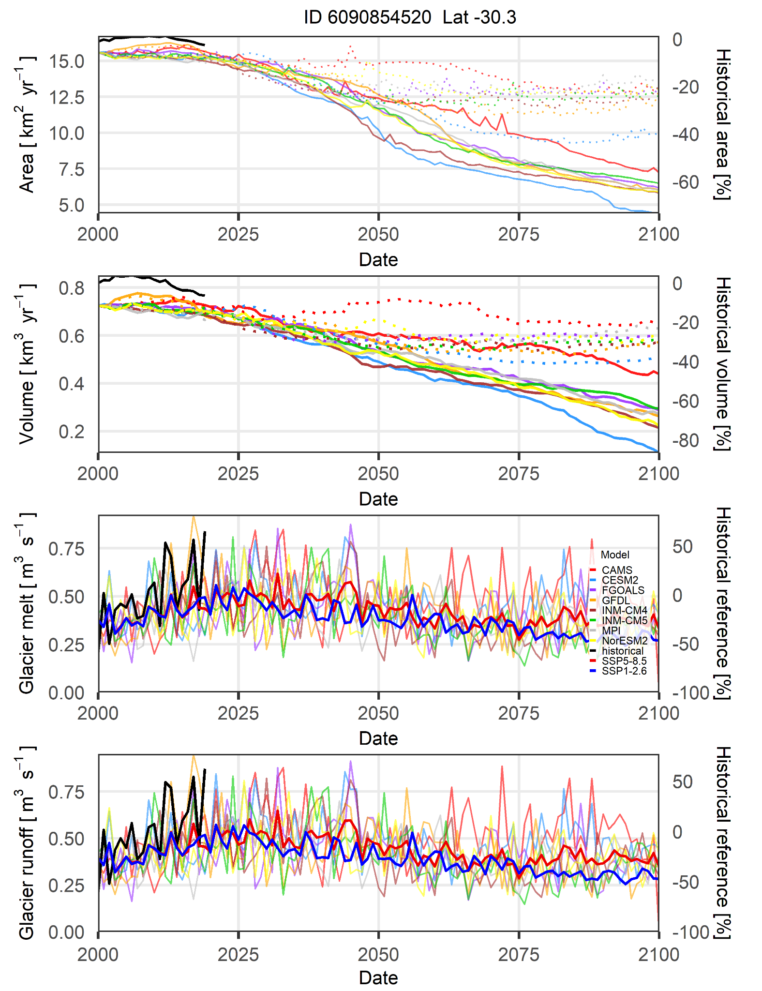
Figure S7. Annual variation of simulated variables between 2000 and 2099 by GCM. The dotted lines represent the SSP1-2.6 scenario whereas solid lines the SSP5-8.5 scenario.

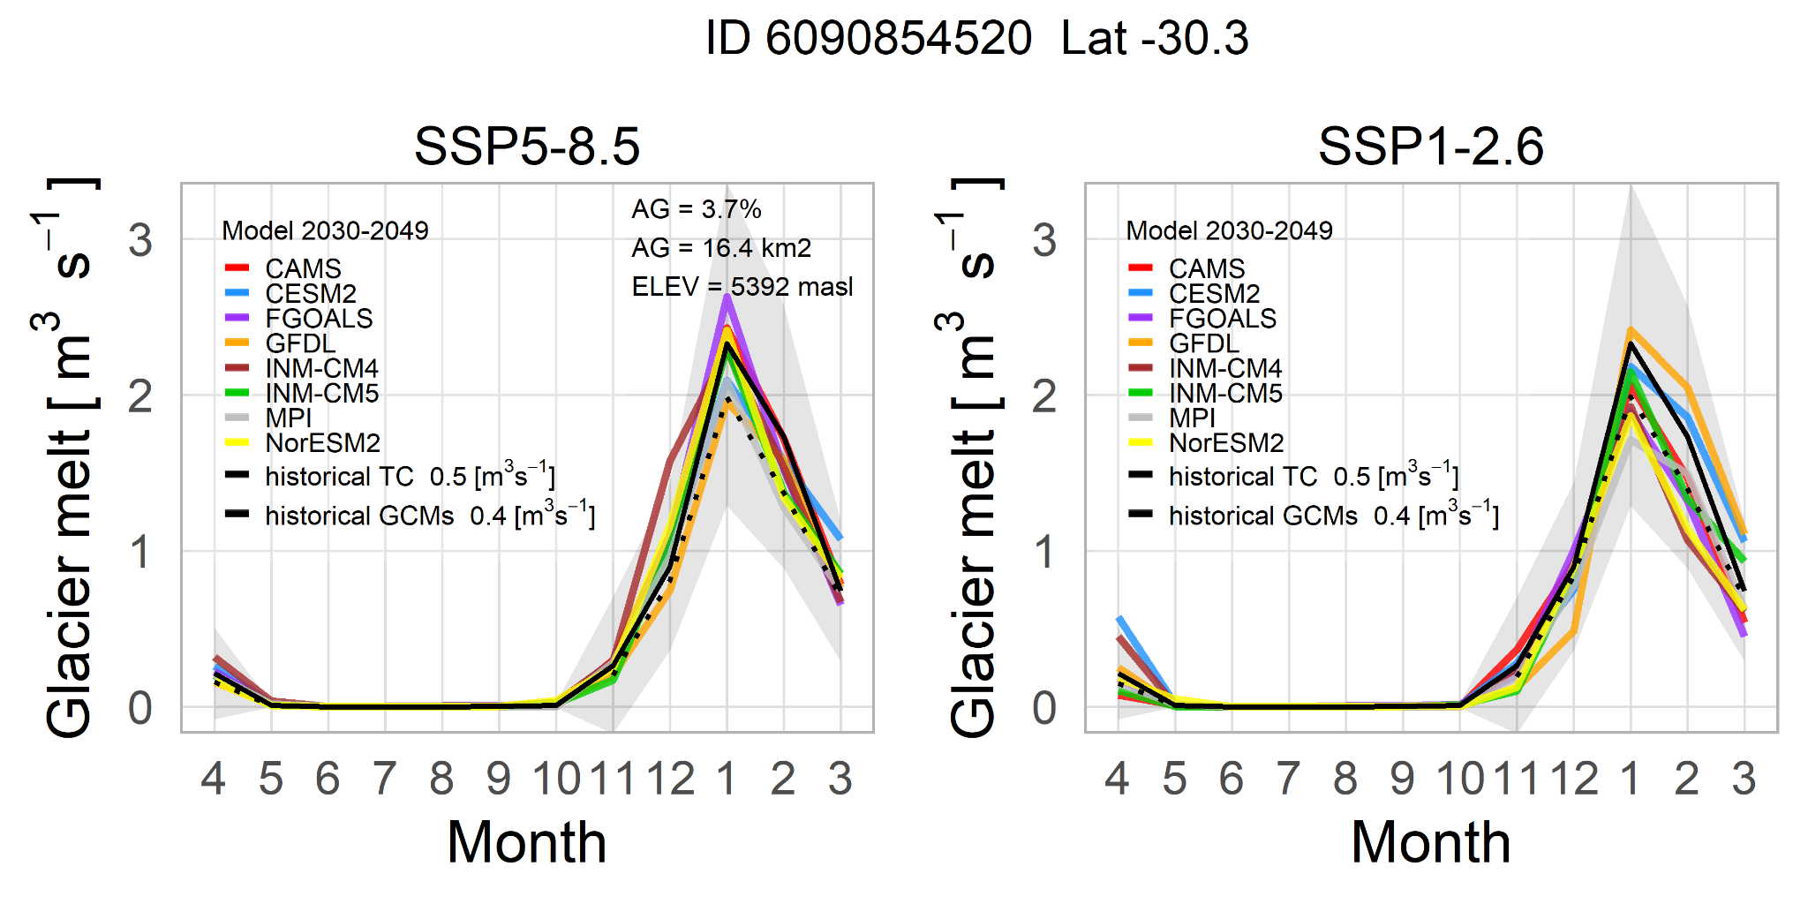
Figure S8. Monthly mean variation of glacier melt by GCM during the future period in comparison with the historical records (solid lines) and historical CGMs (dotted lines). AG, represent the glacierized surface area in percentage regarding the catchment area, and the total glacierized area. ELEV, is the mean elevation of glaciers.

Table S3. Differences of total annual glacier runoff between historical (2000-2019) and future periods (2030-2049) considering changes positive and/or negatives by catchments using the filtered ensemble across the Andes (11°N-55°S)
Scenario | Behavior of glacier runoff change | Glaciological regions
Scenario | Behavior of glacier runoff change | Tropical Andes | Dry Andes | Wet Andes
Mean annual change of glacier runoff in percentage
SSP5-8.5 | Positive | 53.0 | 38.3 | 12.4
SSP5-8.5 | Negative | -34.3 | -34.0 | 30.6
SSP5-8.5 | Both | 16.2 | 5.5 | 4.4
SSP1-2.6 | Positive | 18.3 | 19.1 | 8.7
SSP1-2.6 | Negative | -43.4 | -36.8 | -31.7
SSP1-2.6 | Both | -8.9 | -7.0 | -2.1
Mean annual change of glacier runoff in m³ s⁻¹
SSP5-8.5 | Positive | 0.5 | 3.5 | 3.4
SSP5-8.5 | Negative | -20.4 | -13.3 | -170.7
SSP5-8.5 | Both | 0.4 | 1.1 | 0.3
SSP1-2.6 | Positive | 0.2 | 1.8 | 2.4
SSP1-2.6 | Negative | -25.8 | -14.4 | -177.2
SSP1-2.6 | Both | -0.2 | -1.4 | -0.2
Number of catchments | Positive | 6 | 34 | 24
Number of catchments | Negative | 169 | 74 | 437
Number of catchments | Both | 8 | 22 | 4

Table S4. Analyzed GCMs (CMIP6) in the historical (1990-2019) and future periods (2020-2049)
GCM name | Institute | Horizontal grid spacing (°) | Variant label | Reference
CESM2 | NCAR (USA) | 1.3°×0.9° | r4i1p1f1 | Danabasoglu et al. (2020)
FGOALS-f3-L | China | 1.3°×1° | r1i1p1f1 | He et al. (2019)
NorESM2-MM | NCC (Norway) | 0.9°×1.3° | r1i1p1f1 | Seland et al. (2020)
MPI-ESM1-2-HR | MPI (Germany) | 0.9°×0.9° | r1i1p1f1 | Muller et al. (2018)
INM-CM4-8 | INM (Russia) | 2°×1.5° | r1i1p1f1 | Volodin et al. (2018)
INM-CM5-0 | INM (Russia) | 2°×1.5° | r1i1p1f1 | Volodin et al. (2017)
CAMS-CSM1-0 | CAMS(China) | 1.1°×1.1° | r1i1p1f1 | Xin-Yao et al. (2019)
GFDL-ESM4 | GFDL (USA) | 1.3°×1° | r1i1p1f1 | Dunne et al. (2020)
Note: Variant labels provides information about realization (r), initialization method (i), physics (p), and forcing (f)

Table S5. Calibrated parameter values used in the glacier mass balance and volume simulations across the Andes (11°N-55°S) during the period 2000-2019
Region | Zone | Mass balance parameter values |  |  |  |  |  | Volume parameter
Region | Zone | Temperature LR  [ºC/m a.s.l.] | Precipitation factor  [-] | Mean melt factor  [mm mth⁻¹ ºC⁻¹] | Temperature for melt onset  [ºC] | Temperature at start of snowfall  [ºC] | Temperature at start of rainfall  [ºC] | Glen A inversion  s⁻¹ Pa⁻³
Tropical Andes | IT | -0.0066 | 1 | 434 | 2.1 | 2.1 | 4.1 | 2.4 10⁻²³
Tropical Andes | OT2 | -0.0066 | 1 | 284 | 2.1 | 2.1 | 4.1 | 6.3 10⁻²⁴
Tropical Andes | OT3 | -0.0066 | 1 | 432 | 2.1 | 2.1 | 4.1 | 1.2 10⁻²³
Dry Andes | DA1 | -0.0082 | 2.8 | 418 | 0 | 0 | 2 | 2.4 10⁻²⁵
Dry Andes | DA2 | -0.0065 | 1.9 | 479 | 0 | 0 | 2 | 1.3 10⁻²³
Dry Andes | DA3 | -0.0063 | 4 | 299 | 0 | 0 | 2 | 2 10⁻²⁴
Wet Andes | WA1 | -0.0051 | 4 | 103 | 0 | 0 | 2 | 1.7 10⁻²³
Wet Andes | WA2 | -0.0051 | 4 | 118 | 0 | 0 | 2 | 1.9 10⁻²³
Wet Andes | WA3 | -0.0063 | 2.3 | 152 | 0 | 0 | 2 | 6 10⁻²⁴
Wet Andes | WA4 | -0.0063 | 2.3 | 128 | 0 | 0 | 2 | 1.3 10⁻²³
Wet Andes | WA5 | -0.0063 | 2.3 | 179 | 0 | 0 | 2 | 1 10⁻²³
Wet Andes | WA6 | -0.0063 | 2.3 | 139 | 0 | 0 | 2 | 1.5 10⁻²³

References

Danabasoglu, G., et al. TheCommunity Earth System ModelVersion 2 (CESM2). Journal of Advances in Modeling Earth Systems, 12. 10.1029/2019MS001916 (2020).

Dunne, J. P., et al. The GFDL Earth SystemModel Version 4.1 (GFDL‐ESM 4.1):Overall coupled model description andsimulation characteristics. Journal of Advances in Modeling Earth Systems. 12. 10.1029/2019MS002015 (2020).

He, B., et al. CAS FGOALS-f3-L model datasets for CMIP6 historical Atmospheric Model Intercomparison Project simulation. Adv. Atmos. Sci., 36(8), 771–778. 10.1007/s00376-019-9027-8 (2019).

Müller, W. A., et al. A higher-resolution version of theMax Planck Institute Earth System Model(MPI-ESM1.2-HR). Journal of Advances inModeling Earth Systems, 10, 1383–1413. 10.1029/2017MS001217 (2018).

Seland, Ø., et al. Overview of the Norwegian Earth System Model (NorESM2) and key climate response of CMIP6 DECK, historical, and scenario simulations. Geosci. Model Dev., 13, 6165-6200. 10.5194/gmd-13-6165-2020 (2020).

Volodin, E. M., et al. Simulation of the modern climate using the INM-CM48 climate model. Russian Journal of Numerical Analysis and Mathematical Modelling. 33, 6, 367-374. 10.1515/rnam-2018-0032 (2018).

Volodin, E. M., et al. Simulation of modern climate with the new version of the INM RAS climate model, Izvestiya, Atmos. Ocean. Phys. 53, 142–155. (2017).

Xin-Yao, R. et al. Introduction of CAMS-CSM model and its participation in CMIP6[J]. Climate Change Research. 15(5): 540-544. 10.12006/j.issn.1673-1719.2019.186 (2019).

