SUPPLEMENT MATERIAL

S1. Methods and variables assessed in the questionnaire and included in the study.
Post-traumatic stress disorder (PTSD) symptoms: we used the PTSD checklist for DSM-5 (PCL-5)¹ composed by a 20-item self-report measure that assesses the PTSD symptoms based on DSM-5 criteria. Each item corresponds to one of the 20 symptoms pertaining to the diagnosis of PTSD in the Diagnostic and Statistical Manual for Mental Disorders (5th ed.; DSM–5)². Scores are rated on a 5-point scale (from 0 = "Not at all", to 4 = "Extremely") based on the symptom severity over the past week, items scored 2 (moderate) or higher were considered symptoms. A cutoff score of 31 is indicated for probable current PTSD¹.
Pandemic Psychological Stress (PPS): self-reported psychological stress secondary to COVID-19 pandemic in pregnancy was investigated through a set of 7 questions. Participants were asked to report how much they felt worried (1 = “Not worried at all” to 7 = “Very worried”) about 7 different single-item domains regarding their: i) personal health, ii) their significant ones’ health, iii) the risk that they contract the virus, iv) their significant ones do; v) duration of pandemic; vi) job impact; vii) economic impact. Internal consistency for the four items was good (Cronbach’s α = 0.79) and we produced a PPS score by means of regression scores of an exploratory factor analysis (EFA) (see Supplement Material: S2, Table S1).
COVID-19 Stressful Events Exposure (SEE): a short checklist of questions regarding the direct exposure to COVID-19 major stressful events, during pregnancy and/or during the first 6 months postpartum was assessed at t1. For each period (during pregnancy and postpartum) four significant events were identified, and items were constructed with a y/n dichotomous answer). The two different composite scores (one for the pregnancy and one for the postpartum period) were computed as the sum of the items. After computed the sum, due to the highly skewed nature of the composite scores, we dichotomized both variables between participants who scored 0 (not exposed) and participants who scored higher than 0 (exposed). Complete information about the scale is reported in Sacchi and colleagues³.
Social Support: perceived social support has been investigated at t1 through the Multidimensional Scale for Perceived Social Support (MSPSS)⁴. MSPSS is a widely applied 12-items measure of the perceived adequacy of social support from three sources: family members, friends, and significant others. Items are rated on a 7-point Likert-type scale ranging from very strongly disagree (1) to very strongly agree (7), with higher scores indicating greater social support.
Child emotional-behavioral problems: The Child Behavior CheckList⁵ (CBCL/1½-5) is a gold-standard parent-report questionnaire to assess emotional behavioral problems in children aged 1 ½- 5 years. The 99 items are rated on a 3-point scale (0 = not true; 1 = sometimes true; 2 = very often true). The CBCL/1½-5 allows the evaluation of children's problems according to syndromes scales, DSM-oriented scales, and three broad band scales, namely Internalizing, Externalizing and Total scales. The Internalizing scale is composed by the sum of scores on Emotional Reactivity, Anxious/Depression, Somatic Complaints and Withdrawn syndrome scales, while the Externalizing scale is composed by the sum of scores on Attention Problems and Aggressive Problems syndromes scales.

S2. Pandemic Psychological Stress - exploratory factor analysis
An explorative factorial analysis was performed on the respondents’ scores of 7 questions related to the concern about COVID-19. The set of questions was on a 7-point scale from 1 (Not worried at all) to 7 (Very worried). Internal consistency for the seven items was good (Cronbach’s α = 0.79). Because these groups of variables were closely related, we wanted to extract only one index for each dimension. Specifically, a single factor was estimated (Table S1) with a weighted least square mean and variance adjusted (WLSMV) estimator due to the presence of ordinal data; the single factor represented the overall COVID-19 risk. The amount of variance explained by the one-factor solution was discrete (39.0%). The factor loadings for COVID-19 reported a high relevance of the health and people concern.

S3. EM algorithm for Poisson non parametric regressions
Since the PTSD scores were represented by three-point discrete valued time series, our aim was to cluster time series in a flexible way adopting a procedure based on Poisson regression model and a flexible approach bases on natural splines. We denote the time series $y\left(t\right)=(y_{1}\left(t\right),…,y_{N}\left(t\right))$ each one formed by three PTSD temporal observations. In the Expectation step (E-step) we estimated the membership of each time series starting by computing the conditional probability
$P\left(z_{i}=c|θ_{c}\right)=f(y_{i}(t)|z_{i}=c,θ_{c})$,
which depends on the membership $z_{i}$ to the cluster c, where $f(y_{i}|z_{i}=c,θ_{c})$, is the density of a Poisson random variable such that its expected value $E\left[Y(t)\right]=λ=exp⁡(\sum_{j=1}^{3}{θ_{cj}B_{j}(t)})$ is the time varying function composed by three basis of natural splines $B_{j}\left(t\right)$, with t=(1,2,3) due to the presence of three time points, and finally $θ_{c}$ is the vector of parameters associated to the natural spline basis for the cluster c. We adopt natural splines since its definition allows us the estimation of a curve with only three time points and the possibility to include an intercept. In the E-step, we compute the conditional likelihood for each possible value of c defined by the number of clusters C with $c=1,…,C$; then the new membership vector is $z^{\left(k\right)}=z_{1}^{(k)},…,z_{N}^{(k)}$ is estimated calculating the membership probabilities
$$P(z_{i}^{k}=c\left|y_{i}(t),θ_{i}^{\left(k-1\right)}\right)=\frac{f(y_{i}(t)|z_{i}^{(k-1)}=c,θ_{i}^{(k-1)})}{\sum_{c'=1}^{C}{f(y_{i}(t)|z_{i}^{\left(k-1\right)}=c',θ_{i}^{(k-1)})}},$$
and assigning $z_{i}^{k}$ at the membership with the highest probability. In the Maximization step (M-step), we compute a new estimation of the parameters for each cluster
$θ_{c}^{(k)}= \underset{θ_{c}}{argmax} f(y(t),z^{k}=c|θ_{c}^{(k-1)})$,
with the new estimated membership vector $z^{\left(k\right)}$.
We repeat the previous steps until the convergence of the parameters. An initial guess for ${\hat{z}}^{\left(0\right)}$, it can be obtained by the unsupervised functional clustering procedure⁶. The EM algorithm was iterated until convergence. The optimal number of clusters is chosen by means of the elbow method applied to the Bayesian Informative Criterion (BIC) for mixtures models calculated as follows
$$BIC\left(c\right)=\left(kc\right)\log\left(n\right)-2l\left(y\left(t\right) | c, {\hat{θ}}_{c}\right),$$
where $2l(y(t)|c, {\hat{θ}}_{c})$ is the log-likelihood, k is the number of parameters equal to 3 and c is the number of components (for further details see Baudry et al., 2010⁷).

Table S1. Loadings of the factorial analysis for Pandemic Psychological Stress (PPS) score.
PPS items
Health Concern (Median: 4, IQR: 3-5) | 0.77
People Concern (Median: 5, IQR: 4-7) | 0.79
Virus Concern (Median: 2, IQR: 1-4) | 0.58
Family Concern (Median: 4, IQR: 2.5-6) | 0.73
Duration Concern (Median: 6, IQR: 5-7) | 0.46
Job Concern (Median: 5, IQR: 3-6) | 0.34
Economical Concern (Median: 5, IQR: 3-7) | 0.42
Var. % explained | 39.0%

Table S2. Percentage of missing observations, overall and by PTSD at t0 higher than 31.
Characteristics with missing data | Overall,  N = 327¹ | PTSD T0 >31 |  | p-value²
Characteristics with missing data | Overall,  N = 327¹ | 0, N = 274¹ | 1, N = 53¹ | p-value²
Marital status | 5 (1.5%) | 5 (1.8%) | 0 (0%) | > 0.999
Residence in red region | 1 (0.3%) | 1 (0.4%) | 0 (0%) | > 0.999
Job status | 3 (0.9%) | 2 (0.7%) | 1 (1.9%) | 0.413
Family income | 1 (0.3%) | 1 (0.4%) | 0 (0%) | > 0.999
Parity | 2 (0.6%) | 2 (0.7%) | 0 (0%) | > 0.999
Gestational week at enrollment | 14 (4.3%) | 14 (5.1%) | 0 (0%) | 0.138
Child’s sex | 2 (0.6%) | 2 (0.7%) | 0 (0%) | > 0.999
Child’s gestational age at birth | 15 (4.6%) | 12 (4.4%) | 3 (5.7%) | 0.718
CBCL total problems | 67 (20%) | 56 (20%) | 11 (21%) | > 0.999
CBCL externalizing problems | 68 (21%) | 57 (21%) | 11 (21%) | > 0.999
CBCL internalizing problems | 67 (20%) | 56 (20%) | 11 (21%) | > 0.999
PPS | 1 (0.3%) | 0 (0%) | 1 (1.9%) | 0.162
¹ Median (IQR) or Frequency (%)
² Fisher's exact test

Table S3. Odds Ratios and 95% Confidence Interval (CI) for the logistic regression estimated for the propensity score model where the dependent variable is the presence of COVID-19 SEE during pregnancy.

Predictors | Odds Ratios | 95% CI | p-value
Mother’s age (+1 years increase) | 1.02 | 0.93 – 1.11 | 0.703
Educational level
Master’s degree or higher | 0.46 | 0.20 – 1.01 | 0.054
Bachelor’s degree | 1.00 (ref.)
High school or lower | 0.60 | 0.26 – 1.39 | 0.238
Marital status
Not married | 1.00 (ref.)
Married | 1.73 | 0.85 – 3.66 | 0.139
Residence in red region
No | 1.00 (ref.)
Yes | 1.52 | 0.78 – 3.03 | 0.228
Job status
Unemployed | 1.00 (ref.)
Employed | 4.02 | 0.73 – 75.63 | 0.194
Family income
High >50k € | 1.00 (ref.)
Low ≤12k € | 1.03 | 0.12 – 6.60 | 0.977
Low-Medium (12k-25k] € | 0.32 | 0.09 – 1.07 | 0.071
Medium (25k-50k] € | 0.71 | 0.30 – 1.74 | 0.433
Parity
No | 1.00 (ref.)
Yes | 1.07 | 0.46 – 2.36 | 0.867
Gestational week at enrollment (+1 week increase) | 0.99 | 0.95 – 1.03 | 0.512
PPS (+1 pt increase) | 1.61 | 1.10 – 2.39 | 0.016

Figure S1. Propensity score stabilized weights by COVID-19 SE during pregnancy.
Figure S2. Pearson’s pairwise correlations between CBCL scores (total, internalizing, externalizing)
and PTSD during pregnancy (t0) and at 6 months (t1) and 12 months (t2) postpartum.
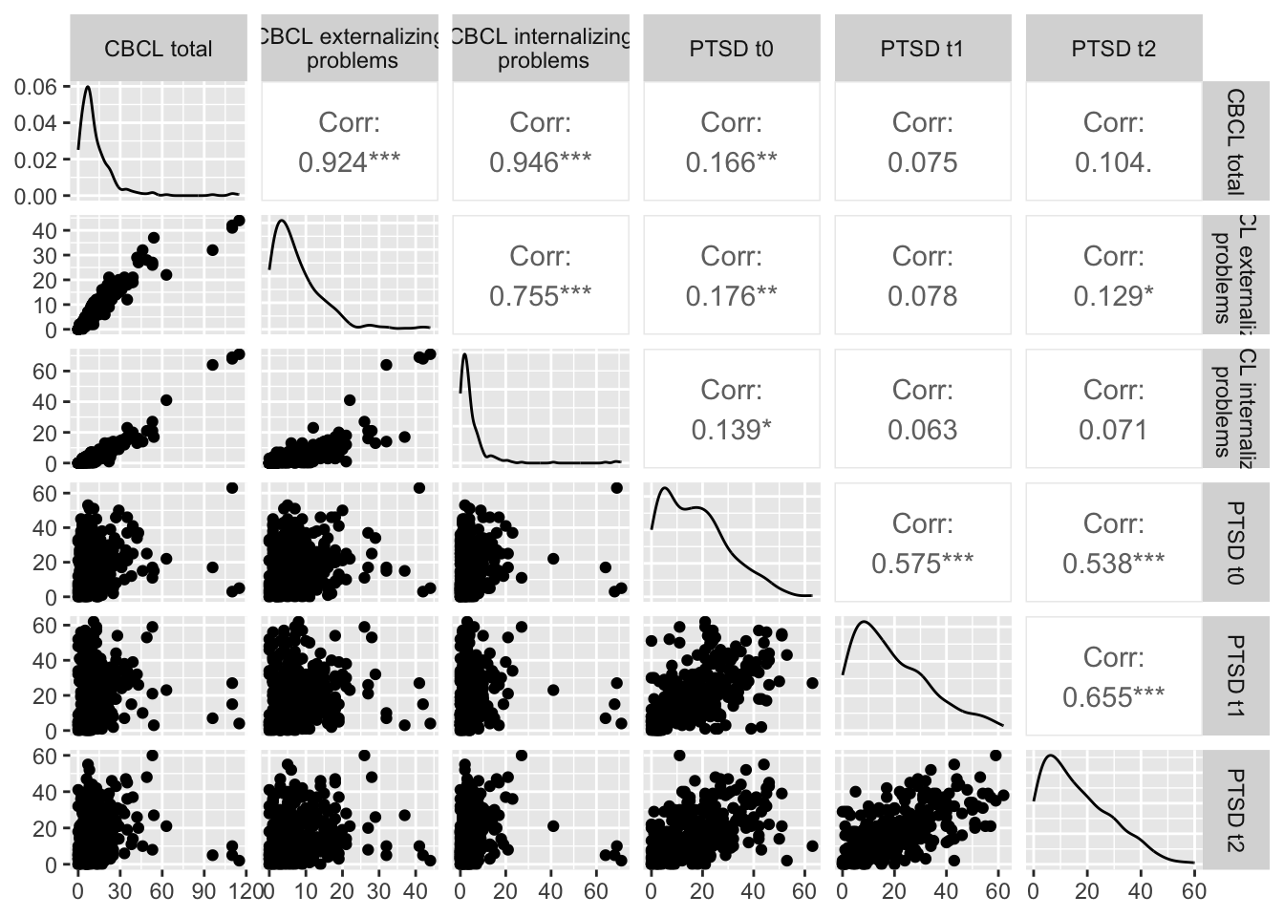
***p<0.001, **p<0.01, **p<0.05.

Figure S3. First order BIC difference by number of clusters.
Figure S4. Quantile-Quantile diagram of Pearson residuals for the internalizing (left), externalizing (middle), and total (right) CBCL regression model.
References for the supplementary materials
- Weathers, F. W., Litz, B. T., Keane, T. M., Palmieri, P. A., Marx, B. P., & Schnurr, P. P. (2021). The ptsd checklist for dsm-5 (pcl-5). 2013. Scale available from the National Center for PTSD at https://www.ptsd.va.gov/professional/assessment/adult-sr/ptsd-checklist.asp. (Last access on March 21, 2024).
- American Psychiatric Association, D. S. M. T. F., and American Psychiatric Association. Diagnostic and statistical manual of mental disorders: DSM-5. Vol. 5. No. 5. Washington, DC: American psychiatric association, 2013.
- Sacchi, C., De Carli, P., Gregorini, C., Monk, C., & Simonelli, A. (2023). In the pandemic from the womb. Prenatal exposure, maternal psychological stress and mental health in association with infant negative affect at 6 months of life. Development and psychopathology, 1-11.
- Zimet, G. D., Powell, S. S., Farley, G. K., Werkman, S., & Berkoff, K. A. (1990). Psychometric characteristics of the multidimensional scale of perceived social support. Journal of personality assessment, 55(3-4), 610-617.. doi:10.1080/00223891.1990.967409.
- Achenbach, T. M., & Rescorla, L. A. (2001). Manual for the ASEBA school-age forms & profiles: an integrated system of multi-informant assessment Burlington, VT: University of Vermont. Research Center for Children, Youth, & Families, 1617.
- Abraham, C., Cornillon, P. A., Matzner‐Løber, E. R. I. C., & Molinari, N. (2003). Unsupervised curve clustering using B‐splines. Scandinavian journal of statistics, 30(3), 581-595.doi:10.1111/1467-9469.00350.
- Baudry, J. P., Raftery, A. E., Celeux, G., Lo, K., & Gottardo, R. (2010). Combining mixture components for clustering. Journal of computational and graphical statistics, 19(2), 332-353.

