SUPPLEMENTAL FIGURES

Supplemental Figure 1. Hierarchy of themes and codes developed for analysis of qualitative reports

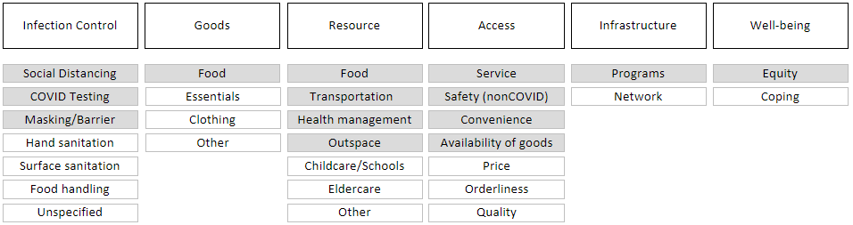

Hypothesized codes in figure above are shaded in grey; all others were emergent from inductive analysis

Supplemental Figure 2. Distribution of code applications within each parent theme

