Table 1. Summary of yield and color characteristics of the eggshell samples and the bio-CaO obtained from calcination in the air atmosphere.
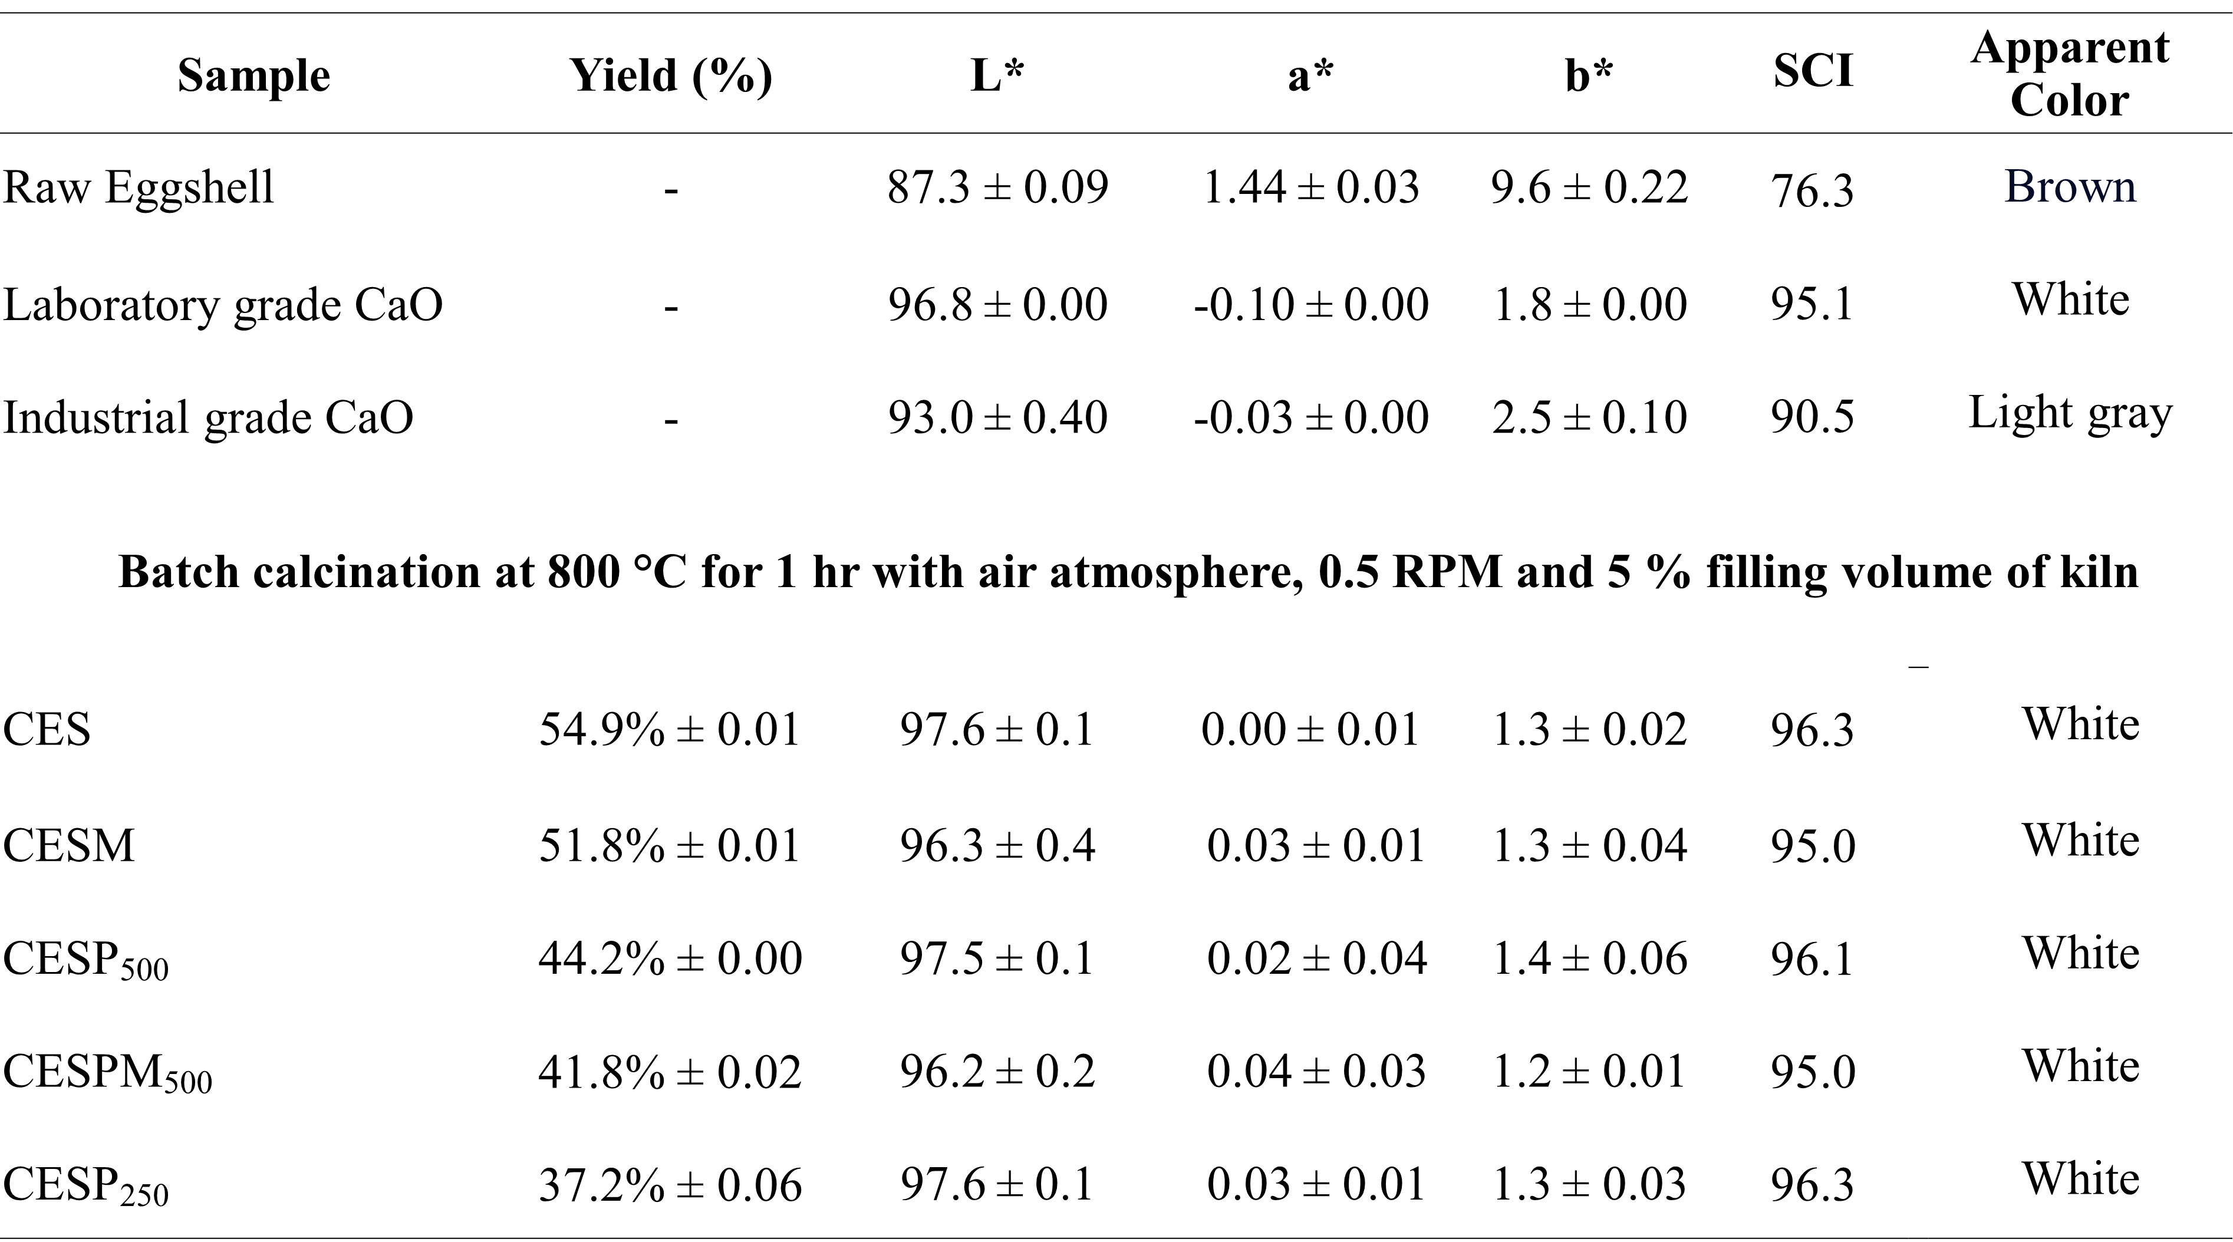

Table 2. Summary of yield and color characteristics of the bio-CaO obtained from calcination in N₂ with 5% filling volume and in air atmosphere with the variation of raw material filling volume.
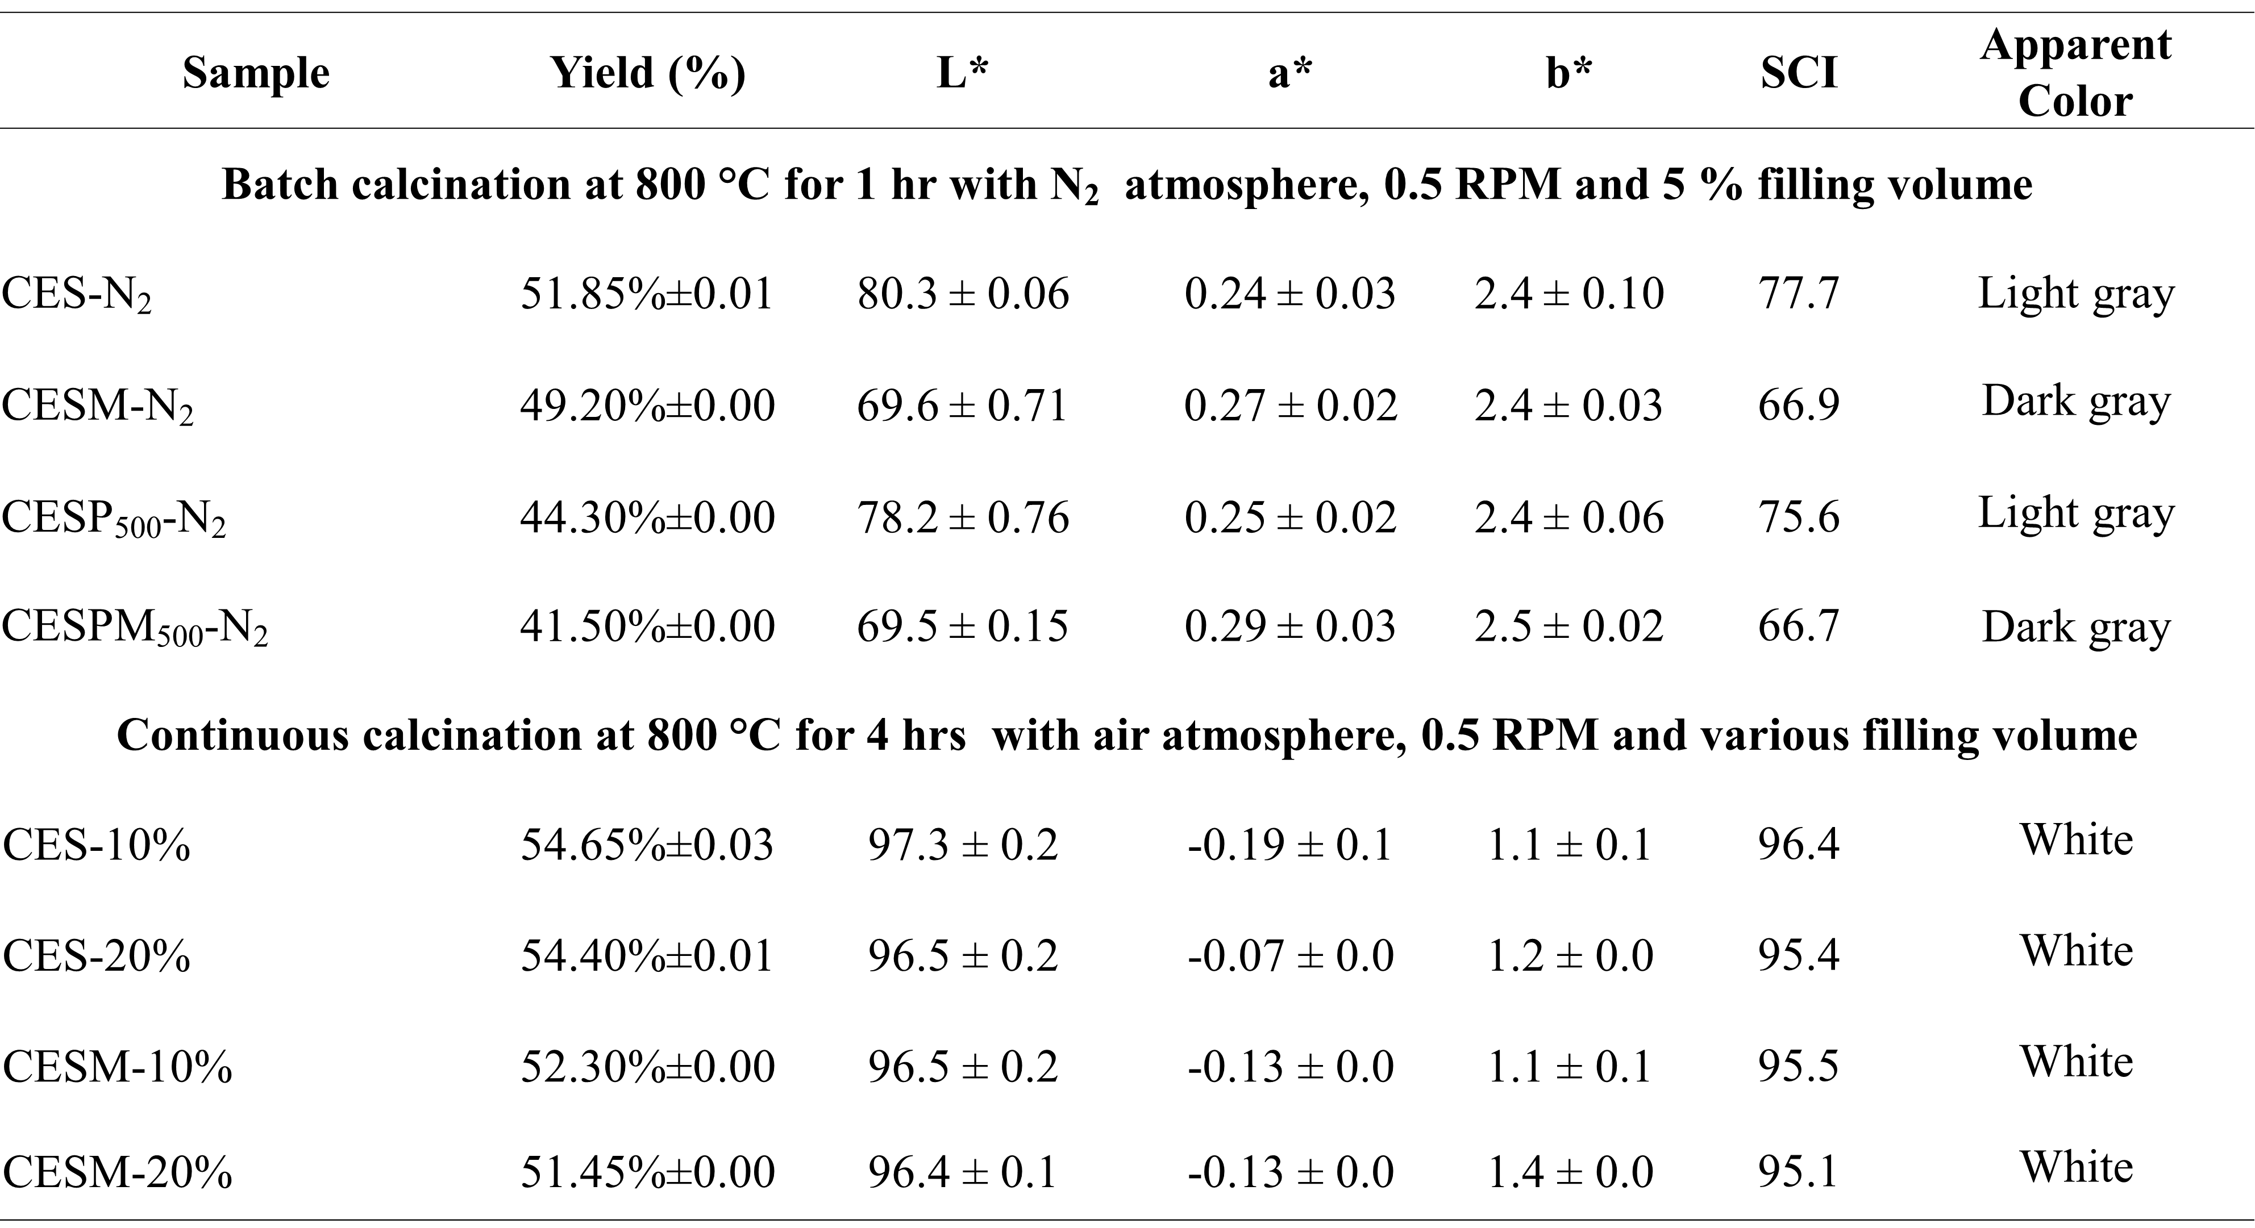
Table 3 Surface area, pore volume and average pore size of bio-CaO obtained from various treatments. 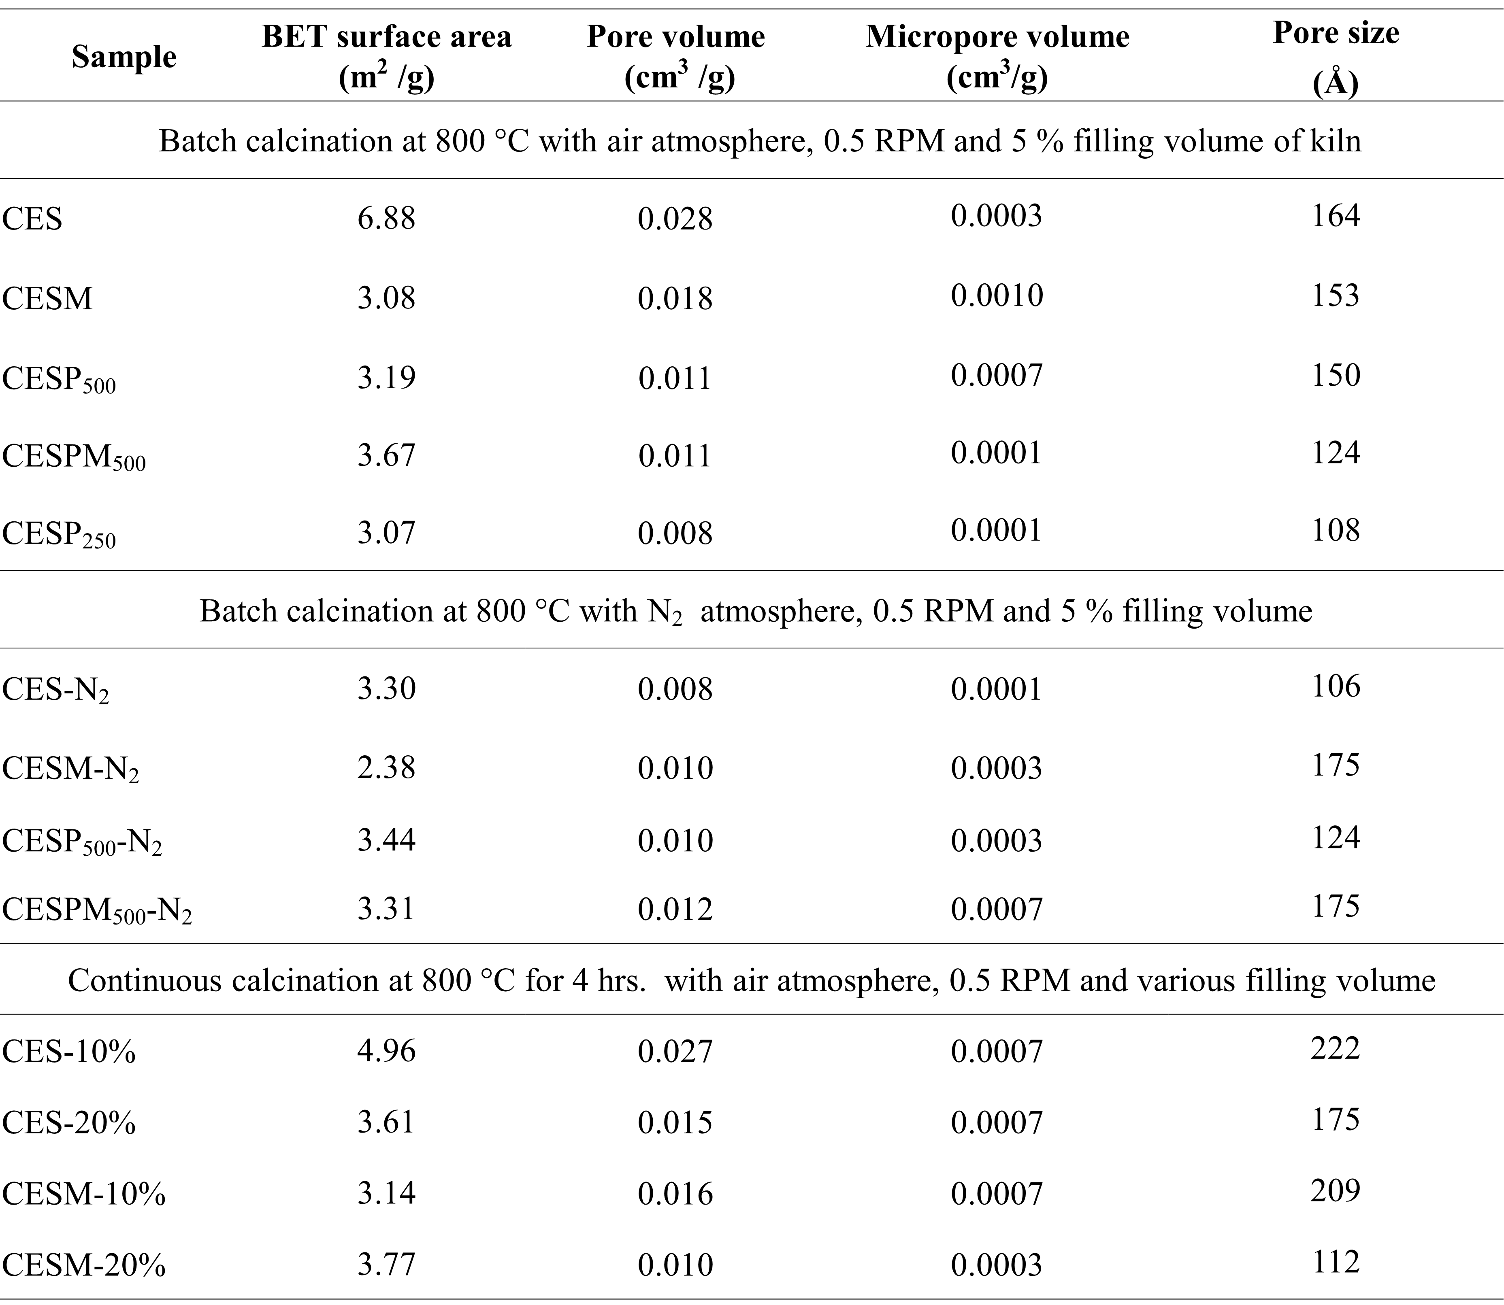

Table 4 Chemical composition of the obtained CaO samples and Thailand industrial standard institute 319 (TISI).
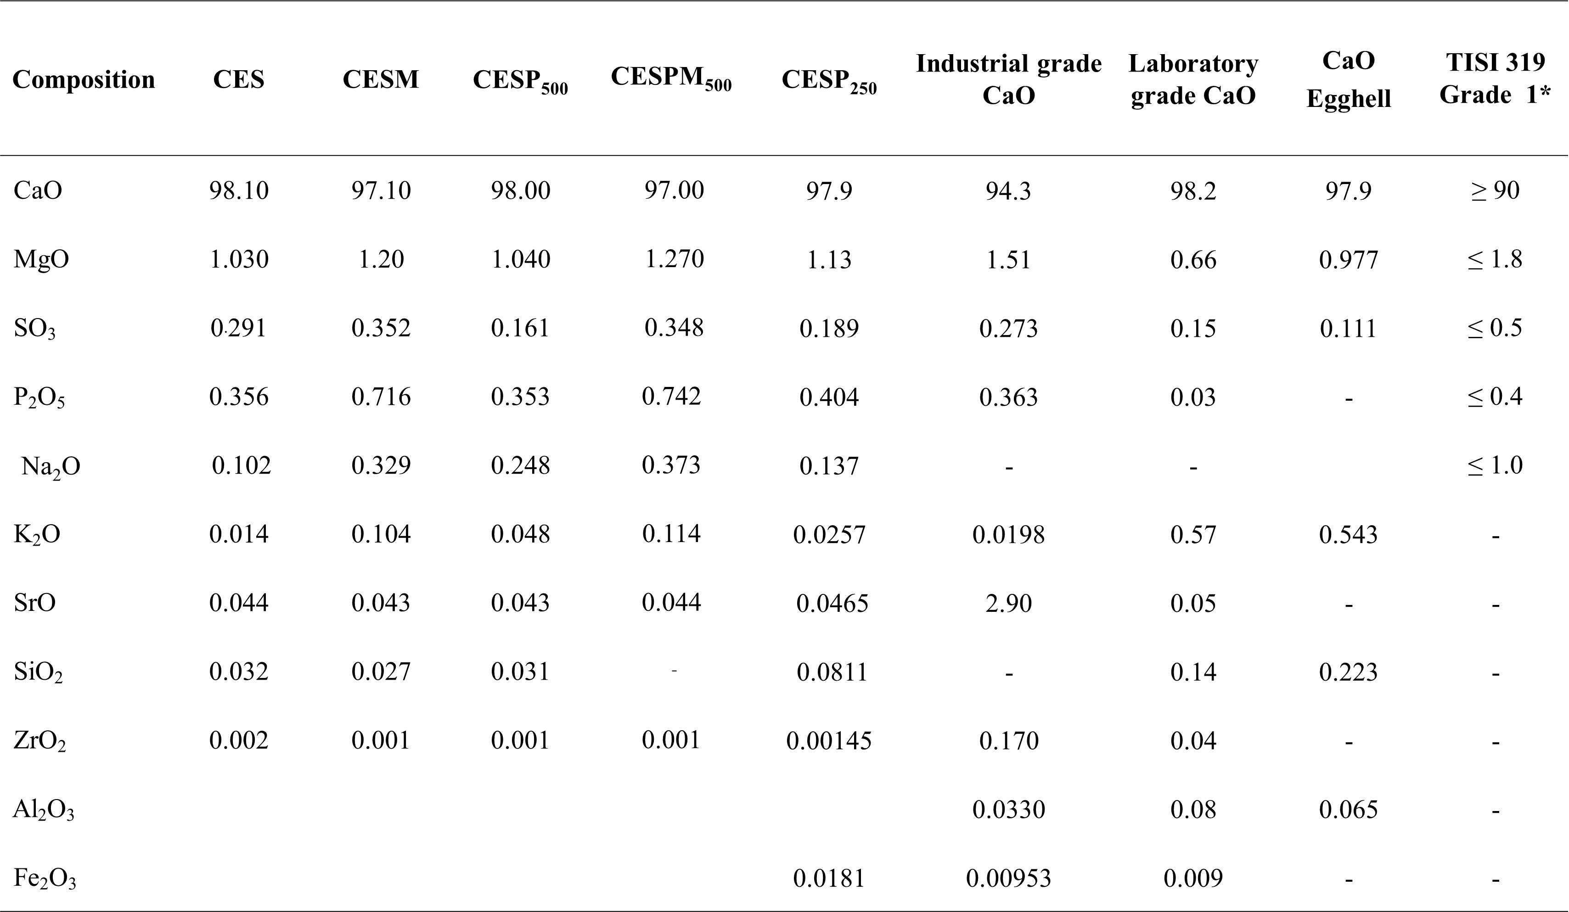

Table 5 Chemical composition of the CaO products obtained from either calcination under N₂ atmosphere with 5% feeding rate or calcination in air atmosphere with variation of raw material filling rate.
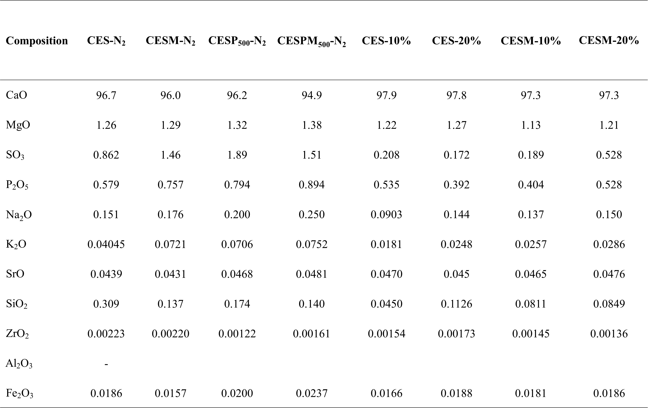

Table 6. Comparison of bio-CaO specification obtained from eggshell and specification of CaO for food additive announced by JECFA.
