Supplemental Information for
Genome-wide marker reveals geographical isolation by distance and barriers as well as local heterogeneity in the genetic structure of seagrasses

Shinya Hosokawa^{1,2} · Kyosuke Momota^{1,3,4} · Masaaki Sato⁵ · Kenta Watanabe⁶ · Yuki Watanabe^{3,7} · Shota Homma² · Shota Okura^{1,8} · Shinya Uwai⁹ · Taichi Kosako¹⁰ · Yusuke Uchiyama^{10,11}

* Corresponding author: Shinya Hosokawa, hosokawa@p.mpat.go.jp

¹ Marine Environmental Information Group, Port and Airport Research Institute, Yokosuka, Japan
² Big Data Technology Group, Port and Airport Research Institute, Yokosuka, Japan
³ Central Laboratory, Marine Ecology Research Institute, Onjuku, Isumi, Japan
⁴ Data Synthesis and Fusion Analysis Research Group, Center for Earth Information Science and Technology, Japan Agency for Marine-Earth Science and Technology, Yokohama, Japan
⁵ Fisheries Technology Institute, Japan Fisheries Research and Education Agency, Kamisu, Japan
⁶ Coastal and Estuarine Environment Research Group, Port and Airport Research Institute, Yokosuka, Japan
⁷ Sustainable System Research Laboratory, Central Research Institute of Electric Power Industry, Abiko, Japan
⁸ Port Advanced Information Technology Division, National Institute for Land and Infrastructure Management, Yokosuka, Japan
⁹ Research Center for Inland Seas, Kobe University, Kobe, Japan
¹⁰ Coastal and Estuarine Sediment Dynamics Group, Port and Airport Research Institute, Yokosuka, Japan
¹¹ Department of Civil Engineering, Kobe University, Kobe, Japan

Supplementary Information A: Changes in the number of samples and single nucleotide polymorphisms (SNPs) by filtering and the statistical differences between the samples collected in 2019 and 2022

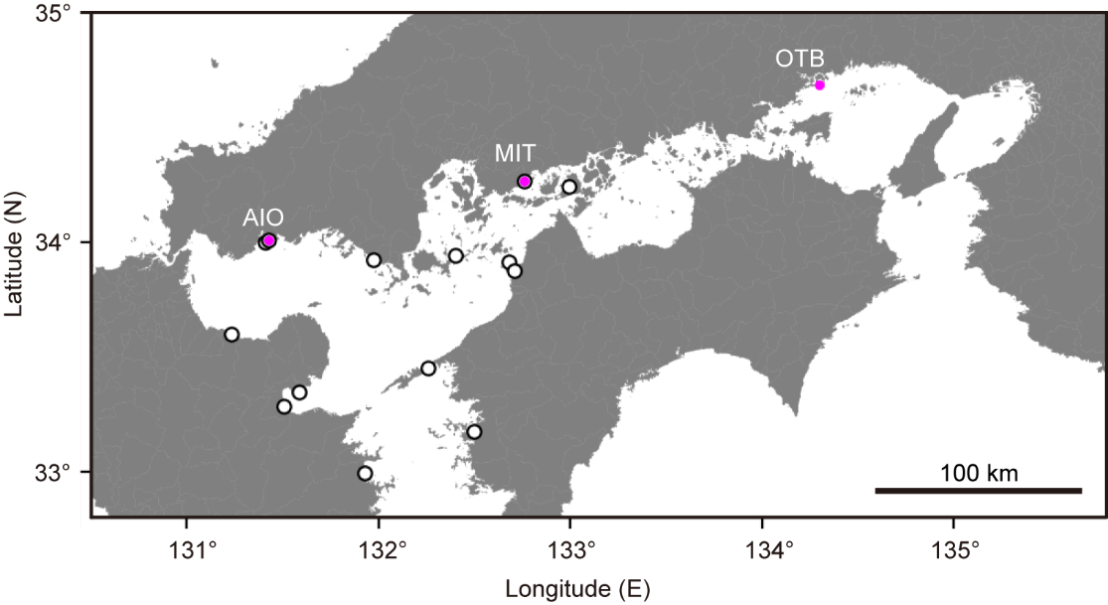

Fig. S1 Locations of test sites AIO, MIT, and OTB, where the eelgrass samples were taken in 2019 and 2022. The open circles indicate the sites analyzed in the main text. Twenty samples were collected at each site and each year. A total 120 samples were collected.

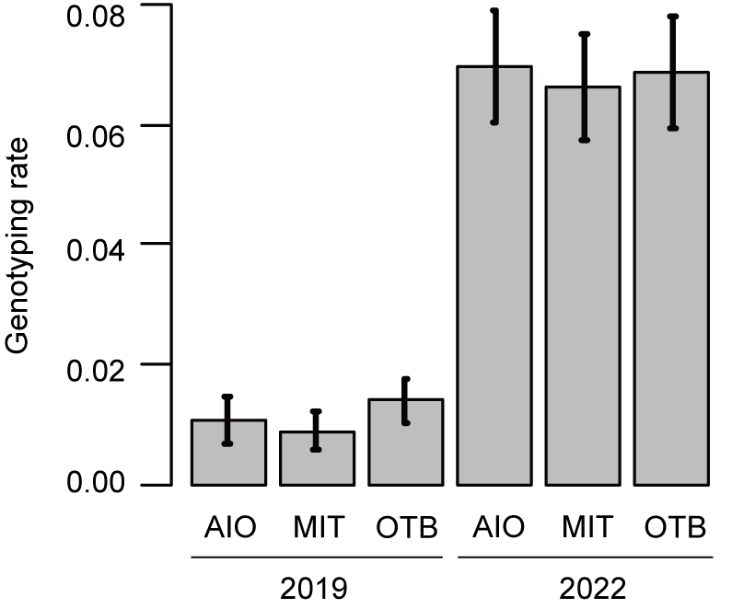

Fig. S2 Rate of genotyping for the test sites analyzed using the GRAS-Di method. The rate of genotyping was calculated based on the 185,430 single nucleotide polymorphism (SNPs) remaining after the first stage of SNP filtering.

Table S1 The number of samples that remained after sample filtering at the test sites. After the first-stage filtering, 185,430 single nucleotide polymorphisms (SNPs) remained. The SNP filtering was performed as a preprocessing of sample filtering using the software VCFtools, and after the second stage of filtering 3613 SNPs remained. Two sample filters were performed by allowing a minimum genotyping rate of 0.5 (sample GR = 0.5; strict filtering) and 0.1 (sample GR = 0.1; moderate filtering). All 120 samples remained after moderate filtering. However, many samples in 2019 were rejected by strict filtering, and 75 samples remained. “--mind 0.5” and “--mind 0.1” are the descriptions of options in the software PLINK
 | No. samples
 | Before filtering | Remaining | Remaining
 |  | sample GR = 0.5 | sample GR = 0.1
 |  | --mind 0.5 | --mind 0.9
AIO, 2019 | 20 | 4 | 20
MIT, 2019 | 20 | 0 | 20
OTB, 2019 | 20 | 11 | 20
AIO, 2022 | 20 | 20 | 20
MIT, 2022 | 20 | 20 | 20
OTB, 2022 | 20 | 20 | 20
Total | 120 | 75 | 120

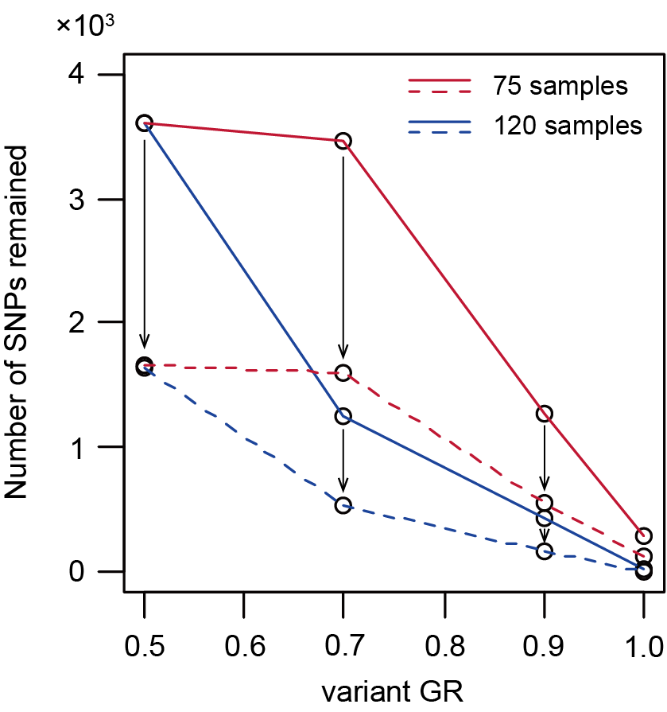

Fig. S3 The decrease in single nucleotide polymorphisms (SNPs) by filtering in the test sites. Solid lines represent the decrease due to SNP filtering by allowing a minimum genotyping rate for SNP (variant GR), and dashed lines represent the decrease due to the additional SNP filtering with minor allele frequency (MAF). Thus, the arrows represent the SNP reduction by the SNP filtering with MAF. Red and blue lines are the SNPs that remained after sample filtering by allowing the minimum genotyping rate (sample GR) of 0.5 (strict filtering) and 0.1 (moderate filtering), respectively. See Table S1 for the difference in the number of samples between strict and moderate filtering. Although in the main text the value of MAF depends on the proportion of the minimum number of populations in the site to the total population analyzed, the MAF of 0.04 was employed here in both sample GRs to compare the filtering effect. The number of SNPs declined drastically from 0.7 to 0.9 in the variant GR in strict filtering (red solid line). However, a drastic decline occurred from 0.5 to 0.7 in the moderate filtering (blue solid line). If we used the variant GR of 0.7, the number of SNPs remaining was less in the moderate filtering than in the strict filtering, instead of all 120 samples remaining.

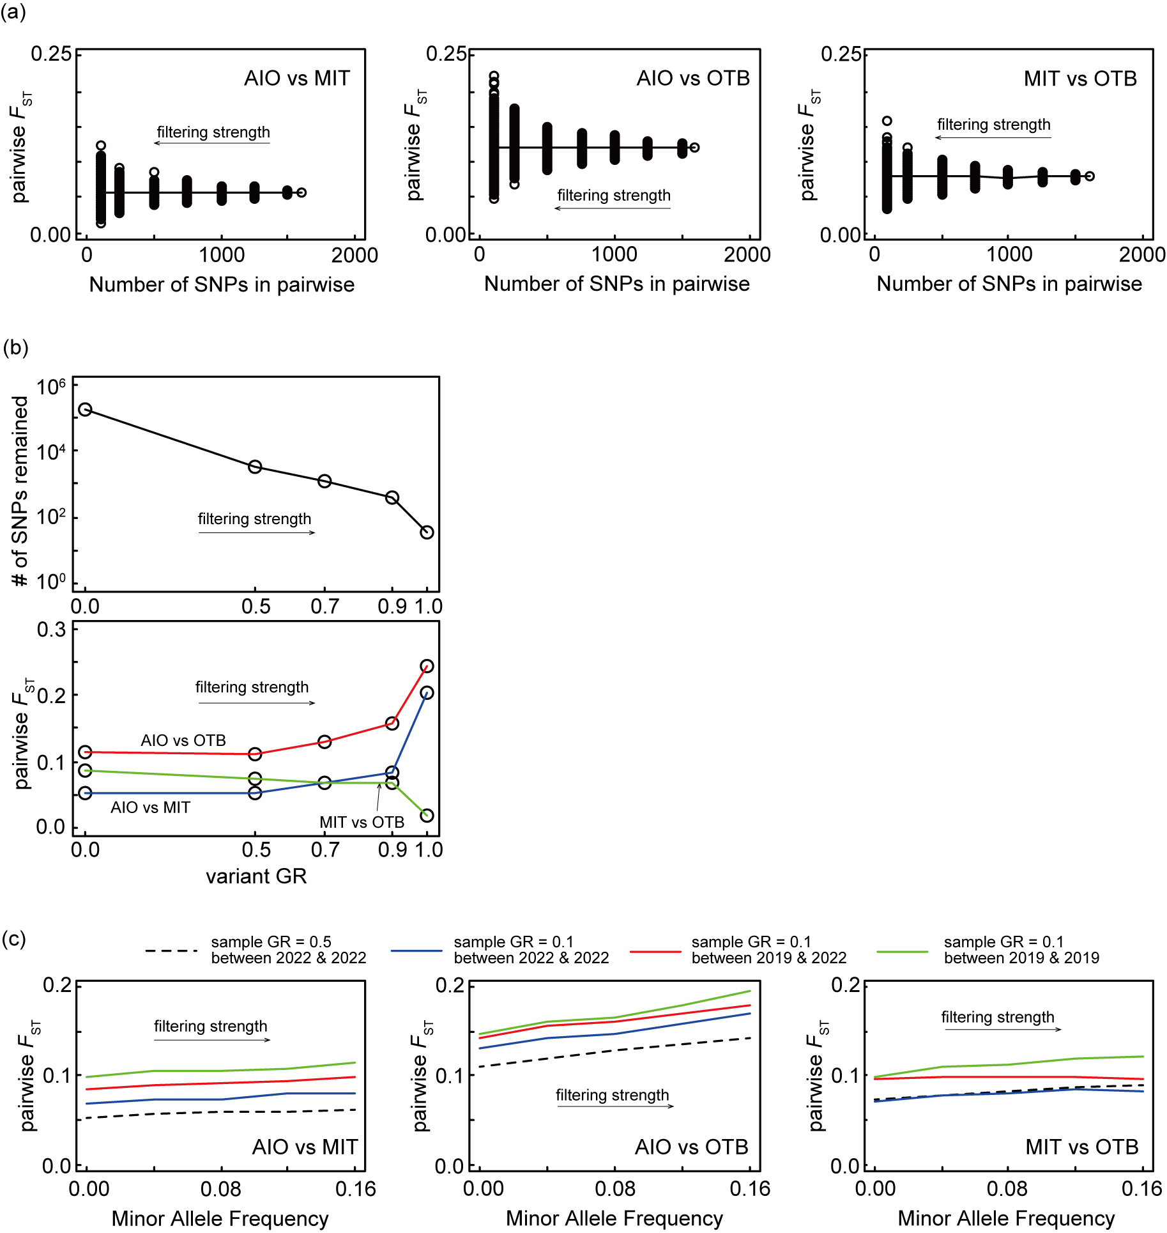

Fig. S4 The sensitivity of pairwise F_{ST} against single nucleotide polymorphism (SNP) filtering. The decrease of the number of SNPs by SNP filtering (see Fig. S3). In a simulation with 1000 iterations where the SNP was sampled randomly by an arbitrary number of SNPs on the sample in 2022, (a) the expected pairwise F_{ST} (line) is not biased. This robustness is explained by the rationale that the expected pairwise F_{ST} is unaffected by the decrease in the number of SNPs without any selection. However, (a) under the high strength of SNP filtering, the size of the remaining SNPs is small, and the pairwise F_{ST} becomes large or small. (b) The change in pairwise F_{ST} against the strength of SNP filtering by allowing the minimum genotyping rate (variant GR) is complex. The variability in the pairwise F_{ST} on the small size of SNPs may explain this change in the pairwise F_{ST}. In addition, (c) the pairwise F_{ST} increases with increasing minor allele frequency (MAF). The rationale to explain the result is that the pairwise F_{ST} will be overestimated if the neutral SNPs decrease with selective filtering.

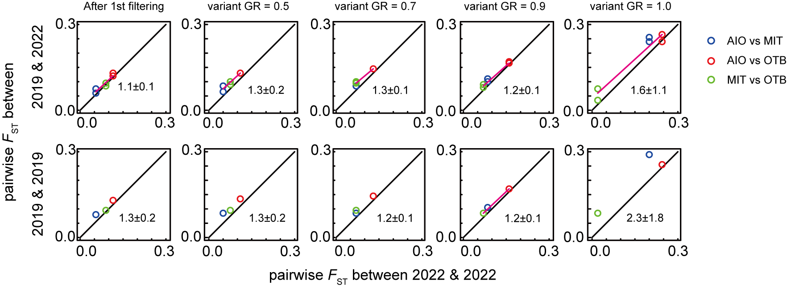

Fig. S5 Comparison of the pairwise F_{ST} between samples obtained in different years. The pairwise F_{ST} tends to be overestimated if pairwise analysis includes the samples in 2019. However, no filtering mitigates the overestimation. Black and magenta lines are the one-to-one and significant relationships by linear regression, respectively

Supplementary Information B: The trade-off by single nucleotide polymorphism (SNP) filtering on the analysis of genetic structure for the samples of 2019 and 2022 and the repeatability and difference between the samples taken in those two years

In the SNP filtering, although relatively strict filtering has merits to close the gap in the rate of genotyping between the samples in 2019 and more recent samples (Fig. S6), too strict filtering causes the SNP size to become too small, and the probable real genetic difference becomes unclear in the PCA and ADMIXTURE analyses (Figs. S7 and S8). The allowed minimum genotyping rate of 0.7 for the SNP filtering showed a moderate result in the trade-off. Although the trade-off was associated only with the analysis of Tokyo Bay, we used the value in the three study areas to provide consistency among them. The threshold value of minor allele frequency used was below the proportion of a minimum number of populations at a site to the total population analyzed. Before the three filtering procedures, SNP filtering by allowing the minimum genotyping rate of 0.5 was performed using VCFtools on the SNP products of the first-stage filtering. The three filtering procedures were performed using PLINK ver. 1.90b7 (Purcell et al. 2007). After the second stage of filtering, we tried to prune the SNPs in possible linkage disequilibrium using a window size of 50 kb and 0.5 coefficient of determination (r²) using PLINK. However, no SNP was pruned using PLINK because too few valid variants were available.

References
Purcell, S., B. Neale, K. Todd-Brown, L. Thomas, M. A. R. Ferreira, D. Bender, J. Maller, et al. 2007. PLINK: A tool set for whole-genome association and population-based linkage analyses. American Journal of Human Genetics 81: 559–575. https://doi.org/10.1086/519795.

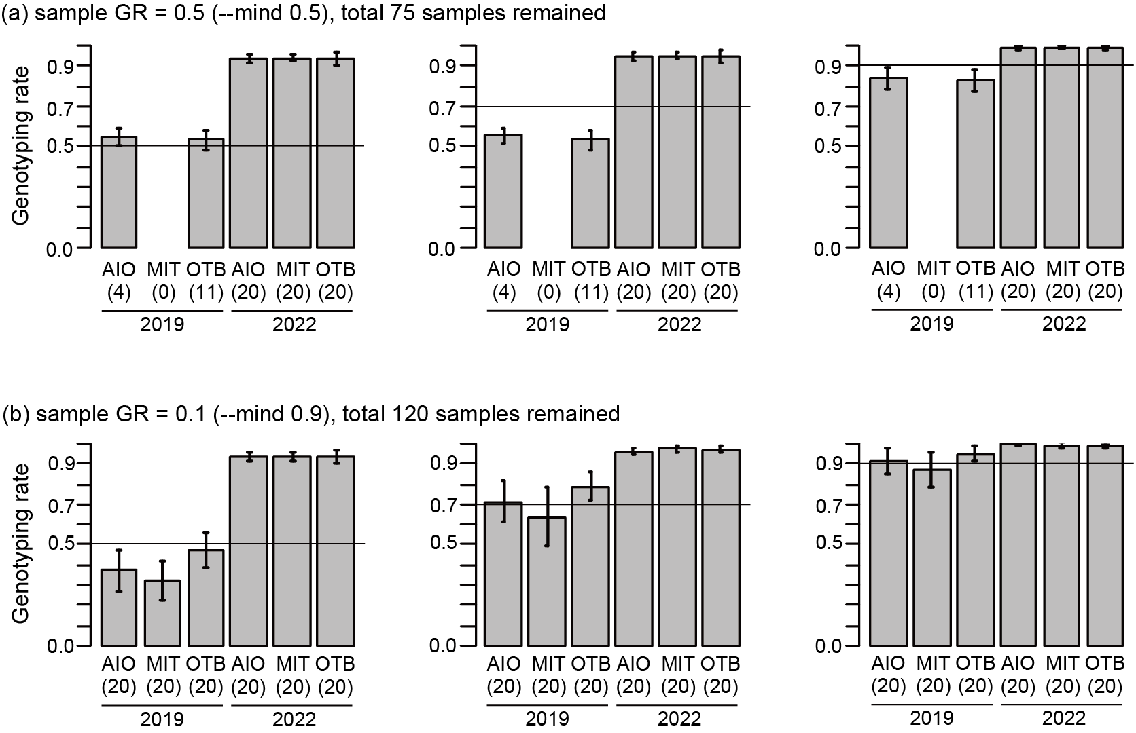

Fig. S6 The rate of genotyping after the second stage of filtering in the test sites. The final products and the allowed minimum rate of genotyping in the sample (sample GR) are shown for 0.5 in (a) and 0.1 in (b). Horizontal lines mean the allowed minimum rate of genotyping in a single nucleotide polymorphism (SNP) (variant GR). A minor allele frequency of 0.04 was used in both sample GRs. The number of samples remaining is shown in parentheses. The gap in genotyping rate between years was large in the variant GR of 0.5 and low in the variant GR of 0.9. However, the number of SNPs remaining in final products decreased significantly in the large variant GR (see Fig. S3). The effect of this trade-off between the gap size of the genotyping rate and the number of SNPs remaining on the analysis for genetic structure is shown in Figs. S7 and S8

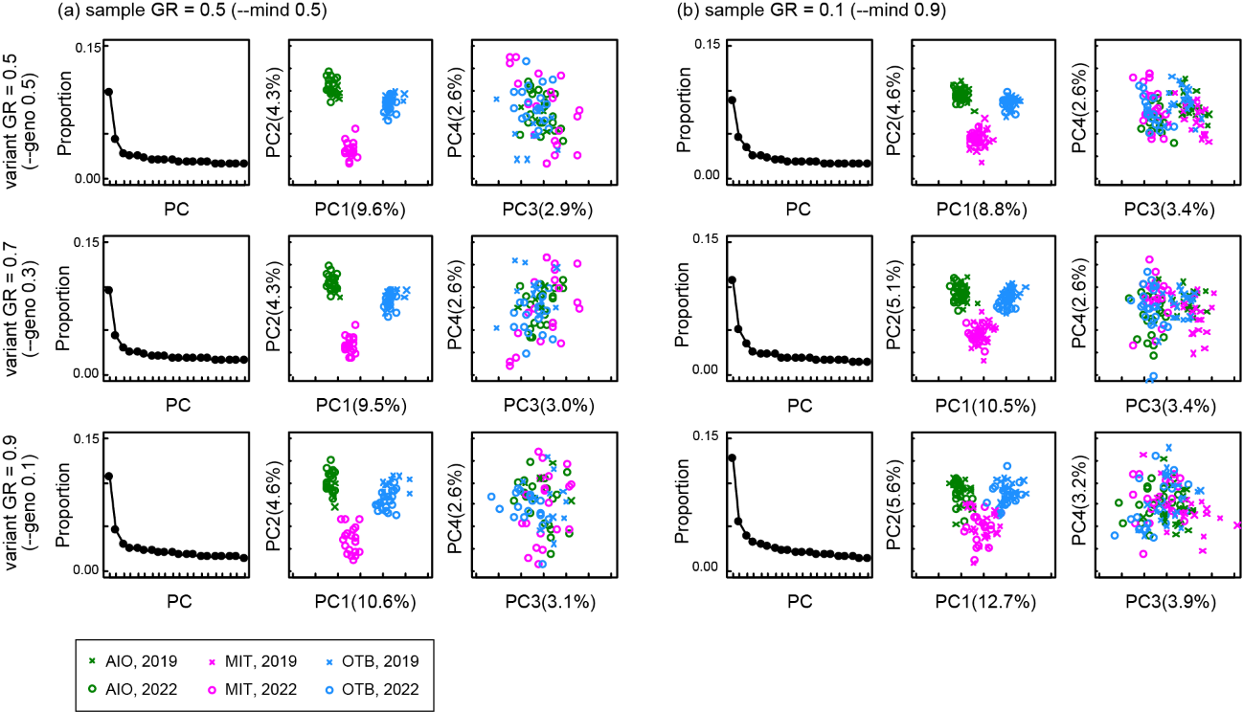

Fig. S7 Comparison of the principal component analysis (PCA) for the genetic structure at the test sites. The results are shown for the allowed minimum genotyping rate for the sample filtering (sample GR) of (a) 0.5 and (b) 0.1. The results based on the allowed minimum genotyping rate for the single nucleotide polymorphism (SNP) filtering (variant GR) are shown vertically in each panel. By the first principal component (PC1) and the second one (PC2) of these panels, we can understand that the difference in genetic structure is governed by the site, not by year (see both panels). However, we can see the difference between years in the direction of the third principal component (PC3) in the sample GR of 0.1 (b). We suggest that the difference would be caused by the complementary method of missing data by the R package “pcadapt” because the difference is unclear in the variant GR of 0.9, which has less gap in the genotyping rate. The moderate sample filtering (sample GR = 0.1) has merit in retaining the greater number of samples remaining but also has a demerit in that such uncertain differences in genetic structure are shown. At the very least, careful interpretation is required for the PCA results, which include the samples in 2019 and newer ones.
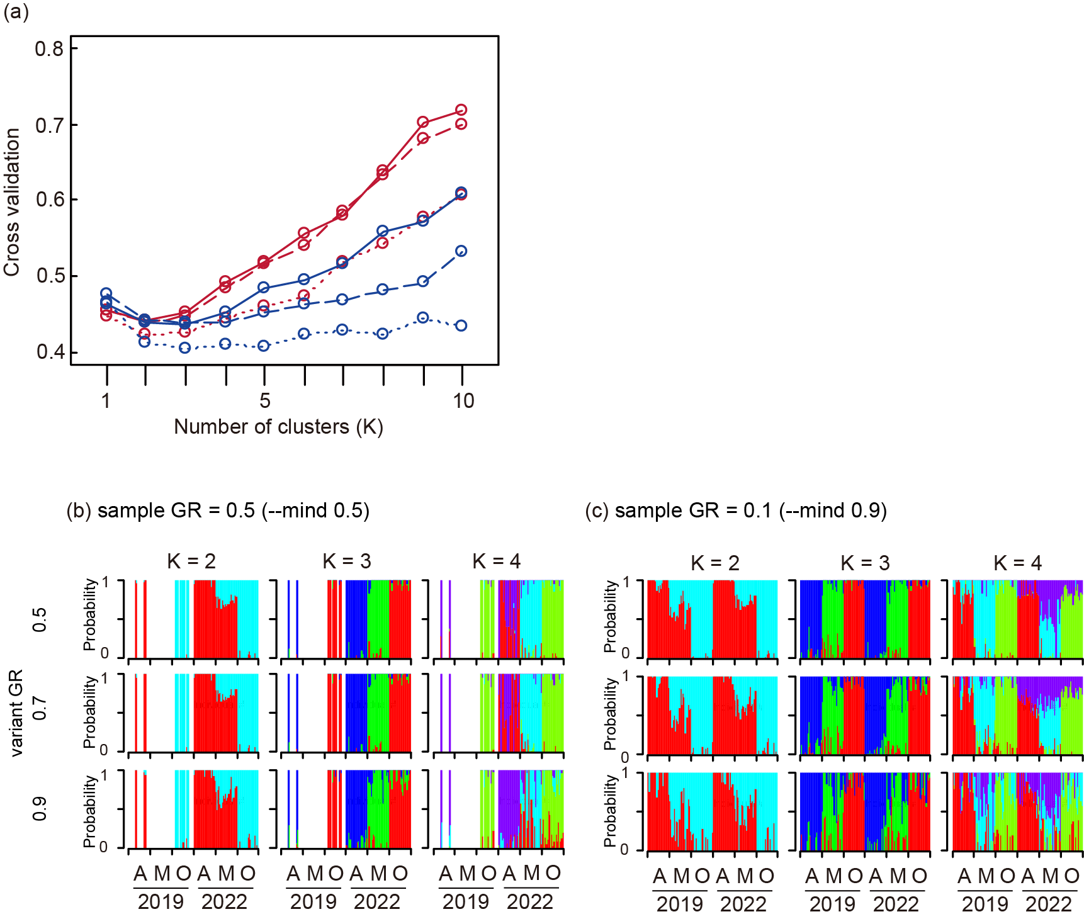

Fig. S8 Comparison of the ADMIXTURE analysis in the test sites. (a) The 5-fold cross-validations in the six filtering combinations show that two or three clusters (K) may be reasonable to choose as the number of ancestral populations. As a result, we show the results of two, three, and four clusters. Panels are for the allowed minimum genotyping rate for the sample filtering (sample GR) off (b) 0.5 and (c) 0.1, with the subpanels for the allowed minimum genotyping rate for the single nucleotide polymorphism filtering (variant GR). Letters A, M, and O mean sites AIO, MIT, and OTB, respectively. The greater number of samples remaining is of obvious merit in the sample GR of 0.1. However, the increases in cross-validation with increasing number of clusters (K) is unclear in the sample GR of 0.1 (a), and the results are noisy (c). Careful interpretation is required to determine the best number of clusters and partitioning in the analysis, which includes the samples from 2019 and more recent samples.

Supplementary Information C: The set of the values for filtering in the analysis of the main text

Table S2 Values for the second stage of filtering. The allowed minimum genotyping rates for the sample filtering (sample GR) and for the single nucleotide polymorphism (SNP) filtering (variant GR) and minor allele frequency (MAF) are shown with the descriptions of options in the PLINK software. The numbers of total samples remaining (total sample), minimum samples in site (min sample), and SNPs remaining are also shown. This filtering set is called strict filtering in the analysis of Tokyo Bay.
Filter | SIS |  |  |  |  | Tokyo Bay |  |  |  |  | Akkeshi
Filter | Value | PLINK option | Total sample | Min sample | SNPs | Value | PLINK option | Total sample | Min sample | SNPs | Value | PLINK option | Total sample | Min sample | SNPs
 |  |  | 244 | 10 | 13635 |  |  | 89 | 29 | 7022 |  |  | 140 | 20 | 11070
sample GR | 0.5 | --mind 0.5 | 239 | 10 | 13635 | 0.5 | --mind 0.5 | 68 | 29 | 7022 | 0.5 | --mind 0.5 | 139 | 20 | 11070
variant GR | 0.7 | --geno 0.3 | 239 | 10 | 5038 | 0.7 | --geno 0.3 | 68 | 29 | 6032 | 0.7 | --geno 0.3 | 139 | 20 | 6955
MAF | 0.01 | --maf 0.01 | 239 | 10 | 4893 | 0.1 | --maf 0.1 | 68 | 29 | 2103 | 0.04 | --maf 0.04 | 139 | 20 | 2988

Table S3 The values for the second stage of SNP filtering. See Table S2 for the details of parameters and abbreviations. This filtering set is called moderate filtering in the analysis of Tokyo Bay.
Filter | Tokyo Bay
Filter | Value | PLINK option | Total sample | Min sample | SNPs
 |  |  | 89 | 20 | 7022
sample GR | 0.1 | --mind 0.9 | 87 | 19 | 7022
variant GR | 0.7 | --geno 0.3 | 87 | 19 | 3690
MAF | 0.05 | --maf 0.05 | 87 | 19 | 1827

Supplementary Information D: Supporting information for the results in the main text

Table S4 The 5-fold cross-validation of the ADMIXTURE analysis for the Seto Inland Sea (SIS), Tokyo Bay, and Akkeshi. The cross-validation was calculated in each genetic cluster (K). Bold values indicate the minimum or approximately minimum in the 5-fold cross-validation. The numbers of genetic clusters associated with the bold values are shown in the main text.
K | SIS | Tokyo Bay |  | Akkeshi
 |  | strict | moderate
1 | 0.324 | 0.492 | 0.452 | 0.443
2 | 0.317 | 0.459 | 0.430 | 0.434
3 | 0.314 | 0.467 | 0.429 | 0.427
4 | 0.312 | 0.476 | 0.437 | 0.431
5 | 0.313 | 0.482 | 0.450 | 0.441
6 | 0.316 | 0.519 | 0.453 | 0.453
7 | 0.320 | 0.531 | 0.474 | 0.463
8 | 0.324 | 0.556 | 0.485 | 0.478
9 | 0.332 | 0.601 | 0.510 | 0.483
10 | 0.336 | 0.611 | 0.528 | 0.504

Supplementary Information E: A comparison between the analyses after strict filtering and moderate filtering in Tokyo Bay

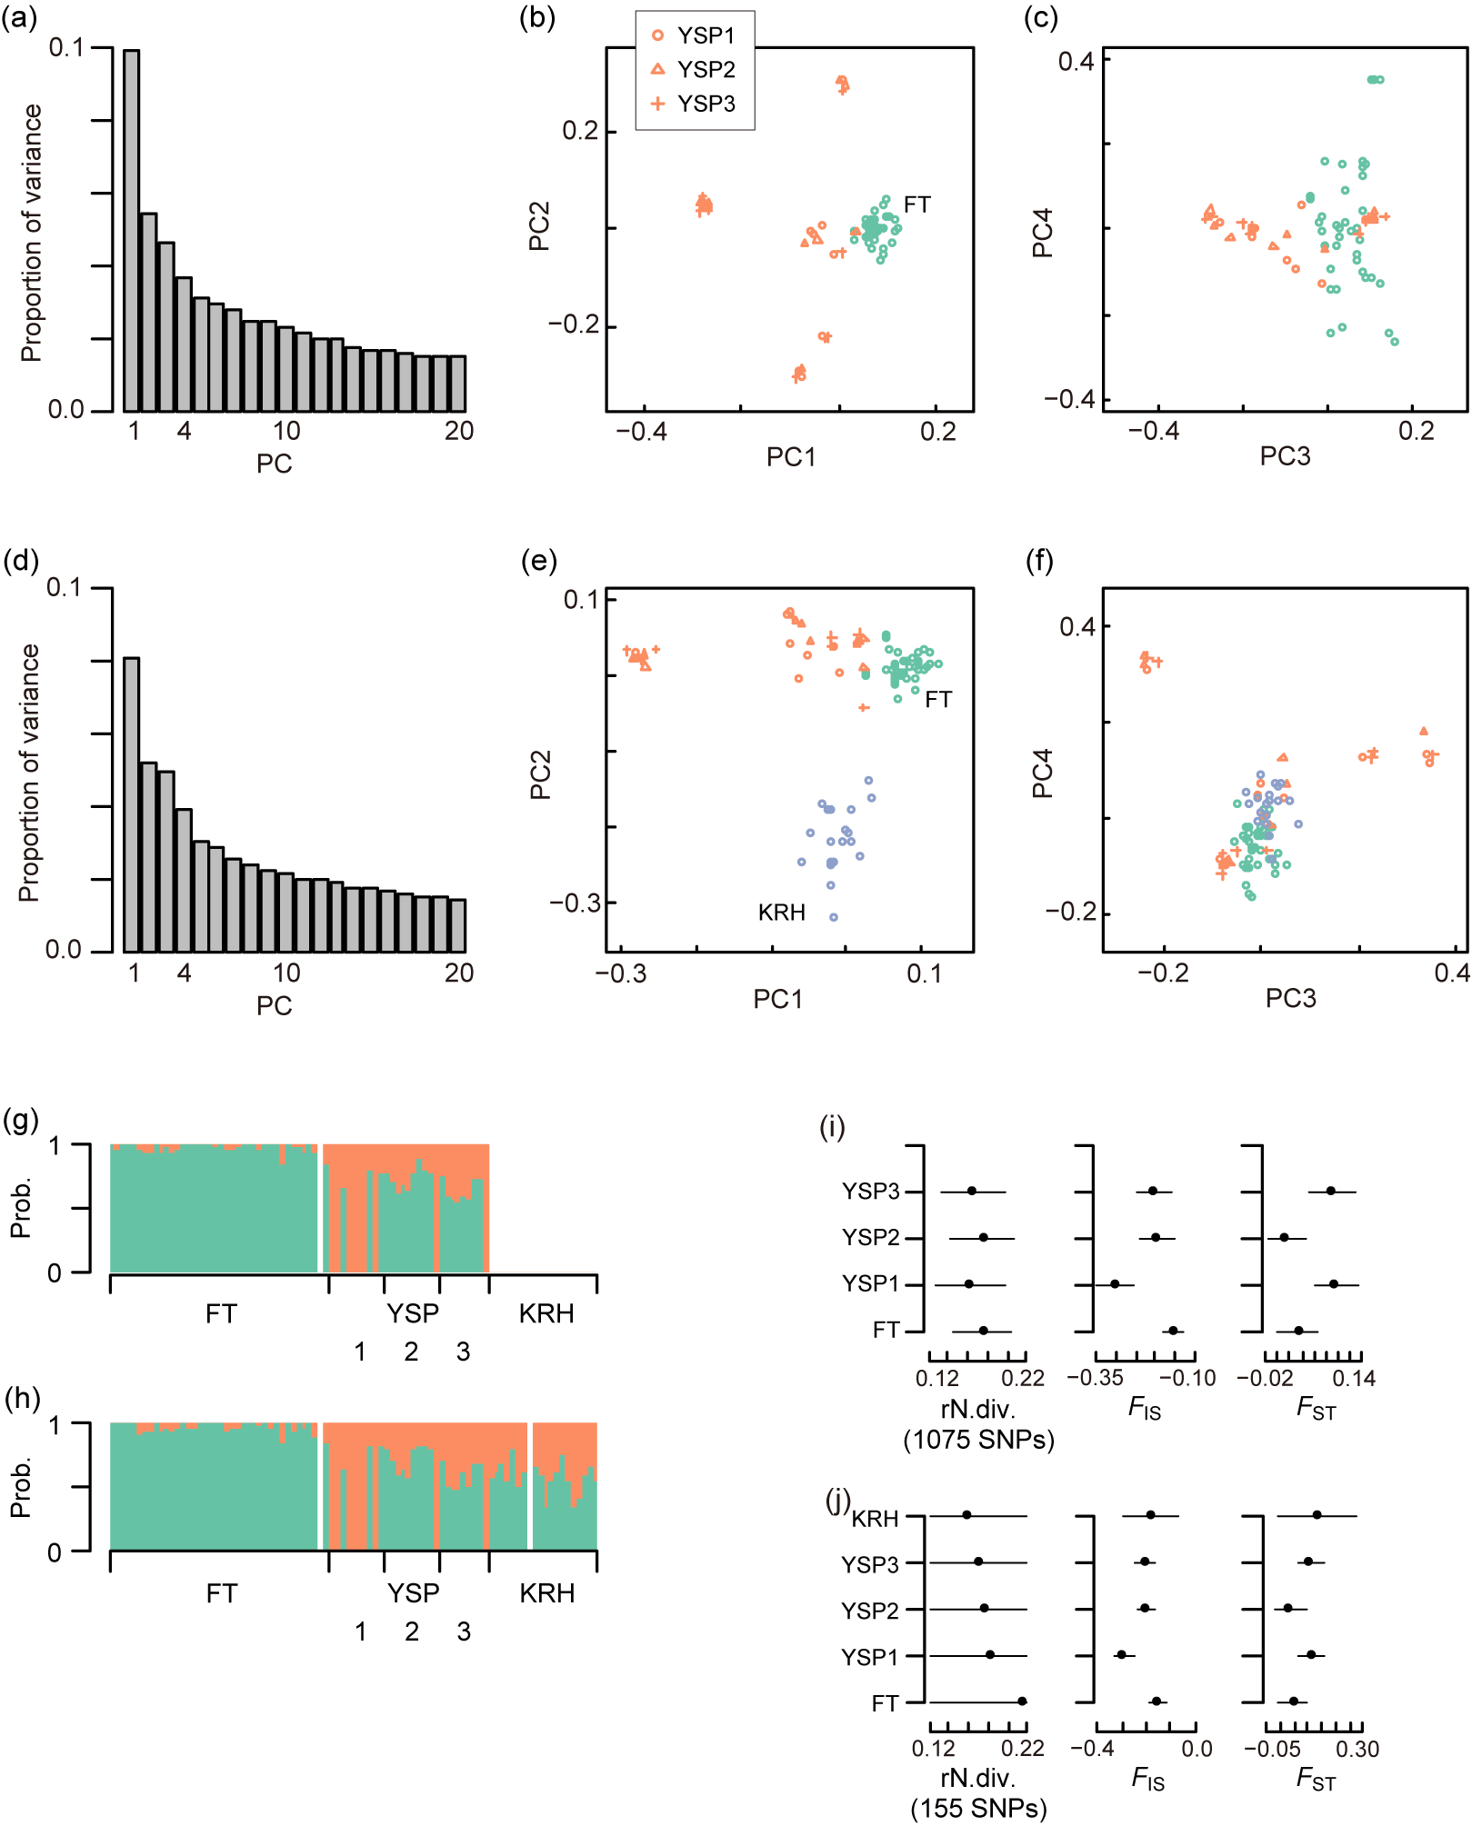

Fig. S9 Comparison between the analyses after strict filtering and moderate filtering in Tokyo Bay. The results of the principal component analysis (PCA) after (a–c) strict filtering and (d–f) moderate filtering. (a and d) Scree plot of the proportion of variance contributed by the eigenvalues of the principal components (PCs). The two-dimensional plots show (b and e) the first and second PCs (PC1 and PC2) and (c and f) the third and fourth PCs (PC3 and PC4). The displayed ADMIXTURE analysis results are for two genetic clusters after (g) strict filtering and (h) moderate filtering. Each color and vertical bar represent genetic structure and an individual, respectively. Each individual is partitioned into genetic clusters. White individuals were removed by filtering. The restricted nucleotide diversity (rN. div.) and the population-specific F_{IS} and F_{ST} were calculated after (i) strict filtering and (j) moderate filtering. The second stage of strict filtering rejected one individual of FT and twenty individuals of KRH. A total of 68 individuals remained. The PCA and ADMIXTURE analyses were based on 2103 single nucleotide polymorphisms (SNPs) by strict filtering. The population-specific F_{IS} and F_{ST} bootstrap of panel i were calculated based on 49,266 SNPs, which were obtained by first-stage filtering of 68 individuals.

Supplementary Information F: Simulation of currents in the Seto Inland Sea

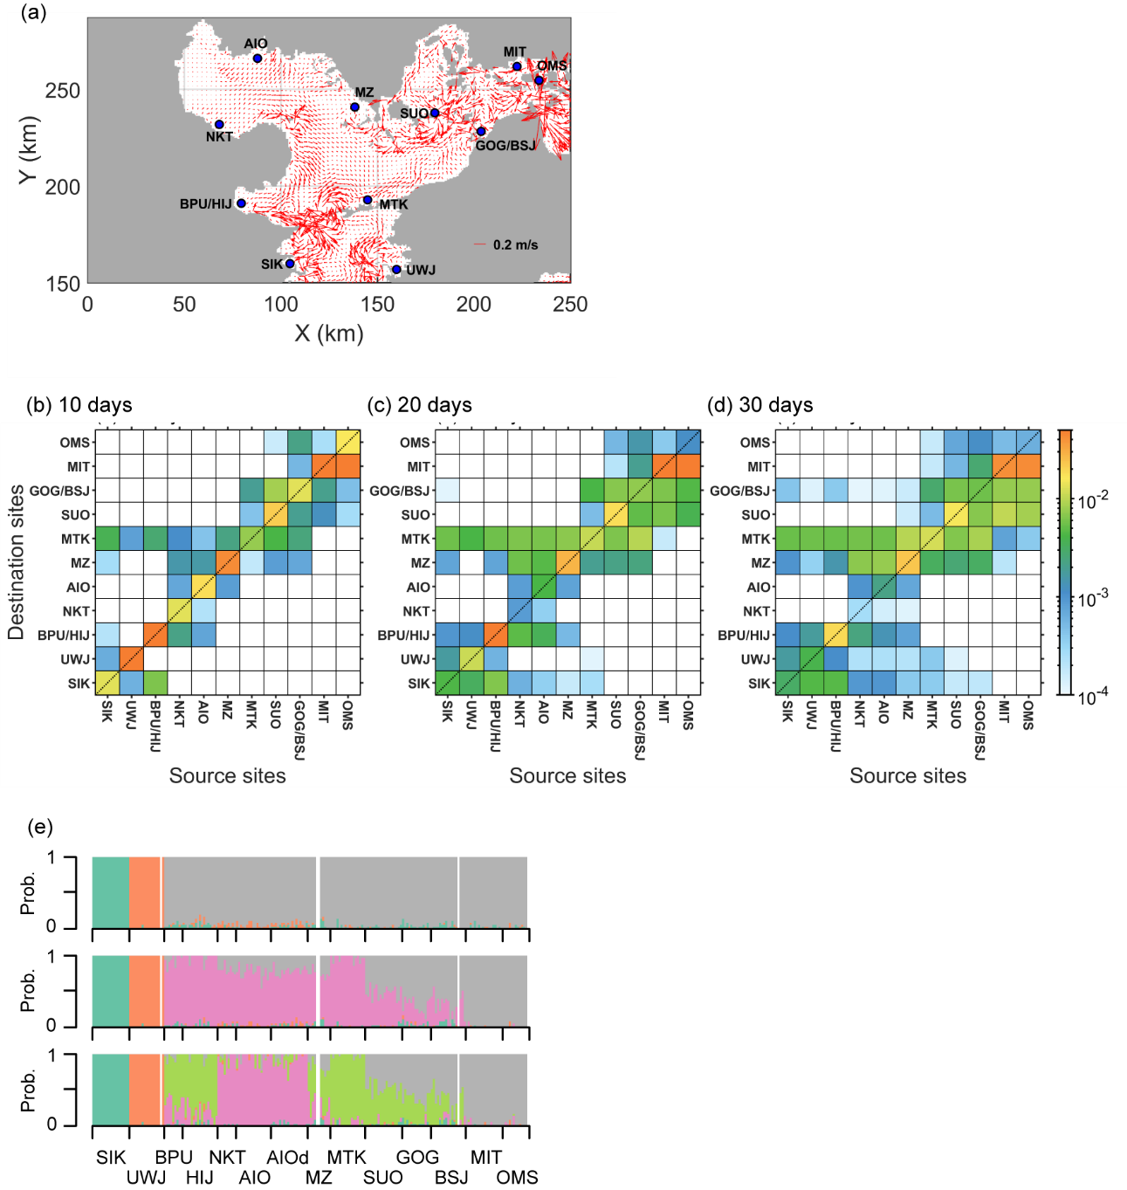

Fig. S10 Potential connectivity in the Seto Inland Sea. (a) The mean surface residual current and the potential connectivity matrix at an advection time of (b) 10 days, (c) 20 days, and (d) 30 days. The potential connectivity was calculated as the probability density that a particle is transported from a source (x-axis) and destination (y-axis) sites. Colors show the probability density of particles at the destination site after the advection time. The SIK site in the simulation is located north of the site of field sampling because the sampling site was not included in the simulation. As a result, the particles from SIK and UWJ do not reach NKT, AIO, SUO, MIT, and OMS by a dispersal time of 30 days. Although this is optimistic connectivity in a single generation of seed dispersal, the limitation of connectivity between these sites would mean that the gene flow between them is weak. Conversely, with a dispersal of 10 days, which may be relatively realistic connectivity, the particles from the outer sites do not reach the sites, except for the MTK, BPU, and MZ. (c) The ADMIXTURE analysis in the Seto Inland Sea is a result from the main text, but the x-axis is rearranged to give the same sequence as the potential connectivity matrix

