WISCA Methodology Description
The weighted incidence syndromic combination antibody (WISCA) tool was implemented using a Bayesian hierarchical logistic regression model to estimate the effectiveness of various antibiotic regimens against pathogens. This hierarchical model included varying intercepts for both pathogens and treatment regimens to ensure stable and reliable coverage estimates, especially for antibiotic regimens with limited sensitivity data. The Hamiltonian Monte Carlo algorithm was used to sample from the posterior distribution of the model parameters via Stan, a probabilistic programming language for Bayesian inference. The model's structure considered fixed effects such as sex and age, as well as random effects for pathogens and regimens.
The model was specified as follows:
logit (P (coverage_{i} = 1)) = α+ α_{pathogen[i]} + α_{regimen [i]} + β X_{i}
where:
- α represents the overall intercept.
- α_{pathogen[i]} and α_{regimen [i]} ​ are the random effects for pathogens and regimens, respectively.
- β is the vector of fixed effects coefficients.
- X_{i} is the design matrix for the fixed effects, including covariates such as age and sex.
The priors imposed on the model parameters were weakly informative for regularizing the estimates:
- α ∼ N (0, 2)
- α_{pathogen}∼ N (0, 1)
- α_{regimen} ∼ N (0, 1)
- β ∼ N (0, 0.5)
The Hamiltonian Monte Carlo algorithm executed four chains, each with 12000 iterations, discarding the first 2000 iterations as warm-up. Convergence was evaluated using trace plots and the R^ diagnostic to ensure reliable parameter estimates. The posterior distributions of the parameters were summarized using the median and 95% highest density intervals (HDIs), with wider HDIs indicating greater uncertainty in the coverage estimates.
Tables and Figures
Table S1. Frequencies of Empiric Antimicrobial Regimens for VAP.
Table S2. R ̂ Index Values of the WISCA Model Parameters.
Table S3. Comparison of VAP-Associated Bacterial Pathogens Regarding the Onset of VAP and Resistance Profiles.
Table S4. WISCA Estimated Coverage for All Evaluated Antibiotic Regimens and the Associated 95% Highest Density Intervals in Patients Who Developed VAP with Less and More than 5 Days of IMV.
Table S5. R ̂ Index Values of the WISCA Model Parameters in Patients with Less and More than 5 Days of IMV Who Develop VAP.
Table S6. Univariate Analysis Regarding In-Hospital Mortality and Extended Hospital Stay.
Figure S1. Monte Carlo Markov Chains (MCMC) Trace Plots of the WISCA Model Parameters.
Figure S2. Density plots of the posterior distributions of the parameters of the model
Figure S3. Distribution of Isolated Microorganisms Over Time of IMV from Patients Who Developed VAP

Table S1. Frequencies of Empiric Antimicrobial Regimens for VAP.
Antibiotic regimen | Frequency | Percentage
Meropenem | 49 | 24.87
Colistin+Tigecycline | 36 | 18.27
Piperacillin/Tazobactam | 27 | 13.71
Meropenem+Linezolid | 15 | 7.61
Clindamycin+Ceftriaxone | 9 | 4.57
Ceftriaxone | 8 | 4.06
Colistin+Meropenem | 7 | 3.55
Colistin | 5 | 2.54
Colistin+Meropenem+Tigecycline | 3 | 1.52
Colistin+Linezolid+Tigecycline | 3 | 1.52
Ciprofloxacin+Meropenem | 2 | 1.02
Meropenem+Vancomycin | 2 | 1.02
Ceftriaxone+Metronidazole | 2 | 1.02
Ceftazidime+Piperacillin/Tazobactam | 2 | 1.02
Tigecycline | 2 | 1.02
Cefepime+Linezolid | 2 | 1.02
Ampicillin+Ceftriaxone | 2 | 1.02
Colistin+Levofloxacin+Vancomycin | 2 | 1.02
Amikacin+Linezolid | 1 | 0.51
Linezolid+Piperacillin/Tazobactam | 1 | 0.51
Meropenem+Metronidazole | 1 | 0.51
Colistin+Trimethoprim/Sulfamethoxazole | 1 | 0.51
Metronidazole+Trimethoprim/Sulfamethoxazole+Vancomycin | 1 | 0.51
Piperacillin/Tazobactam+Vancomycin | 1 | 0.51
Daptomycin+Meropenem | 1 | 0.51
Colistin+Linezolid | 1 | 0.51
Colistin+Tigecycline+Vancomycin | 1 | 0.51
Colistin+Linezolid+Meropenem | 1 | 0.51
Amikacin+Meropenem | 1 | 0.51
Colistin+Cefotaxime | 1 | 0.51
Colistin+Cefepime | 1 | 0.51
Clarithromycin+Meropenem | 1 | 0.51
Ceftriaxone+Meropenem+Vancomycin | 1 | 0.51
Ceftazidime+Vancomycin | 1 | 0.51
Ceftazidime+Clindamycin | 1 | 0.51
Ceftazidime | 1 | 0.51
Trimethoprim/Sulfamethoxazole+Piperacillin/Tazobactam | 1 | 0.51

Table S2. R ̂ Index Values of the WISCA Model Parameters.

Parameter | R-hat
lp__ | 1.000480
alpha_0 | 1.007100
alpha_pathogen[1] (Klebsiella pneumoniae ssp pneumoniae) | 1.003170
alpha_pathogen[2] (Serratia marcescens) | 1.002980
alpha_pathogen[3] (Acinetobacter baumannii) | 1.003180
alpha_pathogen[4] (Pseudomonas aeruginosa) | 1.003350
alpha_pathogen[5] (Stenotrophomonas maltophilia) | 1.003180
alpha_pathogen[6] (Enterobacter cloacae cpmplex) | 1.003380
alpha_pathogen[7] (Escherichia coli) | 1.002900
alpha_pathogen[8] (Staphylococcus aureus) | 1.003080
alpha_pathogen[9] (Providencia stuartii) | 1.002250
alpha_pathogen[10] (Proteus mirabilis) | 1.002780
alpha_pathogen[11] (Klebsiella oxytoca) | 1.003220
alpha_pathogen[12] (Enterobacter aerogenes) | 1.002170
alpha_pathogen[13] (Hafnia alvei) | 1.002870
alpha_pathogen[14] (Burkholderia gladioli) | 1.000730
alpha_regimen[1] (TZP) | 1.004080
alpha_regimen[2] (MEM) | 1.004180
alpha_regimen[3] (FEP) | 1.004510
alpha_regimen[4] (CAZ) | 1.004320
alpha_regimen[5] (LNZ) | 1.003770
alpha_regimen[6] (VA) | 1.004460
alpha_regimen[7] (CIP) | 1.004250
alpha_regimen[8] (TGC) | 1.004460
alpha_regimen[9] (TZP+LNZ) | 1.004130
alpha_regimen[10] (MEM+LNZ) | 1.004340
alpha_regimen[11] (FEP+LNZ) | 1.004050
alpha_regimen[12] (CAZ+LNZ) | 1.004250
alpha_regimen[13] (TZP+VA) | 1.004370
alpha_regimen[14] (MEM+VA) | 1.004210
alpha_regimen[15] (FEP+VA) | 1.004140
alpha_regimen[16] (CAZ+VA) | 1.004290
alpha_regimen[17] (CIP+TGC) | 1.004630
alpha_regimen[18] (FEP+TGC) | 1.004470
alpha_regimen[19] (CAZ+TGC) | 1.004320
alpha_regimen[20] (MEM+TGC) | 1.004410
alpha_regimen[21] (TGC+TZP) | 1.004250
beta[1] (Edad) | 0.999831
beta[2] (Sexo) | 1.000290

Table S3. Comparison of VAP-Associated Bacterial Pathogens Regarding the Onset of VAP and Resistance Profiles.
Organism | Total Cases (n=197) | VAP development within 5 days of IMV (n=61) | VAP development after 5 days of IMV (n=136) | P value
Acinetobacter baumannii | 71 (36.04%) | 8 (13.33%) | 63 (45.99%) | <0.001
Pseudomonas aeruginosa | 36 (18.27%) | 11 (18.33%) | 25 (18.25%) | 1
Enterobacterales | 53 (26.90%) | 24 (38.33%) | 29 (21.17%) | 0.019
Staphylococcus aureus | 20 (10.15%) | 13 (21.67%) | 7 (5.11%) | 0.001
Stenotrophomonas maltophilia | 16 (8.12%) | 5 (8.33%) | 11 (8.03%) | 1
Burkholderia gladioli | 1 (0.51%) | 0 (0.00%) | 1 (0.73%) | 1
Resistance Pattern
XDR - Acinetobacter baumannii | 62.0 (87.32) | 7.0 (11.29) | 55.0 (88.70) | <0.001
MDR - Acinetobacter baumannii | 4.0 (5.63) | 1.0 (25) | 3.0 (75) | 1.0
Carbapenem resistant Enterobacteriaceae | 4.0 (7.54) | 0.0 (0) | 4.0 (100) | 0.419
MDR - Enterobacteriaceae | 15.0 (28.3) | 6.0 (40) | 9.0 (60) | 0.619
Methicillin Resistant Staphylococcus aureus | 2.0 (1) | 0.0 (0) | 2.0 (100) | 0.854
MDR - Pseudomonas aeruginosa | 7.0 (19.44) | 0.0 (0) | 7.0 (100) | 0.165
XDR - Pseudomonas aeruginosa | 2.0 (5.55) | 1.0 (50) | 1.0 (50) | 1.0
Bold values are for statistically significant variables.

Table S4. WISCA Estimated Coverage for All Evaluated Antibiotic Regimens and the Associated 95% Highest Density Intervals in Patients Who Developed VAP with Less and More than 5 Days of IMV.
Antibiotic regimen | VAP within 5 days of IMV |  |  | VAP after 5 days of IMV
Antibiotic regimen | Median of the posterior distribution (%) | Lower 95% HDI (%) | Upper 95% HDI (%) | Median of the posterior distribution (%) | Lower 95% HDI (%) | Upper 95% HDI (%)
Tigecycline + Piperacillin/Tazobactam (TGC+TZP) | 90.64 | 80.34 | 96.37 | 86.05 | 76.57 | 92.42
Meropenem + Tigecycline (MEM+TGC) | 95.07 | 88.99 | 98.36 | 86.32 | 76.82 | 92.58
Cefepime + Tigecycline (FEP+TGC) | 95.06 | 88.96 | 98.42 | 87.35 | 78.41 | 93.31
Cefepime + Vancomycin (FEP+VA) | 81.19 | 66.19 | 91.13 | 41.14 | 26.54 | 57.79
Meropenem + Vancomycin (MEM+VA) | 85.63 | 72.29 | 93.60 | 41.13 | 26.7 | 57.6
Piperacillin/Tazobactam + Vancomycin (TZP+VA) | 76.21 | 59.46 | 88.01 | 32.85 | 20.2 | 48.66
Cefepime + Linezolid (FEP+LNZ) | 81.16 | 66.94 | 91.25 | 41.23 | 26.77 | 57.64
Meropenem + Linezolid (MEM+LNZ) | 85.71 | 73.41 | 93.56 | 41.28 | 26.75 | 57.89
Piperacillin/Tazobactam + Linezolid (TZP+LNZ) | 76.08 | 59.07 | 88.21 | 32.84 | 20.16 | 48.56
Ceftazidime (CAZ) | 52.86 | 33.23 | 70.77 | 26.72 | 15.53 | 41.69
Cefepime (FEP) | 81.30 | 66.86 | 90.83 | 38.92 | 24.95 | 55.48
Meropenem (MEM) | 85.71 | 72.84 | 93.74 | 39 | 24.9 | 55.69
Piperacillin/Tazobactam (TZP) | 76.04 | 58.89 | 88.09 | 32.13 | 19.44 | 48.37

Table S5. R ̂ Index Values of the WISCA Model Parameters in Patients with Less and More than 5 Days of IMV Who Develop VAP.

VAP within 5 days of IMV |  | VAP after 5 days of IMV
Parameter | R-hat | Parameter | R-hat
Log-posterior | 1.00338 | Log-posterior | 1.00057
Global intercept (alpha0) | 1.00066 | Global intercept (alpha0) | 1.00912
alpha_pathogen[1] (Klebsiella pneumoniae ssp pneumoniae) | 1.00022 | alpha_pathogen[1] (Klebsiella pneumoniae ssp pneumoniae) | 1.00545
alpha_pathogen[2] (Serratia marcescens) | 1.00068 | alpha_pathogen[2] (Serratia marcescens) | 1.00087
alpha_pathogen[3] (Acinetobacter baumannii) | 1.00092 | alpha_pathogen[3] (Acinetobacter baumannii) | 1.00488
alpha_pathogen[4] (Pseudomonas aeruginosa) | 1.00154 | alpha_pathogen[4] (Pseudomonas aeruginosa) | 1.0045
alpha_pathogen[5] (Stenotrophomonas maltophilia) | 1.00497 | alpha_pathogen[5] (Stenotrophomonas maltophilia) | 1.00456
alpha_pathogen[6] (Enterobacter cloacae cpmplex) | 0.999986 | alpha_pathogen[6] (Enterobacter cloacae cpmplex) | 1.00557
alpha_pathogen[7] (Escherichia coli) | 1.00044 | alpha_pathogen[7] (Escherichia coli) | 1.00283
alpha_pathogen[8] (Staphylococcus aureus) | 1.00032 | alpha_pathogen[8] (Staphylococcus aureus) | 1.00106
alpha_pathogen[9] (Enterobacter aerogenes) | 1.00355 | alpha_pathogen[9] (Providencia stuartii) | 1.00341
alpha_pathogen[10] (Hafnia alvei) | 1.00275 | alpha_pathogen[10] (Proteus mirabilis) | 1.00345
 |  | alpha_pathogen[11] (Klebsiella oxytoca) | 1.00136
 |  | alpha_pathogen[12] (Hafnia alvei) | 1.00234
 |  | alpha_pathogen[13] (Burkholderia gladioli) | 1.00422
Tigecycline + Piperacillin/Tazobactam (TGC+TZP) | 0.99912 | Tigecycline + Piperacillin/Tazobactam (TGC+TZP) | 1.00725
Random effect for regimen Meropenem + Tigecycline (MEM+TGC) | 1.00091 | Random effect for regimen Meropenem + Tigecycline (MEM+TGC) | 1.00713
Random effect for regimen Ceftazidime + Tigecycline (CAZ+TGC) | 0.999669 | Random effect for regimen Ceftazidime + Tigecycline (CAZ+TGC) | 1.00806
Random effect for regimen Cefepime + Tigecycline (FEP+TGC) | 1.00025 | Random effect for regimen Cefepime + Tigecycline (FEP+TGC) | 1.0074
Random effect for regimen Ciprofloxacin + Tigecycline (CIP+TGC) | 0.999557 | Random effect for regimen Ciprofloxacin + Tigecycline (CIP+TGC) | 1.01008
Random effect for regimen Ceftazidime + Vancomycin (CAZ+VA) | 0.999626 | Random effect for regimen Ceftazidime + Vancomycin (CAZ+VA) | 1.00852
Random effect for regimen Cefepime + Vancomycin (FEP+VA) | 1.00119 | Random effect for regimen Cefepime + Vancomycin (FEP+VA) | 1.0071
Random effect for regimen Meropenem + Vancomycin (MEM+VA) | 0.999318 | Random effect for regimen Meropenem + Vancomycin (MEM+VA) | 1.00849
Random effect for regimen Piperacillin/Tazobactam + Vancomycin (TZP+VA) | 0.999806 | Random effect for regimen Piperacillin/Tazobactam + Vancomycin (TZP+VA) | 1.00762
Random effect for regimen Ceftazidime + Linezolid (CAZ+LNZ) | 1.00039 | Random effect for regimen Ceftazidime + Linezolid (CAZ+LNZ) | 1.00798
Random effect for regimen Cefepime + Linezolid (FEP+LNZ) | 0.99929 | Random effect for regimen Cefepime + Linezolid (FEP+LNZ) | 1.00827
Random effect for regimen Meropenem + Linezolid (MEM+LNZ) | 0.999733 | Random effect for regimen Meropenem + Linezolid (MEM+LNZ) | 1.0084
Random effect for regimen Piperacillin/Tazobactam + Linezolid (TZP+LNZ) | 1.00029 | Random effect for regimen Piperacillin/Tazobactam + Linezolid (TZP+LNZ) | 1.00758
Random effect for regimen Ceftazidime (CAZ) | 0.99918 | Random effect for regimen Ceftazidime (CAZ) | 0.99976
Random effect for regimen Cefepime (FEP) | 0.999561 | Random effect for regimen Cefepime (FEP) | 0.994559
Random effect for regimen Meropenem (MEM) | 1.004113 | Random effect for regimen Meropenem (MEM) | 1.00229
Random effect for regimen Piperacillin/Tazobactam (TZP) | 0.999496 | Random effect for regimen Piperacillin/Tazobactam (TZP) | 1.00451

Table S6. Univariate Analysis Regarding In-Hospital Mortality and Extended Hospital Stay.

Variable | In-hospital Mortality |  |  |  | Extended Hospital Stay.
Variable | Total events  (n=197) | Non-Survivors  (n=68) | Survivors  (n=129) | p value | Total (n=129) | Extended Hospital stay (Yes) (n=28) | Extended Hospital stay (No) (n=101) | p value
Age - Median (IQR) | 44.0 (35.0-56.0) | 44.5 (38.25-58.0) | 44.0 (32.0-53.5) | 0.423 | 44.0 (32.0-53.5) | 39.5 (30.7-50.2) | 47.0 (32.0-56.0) | 0.070
Male - N (%) | 140 (71.1) | 49 (72.1) | 91 (70.5) | 0.953 | 91 (70.5) | 21 (75.0) | 70 (59.3) | 0.881
Charlson Comorbidity Index - Median (IQR) | 1.0 (0.0-2.0) | 1.0 (0.0-3.0) | 1.0 (0.0-2.0) | 0.383 | 1.0 (0.0-2.0) | 0.0 (0.0-0.8) | 1.0 (0.0-2.0) | 0.007
Initial Empiric Inappropriate Treatment - N (%) | 89 (45.2) | 35 (51.5) | 54 (41.9) | 0.229 | 54 (41.9) | 41 (40.6) | 13 (46.4) | 0.66
Inappropriate Treatment for VAP - N (%) | 28 (14.2) | 19 (27.9) | 9 (7) | <0.001 | 9 (6.9) | 1 (3.6) | 8 (7.9) | 0.683
Days to Correct Treatment - Median (IQR) | 0.0 (0.0-3.0) | 0.0 (0.0-3.0) | 0.0 (0.0-3.0) | 0.199 | 0.0 (0.0-3.0) | 0.0 (0.0-6.0) | 0.0 (0.0-2.0) | 0.083
Days from IMV to VAP development - Median (IQR) | 8.0 (4.0-15.0) | 11.0 (5.0-16.0) | 7.0 (4.0-14.0) | 0.081 | 7.0 (4.0-14.5) | 6.5 (4.0-11.7) | 8.0 (4.0-15.0) | 0.966
Days of IMV after VAP development- Median (IQR) | 9.0 (3.0-14.0) | 6.0 (2.0-12.0) | 10.0 (5.0-15.0) | 0.002 | 10 (5.0-15.0) | 20.0 (11.7-26.0) | 9.0 (4.0-13.0) | <0.001
Need of Vasopressors - N (%) | 80 (40.6) | 51 (63.7) | 29 (22.5) | <0.001 | 29 (22.5) | 8 (28.6) | 21 (20.8) | 0.444
SOFA score - Median (IQR) | 5.0 (3.0-7.0) | 7.0 (6.0-9.0) | 4.0 (2.0-5.0) | <0.001 | 4 (2.0-5.0) | 4.0 (2.0-6.0) | 4.0 (2.0-5.0) | 0.750
PaO2/FiO2 Ratio - Median (IQR) | 232.5 (175.5-303.0) | 173.0 (104.5-280.5) | 250.5 (207.8-313.0) | <0.001 | 250.5 (207.0-313.0) | 233.0 (188.0-313.0) | 251.0 (208.5-323.0) | 0.437
ARDS diagnosis - N (%) | 52.0 (26.5) | 35.0 (51.5) | 17.0 (13.3) | <0.001 | 17 (13.3) | 5 (18.5) | 12 (11.9) | 0.353
SARS-CoV-2 Infection - N (%) | 24 (12.1) | 9 (13.2) | 15 (11.6) | 0.542 | 12 (9.3) | 3(10.7) | 9 (8.9) | 0.693
Multiple Isolates - N (%) | 81 (41.1) | 27 (39.7) | 54 (41.9) | 0.888 | 54 (41.9) | 16 (57.1) | 38 (37.6) | 0.0.83
Days of hospitalization after VAP event - Median (IQR) | 12.0 (6.0-22.0) | 6.0 (3.0-12.0) | 15.0 (10.0-29.0) | <0.001 | 15.0 (10.0-29.0) | 36.0  (34.0-57-5) | 12.0 (9.0-17.5) | <0.001
Acinetobacter baumannii - N (%) | 71 (36.0) | 33 (48.5) | 38 (29.5) | 0.012 | 23 (17.8) | 7 (5.4) | 16 (15.8) | 0.273
Pseudomonas aeruginosa - N (%) | 36 (18.3) | 13 (19.1) | 23 (17.8) | 0.977 | 36 (100.0%) | 3 (20.00%) | 33 (28.95%) | 0.744
Enterobacterales - N (%) | 52 (26.4) | 13 (19.1) | 39 (30.2) | 0.130 | 39 (30.2) | 6 (21.4) | 33 (32.7) | 0.353
Staphylococcus aureus - N (%) | 20 (10.2) | 3 (4.4) | 17 (13.2) | 0.091 | 17 (13.2) | 4 (14.3) | 13 (12.9) | 0.763
Stenotrophomonas maltophilia - N (%) | 16 (8.1) | 6 (8.8) | 10 (7.8) | 1.0 | 10 (7.8) | 1 (3.6) | 9 (8.9) | 0.689
SOFA, Sequential Organ Failure Assessment score. ARDS, Acute Respiratory Distress Syndrome. SARS-CoV-2, Severe Acute Respiratory Syndrome Coronavirus 2. VAP, Ventilator-Associated Pneumonia. IMV, Invasive Mechanical Ventilation.
Bold values are for statistically significant variables.

Figure S1. Monte Carlo Markov Chains (MCMC) Trace Plots of the WISCA Model Parameters.
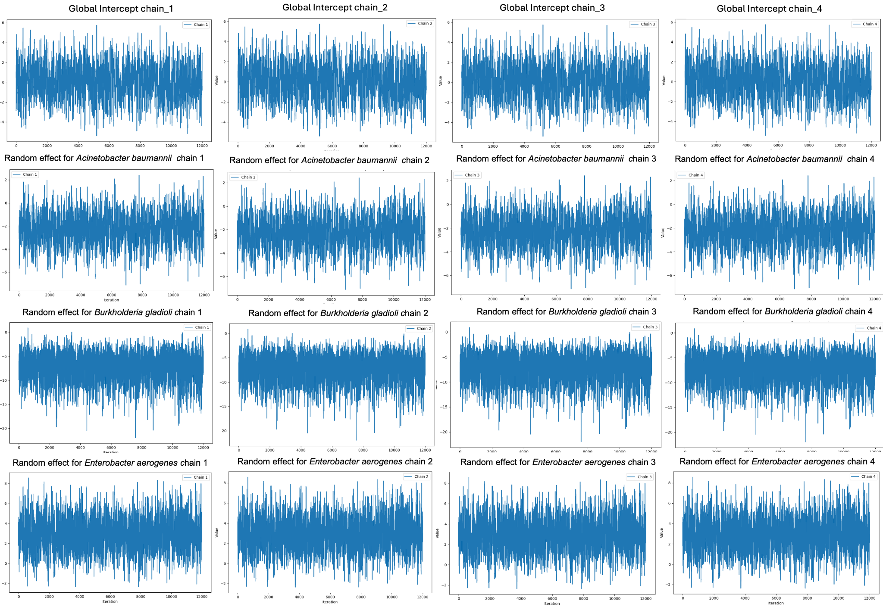
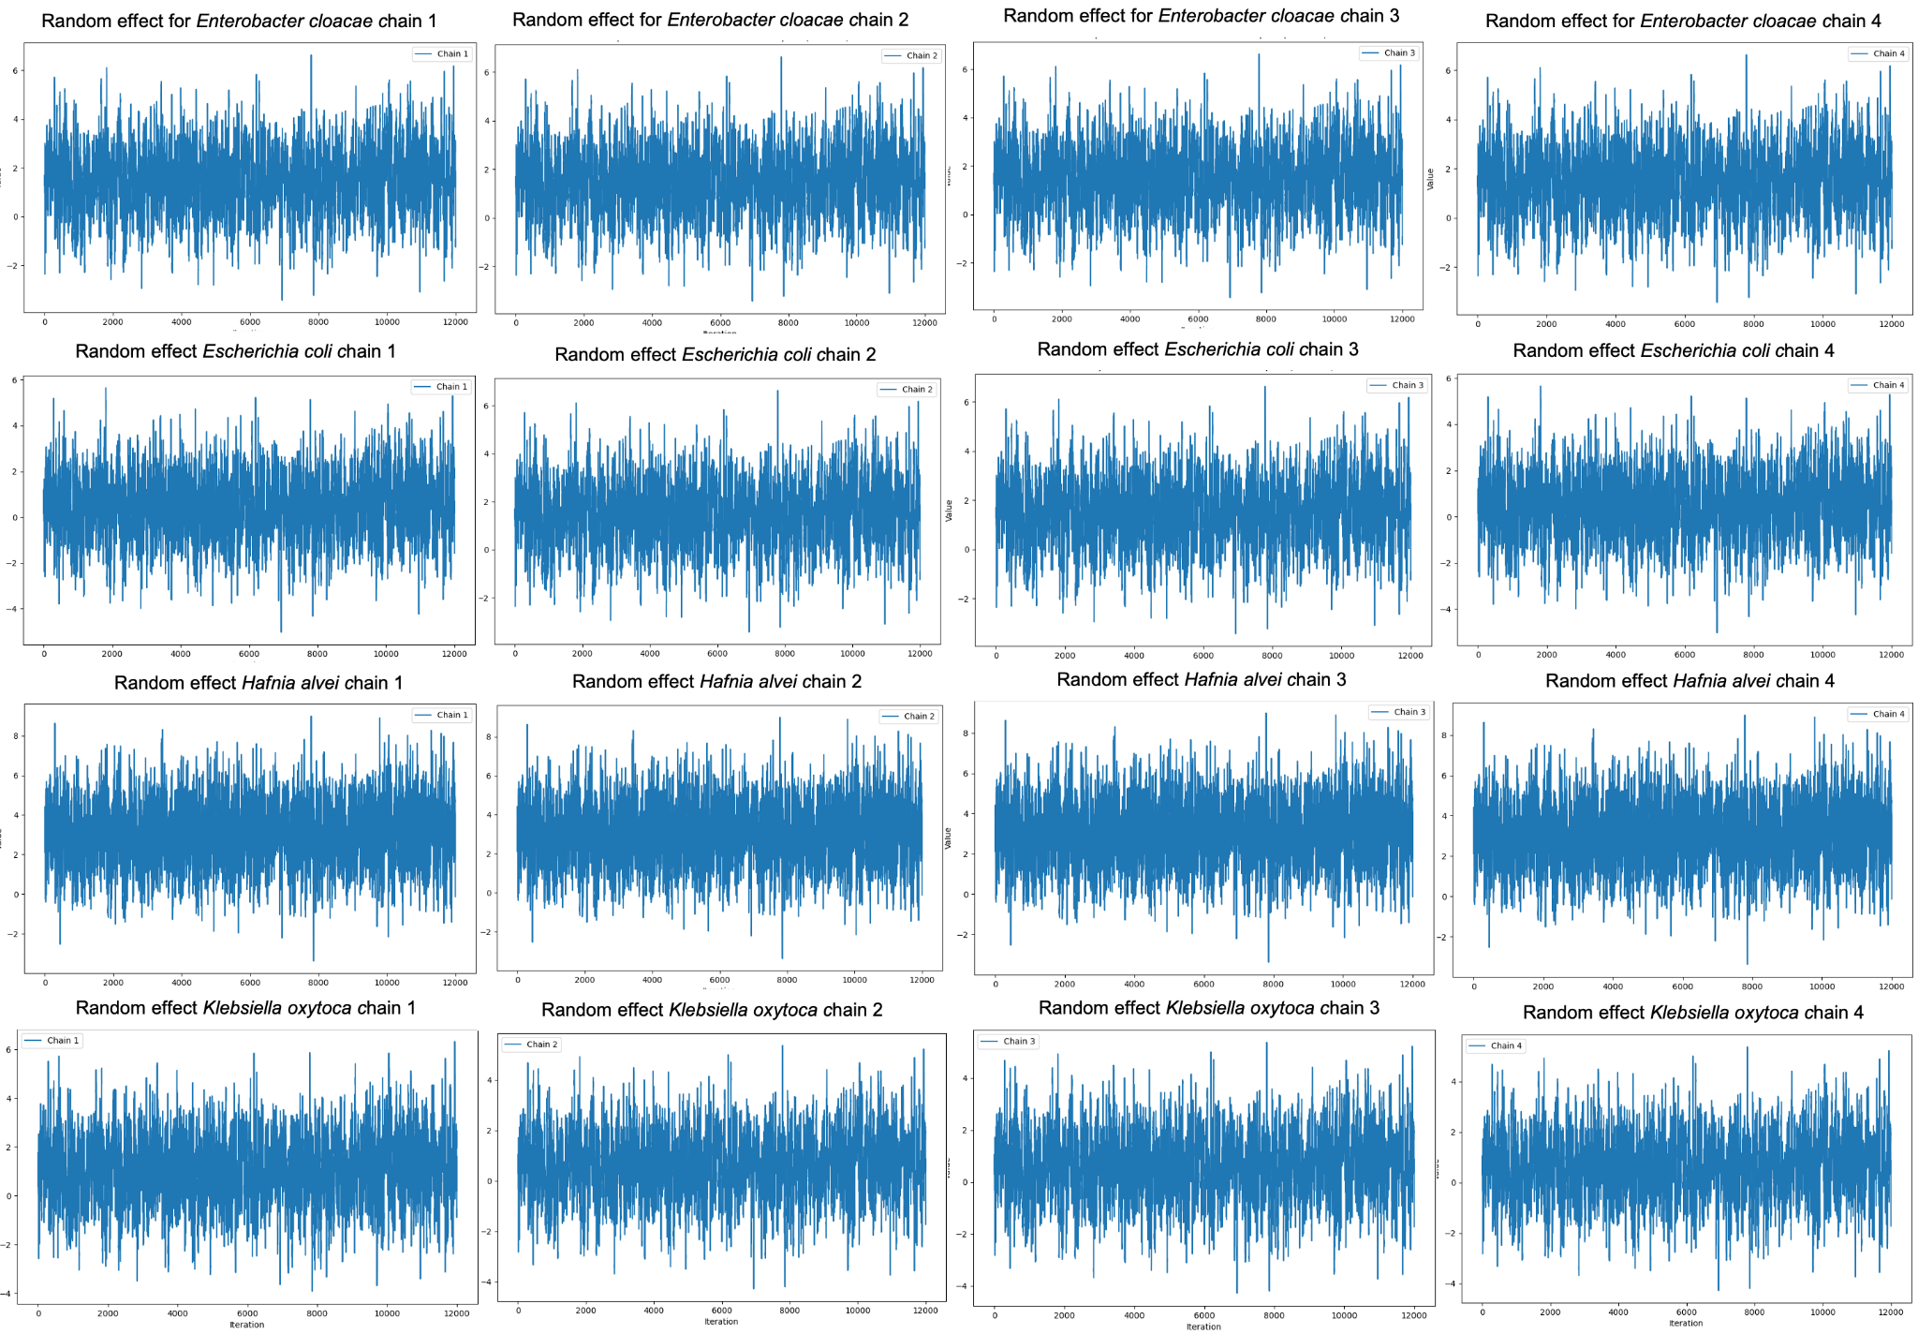
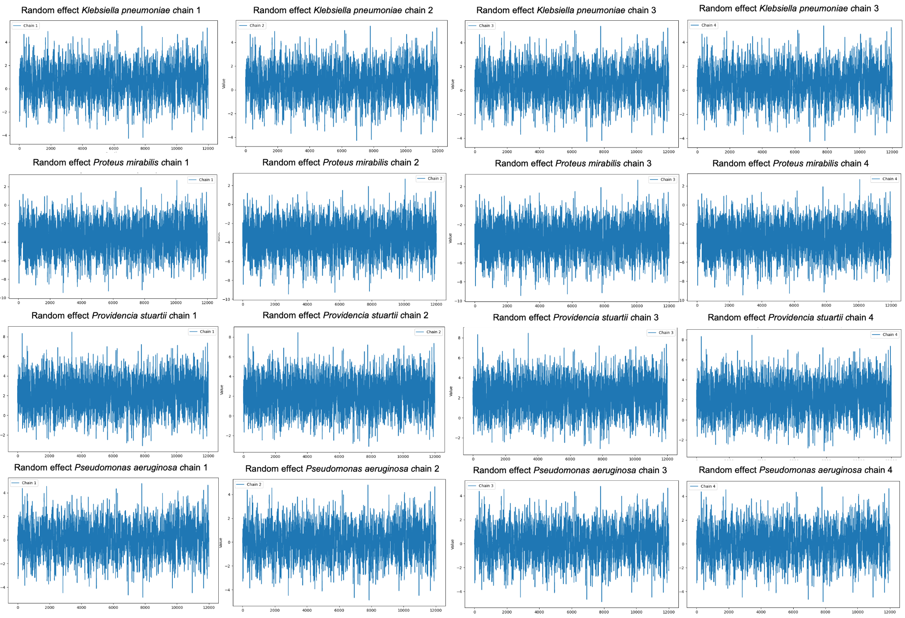
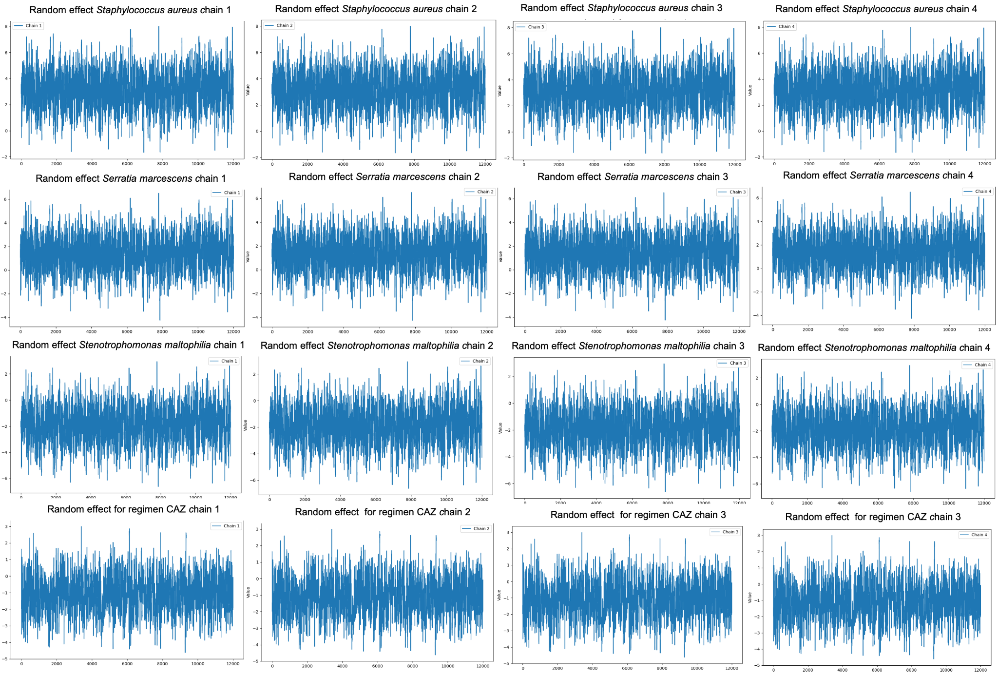
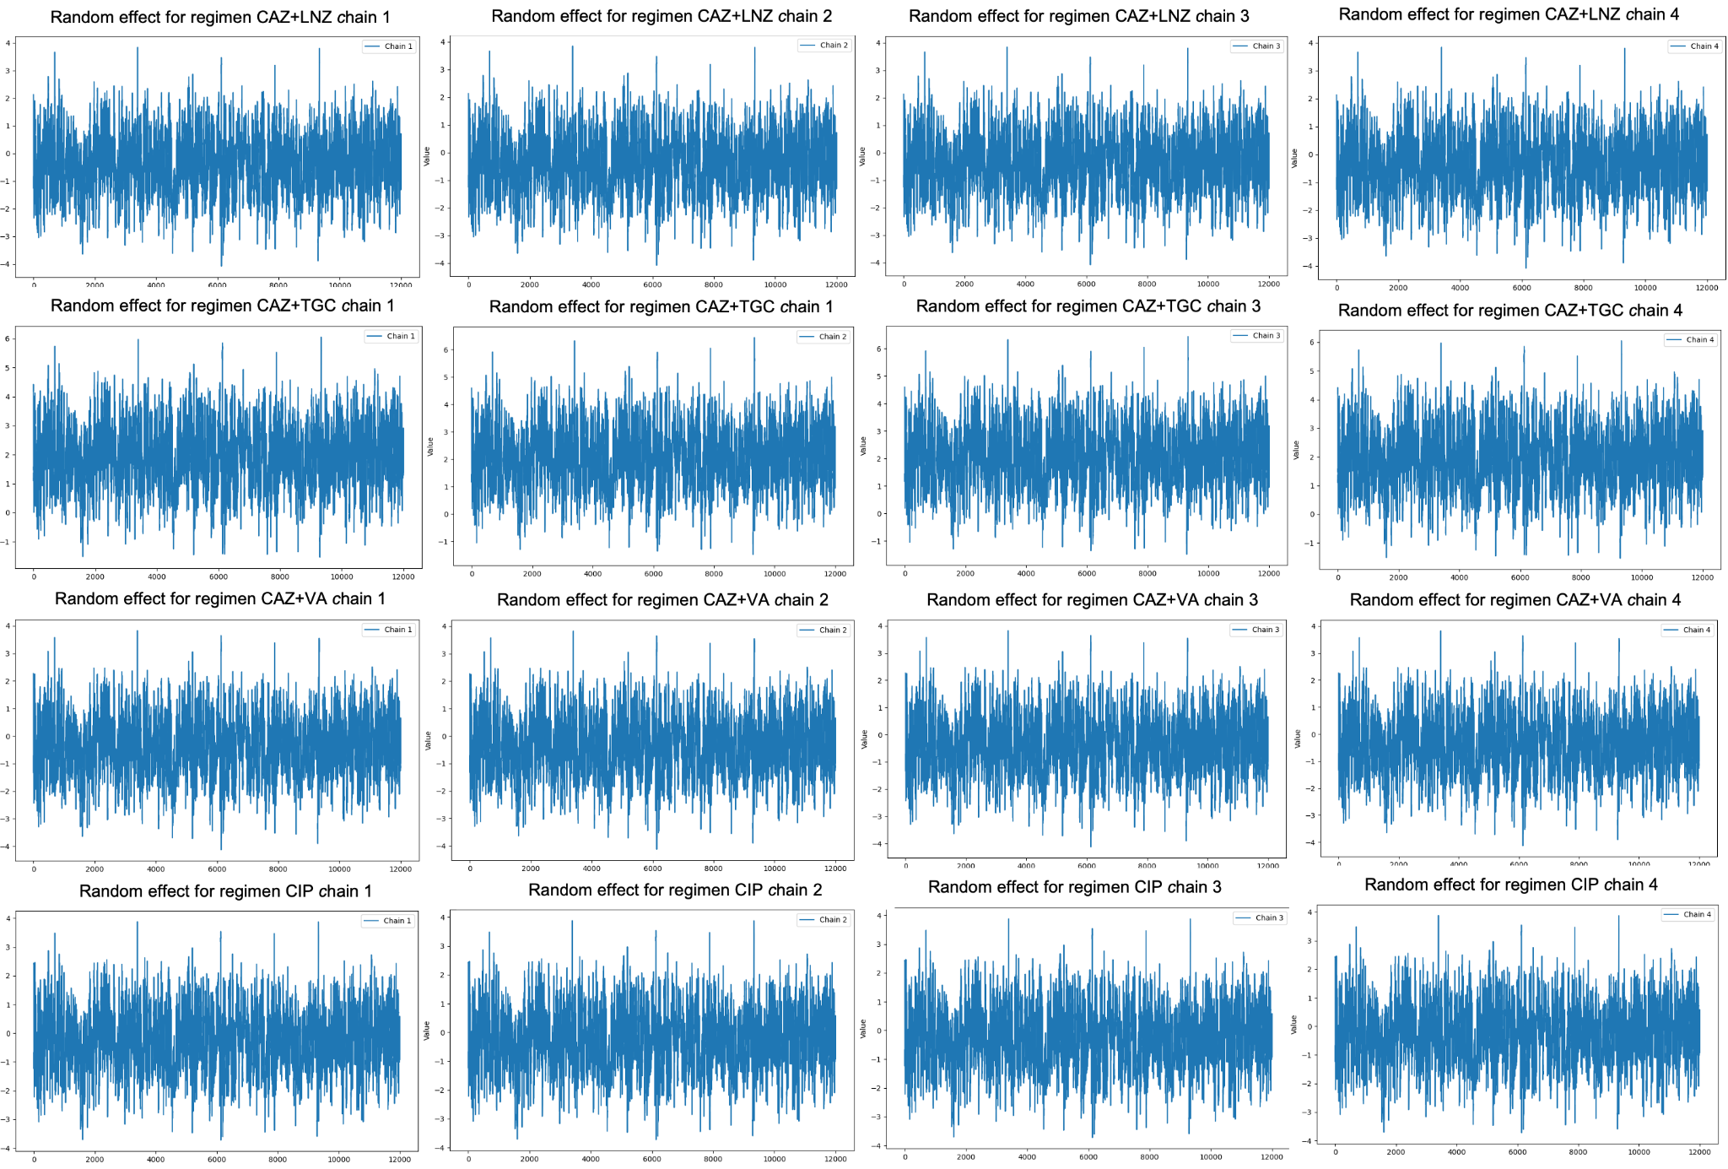
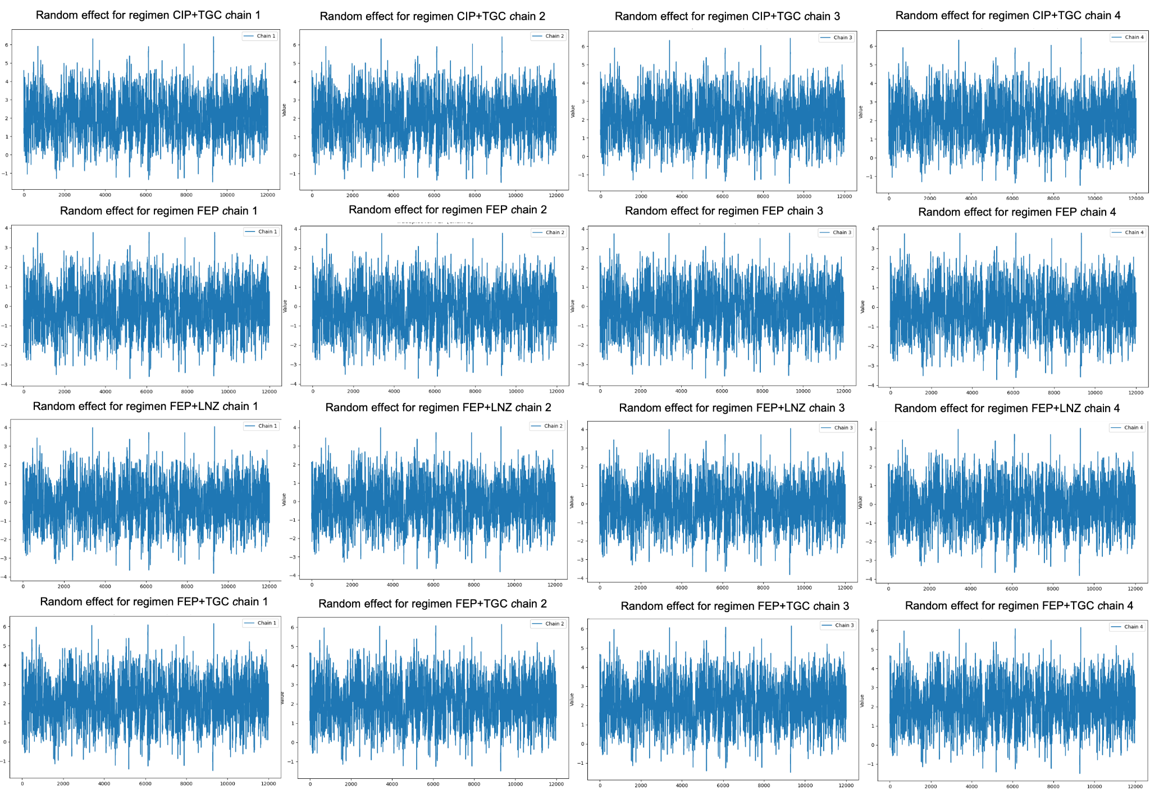
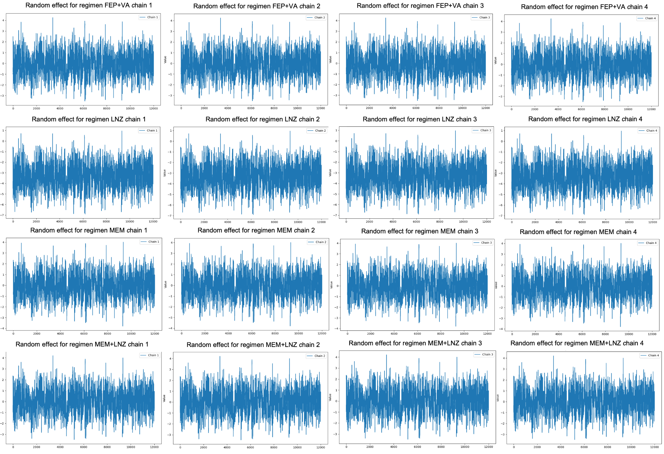
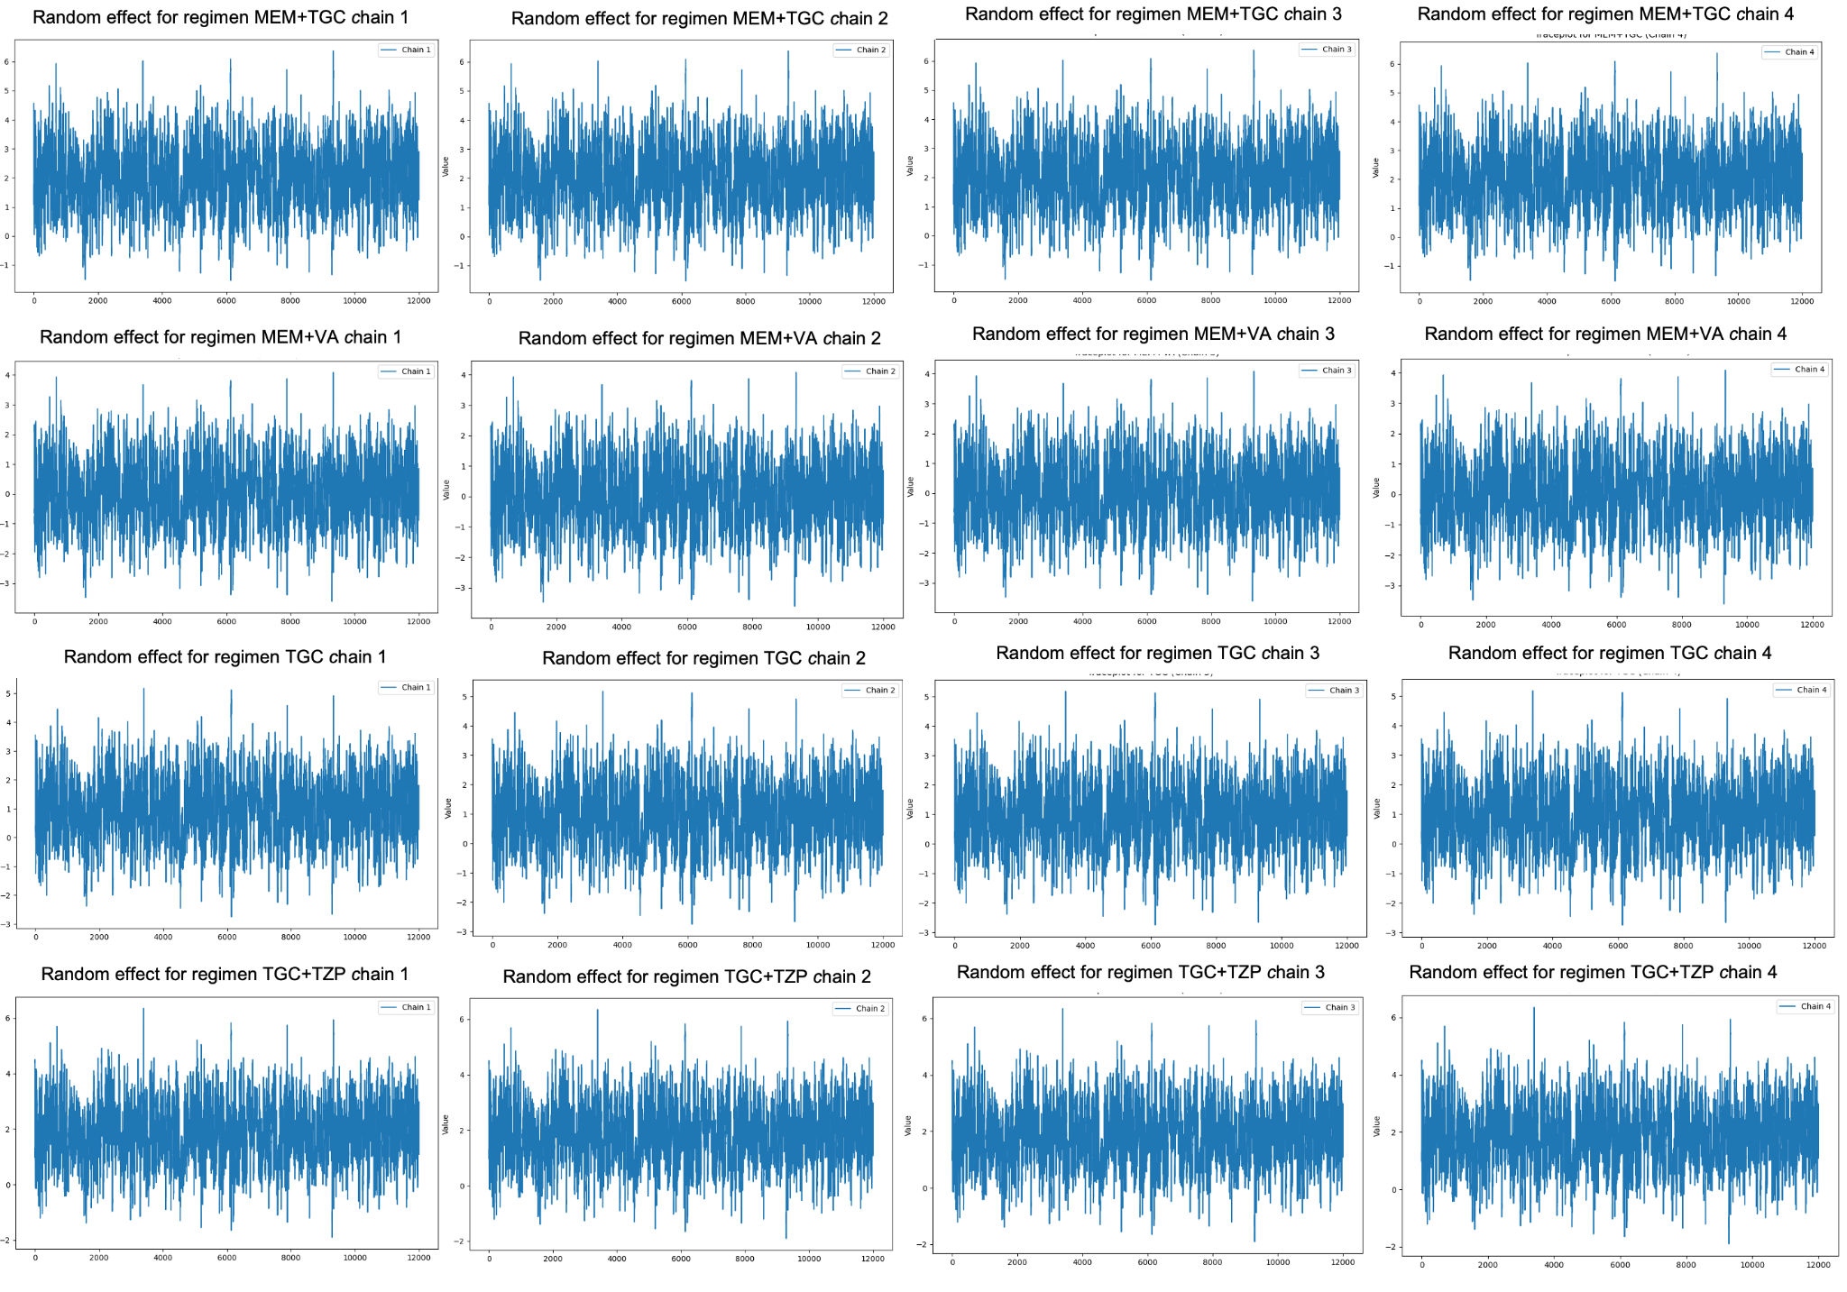
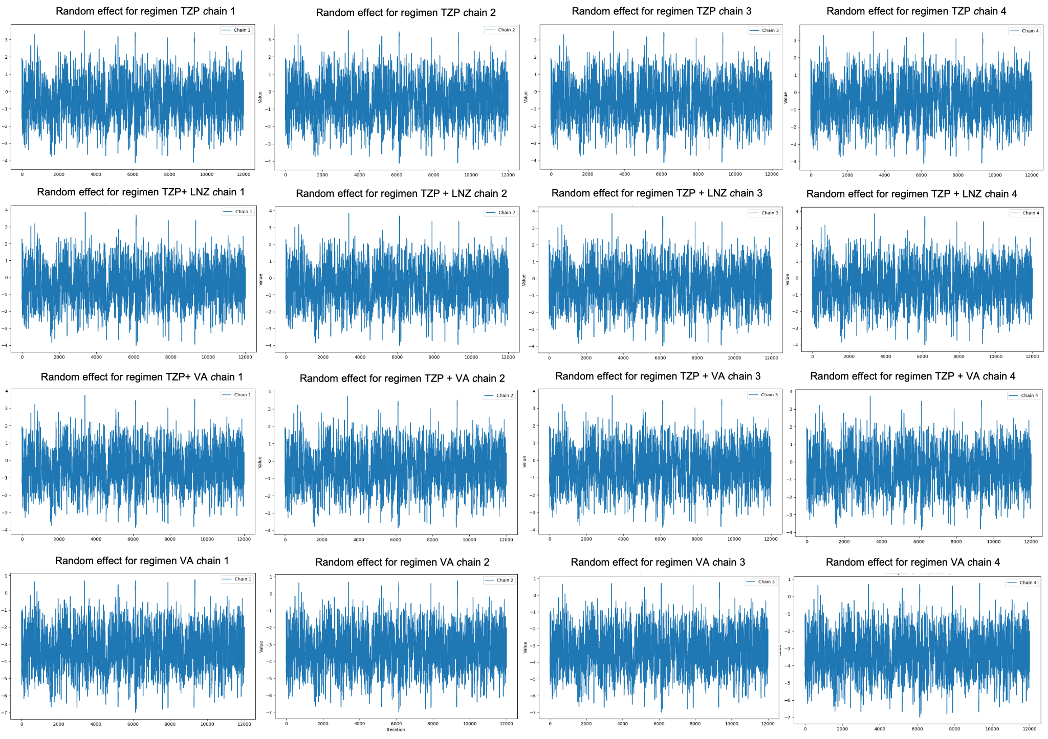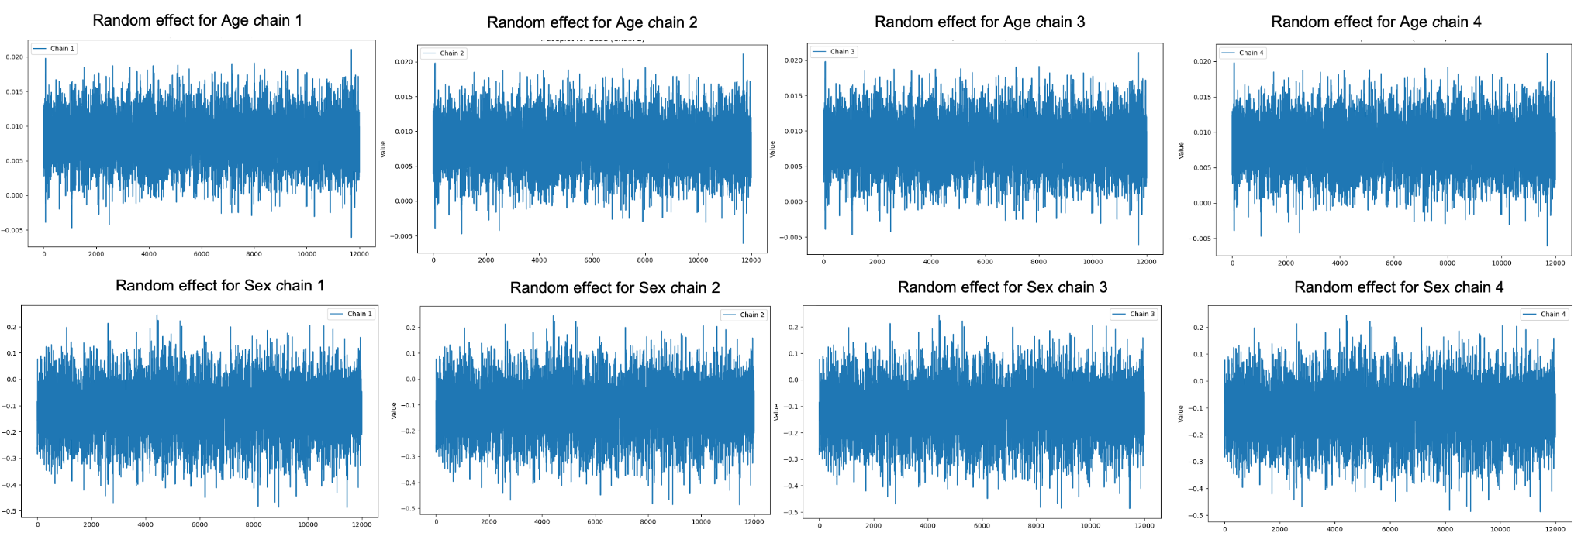

Figure S2. Density plots of the posterior distributions of the parameters of the model.
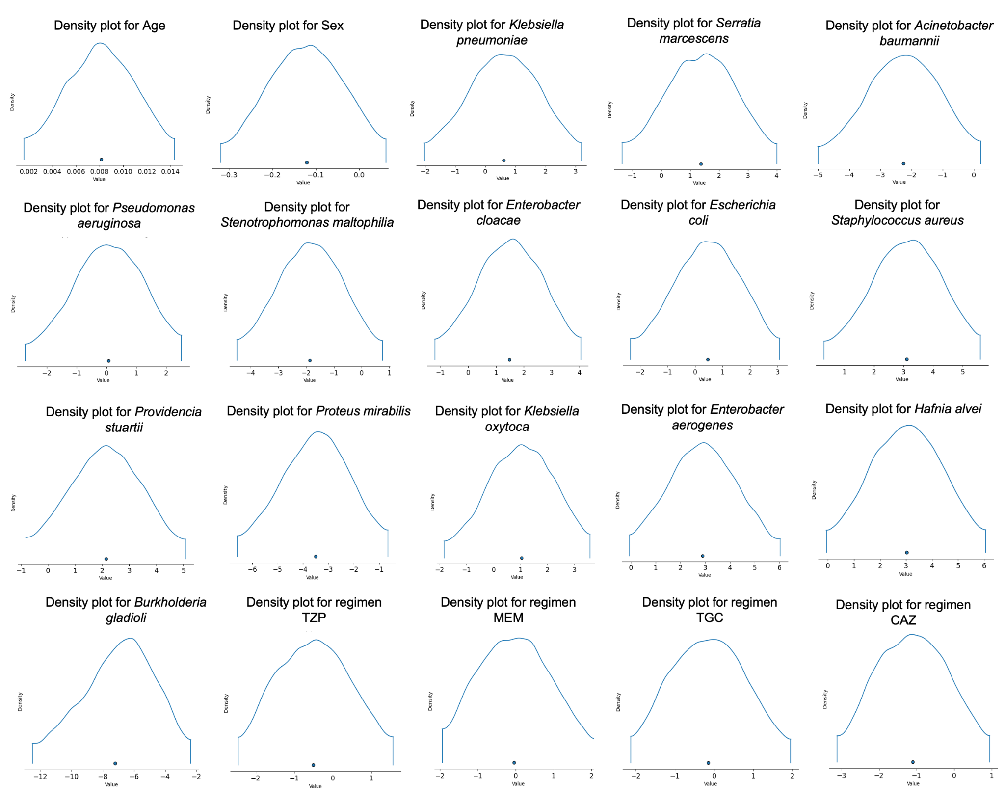
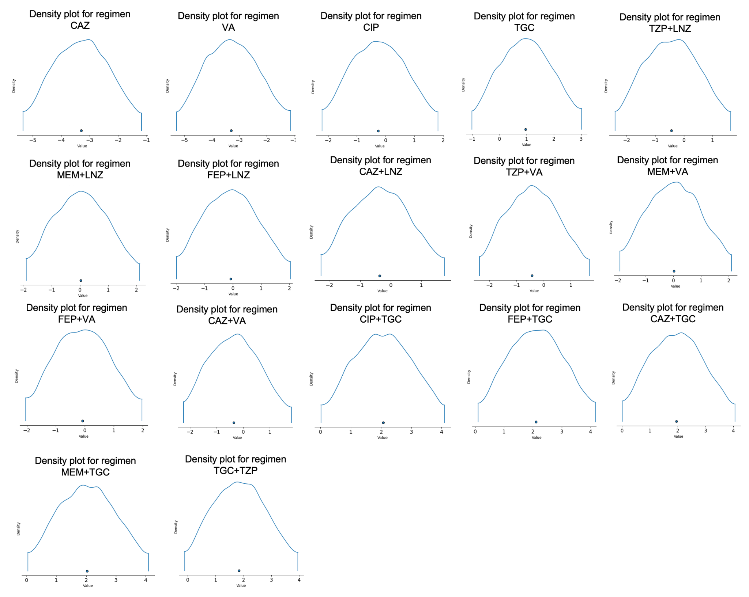
Figure S3. Distribution of Isolated Microorganisms Over Time of IMV from Patients Who Developed VAP.
