Supplementary Material

Molecular Insights into Genistein-NSAID Hybrids – Synthesis, Characterisation and DFT Study
Kacper Kossakowski¹, Justyna Żwawiak¹, Alina Cherniienko¹, Lucjusz Zaprutko¹ and Anna Pawełczyk*¹
¹Chair and Department of Organic Chemistry, Faculty of Pharmacy, Poznan University of Medical Sciences, Rokietnicka 3, 60-806 Poznań, Poland
*Corresponding Author: apaw@ump.edu.pl

S1. MS measurements
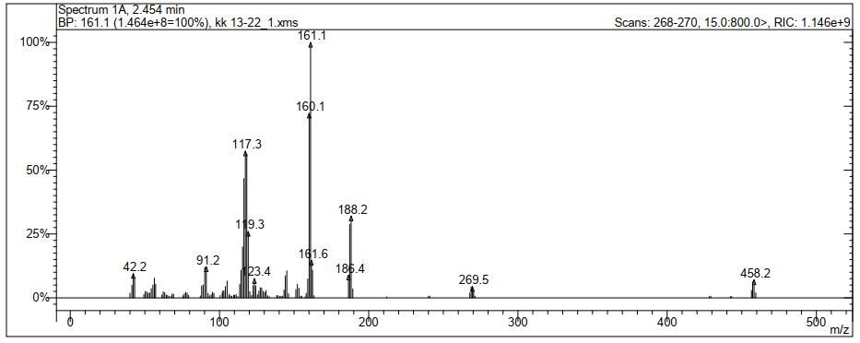
Figure S1. MS spectra of GEN-IBU (M: 458 g/mol).
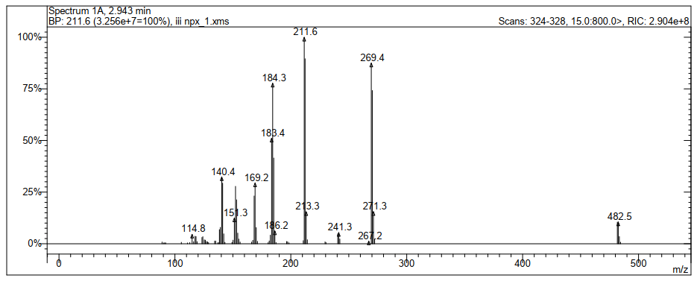
Figure S2. MS spectra of GEN-NPX (MW: 482 g/mol).

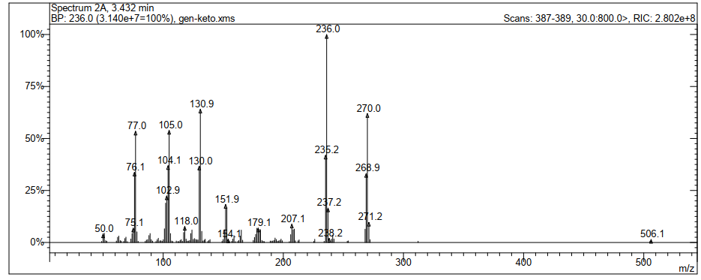
Figure S3. MS spectra of GEN-KETO (MW: 506 g/mol).

S2. IR measurements
Figure S4. IR spectra of GEN-IBU. Peaks: 1648.44 (C=O stretching in genistein); 1709.84 (COOH stretching in ibuprofen ); 1758.95 (COOR stretching in GEN-IBU); 1652.53 (C=O stretching in GEN-IBU).

Figure S5. IR spectra of GEN-NPX. Peaks: 1648.44 (C=O stretching in genistein); 1732.35 (COOH stretching in naproxen); 1724.16 (COOR stretching in GEN-NPX); 1646.39 (C=O stretching in GEN-NPX).

Figure S6. IR spectra of GEN-KETO. Peaks: 1648.44 (C=O stretching in genistein); 1696.74 (COOH stretching in ketoprofen); 1754.37 (COOR stretching in GEN-KETO); 1653.52 (C=O stretching in GEN-KETO).

S3. ¹H-NMR measurements
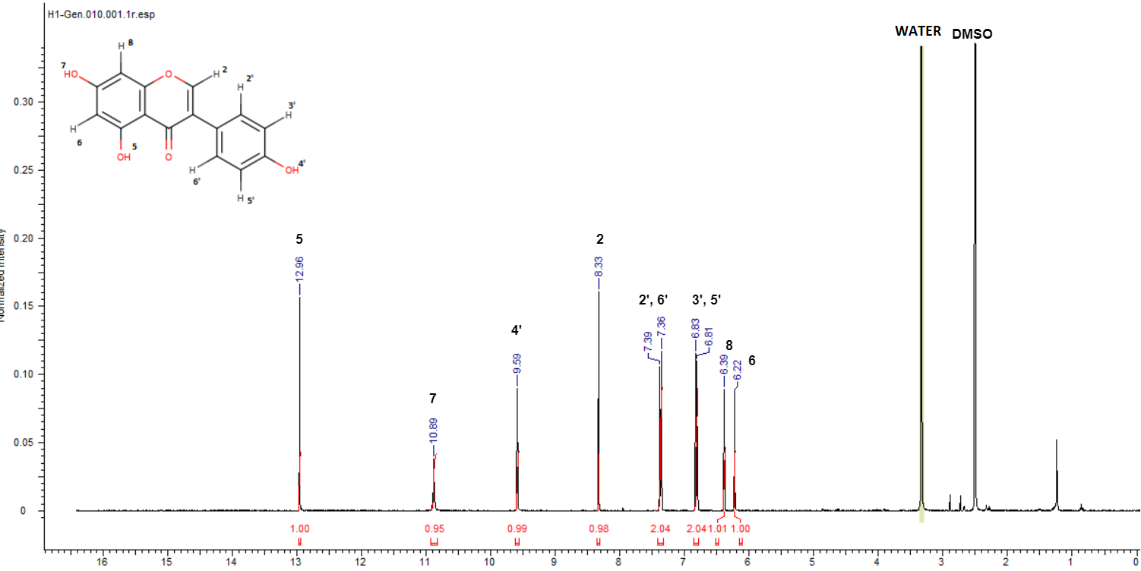
Figure S7. ¹H-NMR spectra of genistein. ¹H NMR (DMSO-d₆) (δ[ppm]): 12.96 (s, 1H), 10.89 (s, 1H), 9.59 (s, 1H), 8.33 (s, 1H), 7.39-7.36 (d, 2H), 6.83-6.81 (d, 2H), 6.40-6.39 (d, 1H), 6.22-6.21 (d, 1H).
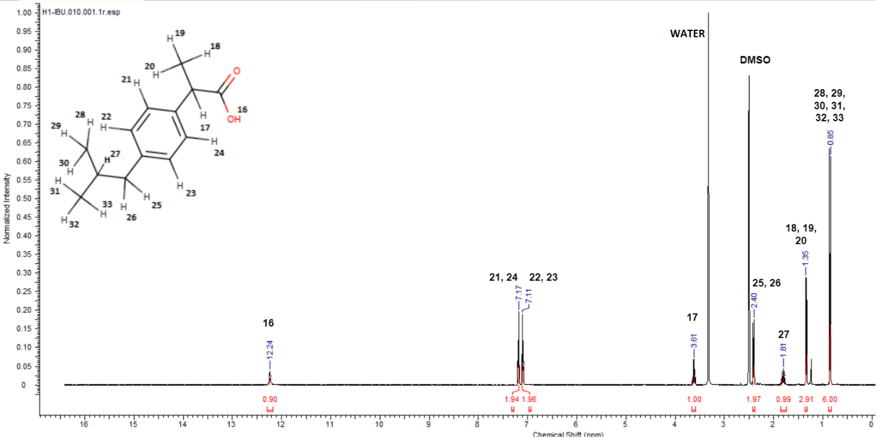
Figure S8. ¹H-NMR spectra of ibuprofen. ¹H NMR (DMSO-d₆) (δ[ppm]): 12.24 (s, 1H), 7.19-7.18 (d, 2H), 7.11-7.10 (d, 2H), 3.64-3.60 (q, 1H), 2.41-2.40 (d, 2H), 1.83-1.79 (m, 1H), 1.35-1.34 (d, 3H), 0.86-0.85 (d, 6H).
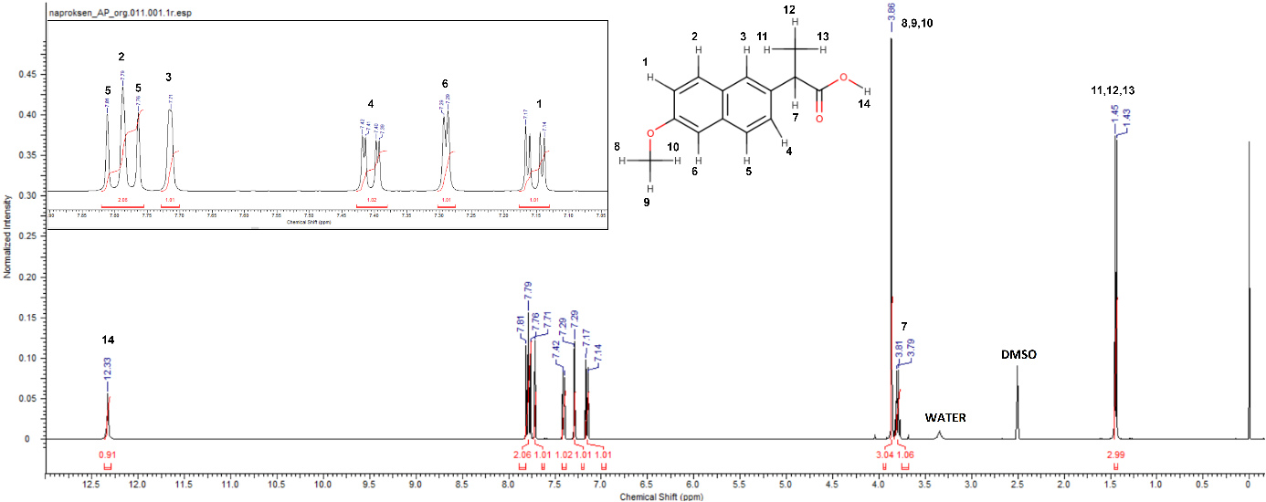
Figure S9. ¹H-NMR spectra of naproxen. ¹H NMR (DMSO-d₆) (δ[ppm]): 12.33 (s, 1H), 7.81-7.79 (d, 1H), 7.79-7.76 (d, 1H), 7.71 (s, 1H), 7.42-7.39 (dd, 1H), 7.29 (d, 1H), 7.17-7.14 (dd, 1H), 3.86 (s, 3H), 3.82-3.78 (q, 1H), 1.45-1.43 (d, 3H).
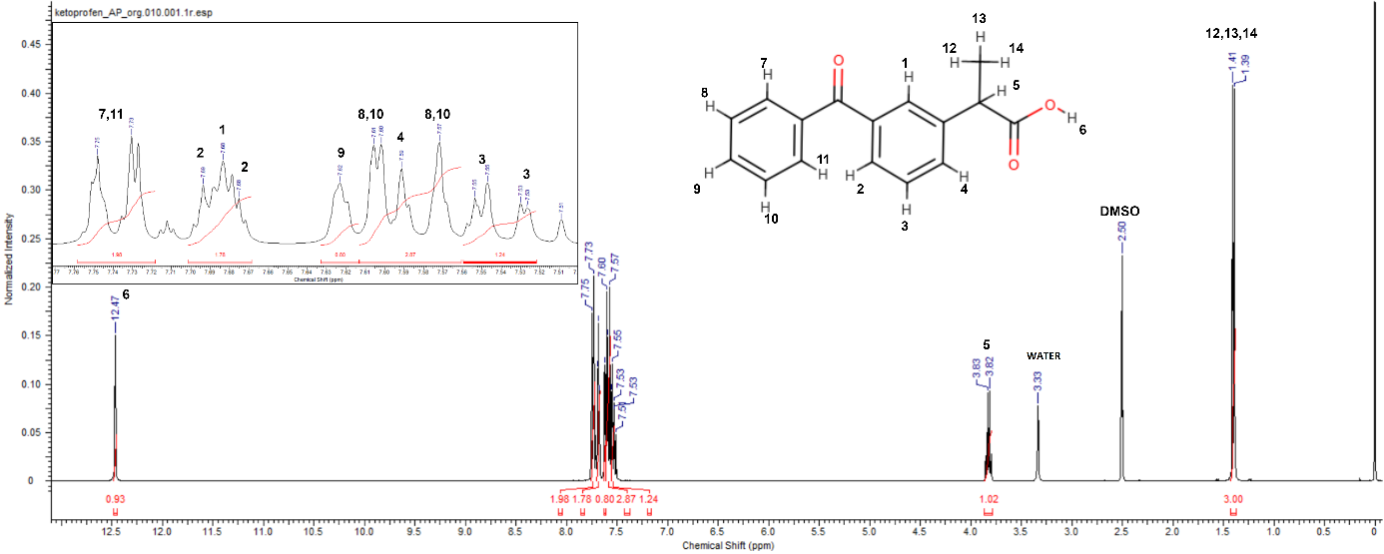
Figure S10. ¹H-NMR spectra of ketoprofen. ¹H NMR (DMSO-d₆) (δ[ppm]): 12.47 (s, 1H), 7.75-7.72 (dd, 2H), 7.69-7.68 (d, 1H), 7.68 (s, 1H), 7.62 (d, 1H), 7.61-7.57 (dd, 2H), 7.59 (d, 1H), 7.55-7.53 (dd, 1H), 3.84-3.81 (q, 1H), 1.41-1.39 (d, 3H).

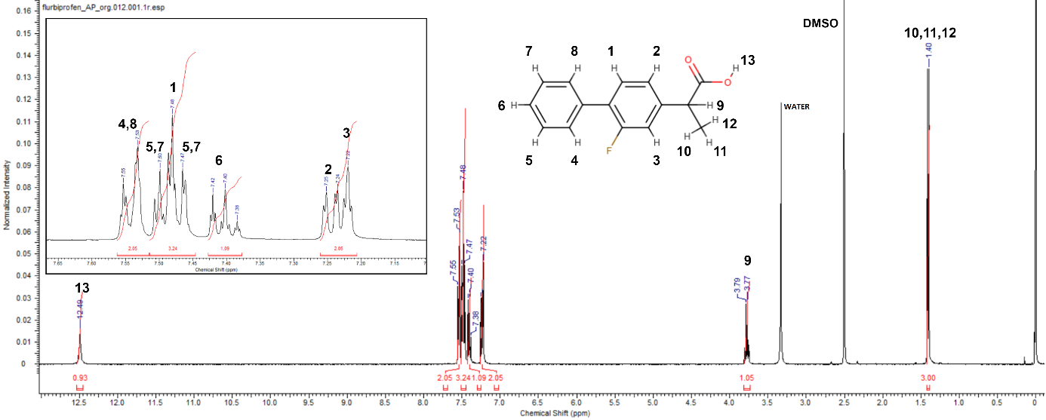
Figure S11. ¹H-NMR spectra of flurbiprofen. ¹H NMR (DMSO-d₆) (δ[ppm]): 12.49 (s, 1H), 7.55-7.53 (dd, 2H), 7.51-7.46 (dd, 2H), 7.49-7.48 (d, 1H), 7.42-7.40 (dt, 1H), 7.26-7.24 (dd, 1H), 7.22 (s, 1H), 3.80-3.76 (q, 1H), 1.41-1.40 (d, 3H).

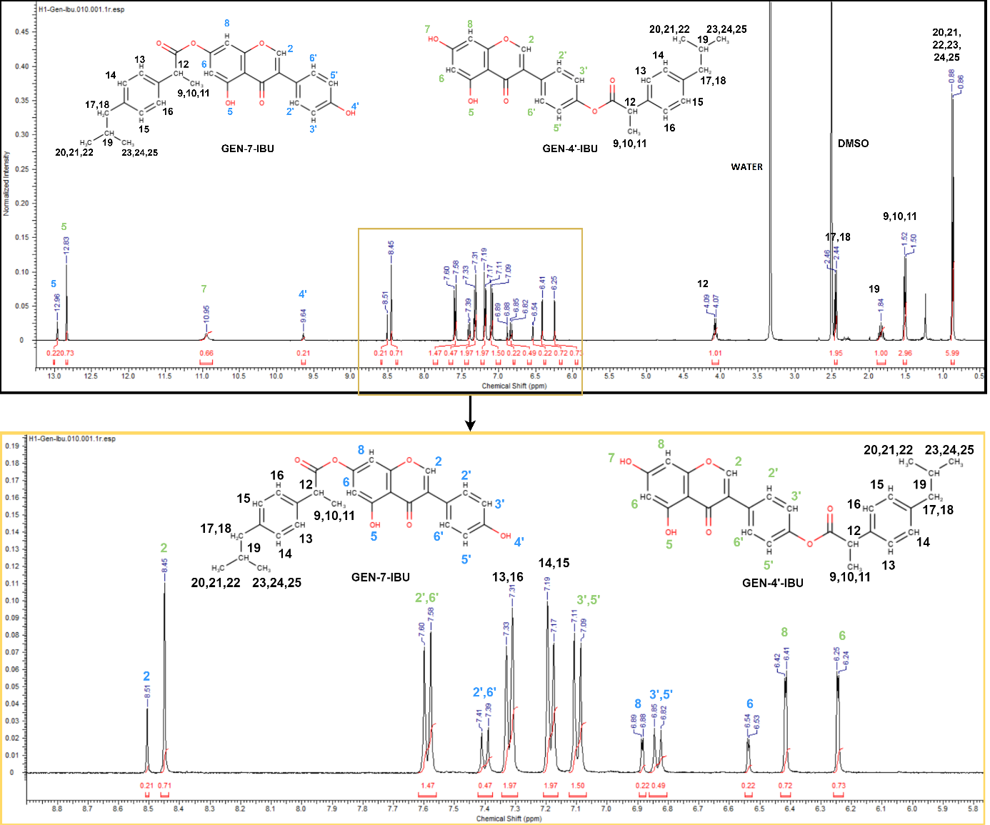
Figure S12. ¹H-NMR spectra of GEN-IBU. ¹H NMR (DMSO-d₆) for GEN-4’-IBU (δ[ppm]): 12.83 (s, 1H), 10.95 (s, 1H), 8.45 (s, 1H), 7.60-7.58 (d, 2H), 7.33-7.31 (d, 2H), 7.19-7.17 (d, 2H), 7.11-7.09 (d, 2H), 6.42 (s, 1H), 6.25 (s, 1H), 4.09-4.07 (q, 1H), 2.46-2.44 (t, 2H), 1.84 (m, 1H), 1.52-1.50 (d, 3H), 0.88-0.86 (d, 6H); ¹H NMR (DMSO-d₆) for GEN-7-IBU (δ[ppm]): 12.96 (s, 1H), 9.64 (s,1H), 7.41-7.39 (d, 2H), 7.33-7.31 (d, 2H), 7.19-7.17 (d, 2H), 6.89 (s, 1H), 6.85-6.82 (d, 2H), 6.54 (s, 1H), 4.09-4.07 (q, 1H), 2.46-2.44 (t, 2H), 1.84 (m, 1H), 1.52-1.50 (d, 3H), 0.88-0.86 (d, 6H).

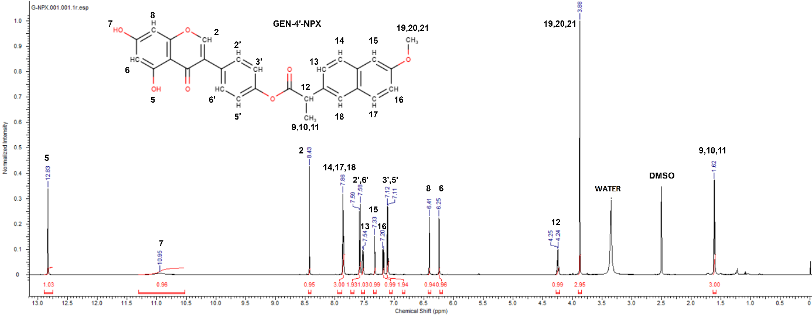
Figure S13. ¹H-NMR spectra of GEN-NPX. ¹H NMR (DMSO-d₆) for GEN-4’-NPX (δ[ppm]): 12.83 (s, 1H), 10.95 (s, 1H), 8.43 (s, 1H), 7.87-7.85 (t, 3H), 7.59-7.58 (d, 2H), 7.54-7.52 (dd, 1H), 7.33 (s, 1H), 7.20-7.18 (dd, 1H), 7.12-7.11 (d, 2H), 6.42-6.41 (d, 1H), 6.25-6.24 (d, 1H), 4.27-4.23 (q, 1H), 3.88 (s, 3H), 1.62-1.61 (d, 3H).

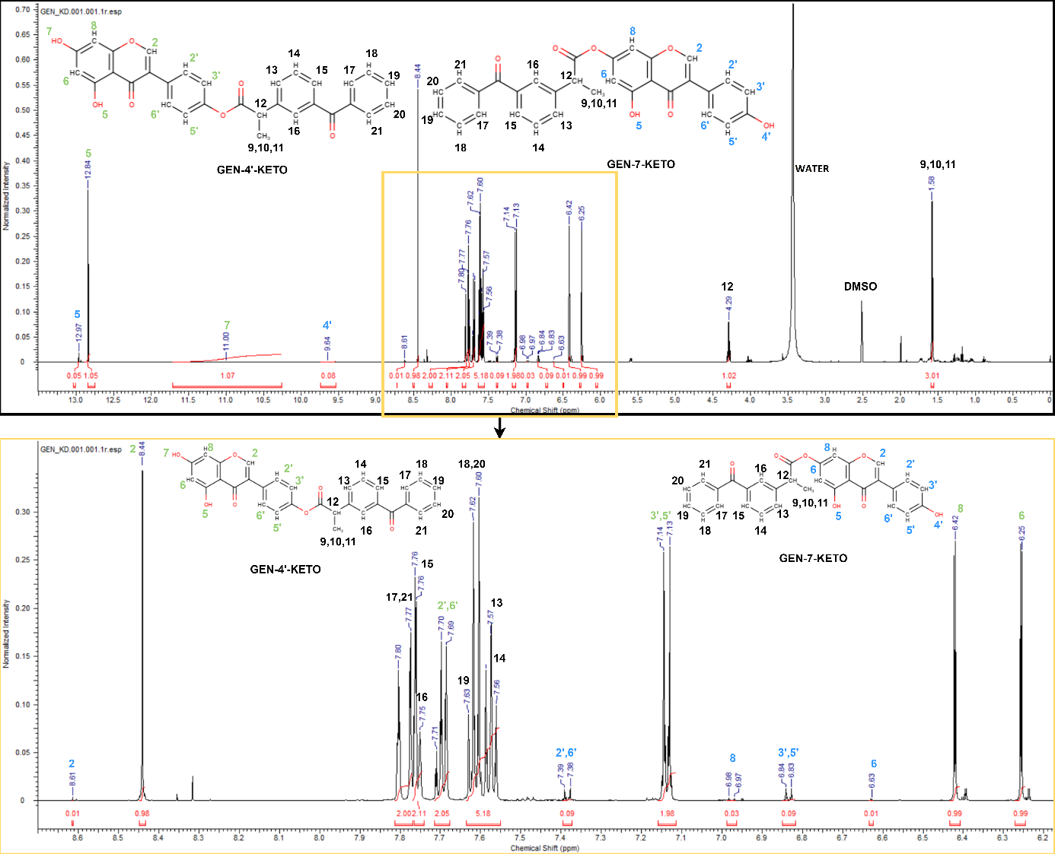
Figure S14. ¹H-NMR spectra of GEN-KETO. ¹H NMR (DMSO-d₆) for GEN-4’-KETO (δ[ppm]): 12.84 (s, 1H), 11.00 (s, 1H), 8.44 (s, 1H), 7.80-7.77 (d, 2H), 7.76-7.75 (d, 1H), 7.75 (s, 1H), 7.70-7.69 (d, 2H), 7.63-7.60 (t, 3H), 7.58-7.57 (d, 1H), 7.58-7.56 (t, 1H), 7.14-7.13 (d, 2H), 6.43-6.42 (d, 1H), 6.25-6.24 (d, 1H), 4.30-4.27 (q, 1H), 1.58-1.57 (d, 3H); ¹H NMR (DMSO-d₆) for GEN-7-KETO (δ[ppm]): 12.97 (s, 1H), 9.64 (s, 1H), 8.61 (s, 1H), 7.80-7.77 (d, 2H), 7.76-7.75 (d, 1H), 7.75 (s, 1H), 7.63-7.60 (t, 3H), 7.58-7.57 (d, 1H), 7.58-7.56 (t, 1H), 7.39-7.38 (d, 2H), 6.98-6.97 (d, 1H), 6.84-6.83 (d, 2H), 6.64-6.63 (d, 1H), 4.30-4.27 (q, 1H), 1.58-1.57 (d, 3H).

S4. ¹³C-NMR measurements
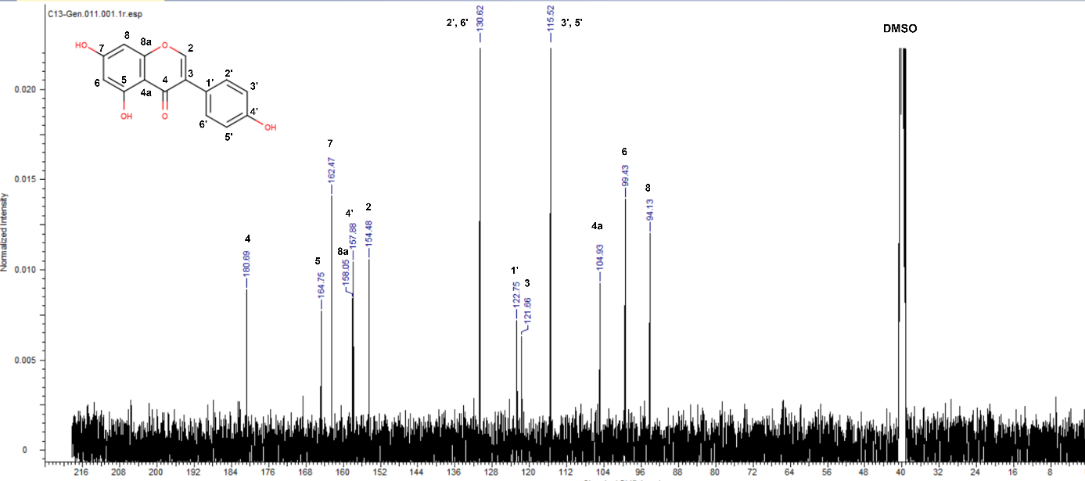
Figure S15. ¹³C-NMR spectra of genistein. ¹³C-NMR (DMSO-d₆) (δ[ppm]): 180.69 (s, 1C), 164.75 (s, 1C), 162.47 (s, 1C), 158.05 (s, 1C), 157.88 (s, 1C), 154.48 (s, 1C), 130.62 (s, 2C), 122.75 (s, 1C), 121.66 (s, 1C), 115.52 (s, 2C), 104.93 (s, 1C), 99.43 (s, 1C), 94.13 (s, 1C).
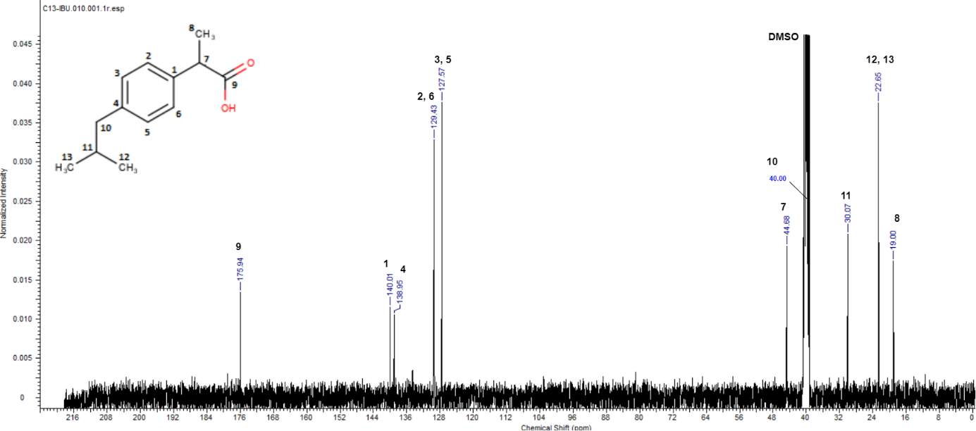
Figure S16. ¹³C-NMR spectra of ibuprofen. ¹³C-NMR (DMSO-d₆) (δ[ppm]): 175.94 (s, 1C), 140.01 (s, 1C), 138.95 (s, 1C), 129.43 (s, 2C), 127.57 (s, 2C), 44.68 (s, 1C), 40.00* (s, 1C), 30.07 (s, 1C), 22.65 (s, 2C), 19.00 (s, 1C).
*approximate value due to overlapping signal from DMSO solvent.
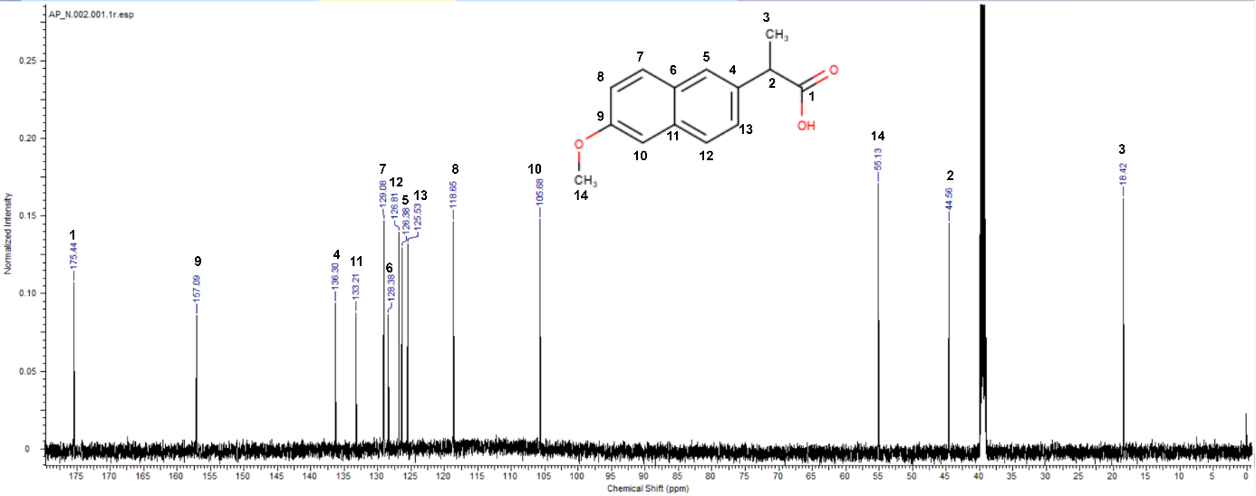
Figure S17. ¹³C-NMR spectra of naproxen. ¹³C-NMR (DMSO-d₆) (δ[ppm]): 175.44 (s, 1C), 157.09 (s, 1C), 136.30 (s, 1C), 133.21 (s, 1C), 129.08 (s, 1C), 128.38 (s, 1C), 126.81 (s, 1C), 126.38 (s, 1C), 125.53 (s, 1C), 118.65 (s, 1C), 105.68 (s, 1C), 55.13 (s, 1C), 44.56 (s, 1C), 18.42 (s, 1C).
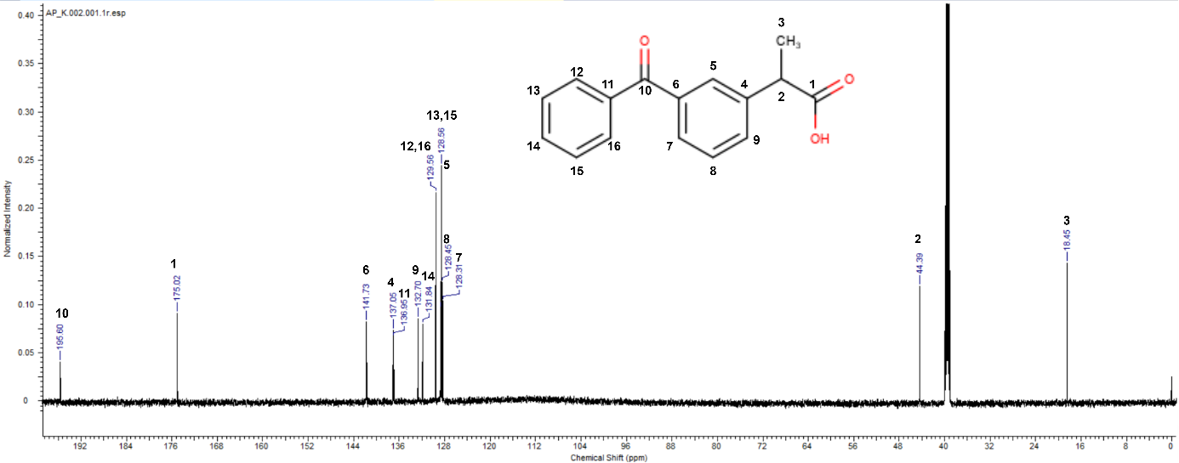
Figure S18. ¹³C-NMR spectra of ketoprofen. ¹³C-NMR (DMSO-d₆) (δ[ppm]): 195.60 (s, 1C), 175.02 (s, 1C), 141.73 (s, 1C), 137.05 (s, 1C), 136.95 (s, 1C), 132.70 (s, 1C), 131.84 (s, 1C), 129.56 (s ,2C), 128.56 (s, 2C), 128.45 (s, 1C), 128.31 (s, 1C), 44.39 (s, 1C), 18.45 (s, 1C).

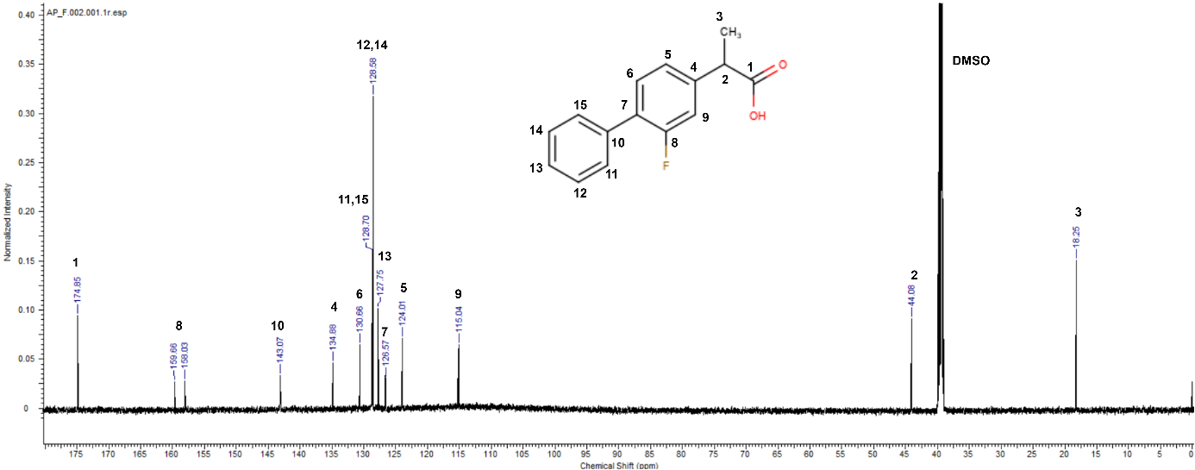
Figure S19. ¹³C-NMR spectra of flurbiprofen. ¹³C-NMR (DMSO-d₆) (δ[ppm]): 174.85 (s, 1C), 159.66-158.03* (d, 1C), 143.07 (s, 1C), 134.88 (s, 1C), 130.66 (s, 1C), 128.70 (s, 2C), 128.58 (s, 2C), 127.75 (s, 1C), 126.57 (s, 1C), 124.01 (s, 1C), 115.04 (s, 1C), 44.08 (s, 1C), 18.25 (s, 1C).
*13C-19F coupling results in a doublet on the spectrum
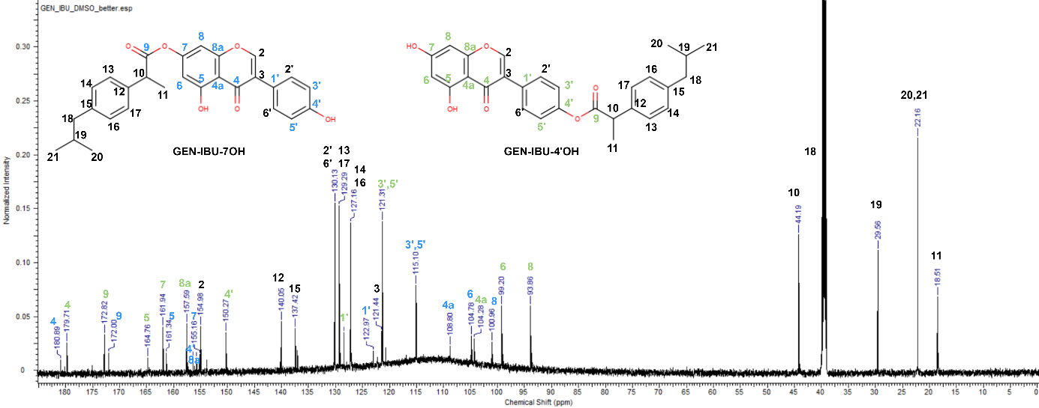
Figure S20. ¹³C-NMR spectra of GEN-IBU. ¹³C-NMR (DMSO-d₆) for GEN-4’-IBU (δ[ppm]): 179.71 (s, 1C), 172.82 (s, 1C), 164.76 (s, 1C) 161.94 (s, 1C), 157.59 (s, 1C), 154.98 (s, 1C), 150.27 (s, 1C), 140.05 (s, 1C), 137.42 (s, 1C), 130.13 (s, 2C), 129.29 (s, 2C), 128.46 (s, 1C), 127.16 (s, 1C), 121.44 (s, 1C), 121.31 (s, 2C), 104.28 (s, 1C), 99.20 (s, 1C), 93.86 (s, 1C), 44.19 (s, 1C), 40.00* (s, 1C), 29.56 (s, 1C), 22.16 (s, 2C), 18.51 (s, 1C); ¹³C-NMR (DMSO-d₆) for GEN-7-IBU (δ[ppm]): 180.89 (s, 1C), 172.00 (s, 1C), 161.34 (s, 1C) 156.42 (s, 1C), 155.74 (s, 1C), 155.16 (s, 1C), 154.98 (s, 1C), 140.05 (s, 1C), 137.42 (s, 1C), 130.13 (s, 2C), 129.29 (s, 2C), 127.16 (s, 2C), 122.97 (s, 1C), 121.44 (s, 1C), 115.10 (s, 2C), 108.80 (s, 1C), 104.78 (s, 1C), 100.96 (s, 1C), 44.19 (s, 1C), 40.00* (s, 1C), 29.56 (s, 1C), 22.16 (s, 2C), 18.51 (s, 1C).
*approximate value due to overlapping signal from DMSO solvent.
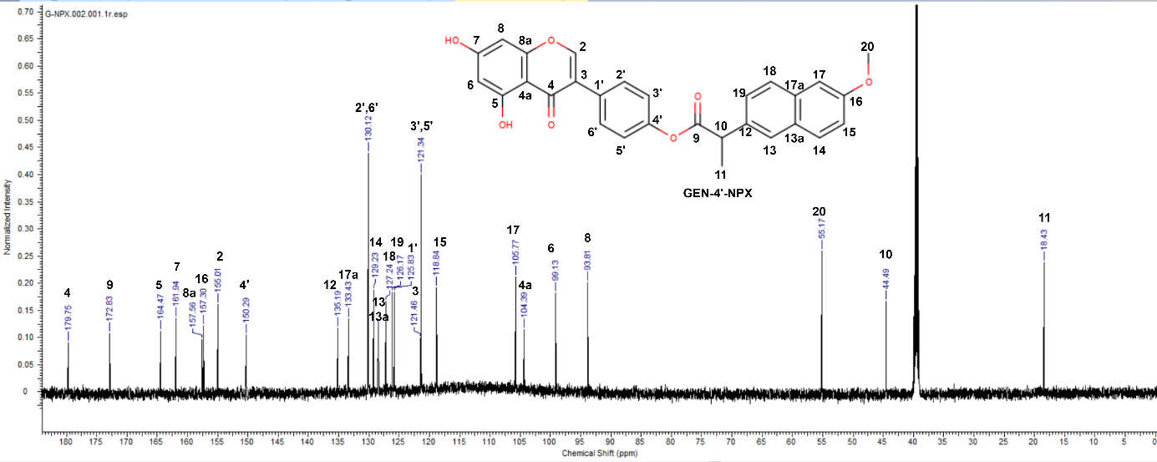
Figure S21. ¹³C-NMR spectra of GEN-NPX. ¹³C NMR (DMSO-d₆) for GEN-4’-NPX (δ[ppm]): 179.75 (s, 1C), 172.83 (s, 1C), 164.47 (s, 1C), 161.94 (s, 1C), 157.56 (s, 1C), 157.3 (s, 1C), 155.01 (s, 1C), 150.29 (s, 1C), 135.19 (s, 1C), 133.43 (s, 1C), 130.12 (s, 2C), 129.23 (s, 1C), 128.48 (s, 1C), 128.45 (s, 1C), 127.24 (s, 1C), 126.17 (s, 1C), 125.83 (s, 1C), 121.46 (s, 1C), 121.34 (s, 2C), 118.84 (s, 1C), 105.77 (s, 1C), 104.39 (s, 1C), 99.13 (s, 1C), 93.81 (s, 1C), 55.17 (s, 1C), 44.49 (s, 1C), 18.43 (s, 1C).

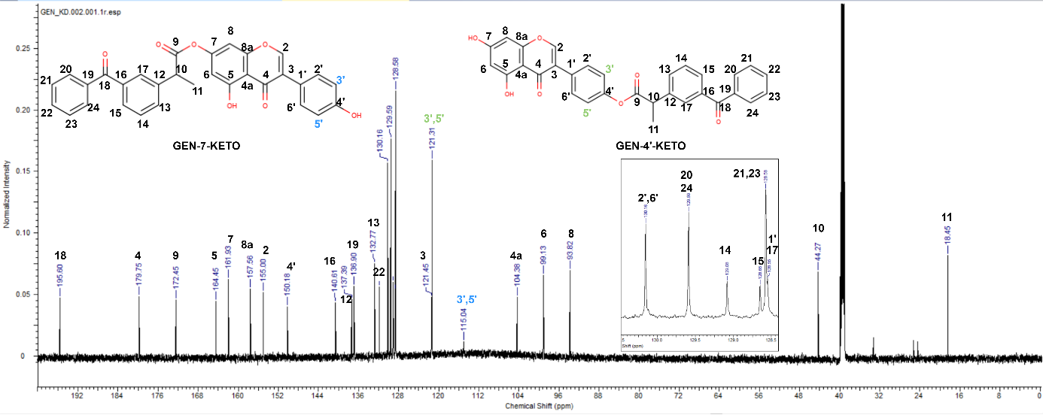
Figure S22. ¹³C-NMR spectra of GEN-KETO. ¹³C-NMR (DMSO-d₆) for GEN-4’-KETO (δ[ppm]): 195.60 (s, 1C), 179.75 (s, 1C), 172.45 (s, 1C), 164.45 (s, 1C), 161.93 (s, 1C), 157.56 (s, 1C), 155.00 (s, 1C), 150.18 (s, 1C), 140.61 (s, 1C), 137.39 (s, 1C), 136.90 (s, 1C), 132.77 (s, 1C), 131.85 (s, 1C), 130.16 (s, 2C), 129.59 (s, 2C), 129.08 (s, 1C), 128.65 (s, 1C), 128.58 (s, 2C), 128.55 (s, 2C), 121.45 (s, 1C), 121.31 (s, 2C), 104.38 (s, 1C), 99.13 (s, 1C), 93.82 (s, 1C), 44.27 (s, 1C), 18.45 (s, 1C); ¹³C-NMR (DMSO- d₆) for GEN-7-KETO (δ[ppm]): 195.60 (s, 1C), 179.75 (s, 1C), 172.45 (s, 1C), 164.45 (s, 1C), 161.93 (s, 1C), 157.56 (s, 1C), 155.00 (s, 1C), 150.18 (s, 1C), 140.61 (s, 1C), 137.39 (s, 1C), 136.90 (s, 1C), 132.77 (s, 1C), 131.85 (s, 1C), 130.16 (s, 2C), 129.59 (s, 2C), 129.08 (s, 1C), 128.65 (s, 1C), 128.58 (s, 2C), 128.55 (s, 2C), 121.45 (s, 1C), 115.04 (s, 2C), 104.38 (s, 1C), 99.13 (s, 1C), 93.82 (s, 1C), 44.27 (s, 1C), 18.45 (s, 1C).
S5. 3D chemical structures
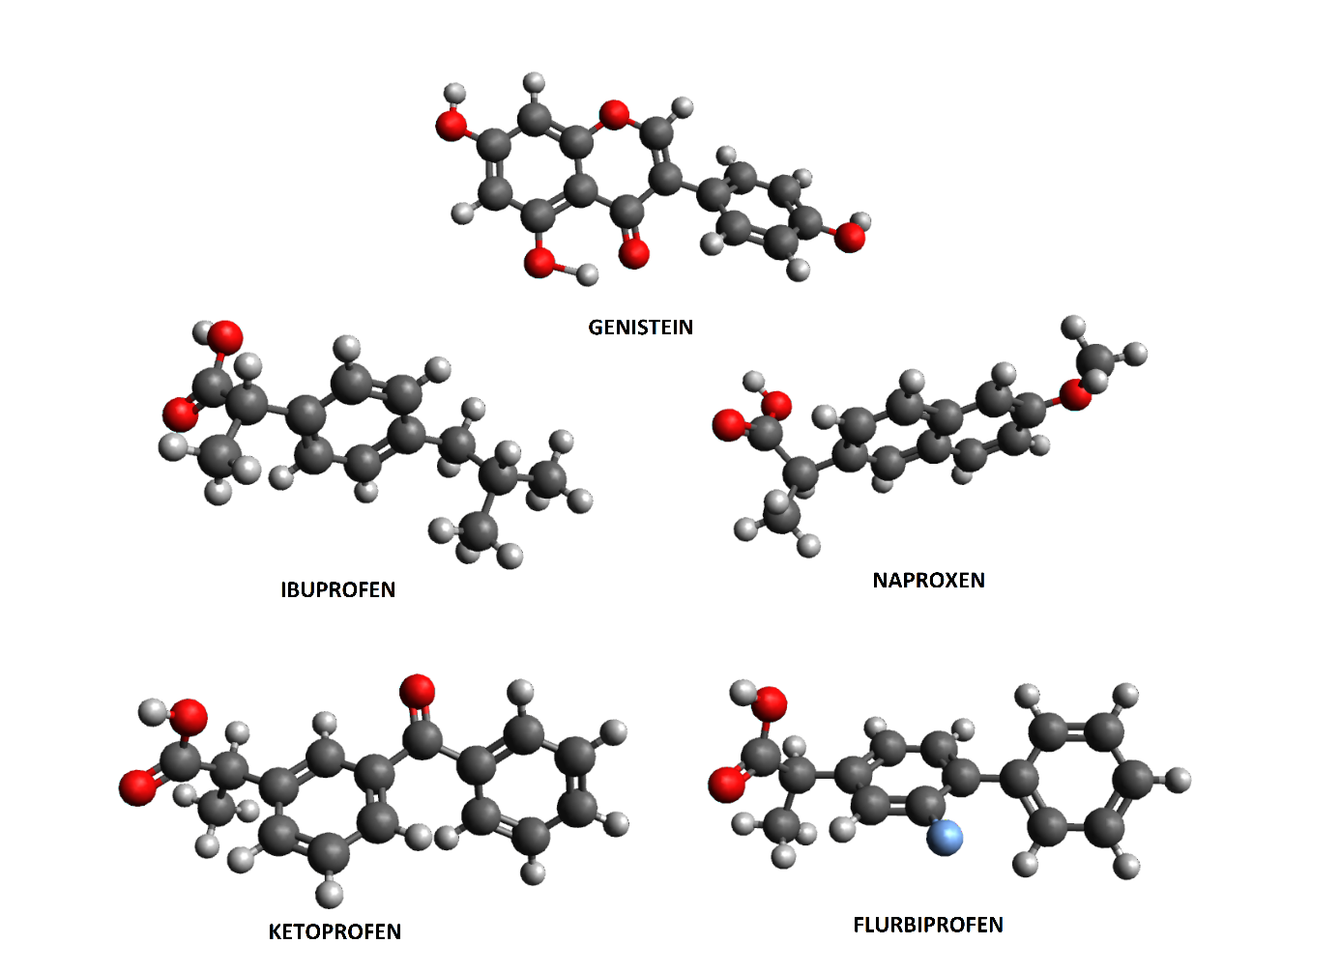
Figure S23. Three-dimensional structures of 1-5.
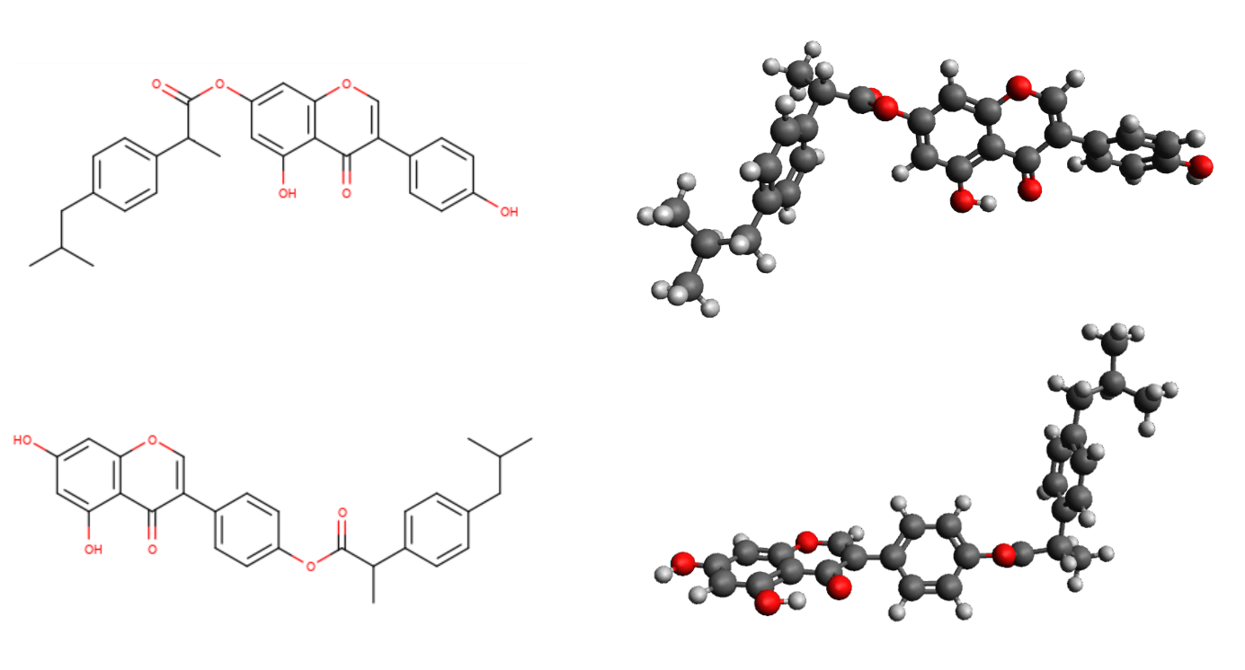
Figure S24. 2D and 3D chemical structures of two GEN-IBU hybrids - GEN-7-IBU (top) and GEN-4'-IBU (bottom).

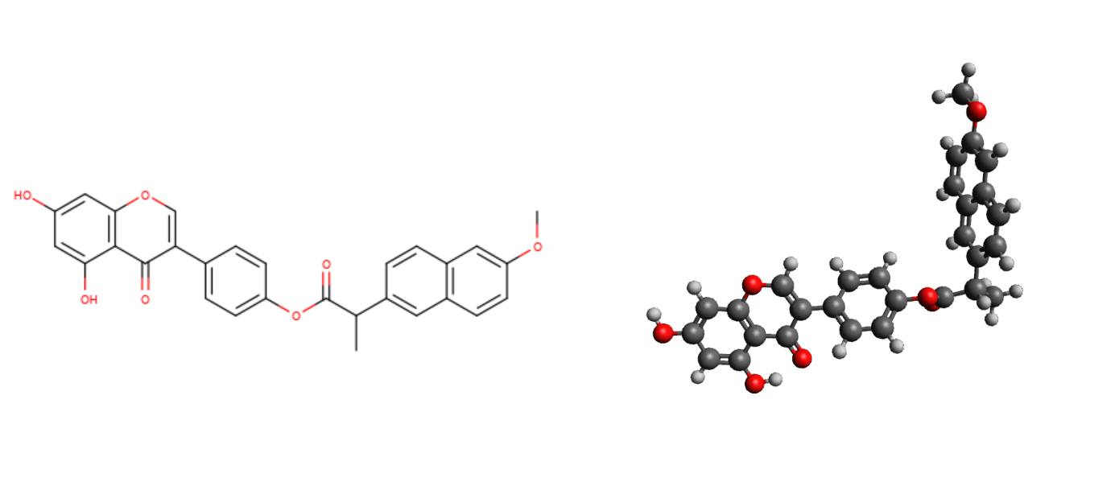
Figure S25. 2D and 3D chemical structure of GEN-4’-NPX.
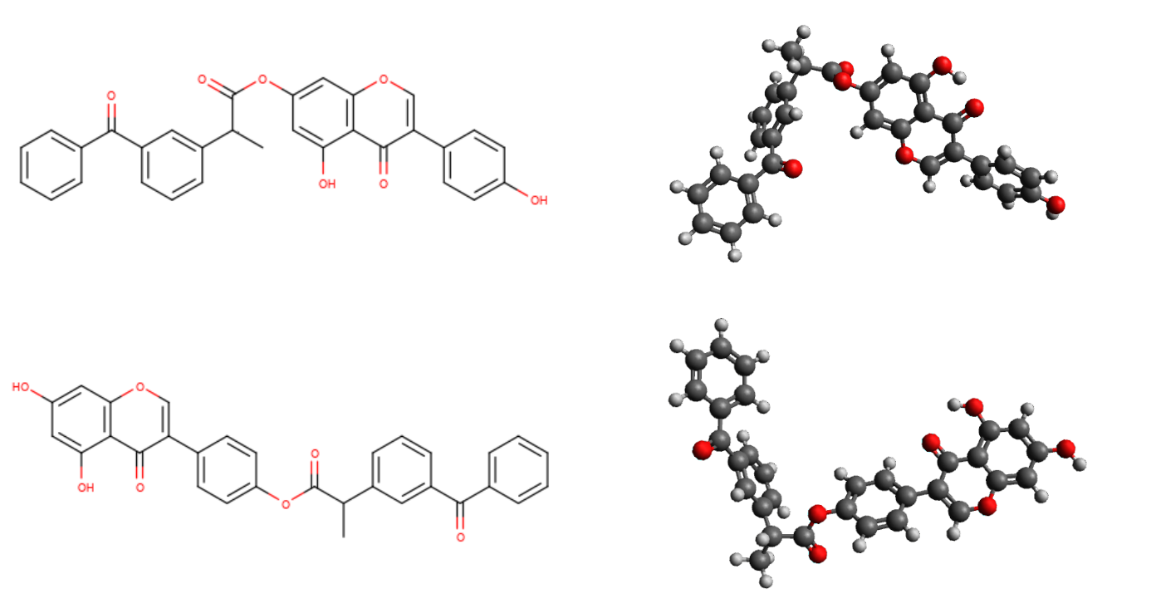
Figure S26. 2D and 3D chemical structures of two GEN-KETO hybrids - GEN-7-KETO (top) and GEN-4'-KETO (bottom).
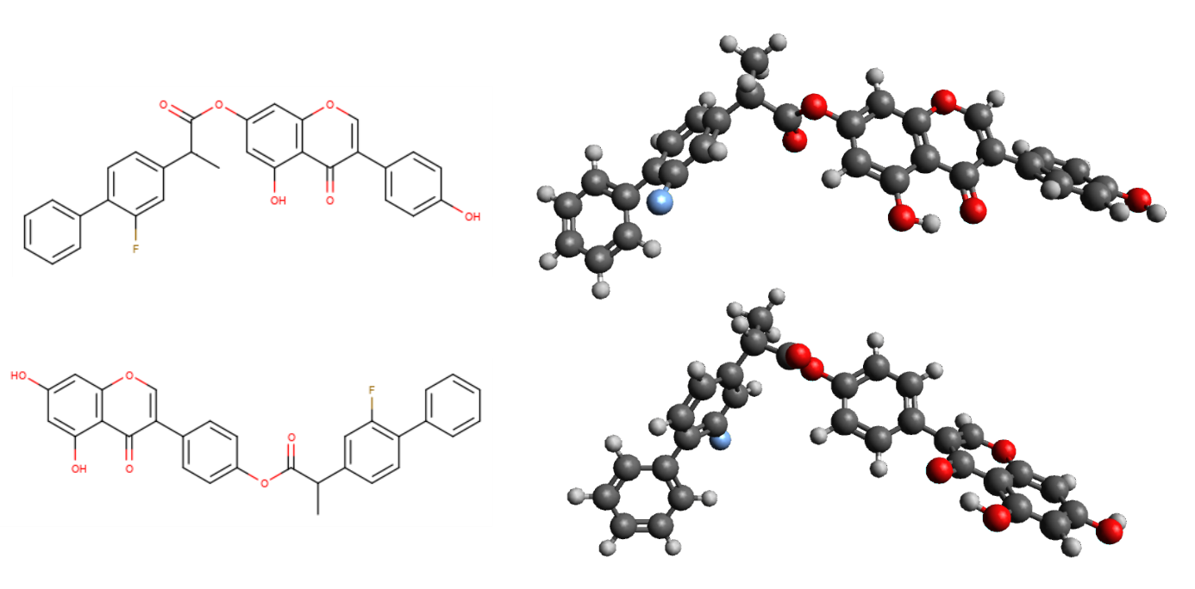
Figure S27. 2D and 3D chemical structures of two GEN-FLUR hybrids - GEN-7-FLUR (top) and GEN-4'-FLUR (bottom).

S6. Linear functions
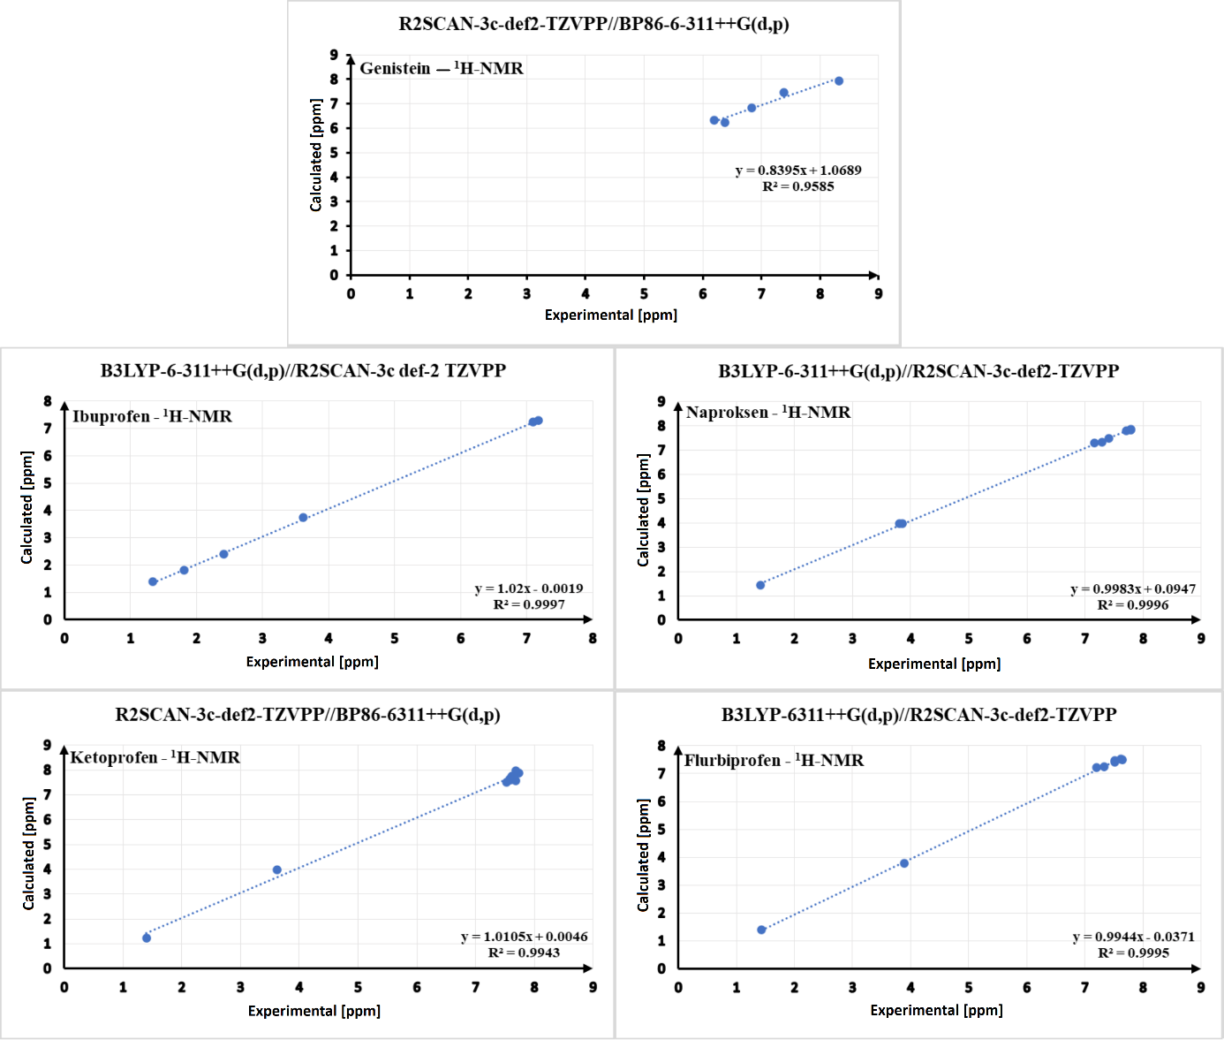
Figure S28. Linear functions for the applied computational methods for compounds 1-5, comparing the computed values of chemical shifts in the ¹H-NMR spectra to the experimentally determined values. At the top is located information about used method – first part (from the left, before ‘/’) is method of optimisation, second part (from the right, after ‘/’) is functional NMR and basis set. At the bottom is located linear function in the form y = ax + b, with the coefficient R².
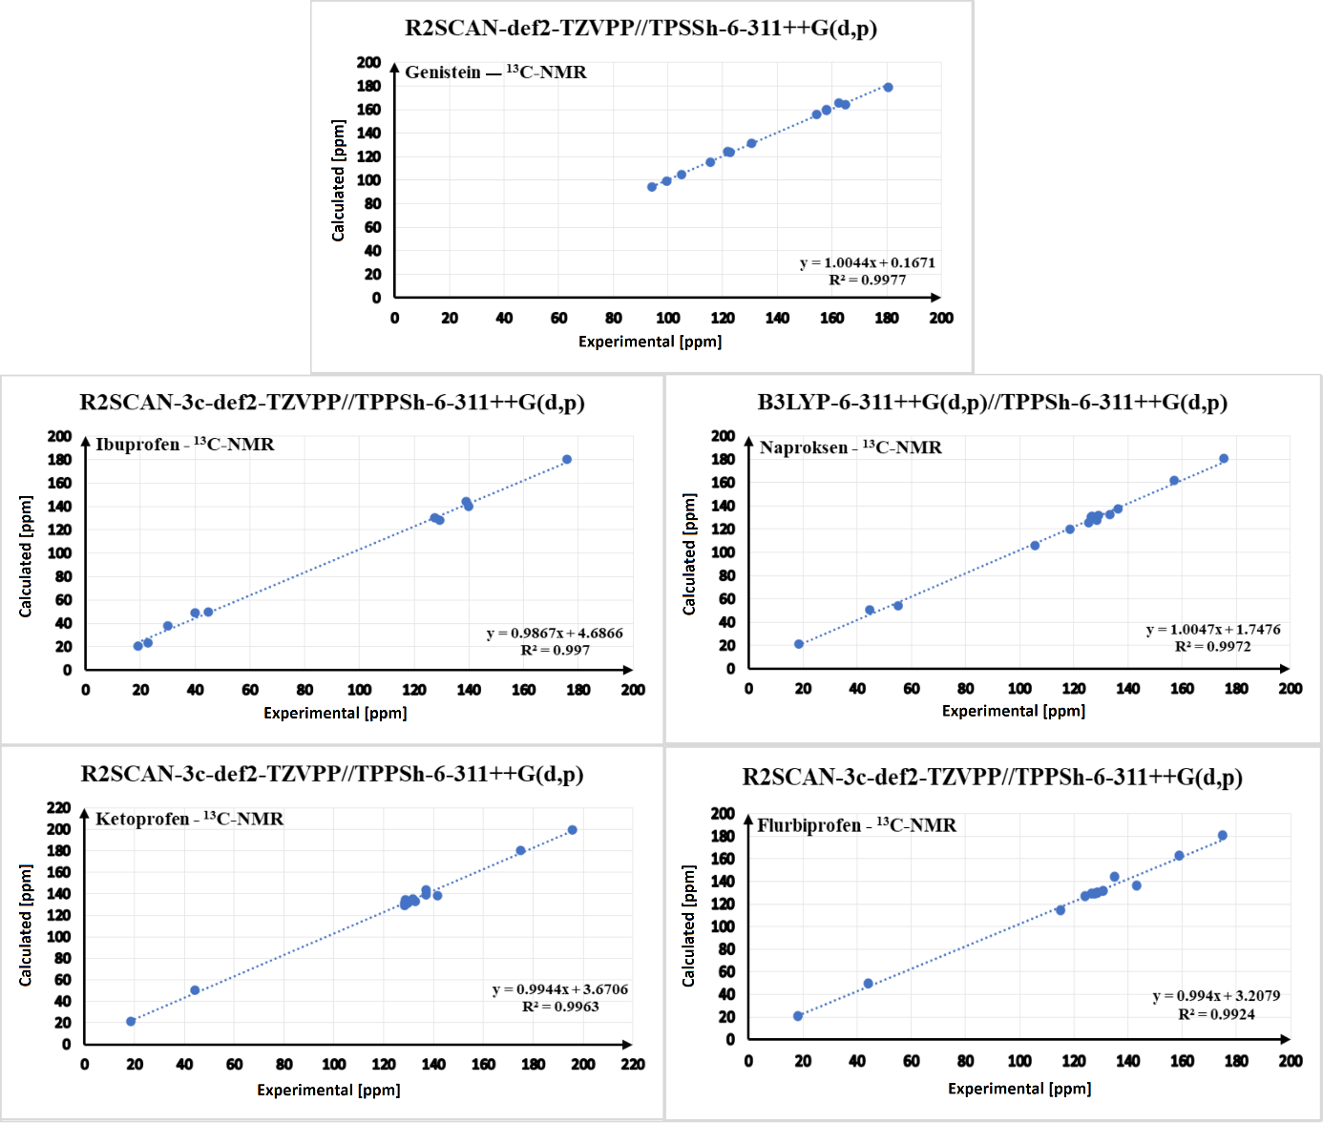
Figure S29. Linear functions for the applied computational methods for compounds 1-5, comparing the computed values of chemical shifts in the ¹³C-NMR spectra to the experimentally determined values. At the top is located information about used method – first part (from the left, before ‘/’) is method of optimisation, second part (from the right, after ‘/’) is functional NMR and basis set. At the bottom is located linear function in the form y = ax + b, with the coefficient R².
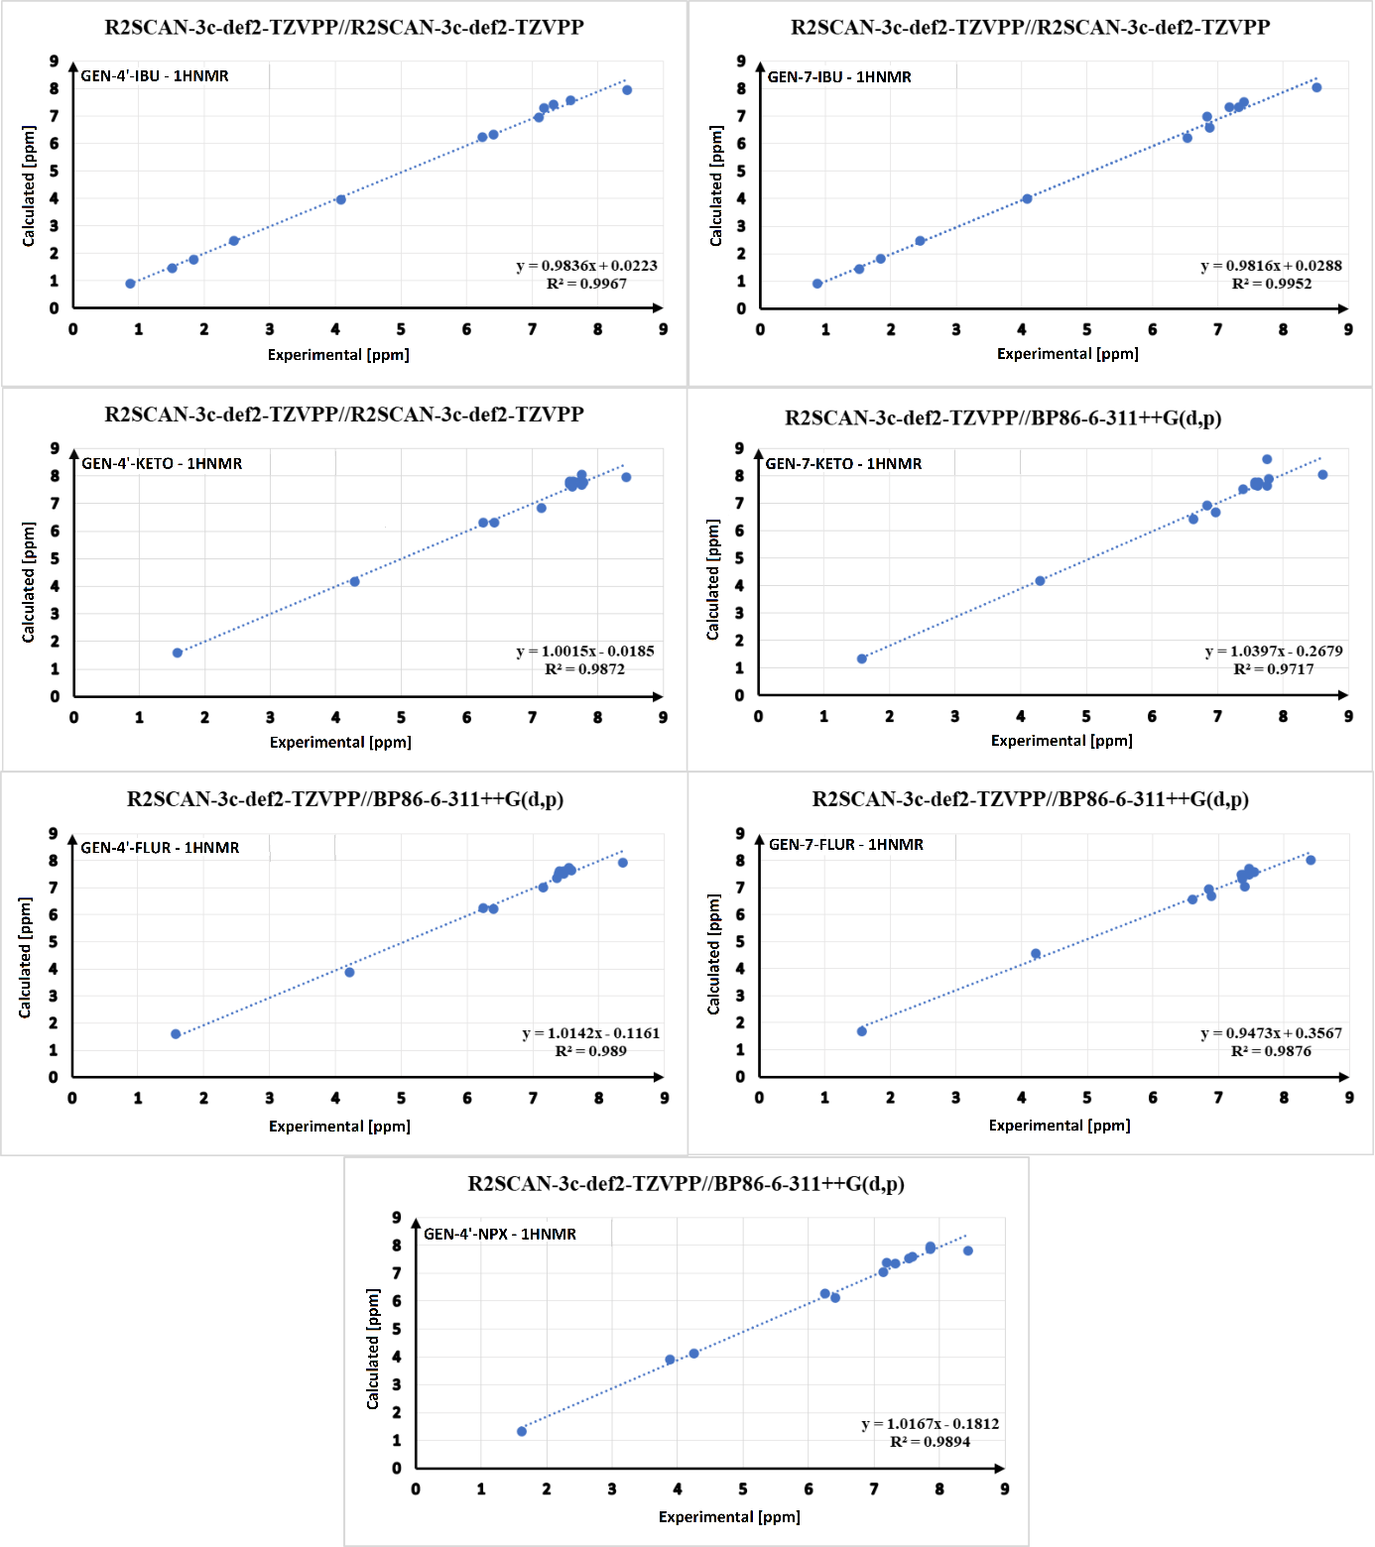
Figure S30. Linear functions for the applied computational methods for each hybrid, comparing the computed values of chemical shifts in the ¹H-NMR spectra to the experimentally determined values. At the top is located information about used method – first part (from the left, before ‘/’) is method of optimisation, second part (from the right, after ‘/’) is functional NMR and basis set. At the bottom is located linear function in the form y = ax + b, with the coefficient R².

S7. ¹H-NMR calculations for hybrids
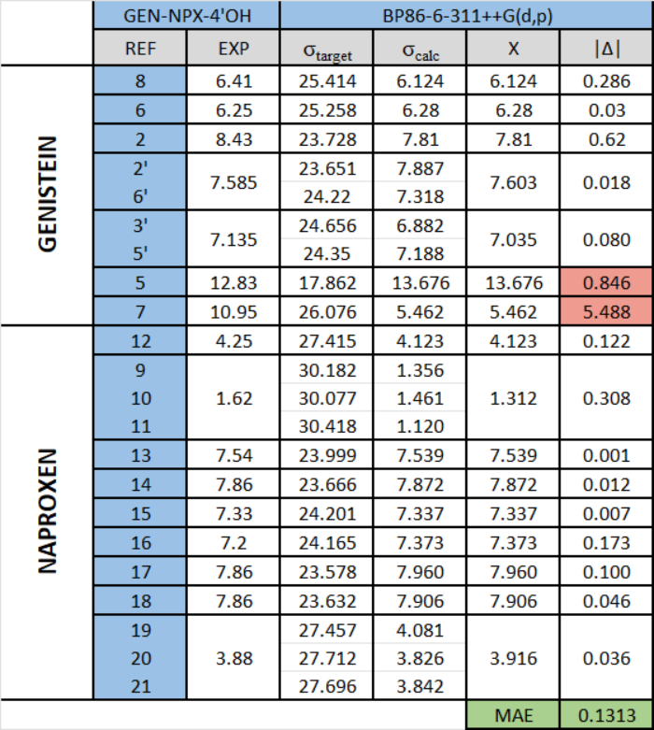
Table S1. Comparison of chemical shift values in the ¹H-NMR spectra between experimental and computational data for GEN-4’-NPX hybrid. The calculation method used is indicated at the top of each column, with labile hydrogen atoms highlighted in red. Labile hydrogen atoms were not included in the MAE calculations. REF - hydrogen identification number; EXP - experimental chemical shift value; σ_{target} - calculated value without regard to the TMS reference value; σ_{calc} - calculated value with regard to the TMS reference value; X - average value for equivalent hydrogen atoms; |Δ| - difference, as an absolute value, between the experimental and calculated values.

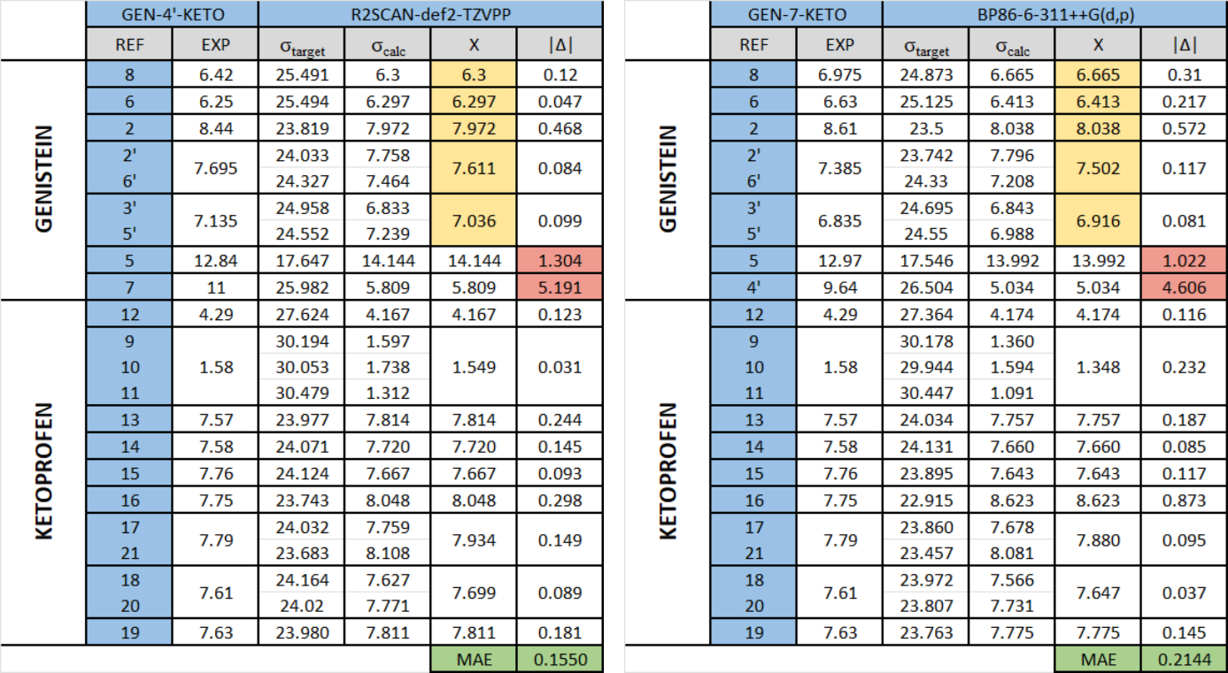
Table S2-S3. Comparison of chemical shift values in the ¹H-NMR spectra between experimental and computational data for GEN-KETO hybrids. The left section presents results for GEN-4'-KETO, while the right section displays data for GEN-7-KETO. The calculation method used is indicated at the top of each column, with labile hydrogen atoms highlighted in red and hydrogen atoms marked in orange for which the reference signal values changes due to the conversion of the hydroxyl group into an ester group. Labile hydrogen atoms were not included in the MAE calculations. REF - hydrogen identification number; EXP - experimental chemical shift value; σ_{target} - calculated value without regard to the TMS reference value; σ_{calc} - calculated value with regard to the TMS reference value; X - average value for equivalent hydrogen atoms; |Δ| - difference, as an absolute value, between the experimental and calculated values.

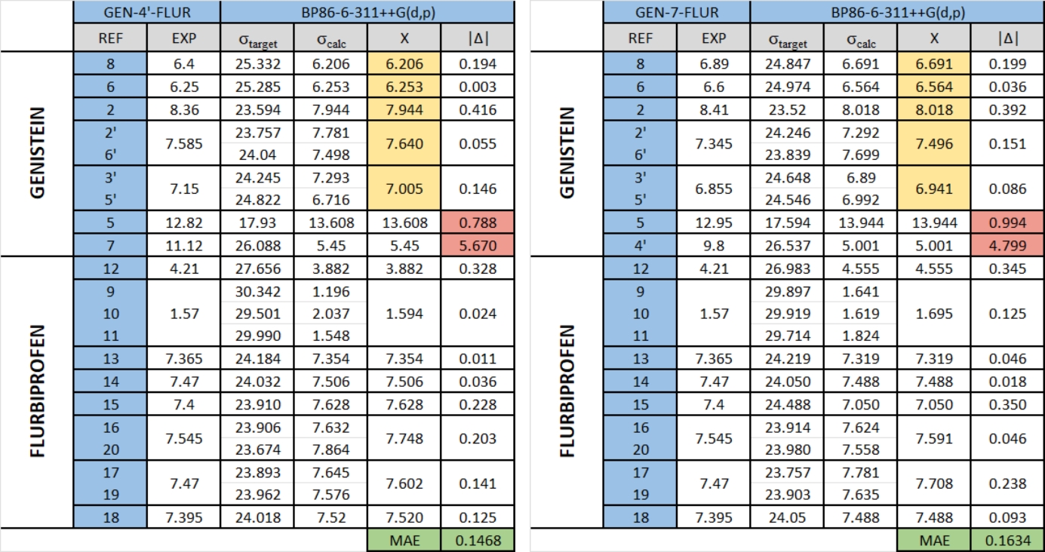
Table S4-S5. Comparison of chemical shift values in the ¹H-NMR spectra between experimental and computational data for GEN-FLUR hybrids. The left section presents results for GEN-4'-FLUR, while the right section displays data for GEN-7-FLUR. The calculation method used is indicated at the top of each column, with labile hydrogen atoms highlighted in red and hydrogen atoms marked in orange for which the reference signal values changes due to the conversion of the hydroxyl group into an ester group. Labile hydrogen atoms were not included in the MAE calculations. REF - hydrogen identification number; EXP - experimental chemical shift value; σ_{target} - calculated value without regard to the TMS reference value; σ_{calc} - calculated value with regard to the TMS reference value; X - average value for equivalent hydrogen atoms; |Δ| - difference, as an absolute value, between the experimental and calculated values.

S8. ¹³C-NMR calculations for hybrids
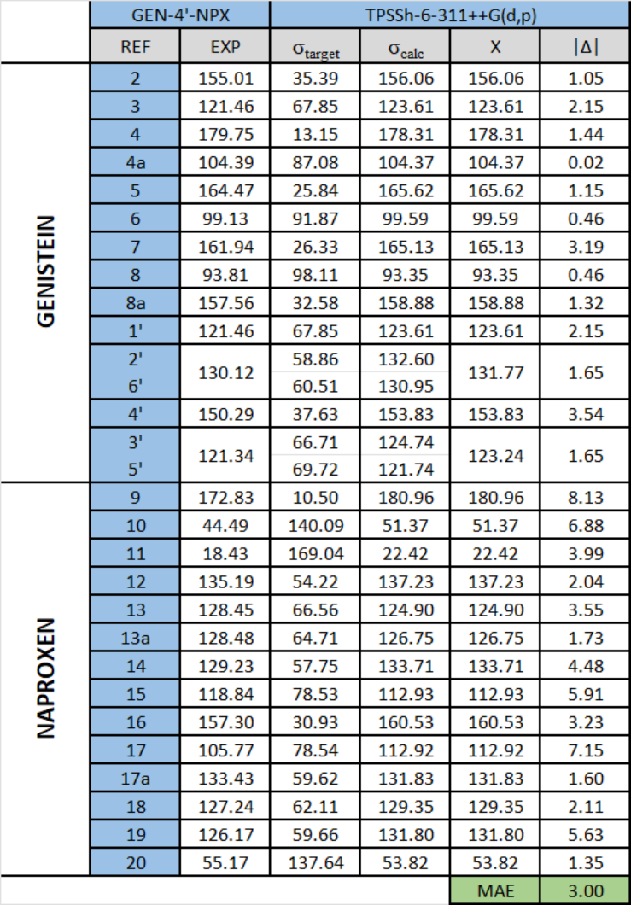
Table S6. Comparison of chemical shift values in the ¹³C-NMR spectra between experimental and computational data for GEN-4’-NPX hybrid. The calculation method used is indicated at the top of each column. REF - carbon identification number; EXP - experimental chemical shift value; σ_{target} - calculated value without regard to the TMS reference value; σ_{calc} - calculated value with regard to the TMS reference value; X - average value for equivalent carbon atoms; |Δ| - difference, as an absolute value, between the experimental and calculated values.
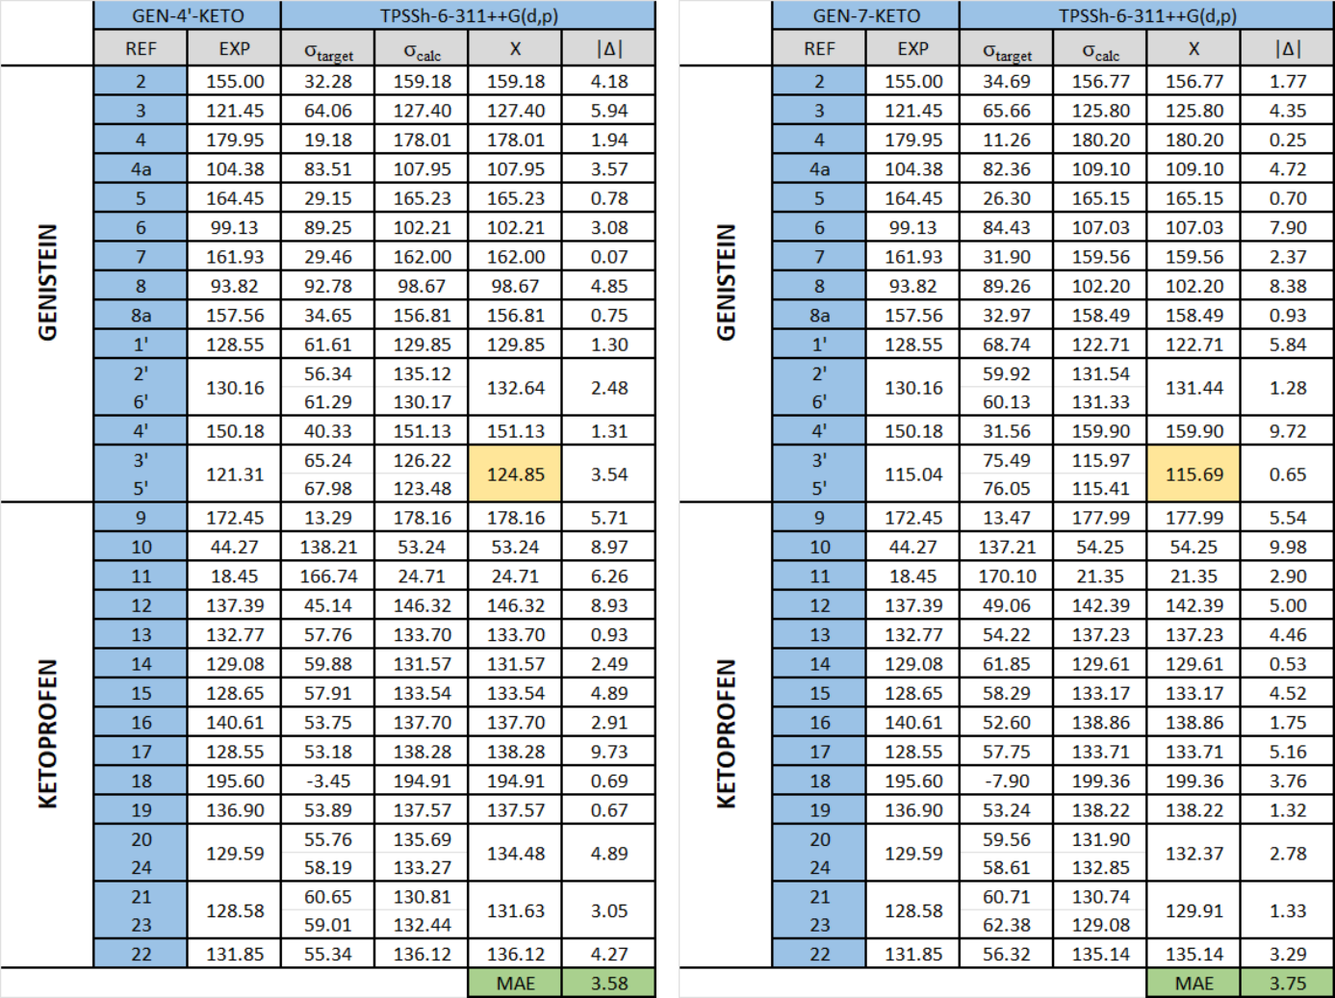
Table S7-S8. Comparison of chemical shift values in the ¹³C-NMR spectra between experimental and computational data for GEN-KETO hybrids. The left section presents results for GEN-4'-KETO, while the right section displays data for GEN-7-KETO. The calculation method used is indicated at the top of each column, with carbon atoms marked in orange for which the reference signal values changes due to the conversion of the hydroxyl group into an ester group. REF - carbon identification number; EXP - experimental chemical shift value; σ_{target} - calculated value without regard to the TMS reference value; σ_{calc} - calculated value with regard to the TMS reference value; X - average value for equivalent carbon atoms; |Δ| - difference, as an absolute value, between the experimental and calculated values.
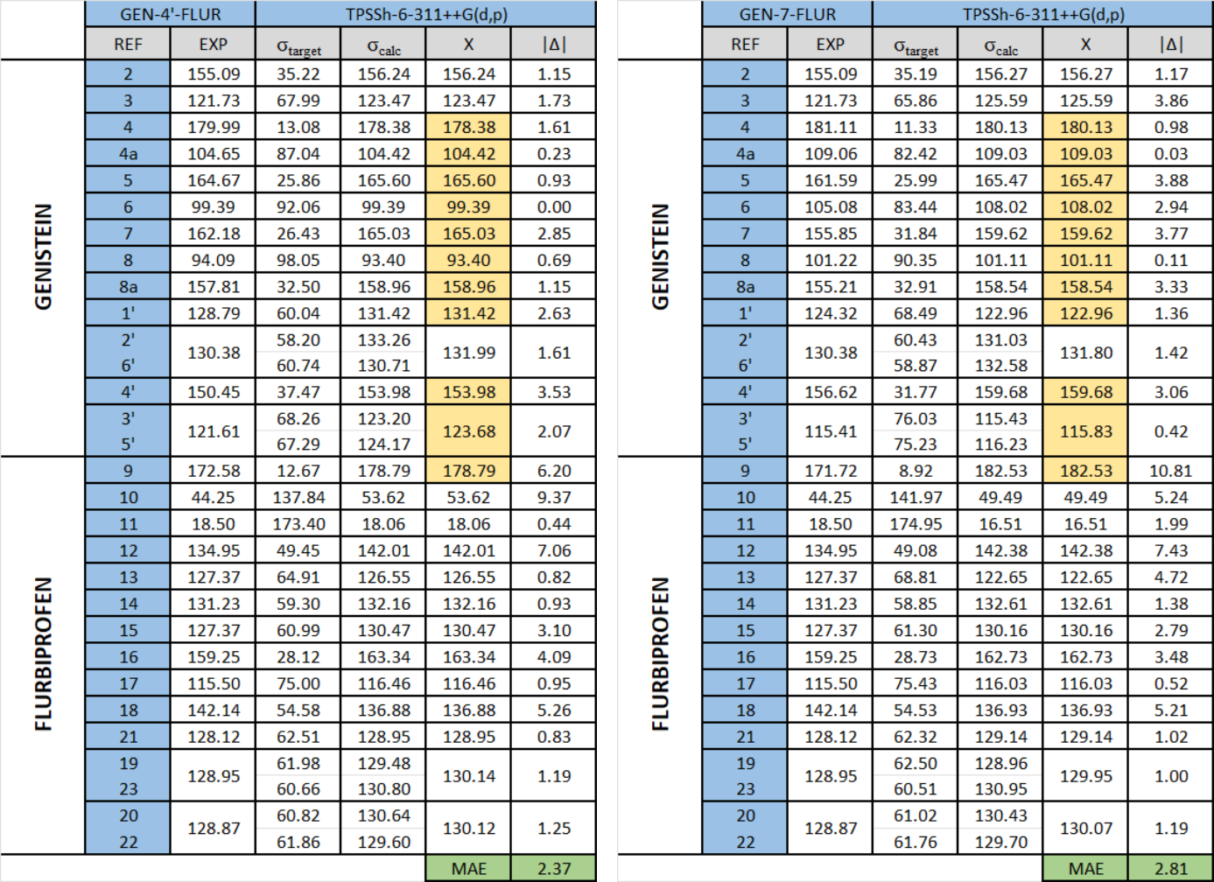
Table S9-S10. Comparison of chemical shift values in the ¹³C-NMR spectra between experimental and computational data for GEN-FLUR hybrids. The left section presents results for GEN-4'-FLUR, while the right section displays data for GEN-7-FLUR. The calculation method used is indicated at the top of each column, with carbon atoms marked in orange for which the reference signal values changes due to the conversion of the hydroxyl group into an ester group. REF - carbon identification number; EXP - experimental chemical shift value; σ_{target} - calculated value without regard to the TMS reference value; σ_{calc} - calculated value with regard to the TMS reference value; X - average value for equivalent carbon atoms; |Δ| - difference, as an absolute value, between the experimental and calculated values.

