Figure S.1:
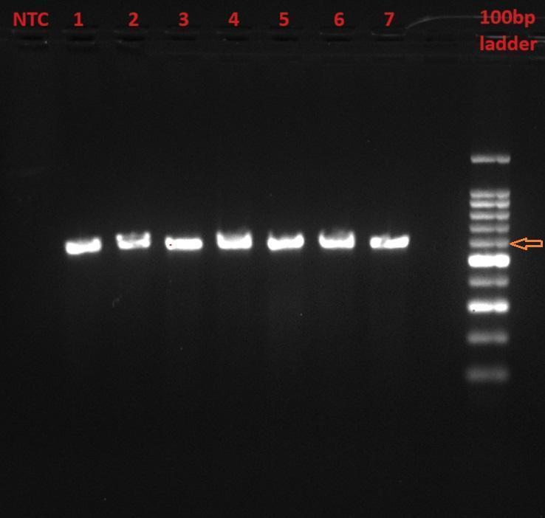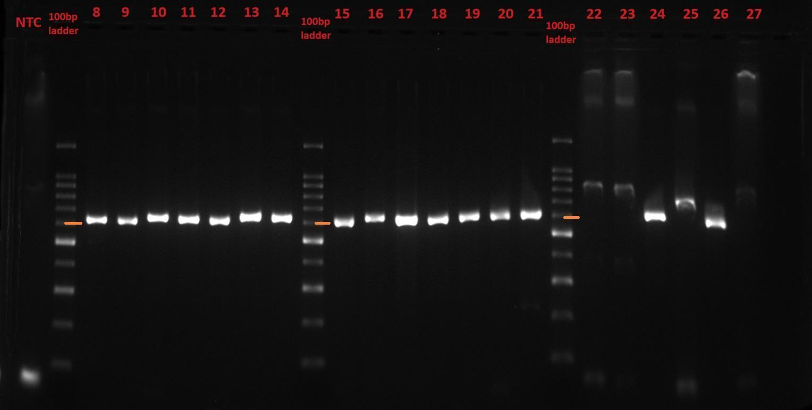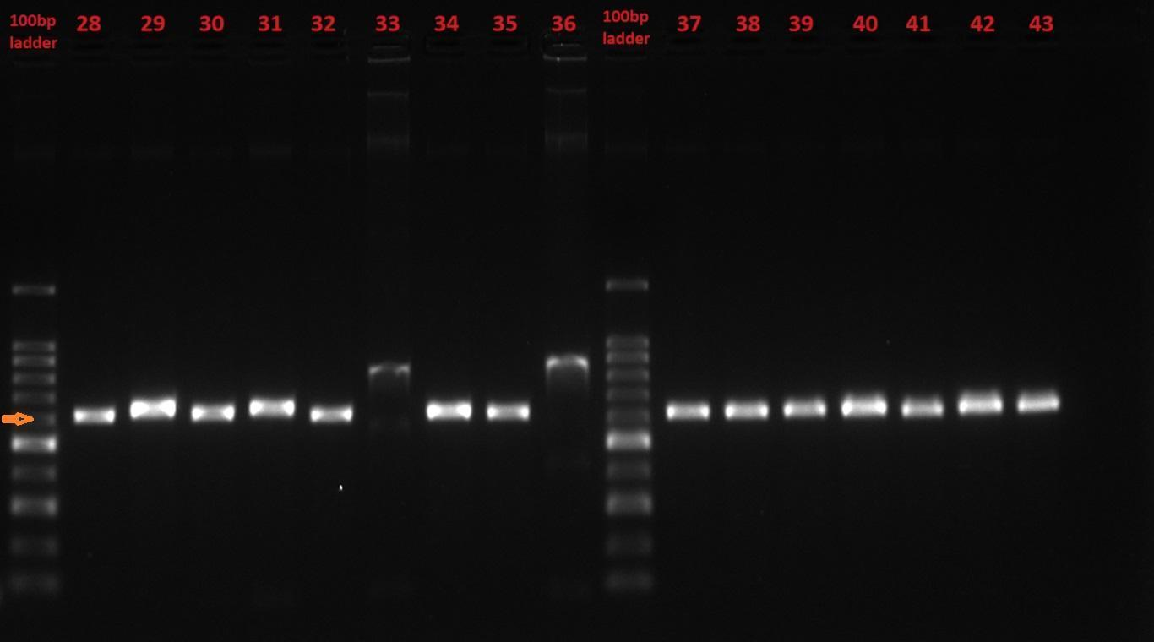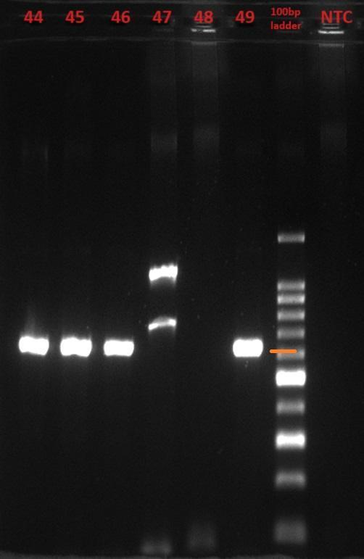

Figure S.1: Gel image of PCR of all clinical samples:
Forty-nine clinical samples were amplified using NDM_ref_F and NDM_ref_R primers. no template control (NTC) was included for each batch. A 100bp ladder is used for reference, with the expected band at ~600bp, marked with an orange arrow mark or line near the ladder. Well-labelled 1 to 49 correspond to the CRE number, details are available in Table S.2.

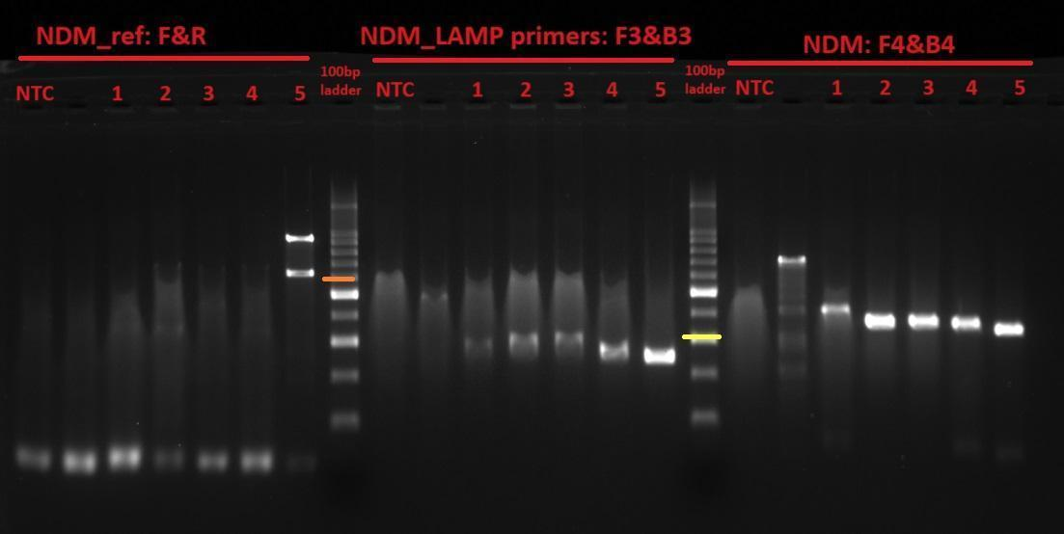
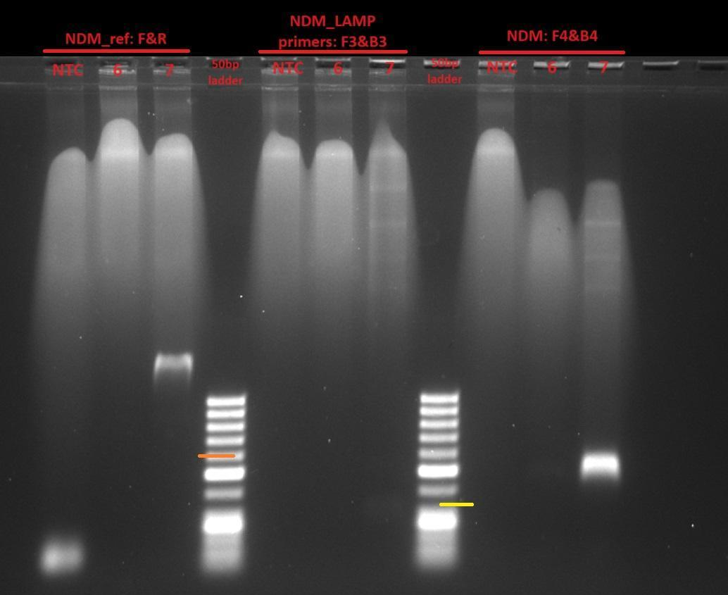
Figure S.2:

Figure S.2: Gel image of PCR of discrepant samples:
Discrepant samples were amplified using three different sets of PCR primer, each producing bands of different sizes: the NDM_ref primer set (~600bp), the F3/B3 primer set (228bp) and the F4/B4 primer set (334bp). The details of the samples loaded on the gel are as follows: 1. CRE-22; 2. CRE-23; 3. CRE-33; 4. CRE-36; 5. CRE-47; 6. CRE-27 and 7: CRE-48. A no template control (NTC) was included for each batch. A 100bp ladder was used for reference. An orange line near the ladder represents the 600bp size, while yellow represents the 300bp size.

