Supplementary Figure 1 – Cost-Effectiveness Analysis
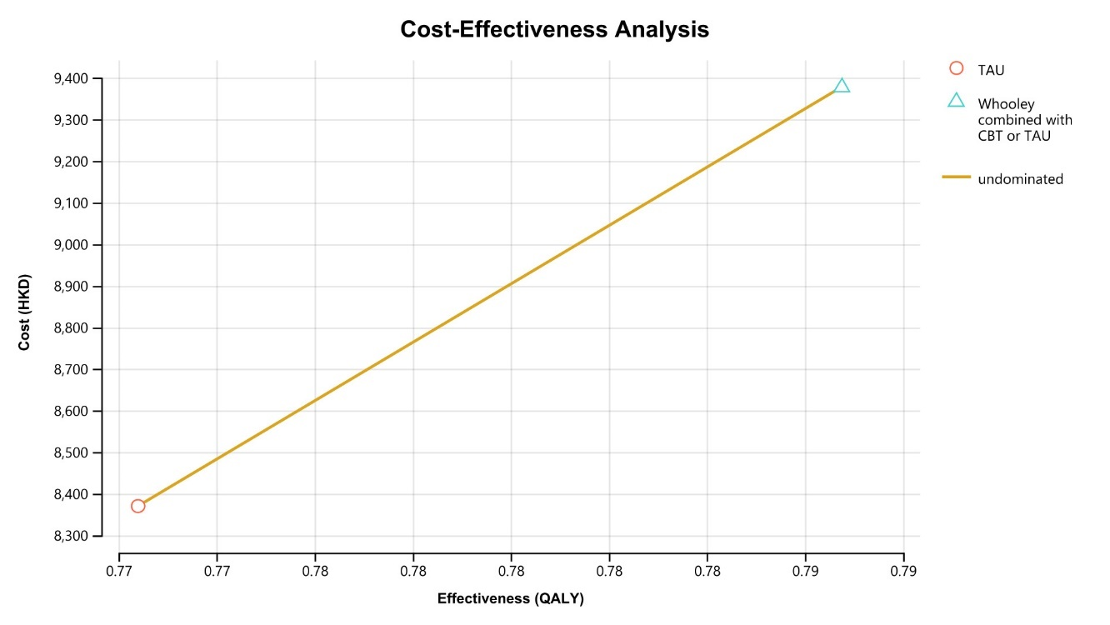

Supplementary Table 1 – Monte Carlo Cost-Effectiveness Statistic
Statistic | Cost\n(TAU) | Cost\n(Whooley combined with CBT or TAU) | Effectiveness\n(TAU) | Effectiveness\n(Whooley combined with CBT or TAU) | NMB\n(TAU)
Mean | 8370.789948 | 9377.868072 | 0.772400459 | 0.786752584 | -2191.58628
Std Deviation | 4287.037247 | 3401.713245 | 0.008765958 | 0.009765143 | 4287.525945
Minimum | 374.4737581 | 1548.199358 | 0.739024748 | 0.750359699 | -26099.4236
2.50% | 2300.254037 | 4112.913791 | 0.755249029 | 0.767439373 | -12611.10142
10% | 3617.4934 | 5450.735939 | 0.761195654 | 0.774175692 | -8001.139412
Median | 7649.929816 | 8921.129847 | 0.772406939 | 0.786727102 | -1470.226689
90% | 14177.25329 | 13887.8579 | 0.783626285 | 0.799374711 | 2557.193809
97.50% | 18788.22475 | 17276.36432 | 0.789342639 | 0.805634575 | 3887.684338
Maximum | 32237.68983 | 28814.76453 | 0.80378433 | 0.824074253 | 5786.027913
Sum | 8.37E+07 | 9.38E+07 | 7724.004585 | 7867.52584 | -2.19E+07
Size (n) | 10000 | 10000 | 10000 | 10000 | 10000
Variance | 1.84E+07 | 1.16E+07 | 7.68E-05 | 9.54E-05 | 1.84E+07
Variance/Size | 1837.868836 | 1157.1653 | 7.68E-09 | 9.54E-09 | 1838.287873
SQRT[Variance/Size] | 42.87037247 | 34.01713245 | 8.77E-05 | 9.77E-05 | 42.87525945
95%% Lower Bound | 8286.765562 | 9311.195718 | 0.772228649 | 0.786561191 | -2275.620244
95%% Upper Bound | 8454.814334 | 9444.540427 | 0.772572268 | 0.786943977 | -2107.552316
Statistic | NMB\n(Whooley combined with CBT or TAU) | G1_TAU_CC | G2_TAU_MC | G3_CBT_CC | G4_CBT_MC
Mean | -3083.847401 | 4169.99066 | 4200.799288 | 4258.441589 | 4804.449722
Std Deviation | 3399.124159 | 2745.26403 | 3275.67397 | 2380.164862 | 3398.032072
Minimum | -22498.76012 | 54.18628577 | 11.00336484 | 146.3159702 | 36.07530577
0.025 | -11003.36736 | 634.8237596 | 374.2505919 | 923.8973097 | 586.2535918
0.1 | -7595.174345 | 1262.115676 | 913.4901961 | 1641.744788 | 1319.262531
Median | -2634.842778 | 3544.665226 | 3387.426791 | 3806.071045 | 4009.679643
0.9 | 841.6101384 | 7831.209861 | 8514.133126 | 7472.794307 | 9375.861041
0.975 | 2143.085216 | 10966.65779 | 12597.95222 | 9973.910886 | 13507.78145
Maximum | 4694.174167 | 26892.02318 | 27699.18911 | 19479.95073 | 32096.27872
Sum | -3.08E+07 | 4.17E+07 | 4.20E+07 | 4.26E+07 | 4.80E+07
Size (n) | 10000 | 10000 | 10000 | 10000 | 10000
Variance | 1.16E+07 | 7536474.595 | 1.07E+07 | 5665184.768 | 1.15E+07
Variance/Size | 1155.404505 | 753.6474595 | 1073.003996 | 566.5184768 | 1154.662196
SQRT[Variance/Size] | 33.99124159 | 27.4526403 | 32.7567397 | 23.80164862 | 33.98032072
95%% Lower Bound | -3150.46901 | 4116.184474 | 4136.597258 | 4211.791215 | 4737.849517
95%% Upper Bound | -3017.225791 | 4223.796846 | 4265.001318 | 4305.091963 | 4871.049926
Statistic | G5_CBT_ACBTC | G6_WhooleyC | B1_IRHK | B2_TNR | B3_TPR
Mean | 2586.929165 | 36.47232486 | 0.204931251 | 0.653223654 | 0.948996169
Std Deviation | 1952.10285 | 70.23600421 | 0.012659314 | 0.021922652 | 0.013213707
Minimum | 21.43033823 | 4.74E-16 | 0.164025722 | 0.565219272 | 0.874712151
2.50% | 284.5982818 | 1.72E-04 | 0.180541873 | 0.610297637 | 0.919982314
10% | 629.8719467 | 0.022257722 | 0.188904353 | 0.624563696 | 0.931430203
Median | 2106.43414 | 7.238666595 | 0.204687146 | 0.653624649 | 0.950005294
90% | 5172.891031 | 109.0576363 | 0.221237333 | 0.681081814 | 0.965240721
97.50% | 7566.837551 | 239.9226946 | 0.230194245 | 0.695297151 | 0.971939076
Maximum | 19120.73025 | 941.0591453 | 0.267061695 | 0.728740434 | 0.983168199
Sum | 2.59E+07 | 364723.2486 | 2049.312514 | 6532.236542 | 9489.961691
Size (n) | 10000 | 10000 | 10000 | 10000 | 10000
Variance | 3810705.536 | 4933.096287 | 1.60E-04 | 4.81E-04 | 1.75E-04
Variance/Size | 381.0705536 | 0.493309629 | 1.60E-08 | 4.81E-08 | 1.75E-08
SQRT[Variance/Size] | 19.5210285 | 0.702360042 | 1.27E-04 | 2.19E-04 | 1.32E-04
95%% Lower Bound | 2548.668652 | 35.09572447 | 0.204683133 | 0.652793978 | 0.948737185
95%% Upper Bound | 2625.189678 | 37.84892525 | 0.205179369 | 0.65365333 | 0.949255153
Statistic | B4_CBT_DTR | B5_CBT_RTD | B6_TAU_DTR | B7_TAU_RTD | U1_WTA
Mean | 0.740649632 | 0.086327929 | 0.423053863 | 0.259580745 | 0.626397488
Std Deviation | 0.025557254 | 0.010220336 | 0.023426191 | 0.020396646 | 0.202923759
Minimum | 0.646545402 | 0.051870816 | 0.340134871 | 0.191102188 | 0.273136495
0.025 | 0.687585388 | 0.067247739 | 0.37708497 | 0.220704104 | 0.293464232
0.1 | 0.707514757 | 0.073456895 | 0.393362445 | 0.233957995 | 0.346674365
Median | 0.741114827 | 0.085920283 | 0.422891684 | 0.259234409 | 0.627454269
0.9 | 0.772849686 | 0.099588554 | 0.453203167 | 0.285772247 | 0.909353465
0.975 | 0.789441775 | 0.107640564 | 0.4686064 | 0.300096069 | 0.963252974
Maximum | 0.820892159 | 0.129381522 | 0.526210722 | 0.338492424 | 0.979853458
Sum | 7406.496318 | 863.2792912 | 4230.538626 | 2595.807454 | 6263.974879
Size (n) | 10000 | 10000 | 10000 | 10000 | 10000
Variance | 6.53E-04 | 1.04E-04 | 5.49E-04 | 4.16E-04 | 0.041178052
Variance/Size | 6.53E-08 | 1.04E-08 | 5.49E-08 | 4.16E-08 | 4.12E-06
SQRT[Variance/Size] | 2.56E-04 | 1.02E-04 | 2.34E-04 | 2.04E-04 | 0.002029238
95%% Lower Bound | 0.740148719 | 0.086127614 | 0.422594718 | 0.259180979 | 0.622420255
95%% Upper Bound | 0.741150545 | 0.086528244 | 0.423513008 | 0.259980512 | 0.63037472
Statistic | B8_QALY_D | B9_QALY_R
Mean | 0.631076852 | 0.840334171
Std Deviation | 0.013522501 | 0.009820899
Minimum | 0.581676395 | 0.799111307
0.025 | 0.604488288 | 0.820374766
0.1 | 0.613623916 | 0.82782959
Median | 0.631158213 | 0.840423701
0.9 | 0.648359767 | 0.852839624
0.975 | 0.657317755 | 0.859464498
Maximum | 0.680856181 | 0.873914557
Sum | 6310.768517 | 8403.341714
Size (n) | 10000 | 10000
Variance | 1.83E-04 | 9.65E-05
Variance/Size | 1.83E-08 | 9.65E-09
SQRT[Variance/Size] | 1.35E-04 | 9.82E-05
95%% Lower Bound | 0.630811816 | 0.840141685
95%% Upper Bound | 0.631341888 | 0.840526657

Supplementary Table 2 – Incremental Cost-Effectiveness Plot Statistic
Component | Quadrant | INCR Eff | INCR Cost | INCR CE | Frequency | Proportion
C1 | IV | IE>0 | IC<0 | Superior | 2757 | 0.2757
C2 | I | IE>0 | IC>0 | ICER<194780.0 | 5684 | 0.5684
C3 | III | IE<0 | IC<0 | ICER>194780.0 | 0 | 0
C4 | I | IE>0 | IC>0 | ICER>194780.0 | 1559 | 0.1559
C5 | III | IE<0 | IC<0 | ICER<194780.0 | 0 | 0
C6 | II | IE<0 | IC>0 | Inferior | 0 | 0
Indiff | origin | IE=0 | IC=0 | 0/0 | 0 | 0

Supplementary Table 3 – Cost-Effectiveness Acceptability Statistic
Weight | Strategy | Strategy Name | Acceptability
0 | 0 | TAU | 0.7243
0 | 1 | Whooley combined with CBT or TAU | 0.2757
4000 | 0 | TAU | 0.7125
4000 | 1 | Whooley combined with CBT or TAU | 0.2875
8000 | 0 | TAU | 0.7007
8000 | 1 | Whooley combined with CBT or TAU | 0.2993
12000 | 0 | TAU | 0.6907
12000 | 1 | Whooley combined with CBT or TAU | 0.3093
16000 | 0 | TAU | 0.678
16000 | 1 | Whooley combined with CBT or TAU | 0.322
20000 | 0 | TAU | 0.6672
20000 | 1 | Whooley combined with CBT or TAU | 0.3328
24000 | 0 | TAU | 0.6532
24000 | 1 | Whooley combined with CBT or TAU | 0.3468
28000 | 0 | TAU | 0.6392
28000 | 1 | Whooley combined with CBT or TAU | 0.3608
32000 | 0 | TAU | 0.6261
32000 | 1 | Whooley combined with CBT or TAU | 0.3739
36000 | 0 | TAU | 0.6129
36000 | 1 | Whooley combined with CBT or TAU | 0.3871
40000 | 0 | TAU | 0.6004
40000 | 1 | Whooley combined with CBT or TAU | 0.3996
44000 | 0 | TAU | 0.5858
44000 | 1 | Whooley combined with CBT or TAU | 0.4142
48000 | 0 | TAU | 0.5736
48000 | 1 | Whooley combined with CBT or TAU | 0.4264
52000 | 0 | TAU | 0.5612
52000 | 1 | Whooley combined with CBT or TAU | 0.4388
56000 | 0 | TAU | 0.547
56000 | 1 | Whooley combined with CBT or TAU | 0.453
60000 | 0 | TAU | 0.5351
60000 | 1 | Whooley combined with CBT or TAU | 0.4649
64000 | 0 | TAU | 0.5214
64000 | 1 | Whooley combined with CBT or TAU | 0.4786
68000 | 0 | TAU | 0.5075
68000 | 1 | Whooley combined with CBT or TAU | 0.4925
72000 | 0 | TAU | 0.4918
72000 | 1 | Whooley combined with CBT or TAU | 0.5082
76000 | 0 | TAU | 0.477
76000 | 1 | Whooley combined with CBT or TAU | 0.523
80000 | 0 | TAU | 0.4647
80000 | 1 | Whooley combined with CBT or TAU | 0.5353
84000 | 0 | TAU | 0.4514
84000 | 1 | Whooley combined with CBT or TAU | 0.5486
88000 | 0 | TAU | 0.4389
88000 | 1 | Whooley combined with CBT or TAU | 0.5611
92000 | 0 | TAU | 0.4248
92000 | 1 | Whooley combined with CBT or TAU | 0.5752
96000 | 0 | TAU | 0.4109
96000 | 1 | Whooley combined with CBT or TAU | 0.5891
100000 | 0 | TAU | 0.398
100000 | 1 | Whooley combined with CBT or TAU | 0.602
104000 | 0 | TAU | 0.3854
104000 | 1 | Whooley combined with CBT or TAU | 0.6146
108000 | 0 | TAU | 0.3735
108000 | 1 | Whooley combined with CBT or TAU | 0.6265
112000 | 0 | TAU | 0.3631
112000 | 1 | Whooley combined with CBT or TAU | 0.6369
116000 | 0 | TAU | 0.3511
116000 | 1 | Whooley combined with CBT or TAU | 0.6489
120000 | 0 | TAU | 0.3399
120000 | 1 | Whooley combined with CBT or TAU | 0.6601
124000 | 0 | TAU | 0.3299
124000 | 1 | Whooley combined with CBT or TAU | 0.6701
128000 | 0 | TAU | 0.3175
128000 | 1 | Whooley combined with CBT or TAU | 0.6825
132000 | 0 | TAU | 0.3065
132000 | 1 | Whooley combined with CBT or TAU | 0.6935
136000 | 0 | TAU | 0.2958
136000 | 1 | Whooley combined with CBT or TAU | 0.7042
140000 | 0 | TAU | 0.2844
140000 | 1 | Whooley combined with CBT or TAU | 0.7156
144000 | 0 | TAU | 0.2745
144000 | 1 | Whooley combined with CBT or TAU | 0.7255
148000 | 0 | TAU | 0.2642
148000 | 1 | Whooley combined with CBT or TAU | 0.7358
152000 | 0 | TAU | 0.2543
152000 | 1 | Whooley combined with CBT or TAU | 0.7457
156000 | 0 | TAU | 0.2422
156000 | 1 | Whooley combined with CBT or TAU | 0.7578
160000 | 0 | TAU | 0.2314
160000 | 1 | Whooley combined with CBT or TAU | 0.7686
164000 | 0 | TAU | 0.2206
164000 | 1 | Whooley combined with CBT or TAU | 0.7794
168000 | 0 | TAU | 0.2104
168000 | 1 | Whooley combined with CBT or TAU | 0.7896
172000 | 0 | TAU | 0.2024
172000 | 1 | Whooley combined with CBT or TAU | 0.7976
176000 | 0 | TAU | 0.1928
176000 | 1 | Whooley combined with CBT or TAU | 0.8072
180000 | 0 | TAU | 0.1846
180000 | 1 | Whooley combined with CBT or TAU | 0.8154
184000 | 0 | TAU | 0.1772
184000 | 1 | Whooley combined with CBT or TAU | 0.8228
188000 | 0 | TAU | 0.1695
188000 | 1 | Whooley combined with CBT or TAU | 0.8305
192000 | 0 | TAU | 0.1609
192000 | 1 | Whooley combined with CBT or TAU | 0.8391
196000 | 0 | TAU | 0.1537
196000 | 1 | Whooley combined with CBT or TAU | 0.8463
200000 | 0 | TAU | 0.1467
200000 | 1 | Whooley combined with CBT or TAU | 0.8533

