Supplementary Information for:

High Triplet Energy Host Material with 1,3,5-Oxadiazine Core from One-step Interrupted Fischer Indolization

Charlotte Riley,¹ Hwan-Hee Cho,² Nguyen Le Phuoc,³ Mikko Linnolahti,³* Neil C. Greenham,²* and Alexander S. Romanov²*

[1] Department of Chemistry, The University of Manchester, Oxford Rd, Manchester M13 9PL, United Kingdom
[2] Department of Physics, Cavendish Laboratory, Cambridge University CB3 0HF, United Kingdom
[3] Department of Chemistry University of Eastern Finland, FI-80101 Joensuu, Finland

Supplementary Methods

- Materials and Methods 2
- Molecular Synthesis, Characterisation and Mechanism 2
- Single Crystal Diffraction Analysis 10
- Electrochemical and Thermal Properties 13
- Photophysical Characterisation 14
- Device Fabrication and Characterisation 23
- Computational Details 24
- Optimised coordinates 28
- References 33

- Materials and Methods
All solvents and reactants required for synthesis are commercially available and were used as received. All reactions were performed under ambient conditions. ¹H, ¹³C, and ¹⁹F NMR spectra were recorded on Bruker AVIII HD 400 MHz or AV II 700 MHz spectrometer. ¹H and ¹³C NMR spectra were referenced to CD₃Cl at δ 7.27 (¹³C δ 77.16). Mass spectrometry data was obtained on a Thermo Orbitrap Exactive Plus Extended Mass Range Spectrometer using an APCI(ASAP) probe by the Mass Spectrometry Laboratory at the University of Manchester. All electrochemical experiments were performed using an Autolab PGSTAT 302N computer-controlled potentiostat. Cyclic voltammetry (CV) was performed using a three-electrode configuration consisting of a glassy carbon macrodisk working electrode (GCE) (diameter of 3 mm; BASi, Indiana, U.S.A.) combined with a Pt wire counter electrode (99.99%; GoodFellow, Cambridge, U.K.) and an Ag wire pseudoreference electrode (99.99%; GoodFellow, Cambridge, U.K.). The GCE was polished between experiments using alumina slurry (0.3 μm), rinsed in distilled water and subjected to brief sonication to remove any adhering alumina microparticles. The metal electrodes were then dried in an oven at 100 °C to remove residual traces of water, the GCE was left to air dry and residual traces of water were removed under vacuum. The Ag wire pseudoreference electrodes were calibrated to the ferrocene/ferrocenium couple in 1,2-difluorobenzene (DFB) at the end of each run to allow for any drift in potential, following IUPAC recommendations. All electrochemical measurements were performed at ambient temperatures under an inert N₂ atmosphere in 1,2-difluorobenzene (DFB) containing the complex under study (0.14 mM) and the supporting electrolyte [n-Bu₄N][PF₆] (0.13 M). Data were recorded with Autolab NOVA software (v. 1.11). Thermogravimetric analysis was performed with a TA Instruments SDT650 simultaneous thermal analyser under a stream of nitrogen.

- Synthesis, Characterisation and Mechanism
The desired 1,3,5-oxadiazine compounds were synthesised using the following general procedure:
Cyclohexane carboxaldehyde (3 equiv, 31.12 mmol) was added slowly to a solution of the substituted phenyl hydriazine hydrochloride (2 equiv, 20.75 mmol) in glacial acetic acid (120 mL). The resulting mixture was stirred at 60 °C for 3 hours, a colour change from orange to dark red was observed. The reaction mixture was concentrated under reduced pressure and then neutralised with K₂CO₃ solution. The product was extracted into DCM (3 × 60 mL) and the organic layer dried with anhydrous MgSO₄ before filtering through a silica plug (10 cm). Removal of the solvent under reduced pressure yielded the crude product as a white solid suspended in yellow oil. The pure product was obtained was a white powder by washing with cold pentane.
NON
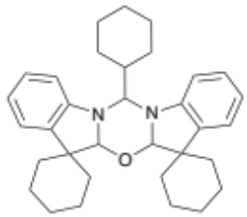
Yield: 26%
¹H NMR (500 MHz, CDCl₃): δ 7.00 (t, J = 6.9 Hz, 2H, H_{b}) 6.91 (d, J = 6.8 Hz, 2H, H_{d}) 6.62 (t, J= 7.5 Hz, 4H, H_{a} H_{c}) 5.23 (s, 2H, H_{e}) 4.95 (d, J = 10.6 Hz, 1H, H_{f}) 2.27 (m, 1H, H_{g}) 2.07-1.09 (m, 30H, CH, cyclohexyl rings overlapped).
¹³C{¹H} NMR (75 MHz, CDCl₃) : δ 148.9 (CH, C₁) 137.7 (CH, C₆) 127.4 (CH, C₃) 122.4 (CH, C₅) 118.2 (CH, C₄) 107.2 (CH, C₂) 91.2 (CH, C₈) 68.7 (CH, C₉) 48.6 (C, C₇) 39.2 (CH, C₁₀) 35.6 (CH₂, cyclohexyl), 30.1 (CH₂, cyclohexyl) 29.0 (CH₂, cyclohexyl) 26.0 (CH₂, cyclohexyl) 26.7(CH₂, cyclohexyl) 25.9(CH₂, cyclohexyl) 24.1(CH₂, cyclohexyl) 23.6(CH₂, cyclohexyl) HRMS C₃₃H₄₂N₂O theoretical 483.3370 MS (APCI 483.3387)
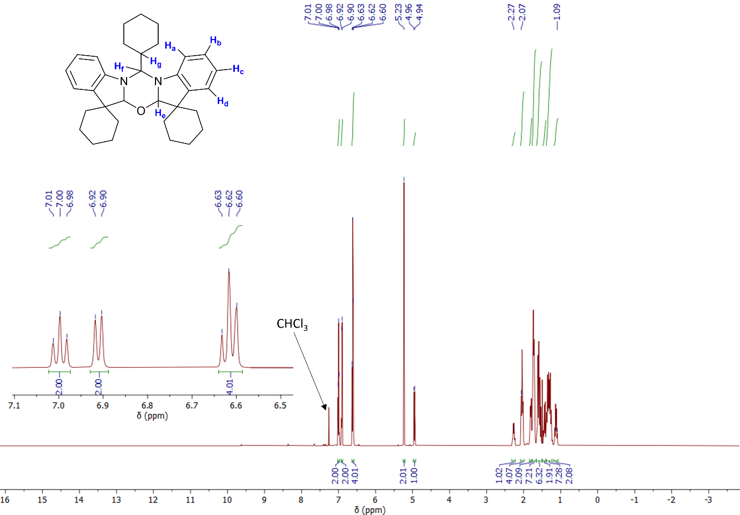Figure S1. ¹H NMR (500 MHz, CDCl₃) of NON
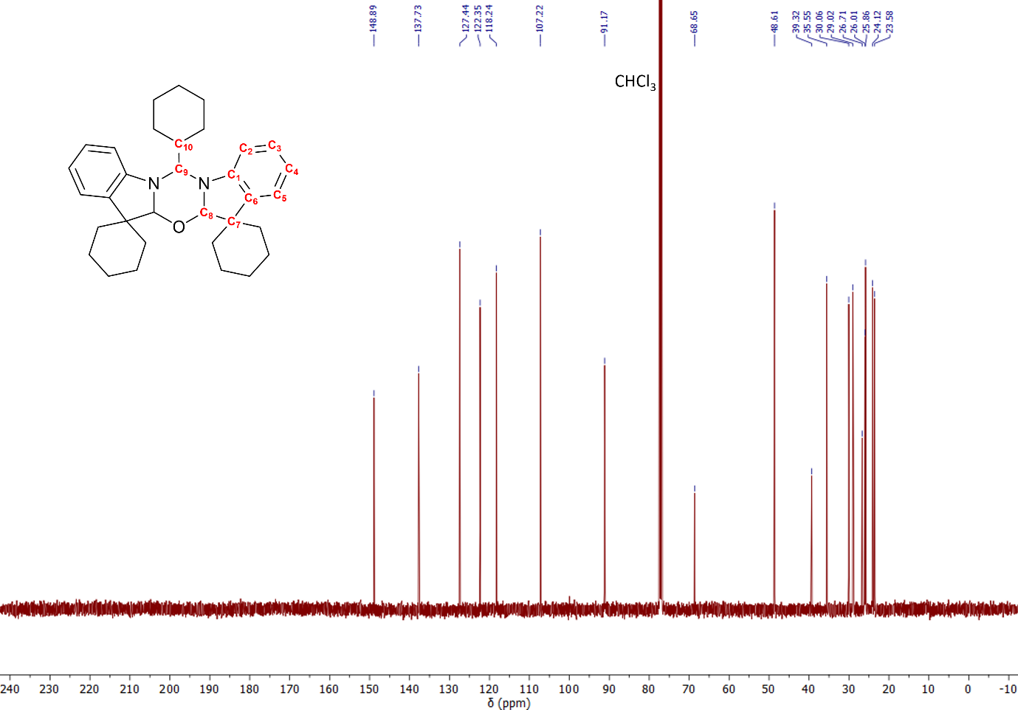Figure S2. ¹³C{¹H} NMR (75 MHz, CDCl₃) of NON
NON-CF₃
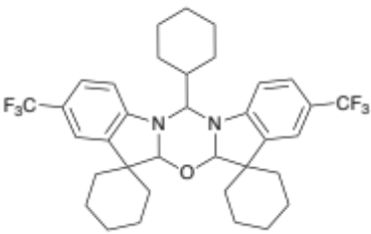
Yield: 82%
¹H NMR (500 MHz, CDCl₃): δ 7.28 (d, J=8.3 Hz, 2H, H_{b}) 7.13 (s, 2H, H_{c}) 6.60 (d, J= 8.4 Hz, 2H, H_{a}) 5.29 (s, 2H, H_{d}) 4.98 (d, J = 10.9 Hz, 1H, H_{e}) 2.28 (m, 1H, H_{f}) 2.08-0.87 (m, 30H, CH₂ cyclohexyl rings overlapped).
¹³C{¹H} NMR (75 MHz, CDCl₃): δ 151.3 (CH, C₁) 138.3 (CH, C₆) 126.1 (CH, q, ³J_{CF} = 3.9 Hz, C₅) 125.4 (CF, broad q, ¹J_{CF}= 275 Hz, C₁₁) 120.8 (CH, q, ²J_{CF}=32 Hz, C₄) 119.9 (CH, q, ³J_{CF}= 3.7 Hz, C₃) 106.5 (CH,C₂) 91.50 (CH, C₈) 69.2(CH, C₉) 48.7 (CH,C₇) 39.0 (CH, C₁₀) 35.5 (CH₂, cyclohexyl), 31.7 (CH₂, cyclohexyl) 29.9 (CH₂, cyclohexyl) 28.9 (CH₂, cyclohexyl) 26.5 (CH₂, cyclohexyl) 25.9 (CH₂, cyclohexyl) 25.6 (CH₂, cyclohexyl) 24.0 (CH₂, cyclohexyl) 23.4(CH₂, cyclohexyl) 22.8(CH₂, cyclohexyl)
¹⁹F NMR (470 MHz): -60.7 (CF₃-aromatic)
HRMS C₃₃H₄₂F₆N₂O theoretical 618.3039 MS (APCI 618.3056)
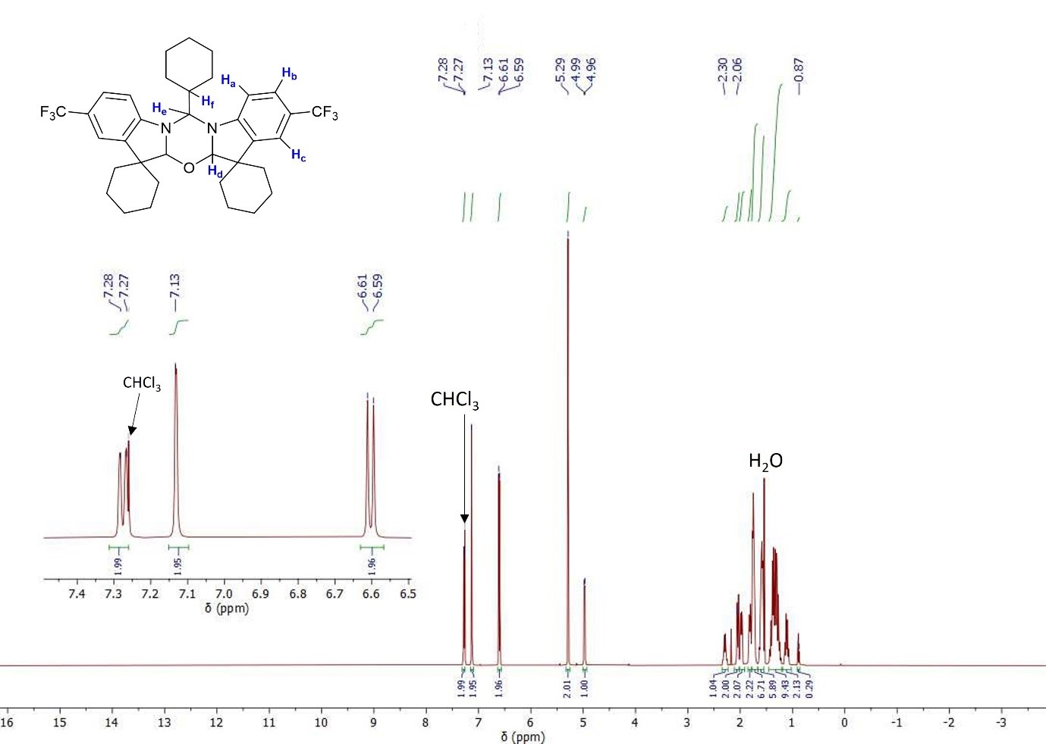Figure S3. ¹H NMR (500 MHz, CDCl₃) of NON-CF₃
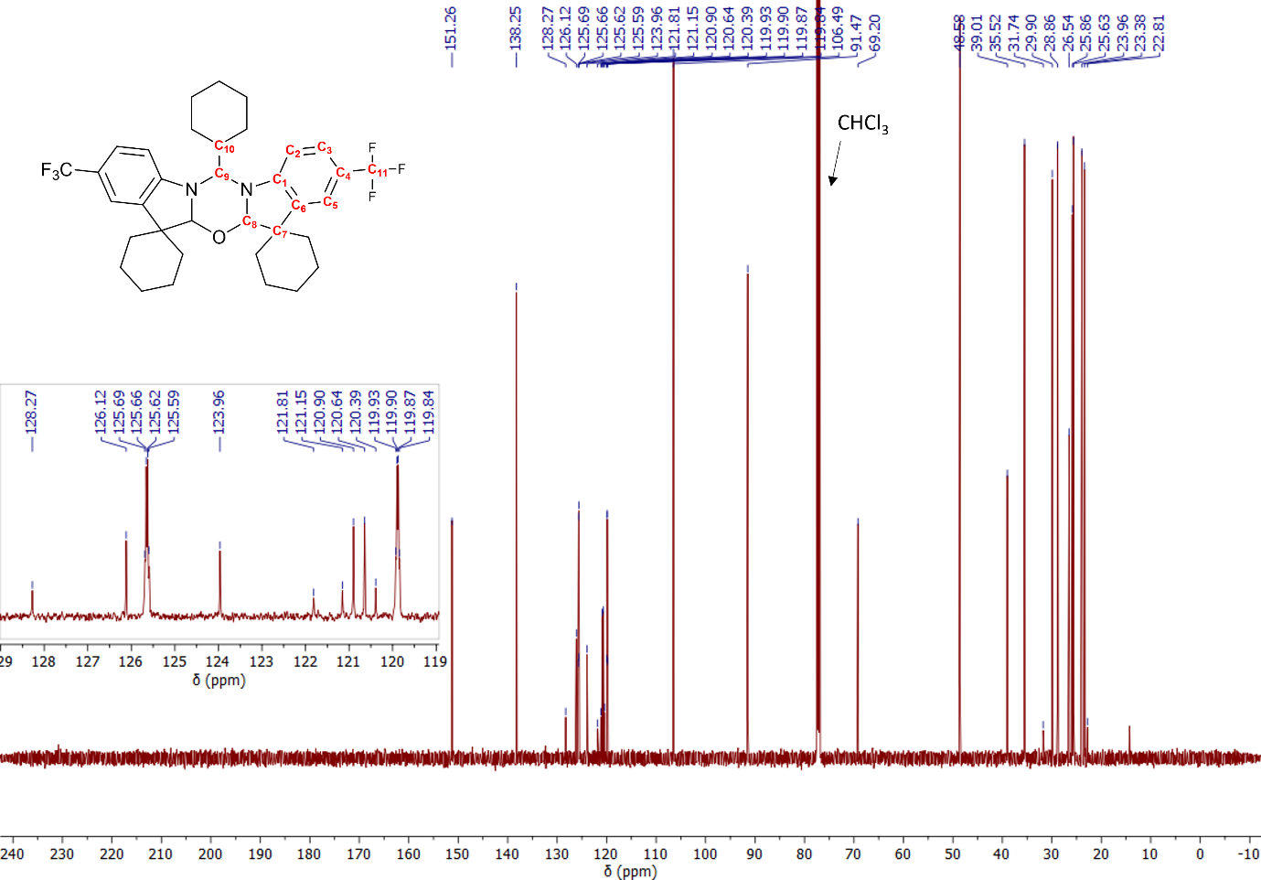Figure S4. ¹³C{¹H} NMR (75 MHz, CDCl₃) of NON-CF₃

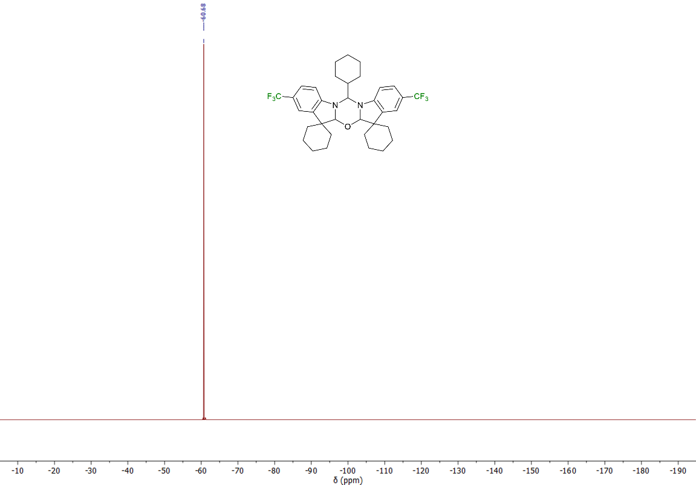Figure S5. ¹⁹F NMR (470 MHz) of NON-CF₃

NON-Br
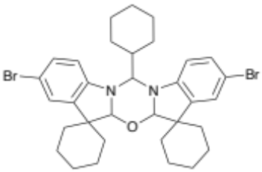
Yield: 22%
¹H NMR (500 MHz, CDCl₃): δ 7.07 (d, J= 8.5 Hz, 2H, H_{b}) 6.98 (s, 2H, H_{c}) 6.45 (d, J=8.3 , 2H, H_{a}) 5.19 (s, 2H, H_{d}) 4.80 (d, J = 10.7 Hz, 1H, H_{e}) 2.22 (m, 1H, H_{f}) 2.02-0.89 (m, ~30H, CH₂, cyclohexyl rings overlapped).
¹³C{¹H} NMR (75 MHz, CDCl₃) 147.8 (CH, C₁) 140.2 (CH, C₆) 130.0 (CH, C₃) 125.8 (CH, C₅) 110.2 (CH, C₂) 108.8 (C-Br, C₄) 91.1 (CH, C₈) 69.1 (CH, C₉) 48.9 (C,C₇) 38.9 (CH, C₁₀) 35.3 (CH₂, cyclohexyl), 31.7 (CH₂, cyclohexyl) 30.1 (CH₂, cyclohexyl) 28.8 (CH₂, cyclohexyl) 26.6 (CH₂, cyclohexyl) 25.9 (CH₂, cyclohexyl) 25.7 (CH₂, cyclohexyl) 23.9 (CH₂, cyclohexyl) 23.5 22.8 (CH₂, cyclohexyl) (CH₂, cyclohexyl)
HRMS C₃₃H₄₀Br₂N₂O 638.1532 MS (APCI 638.1502)
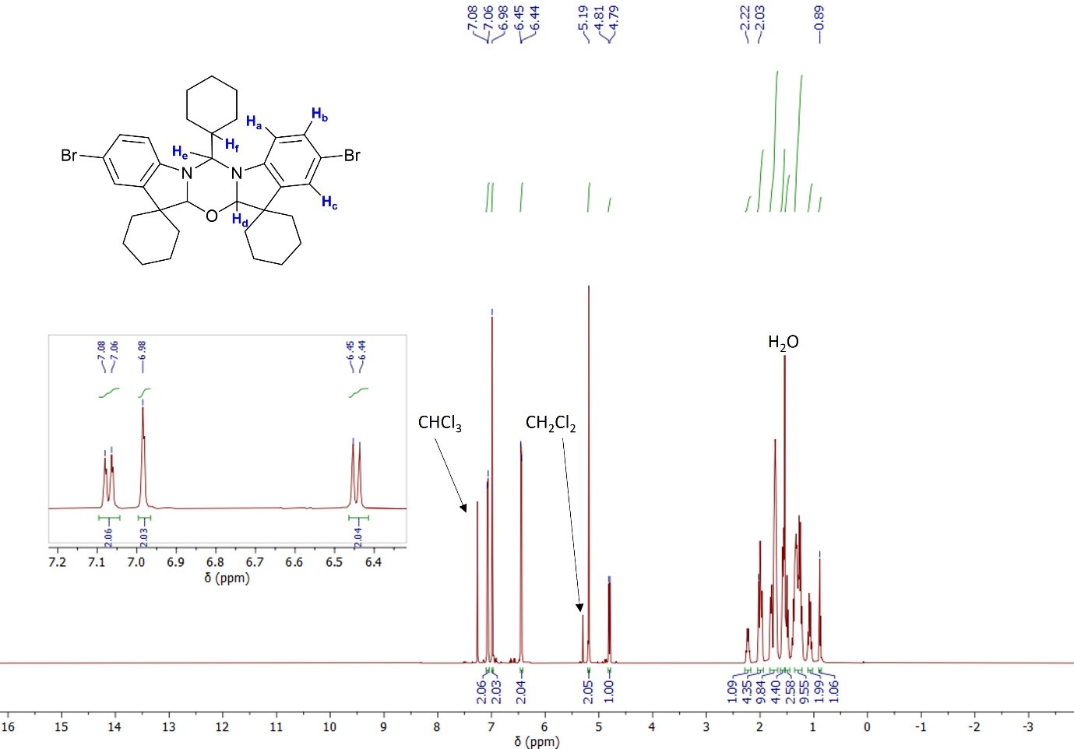Figure S6. ¹H NMR (500 MHz, CDCl₃) of NON-Br
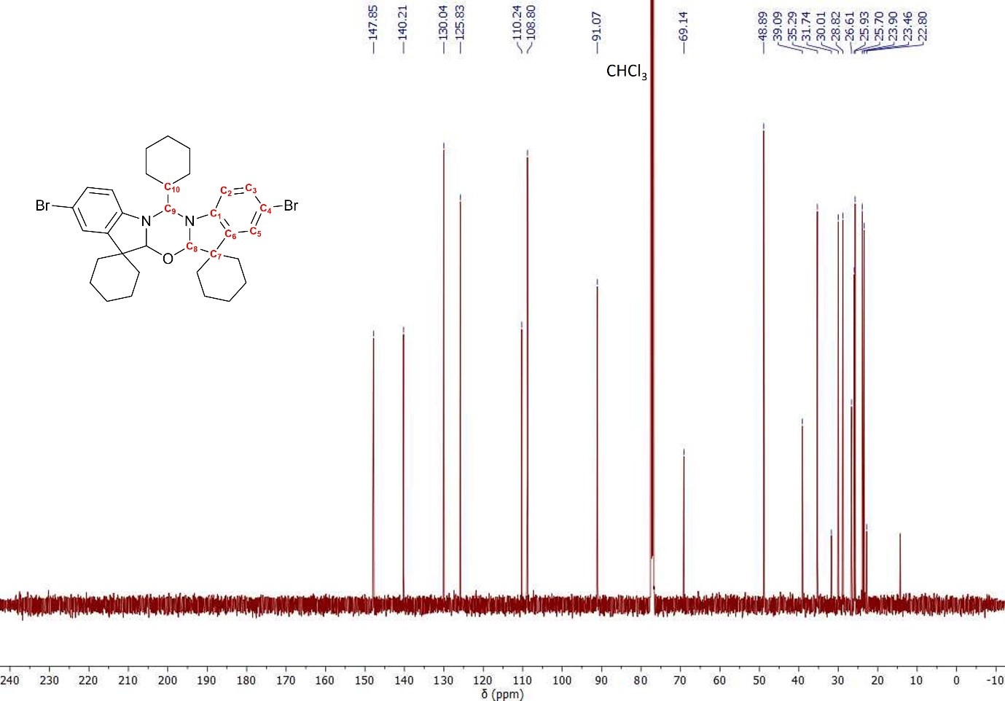
Figure S7. ¹³C{¹H} NMR (75 MHz, CDCl₃) of NON-Br

Mechanism for 1,3,5-oxadiazine formation
Whilst detailed mechanistic studies fall outside the scope of this work we have provided a potential curly arrow mechanism for the formation of NON compounds.

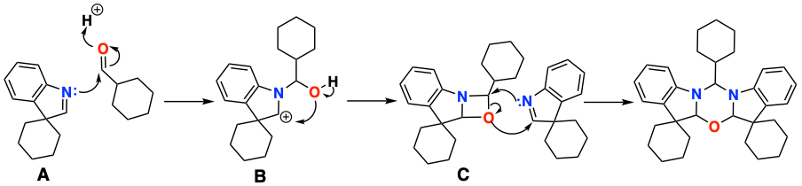
Scheme S1: Curly arrow mechanism for the formation of NON

The reaction proceeds with the formation of the classical fisher product (A). The nitrogen electron lone pair of A is then available to attach the carbonyl bond of the carboxaldehyde which is added to the reaction mixture in excess giving suggested intermediate B. In a manner analogous to the interrupted Fischer indole mechanism intramolecular nucleophilic attack within B leads to the formation of C, a highly strained four-membered ring intermediate. A final equivalent of A initiates a ring opening reaction to yield the observed 1,3,5-oxadiazine. Attempts to isolate any additional products from the reaction were unsuccessful, indicating any imine which formed was consumed.

- Crystallographic data
Crystals suitable for X-ray diffraction study were obtained by slow evaporation of the hexane solution at room temperature. Crystals were mounted in oil on glass fiber and fixed on the diffractometer in a cold nitrogen stream. Data was collected using four-cycle SuperNova, Single source (Kα Mo) X-ray Source, Oxford Rigaku diffractometer at 100 K. Data were processed using the CrystAlisPro-CCD and –RED software. Multi-scan absorption correction was applied for all crystals. Structures were solved by direct method/intrinsic phasing and refined by the full-matrix least-squares against F² in an anisotropic (for non-hydrogen atoms) approximation. All hydrogen atoms were positioned geometrically and constrained to ride on their parent atoms with C-H = 0.95-1.00 Å, and U_{iso} = 1.2−1.5 U_{eq} (parent atom). All calculations were performed using the SHELXL software and Olex2 graphical user interface.

Table S1. Summary of crystallographic data and structure refinement
 | NON | NON-CF₃ | NON-Br
CCDC № | 2363678 | 2363679 | 2363680
Empirical formula | C₃₆H₄₉N₂O | C₃₅H₄₀F₆N₂O | C₃₃H₄₀Br₂N₂O
Molecular weight | 525.77 | 618.69 | 640.49
Crystal system | Triclinic | Monoclinic | Monoclinic
Space group | P-1 | P2₁/n | P2₁/n
Crystal colour, habit | None, none, none | None, none, none | None, none, none
Crystal size (mm³) | 0.37× 0.29 × 0.25 | 0.32 × 0.25 × 0.23 | 0.4 × 0.37 × 0.30
a (Å) | 10.3980(4) | 10.1399(4) | 10.4033(3)
b (Å) | 10.5761(8) | 15.4499(6) | 14.9493(4)
c (Å) | 16.6417(11) | 19.9660(7) | 18.9504(5)
(°) | 79.594(6) | 90 | 90
(°) | 81.659(4) | 101.603(4) | 104.082(3)
(°) | 64.055(6) | 90 | 90
V (Å³) | 1613.83(19) | 3012.9(2) | 2858.64(14)
Z | 2 | 4 | 4
Dcalc (g cm⁻³) | 1.082 | 1.364 | 1.488
2θmax (°) | 55.99 | 58.15 | 58.31
Abs. coeff., (Mo-K) (mm⁻¹) | 0.064 | 0.107 | 2.865
T (K) | 100.00 | 100.15 | 100.00
Number of collected reflections | 22492 | 25412 | 24700
Number of independent reflections | 7442 | 7250 | 6819
R_{int} | 0.0821 | 0.0482 | 0.0422
Number of parameters | 351 | 397 | 343
R₁ (on F for observed reflexions) | 0.1061 | 0.0506 | 0.0367
wR₂ (on F2 for all reflexions) | 0.3517 | 0.1282 | 0.0821
F(000) | 574.0 | 1304.0 | 1320
Goodness-of-fit | 1.042 | 1.042 | 1.019

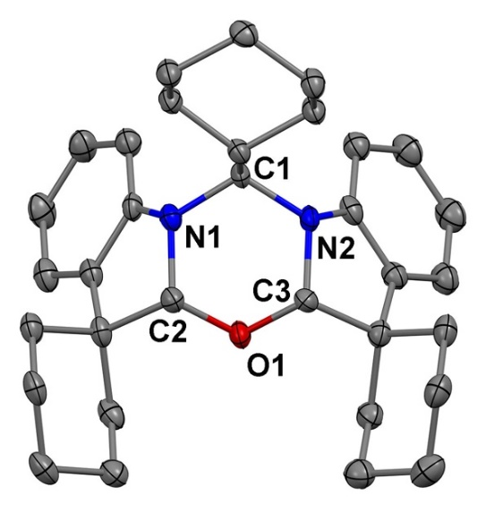

Figure S8. X-ray crystal structure of NON. Ellipsoids are shown at the 50% level. Hydrogen atoms emitted for clarity.
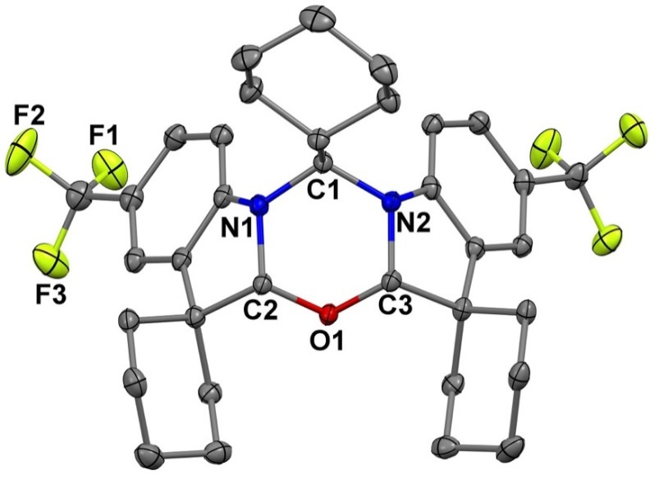
Figure S9. X-ray crystal structure of NON-CF₃. Ellipsoids are shown at the 50% level. Hydrogen atoms emitted for clarity.

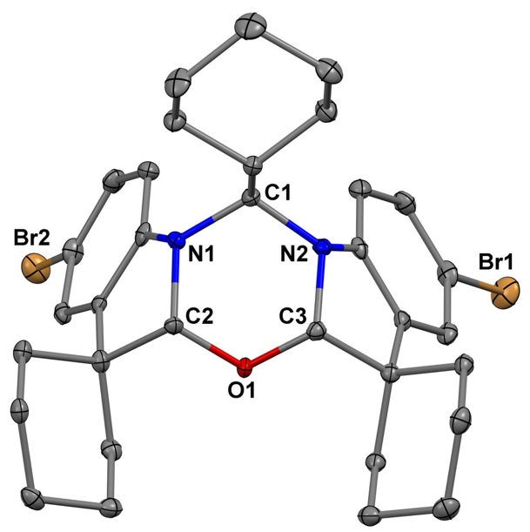
Figure S10. X-ray crystal structure of NON-Br. Ellipsoids are shown at the 50% level. Hydrogen atoms emitted for clarity.

- Electrochemical and Thermal Properties
Electrochemical analysis was conducted for complexes NON, NON-CF₃ and, NON-Br using a glassy carbon electrode in DFB solution (1.4 mM) with [n-Bu₄]PF₆ as the supporting electrolyte (0.13 M), scan rate 0.1 Vs⁻¹
Table S2: Formal electrode potentials (peak position E_{p} for irreversible and E_{1/2} for quasi-reversible processes (*), V, vs. FeCp₂), onset potentials (E, V, vs. FeCp₂), peak to peak separation in parentheses for quasi reversible processes (ΔE_{p} in mV), and E_{LUMO} (eV) compounds NON, NON-CF₃ and, NON-Br. ª
Compound | Oxidation |  |  | E_{HOMO}
Compound | E_{1st} | E_{onset ox} | E_{2nd} | eV
NON | +0.50 | +0.37 | - | – 5.76
NON-CF₃ | +0.90 (100) | +0.75 | +1.38 | – 6.14
NON-Br | +0.62 (90) | +0.51 | +1.12 (140) | – 5.90
ª In DFB solution, recorded using a glassy carbon electrode, concentration 1.4 mM, supporting electrolyte [nBu₄N][PF₆] (0.13 M), measured at 0.1 V s-1. E_{HOMO} = –(E_{onset ox Fc/Fc+} + 5.39) eV (Adv. Mater. 2011, 23, 2367-2371).
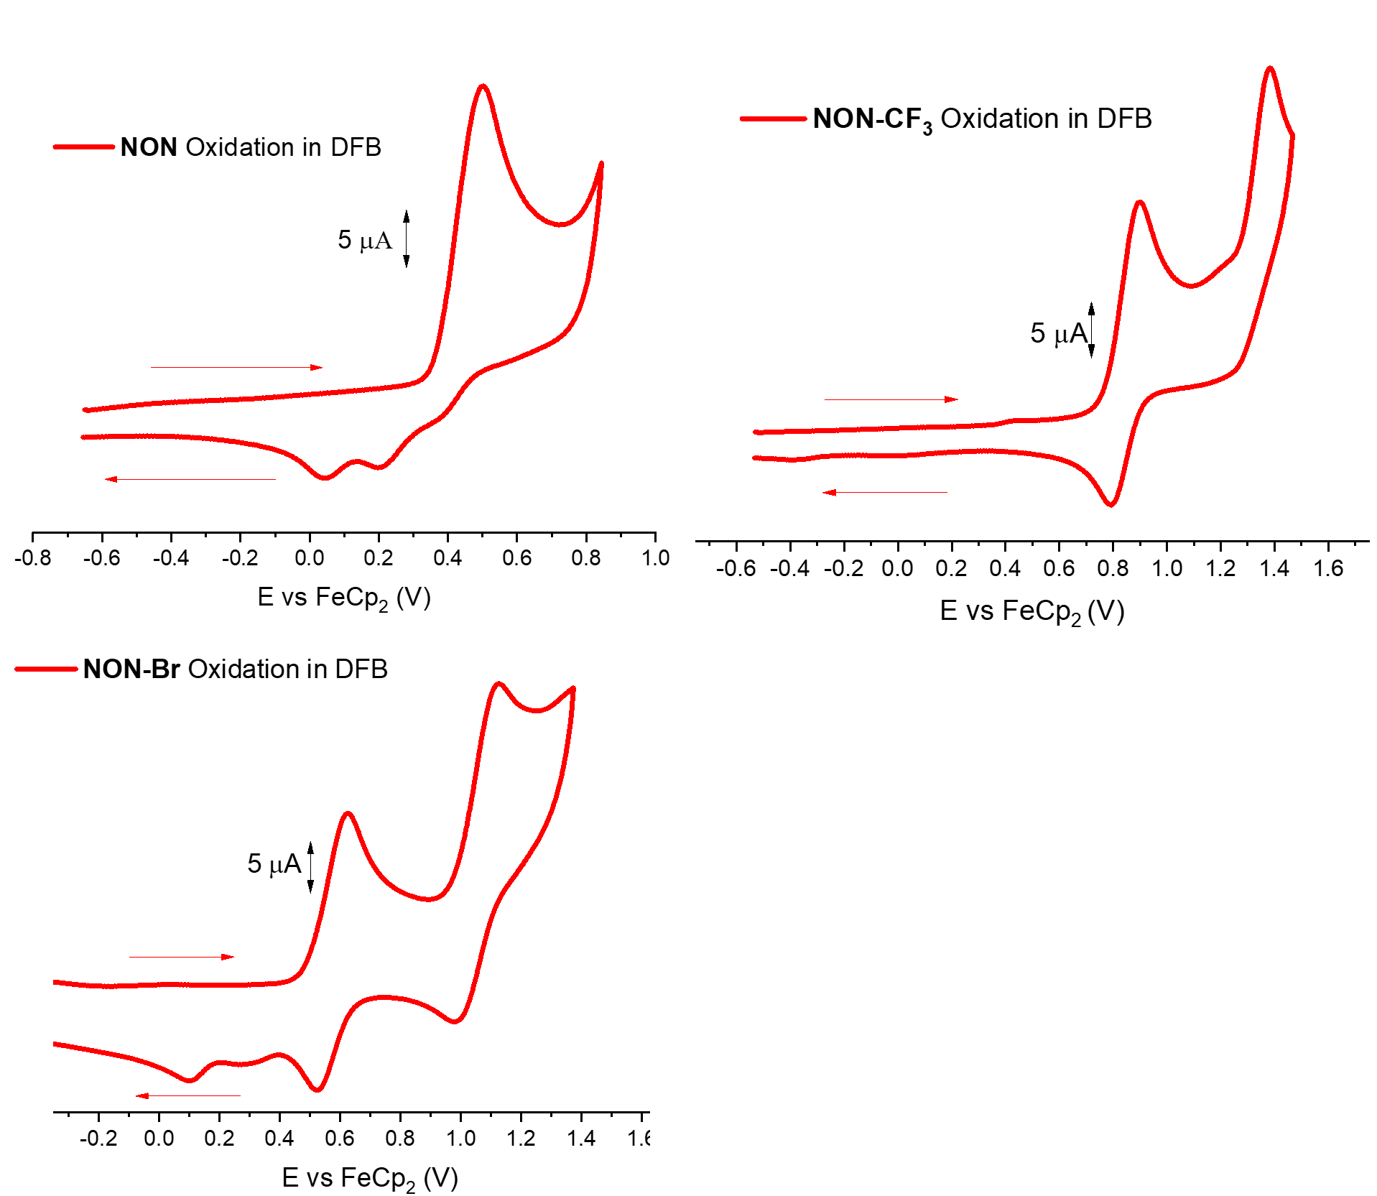
Figure S11: Oxidation only cyclic voltammogram for NON, NON-CF₃, and NON-Br. Recorded using a glassy carbon electrode in DFB solution (1.4 mM) with [n-Bu₄N]PF₆ as supporting electrolyte (0.13 M), scan rate 0.1 V s-1.
Thermogravimetric Analysis
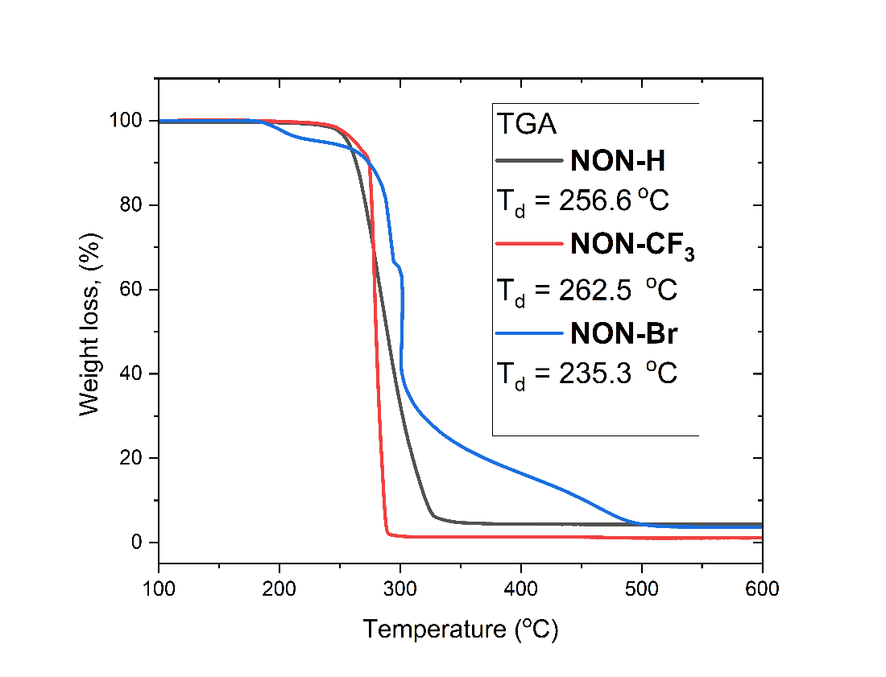
Figure S12: TGA curves for compounds NON, NON-CF₃ and NON-Br. Decomposition temperature (T_{d}) indicates temperature at 5% weight loss.

- Photophysical Characterisation
Photoluminescence Quantum Yield
Quantum yields have been measured in air for solid samples and under nitrogen for solutions. Photoluminescence quantum yields were recorded using an Hamamatsu Quantaurus-QY C11347-11. Quantum yields have been measured in air for solid samples and under nitrogen for solutions.
Steady-state Photoluminescence
Steady-state PL spectra were recorded using an Edinburg Instruments FLS980 spectrofluorimeter. The light source was a monochromated Xenon arc lamp; excitation wavelength varied. Samples were measured in air or under flowing nitrogen, at room temperature.
UV-Vis Absorption
UV-Vis spectra were measured using a Varian Cary 5000 UV-Vis-NIR spectrometer and Shimadzu UV-3600 Plus UV-VIS-NIR spectrophotometer. The spectrometer has a PMT detector for wavelength ranges from UV to visible, as well as InGaAs and PbS detectors for NIR. The light source used was a deuterium lamp for wavelengths less than 280nm and a tungsten halogen lamp for higher wavelengths.

Table S3: UV-vis data for compounds NON, NON-CF₃, and NON-Br in cyclohexane, THF and CH₂Cl₂ solutions
Compound | λ_{abs} [nm], (10³ ɛ/M^{–1} cm^{–1})
Compound | cyclohexane | THF | CH₂Cl₂
NON | 293 (9.4), 303 (sh)ª | 260 (24), 293 (8.4), 303 (sh) | 264 (28), 294 (10.5), 304 (sh)
NON-CF₃ | 267 (22.4), 302 (sh) | 271 (17.8), 302 (sh) | 273 (21.2), 302 (sh)
NON-Br | 266 (18.6), 304 (4.9) | 267 (11.4), 303 (3.4) | 270 (15.7), 304 (4.1)
ª sh = shoulder
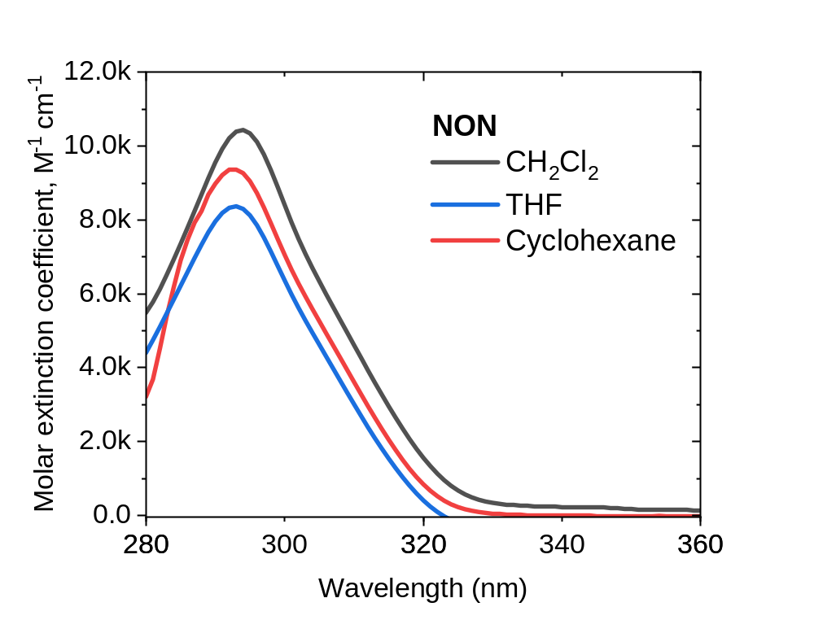
Figure S13: UV-vis absorption spectra for NON in CH₂Cl₂, THF and Toluene solution at 295 K
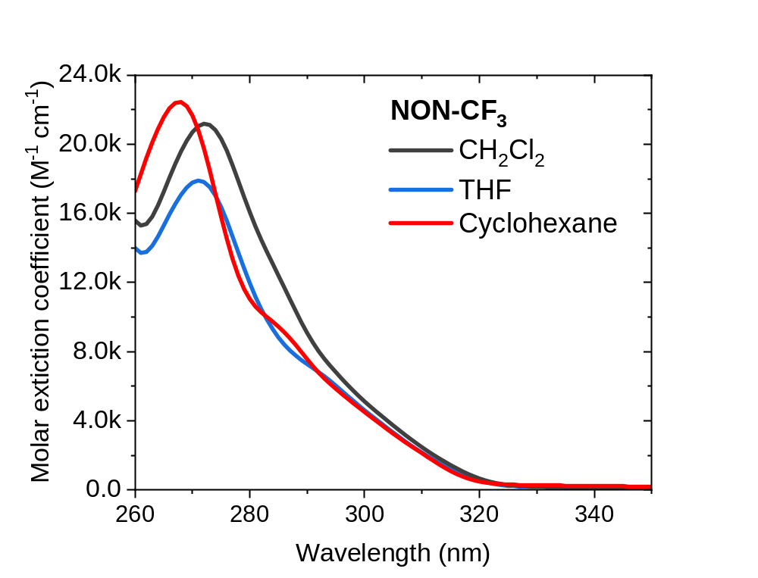
Figure S14: UV-vis absorption spectra for NON-CF₃ in CH₂Cl₂, THF and cyclohexane solution at 295 K

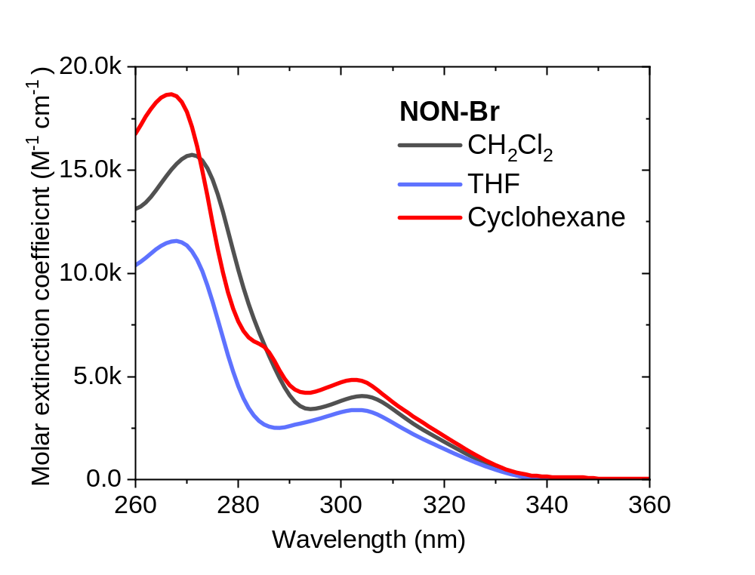
Figure S15: UV-vis absorption spectra for NON-Br in CH₂Cl₂, THF and cyclohexane solution at 295 K

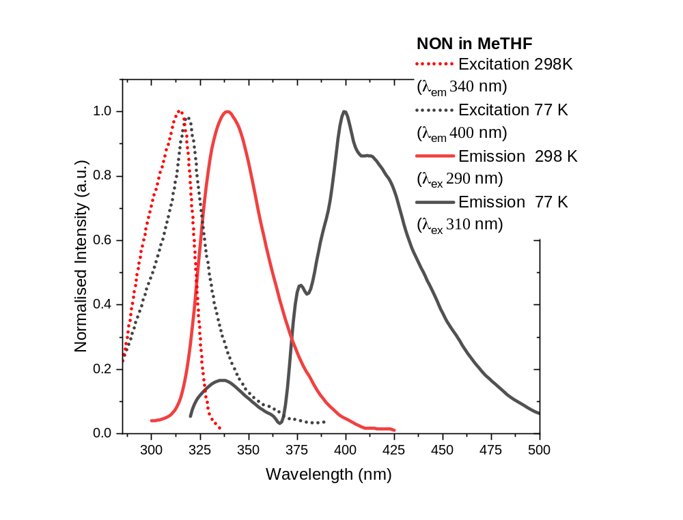
Figure S16: Excitation and Emission spectra for NON in MeTHF solution at 298 and 77 K

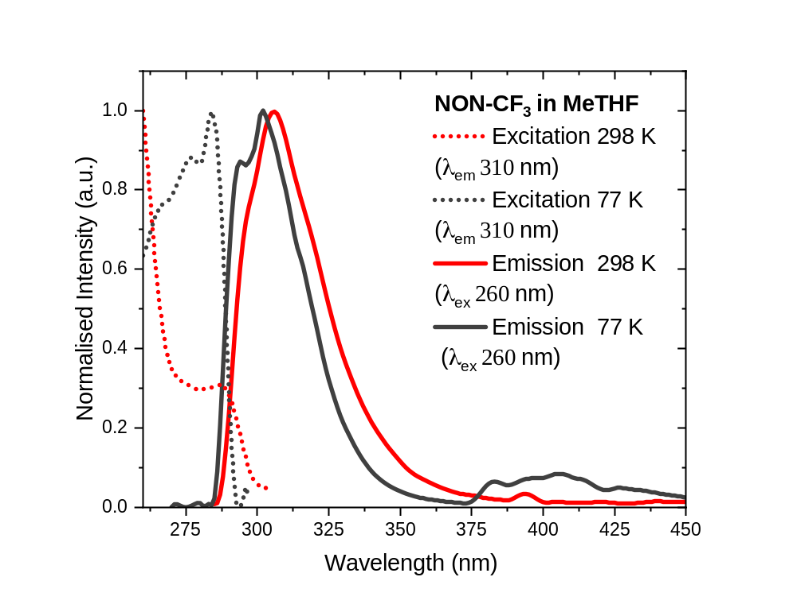
Figure S17: Excitation and Emission spectra for NON-CF₃ in MeTHF solution at 298 and 77 K

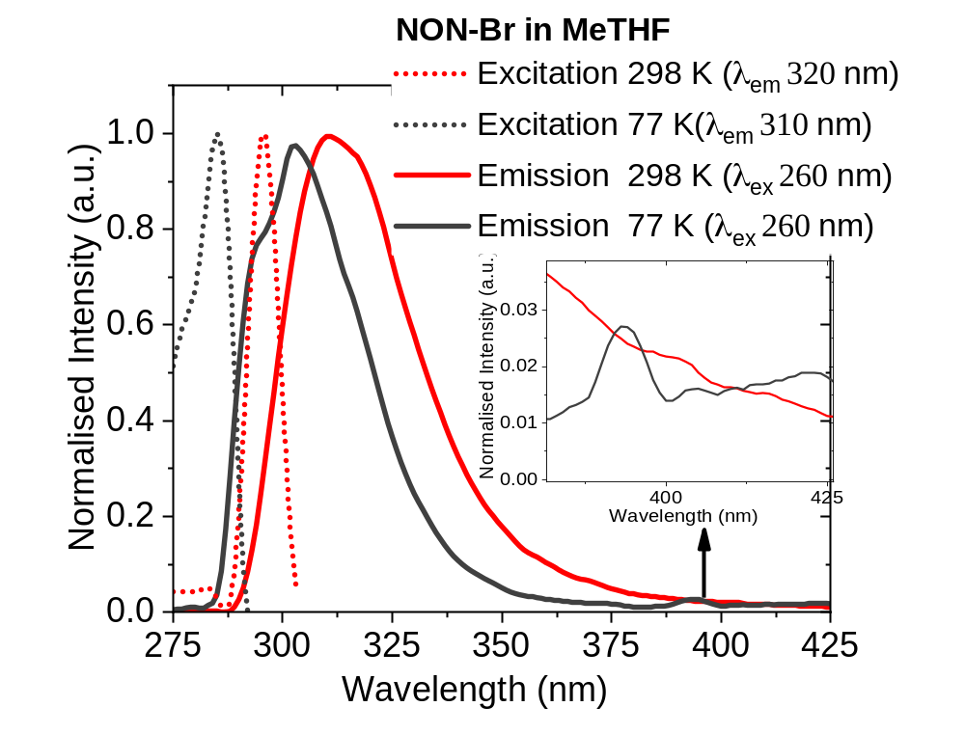
Figure S18: Excitation and Emission spectra for NON-Br in MeTHF solution at 298 and 77 K

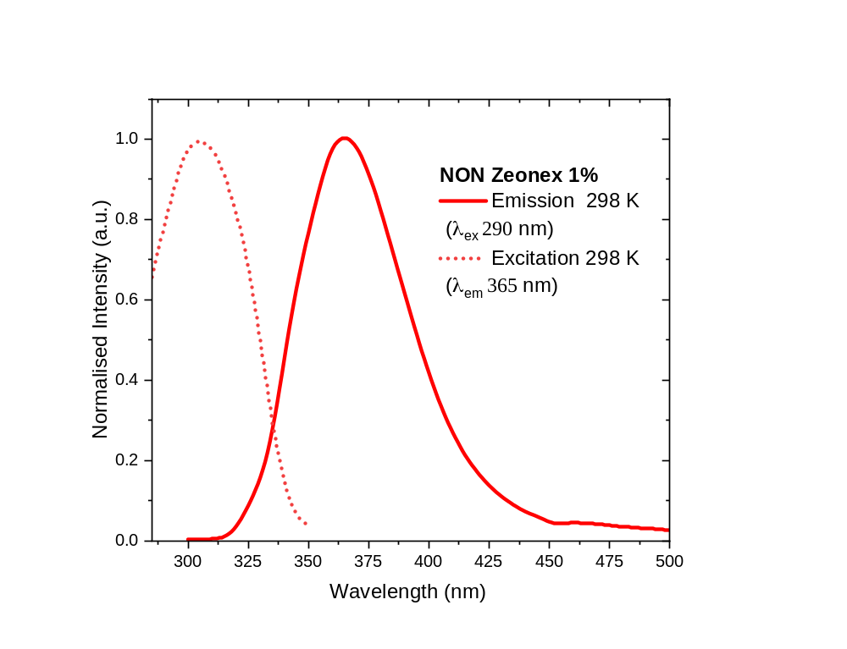
Figure S19: Excitation and Emission spectra for NON in a Zeonex matrix (1 wpc) at 298 K
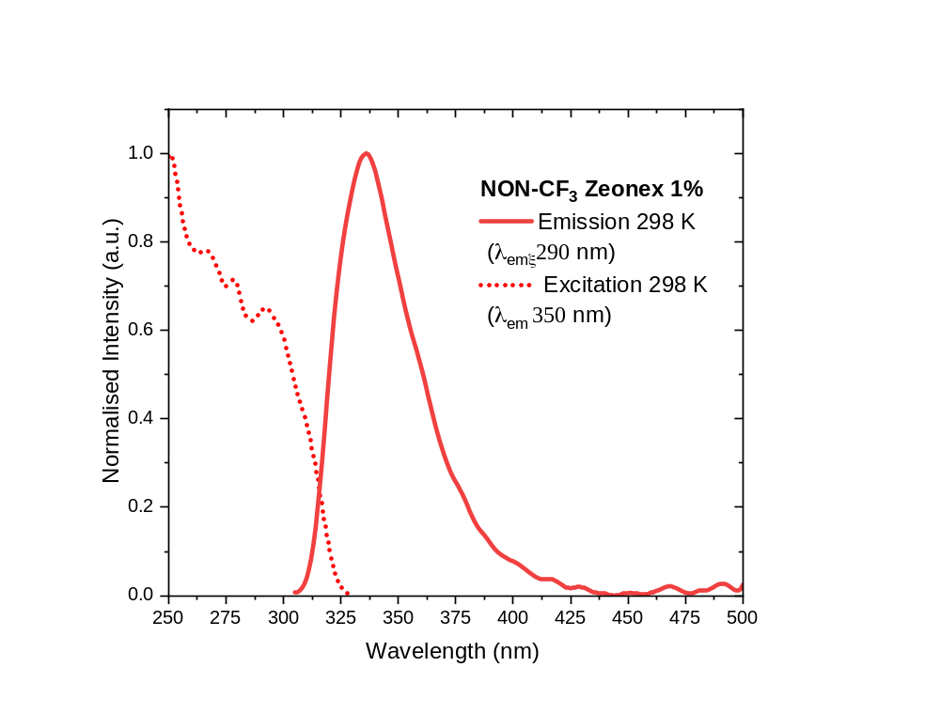
Figure S20: Excitation and Emission spectra for NON-CF₃ in a Zeonex matrix (1 wpc) at 298 K

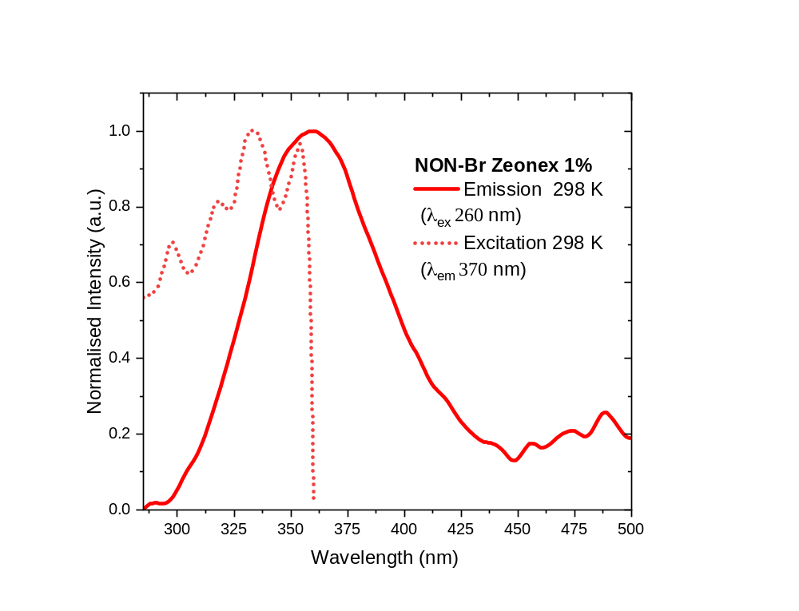
Figure S21: Excitation and Emission spectra for NON-Br in a Zeonex matrix (1% by weight) at 298 K.

- Device fabrication and characterisation

For the fabrication of OLED devices, ITO coated substrates (~15 Ω/cm²) were cleaned with acetone and isopropyl alcohol, and then O₂ plasma treatment was applied to align the energy level with a hole transporting layer. All layers, including organic layers and a LiF/aluminium cathode, were thermally deposited in high vacuum (~10⁻⁷ torr).
The performance of the OLED devices was measured by a Keithley 2635 source-meter and a calibrated Si photodiode. The EL spectra were recorded by an Ocean Optics Flame spectrometer. The voltage pulse was given by a Keithley 2401 function generator (20,000 Hz frequency and 10 µs pulse width).

- Computational results

Table S4. Optimised gas phase structures and molecular orbital distribution of the HOMO (middle) and LUMO (right) for NON-materials involved in vertical excitation (S₀ → S₁).
 | HOMO | LUMO
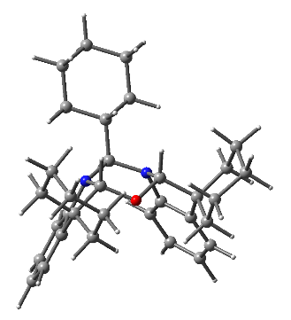  NON  Overlap integral: 0.62 | 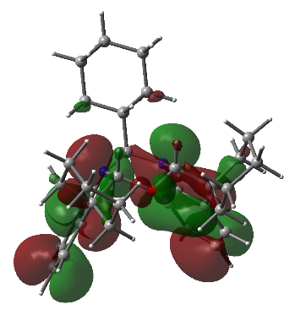 | 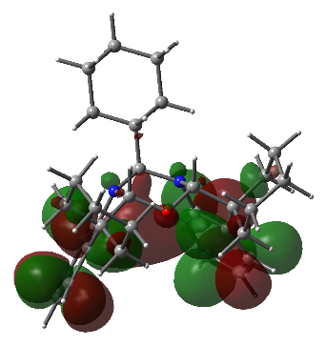
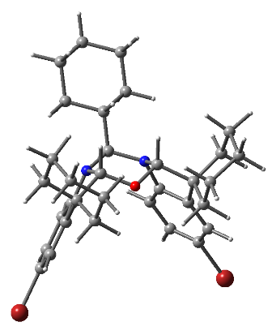  NON-Br  Overlap integral: 0.62 | 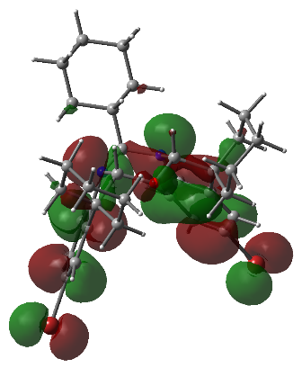 | 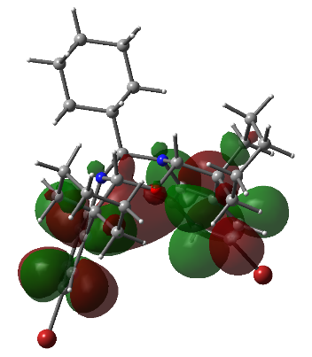
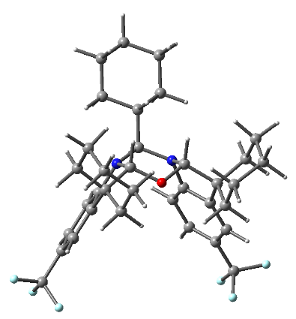  NON-CF₃  Overlap integral: 0.66 | 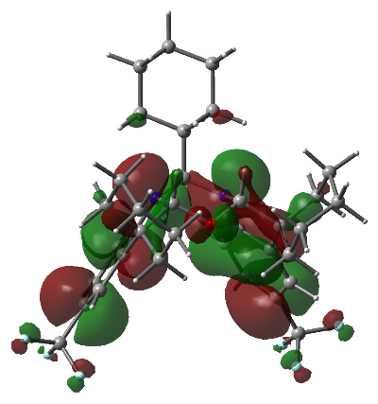 | 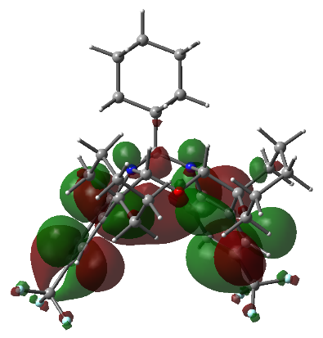

Table S5. Dipole moments of S₀ and S₁ states in S₀ geometry.
 | S₀ | S₁@S₀
NON | 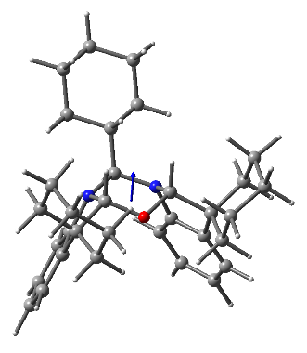  2.1D | 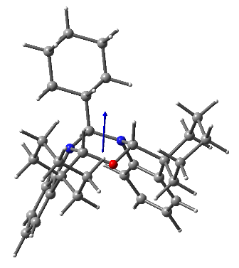  3.7D
NON-Br | 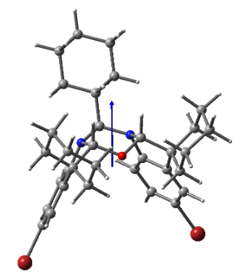  5.9D | 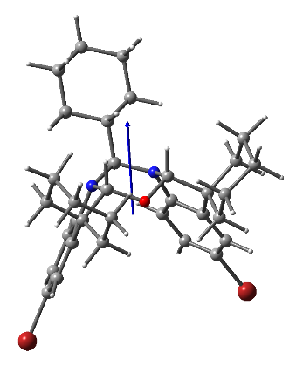  6.7D
NON-CF₃ | 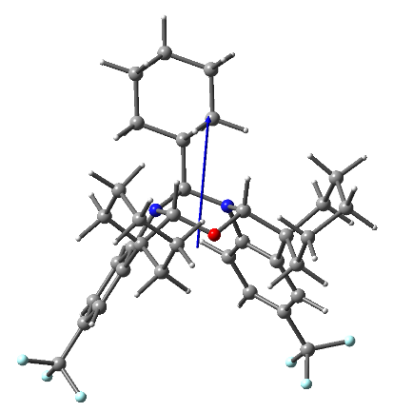  7.9D | 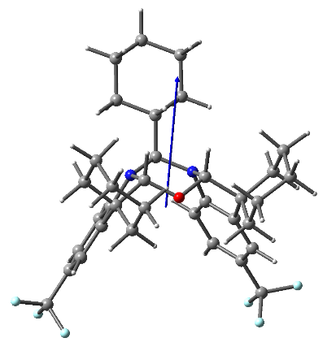  9.4D

Table S6. Theoretically calculated S₁ and T₁ energy levels, orbital (HOMO, LUMO) contributions to vertical excitations (S₀ → S₁, S₀ → T₁, and S₀ → T₂) and oscillator strength coefficients.
 | Excitation energy | Character | Oscillator strength
NON | S₁: 4.63eV = 268nm | HOMO – LUMO (81%) | 0.000
NON | T₁: 3.89eV = 318nm | HOMO – LUMO+2 (57%)  HOMO-1 – LUMO+3 (23%)
NON | T₂: 3.92eV = 316nm | HOMO – LUMO (72%)  HOMO-1 – LUMO+1 (24%)
NON-Br | S₁: 4.43eV = 280nm | HOMO – LUMO (82%) | 0.0003
NON-Br | T₁: 3.72eV = 333nm | HOMO – LUMO (69%)  HOMO-1 – LUMO+1 (20%)
NON-Br | T₂: 3.75eV = 331nm | HOMO – LUMO+2 (57%)  HOMO-1 – LUMO+3 (22%)
NON-CF₃ | S₁: 4.63eV = 268nm | HOMO – LUMO (75%) | 0.0066
NON-CF₃ | T₁: 3.76eV = 329nm | HOMO – LUMO (33%)  HOMO – LUMO+1 (32%)  HOMO-1 – LUMO+3 (19%)
NON-CF₃ | T₂: 3.87eV = 321nm | HOMO – LUMO+3 (40%)  HOMO-1 – LUMO+1 (26%)

Table S7. Natural transition orbitals for vertical excited states.
 |  | HONTO | LUNTO
NON | S₁ | 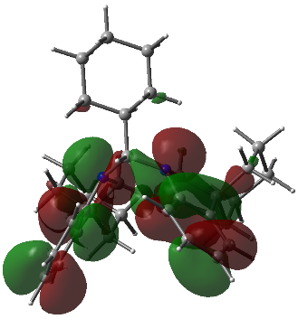 | 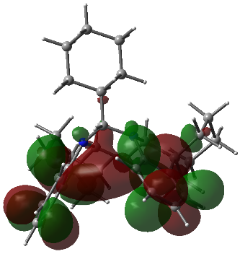
NON | T₁ | 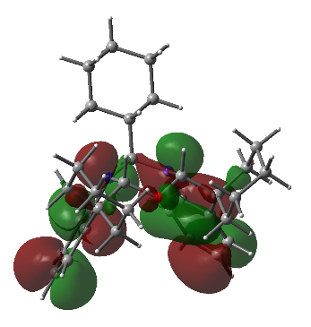 | 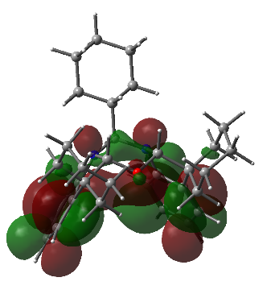
NON | T₂ | 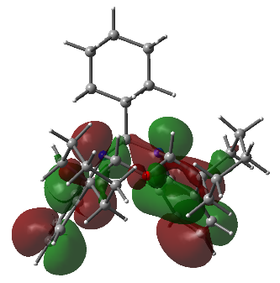 | 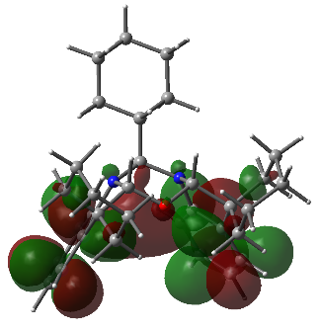
NON-Br | S₁ | 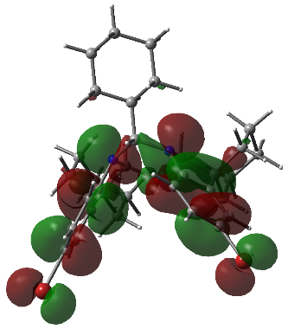 | 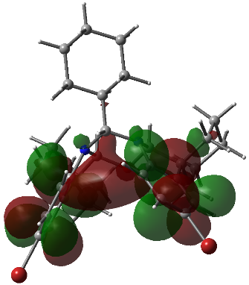
NON-Br | T₁ | 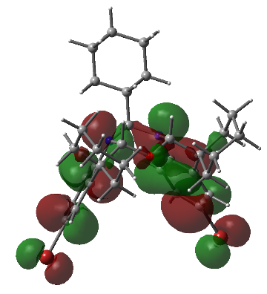 | 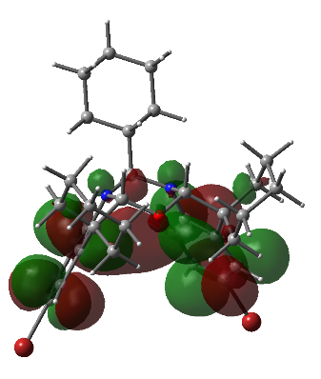
NON-Br | T₂ | 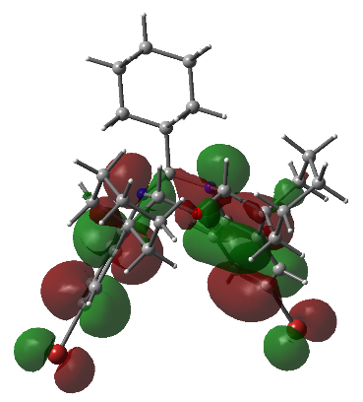 | 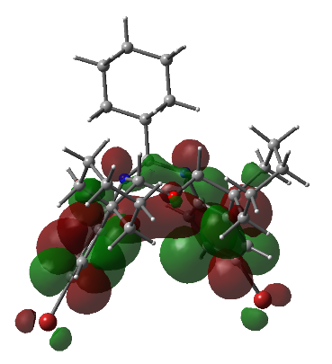
NON-CF₃ | S₁ | 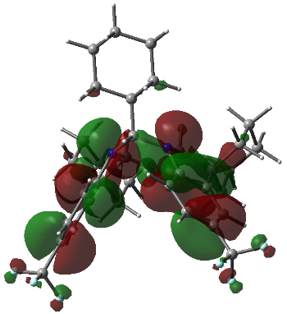 | 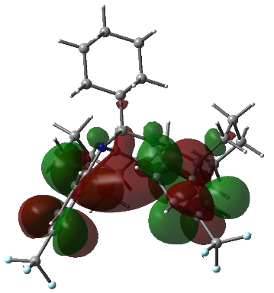
NON-CF₃ | T₁ | 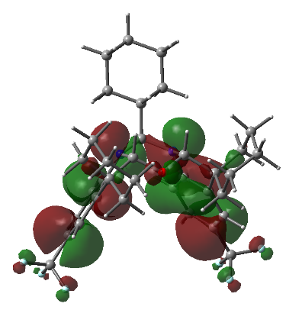 | 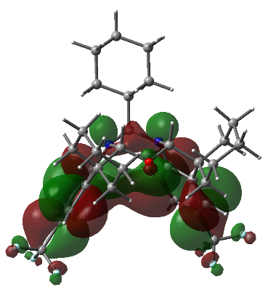
NON-CF₃ | T₂ | 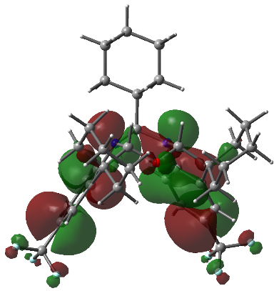 | 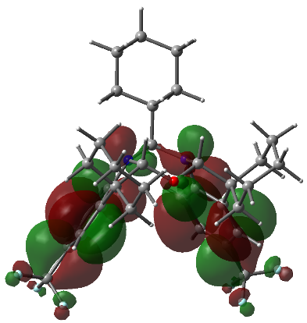

- Optimised coordinates:
78
NON
O 0.00015100 -1.06562100 -0.54311200
N 1.19578600 0.69664000 0.45947800
N -1.19585400 0.69655300 0.45917100
C -0.00003300 2.65449700 -0.43793400
H -0.00013400 2.22554400 -1.45096600
C -2.40512600 -1.15369000 -0.37446600
C -1.25205600 3.51211500 -0.28481600
H -2.14418000 2.89532100 -0.41383300
H -1.27951300 3.89939800 0.74407100
C 2.40536700 -1.15352000 -0.37387600
C -1.81175200 0.07930500 1.55761100
C 0.00005400 5.53410000 -1.08968800
H 0.00013600 5.96991200 -0.08304300
H 0.00005300 6.36613800 -1.79755200
C 3.62037400 -0.61113400 -2.55897900
H 2.80583100 -0.00545600 -2.97213500
H 4.54621500 -0.19452900 -2.96260900
C 1.82160200 0.46143600 2.89041500
H 1.27264200 1.32749700 3.23926000
C 2.53442400 -1.03443600 1.12626500
C 1.81125200 0.07925800 1.55810900
C -1.25000900 4.68070200 -1.26240100
H -1.27581900 4.28919100 -2.28690100
H -2.15142200 5.28352600 -1.13158800
C -1.16543300 -0.27336000 -0.61897600
H -1.17842600 0.24024900 -1.59004400
C -3.63365700 -0.50571500 -1.03813900
H -4.51958200 -1.02053800 -0.64831900
H -3.70353500 0.53825100 -0.71430400
C -1.82266200 0.46166200 2.88986500
H -1.27388500 1.32780000 3.23881000
C 1.16568800 -0.27326300 -0.61870200
H 1.17887400 0.24037600 -1.58975200
C 3.63407200 -0.50537800 -1.03705900
H 3.70377800 0.53854900 -0.71306700
H 4.51990500 -1.02019800 -0.64702700
C -0.00008400 1.51215700 0.58305200
H -0.00021600 1.96786700 1.57721100
C 1.25001100 4.68058200 -1.26256000
H 1.27565300 4.28907700 -2.28706800
H 2.15149800 5.28332200 -1.13186200
C 3.27211500 -1.78266200 2.01935200
H 3.83438200 -2.64635500 1.68043400
C -2.53473400 -1.03445400 1.12561500
C 1.25209800 3.51197800 -0.28499100
H 1.27977200 3.89922300 0.74390300
H 2.14414300 2.89510500 -0.41416900
C -3.27277400 -1.78257800 2.01849900
H -3.83490100 -2.64631500 1.67945900
C 2.23987600 -2.58483600 -0.87379900
H 3.11175100 -3.15674200 -0.53210300
H 1.35625200 -3.03223400 -0.41645400
C -2.23934100 -2.58505000 -0.87416800
H -3.11125700 -3.15700000 -0.53265200
H -1.35580500 -3.03229900 -0.41650700
C 2.17472100 -2.64844200 -2.39482200
H 1.29804000 -2.08683100 -2.74162800
H 2.03599200 -3.68141600 -2.72154600
C -3.28319700 -1.41707100 3.36642400
H -3.84817400 -1.99908100 4.08283400
C -3.61948300 -0.61167600 -2.56004100
H -4.54522100 -0.19518200 -2.96401700
H -2.80484500 -0.00601300 -2.97303100
C 3.28198800 -1.41732200 3.36732600
H 3.84668900 -1.99941000 4.08389200
C 2.56429900 -0.30576300 3.78774600
H 2.57591600 -0.02663600 4.83413300
C -2.17373200 -2.64885000 -2.39516300
H -1.29699100 -2.08722200 -2.74178700
H -2.03483000 -3.68185900 -2.72170500
C 3.43830800 -2.05593600 -3.00745800
H 4.30233000 -2.64618100 -2.67798200
H 3.40742700 -2.11632900 -4.09773500
C -2.56570600 -0.30543800 3.78699100
H -2.57776000 -0.02617300 4.83333600
C -3.43718500 -2.05653000 -3.00825700
H -3.40597700 -2.11708200 -4.09851500
H -4.30126000 -2.64678900 -2.67894800
78
NON_Br
Br -4.55233900 3.77763400 -0.34399300
Br 3.89482800 4.43509500 -0.34807000
O 0.08664900 -0.95515400 1.27825500
C -2.17232100 -0.55743800 2.75061000
H -1.33535300 0.13240300 2.86710500
H -3.08220400 -0.02325300 3.05136200
N 1.27003700 -0.97344000 -0.75415000
C 2.29629000 -0.26435100 2.72493800
H 3.12097900 0.39748900 3.01738700
H 1.36664100 0.28650300 2.87456100
N -1.11336100 -1.15387100 -0.73745500
C -3.44891800 2.25756900 -0.52944500
C 3.12604400 1.83331100 0.49904900
H 3.68040700 2.06807800 1.40019400
C -1.91173000 0.95808500 -1.85809700
H -1.36621600 0.82126200 -2.78339600
C 1.77603000 0.33121300 -0.82487600
C 2.48543800 0.62331100 0.34235700
C 0.36342800 -4.97329100 -3.97601000
H 0.33207800 -4.36046700 -4.88515500
H 0.43546800 -6.01515200 -4.29596800
C 3.04155800 2.76207200 -0.53683600
C 1.48513000 -3.12853600 -2.69374400
H 1.48140800 -2.46927100 -3.57387000
H 2.35449900 -2.84917200 -2.09431500
C 2.46849900 -0.58752300 1.24460800
C 3.86512600 -2.61897400 1.92348100
H 3.10581000 -3.35589200 1.63812900
H 4.83267900 -3.10269700 1.77160300
C -2.54826800 0.24524400 0.36347400
C 3.76565700 -1.38773400 1.02809000
H 3.84475500 -1.65971700 -0.02982100
H 4.60120300 -0.71307300 1.24766100
C -1.82022100 0.05289500 -0.81261200
C -2.73552800 2.07210200 -1.70205800
H -2.81957600 2.79993300 -2.49825400
C 0.09915900 -1.40359500 -1.49885000
H 0.04920800 -0.81889700 -2.42184300
C -1.04609300 -1.52927500 0.66329200
H -0.98369500 -2.62146600 0.75890400
C -2.01015700 -1.78848700 3.63337700
H -1.09535800 -2.32153900 3.34460900
H -1.88332500 -1.48755200 4.67544900
C -2.32560200 -0.93363900 1.28051800
C 3.67076600 -2.24924800 3.38875400
H 3.72083900 -3.14118000 4.01714700
H 4.48761100 -1.58875600 3.70435900
C 1.28026400 -1.36096400 0.64426800
H 1.37668500 -2.45122400 0.73409400
C -3.37919600 -3.13947800 2.03004600
H -2.52175000 -3.75740100 1.74031400
H -4.26391900 -3.76888000 1.91031400
C 2.34475400 2.47968700 -1.69999300
H 2.29799500 3.22086700 -2.48684900
C -3.36909800 1.34144700 0.51797200
H -3.93927000 1.49854300 1.42613600
C -3.21287600 -2.71266000 3.48319200
H -4.11389600 -2.17684500 3.80598300
H -3.11369000 -3.58802900 4.12877800
C -1.01471300 -3.29305100 -2.72037600
H -1.92555500 -3.12821600 -2.14055600
H -1.07605300 -2.63948400 -3.60267600
C 0.20482500 -2.87721400 -1.90386700
H 0.23541300 -3.49503500 -0.99428300
C -0.91255300 -4.74322300 -3.17645700
H -1.79212800 -5.01638600 -3.76336700
H -0.90412000 -5.39565200 -2.29460600
C -3.48898800 -1.92752000 1.10987500
H -4.41374500 -1.38447200 1.33667400
H -3.54703800 -2.23148800 0.05924100
C 1.70389000 1.25144200 -1.85837700
H 1.16840000 1.04153700 -2.77574400
C 2.34585100 -1.52178900 3.58448200
H 2.20012000 -1.26256300 4.63524000
H 1.51614600 -2.18325700 3.30434900
C 1.58179200 -4.57883400 -3.15122000
H 1.64083000 -5.22827000 -2.26905800
H 2.50125900 -4.73377700 -3.71981700
84
NON_CF3
F 3.76423800 4.48774400 -0.67287100
F 4.06693100 4.59353400 1.45911100
F 5.44341300 3.49344800 0.21760300
O -0.00524500 -0.88565900 -1.27891000
F -3.71818900 4.52317400 -0.66846500
F -4.02968200 4.62617100 1.46230700
F -5.40980100 3.54087100 0.21171400
N 1.18800500 -1.00340900 0.74275700
N -1.19564800 -0.99362800 0.74475400
C 3.30424800 1.61291400 -0.47921800
H 3.87547000 1.80604000 -1.38137400
C 2.55316800 0.47115100 -0.34223400
C 3.32167200 2.53847800 0.57014300
C -0.00997300 -2.81548600 1.91048400
H -0.01078700 -3.43761600 1.00347400
C 1.15796400 -1.38668200 -0.65764900
H 1.16410200 -2.48089500 -0.74954800
C 1.84291500 1.14318600 1.87707800
H 1.29102700 0.97189900 2.79242200
C 2.40473400 -0.71555200 -1.26335900
C 2.60206300 2.30286700 1.73023600
H 2.62922700 3.03076800 2.52986000
C -1.17103000 -1.37794600 -0.65542500
H -1.18547200 -2.47214700 -0.74668600
C -2.54949700 0.49182900 -0.33958200
C 1.82267900 0.23598600 0.82932800
C -1.81900600 0.25161800 0.83097500
C -3.29073800 1.63998200 -0.47665200
H -3.86203100 1.83690500 -1.37794100
C -0.00461700 -1.33988400 1.50132200
H -0.00147100 -0.75075200 2.42238000
C 4.14292700 3.77887800 0.40246000
C -1.82919900 1.16032200 1.87754700
H -1.27706400 0.98537400 2.79204700
C -2.41361600 -0.69754500 -1.25916800
C -2.24969100 -0.32994100 -2.73044200
H -3.12429400 0.26480800 -3.02161400
H -1.36938900 0.30225100 -2.85474200
C 3.62176700 -1.64266900 -1.08793600
H 4.51544000 -1.04672800 -1.30583900
H 3.69043600 -1.94718300 -0.03796000
C -3.63804400 -1.61386800 -1.07856100
H -3.70655100 -1.91552600 -0.02775900
H -4.52713100 -1.01072600 -1.29540600
C 2.24000700 -0.34352600 -2.73343900
H 1.36493700 0.29659500 -2.85400900
H 3.11897300 0.24419300 -3.02574200
C 3.58782000 -2.85514000 -2.01305100
H 4.50593600 -3.43353800 -1.88823800
H 2.76490500 -3.52237100 -1.73243000
C -3.29806600 2.56695200 0.57157700
C -2.57834000 2.32649800 1.73060300
H -2.59760600 3.05561100 2.52934900
C -4.10785500 3.81479100 0.40328900
C 2.15603000 -1.57862500 -3.62133700
H 1.27198500 -2.16521500 -3.34088100
H 2.01873900 -1.28137900 -4.66304000
C 1.24125300 -3.14856800 2.71692600
H 1.27148700 -2.48525700 3.59352900
H 2.13472000 -2.93300800 2.12652300
C -2.17889100 -1.56760700 -3.61599700
H -2.04192400 -1.27370000 -4.65869000
H -1.29915400 -2.16125500 -3.33682500
C -3.61695700 -2.82854800 -2.00112900
H -2.79894200 -3.50211800 -1.72134600
H -4.53958800 -3.39888400 -1.87256100
C 3.40865700 -2.43282600 -3.46592300
H 3.36397500 -3.30992900 -4.11509300
H 4.28004300 -1.84563800 -3.78026600
C -1.26638200 -4.59127800 3.18201500
H -2.16907400 -4.79897100 3.76039400
H -1.29257800 -5.24969700 2.30503700
C -1.26482300 -3.14116700 2.71423000
H -1.29342900 -2.47737000 3.59050500
H -2.15578400 -2.92080100 2.12179400
C -3.43829500 -2.41076200 -3.45536100
H -3.40285800 -3.28952700 -4.10285700
H -4.30553800 -1.81684300 -3.76851600
C 1.23354600 -4.59871600 3.18445700
H 1.25758800 -5.25721600 2.30748800
H 2.13386300 -4.81172100 3.76459900
C -0.01812600 -4.90154900 3.99803100
H -0.02158600 -5.94313300 4.32647300
H -0.01713300 -4.28065200 4.90218000

- References

Gritzner, G.; Kůta, J. Recommendations on reporting electrodepotentials in nonaqueous solvents: IUPC commission on electro-chemistry. Electrochim. Acta, 1984, 29, 869−873.
Programs CrysAlisPro, Oxford Diffraction Ltd., Abingdon, UK (2010).
Sheldrick, G. M. Crystal structure refinement with SHELXL. Acta Crystallogr. Sect. C 2015, 71, 3–8.
Dolomanov, O. V.; Bourhis, L. J.; Gildea, R. J.; Howard, J. A. K.; Puschmann, H. OLEX2: a complete structure solution, refinement and analysis program. J. Appl. Crystallogr. 2009, 42, 339–341.

