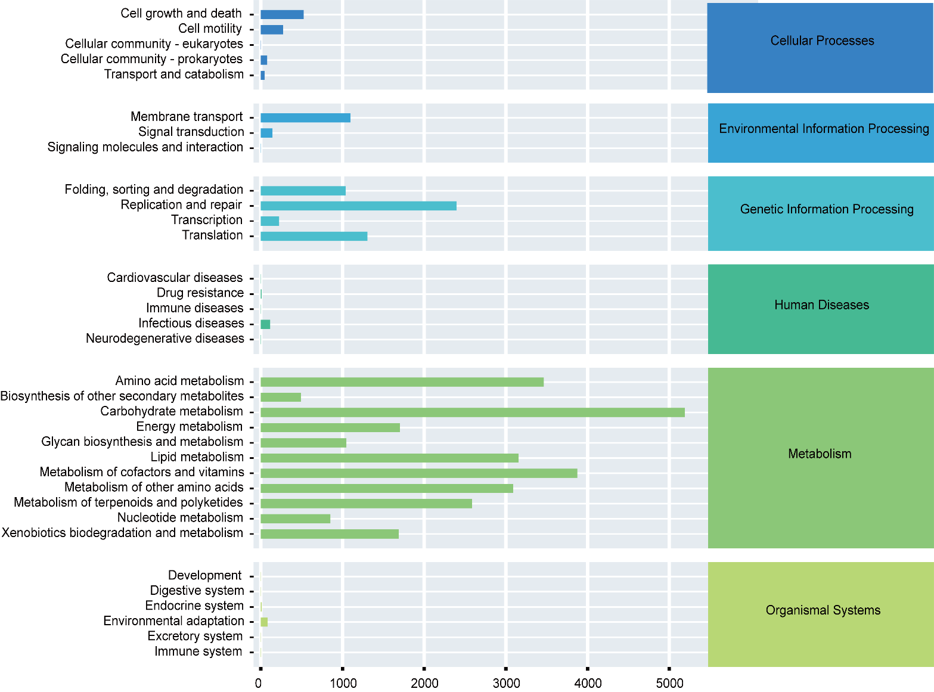
Fig. S1 Abundance statistics of Level 1 metabolic pathways triticale silage by KEGG.

