Supplementary Table 1. Multivariable logistic regression models (three interactions of living arrangement with gender, race, and income, respectively)
Characteristics | Suicidality in the past 12 months
Characteristics | AOR (95% CI) | t-value | p-value
Living alone
No | Reference
Yes | 2.33 (1.06, 5.15) | 2.09 | 0.036
Age
50 years and older | Reference
65 years and older | 0.63 (0.47, 0.85) | -3.06 | 0.002
Gender
Male | Reference
Female | 0.96 (0.69, 1.34) | -0.24 | 0.813
Race
White | Reference
Black | 0.49 (0.28, 0.87) | -2.44 | 0.015
Hispanic | 0.78 (0.43, 1.41) | -0.82 | 0.414
Income
Less than $20,000 | Reference
$20,000 - $49,999 | 1.03 (0.59, 1.79) | 0.10 | 0.923
$50,000 - $74,999 | 1.23 (0.67, 2.29) | 0.67 | 0.504
$75,000 and above | 0.46 (0.26, 0.81) | -2.70 | 0.007
Depression – past 12 months
No | Reference
Yes | 14.45 (10.86, 19.22) | 18.34 | < 0.001
Alcohol use – past 12 months
No | Reference
Yes | 1.82 (1.24, 2.67) | 3.04 | 0.002
Interaction effect
Living alone x Male | Reference
Living alone x Female | 0.52 (0.28, 0.95) | -2.13 | 0.033
Living alone x White | Reference
Living alone x Black | 2.40 (1.02, 6.58) | 1.76 | 0.078
Living alone x Hispanic | 0.77 (0.21, 2.89) | -0.38 | 0.702
Living alone x income less than $20,000 | Reference
Living alone x income: $20,000 - $49,999 | 0.73 (0.32, 1.66) | -0.75 | 0.455
Living alone x income: $50,000 - $74,999 | 0.26 (0.08, 0.87) | -2.19 | 0.029
Living alone x Hispanic: $75,000 and above | 0.66 (0.25, 1.76) | -0.83 | 0.409

Supplementary Figure 1. Risk of suicidality stratified by living arrangement and sociodemographic factors
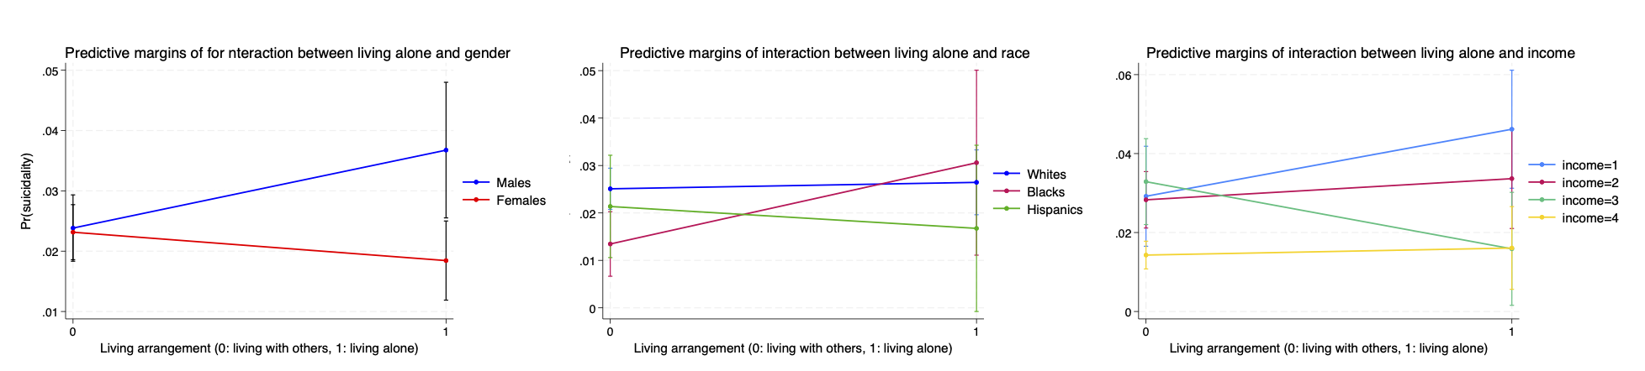
Income: 1 < $20,000, 2 = $20,000 – $49,999, 3 = $50,000 - $74,999, 4 = $75,000 and above
Pr(suicidality): predicted probability of suicidality

