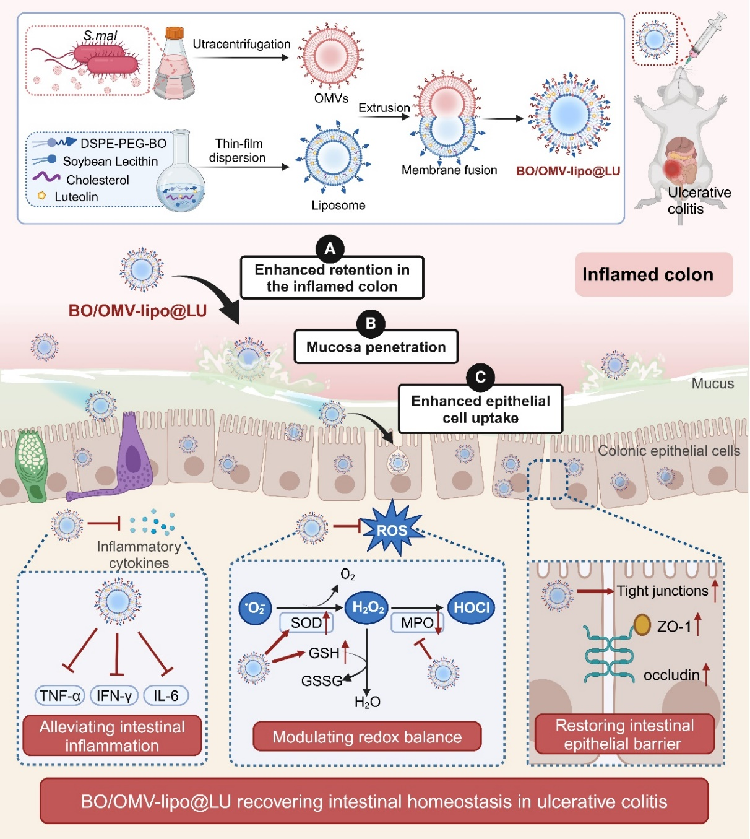
Scheme 1 Schematic illustration of the therapeutic route of BO/OMV-lipo@LU against ulcerative colitis (UC) by achieving targeted delivery of luteolin. The luteolin-loaded liposomes (Lipo@LU) were modified with borneol and fused with bacterial outer membrane vesicles (OMVs) to construct chemotaxis-driven hybrid liposomes (BO/OMV-lipo@LU). After oral administration of BO/OMV-lipo@LU, the fused OMVs contributed to the retention of liposomes in the inflamed colon to achieve chemotaxis-driven UC-targeted delivery. Under the combined effects of OMVs and borneol, BO/OMV-lipo@LU achieved deep mucosa penetration and improved epithelial uptake. The formulation could also sustainedly release luteolin in inflamed colon sites for UC therapy. Thus, BO/OMV-lipo@LU distinctly alleviated the pathological symptoms of DSS-induced UC mice. trilogically recover the intestinal homeostasis in UC by alleviating intestinal inflammation, modulating redox balance and restoring intestinal epithelial barriers. Created with BioRender.com.

