Supplementary Information
Chemoproteomic profiling by a bioorthogonal probe reveals cell growth inhibition by histone H4 dopaminylation
Contents
General Information 1
Supplementary Figures 2
Supplementary Table 11
Supplementary Note 12

General Information

Supplementary Dataset 1: Identification of putative substrates modified with dopamine by pDA. SK-N-SH cells were treated with 200 μM pDA for 2 h. Cell pellets were lysed and incubated with azide-biotin, followed by streptavidin enrichment and on-bead trypsin digestion. The peptides were subjected to LC-MS/MS analysis. The proteins with enrichment ratio (probe/control) over 1.5 are assigned as putative modified proteins.

Supplementary Dataset 2: Identification of dopamine-modified peptides by pDA. SK-N-SH cells were starved of serum for 12 h prior to a two-hour incubation with pDA. The cells were collected and lysed. The cell lysates were collected, and reacted with acid-cleavable azide-biotin. The streptavidin enrichment and on-beads trypsin digestion were performed. Release of the modified peptides from the beads was carried out by incubating with 2% formic acid. The dopamine-modified peptides were analyzed by LC-MS/MS.

Supplementary Dataset 3: Identification of genes regulated by H4Q27dop (ChIP-seq). SK-N-SH Cells were fixed, collected, and scraped into lysis buffer. Chromatin pellets were resuspended and sonicated. Sonicated chromatin was then incubated with anti-histone H4Q27dop or control. The immunoprecipitated DNA fragments were sent for high-throughput sequencing. ChIP-seq reads were aligned to the human reference genome (hg19).

Supplementary Dataset 4: Identification of differentially expressed genes induced by dopamine (RNA-seq). Total RNAs were extracted from control and dopamine-treated cells, respectively. RNA-seq reads were mapped to the human reference genome (hg19). The comparative analysis of the transcriptional differences between control and dopamine-treated cells was performed using DESeq2.

The supplementary datasets are provided in separated files.

Supplementary Figures
Supplementary Fig. 1. Evaluation of dopamine-derived probe propargyl dopamine (pDA). a, Tandem mass of the dopaminylated H3Q5 product. Selected fragment ions (y and b) are labeled. b, Effects of propargyl dopamine (pDA) on cell viability. The data are presented as the mean ± SD, calculated from three independent experiments. **, P < 0.01; ****, P < 0.0001; ns, not significant, as calculated by a two-sided Student’s t-test. (c-e) SK-N-SH cells were treated with 200 μM pDA for 2 h. The labeled whole cell or nuclear fractions were extracted and conjugated with biotin through click chemistry pulled down by streptavidin and eluted twice by boiling the beads (elution). c, Dose-dependent competition of protein labelling by pDA with dopamine. d, Protein labeling with pDA in control and TGM2 knockdown (KD) SK-N-SH cells, as detected by immunoblotting. e, Validation of the efficient labeling of the known substrate histone H3 by pDA. The input and elution samples were analyzed by anti-H3 immunoblotting.
Supplementary Fig. 2. Identification and characterization of protein dopaminylation. a, b, The construction of DDC- (a) and SIRT2-overexpressing (b) neuroblastoma cells. Results are from three independent experiments. All data are presented as the mean ± SD, calculated from three independent experiments. **, P < 0.01; ****, P < 0.0001, as calculated by a two-sided Student’s t-test. c, Workflow for the chemoproteomics of putative dopamine-modified peptides. SK-N-SH cells were incubated with 200 μM pDA for 2 h, lyzed with sonication, clicked with azide acid-cleavable tag, enriched with streptavidin beads. Following with trypsin digestion to release the unmodified peptides, the modified peptides were then specifically released with acid and analyzed by LC-MS/MS. d, In vitro enzymatic reaction of SIRT2 under catalysis of TGM2, tryptic digestion and LC-MS/MS. Tandem mass of the adduct of SIRT2 glutamine 252 with DA. Selected fragment ions (y and b) are labeled.
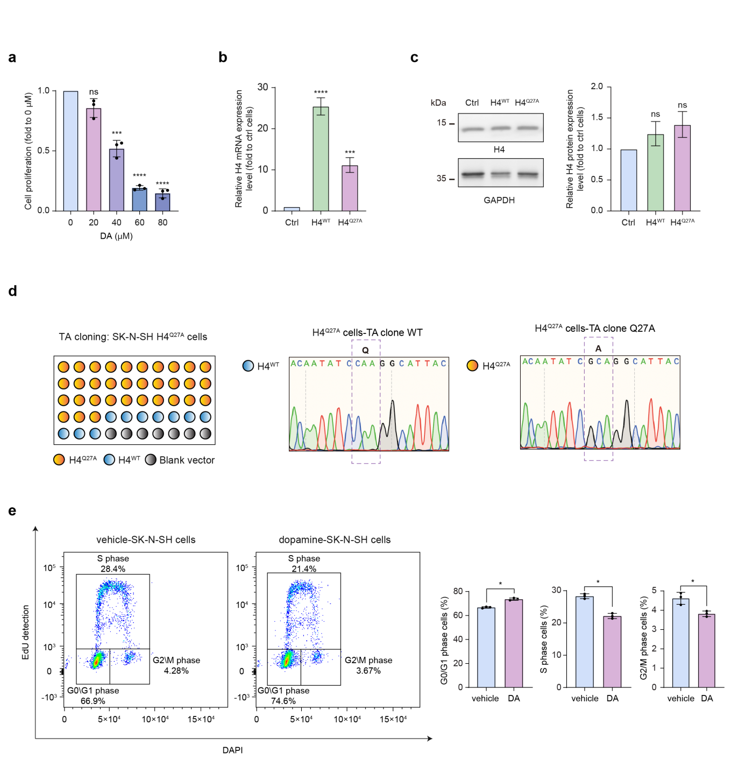
Supplementary Fig. 3. Dopamine-induced histone H4 dopaminylation (H4Q27dop) inhibits cell proliferation. a, Effects of dopamine (DA) on wild-type SK-N-SH neuroblastoma cell proliferation. DA (40–80 μM) caused a dose-dependent inhibition in cell proliferation. b, c, Neuroblastoma cells were overexpressed with H4^{WT} and H4^{Q27A}, respectively, followed by qPCR and immunoblotting analyses of H4^{WT} and H4^{Q27A} mRNA (b) and protein expression (c). d, Sanger sequencing results after TA cloning of the genomic DNA extracted from H4^{Q27A} overexpressing cells, with H4^{WT} presenting a homozygous while H4^{Q27A} presenting a heterozygous peak at Q27 site. e, Cell cycle progression induced by dopamine in wile-type SK-N-SH cells. Dopamine treatment resulted in G0/G1 arrest of the cells. All data are presented as the mean ± SD, calculated from three independent experiments. *, P < 0.05; **, P < 0.01; ****, P < 0.0001; ns, not significant, as calculated by a two-sided Student’s t-test.
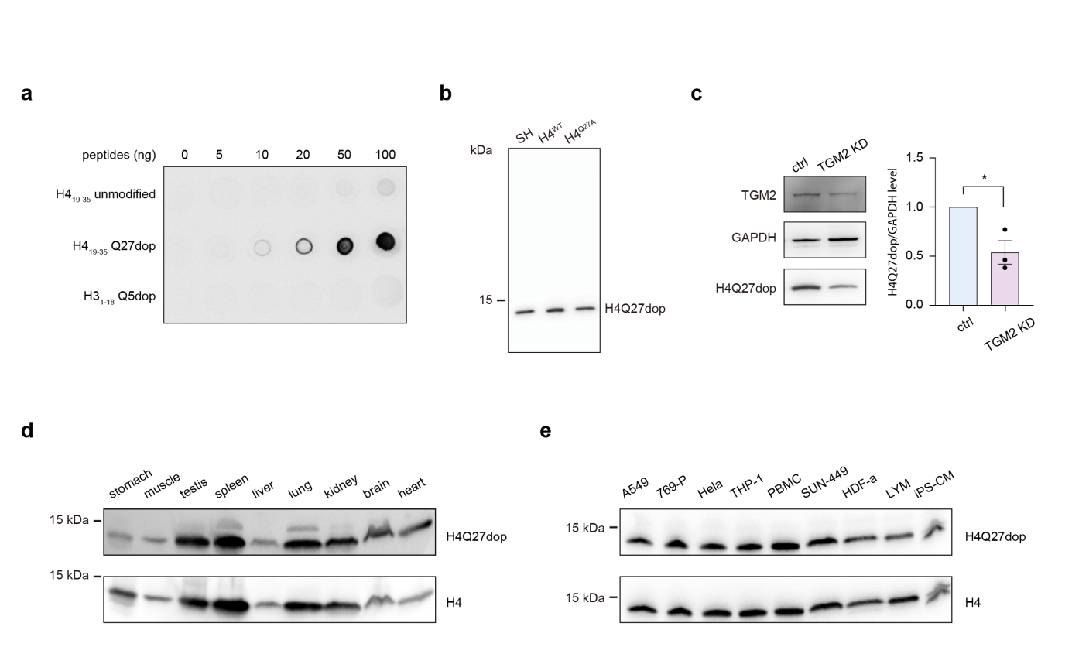
Supplementary Fig. 4. Identification and characterization of H4Q27dop with anti-H4Q27dop antibody. a, Dot-blot assay was used to verify the specificity of H4Q27dop antibody. Nitrocellulose membrane was spotted by different amounts of unmodified H4₁₉₋₃₅ peptide (RKVLRDNIQGITKPAIR), dopamine-modified H3₁₋₁₈ peptide (ARTKQ_{dop}TARKSTGGKAPRK), dopamine-modified H4₁₉₋₃₅ peptide (RKVLRDNIQ_{dop} GITKPAIR), and detected with the anti-H4Q27dop antibody. b, Detection of H4Q27dop levels in H4^{WT} and H4^{Q27A} SK-N-SH cells. Q27A mutation led to decreased H4Q27dop level. c, The H4Q27dop modification level decreased in TGM2 knockdown (KD) SK-N-SH cells, as determined by immunoblotting. The data are presented as the mean ± SD, calculated from three independent experiments. *, P < 0.05, as calculated by a two-sided Student’s t-test. d, Representative analysis of peripheral organ and brain cell extracts from mouse for the presence of H4Q27dop, as determined by immunoblotting. e, Detection of H4Q27dop in A549, 769-P, HeLa, THP-1, PBMC, SUN-449, HDF-a, LYM, and iPS-CM cell lines, as determined by immunoblotting.

Supplementary Fig. 5. Representative uncropped immunoblotting membranes.

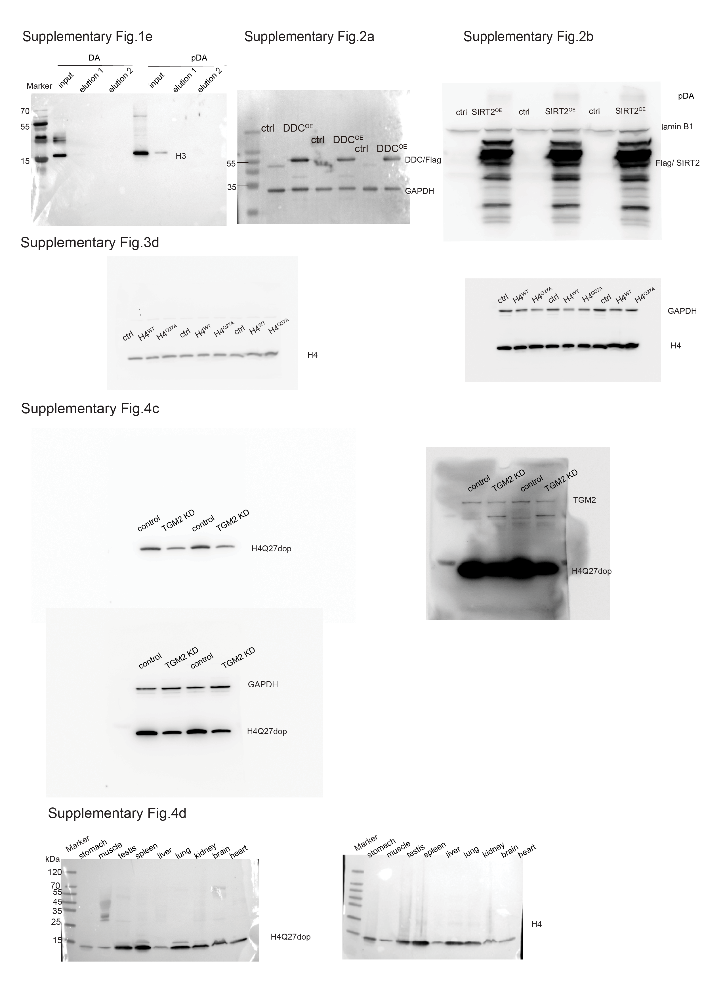

Supplementary Fig. 6. Gating strategy of flow cytometry
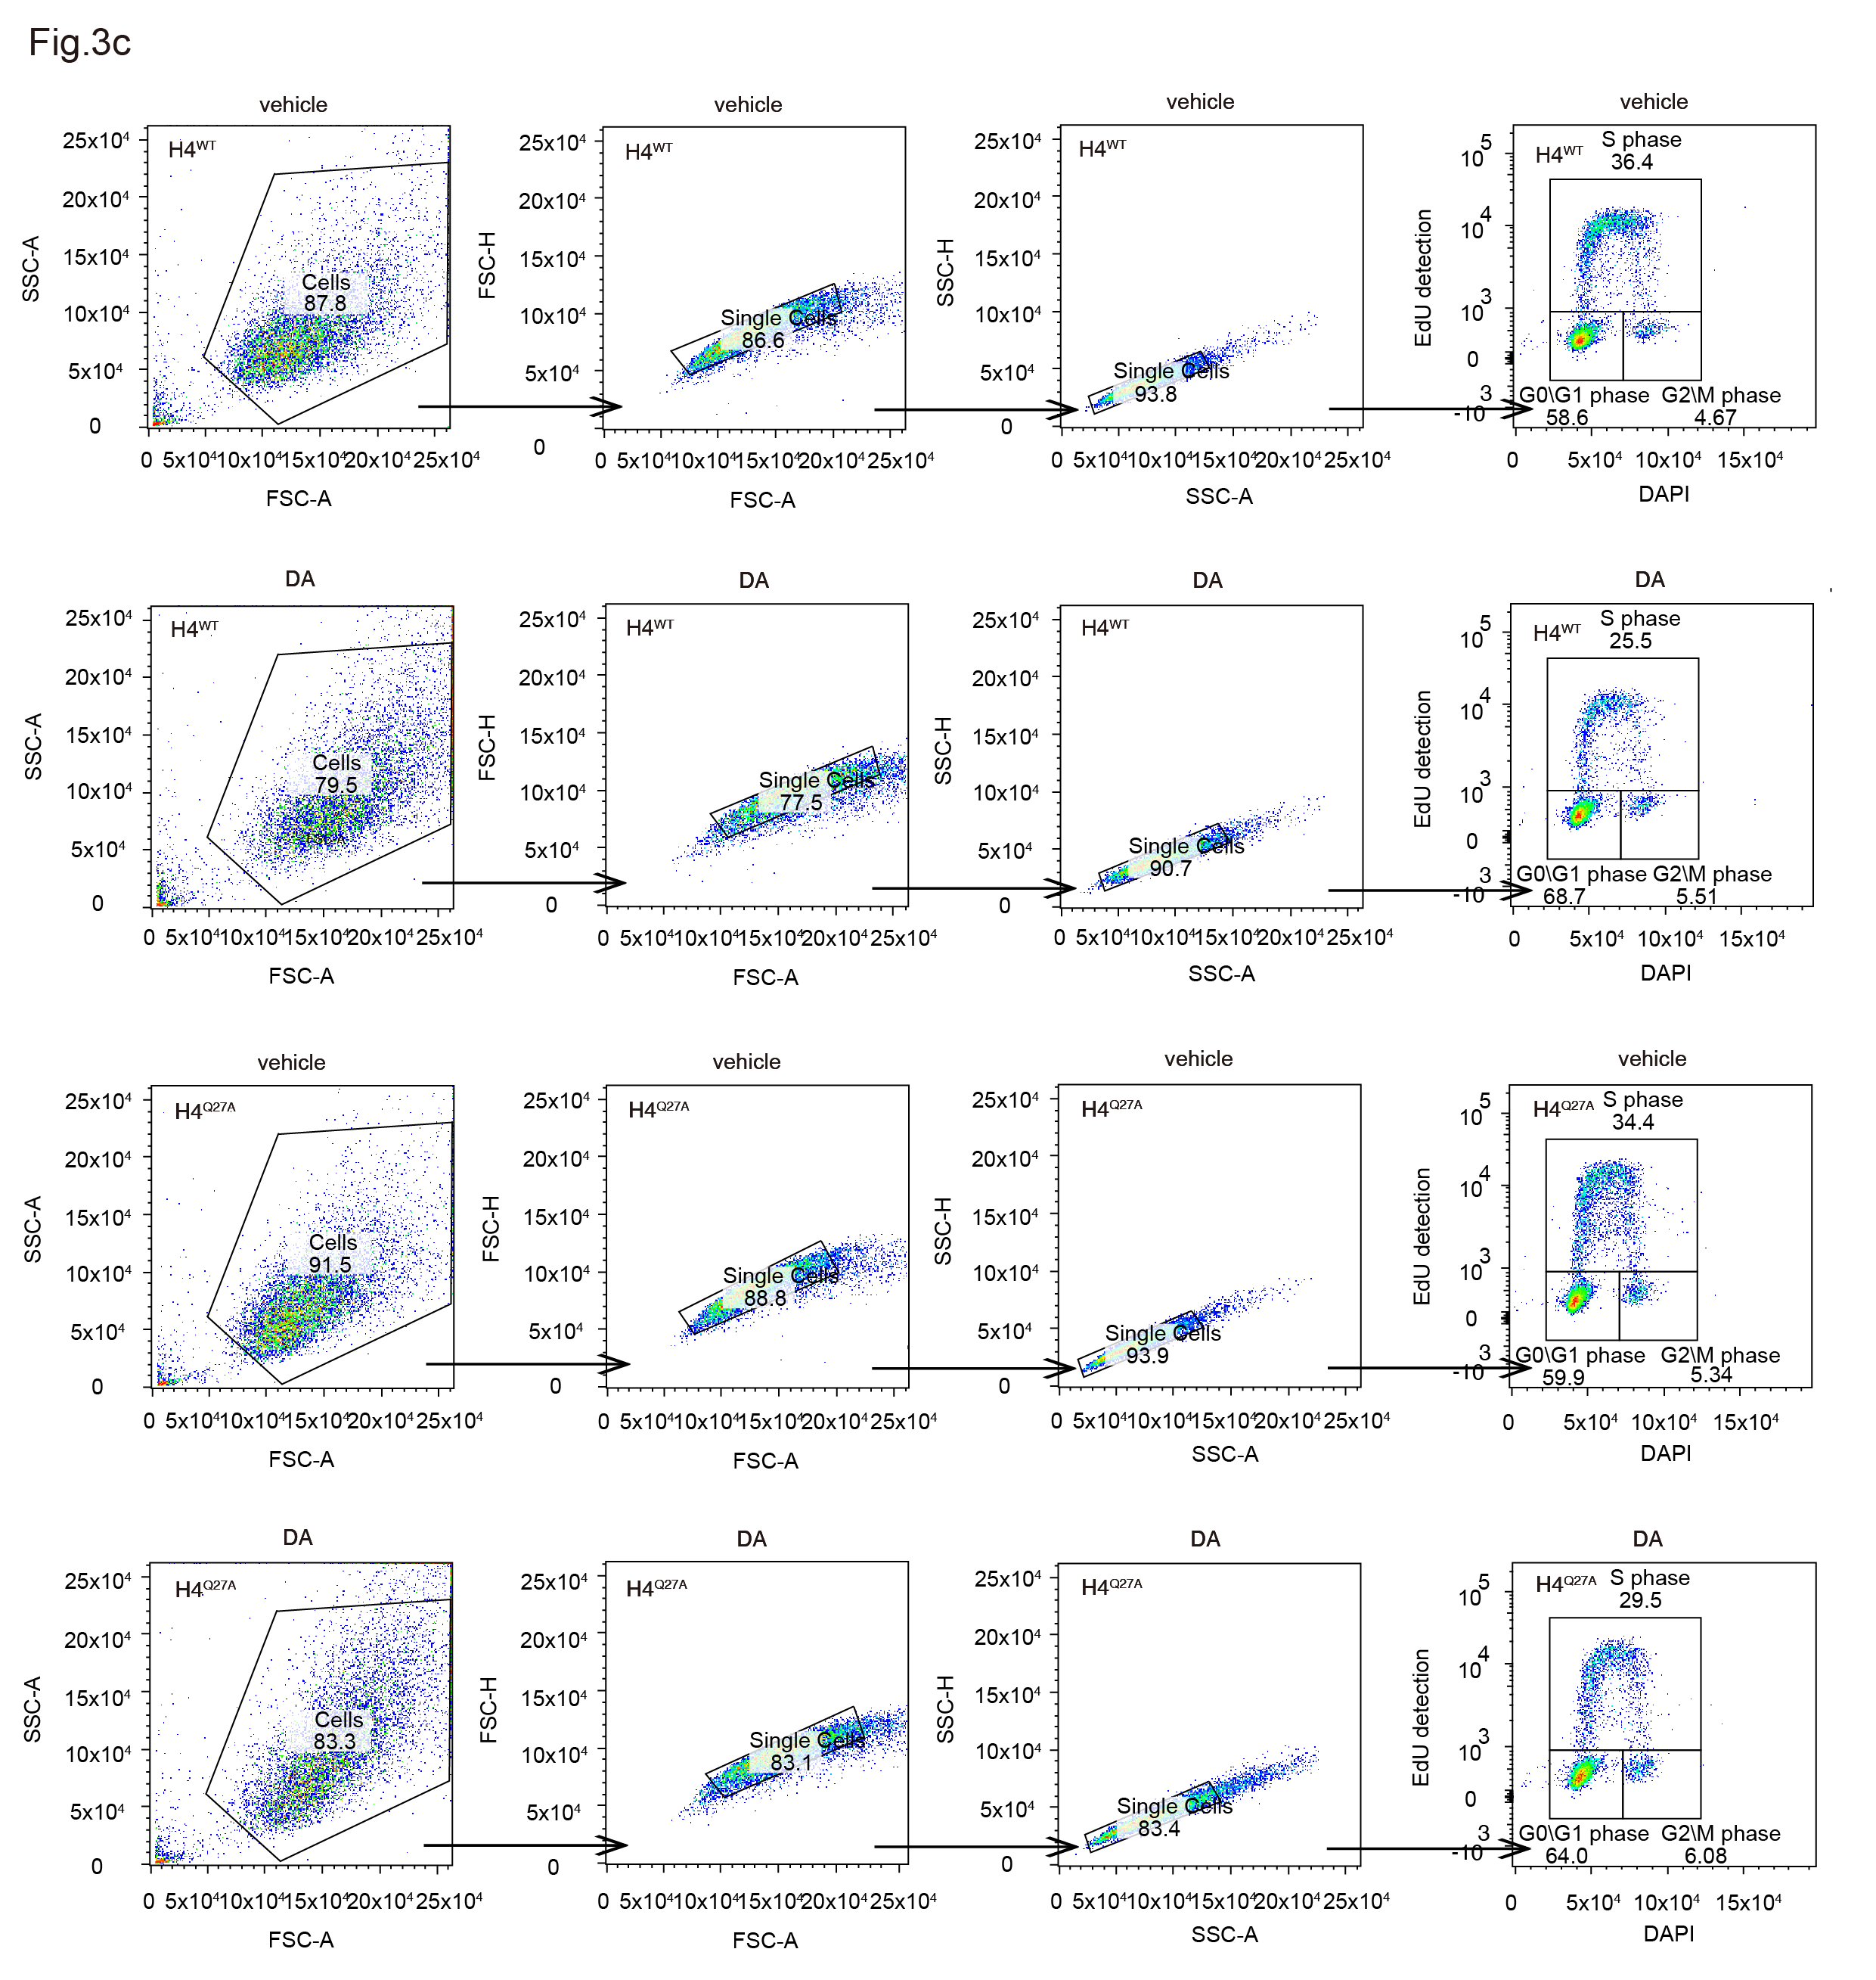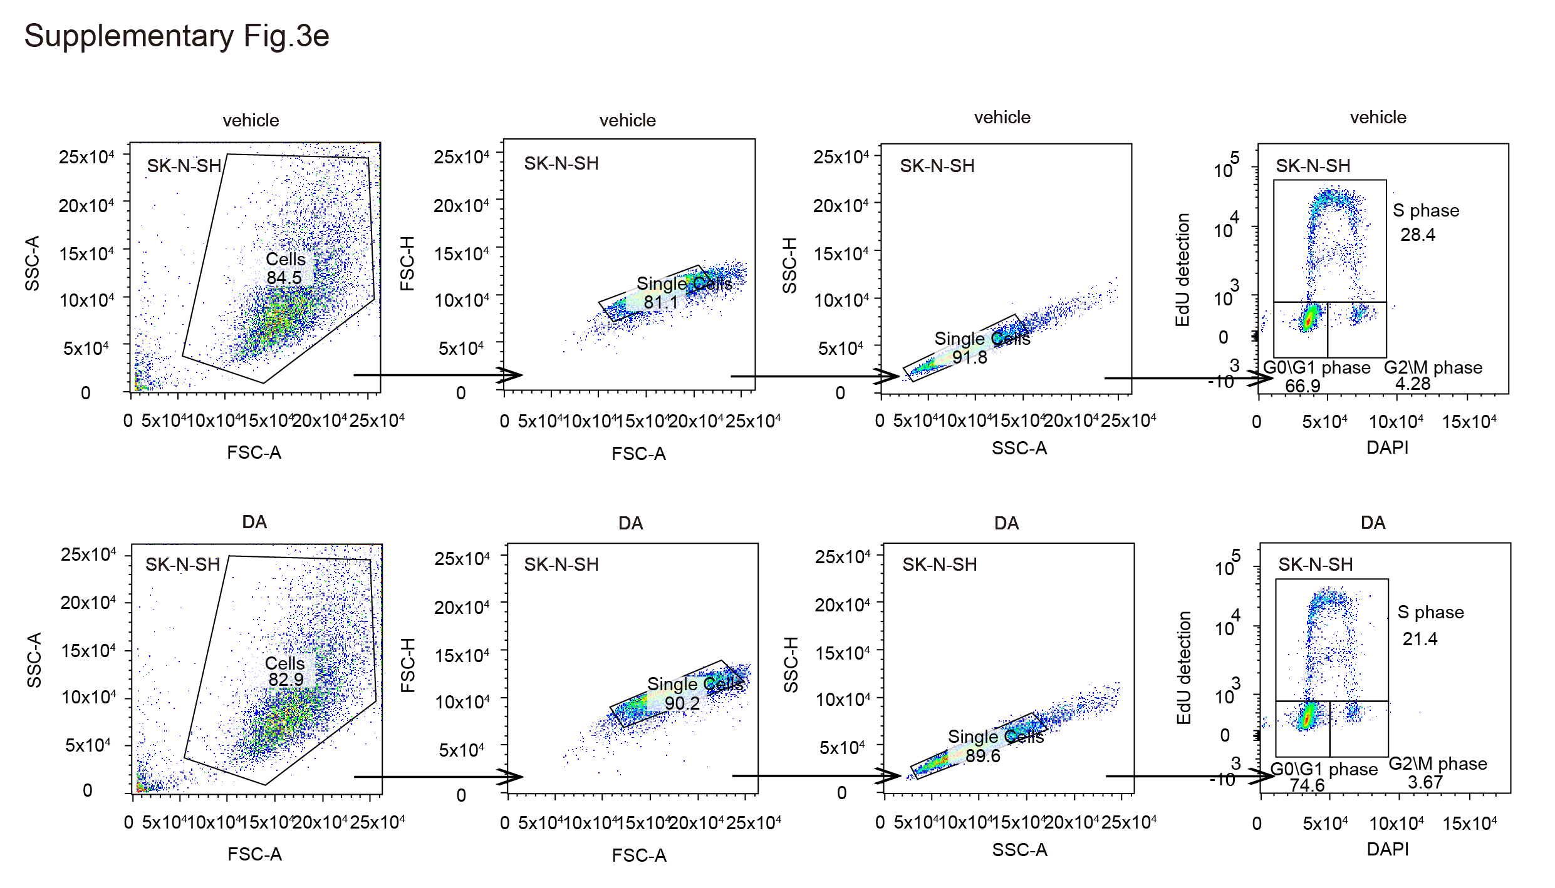

Supplementary Table
List of ChIP-qPCR primers and qPCR primers used to verify the target genes.
Primer names | Sequences
CCND1 ChIP-qPCR Forward | CCCAGACCCACGTTTCTTTG
CCND1 ChIP-qPCR Reverse | TCCCACGAAACGCTACTTCT
ACTB qPCR Forward | CATGTACGTTGCTATCCAGGC
ACTB qPCR Reverse | CTCCTTAATGTCACGCACGAT
DDC qPCR Forward | TAATCATGCCTGGGGTGACG
DDC qPCR Reverse | GAAGCCGATGCAGCCAATG
SIRT2 qPCR Forward | TGCGGAACTTATTCTCCCAGA
SIRT2 qPCR Reverse | GAGAGCGAAAGTCGGGGAT
CCND1 qPCR Forward | GTGGCCTCTAAGATGAAGGAGAC
CCND1 qPCR Reverse | GGCATTTTGGAGAGGAAGTGTTC
Histone H4 qPCR Forward | CGTCAAGCGCATTTCTGGTC
Histone H4 qPCR Reverse | GCGCGTACACCACATCCAT

Supplementary Note
Scheme 1
Reagents and conditions: a) Boc₂O, NaHCO₃, THF/H₂O, 92.8%; b) BrCH₂CCH, DMF, K₂CO_{3,} 44.5%; c) HCl (0.5 M), H₂O (1:1), 95.7%.

tert-Butyl 3,4-dihydroxyphenethyl carbamate (2). To a solution of dopamine hydrochloride 1 (50.0 g, 1.0 eq.) in the mixture of THF/H₂O (2.5:1, 350 mL) was added NaHCO₃ (55.4 g, 2.5 eq.) and Boc₂O (57.5 g, 1.0 eq.). The reaction mixture was stirred at 15 ℃ until it was completed as monitored by TLC. The mixture was diluted with water (100 mL), and the aqueous layer was extracted with EtOAc (100 mL × 3). The combined organic phase was dried over Na₂SO₄. Solvent was removed in vacuo and compound 2 was obtained by column chromatography (62.0 g, 92.8%). R_{f} = 0.32 (petroleum ether: ethyl acetate = 2:1). ¹H NMR (400 MHz, DMSO-d6) δ 8.65−8.75 (br, 2 H), 6.82−6.83 (br, 1 H), 6.62 (d, J = 7.6 Hz, 1 H), 6.55 (d, J = 2.0 Hz, 1 H), 6.41 (dd, J = 7.6, 2.0 Hz, 1 H), 2.92−3.09 (m, 2 H), 2.47 (br, 2 H), 1.37 (s, 9 H).

tert-Butyl 3-hydroxy-4-(prop-2-yn-1-yloxy) phenethyl carbamate (3). To a solution of compound 2 (30.0 g, 1.0 eq.) in DMF (300 mL) was added K₂CO₃ (24.6 g, 1.5 eq) and 3-bromoprop-1-yne (17.6 g, 80.0% purity, 1.0 eq). The reaction was stirred at 20 ℃ until it was completed as monitored by LC-MS. The mixture was diluted with water (50 mL) and acidified to pH < 7, and then the aqueous layer was extracted with EtOAc (100 mL × 2). The combined organic phase was dried over Na₂SO₄. After concentration, the mixture was purified by column chromatography (petroleum ether: ethyl acetate = 5:1 to 0:1). Compound 3 was further separated by prep-HPLC as a colorless oil (column: Xtimate C18, 10 μm, 250 mm × 80 mm; mobile phase: [water (10 mM NH₄HCO₃)-ACN]; B%: 15%-45%, 25 min) and further purified by flash silica gel chromatography (column: DAICEL CHIRALPAK AD (250 mm × 50 mm, 10 μm); mobile phase: [0.1% NH₃H₂O /EtOH]; B%: 35%-35%, 3 min) to give compound 3 (9.80 g, 33.6 mmol, 44.5% yield): ¹H NMR (400 MHz, DMSO-d6) δ 8.91 (s, 1 H), 6.79−6.86 (m, 2 H), 6.69 (d, J = 8.0 Hz, 1 H), 6.60 (dd, J = 8.0, 1.2 Hz,1 H), 4.72 (d, J = 4.0 Hz, 2 H), 3.53 (t, J = 4.0 Hz, 1 H), 2.53 – 2.56 (m, 2 H), 1.36 (s, 9 H). [M+H-tBu]⁺ calculated for compound 3: 235.1, found (ESI) [M+H-tBu]⁺: 235.9.

4-(2-aminoethyl)-2-(prop-2-yn-1-yloxy) phenol (pDA). Compound 3 (3.5 g, 1.0 eq.) was treated with diluted HCl solution (0.5 M, 10 eq., 240 mL) at room temperature. The reaction was stirred until it was completed (around 36 h) as monitored by LC-MS. The reaction mixture was concentrated and the desired product pDA (in HCl salt form) was obtained as a white solid (2.2 g, 11.5 mmol, 95.7% yield) without further purification. ¹H NMR: (400 MHz, MeOH-d4) δ 7.01 (d, J = 8.0 Hz, 1 H), 6.68–6.76 (m, 2 H), 4.76−4.80 (d, J = 2.4 Hz, 2 H), 3.06−3.17 (m, 2 H), 2.95 (t, J = 2.4 Hz, 1 H), 2.81−2.91 (m, 2 H). ¹³C NMR (400 MHz, MeOH-d4): δ 146.9, 144.6, 130.6, 119.7, 116.0, 114.6, 78.6, 76.0, 56.4, 41.05, 40.96, 40.87, 32.5 ppm. Calculated mass [M+H] ⁺: 192.09, Mass Found (ESI) [M+H] ⁺: 192.1.

Characterization of Compounds
