Bel7402 SMMC7721
Dnmt1 Dnmt1
Marker NC SI NC SI Marker
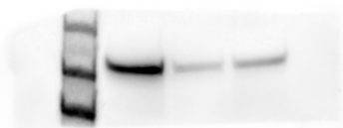
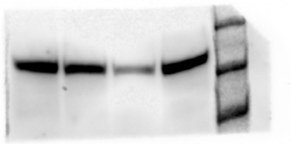
220KD 220KD
180KD 180KD
130KD
130KD

Dnmt1-actin Dnmt1-actin
NC SI Marker Marker NC SI
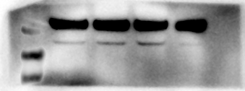
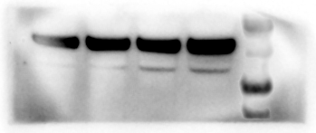
55KD 55KD
40KD 40KD
35KD 35KD
25KD 25KD

Marveld1 Marveld1
Marker NC SI Marker NC SI
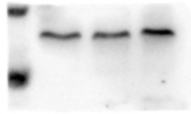
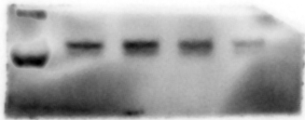
25KD 25KD

15KD 15KD

Marveld1-actin Marveld1-actin
Marker NC SI Marker NC SI
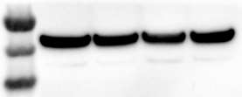
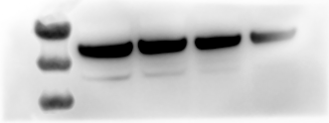
55KD 55KD
40KD 40KD
35KD 35KD

P53 p53
Marker NC SI NC SI Marker
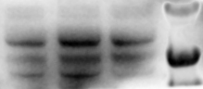
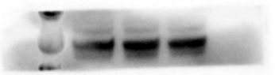
70KD 70KD
55KD
40KD
55KD

CyclinD1 CyclinD1
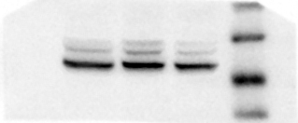
Marker NC SI NC SI Marker
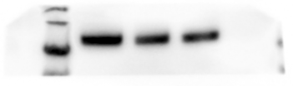
55KD 55KD
40KD 40KD
35KD 35KD
25KD 25KD

Bel7402 SMMC7721
P21 p21
Marker NC SI Marker NC SI
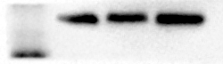
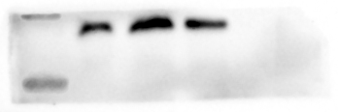
25KD 25KD

15KD 15KD

P16 p16
Marker NC SI Marker NC SI
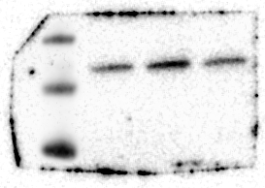
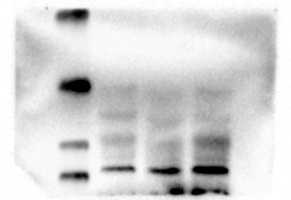
40KD
25KD

35KD 15KD

25KD
15KD 10KD

actinn(p53,CyclinD1,p21,p16) actinn(p53,CyclinD1,p21,p16)
Marker NC SI Marker NC SI
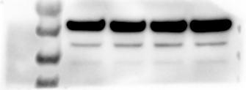
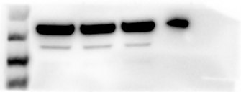
55KD 55KD
40KD 40KD
35KD 35KD
25KD 25KD

