Bel7402 SMMC7721
Dnmt1 Dnmt1
Marker NC SI NC SI Marker
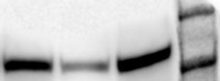
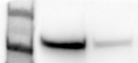
220KD 220KD

180KD 180KD

Dnmt1-actin Dnmt1-actin
NC SI Marker Marker NC SI
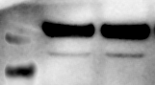
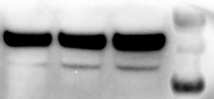
55KD 55KD

40KD 40KD

35KD 35KD

Marveld1 Marveld1
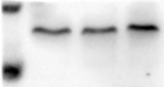
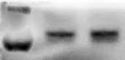
Marker NC SI Marker NC SI
25KD 25KD

15KD
15KD

Marveld1-actin Marveld1-actin
Marker NC SI Marker NC SI
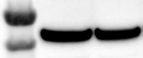
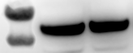
55KD 55KD

40KD 40KD

P53 p53
Marker NC SI NC SI Marker
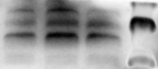
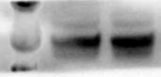
70KD 70KD

55KD 55KD

40KD 40KD

Bel7402 SMMC7721
CyclinD1 CyclinD1
Marker NC SI NC SI Marker
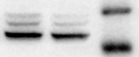
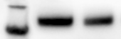
40KD 40KD

35KD
35KD

P21 p21
Marker NC SI Marker NC SI
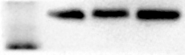
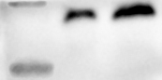
25KD 25KD

15KD

15KD

P16 p16
Marker NC SI Marker NC SI
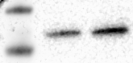
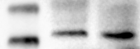
25KD 25KD

15KD
15KD

actin(p53,CyclinD1,p21,p16) actin(p53,CyclinD1,p21,p16)
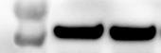
Marker NC SI Marker NC SI
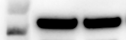
55KD 55KD

40KD 40KD

