Supporting Information
De novo biosynthesis of β-Arbutin in Komagataella phaffii based on
metabolic engineering strategies
Jiashuo Yangª, Liu Yangª, Fengguang Zhaoª, Chunting Yeª, Shuangyan Han^{a, *}

[a]J. Yang, L Yang, F Zhao, C. Ye, S Han
Guangdong Key Laboratory of Fermentation and Enzyme Engineering, School of 8 Biology and Biological Engineering
South China University of Technology
Guangzhou 510006, P. R. China

* Corresponding Author:
Shuangyan Han
Email address: syhan@scut.edu.cn

Table S1 Strains, plasmids and primers used in this study
Names |  | Characteristics
Strains
GS115 |  | His4⁻ | This lab
UA1-1 |  | GS115 harboring plasmids pCre-His-UbiC, pCre-His-MNX1 and pCre-His-AS | This study
UA2-1 |  | GS115 harboring plasmids pCre-His-UbiC and pCre-His-MNX1LAS | This study
UA2-2 |  | GS115 harboring plasmids pCre-His-UbiC and pCre-His-ASLMNX1 | This study
UA3-1 |  | UA2-1 harboring plasmid pCre-Int1-DHAPS1 | This study
UA3-2 |  | UA2-1 harboring plasmid pCre-Int1-DHAPS2 | This study
UA3-3 |  | UA2-1 harboring plasmid pCre-Int1-DHAPS3 | This study
UA3-4 |  | UA2-1 harboring plasmid pCre-Int1-Aro4^{K229L} | This study
UA3-5 |  | UA2-1 harboring plasmid pCre-His-AroM | This study
UA3-6 |  | UA2-1 harboring plasmid pCre-Int1-CRS | This study
UA3-7 |  | UA3-3 harboring plasmid pCre-Int1-DHAPS2 | This study
UA3-8 |  | UA3-3 harboring plasmid pCre-His-AroM | This study
UA3-9 |  | UA3-3 harboring plasmid pCre-Int1-CRS | This study
UA3-10 |  | UA3-9 harboring plasmid pCre-His-AroM | This study
UA4-1 |  | UA2-1 harboring plasmid pCre-Int1-pyc | This study
UA4-2 |  | UA2-1 with prk knocked out | This study
UA4-3 |  | UA2-1 harboring plasmid pCre-Int1-pyk | This study
UA5-1 |  | UA3-10 harboring plasmid pCre-Int1-pyk | This study
UA6-1 |  | UA3-10 harboring plasmid pCre-Int1-tkt | This study
UA7-1 |  | UA3-10 harboring plasmid pCre-Int1-pgm-UGP | This study
UA8-1 |  | UA8-1 harboring plasmid pCre-Int1-xfpk-PTA | This study
Plasmids
pCre-His |  | Expression vector with P_{AOX1} promoter and ZeoR marker recycling, using HIS4 as the Integration site | This study
pCre-Int1 |  | Expression vector with P_{AOXm} promoter and ZeoR marker recycling, using Int1 as the Integration site | This study
pCre-His-UbiC |  | pCre-His carrying the codon-optimized Ubic cassette with P_{AOX1} promoter | This study
pCre-His-MNX1 |  | pCre-His carrying the codon-optimized MNX1 cassette with P_{AOX1} promoter | This study
pCre-His-AS |  | pCre-His carrying the codon-optimized AS cassette with P_{AOX1} promoter | This study
pCre-His-MNX1LAS |  | pCre-His carrying a fusion gene of the codon-optimized MNX1 and AS using a GGGS linker between MNX1 and AS with P_{AOX1} promoter, and MNX1 placed in front of linker | This study
pCre-His-ASLMNX1 |  | pCre-His carrying a fusion gene of the codon-optimized MNX1 and AS using a GGGS linker between MNX1 and AS with P_{AOX1} promoter, and AS placed in front of linker | This study
pCre-Int1-DHAPS1 |  | pCre-Int1 carrying the endogenous gene DHAPS1 cassette with P_{AOXm} promoter | This study
pCre-Int1-DHAPS2 |  | pCre-Int1 carrying the endogenous gene DHAPS2 cassette with P_{AOXm} promoter | This study
pCre-Int1-DHAPS3 |  | pCre-Int1 carrying the endogenous gene DHAPS3 cassette with P_{AOXm} promoter | This study
pCre-Int1-Aro4^{K229L} |  | pCre-Int1 carrying gene Aro4 from Saccharomyces cerevisiae with P_{AOX1} promoter, whose 229th amino acid mutates from lysine to leucine. | This study
pCre-His-AroM |  | pCre-His carrying the endogenous gene AroM cassette with P_{AOX1} promoter | This study
pCre-Int1-CRS |  | pCre-Int1 carrying the endogenous gene CRS cassette with P_{AOXm} promoter | This study
pCre-Int1-pyc |  | pCre-Int1 carrying the endogenous gene pyc cassette with P_{AOXm} promoter | This study
pCre-Int1-pyk |  | pCre-Int1 carrying the endogenous gene pyk cassette with P_{AOXm} promoter | This study
pCre-Int1-tkt |  | pCre-Int1 carrying the endogenous gene tkt cassette with P_{AOXm} promoter | This study
pCre-Int1-pgm |  | pCre-Int1 carrying the endogenous gene pgm cassette with P_{AOXm} promoter | This study
pCre-Int1-pgm-UGP |  | pCre-Int1 carrying the endogenous gene pgm cassette and endogenous gene UGP cassette with P_{AOXm} promoter | This study
pCre-Int1-UbiC |  | pCre-Int1 carrying the endogenous gene UbiC cassette with P_{AOXm} promoter | This study
pCre-Int1-MNX1 |  | pCre-Int1 carrying the endogenous gene MNX1cassette with P_{AOXm} promoter | This study
pCre-Int1-AS |  | pCre-Int1 carrying the endogenous gene AS cassette with P_{AOXm} promoter | This study
pCre-Int1-MNX1LAS |  | pCre-Int1 carrying the endogenous gene MNX1LAS cassette with P_{AOXm} promoter | This study
pCre-Int1-xfpk-PTA |  | pCre-Int1 carrying the endogenous genes xfpk and PTA cassette with P_{AOXm} promoter | This study
Primers |  | Primer sequences(5’→3’)
His-UbiC-F |  | AACTAATTATTCGAAACGAGGAATTCATGTCCCACCCAGCTTTGAC | This study
His-UbiC-R |  | TTTTGTTCGGGCCCAAGCTGGCGGCCGCTTAGTACAATGGAGAAGCAG | This study
His-MNX1-F |  | AACTAATTATTCGAAACGAGGAATTCATGGCTGTTCAAGCTCCATC | This study
His-MNX1-R |  | TTTTGTTCGGGCCCAAGCTGGCGGCCGCTTAACCAGAAGCAGACAAAG | This study
His-AS-F |  | AACTAATTATTCGAAACGAGGAATTCATGGAACACACCCCACACAT | This study
His-AS-R |  | TTTTGTTCGGGCCCAAGCTGGCGGCCGCTTAAGTAGAGGAAATCTTAT | This study
His-MNX1LAS-F |  | AACTAATTATTCGAAACGAGGAATTCATGGCTGTTCAAGCTCCATC | This study
His-MNX1LAS-R |  | TTTTGTTCGGGCCCAAGCTGGCGGCCGCTTAAGTAGAGGAAATCTTAT | This study
His-ASLMNX1-F |  | AACTAATTATTCGAAACGAGGAATTCATGGAACACACCCCACACAT | This study
His-ASLMNX1-R |  | TTTTGTTCGGGCCCAAGCTGGCGGCCGCTTAACCAGAAGCAGACAAAG | This study
Int1-DHAPS1-F |  | CTAATTATTCGAAAGGAATTCACGTGATGACCTCCACACCAGTTCA | This study
Int1-DHAPS1-R |  | TTTTGTTCGGGCCCAAGCTGGCGGCCGCCTAAGCAGCGTTCTTTAATG | This study
Int1-DHAPS2-F |  | CTAATTATTCGAAAGGAATTCACGTGATGACAGTACAAGAGGTCGA | This study
Int1-DHAPS2-R |  | TTTTGTTCGGGCCCAAGCTGGCGGCCGCTTATGTAATGAGTTTCAATG | This study
Int1-DHAPS3-F |  | CTAATTATTCGAAAGGAATTCACGTGATGTTCATTCAAAACGATCA | This study
Int1-DHAPS3-R |  | TTTTGTTCGGGCCCAAGCTGGCGGCCGCCTAATTCTTGAGATTACGAC | This study
Int1-Aro4^{K229L}-F |  | TCGAAACGAGGAATTCACATGAGTGAATCTCCAATGTTCGCTG | This study
Int1-Aro4^{K229L}-R |  | CGGGCCCAAGCTGGCCTATTTCTTGTTAACTTCTCTTCTTTGTCTGACAGC | This study
His-AroM-F |  | AACTAATTATTCGAAACGAGGAATTCATGTCCGGGCTTATCGAAAA | This study
His-AroM-R |  | TTTTGTTCGGGCCCAAGCTGGCGGCCGCCTACAGATCAATGTGGGAGG | This study
Int1-CRS-F |  | CTAATTATTCGAAAGGAATTCACGTGATGTCTTCGTTTGGCCAGGT | This study
Int1-CRS-R |  | TTTTGTTCGGGCCCAAGCTGGCGGCCGCTTAAGAAACAACACTGAGTG | This study
Int1-pyc-F |  | TTTTGTTCGGGCCCAAGCTGGCGGCCGCTTAAGAAACAACACTGAGTG | This study
Int1-pyc-R |  | TTTTGTTCGGGCCCAAGCTGGCGGCCGCTTACTCAGCCTTGACGATTT | This study
Int1-pyk-F |  | AACTAATTATTCGAAACGAGGAATTCATGGCTCCTACTGCTATAGA | This study
Int1-pyk-R |  | TTTTGTTCGGGCCCAAGCTGGCGGCCGCTTACAACTGAGGGCCGGCCT | This study
Int1-tkt-F |  | TCTCGGATCGGTACCTCGAGATGTCTGATCTCTTAGCTAT | This study
Int1-tkt-R |  | GGCCCAAGCTGGCGGCCGCCTACGCATGAACAGACTCAA | This study
Int1-pgm-F |  | AACTAATTATTCGAAACGAGGAATTCATGTCATTTAGCCCTAGAAT | This study
Int1-pgm-R |  | TTTTGTTCGGGCCCAAGCTGGCGGCCGCTCATGTACGAACATCAGGCT | This study
UGP-Re-F |  | AATAAGAATTAATTAAAAAGTCTAGAAGATCTAACATCCAAAGACG | This study
UGP-Re-R |  | TTCTCCTGTATATTTACTCATCTAGATCTCACTTAATCTTCTGTAC | This study
Int1-pgm-UGP-F |  | AACTAATTATTCGAAACGAGGAATTCATGAGCGCCTATCAATCTCC | This study
Int1-pgm-UGP-R |  | TTTTGTTCGGGCCCAAGCTGGCGGCCGCCTAATGCTCCAAAATAGTAA | This study
Int1-UbiC-F |  | AAAACAACTAATTATTCGAAAGGAATTCACGTGATGTCCCACCCAGCTTTGAC | This study
Int1-UbiC-R |  | TTTTGTTCGGGCCCAAGCTGGCGGCCGCttaGTACAATGGAGAAGCAG | This study
Int1-MNX1-F |  | AAAACAACTAATTATTCGAAAGGAATTCACGTGATGGCTGTTCAAGCTCCATC | This study
Int1-MNX1-R |  | TTTTGTTCGGGCCCAAGCTGGCGGCCGCTTAACCAGAAGCAGACAAAG | This study
Int1-AS-F |  | AAAACAACTAATTATTCGAAAGGAATTCACGTGATGGAACACACCCCACACAT | This study
Int1-AS-R |  | TTTTGTTCGGGCCCAAGCTGGCGGCCGCttaAGTAGAGGAAATCTTATTCTCCCACTTACAAGC | This study
Int1-MNX1LAS-F |  | AAAACAACTAATTATTCGAAAGGAATTCACGTGATGGCTGTTCAAGCTCCATC | This study
Int1- MNX1LAS -R |  | TTTTGTTCGGGCCCAAGCTGGCGGCCGCttaAGTAGAGGAAATCTTATTCTCCCACTTACAAGC | This study

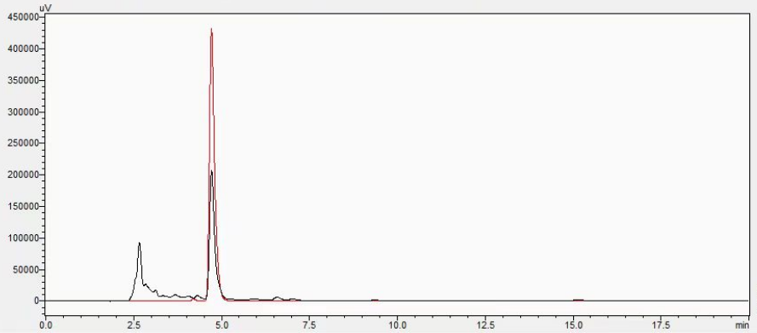
Figure S1 The red curve represents the peak chart of 0.2g/L β-Arbutin standard, while the black curve represents the peak chart of the fermentation supernatant of UA1-1.

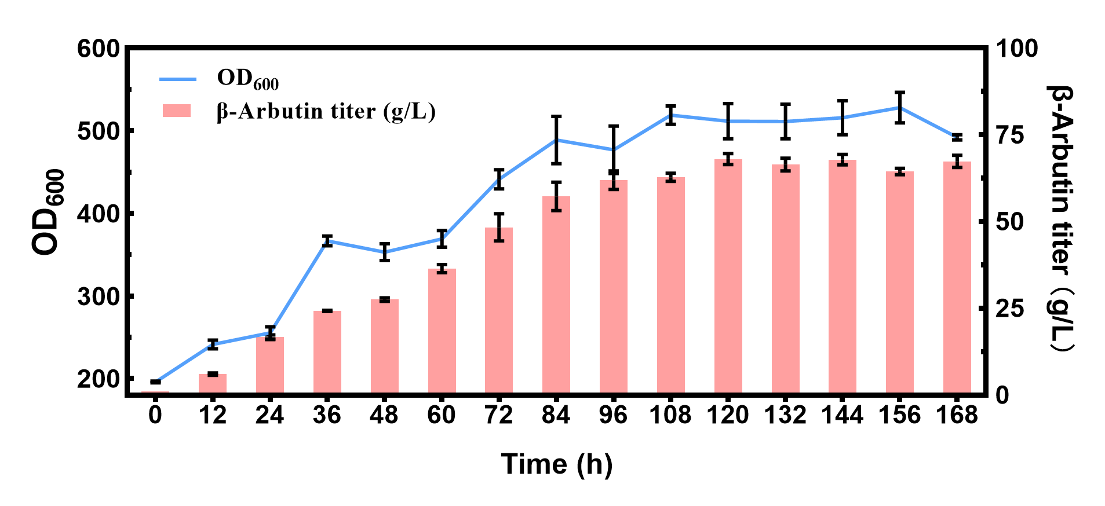
Figure S2 Growth curve and the β-Arbutin titer of strain UA1-1 during methanol induction stage in fed-batch fermentation. The data are averages of 3 biological replicates with error bars representing standard deviations.

