Supplementary Materials for

Burst-like swarms and periodical VT events in the accelerating unrest phase of the Campi Flegrei caldera (2021-2024)

Flora Giudicepietro et al.

*Corresponding author. Email: giovanni.macedonio@ingv.it

This PDF file includes:

Figs. S1 to S2

Other Supplementary Materials for this manuscript include the following:
Data S1 to S4

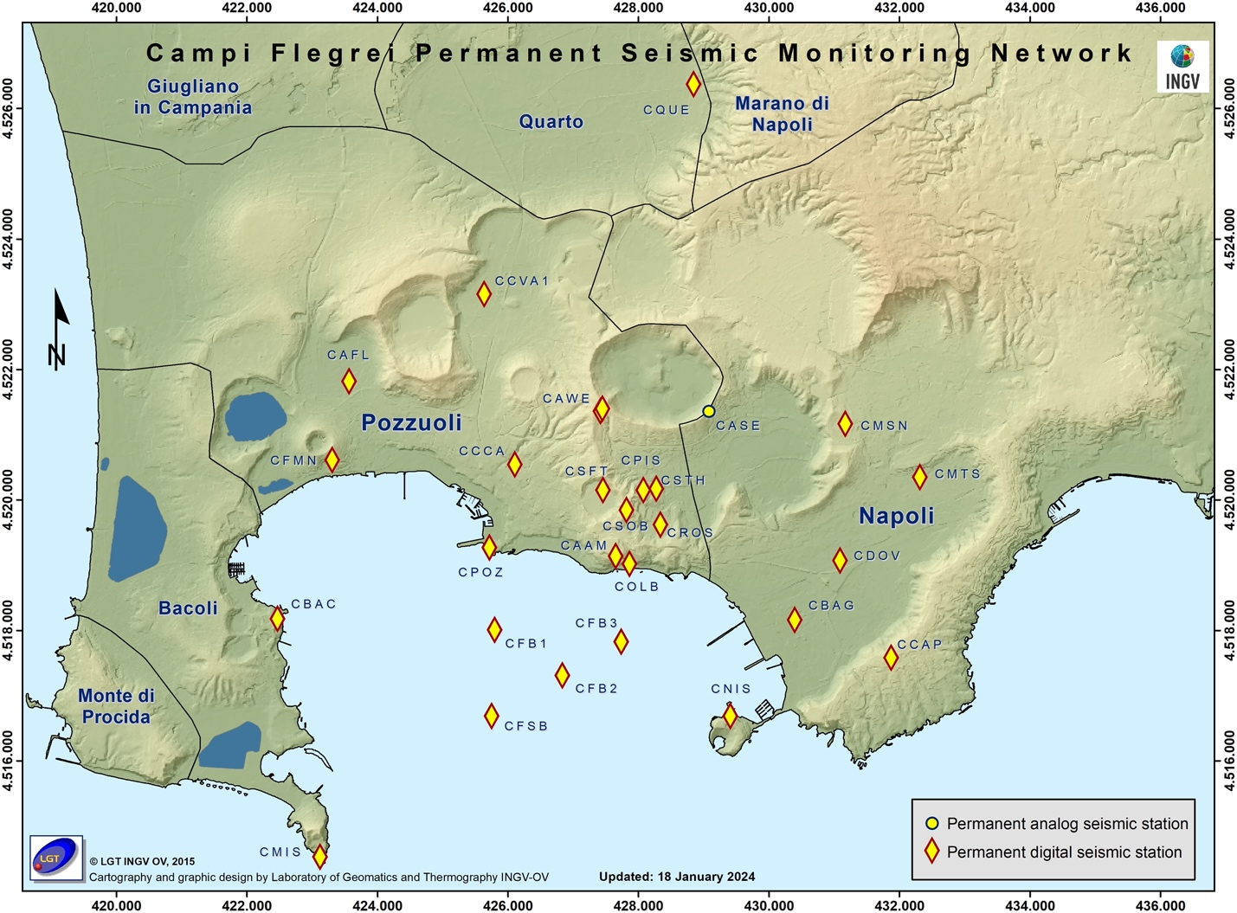

Fig. S1.
Seismic network of the Campi Flegrei.

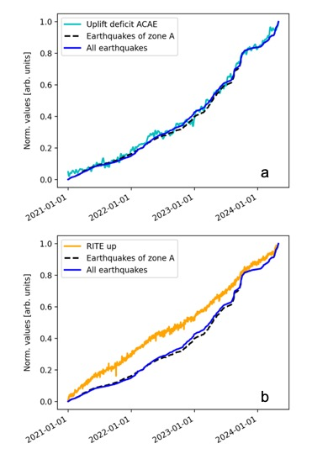

Fig. S2.
Comparison between the uplift deficit of the GNSS ACAE station (cyan line), representative of the geodetic anomaly of Mt. Olibano, and the cumulative earthquake count in the period January 2021 - April 2024. The dashed black line indicates the cumulative count of all earthquakes recorded in the caldera. The blue line indicates the count of earthquakes in zone A of Figure 1 (with first arrival at one of the following seismic stations: CFB3, COLB, CAAM, CROS, CSOB, CSFT, CPIS, CSTH; see the map of seismic stations in Fig. S1). b) Comparison between the uplift of the GNSS RITE station (orange line), representative of the general deformation process, and the cumulative earthquake count in the period January 2021 - April 2024. For the dashed black line and the blue line, see point a.

Data S1. (loc_all_sequences.txt)
Locations of the events of the sequences with very short earthquake intertimes that we recognized in the period between January 2021 and May 2024.

Data S2. (loc_burst_like_swarms.txt)
Locations of the events of the burst-like swarms occurred in the period between January 2021 and May 2024.

Data S3. (loc_periodical_VT.txt)
Locations of the periodical VT sequences of the burst-like swarms occurred between January 2021 and May 2024.

Data S4. (databaseCO2flux.xls)
Database of the soil CO2 flux in the Solfatara area (‘target area’, Chiodini et al., 2021).

