Appendix:

Table S1. Endurance training program per week for each of the training intervention groups.
 |  | Mesocycle 1 |  |  |  | Mesocycle 2 |  |  |  | Mesocycle 3
 |  | week 1 | week 2 | week 3 | week 4 | week 5 | week 6 | week 7 | week 8 | week 9 | week 10 | week 11 | week 12
LIE | Z1 training (min) | 75 | 79 | 83 | 63 | 88 | 92 | 97 | 74 | 100 | 105 | 111 | 84
LIE | Z1 training (min) | 113 | 118 | 124 | 95 | 131 | 138 | 145 | 111 | 150 | 158 | 166 | 126
LIE | Z1 training (min) | 56 | 59 | 62 | 47 | 66 | 69 | 73 | 55 | 75 | 79 | 83 | 63
LIE | Z1 training (min) | 38 | 39 | 41 | 32 | 44 | 46 | 48 | 37 | 50 | 53 | 55 | 42
LIE | Z1 training (min) | 94 | 99 | 104 | 79 | 109 | 115 | 121 | 92 | 125 | 132 | 138 | 105
POL | Z1 training (min) | 72 | 81 | 92 | 61 | 83 | 95 | 107 | 77 | 95 | 108 | 122 | 94
POL | Z1 training (min) | 90 | 90 | 90 | 70 | 110 | 110 | 110 | 80 | 130 | 130 | 130 | 90
POL | Interval training | 6x 2 min Z2 + 4 min Z3 (r. 1 min Z2 + 2 min Z1) | 4x 2 min Z2 + 4 min Z3 (r. 1 min Z2 + 2 min Z1) | 7x 2 min Z2 + 4 min Z3 (r. 1 min Z2 + 2 min Z1) | 3x 2 min Z2 + 4 min Z3 (r. 1 min Z2 + 2 min Z1) | 7x 2 min Z2 + 4 min Z3 (r. 1 min Z2 + 2 min Z1) | 5x 2 min Z2 + 4 min Z3 (r. 1 min Z2 + 2 min Z1) | 8x 2 min Z2 + 4 min Z3 (r. 1 min Z2 + 2 min Z1) | 4x 2 min Z2 + 4 min Z3 (r. 1 min Z2 + 2 min Z1) | 8x 2 min Z2 + 4 min Z3 (r. 1 min Z2 + 2 min Z1) | 6x 2 min Z2 + 4 min Z3 (r. 1 min Z2 + 2 min Z1) | 9x 2 min Z2 + 4 min Z3 (r. 1 min Z2 + 2 min Z1) | 5x 2 min Z2 + 4 min Z3 (r. 1 min Z2 + 2 min Z1)
POL | Interval training | 5x 1 min Z2 + 3 min Z3 (r. 1 min Z2 + 1 min Z1) | 8x 1 min Z2 + 3 min Z3 (r. 1 min Z2 + 1 min Z1) | 5x 1 min Z2 + 3 min Z3 (r. 1 min Z2 + 1 min Z1) | 7x 1 min Z2 + 3 min Z3 (r. 1 min Z2 + 1 min Z1) | 6x 1 min Z2 + 3 min Z3 (r. 1 min Z2 + 1 min Z1) | 9x 1 min Z2 + 3 min Z3 (r. 1 min Z2 + 1 min Z1) | 6x 1 min Z2 + 3 min Z3 (r. 1 min Z2 + 1 min Z1) | 8x 1 min Z2 + 3 min Z3 (r. 1 min Z2 + 1 min Z1) | 7x 1 min Z2 + 3 min Z3 (r. 1 min Z2 + 1 min Z1) | 10x 1 min Z2 + 3 min Z3 (r. 1 min Z2 + 1 min Z1) | 7x 1 min Z2 + 3 min Z3 (r. 1 min Z2 + 1 min Z1) | 9x 1 min Z2 + 3 min Z3 (r. 1 min Z2 + 1 min Z1)
CT_{CON} & CT_{ECC} | Z1 training (min) | 41 | 46 | 52 | 40 | 50 | 55 | 63 | 50 | 59 | 65 | 75 | 60
CT_{CON} & CT_{ECC} | Z1 training (min) | 60 | 60 | 60 | 41 | 70 | 70 | 70 | 46 | 80 | 80 | 80 | 52
CT_{CON} & CT_{ECC} | Interval training | 6x 2 min Z2 + 4 min Z3 (r. 1 min Z2 + 2 min Z1) | 8x 1 min Z2 + 3 min Z3 (r. 1 min Z2 + 1 min Z1) | 7x 2 min Z2 + 4 min Z3 (r. 1 min Z2 + 2 min Z1) | 7x 1 min Z2 + 3 min Z3 (r. 1 min Z2 + 1 min Z1) | 7x 2 min Z2 + 4 min Z3 (r. 1 min Z2 + 2 min Z1) | 9x 1 min Z2 + 3 min Z3 (r. 1 min Z2 + 1 min Z1) | 8x 2 min Z2 + 4 min Z3 (r. 1 min Z2 + 2 min Z1) | 8x 1 min Z2 + 3 min Z3 (r. 1 min Z2 + 1 min Z1) | 8x 2 min Z2 + 4 min Z3 (r. 1 min Z2 + 2 min Z1) | 10x 1 min Z2 + 3 min Z3 (r. 1 min Z2 + 1 min Z1) | 9x 2 min Z2 + 4 min Z3 (r. 1 min Z2 + 2 min Z1) | 9x 1 min Z2 + 3 min Z3 (r. 1 min Z2 + 1 min Z1)

Abbreviations: LIE: low-intensity exercise group POL: polarised training group, CT_{CON} concurrent training group 1, CT2: concurrent training group 2, min: minutes, r: rest, Z1 zone 1, Z2 zone 2, Z3 zone 3

Table S2: The upper part shows the traditional strength training program for the first training session that’s followed by CT_{CON}.
The bottom part shows the traditional strength training program for the second training session that’s followed by CT_{CON}. The weight for the strength exercises is expressed in % of 1RM.

Training 1
 | Mesocycle 1 |  |  |  | Mesocycle 2 |  |  |  | Mesocycle 3
Exercise | week 1 | week 2 | week 3 | week 4 | week 5 | week 6 | week 7 | week 8 | week 9 | week 10 | week 11 | week 12
2-legged leg press | 3x10 (65%) | 3x10 (70%) | 3x10 (75%) | 2x8x(70%) | 4x8 (70%) | 4x8 (75%) | 4x8 (80%) | 2x6 (75%) | 5x6 (75%) | 5x6 (80%) | 5x6 (85%) | 4x4 (80%)
Split squat | 3x10 (65%) | 3x10 (70%) | 3x10 (75%) | 2x8x(70%) | 4x8 (70%) | 4x8 (75%) | 4x8 (80%) | 2x6 (75%) | 5x6 (75%) | 5x6 (80%) | 5x6 (85%) | 4x4 (80%)
Deadlift | 3x10 (65%) | 3x10 (70%) | 3x10 (75%) | 2x8x(70%) | 4x8 (70%) | 4x8 (75%) | 4x8 (80%) | 2x6 (75%) | 5x6 (75%) | 5x6 (80%) | 5x6 (85%) | 4x4 (80%)
Hip flexion (machine) | 3x10 (65%) | 3x10 (70%) | 3x10 (75%) | 2x8x(70%) | 4x8 (70%) | 4x8 (75%) | 4x8 (80%) | 2x6 (75%) | 5x6 (75%) | 5x6 (80%) | 5x6 (85%) | 4x4 (80%)
Training 2
 | Mesocycle 1 |  |  |  | Mesocycle 2 |  |  |  | Mesocycle 3
Exercise | week 1 | week 2 | week 3 | week 4 | week 5 | week 6 | week 7 | week 8 | week 9 | week 10 | week 11 | week 12
Squat (90 deg) | 3x10 (65%) | 3x10 (70%) | 3x10 (75%) | 2x8x(70%) | 4x8 (70%) | 4x8 (75%) | 4x8 (80%) | 2x6 (75%) | 5x6 (75%) | 5x6 (80%) | 5x6 (85%) | 4x4 (80%)
1-legged leg press | 3x10 (65%) | 3x10 (70%) | 3x10 (75%) | 2x8x(70%) | 4x8 (70%) | 4x8 (75%) | 4x8 (80%) | 2x6 (75%) | 5x6 (75%) | 5x6 (80%) | 5x6 (85%) | 4x4 (80%)
Hip thruster | 3x10 (65%) | 3x10 (70%) | 3x10 (75%) | 2x8x(70%) | 4x8 (70%) | 4x8 (75%) | 4x8 (80%) | 2x6 (75%) | 5x6 (75%) | 5x6 (80%) | 5x6 (85%) | 4x4 (80%)
Hip flexion (machine) | 3x10 (65%) | 3x10 (70%) | 3x10 (75%) | 2x8x(70%) | 4x8 (70%) | 4x8 (75%) | 4x8 (80%) | 2x6 (75%) | 5x6 (75%) | 5x6 (80%) | 5x6 (85%) | 4x4 (80%)

Table S3: Training prescription of strength training for CT_{ECC}.
The upper part shows the combined eccentric strength and plyometric training program for the first training session that’s followed by CT_{ECC}. The bottom part shows the combined eccentric strength and plyometric training program for the second training session that’s followed by CT_{ECC}. The weight for the strength exercises is expressed in % of 1RM. The weight for the plyometric exercises was expressed in in % bodyweight.

Training 1
 | Mesocycle 1 |  |  |  | Mesocycle 2 |  |  |  | Mesocycle 3
Exercise | week 1 | week 2 | week 3 | week 4 | week 5 | week 6 | week 7 | week 8 | week 9 | week 10 | week 11 | week 12
goblet squat jump | 3x6 (10%) | 3x6 (15%) | 3x6 (20%) | 2x4 (15%) | 4x6 (10%) | 4x6 (15%) | 4x6 (20%) | 3x4 (15%) | 5x6 (10%) | 5x6 (15%) | 5x6 (20%) | 4x4 (10%)
1 legged CMJ | 3x6 L+R | 3x6 L+R | 3x6 L+R | 2x4 L+R | 4x6 L+R | 4x6 L+R | 4x6 L+R | 3x4 L+R | 5x6 L+R | 5x6 L+R | 5x6 L+R | 4x4 L+R
eccentric psoas | 3x6 L+R (5%) | 3x6 L+R (7.5%) | 3x6 L+R (10%) | 2x5 L+R (7.5%) | 4x6 L+R (5%) | 4x6 L+R (7.5%) | 4x6 L+R (10%) | 3x5 L+R (7.5%) | 5x6 L+R (5%) | 5x6 L+R (7.5%) | 5x6 L+R (10%) | 4x5 L+R (5%)
nordic hamstring curl | 2x3x (assisted) | 2x4x (assisted) | 2x5x (assisted) | 2x4x (assisted) | 2x3x | 2x4x | 2x5x | 2x4x | 3x3x | 3x4x | 3x5x | 3x4x
Training 2
 | Mesocycle 1 |  |  |  | Mesocycle 2 |  |  |  | Mesocycle 3
Exercise | week 1 | week 2 | week 3 | week 4 | week 5 | week 6 | week 7 | week 8 | week 9 | week 10 | week 11 | week 12
jump lunge | 3x6 (10%) | 3x6 (15%) | 3x6 (20%) | 3x4 (15%) | 4x6 (10%) | 4x6 (15%) | 4x6 (20%) | 4x4 (15%) | 5x6 (10%) | 5x6 (15%) | 5x6 (20%) | 5x4 (15%)
tripple jump 2 legged | 3x3 | 3x4 | 3x5 | 2x3 | 4x3 | 4x4 | 4x5 | 3x3 | 5x3 | 5x4 | 5x5 | 4x3
eccentric psoas | 3x6 L+R (5%) | 3x6 L+R (7.5%) | 3x6 L+R (10%) | 2x5 L+R (7.5%) | 4x6 L+R (5%) | 4x6 L+R (7.5%) | 4x6 L+R (10%) | 3x5 L+R (7.5%) | 5x6 L+R (5%) | 5x6 L+R (7.5%) | 5x6 L+R (10%) | 4x5 L+R (7.5%)
eccentric sliders | 2x6 | 2x8 | 2x10 | 2x4 | 3x6 | 3x8 | 3x10 | 2x6 | 3x8 | 3x10 | 3x12 | 2x8

Table S4. Overview of all used features used in the ML modelling

Personal
Age | Age of the participant in years
Sex | Sex of the participant (0=male, 1=female)
Height | Height of the participant in m
Biceps sf | Thickness of the skinfold taken at the biceps site in mm (Durnin & Womersley, 1974)
Triceps sf | Thickness of the skinfold taken at the triceps site in mm (Durnin & Womersley, 1974)
Subscapular sf | Thickness of the skinfold taken at the subscapular site in mm (Durnin & Womersley, 1974)
Iliac crest sf | Thickness of the skinfold taken at the iliac crest site in mm (Durnin & Womersley, 1974)
Sum sf | Sum of all the taken skinfolds in mm (Durnin & Womersley, 1974)
Fat % | Fat percentage of the participant. Measured using the four-site skinfold measurement (Durnin & Womersley, 1974)
Lean body mass | Weight – fat%*weight in kg
Thigh length | Length of the thigh obtained following the ISAK protocol (Norton, 2019) in m.
Shank length | Length of the shank obtained following the ISAK protocol (Norton, 2019) in m.
Thigh circumference | Circumference of the thigh obtained following the ISAK protocol (Norton, 2019) in m.
Shank circumference | Circumference of the shank obtained following the ISAK protocol (Norton, 2019) in m.
Comprehensive physiological profiles
Wingate peak power | Maximum 1s average value obtained from Wingate test in Watt
Wingate average power | Mean power obtained during the Wingate test in Watt
Wingate min power | Minimal power obtained during the Wingate test in Watt
Wingate power drop | Difference between minimal and maximal power in Watt
Wingate vmax | Maximal velocity during wingate test in rpm
Power @ vmax | Power obtained at vmax in Watt
Maxtest $\dot{V}O_{2}$@ VT1 | Oxygen uptake at the first ventilatory threshold in mL*min⁻¹
Maxtest $\dot{V}O_{2}$ @ VT2 | Oxygen uptake at the second ventilatory threshold in mL*min⁻¹
Maxtest $\dot{V}O_{2}$-max | Maximal Oxygen uptake in mL*min⁻¹
Maxtest power @ VT1 | Power at the first ventilatory threshold in Watts
Maxtest power @ VT2 | Power at the second ventilatory threshold in Watts
Maxtest power @ $\dot{V}O_{2}$-max | Power at the moment the $\dot{V}O_{2}$-max is reached in Watts
Maxtest HR @ VT1 | Heartrate at the first ventilatory threshold in bpm
Maxtest HR @ VT2 | Heartrate at the second ventilatory threshold in bpm
Maxtest HR @ $\dot{V}O_{2}$-max | Heartrate at the moment the $\dot{V}O_{2}$-max is reached in bpm
Maxtest HR max | Maximal heartrate reached during maximal incremental cycling test in bpm
Jump height | Maximal jump height of five performed jumps with two legs in m
Jump height norm | Jump height divided by leg length (shank+thigh length)
Muscle fascicle length | Muscle fibre length of the m. vastus lateralis in cm
Muscle fascicle pennation angle | The angle the muscle fibre makes with the distal aponeurosis in degrees
Max ACSA | Maximal anatomical cross-section of the m. vastus lateralis muscle in cm²
Muscle volume | Muscle volume of the m. vastus lateralis in cm³
Muscle belly length | Length of the muscle belly in cm
Base $\dot{V}O_{2}$ | Baseline $\dot{V}O_{2}$ cycling at 20W in mL*min⁻¹
Amplitude | The amplitude of increase in $\dot{V}O_{2}$ in mL$∙$min⁻¹ above ${p\dot{V}O_{2}}_{ BL}$ in mL*min⁻¹
Time-delay | Time-delay in the fitted response to a step in resistance in s
τ_{p} (tau) | Time it takes to reach 63% of the amplitude in s
Mean response time | Sum of the time delay and τ_{p} in s
Gross efficiency | Gross efficiency determined from the warming up of the time-trial in %
Time trial $\dot{V}O_{2}$ | Average $\dot{V}O_{2}$ during the time trial in mL*min⁻¹
ΔHHB | Difference between HHB at the start of the time trial and the mean HHB value during the time trial in a.u
ΔO2HB | Difference between O₂HB at the start of the time trial and the mean HHB value during the time trial in a.u
Individual training load and well-being during the intervention
Group | Allocated group for training intervention
Training data | The compliance taken as the recorded training time divided by the prescribed training time in %
Daily questionnaire | The compliance taken as the recorded daily questionnaires divided by the total days of the study in %
Training log | The compliance taken as the recorded number of training logs divided by the total number of training sessions prescribed in %
Sick days | The total number of sick days during the training intervention
Weekly questionnaire | The compliance taken as the recorded weekly questionnaires divided by the total weeks of the study in %
Mean HR | Mean heartrate over a selected window in bpm
SD HR | Standard deviation of the heartrate over a selected window in bpm
IQR HR | Inter quartile range of the heartrate over a selected window in bpm
0-percentile HR | 0 percentile of the heartrate over a selected window in bpm
5-percentile HR | 5-percentile of the heartrate over a selected window in bpm
50-percentile HR | 50-percentile of the heartrate over a selected window in bpm
75-percentile HR | 75-percentile of the heartrate over a selected window in bpm
95-percentile HR | 95-percentile of the heartrate over a selected window in bpm
100-percentile HR | 100-percentile of the heartrate over a selected window in bpm
Mean TRIMP | Mean training impulse over a selected window in a.u.
SD TRIMP | Standard deviation of the training impulse over a selected window in a.u.
IQR TRIMP | Inter quartile range of the training impulse over a selected window in a.u.
5-percentile TRIMP | 5-percentile of the training impulse over a selected window in a.u.
50-percentile TRIMP | 50-percentile of the training impulse over a selected window in a.u.
75-percentile TRIMP | 75-percentile of the training impulse over a selected window in a.u.
95-percentile TRIMP | 95-percentile of the training impulse over a selected window in bpm
Mean sleep duration | Mean sleep duration over a selected window in hours
SD sleep duration | Standard deviation of sleep duration over a selected window in hours
IQR sleep duration | Interquartile range of sleep duration over a selected window in hours
5-percentile sleep duration | 5-percentile of sleep duration over a selected window in hours
50-percentile sleep duration | 50-percentile of sleep duration over a selected window in hours
75-percentile sleep duration | 75-percentile of sleep duration over a selected window in hours
95-percentile sleep duration | 95-percentile of sleep duration over a selected window in hours
Mean well-being | Mean well-being over a selected window in a.u.
SD well-being | Standard deviation of well-being over a selected window in a.u
IQR well-being | Interquartile range of sleep duration over a selected window in hours
5-percentile well-being | 5-percentile of well-being over a selected window in a.u.
50-percentile well-being | 50-percentile of well-being over a selected window in a.u.
75-percentile well-being | 75-percentile of well-being over a selected window in a.u.
95-percentile well-being | 95-percentile of well-being over a selected window in a.u.
Mean resting HR | Mean resting heartrate over a selected window in bpm.
SD resting HR | Standard deviation of resting heartrate over a selected window in bpm.
IQR resting HR | Interquartile range of resting heartrate over a selected window in bpm.
5-percentile resting HR | 5-percentile of resting heartrate over a selected window in bpm.
50-percentile resting HR | 50-percentile of resting heartrate over a selected window in bpm.
75-percentile resting HR | 75-percentile of resting heartrate over a selected window in bpm.
95-percentile resting HR | 95-percentile of resting heartrate over a selected window in bpm.

Table S5. Overview of hyperparameters used in the ML modelling

Model | Hyperparameter | Short description
glm | Alpha | Mixing percentage between full LASSO(alpha=1) and full Ridge (alpha=0) regression.
glm | Lambda | Size of the penalty used.
rf | mtry | Number of randomly selected predictors for each tree.
rf | Splitrule | Splitting rule on the measure to separate classes.
rf | Min.node.size | Minimal node size in the terminal node.
pcr | comp | Number of principal components used

Figure S1. Distributions of TT performance within the training and testing sets for modelling at baseline (A), after training (B) and for changes in TT performance (C).
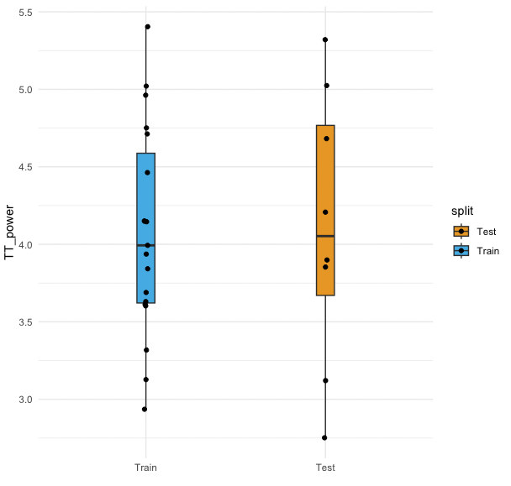
A)

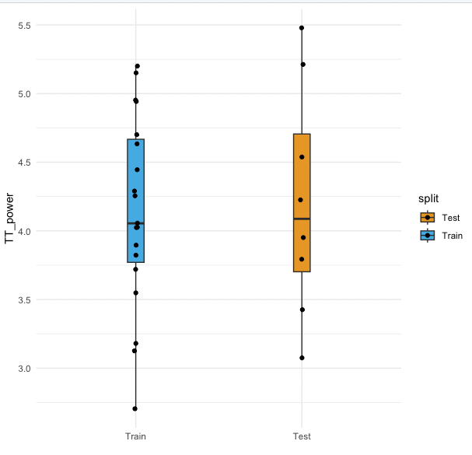

B)

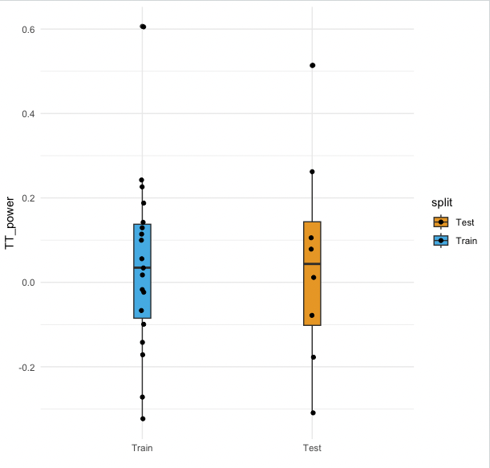
C)

