Supplementary Figures
Supplementary Figure 1: Free and vesicular eHsp70 (ng/mL) levels measured in the plasma of healthy individuals (n=108) and NSCLC patients in the respective tumor stages (A): I (n=25), II (n=11), III (n=89) and IV (n=53) or (B) IA (n=16), IB (n=9), IIB (n=11), IIIA (n=49), IIIB (n=40), IV (n=53). Statistically significant differences *p<0.05, **p<0.01, ***p<0.001.
Supplementary Figure 2: Correlative analysis of the largest tumor diameter (cm) of the surgically resected tumors and eHsp70 levels (ng/mL) in NSCLC patients (n=47, R2=0.0616, mean diameter 3.26 cm).
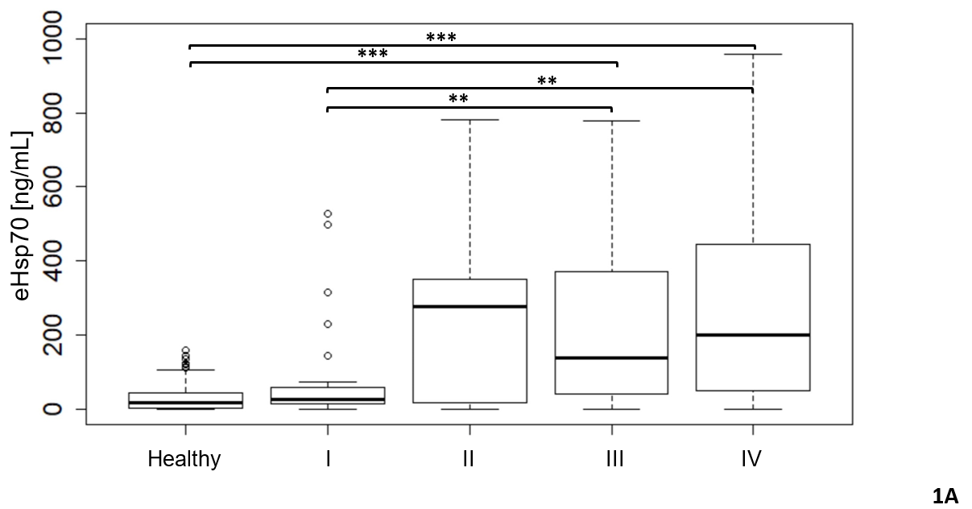
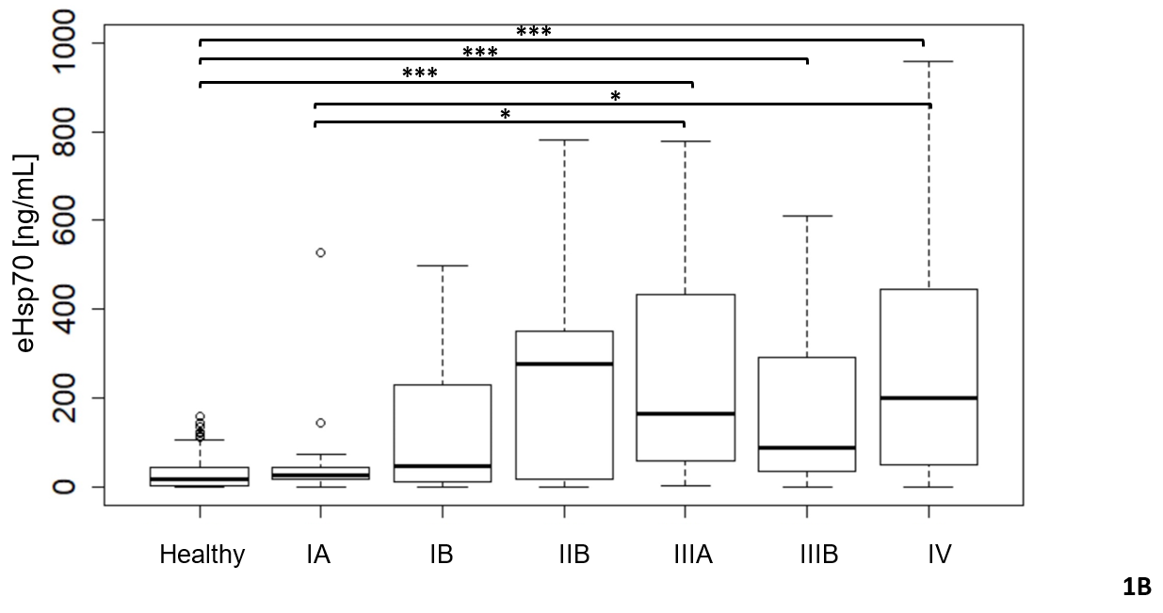
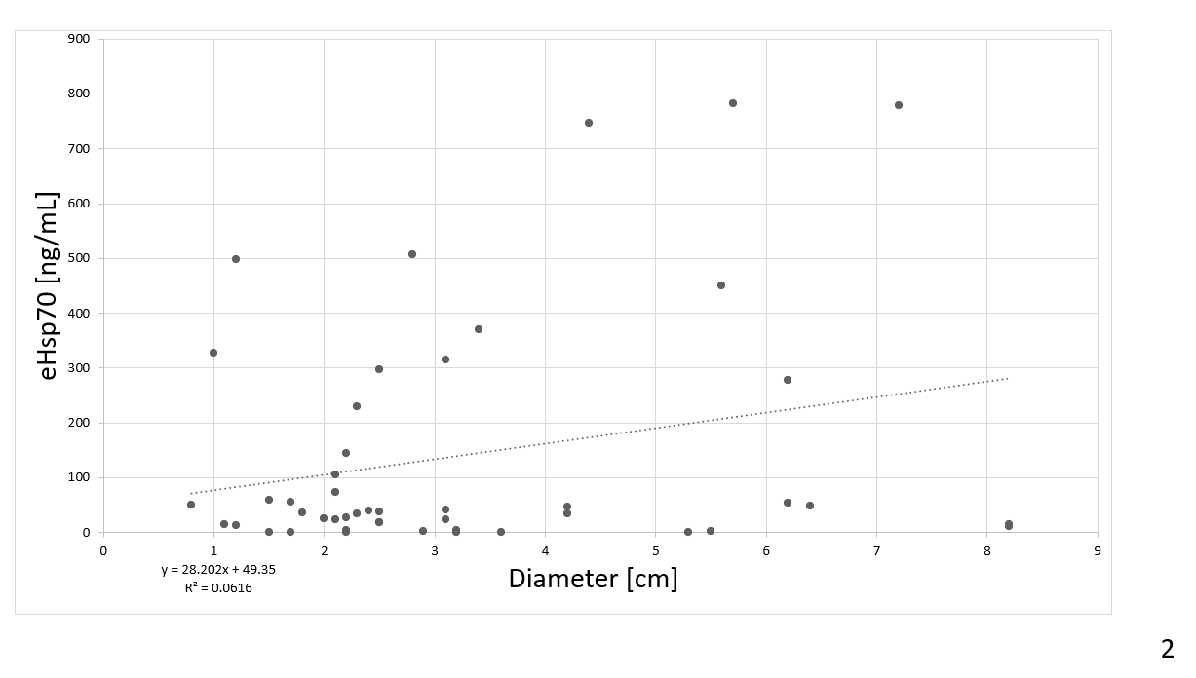

Supplementary Table 1: Patient characteristics of surgical cases
Stage | ∑n |  | n | Adeno | SCC | Other | Median age | Female | Male
I | 25 | IA | 16 | 17 | 5 | 3 | 71 | 15 | 10
I | 25 | IB | 9
II | 11 | IIA | / | 5 | 1 | 5 | 73 | 4 | 7
II | 11 | IIB | 11
III | 17 | IIIA | 15 | 7 | 8 | 2 | 64 | 4 | 13
III | 17 | IIIB | 2

Supplementary Table 2: Entity of extrathoracic primary tumors
Tumor entity | n
Sarcoma | 3
Testicular carcinoma | 6
Colorectal cancer | 8
Melanoma | 2
Breast cancer | 1
Renal cell carcinoma | 2
Pharyngeal carcinoma | 3
Pancreatic carcinoma | 1
Thymus carcinoma | 1
Squamous cell carcinoma | 1
Prostate cancer | 4
Urothelial carcinoma | 3
∑ | 35
Female | 9
Male | 26
Median age [years] | 64

