Table 1. Selected Reaction Optimization. ª
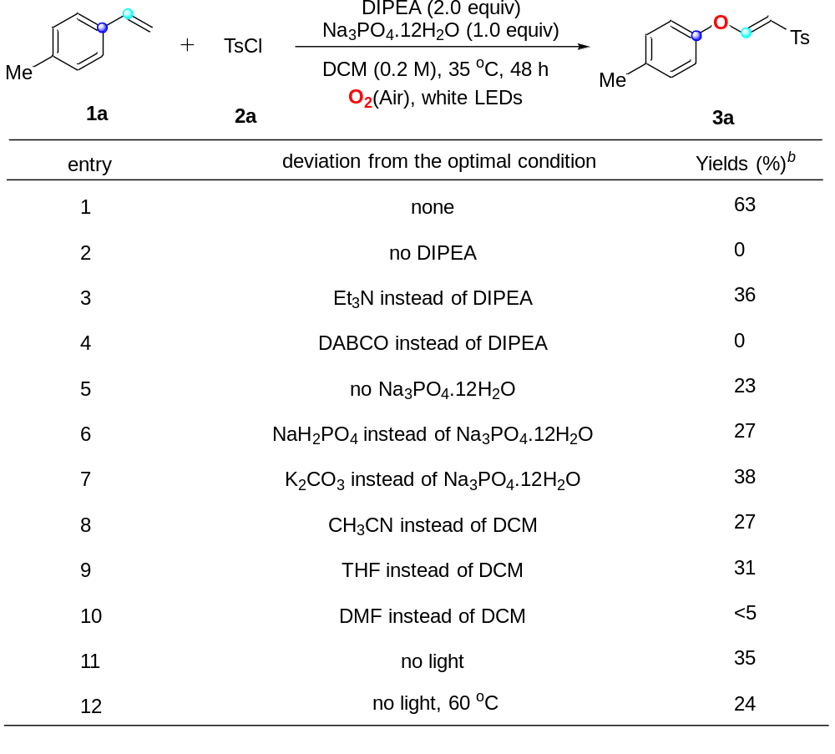
ª Reaction conditions: 1a (0.2 mmol), 2a (0.4 mmol), DIPEA (2.0 equiv), base (1.0 equiv), DCM (1.0 mL/0.2 M), stirred at 35 ºC under Air and irradiated by 90 W white LEDs for 48 h. ^{b} Isolated yields.

Table 2. Scope of Substrates. ^{a,b}
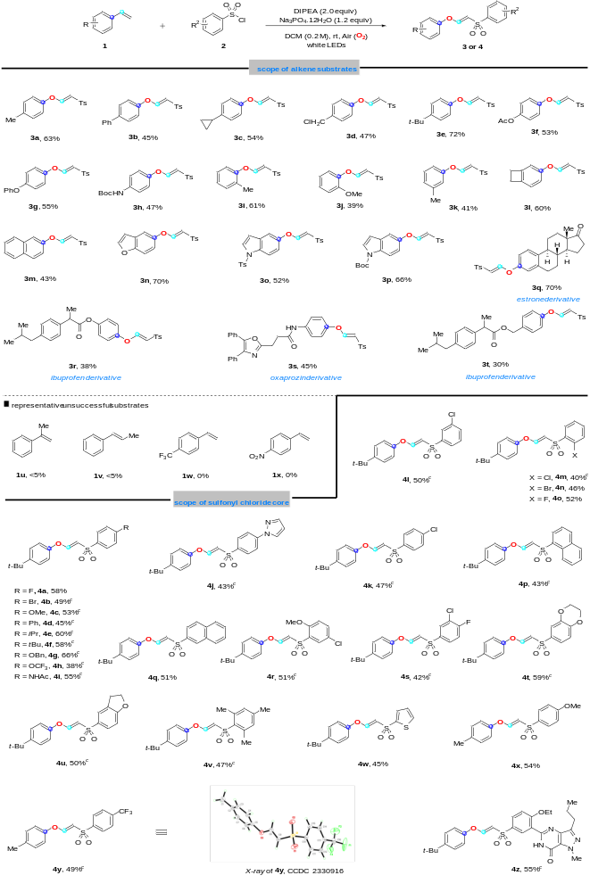
ª Reaction conditions: 1 (0.2 mmol), 2 (0.4 mmol), DIPEA (2.0 equiv), Na₃PO₄.12H₂O (1.2 equiv), DCM (1.0 mL/0.2 M), stirred at 35 ºC under Air and irradiated by 90 W white LEDs for 48 h. ^{b} Isolated yields. ^{c} 2 (0.5 mmol, 2.5 equiv), DIPEA (2.5 equiv) were used.

