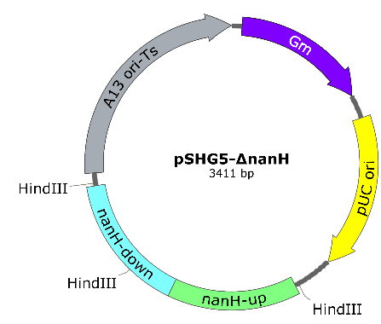
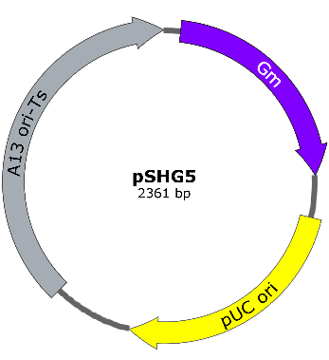
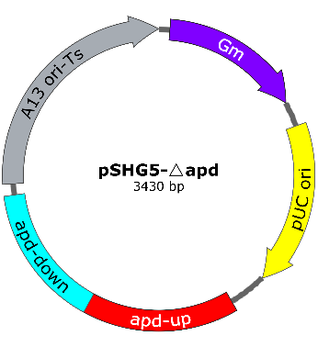
Supplementary Materials
a
b
c
Fig. S1. Vector and plasmids utilized in this study, including: (a) Vector pSHG5; (b) Plasmid pSHG5-ΔnanH; (c) Plasmid pSHG5-Δapd.

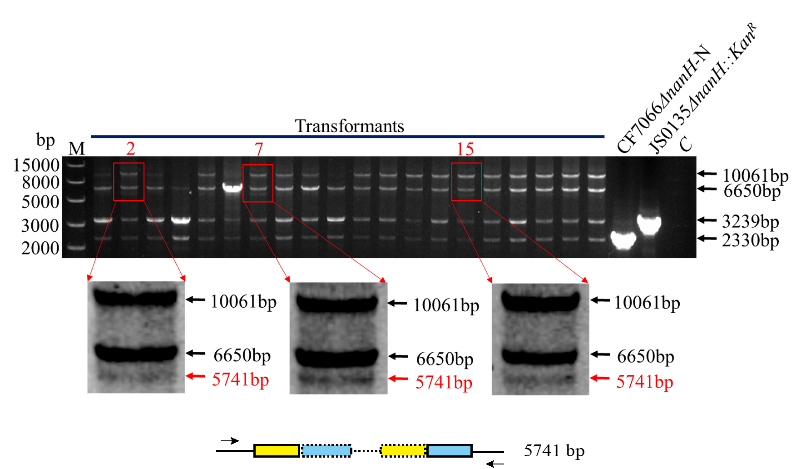
Fig. S2. After enlarging the electropherogram (Fig. 1c), a faint but distinguishable “knockout single crossover” band (5741 bp) was observed. Based on its size, we deduced that this band corresponded to the integration of the entire plasmid into the genome of the Kan^{R} cassette knockout strain.

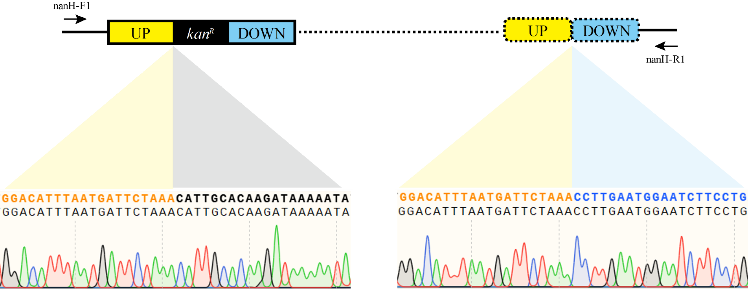
Fig. S3. Sanger sequencing verified the integration of plasmid pSHG5-ΔnanH into the genome of the JS0135ΔnanH::Kan^{R} single-crossover mutant.

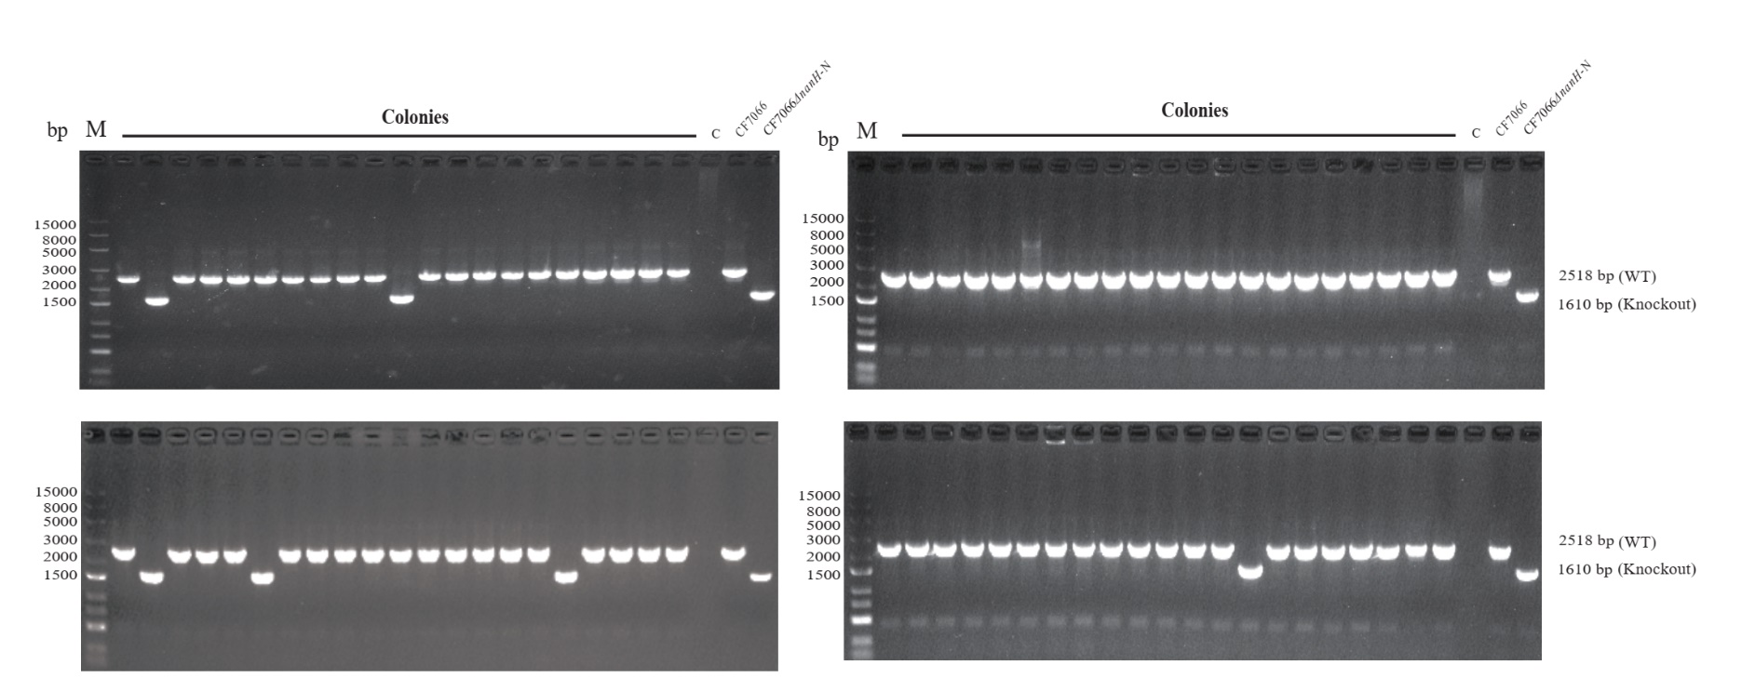
Fig. S4. Screening for the ΔnanH genotype in progeny colonies was performed after the transformed strain CF7066 was cultured at 42°C for two passages. In addition to the 21 colonies shown in Fig. 2d, 84 more colonies were picked for colony PCR identification. The results showed that 7.6% (8/105) of colonies exhibited the knockout genotype.

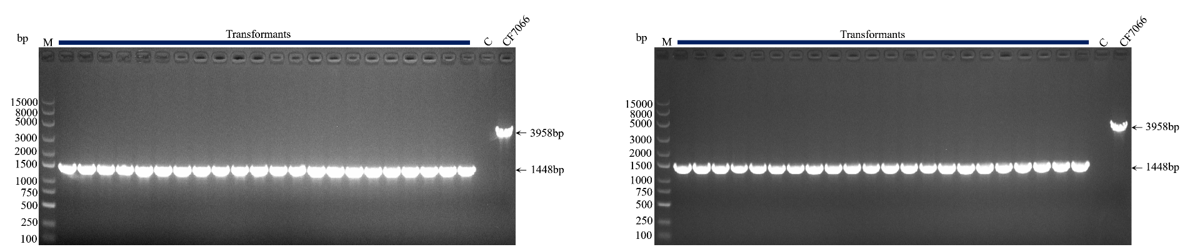
Fig. S5. Screening for the Δapd genotype in progeny colonies was performed after the transformed strain CF7006 was cultured at 42°C for one passage. In addition to the 22 colonies shown in Fig. 3d, 44 more colonies were picked for colony PCR identification. The results showed that all 66 colonies were the knockout genotype.

Table S1. Primers used in this study.
Primers | Primer sequence (5′ → 3′) | PCR product/purpose
K5-F | AACACCCCTTGTATTACTGTTTATGTAAG | Construction of plasmid pSHG5
K5-R | TCAGAATTGGTTAATTGCATATGC | Construction of plasmid pSHG5
G3-F | ATGCAATTAACCAATTCTGAATGTTACGCAGCAGCAACGA | Construction of plasmid pSHG5
G3-R | ACAGTAATACAAGGGGTGTTTTAGGTGGCGGTACTTGGGTC | Construction of plasmid pSHG5
nanH-G5-F | CAGGAATTCGATATCAAGCTTACCGCTTGTTGTGAAAATATGGA | Construction of plasmid pSHG5-ΔnanH
nanH-G5-R | GTCGACGGTATCGATAAGCTTACAAGCGGTACTTTTTCACTAACCG | Construction of plasmid pSHG5-ΔnanH
apdU-F | GGCTGCAGGAATTCGATATCTAATACGCTCAGCATCTTCAATCG | Construction of plasmid pSHG5-ΔapD
apdU-R | CACTGCGTTTAACTTTCAGCATTGGCATTAGTCACTGT | Construction of plasmid pSHG5-ΔapD
apdD-F | GCTGAAAGTTAAACGCAGTGGGATTTCC | Construction of plasmid pSHG5-ΔapD
apdD-R | TCGACGGTATCGATAAGCTTCGAAACTCAATGGCAAGGGG | Construction of plasmid pSHG5-ΔapD
G5-apD-F | AAGCTTATCGATACCGTCGACC | Construction of plasmid pSHG5-ΔapD
G5-apD-R | GATATCGAATTCCTGCAGCCC | Construction of plasmid pSHG5-ΔapD
nanH-F1 | GCTTCGGTTCATTCGGCTTAA | Screening for ΔnanH mutants in JS0135
nanH-R1 | TCACACCAACATCTCCAGCATA | Screening for ΔnanH mutants in JS0135
nanH-F2 | CGATGTAGTTGAAGTGAAAGAGTG | Screening for ΔnanH mutants in CF7066
nanH-R2 | CTTATTAACAGCGACATCCTGATC | Screening for ΔnanH mutants in CF7066
apd-F | CTTCTTCTCGTGCTGTCTT | Screening for ΔapD mutants in CF7066
apd-R | ATAATCGTGGCGTTCTTGT | Screening for ΔapD mutants in CF7066
G5-F | GGATCCCCCGGGCTGCAG | Screening for transformants
G5-R | CCCCTCGAGGTCGACGGTATCG | Screening for transformants
GAPDH-q-F | CAGGTATGGCGTTCCGTGTTCC | For RT-qPCR of gene GAPDH
GAPDH-q-R | GCACCGTTGAAGTCTGTTGATACTACT | For RT-qPCR of gene GAPDH
recA-q-F | GCGACAGAGTCCACAATAATAACATCAAC | For RT-qPCR of gene recA
recA-q-R | TTCTCAGCCAGATAACGGTGAACAAG | For RT-qPCR of gene recA
recB-q-F | TCGTCTTCAGGCACATCATTATCAACT | For RT-qPCR of gene recB
recB-q-R | AAGCAGTGGCGAGATTGGAACAG | For RT-qPCR of gene recB
recC-q-F | CAATATCTCGTGTACCGTCCGCAAT | For RT-qPCR of gene recC
recC-q-R | CCGCTCGCATAATCTCATCAACCA | For RT-qPCR of gene recC
recD-q-F | ACTTGGCAAACGACTAAGGGAAATGT | For RT-qPCR of gene recD
recD-q-R | CCAGATGAAGCAGGAAGATTGAGAGTAT | For RT-qPCR of gene recD
ruvA-q-F | AACGGTGTAGGACCTAAGTTAGCATT | For RT-qPCR of gene  ruvA
ruvA-q-R | CTTTCAATTCAACCAACAAACGCTCTG | For RT-qPCR of gene  ruvA
Gm-q-F | AGTTCGGAGACGTAGCCACCTA | For RT-qPCR of gene  Gm
Gm-q-R | CGGAGACTGCGAGATCATAGATATAGAT | For RT-qPCR of gene  Gm

