Supplementary Information for
Opto-electrical decoupled phototransistor for starlight detection

Shaoyuan Zhou¹, Xinyue Zhang², Ying Wang^{2,}*, Dongyi Lin¹, Shoubin Zou³, Jingwen Wang², Luna Xiao⁴, Dijie Zhang⁴, Jianhua Jiang¹, Panpan Zhang¹, Jianbing Zhang⁵, Jiang Tang⁴, and Zhiyong Zhang^{1,}*

¹Key Laboratory for the Physics and Chemistry of Nanodevices and Center for Carbon-based Electronics, School of Electronics, Frontiers Science Center for Nano-optoelectronics, Peking University, Beijing, China.
²Key Laboratory of Luminescence & Optical Information, Ministry of Education, School of Physical Science and Engineering, Beijing Jiaotong University, Beijing, China.
³Institute of Microelectronics of the Chinese Academy of Sciences; University of Chinese Academy of Sciences; Key Laboratory of Science and Technology on Silicon Devices, Chinese Academy of Sciences, Beijing, China.
⁴School of Optical and Electronic Information and Wuhan National Laboratory for Optoelectronics (WNLO), Huazhong University of Science and Technology, Wuhan, China.
⁵School of Integrated Circuits, Huazhong University of Science and Technology (HUST), Wuhan, 430074, China

e-mail: yingw@bjtu.edu.cn and zyzhang@pku.edu.cn

Section 1. Fabricaiton of Materials and Devices
Figure S1a shows a scanning electron micrograph (SEM) image of the fabricated CNTs network. The Raman spectrum indicates a high G/D band ratio of approximately 21, indicating minimal defects in the CNTs film. Figure S1b depicts the SEM image of the fabricated aligned CNTs film, revealing a density of approximately 350 CNTs per µm.
Fig. S1 | SEM images of the fabricated CNTs film. a, Randomly oriented CNTs film with a density of 35 CNTs per µm. Inset: Raman spectrum of the CNTs film showing a high G/D band ratio of ~21. b, Aligned CNTs film with a density of ~350 CNTs per µm.
Fabrication of HGFET Detectors
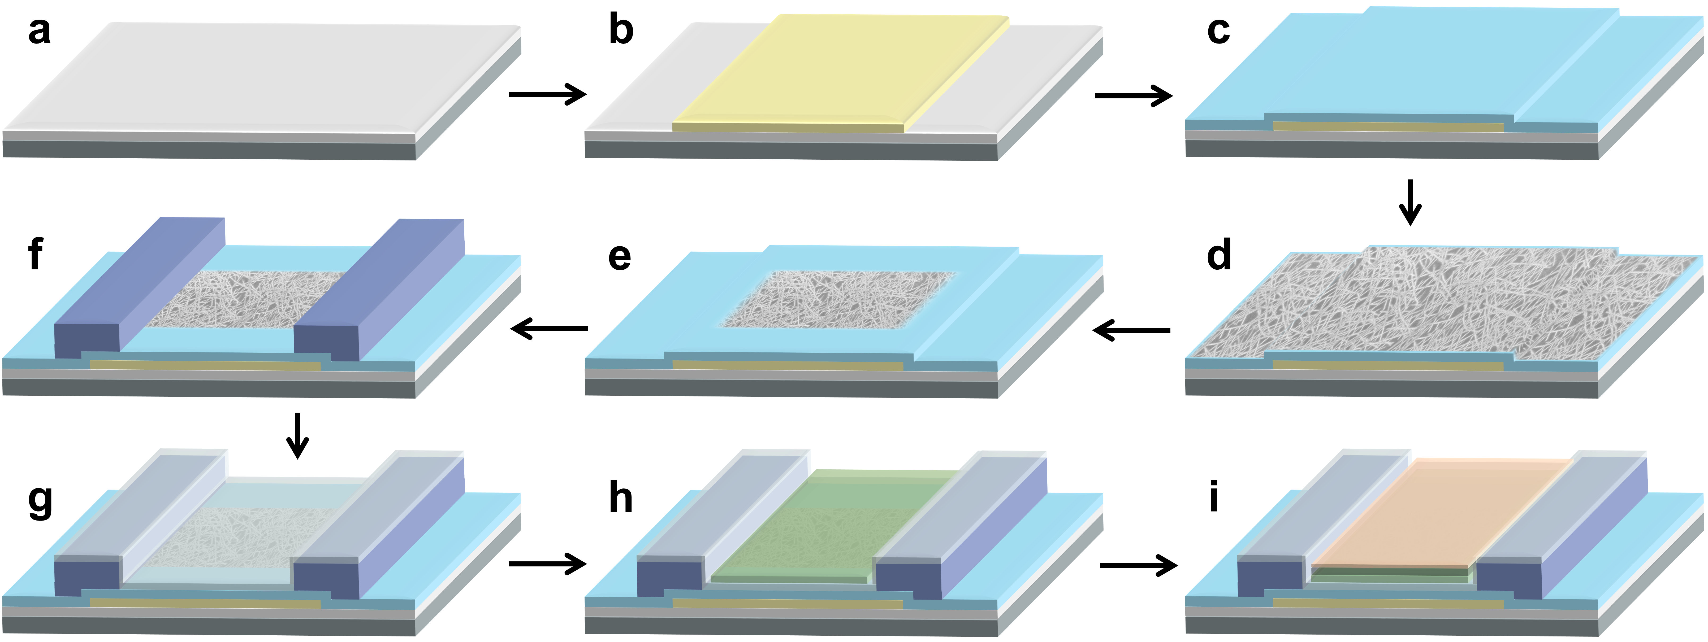
Fig. S2 | Illustration of the fabrication process for the HGFET. a, Preparation of the Si/SiO₂ substrate. b, Deposition of the local bottom-gate metal (Ti/Pd of 1/20 nm) by EBE. c, Deposition of the bottom-gate dielectric of 10 nm-thick HfO₂ by ALD. d, Deposition of the CNTs thin film on the HfO₂ dielectric. e, Etching of redundant CNTs by RIE to define the channel region. f, Deposition of the source and drain electrodes (Ti/Pd/Au of 0.3/40/30 nm). g, Deposition of the ultrathin high-κ dielectric, a 6 nm-thick layer of Y₂O₃. h, Deposition of the 40 nm-thick ZnO thin film by magnetron sputtering. i, Deposition of the PbS-halide CQDs layer (150 nm) and the PbS-EDT CQDs layer (30 nm) by spin coating and an in-situ ligand exchange process.

Section 2. Calculated Gain in HGFET
In Fig. 1d, the internal gain of the HGFET is calculated based on a photovoltage-gated field-effect transistor model. The gain of the HGFET is determined by the following expression:
$Gain=\frac{N_{hole}}{N_{photon}}=\frac{\frac{I_{ph}}{q}}{\frac{AP_{light}η}{hν}}=\frac{I_{ph}hν}{{AP}_{light}ηq}$ (1)
where $N_{hole}$ is the number of photo-induced holes in CNTs channel, $N_{photon}$ is the number of absorbed photons, $I_{ph}$ is the photocurrent,$A$ is the effective device area, $q$ is the elementary charge, $P_{light}$ is the incident power density, $η$ is the external quantum efficiency, and $h\text{ν}$ is the energy of one photon. The relationship between the open-circuit photovoltage ($V_{oc}$) of the p-i-n heterojunction and incident power density can be described by:
$V_{oc}=\frac{k_{B}T}{q}ln\left(\frac{ηqAP_{light}}{hνI_{0}}+1\right)$ (2)
where $k_{B}$ is the Boltzmann constant, $T$ is the temperature, and $I_{0}$ is the reverse saturation current. This photovoltage acts as a top-gate voltage for the CNTs channel, resulting in an increase in the number of holes and consequently the drain-source current. The photovoltage-induced current ($I_{ph}$) follows:
$I_{ph}=g_{m}V_{oc}$ (3)
where $g_{m}$ is the transconductance of photovoltage-gated CNTs transistor. Therefore, the gain in HGFET devices can be expressed as:
$Gain=\frac{I_{ph}hν}{{ηqAP}_{light}}=\frac{g_{m}\frac{k_{B}T}{q}ln\left(\frac{ηqAP_{light}}{hνI_{0}}+1\right)hν}{ηq{AP}_{light}}$ (4)
For high-sensitive SWIR detectors under low light conditions (weak radiation), the incident power density ($P_{light}$) is typically small. Thus, the gain can be approximated as:
$Gain=\frac{g_{m}k_{B}T}{I_{0}q}={k_{T}g}_{m}$ (5)
where $k_{T}$ is a constant and representing$\frac{k_{B}T}{I_{0}q}$.

Section 3. Photodetectors with Trap- Dominated Internal Gain
Figure S3 illustrates three typical photodetectors with trap-dominated internal gain: the photoconductor, the phototransistor, and the sensitized photogating device. In these device architectures, photoconductive gain has been widely reported in nanomaterials and is attributed to trap-induced long excess carrier lifetime. The trapped photocarriers exhibit a prolonged lifetime (τ), while the other type of photocarriers is collected within the transit time (τ_{T}). To maintain neutrality, charge carriers recirculate during the lifetime of the trapped carriers, resulting in an optical gain of τ/τ_{T}. In fact, photoconductive gain can be observed in a photoconductor even without traps or defects, especially in the SWIR region or for cryogenically cooled devices¹. In most semiconductors, photogenerated electrons reach the positively charged electrode much faster than holes reach the negative electrode and exit the channel quickly. Recirculation of electrons also occurs to maintain the sample’s neutrality. However, controlling trap-dominated or asymmetric mobility-induced gain presents challenges due to the difficulties in engineering trap densities, distributions, and time constants. Additionally, there is a theoretical trade-off between gain and bandwidth for these photogating devices, and overcoming this challenge is not trivial.
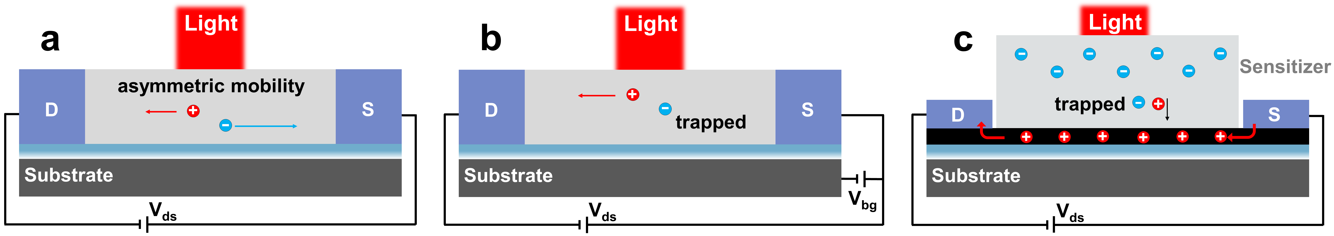
Fig. S3 | Trap-dominated internal gain in three typical photodetectors. a, Photoconductor exhibiting gain resulting from traps or asymmetric mobility of holes and electrons. b, Phototransistor showing gain attributed to traps. c, Sensitized photogating detector showing photoconductive gain induced by traps that prolong carrier lifetime.

Section 4. Response Characteristics of HGFET
In Fig. 2, we measured the photoresponse of the HGFET device at a constant bottom-gate voltage (V_{bg}) of -0.6 V. This V_{bg} value was selected based on considerations of responsivity and dark current characteristics. When the CNTs channel is biased in the linear region by V_{bg}, the HGFET exhibits higher responsivity, albeit with elevated levels of dark current and noise. Conversely, when the CNTs channel is depleted at V_{bg}~-0.25 V, the HGFET shows minimal dark current and noise; however, the responsivity becomes extremely low. Therefore, applying a bottom-gate voltage of -0.6 V was aimed at enabling the HGFET to achieve high gain while maintaining moderate noise levels.
Fig. S4 | Typical transfer characteristic of the bottom-gate HGFET at V_{ds}=-0.1 V.
Fitting Photocurrent Using a Combined P-N Junction and FET Model
The relationship between the open-circuit voltage ($V_{oc}$) of the p-i-n heterojunction and incident light intensity can be calculated using the expression:
$V_{oc}=\frac{k_{B}T}{q}ln\left(\frac{ηqAP_{light}}{hνI_{0}}+1\right)$ (1)
where $k_{B}$ is the Boltzmann constant, $T$ is the temperature, $A$ is the optical area, $I_{0}$ is the reverse saturation current, $η$is the external quantum efficiency, $P_{light}$is the incident power density, $q$ is the elementary charge, and $h\text{ν}$ is the energy of one photon.
In the subthreshold region of a FET, the relationship between the drain-source current ($I_{ds}$) and threshold drift (${ΔV}_{th}$) can be expressed as:
$logI_{ds}=\frac{{ΔV}_{th}}{SS}+logI_{ds0}$ (2)
where $SS$ is the subthreshold swing, $I_{ds0}$ is the initial drain-source current. For an HGFET detector based on the opto-electronic decoupling model, the relationship between ${ΔV}_{th}$ and $V_{oc}$ can be calculated by:
${ΔV}_{th}=αV_{oc}$ (3)
where $α$ is the coupling coefficient, representing the effective utilization of photovoltage and depending on the internal resistance of the p-i-n heterojunction ($R_{HG}$) and FET gate-source ($R_{gs}$). The expression for $I_{ds}$ can be derived by substituting expressions (1) and (3) into expression (2):
$I_{ds}=\left[{\left(\frac{ηqAP_{light}}{hνI_{0}}+1\right)}^{\frac{2.3αk_{B}T}{qSS}}\right]I_{ds0}$ (4)
The coefficient 2.3 in the expression is a result of converting the natural logarithm (ln) to the base-10 logarithm (log). The expression for $I_{ph}$ in the subthreshold region can thus be derived as:
$I_{ph}=\left[{\left(\frac{ηqAP_{light}}{hνI_{0}}+1\right)}^{\frac{2.3αk_{B}T}{qSS}}-1\right]I_{ds0}$ (5)
In the linear region of the FET, the relationship between the drain-source current ($I_{ds}$) and threshold drift (${ΔV}_{th}$) is given by:
$I_{ds}=g_{m}{ΔV}_{th}$+$I_{ds0}$ (6)
where $g_{m}$ is the transconductance of the photovoltage-gated CNTs FET. The expression for $I_{ph}$ can be derived in the linear region as:
$I_{ph}=\frac{g_{m}αk_{B}T}{q}ln\left(\frac{ηqAP_{light}}{hνI_{0}}+1\right)$ (7)
Based on the theory described above, a fitting of the photocurrent variation with power density was conducted as shown in Fig. 2c. The fitted product$α{∙g}_{m}$is 11.57 nS/µm.
Validation of the Photovoltage-Gated CNTs FET Model through Fabrication of a Top Metal-Gated CNTs FET
To further validate the photoresponse theory described above, we fabricated top metal-gated CNTs FETs with identical channel length, channel width, and gate length as those of the HGFET (Fig. S5). Now, we can compare the electrical properties of these two types of top-gate CNTs FETs: the photovoltage-gated CNTs FET and the externally top-gate voltage (V_{tg}) gated CNTs FET.
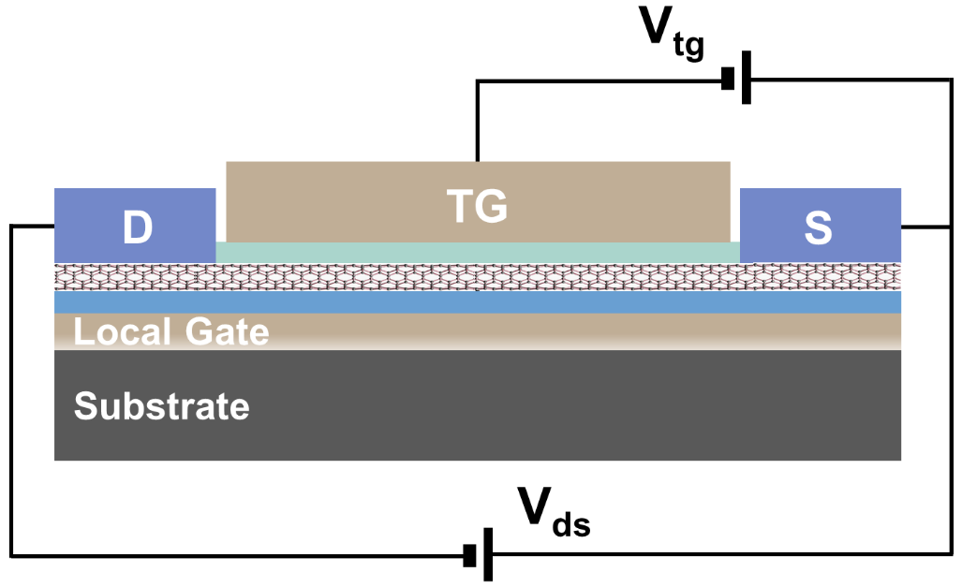
Fig. S5 | Schematic of a top metal-gated CNTs FET. Compared to the HGFET, the p-i-n heterojunction is replaced with a top-gate metal of Pd. The top-gate CNTs FET is designed with the same channel length (10 µm) and channel width (10 µm) as the HGFET. Additionally, the gate length and width are designed to match the dimensions of the ZnO layer in the HGFET. We use V_{tg} to differentiate the top gate voltage from V_{bg}, which represents the bottom-gate voltage.
In Fig. S6a and S6b, we illustrate the dynamic photocurrent as the irradiation power densities increase for three HGFETs controlled by varying bottom-gate voltages. The relationship between the open-circuit voltage ($V_{oc}$) of the p-i-n heterojunction and incident power density is described by the above expression (1). In Fig. S6a, these devices were operated within the linear region of the CNTs FET, allowing us to extract the approximate peak transconductance (g_{m}*). Each device underwent three repeated measurements, yielding nine g_{m}* data points ranging from 35.6 to 42.4 nS/µm (Fig. S6c). In Fig. S6b, these devices were operated within the subthreshold region of the CNTs FET, enabling us to extract subthreshold swing (SS*) data ranging from 76 to 108 mV/dec (Fig. S6c). Figure S6d presents the transfer characteristic curves of five V_{tg}-gated CNTs FETs with identical geometrical dimensions and gate length as those of the HGFETs. The extracted peak transconductance (g_{m}) ranges from 36 to 52 nS/µm, and the extracted subthreshold swing (SS) is 92 mV/dec. The g_{m} and SS data from the two sets of experiments exhibit strong resemblance, confirming the validity of the photovoltage-gated response characteristics of HGFETs. Furthermore, we calculated the coupling coefficient $α$ based on the g_{m}* data of 35.6-42.4 nS/µm and the fitted $α{×g}_{m}$product of 11.57 nS/µm. The obtained $α$ ranges from 27.3% to 35.6%. This indicates that less than 40% of the photovoltage is effectively applied to the CNTs FET, which can be attributed to a relatively small FET gate resistance ($R_{gs}$).
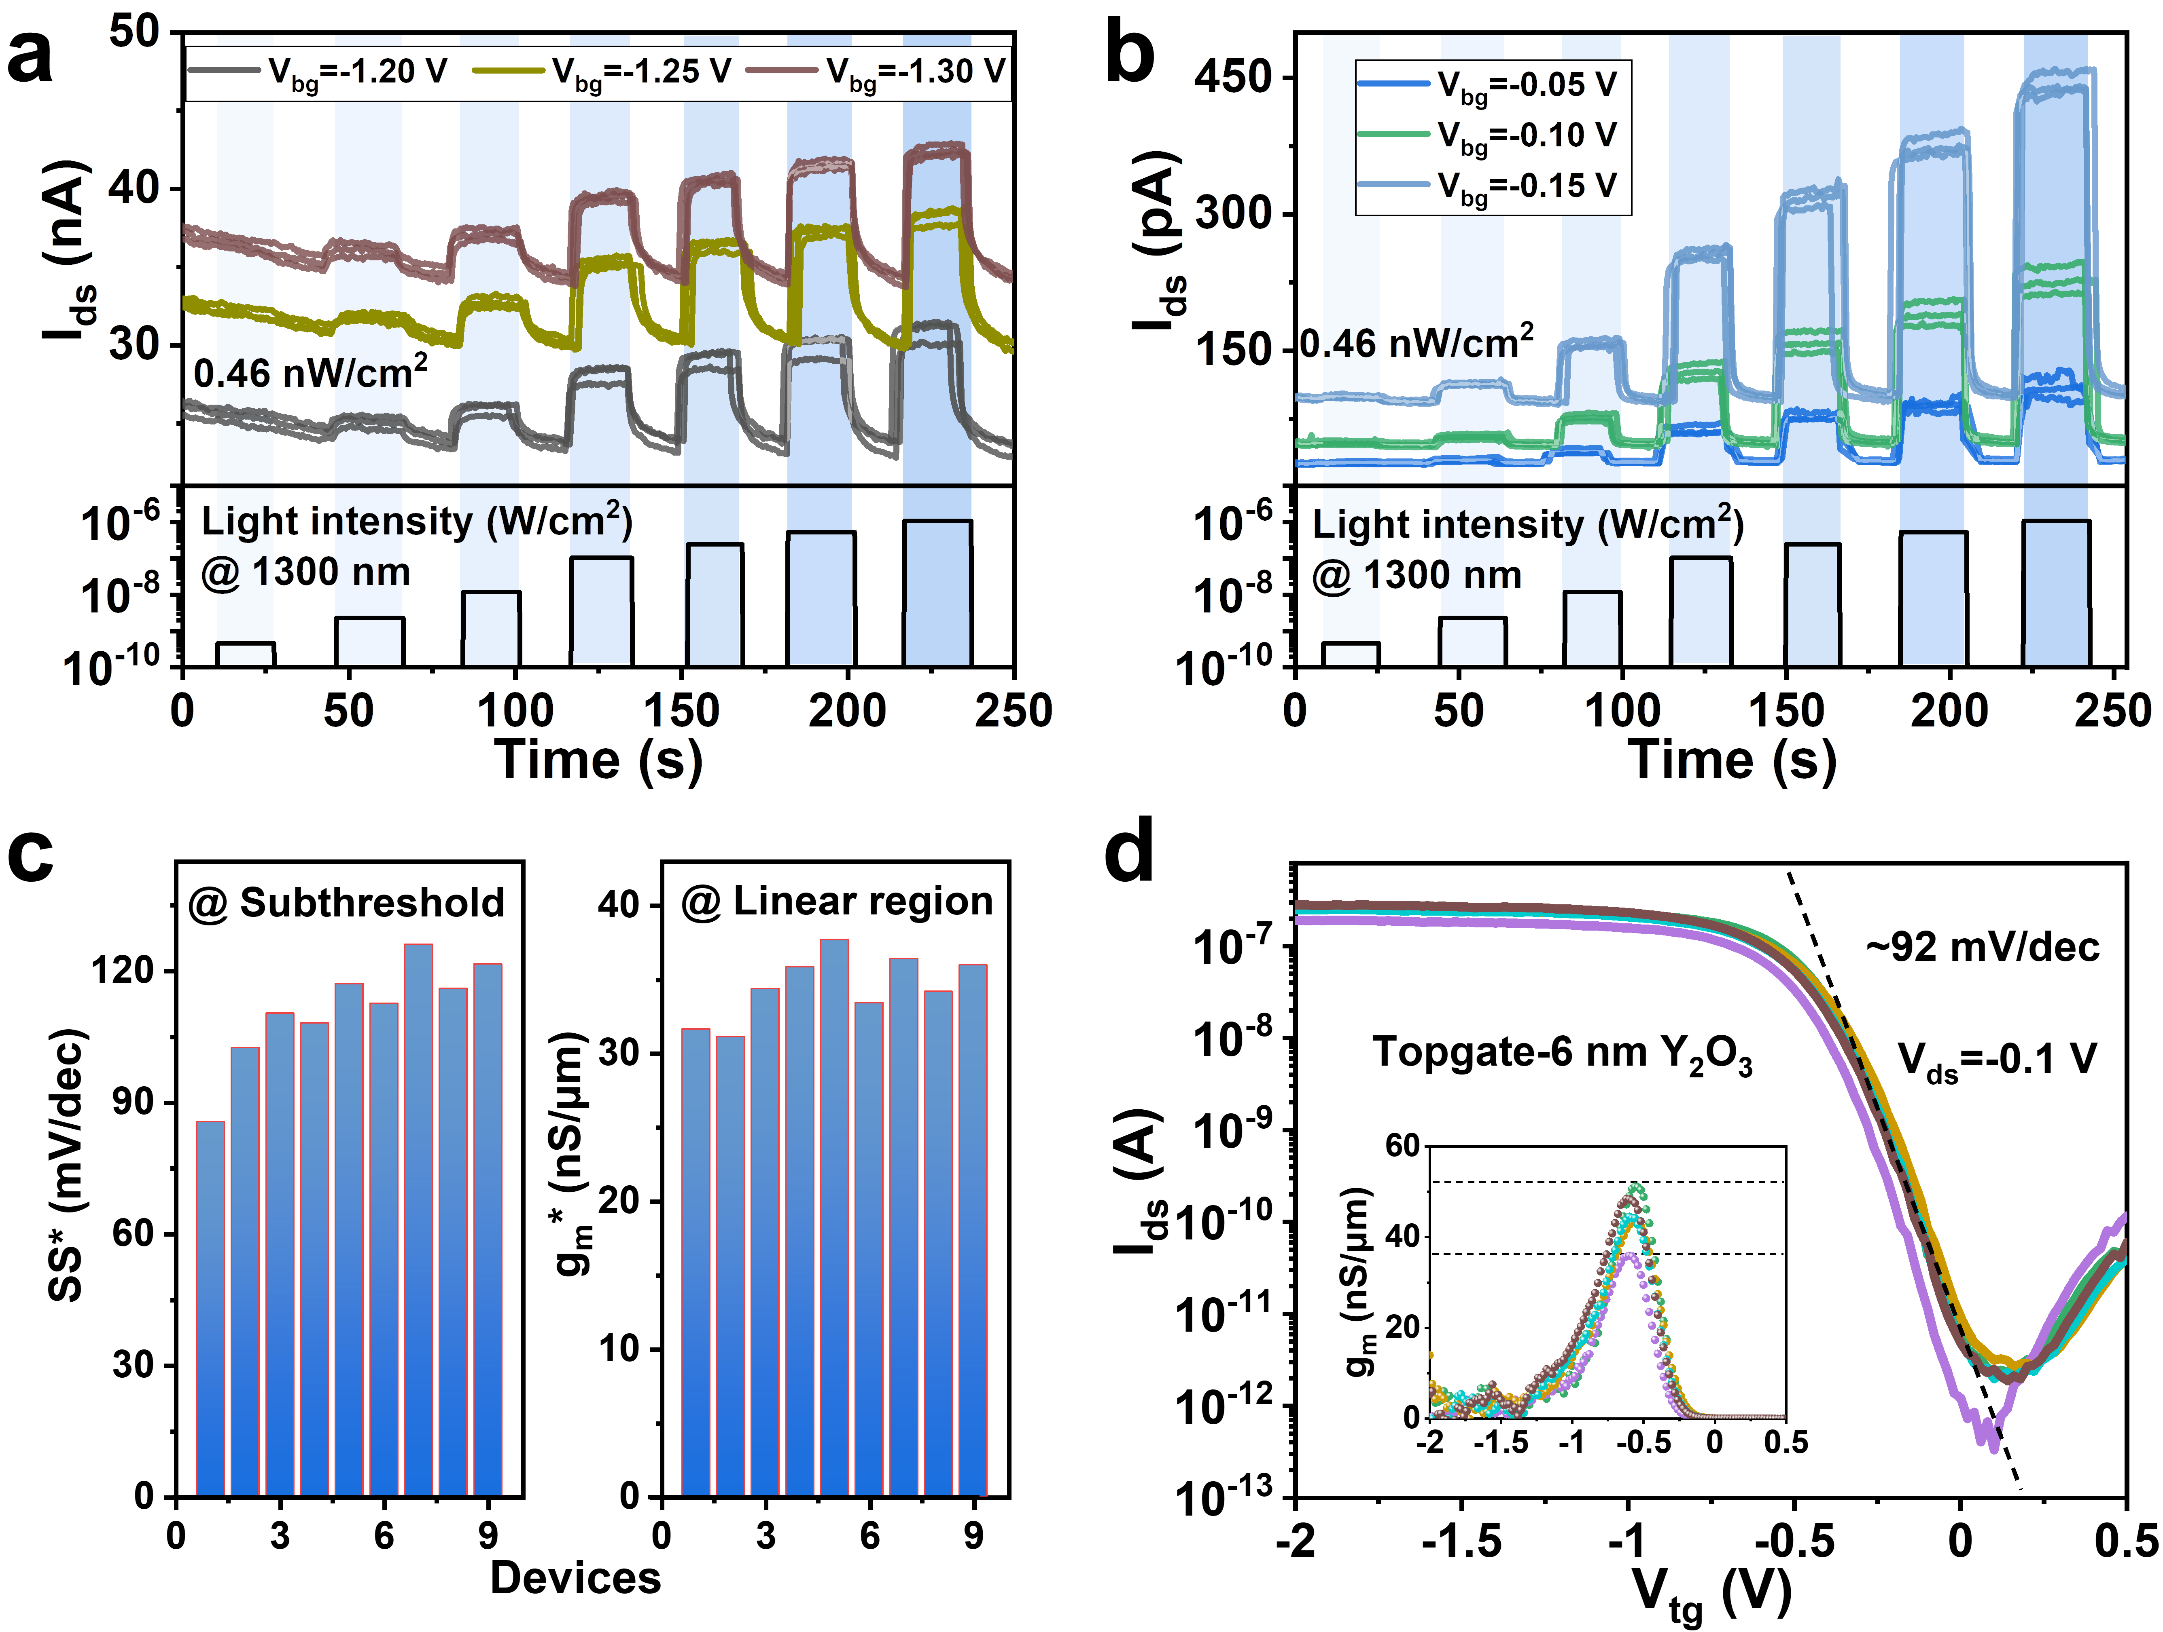
Fig. S6 | Comparison of the electrical properties of the photovoltage-gated CNTs FET and the external V_{tg}-gated CNTs FET. a, Real-time response curves of three devices at bottom-gate voltages of -1.2 V, -1.25 V, and -1.30 V, operation within the linear region of the HGFET. Each device underwent three repeated measurements. The corresponding irradiation power density at 1300 nm is shown at the bottom. b, Real-time response curves of three devices at bottom-gate voltages of -0.05 V, -0.10 V, and -0.15 V, ensuring operation within the subthreshold region of the HGFET. c, Extracted subthreshold swing (SS*) and transconductance (g_{m}*) from irradiation-dependent photovoltage (V_{oc}) of the p-i-n heterojunction. d, Transfer characteristic curves of five top metal-gated CNTs FETs with identical geometrical dimensions and gate length as those of the HGFETs. The extracted g_{m} ranges from 36 to 52 nS/µm, and the extracted SS is 92 mV/dec.
TCAD Simulation of HGFET
q = 1.6×10⁻¹⁹ C (@ Elementary charge)
k_{B} = 1.38×10⁻²³ m²kgs⁻²K⁻¹ (@ Boltzmann constant)
T = 290 K (@ Temperature)
h = 6.6×10⁻³⁴ m²Kg/s (@ Planck constant)
CNTs FET
L_{ch} = W_{ch} = 10 µm (@ channel length and width of CNTs channel)
µ₁ = 50 cm²/Vs (@ mobility of randomly oriented CNTs thin film)
µ₂ = 1000 cm²/Vs (@ mobility of aligned CNTs thin film)
t₁ = 1.4 nm (@ thickness of CNTs thin film)
t₂ = 10 nm (@ thickness of bottom-gate dielectric)
ε₁ = 22×8.854×10⁻¹² F/m (@ dielectric constant of bottom-gate dielectric)
V_{ds} = -0.1 V (@ source-drain voltage)
ZnO:PbS CQDs heterojunction
L_{HG} = 8 µm, W_{HG} = 10 µm (@ length and width of ZnO:PbS CQDs heterojunction)
N_{A}=10¹⁷ cm⁻³ (@ doping density of n-type ZnO and p-type PbS CQDs)
µ₃ = 0.01 cm²/Vs (@ mobility of PbS CQDs thin film)
t₃ = 40 nm (@ thickness of n-type ZnO thin film)
t₄ = 150 nm (@ thickness of i-type PbS CQDs layer)
t₅ = 30 nm (@ thickness of p-type PbS CQDs layer)
t₆ = 6 nm (@ thickness of high-κ dielectric on CNTs thin film)
ε₂ = 8×8.854×10⁻¹² F/m (@ dielectric constant of high-κ dielectric)
η = 10% (@ external quantum efficiency of ZnO:PbS CQDs heterojunction)

Based on the heterojunction-gated FET model, we conducted a comparison between this analytical model and fully self-consistent numerical simulations (TCAD). Firstly, we fabricated the ZnO:CQDs p-i-n diodes with identical geometrical dimensions and structures as those in the HGFETs. The p-i-n photodiodes feature ohmic contacts at the interfaces of ZnO:ITO and p-type PbS CQDs:Au (Fig. S7a and S7b), ensuring that there is no additional consumption of photocarriers due to contact barriers. Next, we measured the photoresponse of the p-i-n photodiodes. Figure S7c displays the open-circuit voltage as a function of irradiation intensities at 1300 nm. The extracted EQE is approximately 10% due to the reduced film thickness of the intrinsic PbS CQDs layer. We compared this photovoltage-gated FET model to TCAD simulation and found good agreement, as depicted in Fig. S7d. The simulated coupling efficiency α is 26.9%, which closely matches the calculated value ranging from 27.3% to 35.6% in Fig. S6.
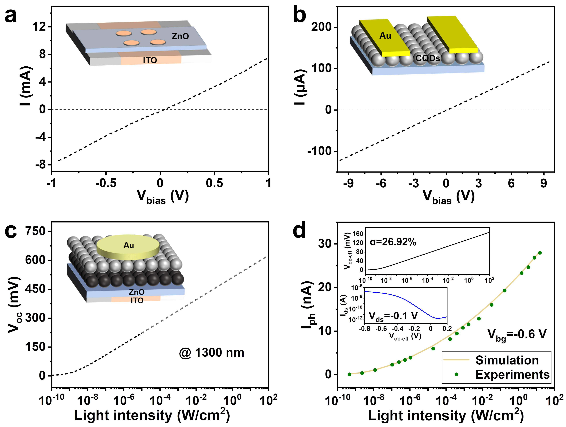
Fig. S7 | Heterojunction properties and TCAD simulation of the HGFET. a, Current-voltage curve of an ITO-contacted ZnO device, demonstrating a linear relationship. Inset: Schematic of the fabricated device. b, Current-voltage curve of an Au-contacted PbS CQDs film with EDT ligands. c, Open-circuit voltage as a function of irradiation intensities at 1300 nm. Inset: Schematic of the fabricated p-i-n photodiode. The extracted η is approximately 10%. d, TCAD simulation showing the response characteristics with increasing irradiation intensities at 1300 nm. The green dots represent experimental data in Fig. 2. Top Inset: Simulated effective photovoltage as a function of irradiation intensity, showing a coupling efficiency (α, the slope of the curve) of 26.9%. Bottom Inset: Simulated transfer characteristics curve of an HGFET at V_{ds}=-0.1 V.
Section 5. Noise Measurements of HGFET
Noise is associated with the random fluctuations in output current and voltage signals over time. In the case of high-impedance detectors (over kΩ), noise current (I_{n}) is typically measured using current-mode readout. All system components significantly influence test outcomes, including the power supply, preamplifier, spectrum analyzer, cables, connectors, shielded housing, and temperature controller. We employed a standard noise measurement system (refer to Fig. S8a) consisting of an advanced probe station (Cascade, providing fA-level current precision), a semiconductor parameter analyzer (Keithley 4200), and a broad-spectrum analyzer. The noise data were collected under the same V_{ds} and V_{bg} conditions used for the photoelectric measurement of the HGFET. To validate the reliability of the acquired noise data, we measured the noise spectral density of the HGFET detector using two different systems: the PDA FS380 from Bodawei Electronic Technology Co., Ltd. and the E4727B from Keysight Technologies Co., Ltd. The two sets of noise data exhibit good agreement, as illustrated in Fig. S8.
The current noise of the HGFET detector comprises contributions from shot noise, thermal noise and flicker noise (or 1/f noise). The shot noise power spectral density increases with the current and can be given by $I_{ns}=\sqrt{2qI_{d}∆f}$, where q is the elementary charge, I_{d} is the dark current, and Δf is the electronic bandwidth of the noise measurement. The thermal noise power spectral density of the HGFET detector includes two categories and can be given by $I_{nt}={(\frac{4k_{B}TΔf}{R_{FET}}+4KTR_{HG}Δfg_{m}^{2})}^{1/2}$, where $k_{B}$ is the Boltzmann constant, T is the temperature, $R_{FET}$ is the differential resistance of the FET, $R_{HG}$ is the internal resistance of the heterojunction, and $g_{m}$ is the transconductance of the heterojunction-gated FET (considering an amplified thermal noise of the heterojunction, detailed in Section 8). The flicker noise power spectral density is calculated as$I_{nf}=\sqrt{CI_{d}^{a}/f^{b}}$, where C, a and b are constants, I_{d} is the dark current, f is the operating frequency². The total current fluctuations are the root-sum-square of the individual noise components: $I_{n}=\sqrt{{I_{ns}}^{2}+{I_{nt}}^{2}+{I_{nf}}^{2}}$. We thus fit the measured noise data in Fig. 2e using the above expressions.
Fig. S8 | Characterization of the noise spectral density. a, Schematic diagram of the test system for noise current measurement. b, Noise power spectra of the HGFET detector obtained at V_{ds}=-0.1 V and V_{bg}=0 V, using two different measurement systems: PDA FS380 (Bodawei Electronic Technology Co., Ltd.) and E4727B (Keysight Technologies Co., Ltd.). c, Noise power spectra measured using PDA FS380 with varying V_{bg} from 1 V to -2 V in steps of 0.05 V. d, Comparison of the noise power spectra measured using PDA FS380 (blue) and E4727B (gray) at specific V_{bg} values (-1.6 V, -1 V, and -0.6 V), corresponding to different operational regions (saturation, linear, and subthreshold) of the HGFET.
Section 6. Photocurrent Response of HGFET at Different Bottom-Gate Voltages
To investigate the bottom-gate tunable photoresponse behavior, we conducted real-time photocurrent measurements on the HGFET device while varying V_{bg} across a range from 0 V to -2 V. By selecting thirteen specific V_{bg} values, we were able to explore the HGFET’s operational behavior from the off-state to nearly the saturation region.

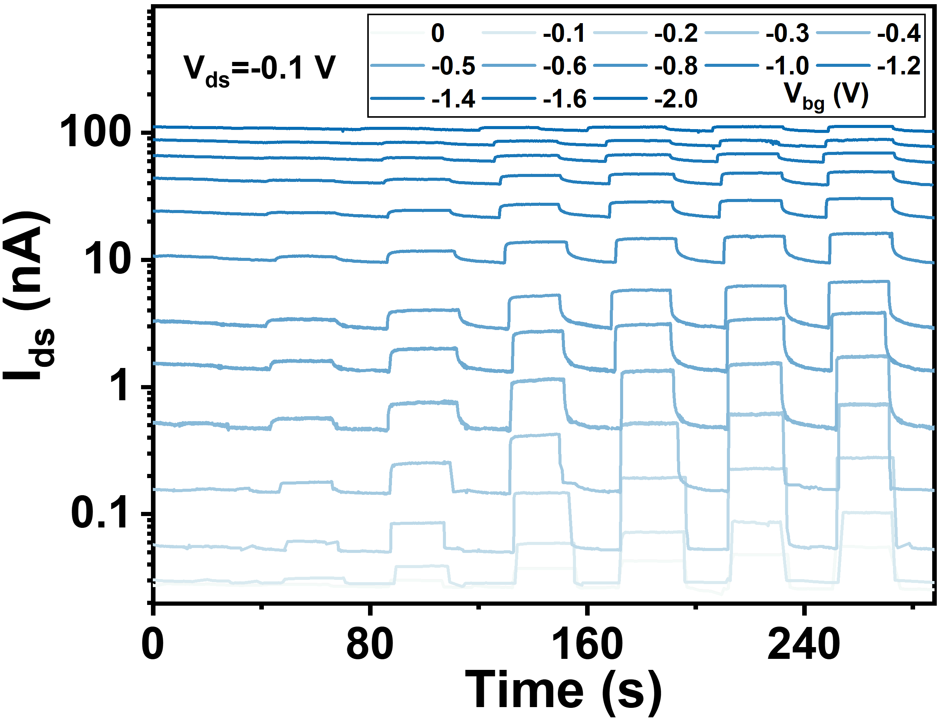
Fig. S9 | Real-time photocurrent response at different bottom-gate voltages. The time-resolved photoresponse of the HGFET device measured at various V_{bg} ranging from 0 to -2 V, irradiated at low power densities ranging from 0.46 nW/cm² to 1.08 μW/cm².
Section 7. Gain Fitted Using the Photovoltage-Gated FET Model
To validate the derived gain from Section 2, we performed a fitting of the bottom-gate tunable gain, as illustrated in Fig. 3d, utilizing the expression: Gain = k_{T}g_{m}. Under constant irradiation of 0.46 nW/cm², the photovoltage of p-i-n heterojunction remains unchanged. The varied V_{bg} are intended to modify the threshold voltage of the HGFET, resulting in a noticeable alteration of g_{m} and, consequently, a change in gain. The HGFET behaves akin to a double-gate transistor.
The relationship between the transconductance ($g_{m}$) of a typical FET and gate capacitance ($C_{g}$) is expressed as follows:
$g_{m}=μC_{g}\frac{W}{L}V_{ds}$ (1)
Where $μ$ represents the carrier mobility, $W$ and $L$ denote the width and length of the CNTs FET channel, and $V_{ds}$ is the drain-source voltage. By rearranging Equation (1), $I_{ds}$ in terms of $g_{m}$ can be obtain as:
$V_{ds}=\frac{L}{μC_{g}W}g_{m}$ (2)
Assuming a bottom-gate voltage ($V_{bg}$) induced drain-source voltage ($V_{ds0}$), it can be expressed as:
$V_{ds0}=\frac{L}{μC_{bg}W}g_{m-bg}$ (3)
where $C_{bg}$ is the bottom-gate capacitance, and $g_{m-bg}$ is the bottom-gate induced transconductance at this operating point (representing the channel charge concentration $n_{0}$). At the same $V_{bg}$, the heterojunction-gate induced transconductance ($g_{m-hg}$) can be calculated as:
$g_{m-hg}=μC_{hg}\frac{W}{L}V_{ds0}=μC_{hg}\frac{W}{L}\frac{L}{μC_{bg}W}g_{m-bg}=\frac{C_{hg}}{C_{bg}}g_{m-bg}$ (4)
where $C_{hg}$ is the heterojunction-gate capacitance. The photocurrent ($I_{ph}$) can thus be expressed as:
$I_{ph}=g_{m-hg}V_{oc}=\frac{C_{hg}}{C_{bg}}g_{m-bg}V_{oc}$ (5)
where $V_{oc}$ is the photovoltage. Additionally, the relationship between $V_{oc}$ and incident power density ($P_{light}$) follows:
$V_{oc}=\frac{k_{B}T}{q}ln\left(\frac{ηqAP_{light}}{hνI_{0}}+1\right)$ (6)
where $k_{B}$ is the Boltzmann constant, $T$ is the temperature, $q$ is the elementary charge, $η$ is the external quantum efficiency, $A$ is the effective device area, $I_{0}$ is the reverse saturation current, and $h\text{ν}$ is the energy of one photon. The relationship between $I_{ph}$ and $g_{m-bg}$ can be written as:
$I_{ph}=\frac{C_{hg}}{C_{bg}}g_{m-bg}V_{oc}=\frac{k_{B}T}{q}ln\left(\frac{ηqAP_{light}}{h\text{ν}I_{0}}+1\right)\frac{C_{hg}}{C_{bg}}g_{m-bg}$ (7)
Therefore, the relationship between gain ($Gain$) and photocurrent can be calculated by:
$Gain=\frac{I_{ph}hν}{{AP}_{light}ηq}=\frac{hν}{{AP}_{light}ηq}\frac{k_{B}T}{q}ln\left(\frac{ηqAP_{light}}{h\text{ν}I_{0}}+1\right)\frac{C_{hg}}{C_{bg}}g_{m-bg}$ (8)
For highly sensitive SWIR detectors under weak radiation, where $P_{light}$ is typically small, the gain (Equation (8)) can be approximated as:
$Gain=\frac{k_{B}T}{I_{0}q}\frac{C_{hg}}{C_{bg}}g_{m-bg}={k_{T}\frac{C_{hg}}{C_{bg}}g}_{m-bg}$ (9)
where $k_{T}$ is a constant and representing$\frac{k_{B}T}{I_{0}q}$. By utilizing the measured transfer characteristic of the bottom-gated HGFET device (shown in Fig. S10a), we can fit the V_{bg}-dependent gain as illustrated in Fig. 3d.
Fig. S10 | Plotting the gain as a function of the applied bottom-gate voltage. a, Transfer characteristic curve of the bottom-gate CNTs FET, showing the bottom-gate induced transconductance ($g_{m-bg}$). b, Real-time photocurrent response at different V_{bg}. The extracted gain data at various V_{bg} were calculated by: Gain = (I_{ph}hν)/(qηAP_{light}), in which η was measured to be ~10%. The solid green line represents the fitted gain.
Section 8. Noise Characteristics of HGFET
Noise Theory of HGFET
In the opto-electronic decoupling model of HGFET, noise can be categorized into two sources: one originating from the heterojunction and the other from the underlying FET. We specifically divide the related noises into four types: thermal noise ($I_{nT-FET}$) in the CNTs FET, thermal noise ($V_{nT-HG}$) in the heterojunction³, shot noise ($I_{nS-FET}$) and flicker noise ($I_{nf-FET}$) in the CNTs FET². The thermal noise of heterojunction can be calculated using the expression:
$V_{nT-HG}=\sqrt{4k_{B}TR_{HG}Δf}$ (1)
where $k_{B}$ is the Boltzmann constant, $T$ is the temperature, $R_{HG}$ is the internal resistance of the heterojunction, and $Δf$is the bandwidth. The thermal noise of a FET follows the expression:
$I_{nT-FET}=\sqrt{\frac{4k_{B}TΔf}{R_{ds}}}$ (2)
where $g_{m}$ is the transconductance of the FET. The shot noise of the FET follows the expression:
$I_{nS-FET}=\sqrt{2qI_{ds}Δf}$ (3)
where $I_{ds}$ is the drain-source current of the FET. The flicker noise of a typical FET operated in the subthreshold region can be calculated by the expression:
$I_{nf-FET-subthreshold}=\sqrt{\frac{{C_{inv}}^{2}}{{\left(C_{ox}+C_{d}\right)}^{4}}\frac{q^{4}}{{\left(KT\right)}^{2}}\frac{N_{ot}}{WLf}}∙I_{ds}$ (4)
where $C_{inv}$ is the inverse capacitance, $C_{ox}$ is the oxide capacitance, $C_{d}$ is the depletion capacitance, $N_{ot}$ is the density of oxide traps, $W$ and $L$ are the width and length of the channel, respectively. The flicker noise of a FET operated in the linear region can be calculated by the expression:
$I_{nf-FET-linear}=\sqrt{\frac{q^{2}μV_{ds}N_{ot}}{{C_{ox}}^{2}L^{2}\left(V_{bg}-V_{th}\right)f}I_{ds}}$ (5)
where $μ$ is the carrier mobility, $V_{ds}$ is the drain-source bias, $V_{bg}$ is the bottom-gate voltage, $V_{th}$ is the threshold voltage. Therefore, the total current noise of an HGFET can be calculated by the following expression:
$I_{n-HGFET}=\sqrt{g_{m}^{2}V_{nT-HG}^{2}+I_{nT-FET}^{2}+I_{nS-FET}^{2}+I_{nf-FET}^{2}}$ (6)
For thin-film semiconductors at low frequency (<1 KHz), the flicker noise is typically much higher than other noise sources,
$I_{nf-FET}^{2}≫g_{m}^{2}V_{nT-HG}^{2}+I_{nT-FET}^{2}+I_{nS-FET}^{2}$ (7)
Thus, the noise of an HGFET in the subthreshold region and the linear region can thus be approximated as:
$I_{n-HGFET-subthreshold}≈\sqrt{\frac{{C_{inv}}^{2}}{{\left(C_{ox}+C_{d}\right)}^{4}}\frac{q^{4}}{{\left(KT\right)}^{2}}\frac{N_{ot}}{WLf}}I_{ds}$ (8)
$I_{n-HGFET-linear}≈\sqrt{\frac{q^{2}μV_{d}N_{ot}}{{C_{ox}}^{2}L^{2}\left(V_{bg}-V_{th}\right)f}I_{ds}}$ (9)
Experiment Data Showing Barely Amplified Noise in the HGFET Structure
The comprehensive current noise of an HGFET device was measured at various V_{bg} before and after depositing the p-i-n heterojunction on the high-κ layer of the CNTs channel, as shown in Fig. S11. The noise power as a function of the applied bottom-gate voltage exhibited only a slight negative shift after depositing the heterojunction. This shift can be attributed to the built-in potential of the p-i-n junction, which altered the threshold voltage. The calculated noise (the yellow dotted line in Fig. S11) on the HGFET noise model also demonstrates a negligible change in current noise after depositing the heterojunction. Indeed, a noticeable change in current noise would be observed, if there were any other noise sources present in the heterojunction when operated in an open-circuit configuration. This is illustrated by the green dashed line in Fig. S10, which takes into account the possibility of additional amplified shot noise.
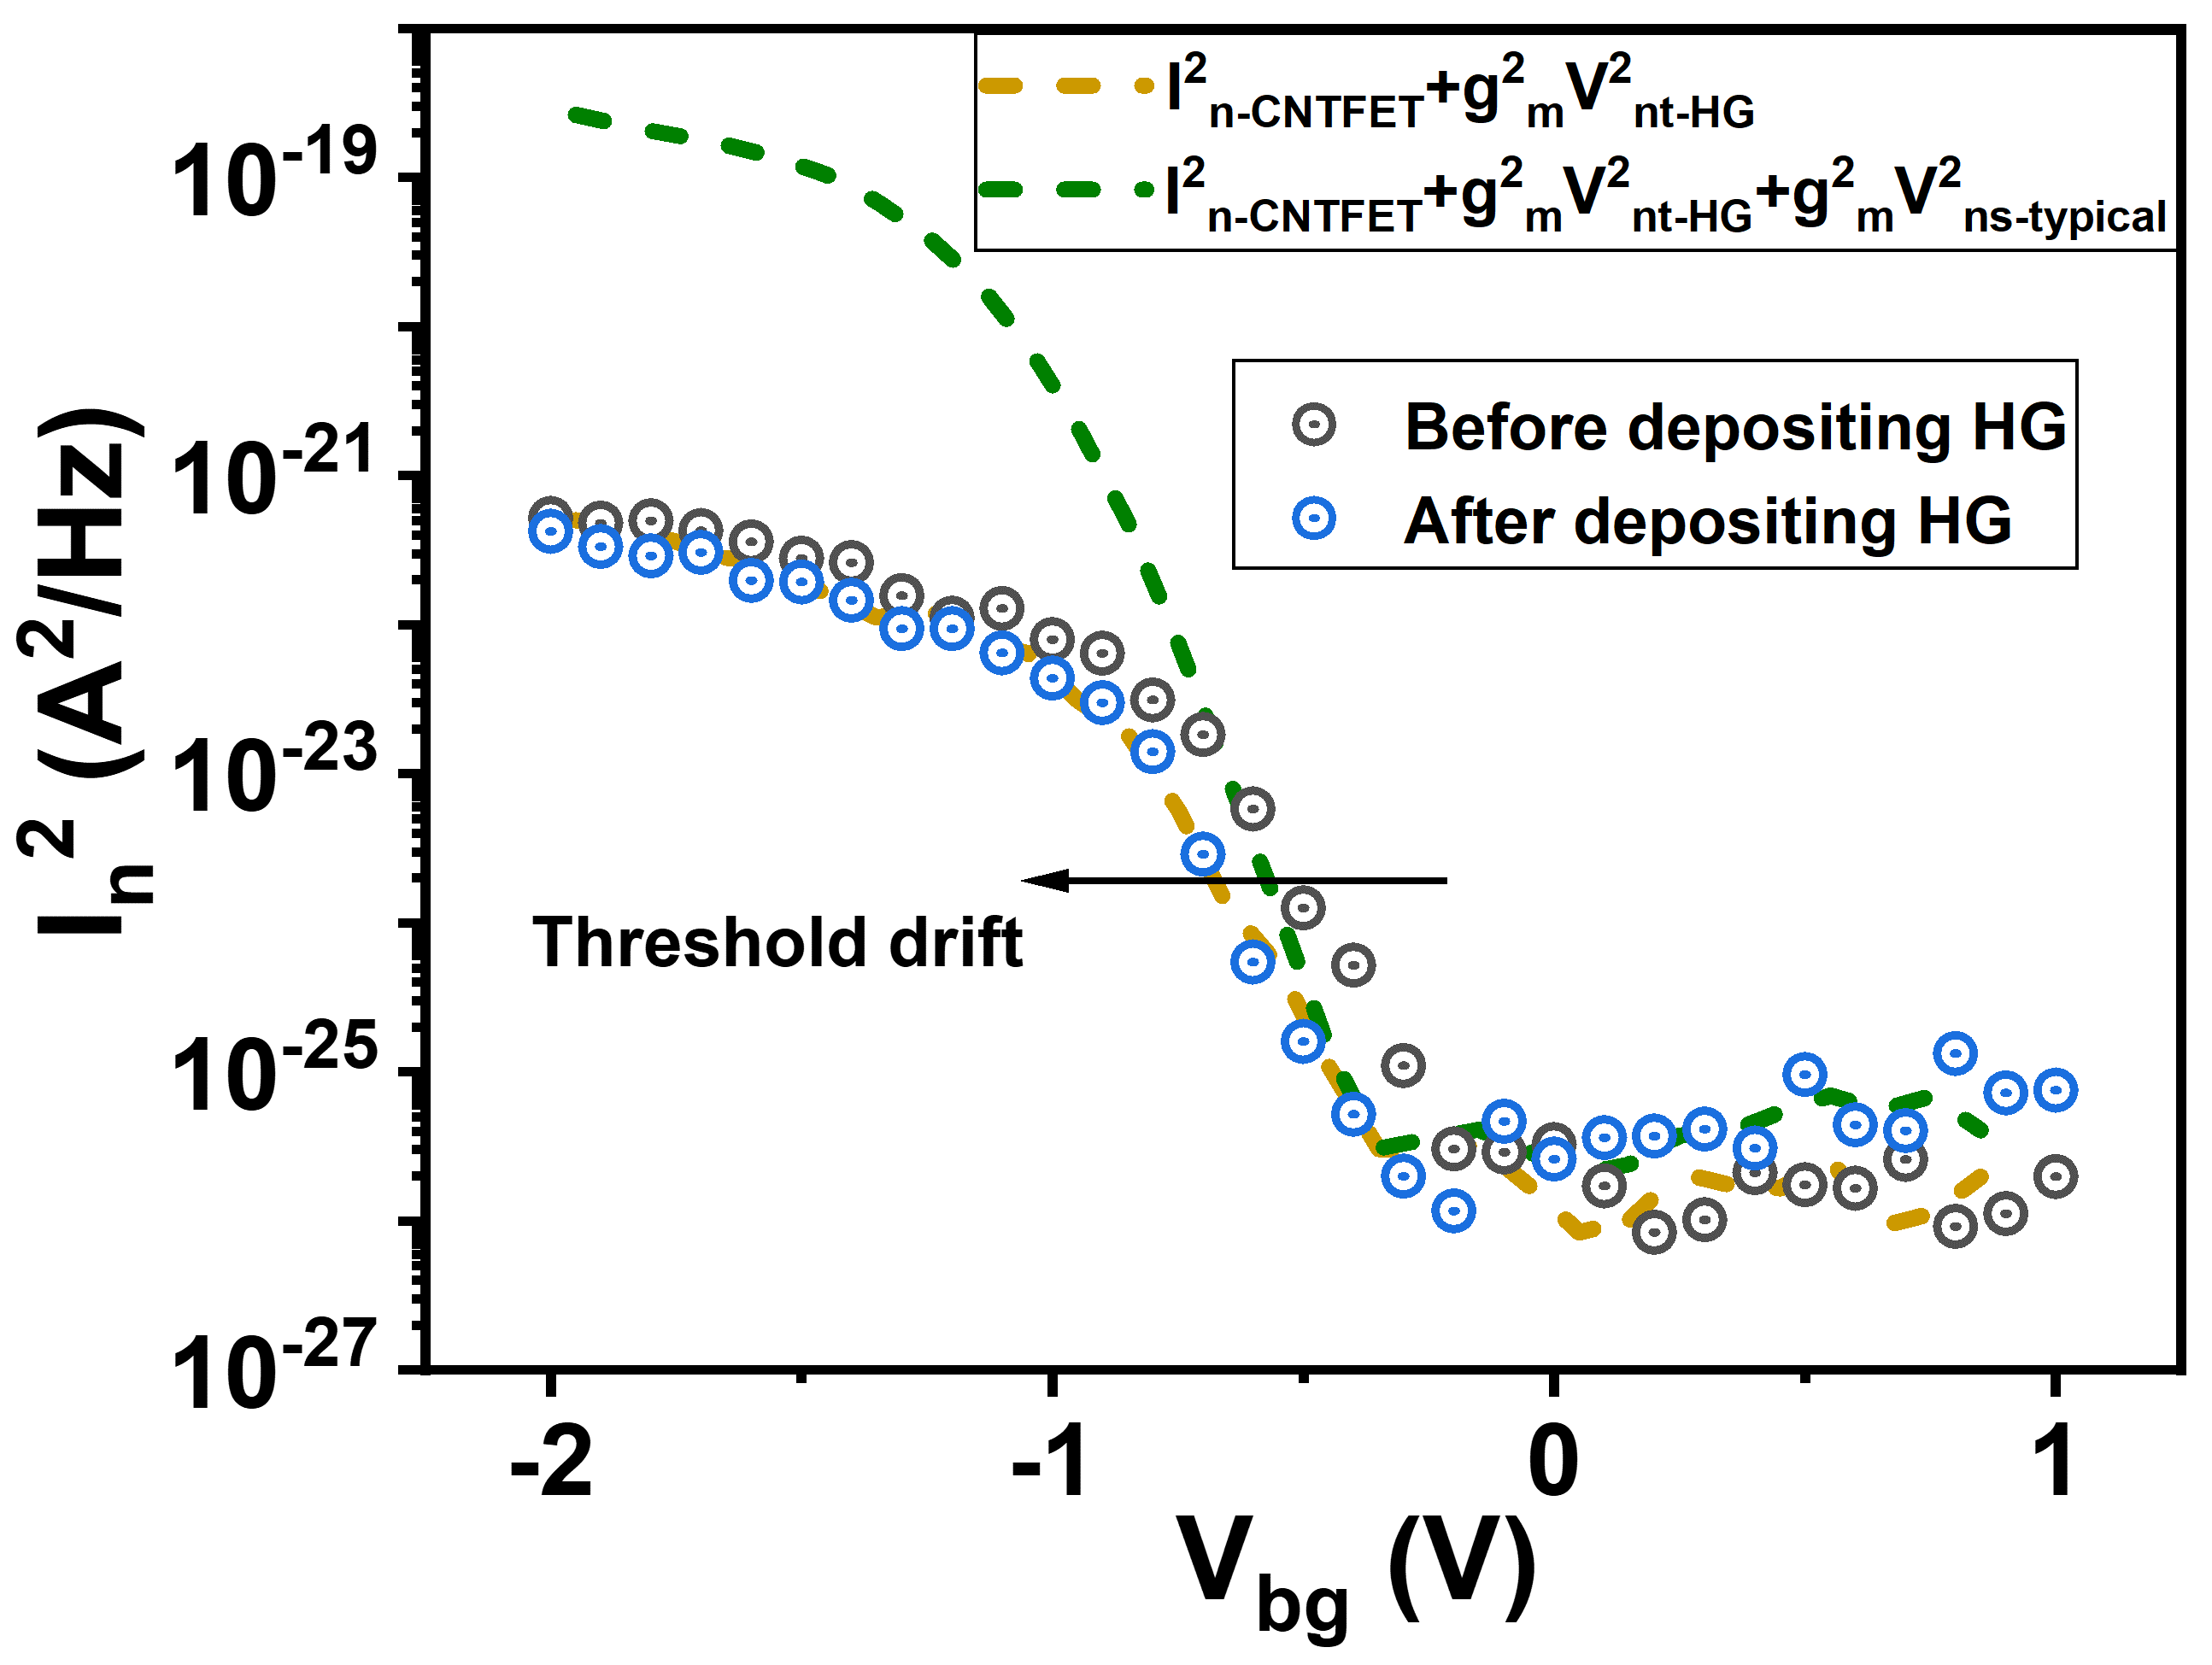
Fig. S11 | Current noise of the HGFET before (gray) and after (blue) depositing the p-i-n heterojunction. The calculated HGFET noise (yellow dashed line) based on the noise model includes the amplified thermal noise of the heterojunction and the noise from the underlying CNTs FET. The calculated current noise (green dashed line) incorporates the noise of CNTs FET as well as the amplified thermal noise and shot noise (I_{ns}~1×10⁻¹⁴ A Hz^{-1/2}) from a typical PbS CQDs photodiode⁴.

Section 9. Detectivity Characteristics of HGFETs
Normalized Detectivity of HGFETs Operated in Different Regions
Based on the aforementioned response and noise model of the HGFET, the normalized detectivity ($D^{*}$) of the HGFET can be calculated using the expression:
$D^{*}=\frac{R\sqrt{AΔf}}{I_{n}}=\frac{V_{oc}\sqrt{AΔf}}{P_{light}}\frac{g_{m}}{I_{n-HGFET}}$ (1)
where $R$ is the responsivity of the HGFET, $A$ is the optical area, $Δf$ is the electrical bandwidth of the test circuit, $I_{n}$ is the current noise of the HGFET, $V_{oc}$ is the open-circuit photovoltage of the heterojunction, $P_{light}$ is the incident power density, $g_{m}$ is the transconductance of the CNTs FET, and $I_{n-HGFET}$ is the current noise of the HGFET.
At low frequency (1 Hz), the noise of HGFET is dominated by flicker noise, and thus $D^{*}$ can be approximated as:
$D^{*}≈\frac{V_{oc}\sqrt{AΔf}}{P_{light}}\frac{g_{m}}{I_{nf-FET}}∝\frac{g_{m}}{I_{nf-FET}}$ (2)
where $I_{nf-FET}$ is the flicker noise of the HGFETs. According to the noise model in Section 8, $D^{*}$ can be further derived as:
$D^{*}∝\frac{g_{m}}{I_{ds}}$ (3)
when the HGFET is operated in the subthreshold region. Additionally, $D^{*}$ can be derived as:
$D^{*}∝\frac{g_{m}^{2}}{I_{ds}}$ (4)
when the HGFET is operated in the linear region. Thus, we define $\frac{g_{m}}{I_{ds}}$ and $\frac{g_{m}^{2}}{I_{ds}}$ as the characteristic parameters, denoted as β, for describing the signal-to-noise ratio (SNR) in the subthreshold and linear regions, respectively.
Figure S12 displays the transfer characteristic and the extracted β. Clearly, β begins to saturate within the range of V_{bg} between -1.28 V and -0.96 V in the linear region, and it exhibits a noticeable maximum value within the range of V_{bg} between -0.6 V and -0.3 V in the subthreshold region. The SNR characteristics based on the developed HGFET model provide a clear explanation for the measured D* at different bottom-gate voltages in Fig. 3f.
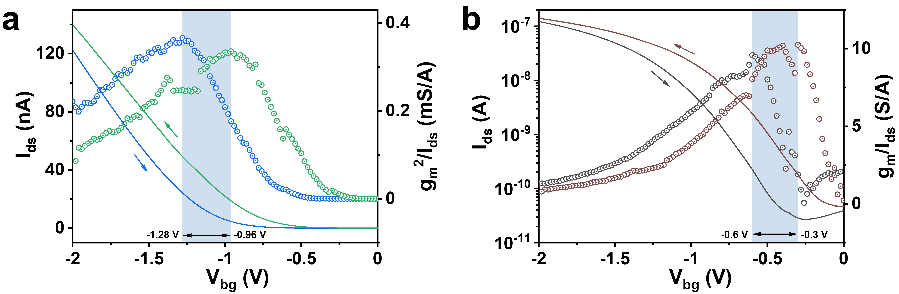
Fig. S12 | Gate-tunable SNR characteristic parameters (β) of HGFET. a, Transfer characteristic curve and the extracted g_{m}²/I_{ds} of the HGFET device (the same device as shown in Fig. S9), indicating a transition point of g_{m}²/I_{ds} into the saturation region with V_{bg} ranging between -1.28 V and -0.96 V. This distribution of V_{bg} is associated with the hysteresis of the bottom-gate CNTs FET. b, Transfer characteristic curve and the extracted g_{m}/I_{ds} of the HGFET device, demonstrating a peak g_{m}/I_{ds} observed at V_{bg} ranging between -0.6 V and -0.3 V.
Section 10. Performance Comparison
Calibration of the Incident Light Intensity
In our photoresponse testing system (Fig. 4a), we utilize a super-continuous spectrum laser (NKT Company) to characterize the response of the device, with the laser’s wavelength tunable from 640 to 2100 nm. Monochromatic light is generated through the deflected grating of a spectrometer, and its output power is controlled using slot and neutral attenuators. To ensure accuracy, we employ a germanium power meter (PM 100D, Thorlabs) and a standard InGaAs photodiode (FGA21, Thorlabs) to validate and cross-check the output power measurements. The output beam spot is controlled using two objective lenses with different amplification factors: 10× and 50×, respectively. For measurements with the HGFET, we select the 50× objective lens, while the 10× objective lens is used for the InGaAs diode to match the optical areas of the respective devices. Additionally, we have prepared a standard sample featuring patterned Au squares, allowing us to collect reflected infrared light using an attached InGaAs camera (First Light Vision C-Red3). The size and intensity profile of the output beam spot are characterized using a commercial software.
Table S1 presents the calibrated light intensity obtained through various combinations of slot and neutral density attenuators. Figure S13 displays images of the output beam spots captured by the two objective lenses. The non-circular deviation in the beam spot shape is due to slight abrasion on the 10× objective lens. A graphics algorithm was employed to extract the power intensity within the irregular area.
Table S1 | Calibration of incident light intensity (1300 nm).
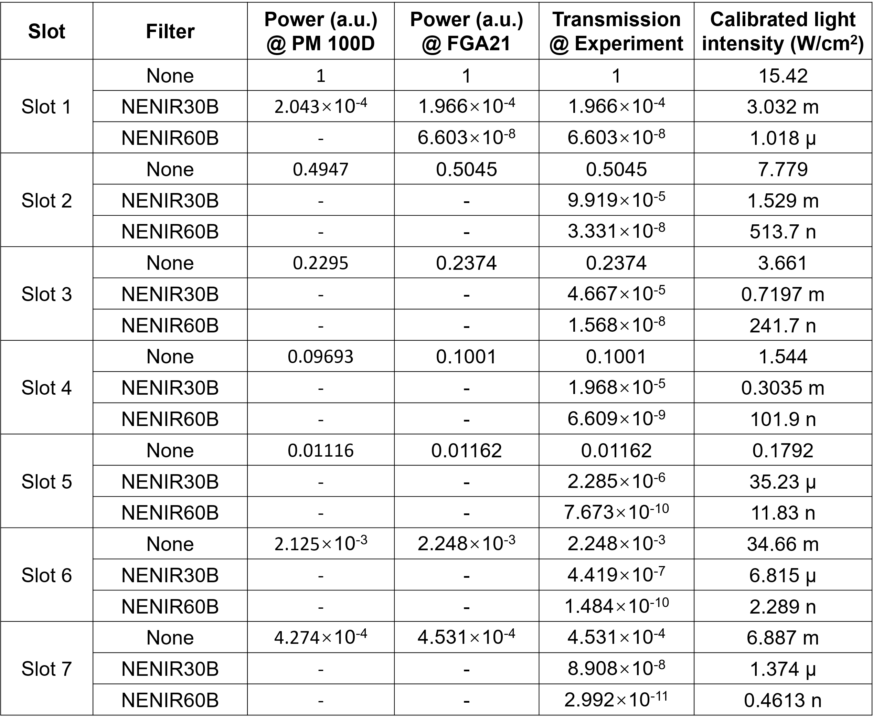
Note. A series of aperture slots (denoted as Slot 1 - 7) and two neutral density filters (NENIR30B and NENIR60B, Thorlabs) were employed to control the power density. The output power density was calibrated using the germanium power meter (PM100D, Thorlabs) and a standard InGaAs diode (FGA21, Thorlabs). The symbol ‘-’ indicates either an unselected combination or an undetectable signal.
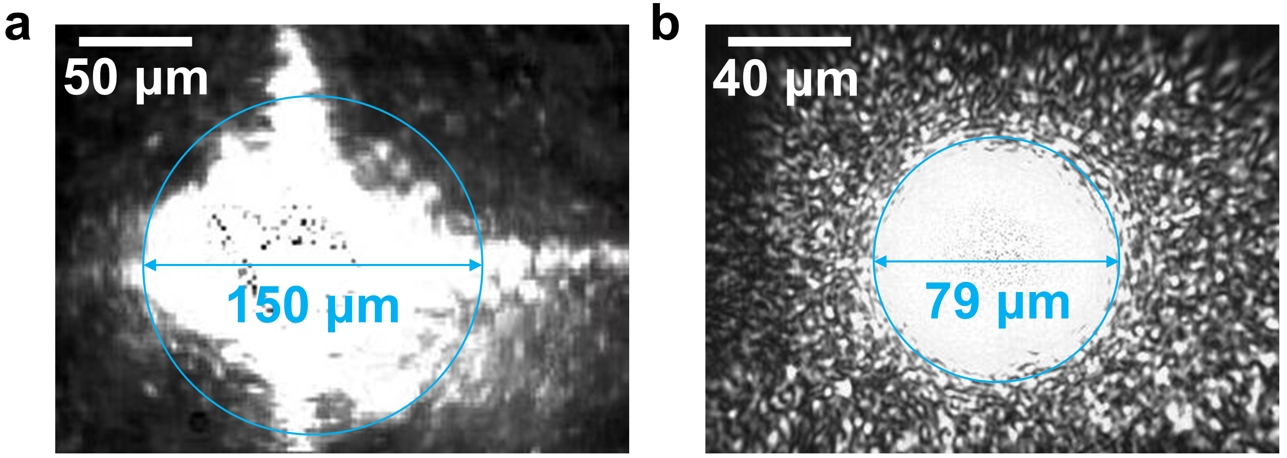
Fig. S13 | Imaging the output beam spot. Images of the beam spot focused using a (a) 10× and (b) 50× objective lens, providing detailed views of the size and intensity profile.
The main algorithm for extracting the irregular area is as follows:
img = imread(‘spot.png');
[height, width, ~] = size(img);
grayImg = rgb2gray(img);
bw = imbinarize(grayImg);
[x, y] = meshgrid(1:width, 1:height);
regionPixels = bw & (y <= 365);
area = sum(regionPixels(:));
disp([' The spot area is ：', num2str(area)]);

Performance Characterization of the FGA015 InGaAs Diode
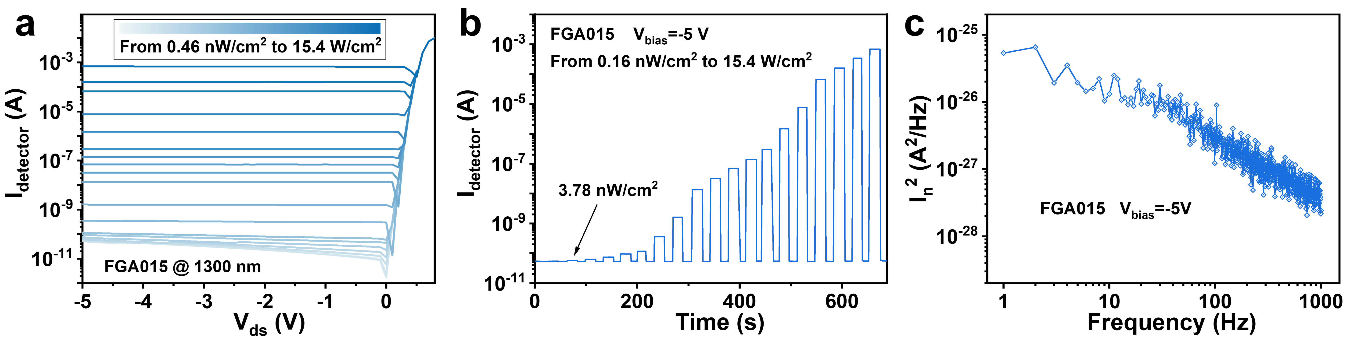
Fig. S14 | Response and noise characteristics of the FGA015 InGaAs photodiode at -5 V bias. a, Steady-state responses of the InGaAs photodiode under 1300 nm irradiation with power densities varied from 0.46 nW/cm² to 15.4 W/cm². b, Time-resolved photoresponse. c, Measured current noise spectra.

Section 11. Fabrication and Characterization of the 64×64 Pixel HGFET Imager
We fabricated a 64×64 pixel HGFET imager on the SiO₂/Si substrate and connected it to the designed readout circuit through wire bonding. The following section presents the fabrication process, uniformity assessment, design of the readout circuit, and the image capturing procedure.
Fig. S15 | Illustration of the fabrication process for the HGFET imager. a, Deposition of randomly oriented CNTs film. b, Removal of redundant CNTs using reactive ion etching. c, Deposition of source and drain electrodes, as well as the lower interconnect line (30 nm Pd). d, Deposition of the isolation layer of 60 nm SiO₂. e, Deposition of the upper interconnect line (20/600 nm Ti/Au for wire-bonding). f, Deposition of the high-κ dielectric (6 nm Y₂O₃). g, Deposition of the patterned ZnO film (40 nm). h, Deposition of the 150 nm intrinsic PbS-halide CQDs film and the 30 nm PbS-EDT CQDs thin films.
Uniformity
Twelve pixels were randomly measured out of the 4096 devices. The deviation in photocurrent under power densities of 0.4 µW/cm², 90 µW/cm², and 900 µW/cm² are 28%, 26% and 18%, respectively. This deviation may be attributed to the presence of the thick interconnect line (~700 nm, see Fig. S15) surrounding each pixel, which can affect the uniformity of the spin-coated PbS CQDs thin film. This issue can be addressed in further designs by integrating monolithically with the silicon-based ROICs.
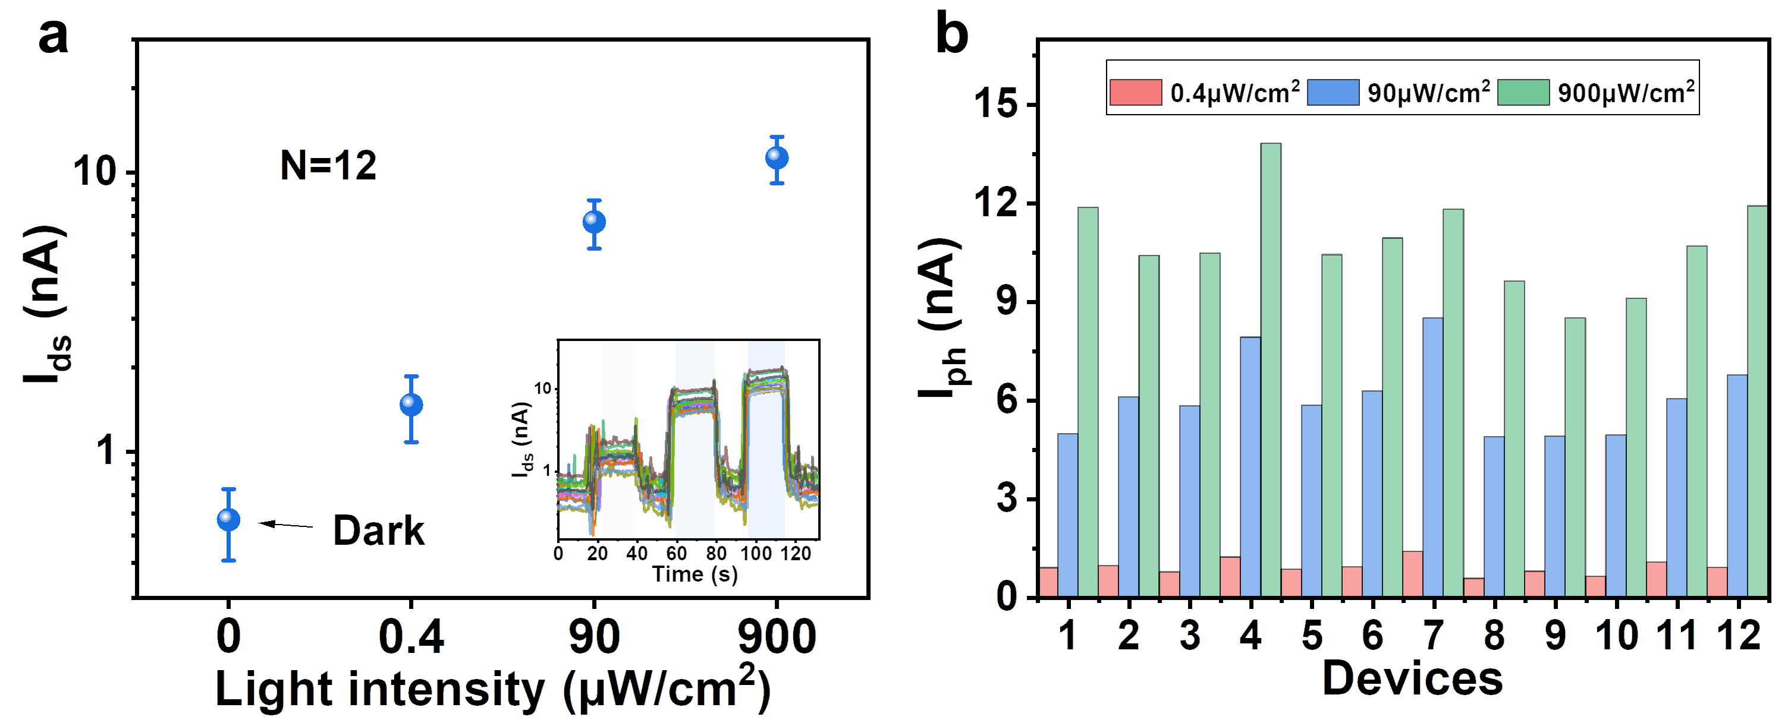
Fig. S16 | Uniformity of the fabricated pixels. a, Statistical drain-source current data for 12 pixels measured in dark conditions and under power densities of 0.4 µW/cm², 90 µW/cm², and 900 µW/cm². Inset: time-resolved photoresponse of the 12 devices at V_{bg} = 0 V and V_{ds} = -0.1 V. b, Extracted photocurrent of these pixels.
Readout Circuit
The readout circuit utilizes an FPGA (field-programmable gate array) as the core control decoder to manage row selection of the sensor array. It also handles the Analog Front End (AFE), and the Analog to Digital Converter (ADC) block, which converts the current into a 14-bit binary code. Subsequently, all data is transmitted to the host computer to complete the imaging process. Additionally, due to the shared row selector among the 64 pixels in each row of the sensor array, electrical cross-talk exists, which may influence the readout and imaging process.
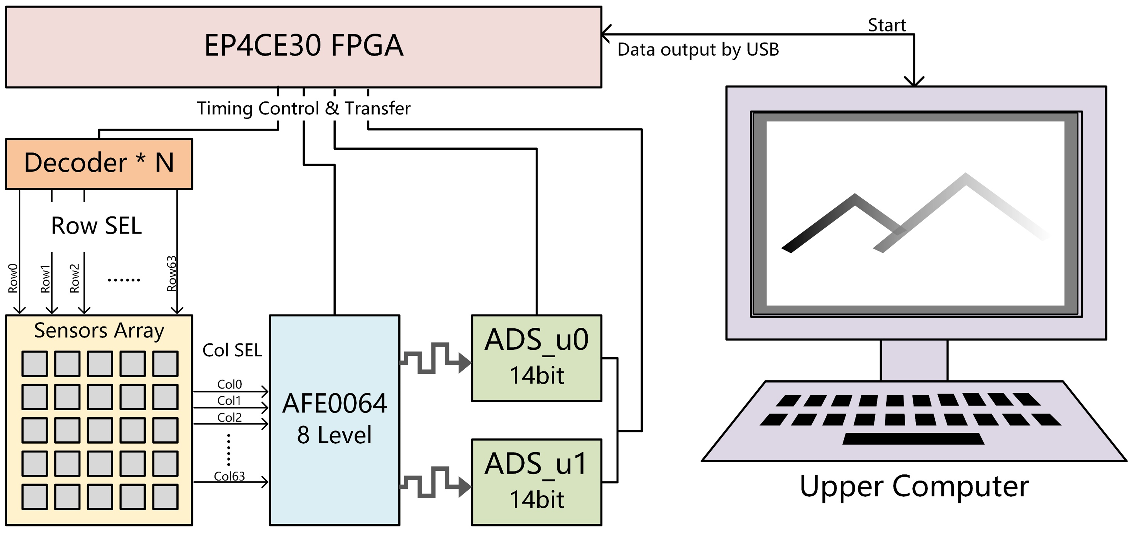
Fig. S17 | Schematic diagram of the designed readout circuit on the printed circuit boards.
The HGFET Imager
Figure S18 illustrates the wafer-scale fabrication of HGFET arrays with various array sizes, including 2×2, 5×5, 16×16, 32×32, and 64×64. The fabricated 64×64 image sensor integrated with the ROIC on the printed circuit board (PCB) is depicted in Fig. S18b-d. It’s important to note that due to the circuit area limitation, only one switch transistor can be accommodated in each row. This limitation results in cross-talk between the 64 pixels in each row.
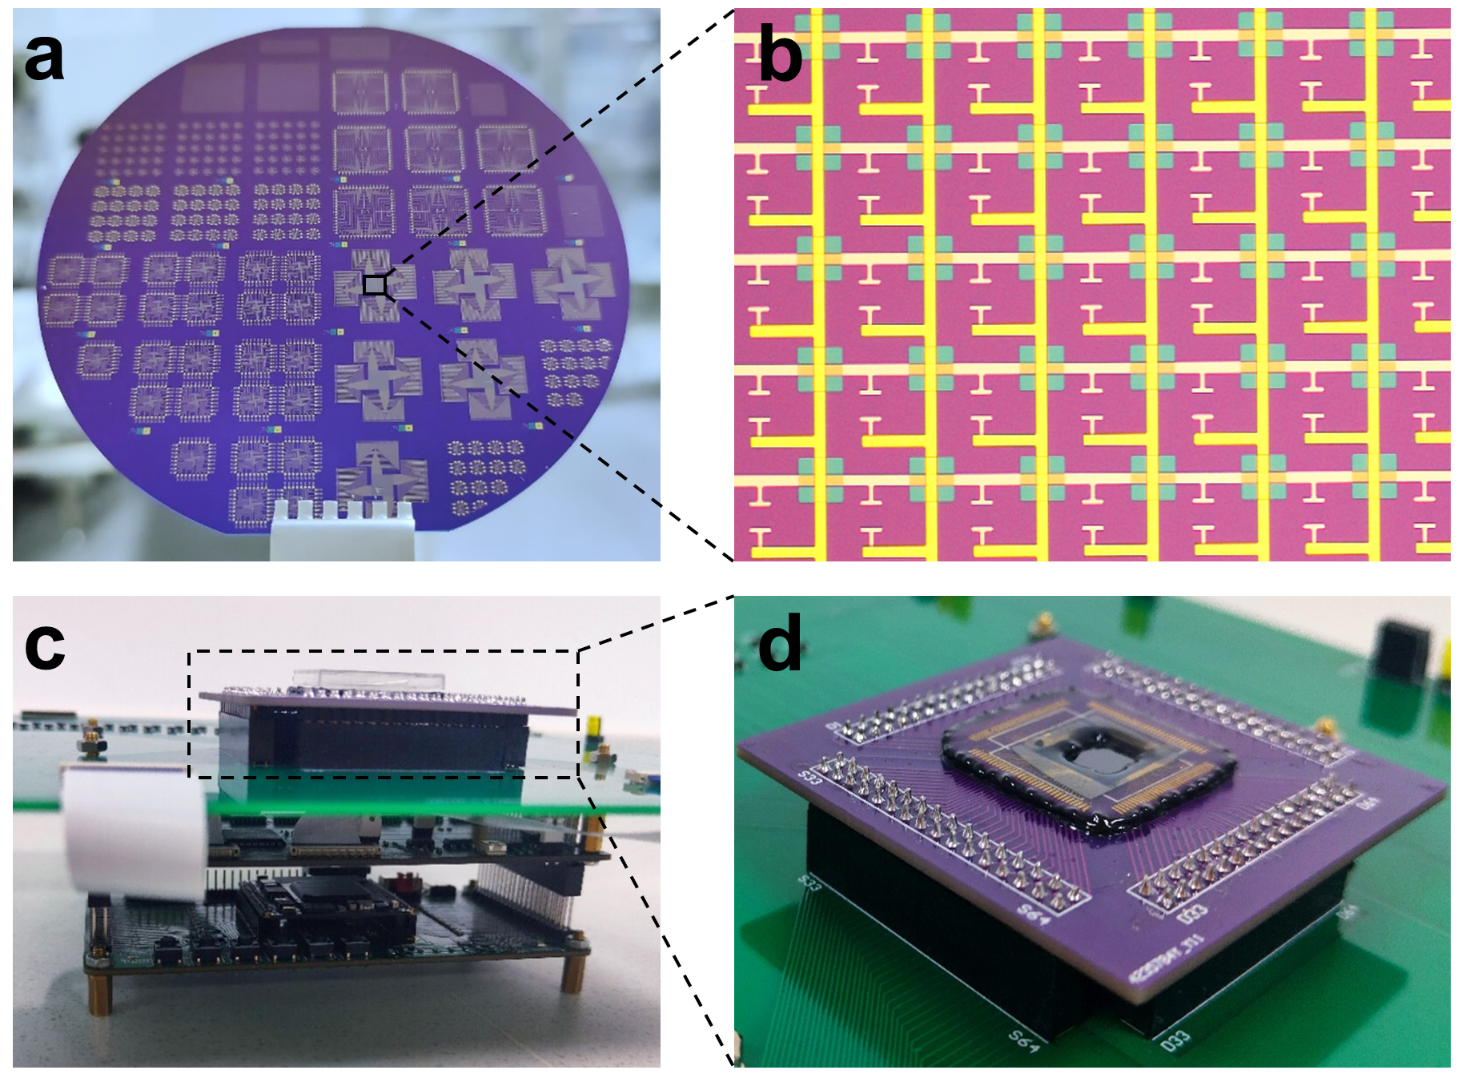
Fig. S18 | Photographs of the HGFET imager. a, Photograph of the fabricated HGFET arrays on a 4-inch wafer. b, Optical micrograph showing the pixels in a 64×64 HGFET array. The center-to-center pixel spacing is 50 µm. c-d, Photographs of the integrated 64×64 pixel HGFET imager.

Image Capturing
Figure 4f and Fig. S19 shows images captured by our 64×64 HGFET pixel imager under 940 nm infrared irradiation with various power densities. Despite cross-talk between the 64 pixels in each row, the HGFET imager successfully captured the “PKU” pattern at a low power density of 100 nW/cm² (Fig. 4f). This demonstrates the imaging capability and performance of the HGFET array under challenging conditions, highlighting its potential for ultra-weak infrared radiation detection applications.
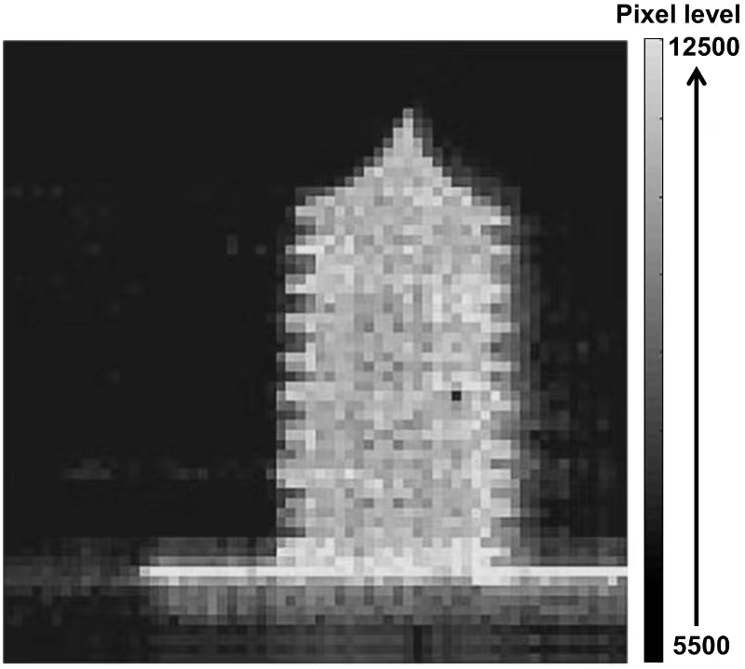
Fig. S19 | Image of the “Bo Ya Pagoda” captured by our HGFET imager under 940 nm LED irradiation with a power density of 25 µW/cm².

Section 12. Benchmarking the Detectivity and Gain-Bandwidth Product
Table S2 | Detailed performance parameters benchmarked in Fig. 5b.
No. | Material | Architecture  /Mechanism | λ (nm) | D* (Jones) | Response time | Ref.
1 | PbS CQDs | Photoconductor | 1300 | 1.8×10¹³ | 70 ms | ⁵
2 | PbS CQDs | Photodiode | 1550 | 1.00×10¹¹ | 300 ns | ⁶
3 | GR/ PbS CQDs | Photogating device | 950 | 7.00×10¹³ | 10 ms | ⁷
4 | s-SWCNT / P3HT | Photogating device | 1050 | 2.30×10⁸ | 0.57 ms | ⁸
5 | SWNT / C60 | Photogating device | 1200 | 4.00×10⁷ | 1.7 ms | ⁹
6 | CNT | Photoconductor | 1800 | 1.00×10¹¹ | 20 ms | ¹⁰
7 | GR / Au QDs | Photogating device | 1550 | 1.00×10⁸ | 600 ns | ¹¹
8 | CNTs | Photodiode | 1650 | 5.79×10⁸ | - | ¹²
9 | Si / PbS CQDs | Photogating device | 1500 | 1.80×10¹² | 40 µs | ¹³
10 | 2D Bi₂O₂Se | Photoconductor | 1200 | 2.00×10⁹ | 1 ps | ¹⁴
11 | CNTs | Photoconductor | 1064 | 1.81×10⁷ | 150 µs | ¹⁵
12 | GaSb NWs | Photoconductor | 1550 | 8.00×10⁷ | 195.1 µs | ¹⁶
13 | PdSe₂ / Perovskite | Photodiode | 800 | 1.00×10¹³ | 3.5 µs | ¹⁷
14 | HgTe CQDs | Photodiode | 2500 | 3.00×10¹⁰ | 2 µs | ¹⁸
15 | PbS CQDs | Photodiode | 1125 | 3.20×10¹¹ | 0.33 µs | ¹⁹
16 | CH₃NH₃PbI₃ | Photoconductor | 1064 | 6.00×10⁷ | 76 ns | ²⁰
17 | InSiTe₃ | Photoconductor | 1310 | 2.00×10⁸ | 2 µs | ²¹
18 | PbS CQDs | Photodiode | 970 | 2.00×10¹² | 0.49 µs | ⁴
19 | CNTs | Photoconductor | 2000 | 8.00×10⁷ | 70 ms | ²²
20 | InGaAs | Photodiode | 1300 | 9.27×10¹¹ | 300 ps | ²³
21 | PbS CQDs / CNTs | HGFET | 1300 | 1.24×10¹⁴ | 95 µs | This work

Gain and -3dB Bandwidth of the HGFETs
Fig. S20 | Gain and -3dB bandwidth of HGFETs. Responsivity, gain (a) and -3dB bandwidth (b) of an HGFET based on the randomly oriented CNTs thin film at V_{bg}=-1.2 V and V_{ds}=-5 V. Responsivity, gain (c) and -3dB bandwidth (d) of an HGFET based on the aligned CNTs thin film at V_{bg}=-2 V and V_{ds}=-0.1 V (channel length of 2 μm and width of 10 μm).
Fig. S21 | Extracted D* of the aligned CNTs HGFET (the same device shown in Fig. S20c) under 1300 nm irradiation.

References
1. Bielecki Z., Achtenberg K., Kopytko M., Mikołajczyk J., Wojtas J. & Rogalski A. Review of photodetectors characterization methods. Bulletin of the Polish Academy of Sciences Technical Sciences, 70, 140534-140534 (2022).
2. Nemirovsky Y B. I. J. C. 1=f Noise in CMOS Transistors for Analog Applications. IEEE Trans. Electron Devices. 48, 921-927 (2001).
3. Rogalski A. Infrared Detectors. CRC press: (2000).
4. Liu J., Liu P., Chen D., Shi T., Qu X. & Chen L. et al. A near-infrared colloidal quantum dot imager with monolithically integrated readout circuitry. Nat. Electron. 5, 443-451 (2022).
5. Konstantatos G., Howard I., Fischer A., Hoogland S., Clifford J. & Klem E. et al. Ultrasensitive solution-cast quantum dot photodetectors. Nature. 442, 180-183 (2006).
6. Sargent E. H., Clifford J. P., Konstantatos G., Johnston K. W., Hoogland S. & Levina L. Fast, sensitive and spectrally tuneable colloidal-quantum-dot photodetectors. Nat. Nanotechnol. 4, 40-44 (2009).
7. Konstantatos G., Badioli M., Gaudreau L., Osmond J., Bernechea M. & Garcia D. A. F. et al. Hybrid graphene-quantum dot phototransistors with ultrahigh gain. Nat. Nanotechnol. 7, 363-8 (2012).
8. Lu R., Christianson C., Kirkeminde A., Ren S. & Wu J. Extraordinary Photocurrent Harvesting at Type-II Heterojunction Interfaces: Toward High Detectivity Carbon Nanotube Infrared Detectors. Nano Lett. 12, 6244-6249 (2012).
9. Park S., Kim S. J., Nam J. H., Pitner G., Lee T. H. & Ayzner A. L. et al. Significant Enhancement of Infrared Photodetector Sensitivity Using a Semiconducting Single-Walled Carbon Nanotube/C60 Phototransistor. Adv. Mater. 27, 759-765 (2015).
10. Liu Y., Wei N., Zeng Q., Han J., Huang H. & Zhong D. et al. Photodetectors: Room Temperature Broadband Infrared Carbon Nanotube Photodetector with High Detectivity and Stability (Advanced Optical Materials 2/2016). Adv. Opt. Mater. 4, 188-188 (2016).
11. Chen Z., Li X., Wang J., Tao L., Long M. & Liang S. et al. Synergistic Effects of Plasmonics and Electron Trapping in Graphene Short-Wave Infrared Photodetectors with Ultrahigh Responsivity. ACS Nano. 11, 430-437 (2017).
12. Huang H., Wang F., Liu Y., Wang S. & Peng L. Plasmonic Enhanced Performance of an Infrared Detector Based on Carbon Nanotube Films. ACS Appl. Mater. Interfaces. 9, 12743-12749 (2017).
13. Adinolfi V. & Sargent E. H. Photovoltage field-effect transistors. Nature. 542, 324-327 (2017).
14. Yin J., Tan Z., Hong H., Wu J., Yuan H. & Liu Y. et al. Ultrafast and highly sensitive infrared photodetectors based on two-dimensional oxyselenide crystals. Nat. Commun. 9, 3311 (2018).
15. Liu Y., Yin J., Wang P., Hu Q., Wang Y. & Xie Y. et al. High-Performance, Ultra-Broadband, Ultraviolet to Terahertz Photodetectors Based on Suspended Carbon Nanotube Films. ACS Appl. Mater. Interfaces. 10, 36304-36311 (2018).
16. Sun J., Peng M., Zhang Y., Zhang L., Peng R. & Miao C. et al. Ultrahigh Hole Mobility of Sn-Catalyzed GaSb Nanowires for High Speed Infrared Photodetectors. Nano Lett. 19, 5920-5929 (2019).
17. Zeng L. H., Chen Q. M., Zhang Z. X., Wu D., Yuan H. & Li Y. Y. et al. Multilayered PdSe2/Perovskite Schottky Junction for Fast, Self‐Powered, Polarization‐Sensitive, Broadband Photodetectors, and Image Sensor Application. Adv. Sci. 6, 1901134 (2019).
18. Tang X., Ackerman M. M., Chen M. & Guyot-Sionnest P. Dual-band infrared imaging using stacked colloidal quantum dot photodiodes. Nat. Photonics. 13, 277-282 (2019).
19. Xu Q., Meng L., Sinha K., Chowdhury F. I., Hu J. & Wang X. Ultrafast Colloidal Quantum Dot Infrared Photodiode. ACS Photonics. 7, 1297-1303 (2020).
20. Li Y., Zhang Y., Li T., Li M., Chen Z. & Li Q. et al. Ultrabroadband, Ultraviolet to Terahertz, and High Sensitivity CH3NH3PbI3 Perovskite Photodetectors. Nano Lett. 20, 5646-5654 (2020).
21. Chen J., Li L., Gong P., Zhang H., Yin S. & Li M. et al. A Submicrosecond-Response Ultraviolet–Visible–Near-Infrared Broadband Photodetector Based on 2D Tellurosilicate InSiTe3. ACS Nano. 16, 7745-7754 (2022).
22. Chen C., Zhao Y., Yu H., Jiao X., Hu X. & Li X. et al. High-performance infrared photodetector based on single-wall carbon nanotube films. Carbon. 206, 150-156 (2023).
23. InGaAs photodiode 800-1700 nm. FGA015; https://www.thorlabs.com

