Supplementary Information
Continuous multivariate conversion processes for stabilized anode in aqueous zinc-ion battery
Changlei Zhuang^{1,2}, Jinzhang Yang², Bosi Yin²*, Lingfeng Zhu¹, Ying Sun², Hui Li¹, Jiazhuo Li², Xinyu Feng², Lei Zhang¹, Fanbo Meng³, Xiaoguang Duan⁴, Dawei Su¹*, Siwen Zhang^{1,2}*, Tianyi Ma¹*
¹ School of Science, RMIT University, Melbourne, VIC 3000, Australia. E-mail: dawei.su@rmit.edu.au; tianyi.ma@rmit.edu.au
² Institute of Clean Energy Chemistry, Key Laboratory for Green Synthesis and Preparative Chemistry of Advanced Material, College of Chemistry, Liaoning University, Shenyang 110036, P. R. China. E-mail: yinbosi@lnu.edu.cn; zhangsiwen@lnu.edu.cn
³ State Key Laboratory of Electromechanical Integrated Manufacturing of High-performance Electronic Equipments, Xidian University, Xian, Shanxi, China.
⁴ School of Chemical Engineering, The University of Adelaide, Adelaide, SA 5005, Australia

(These authors contributed equally: Changlei Zhuang, Jinzhang Yang)

1 Supplementary Figures
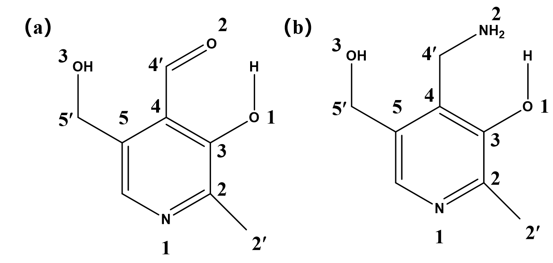
Supplementary Fig. 1 Molecular structure of (a) pyridoxal (PL) and (b) pyridoxamine (PM).

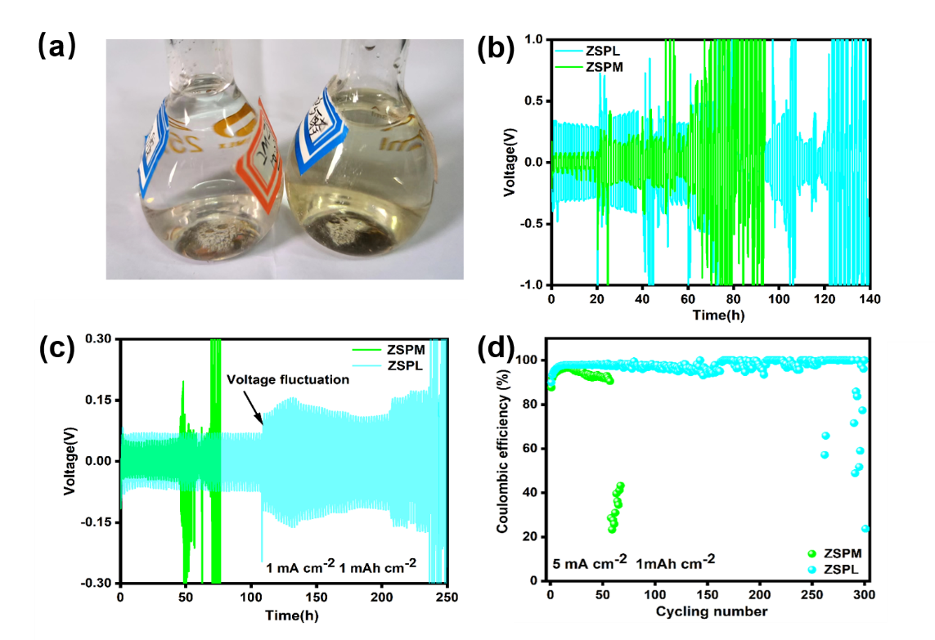
Supplementary Fig. 2 Electrochemical performance test of ZSPM and ZSPL. (a) Optical picture of prepared electrolyte of ZSPM and ZSPL. (b) Rate performance of ZSPM and ZSPM in Zn||Zn symmetrical cell. (c) Lifespans of ZSPM and ZSPL in Zn||Zn symmetrical cell under 1mA cm⁻² and 1mAh cm⁻². (d) Comparison of Zn||Cu Coulombic efficiency (CE) under 5 mA cm⁻² and 1 mAh cm⁻².
Note: Darker color was seen in ZSPL in open environment for its easy to be oxidized during resting time. Comparison of above electrochemistry performance test, it can be seen that ZSPL performed better than ZSPM, however, both failed to display a satisfied performance.

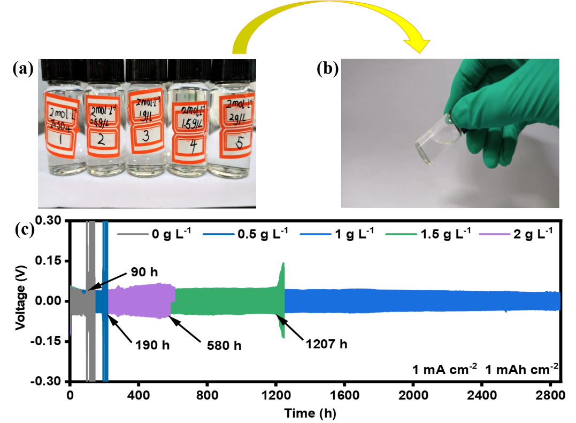
Supplementary Fig. 3 Ideal PN concentration selecting via electrochemical performance test. (a)-(b) The digital photos of the prepared electrolyte of ZSPN. The electrolyte was composed of ZS and 0.5 g L⁻¹, 1 g L⁻¹, 1.5 g L⁻¹, 2 g L⁻¹ PN, respectively. (c) Lifespans test under 1 mA cm⁻² 1mAh cm⁻² were conducted to select the most optimal concentration.
Note: The photo was pictured against white paper, the property of uniform, clear, colorless electrolyte was not difficult to observe. The conclusion can be drawn that PN of 1 g L⁻¹ was far outperformed than residual experimental groups.

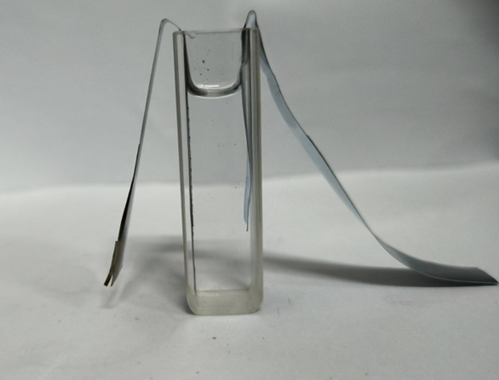
Supplementary Fig. 4 The image of quartz cuvette for in situ UV-vis instrument.
Note: A quartz cuvette was utilized as electrolyte cell, two electrodes were lean on the cell wall to prevent short circuit and electric wires were clipped on electrodes to make loops. UV-vis source, quartz cuvette and detector were operated in dark environment to prevent other light interference. Before formal experimental, NVO cathode was activated under 0.01 A g⁻¹ of 3 cycles to arrive the most optimum state.

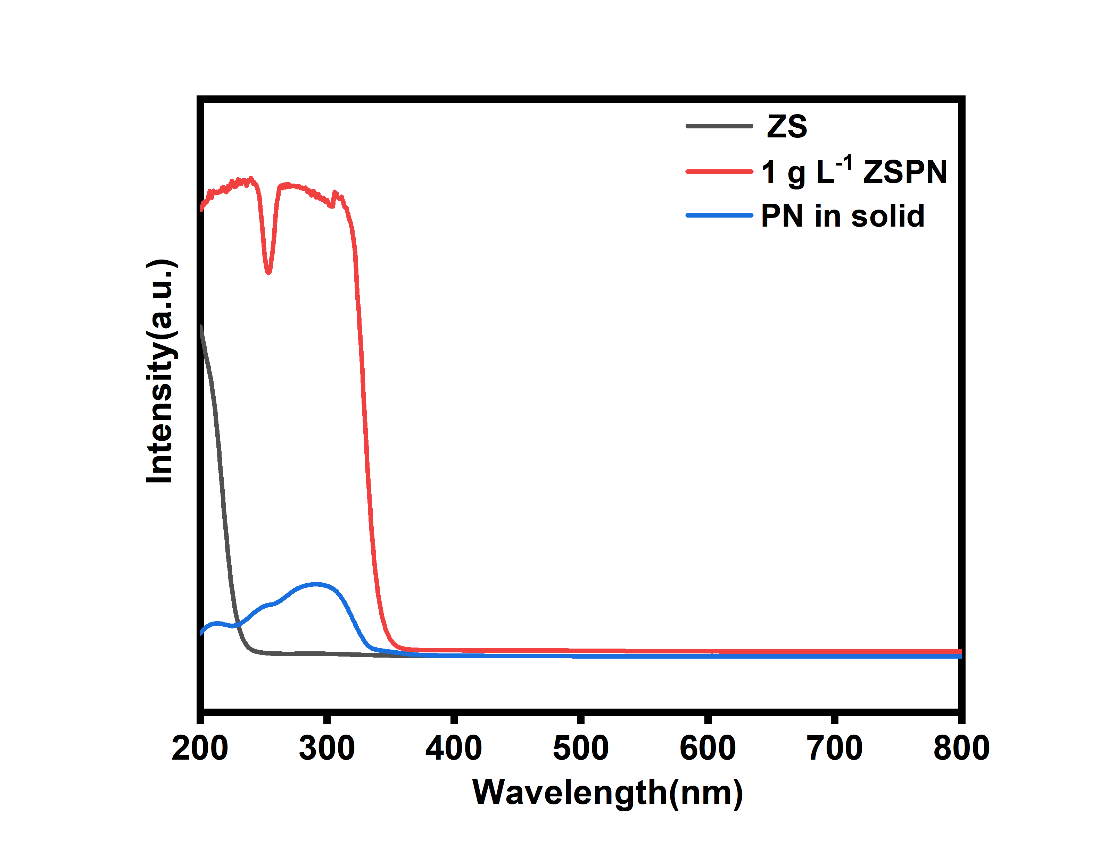
Supplementary Fig. 5 UV-vis spectra ZS, ZSPN electrolyte and PN in solid state.
Note:1g L⁻¹ ZSPN only displayed an abnormal 250 nm peak in nonconformity with reported literature which may accounted for its high concentration⁵. Therefore, 0.01 g L⁻¹ concentration of PN was selected and 0.01 M ZS was chosen finally and successfully captured peaks under the current density of 0.03 A g⁻¹ in Zn||NVO batteries to track PN variants. Under such a condition, the PN conversion steps was infinitely slowed down and can be considered as quasistatic processes. Witnessed that no peak in 500 nm to 800 nm, so the spectra wavelength was shrunk to 200-400 nm or less.

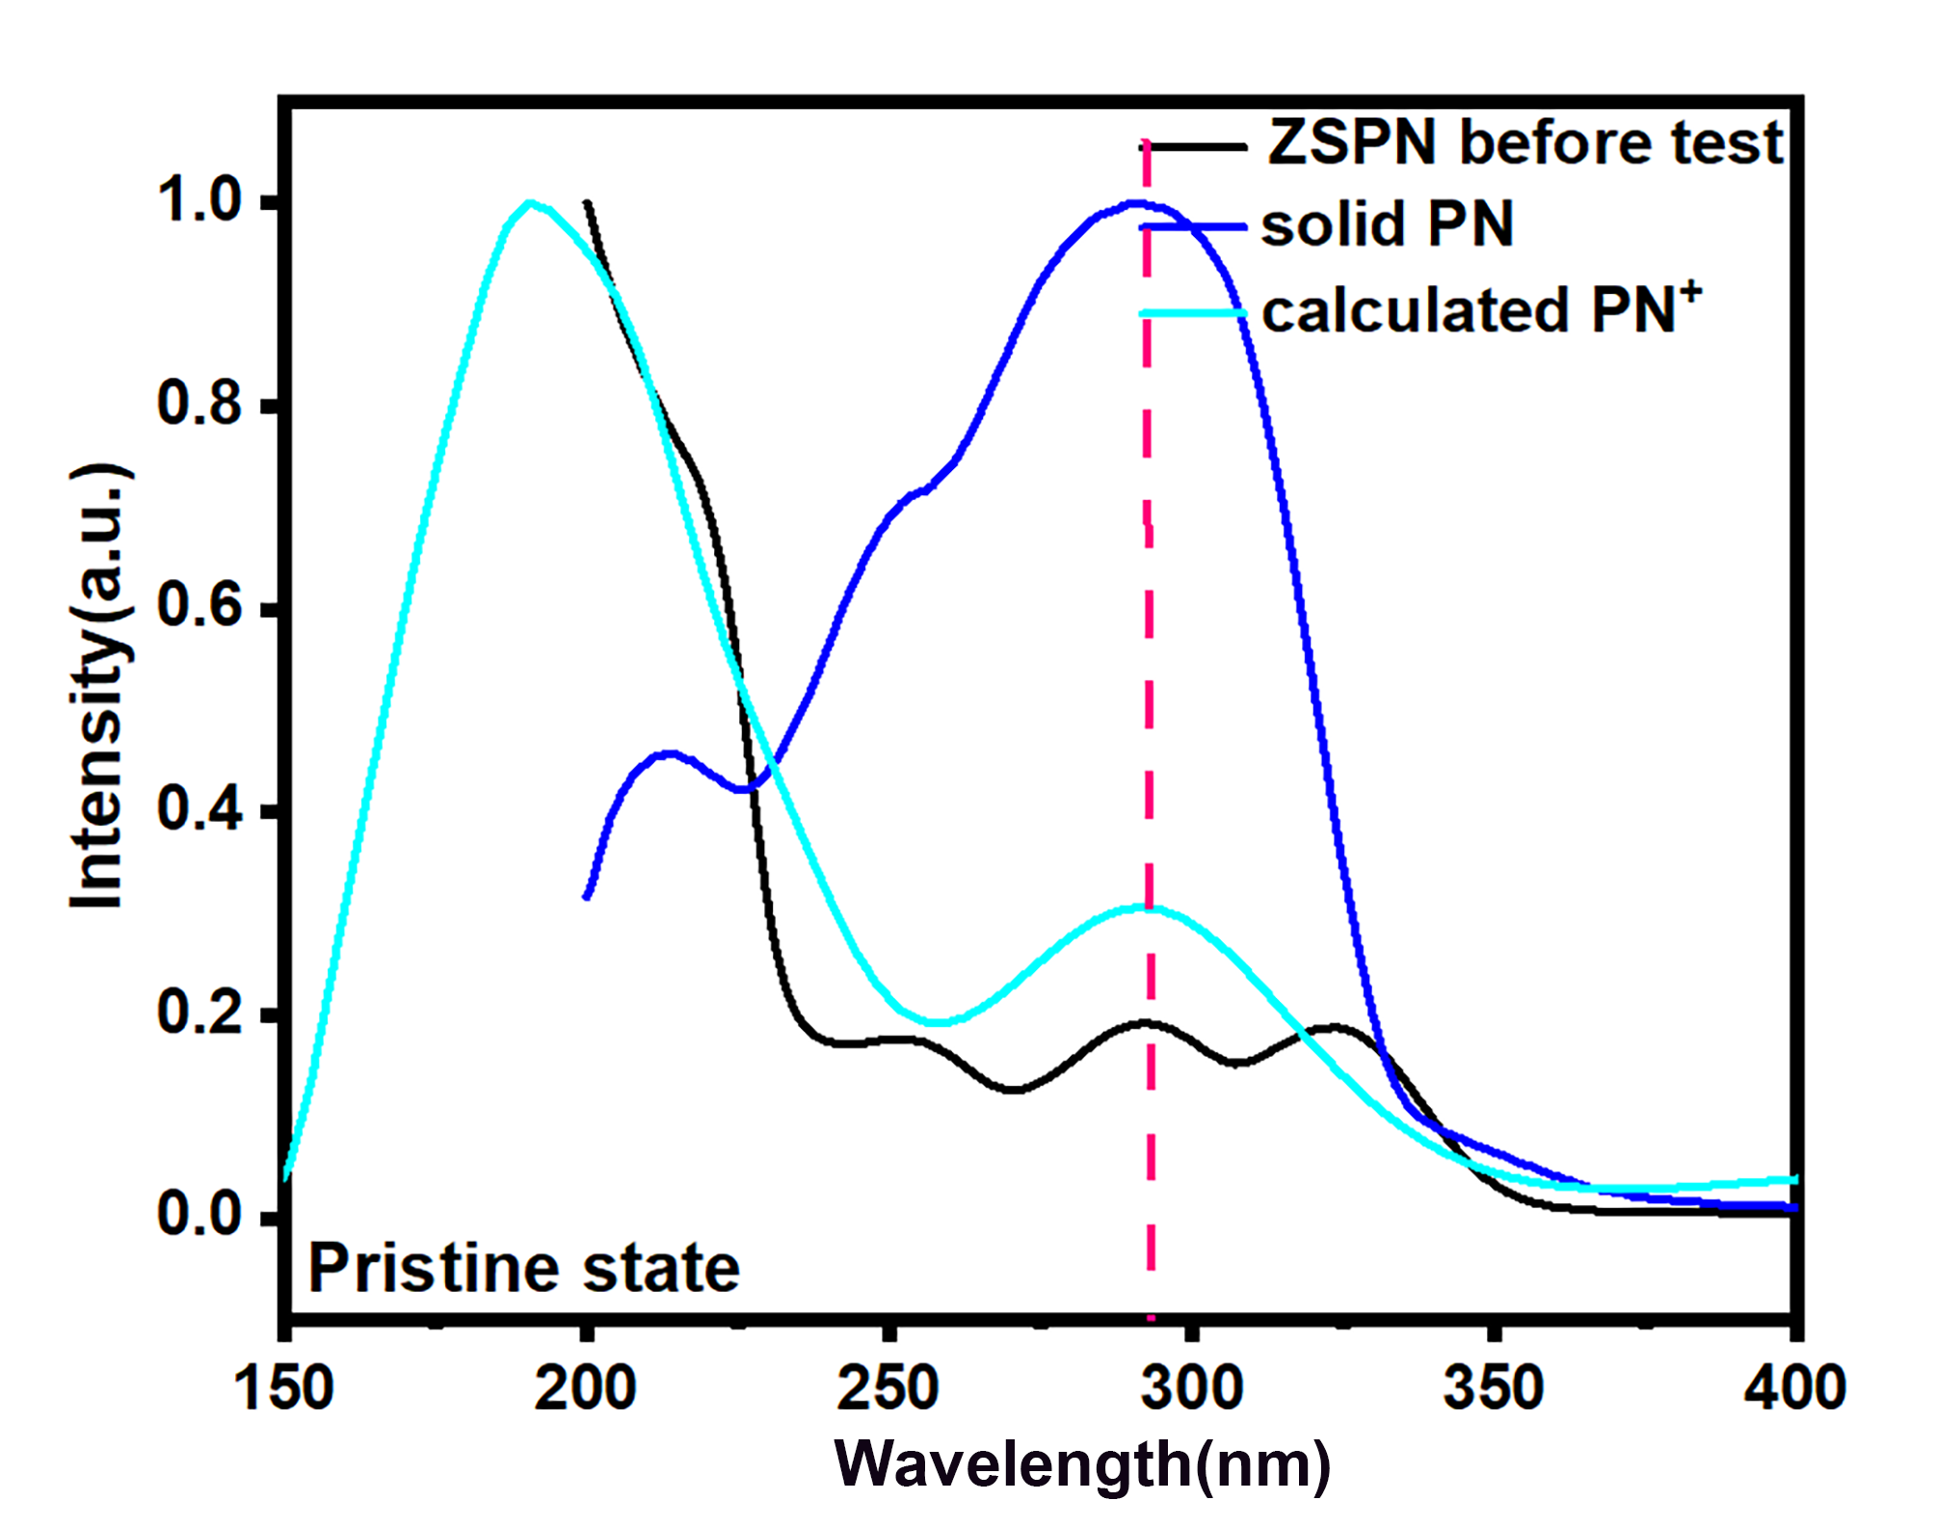
Supplementary Fig. 6 Comparisons of UV-vis spectra of ZSPN before test, solid PN and calculated PN⁺, respectively.

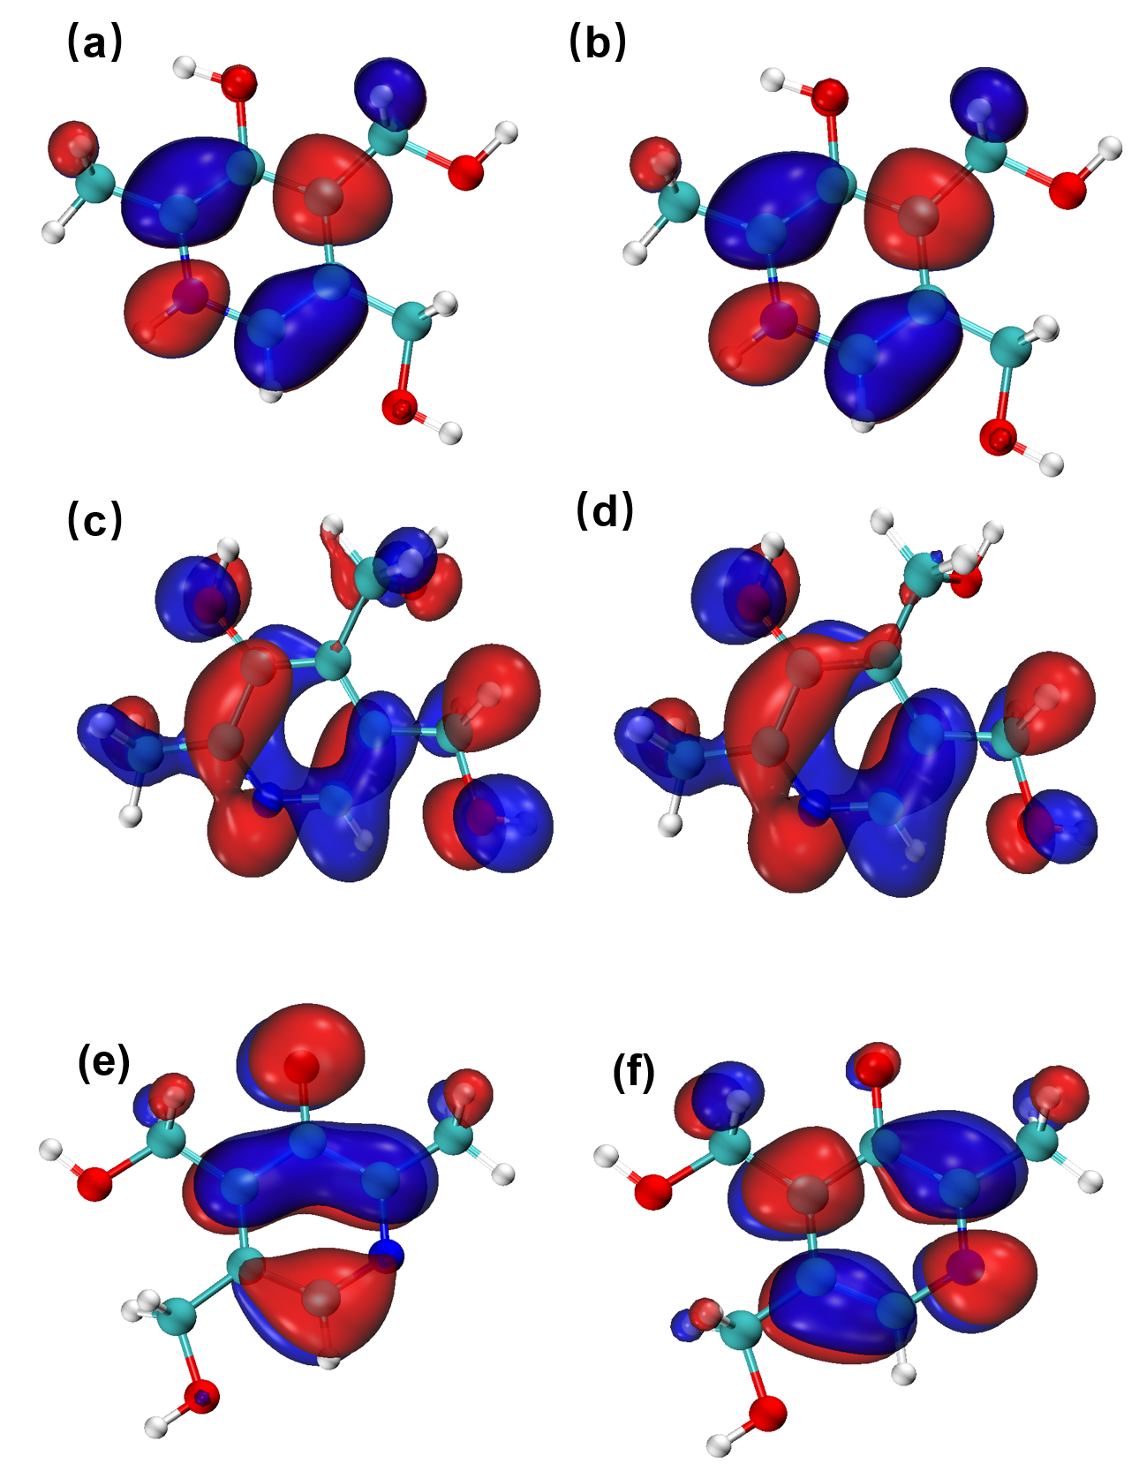
Supplementary Fig. 7 (a)HOMO (b)LOMO of PN⁺;(c) HOMO (d) LOMO of PN;(e) HOMO (f) LOMO of PN⁻.

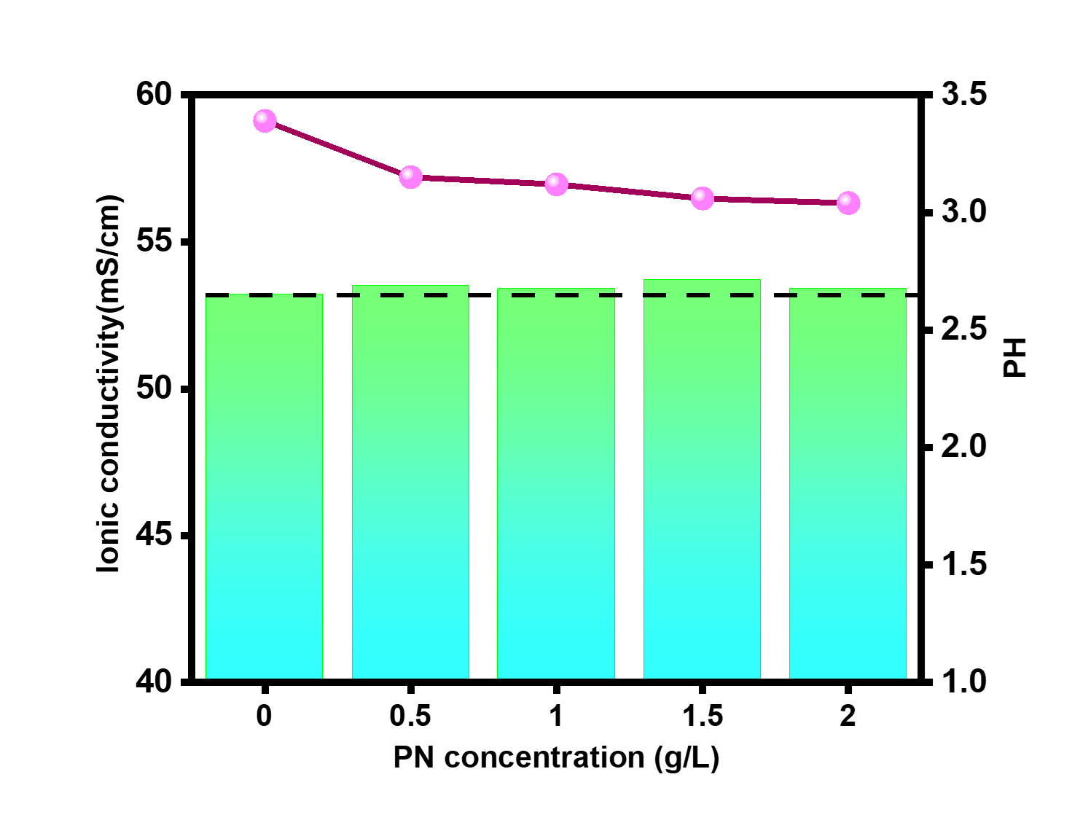
Supplementary Fig. 8 PH value and ionic conductivity of ZS and with different contents of PN at room temperature.
Note: It suggested that with the increasing concentration of PN, pH value decreased, which proved that protonated PN was added again and H⁺ were released due to multivariate conversion process, as opposed to pH changes, it suggested that more ions occurred in multivariate conversion contributed to ionic conductivity of ZSPN with different concentrations increased than ZS. It is universally acknowledged that thermodynamically unstable in an acidic electrolyte, hence 1g L⁻¹ PN were the most ideal concertation combined with Supplementary Fig. 3. For simple, ZSPN refer to 1g L⁻¹ PN in the following.

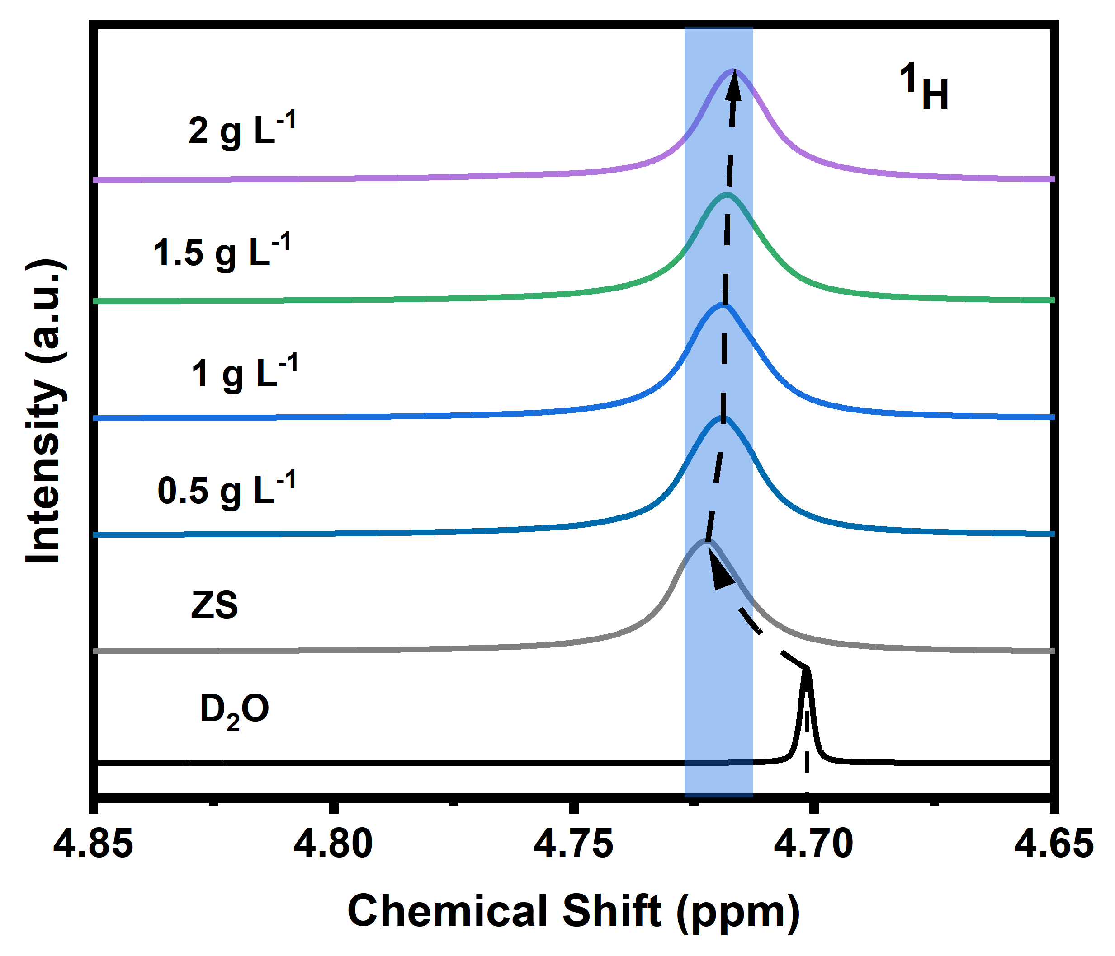
Supplementary Fig. 9 NMR spectra of 2 M ZS electrolyte and 2 M ZS with different concertation of PN.

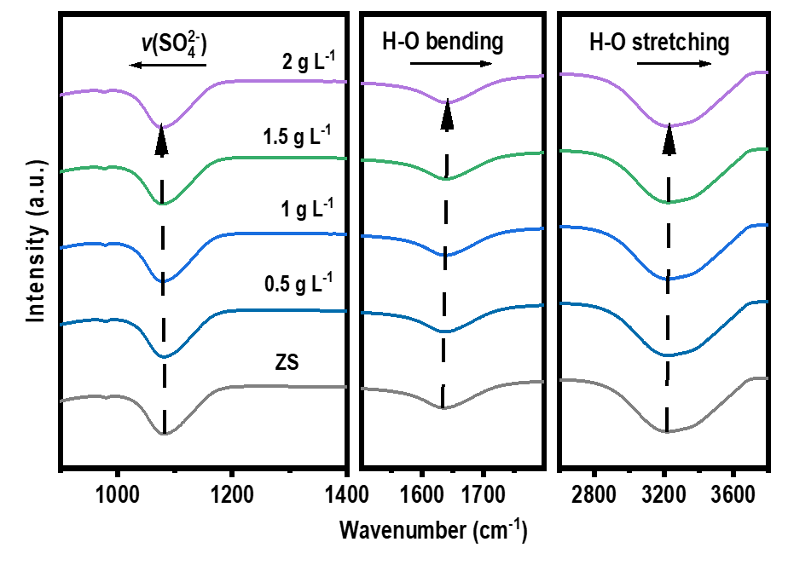
Supplementary Fig. 10 FTIR spectra of 2 M ZS electrolyte and containing different concentrations of PN.

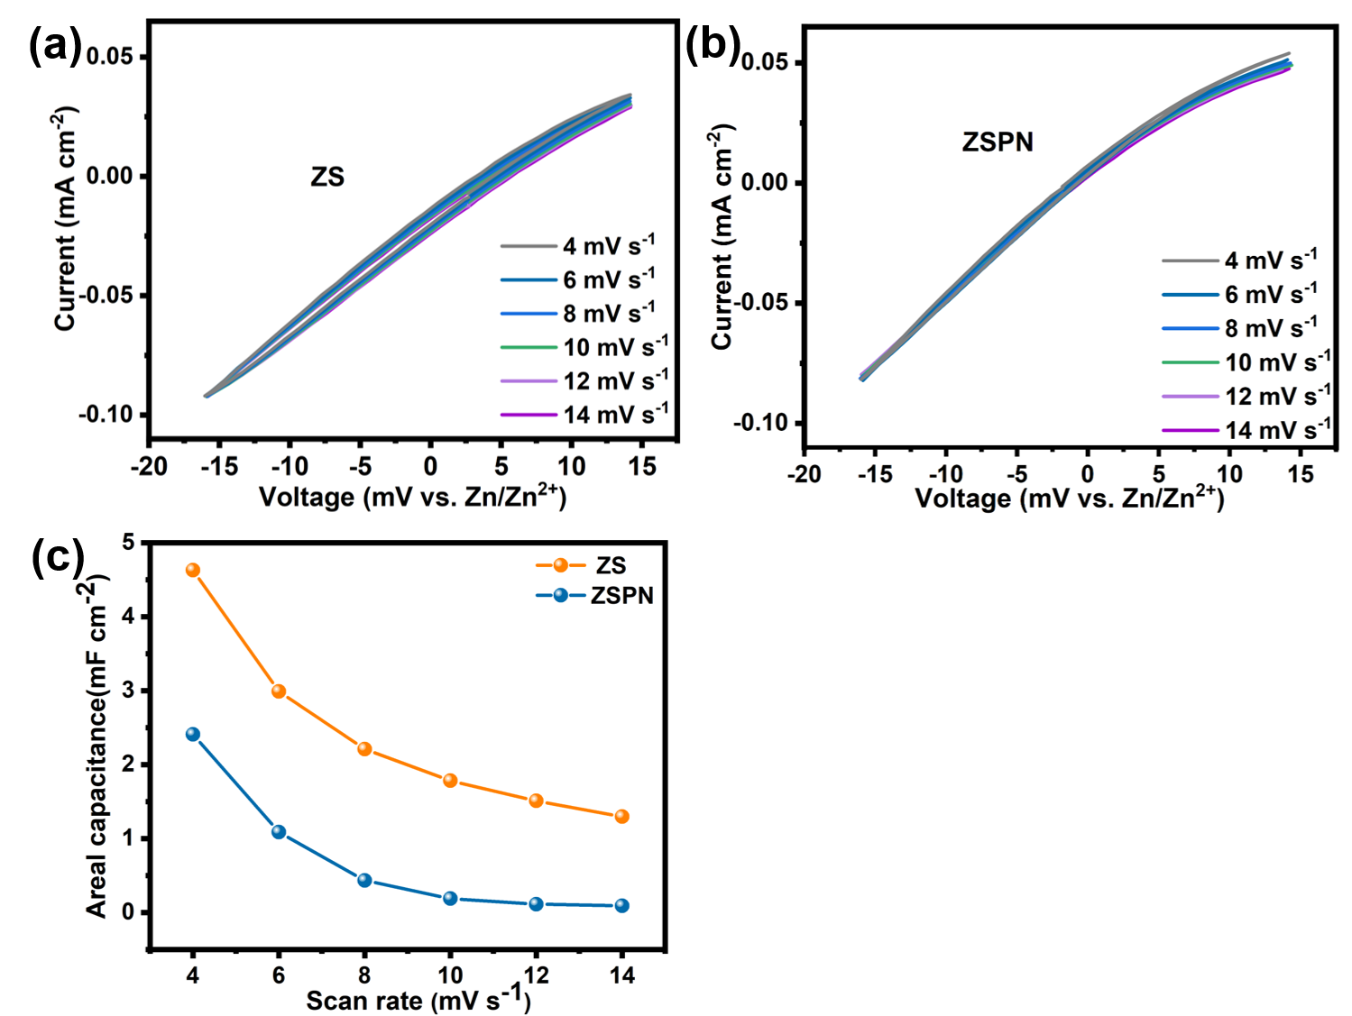
Supplementary Fig. 11 CV curve of Zn||Zn symmetric batteries of (a) ZS and (b) ZSPN at different sweep speed, (c) calculated electric double layer capacitances.

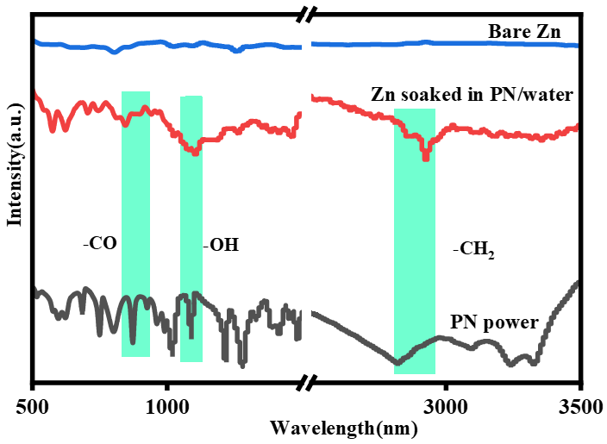
Supplementary Fig. 12 ATR-FTIR spectra of the PN power, bare Zn and Zn soaking in PN solution in one day at room temperature.

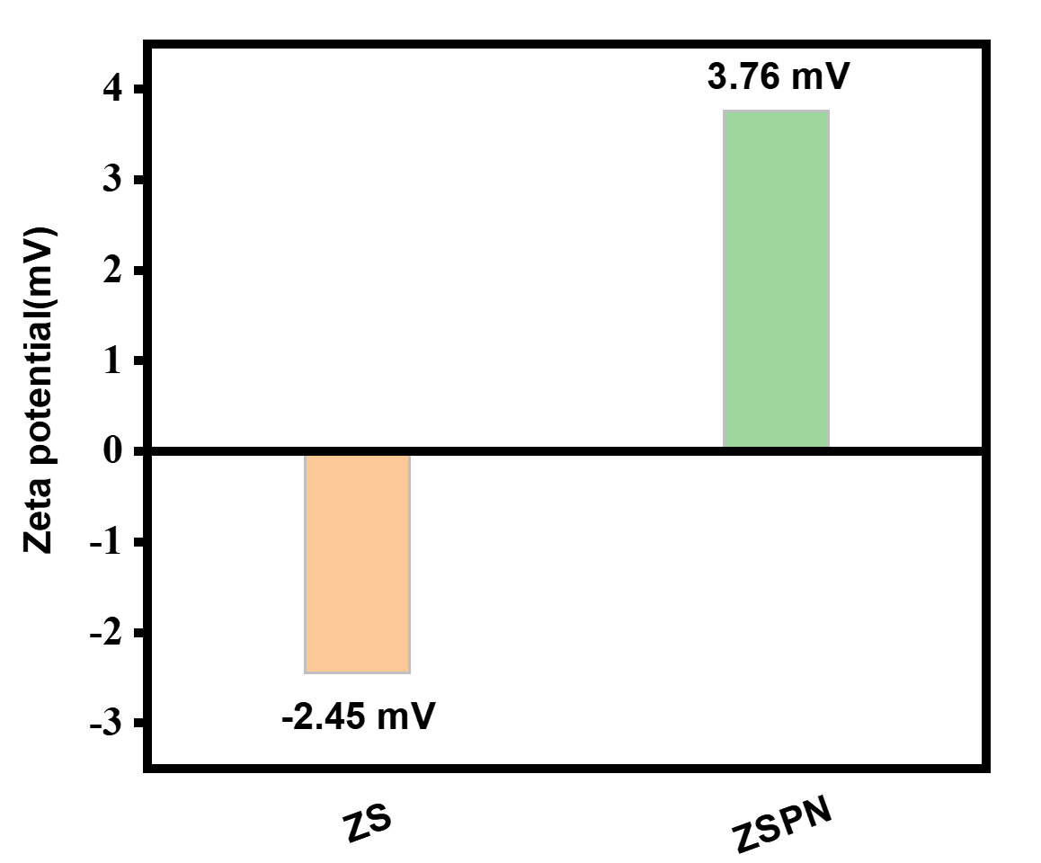
Supplementary Fig. 13 Zeta potential value of zinc powder in electrolytes of ZS and ZSPN, respectively.

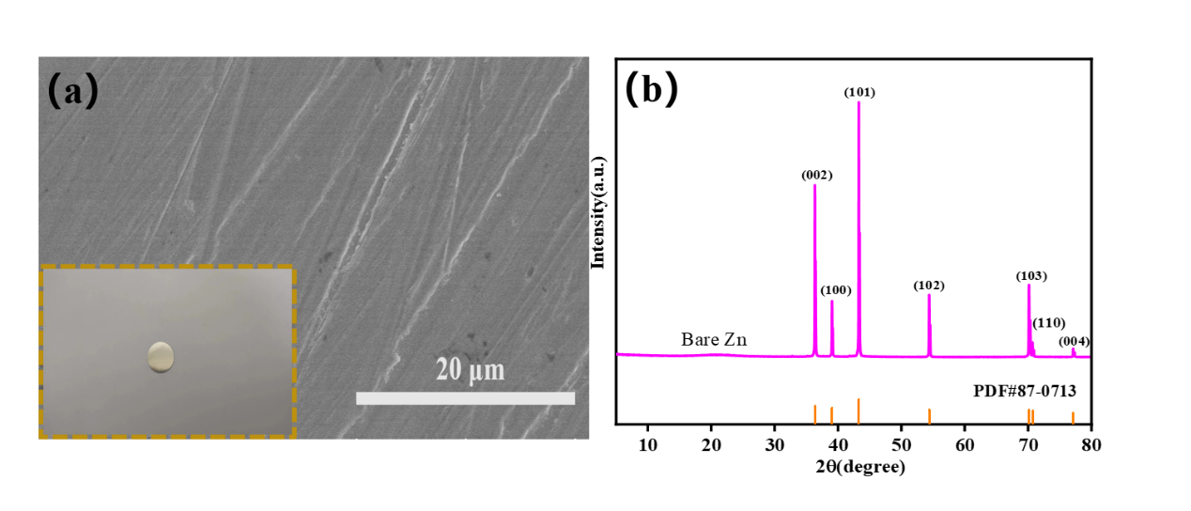
Supplementary Fig. 14 Fresh zinc slab images prior to operation (a) optical image in bottom left and SEM image. (b) Corresponding XRD patterns of Zn. All these detailed information was proved as background and thus contributing a sharp contrast with zinc anode after detaching from coin cells.

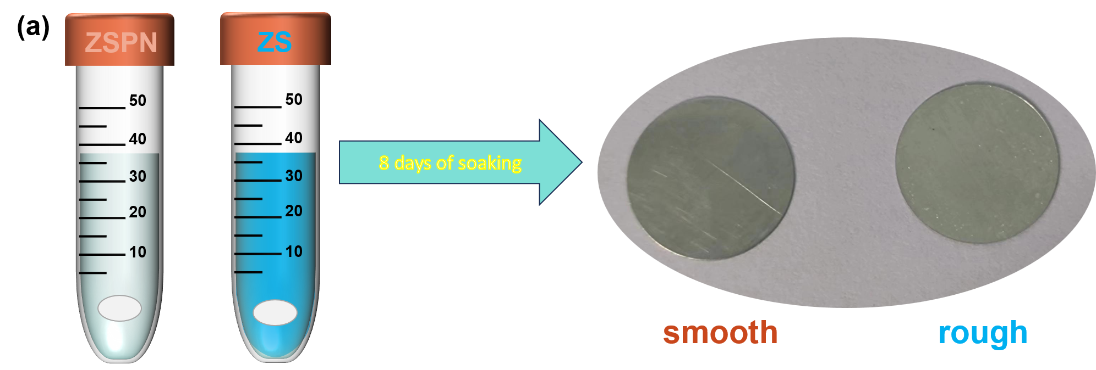
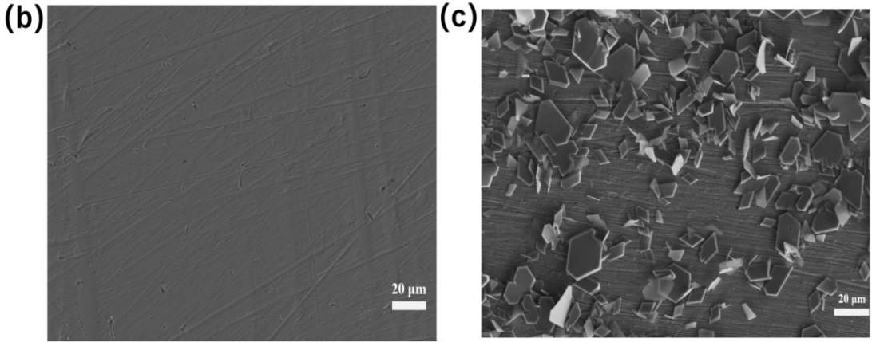
Supplementary Fig. 15 (a) Schematic diagram of soaking experiment; (b) SEM images in different scales of zinc sheet soaking on ZSPN. (c) SEM images in different scales of zinc sheet soaking on ZS.
Note: Soaking test was conducted to probe electrolyte-induced byproduct. After eight days of soaking, metallic texture was readily found in the left comparing with Supplementary Fig. 14, whilst white spot covered in the right, suggesting the restriction role of PN on zinc hydroxide sulfate (ZHS) visually. And SEM further verified these results, zinc sheet remained clean, nevertheless, scaly like byproduct stacked unregularly, which suggested ZHS came into being.
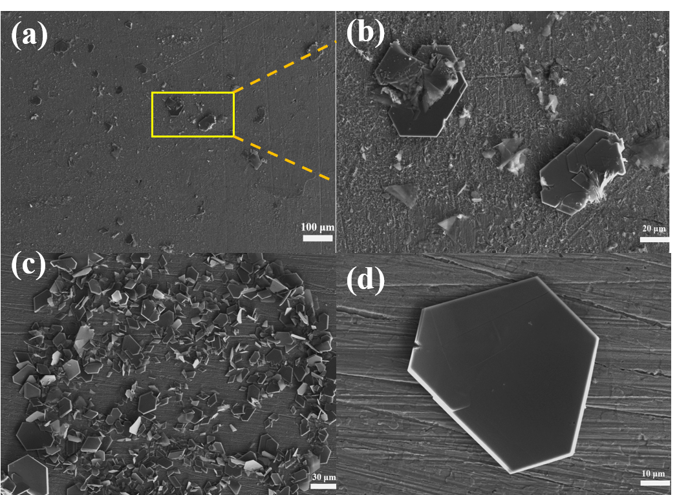
Supplementary Fig. 16 (a)-(d) Detailed images of ZSH in different scales.

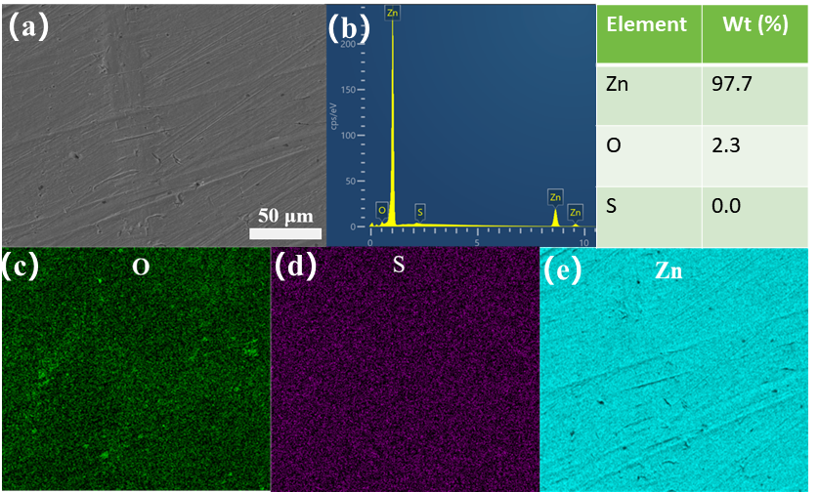
Supplementary Fig. 17 (a) selected area of zinc sheet soaking in ZSPN, (b)-(e) corresponding EDS elemental mapping of zinc sheet soaking in ZSPN.

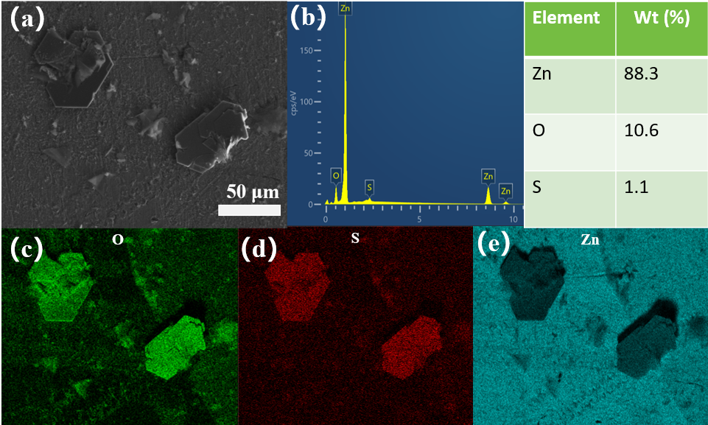
Supplementary Fig. 18 (a) selected area of zinc sheet soaking in ZS; (b)-(e) corresponding EDS mapping of zinc sheet soaking in ZS.

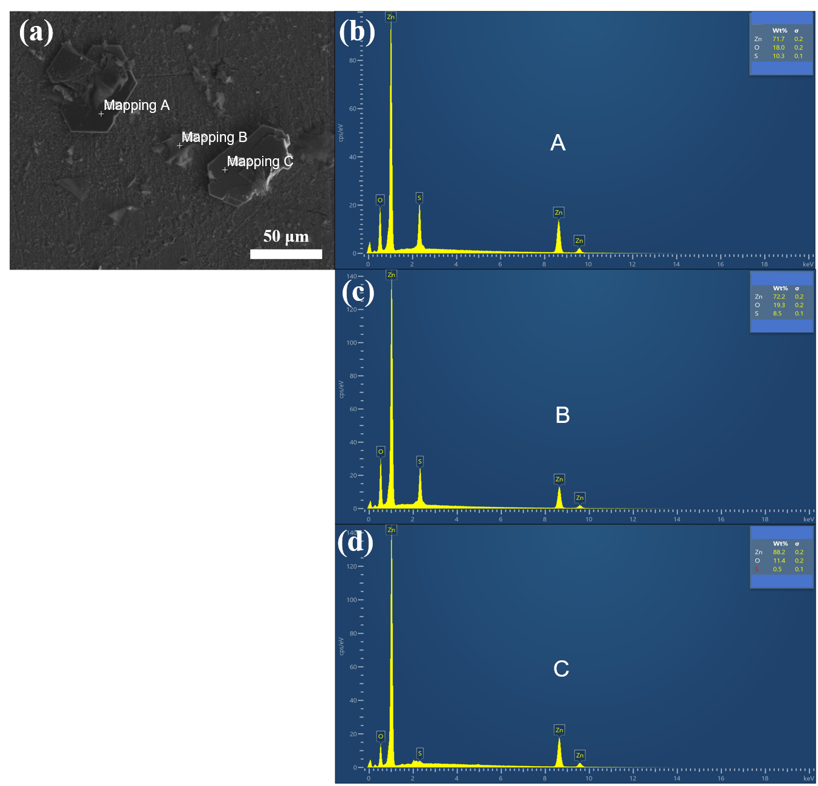
Supplementary Fig. 19 (a) selected point of zinc sheet soaking in ZS; (b)-(d) corresponding EDS results. The above test suggested that the flake solids were undesired byproducts.

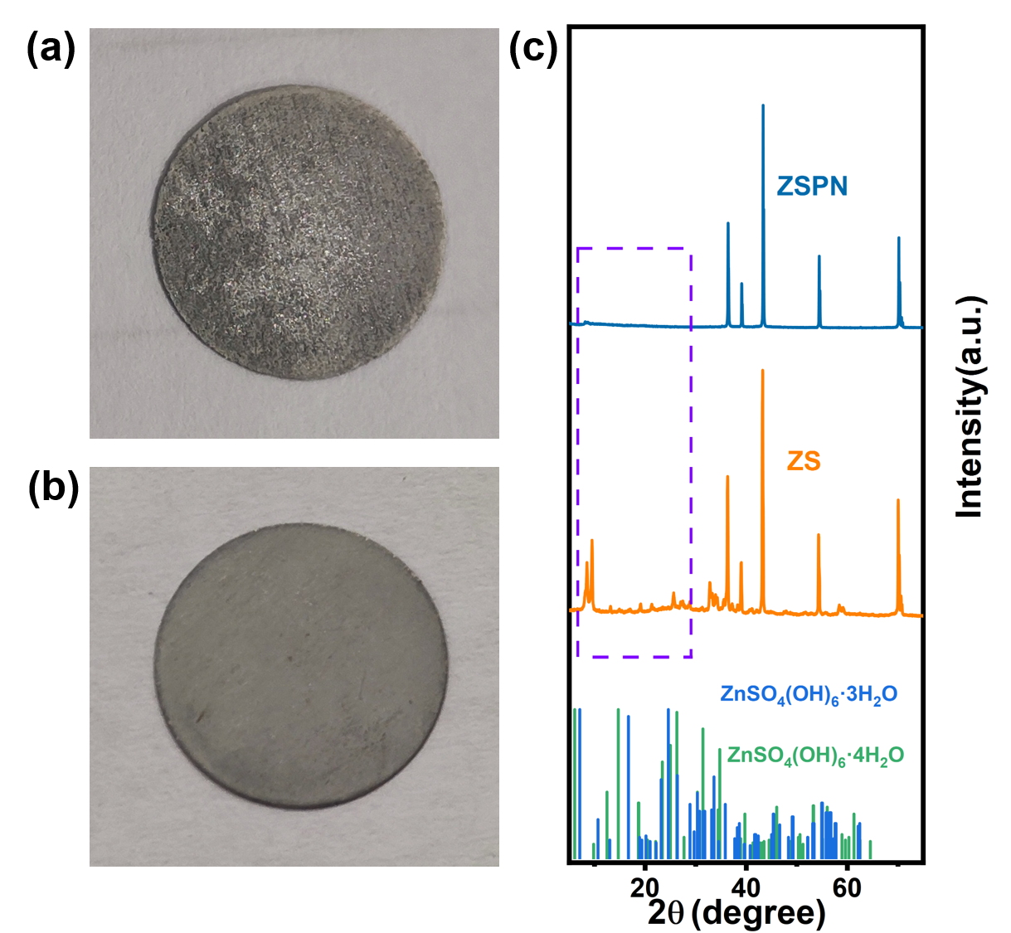
Supplementary Fig. 20 Optical images of detached zinc sheet from deposition side of last cycle (a) ZS and (b) ZSPN under 1mA⁻² 1mAh⁻² for 100 cycles; (c) XRD patterns of above zinc sheet.

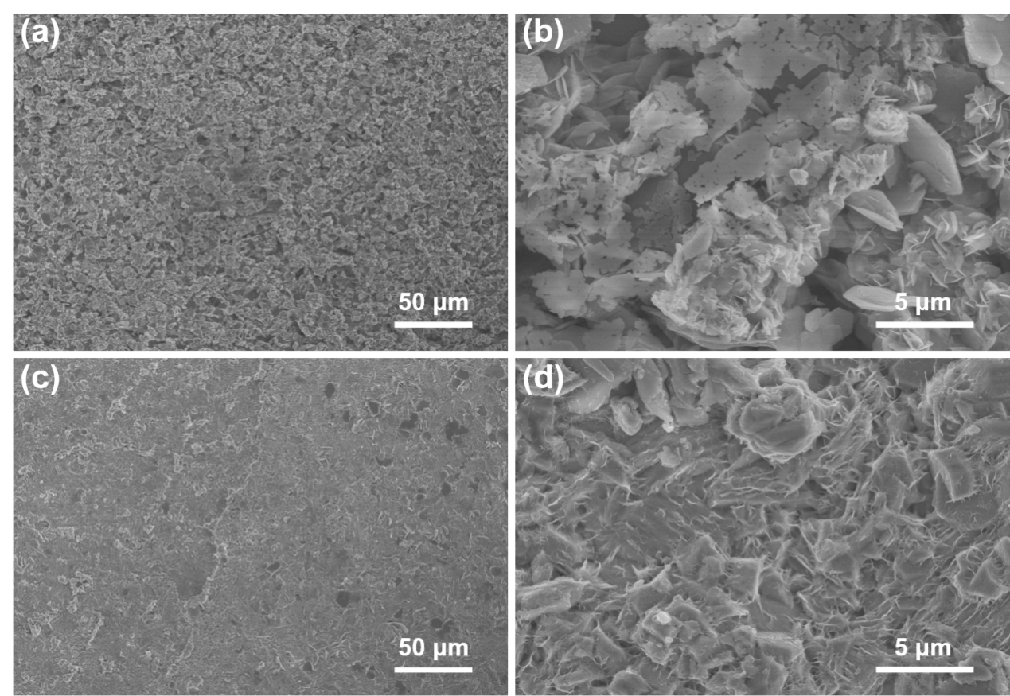
Supplementary Fig. 21 SEM micrographs of Zn foil in different scales detached from (a-b) ZS and (c-d) ZSPN.

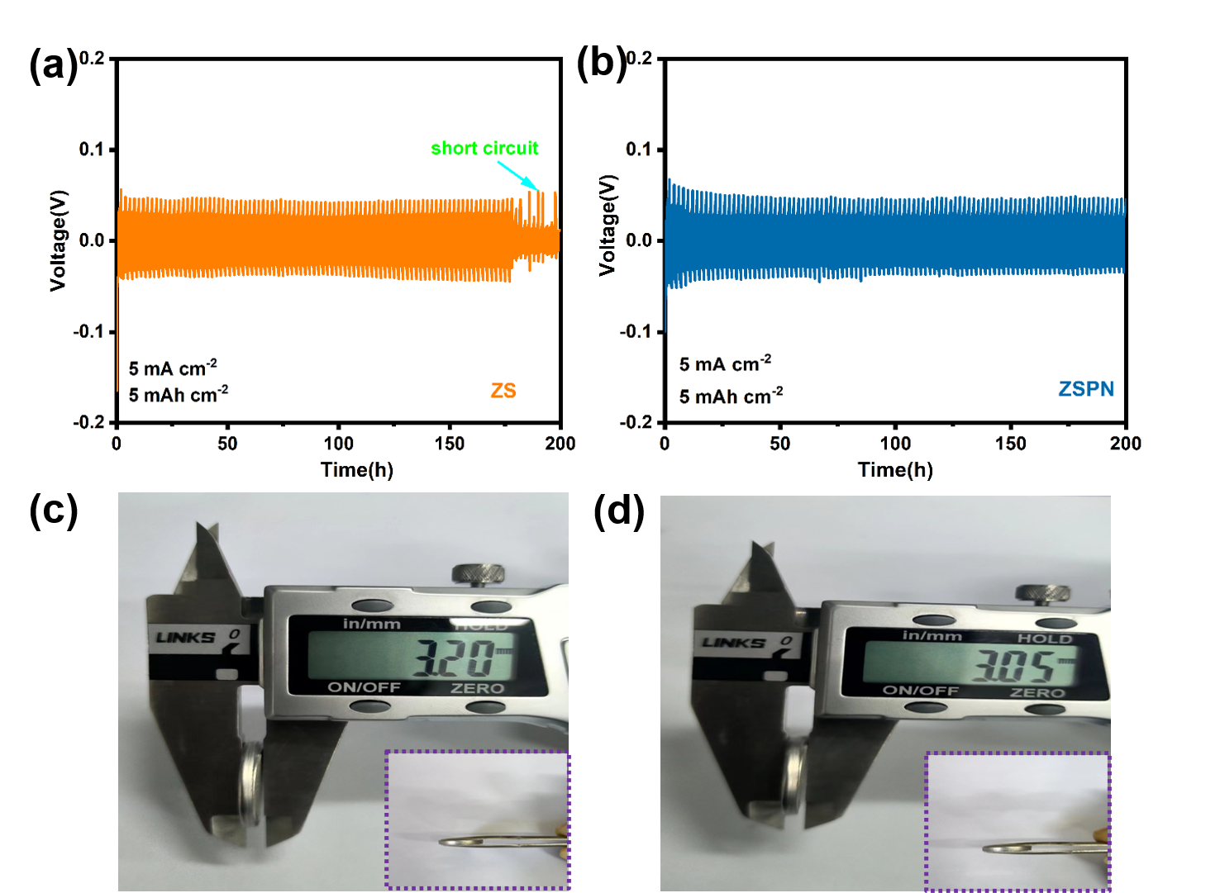
Supplementary Fig. 22 The cycling performance of Zn||Zn symmetrical batteries with (a) ZS and (b) ZSPN under conditions of 5 mA cm⁻², 5 mAh cm⁻². Measurement of the thickness of symmetric batteries after cycling in (c) ZS and (d) ZSPN.
Note: The thickness of symmetric batteries was recorded after 100 cycles of testing, as above images suggested, batteries with ZSPN suffered short circuits and slight flat (signifying HER) than ZSPN.

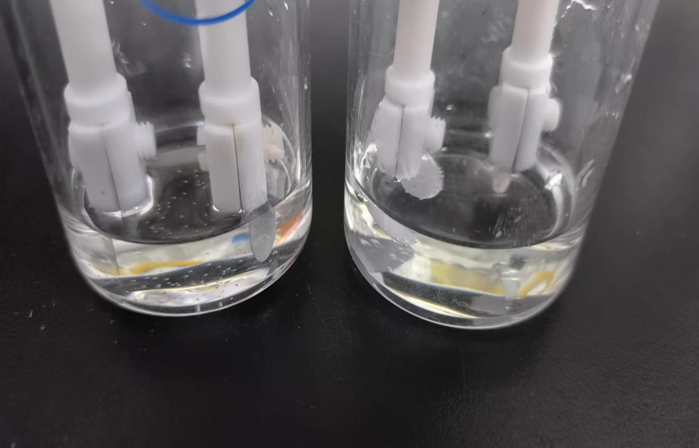
Supplementary Fig. 23 Bubble image of one day resting.
Note: Zn||Zn symmetrical batteries in electrolytic cells were simulated so as to qualitative the HER restriction role that PN played, it was evident that bubble number was greater in ZS than ZSPN electrolyte after one day of resting.

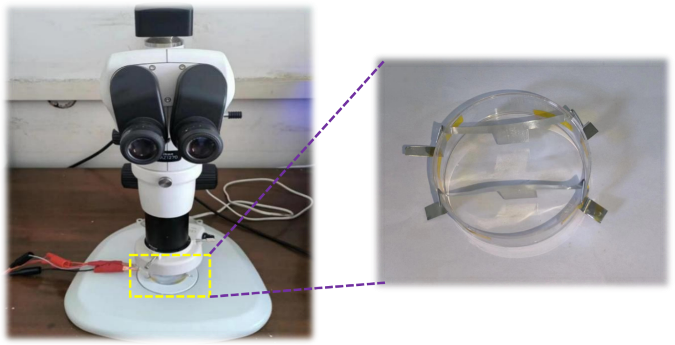
Supplementary Fig. 24 In situ optical microscope with a self-assembled optical cell powered by Neware testing system.
Note: The contacted part of the electrode clamp was sealed with insulation tape to prevent a short circuit from happening. During dendrite observation process, electrolyte was required to be added from time to time because of lamp-induced evaporation so as to maintain a constant liquid level.

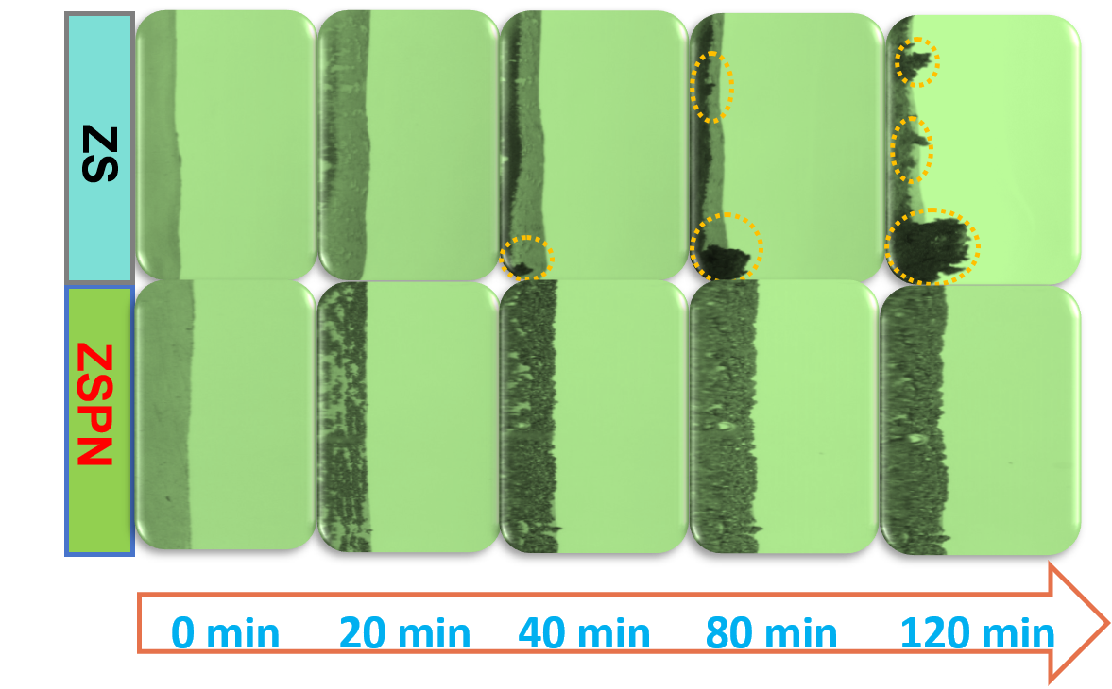
Supplementary Fig. 25 Omitted optical images in electrolytes in ZS and ZSPN, respectively.

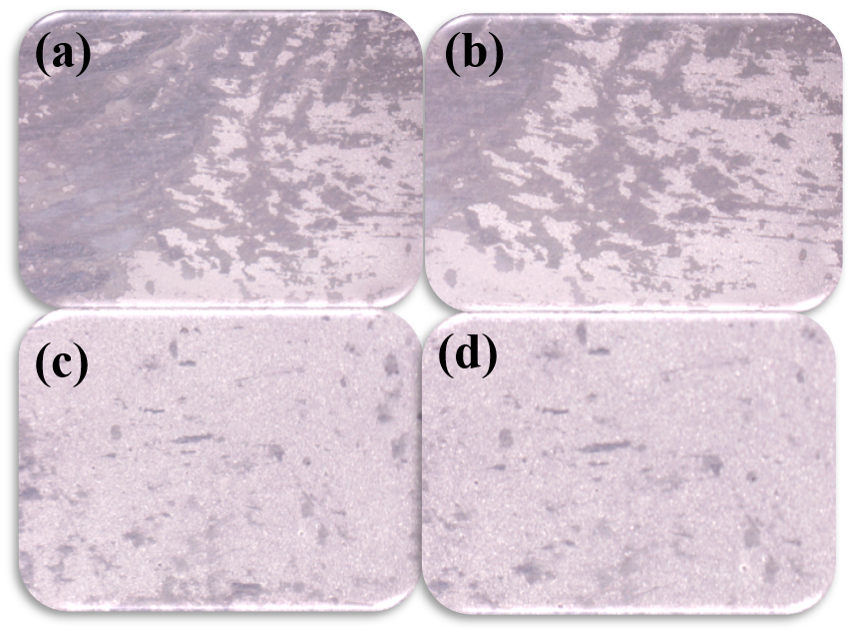
Supplementary Fig. 26 (a)-(b) Optical images of Zinc sheet under 5 mA cm⁻² exposing in ZS and (c)-(d) exposing in ZSPN.
Note: Optical images stem from detached zinc sheets under 5 mA cm⁻² after 30 min soaking in pristine ZS. In pristine ZS, the deposited zinc was not uniform and the surface was uneven for randomly stacked. There laid a sharp contrast in ZSPN as its uniform and dense manner.

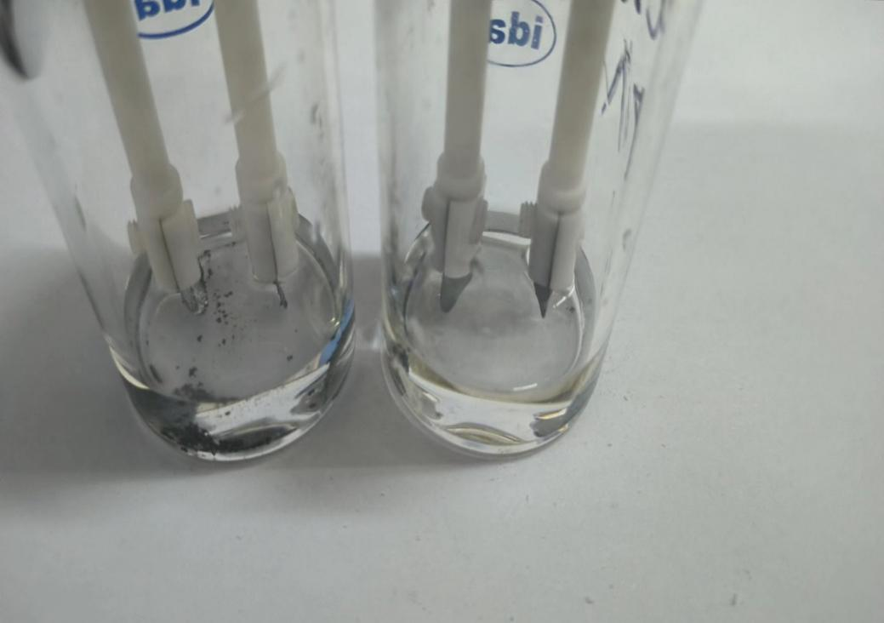
Supplementary Fig. 27 GCD tests in electrolytic cell after 20 cycles under the condition of 5 mA cm⁻², 5 mAh cm⁻².
Note: Without separator restriction, Zinc dendrite grew rampantly and even fell into electrolyte being as “dead zinc", whilst catching no sight of unsettled zinc in the PN-modified electrolyte system.

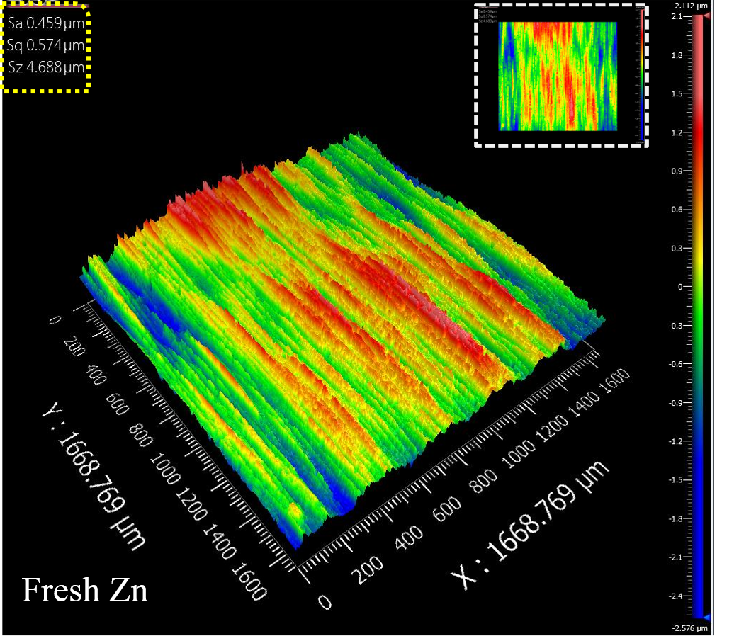
Supplementary Fig. 28 2D and 3D images of fresh Zn, above images, demonstrated that the origin zinc sheet was in flat and uniform state as deposition substrate, which was in agreement with its SEM and optical images showed in Supplementary Fig. 14.

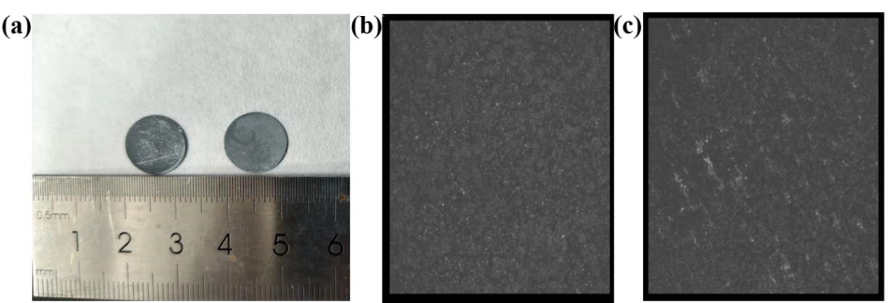
Supplementary Fig. 29 (a) Detached zinc sheet from different electrolytes. The left one was from ZS and the right one was from ZSPN, and the corresponding scanned area of (b) ZS and (c) ZSPN.

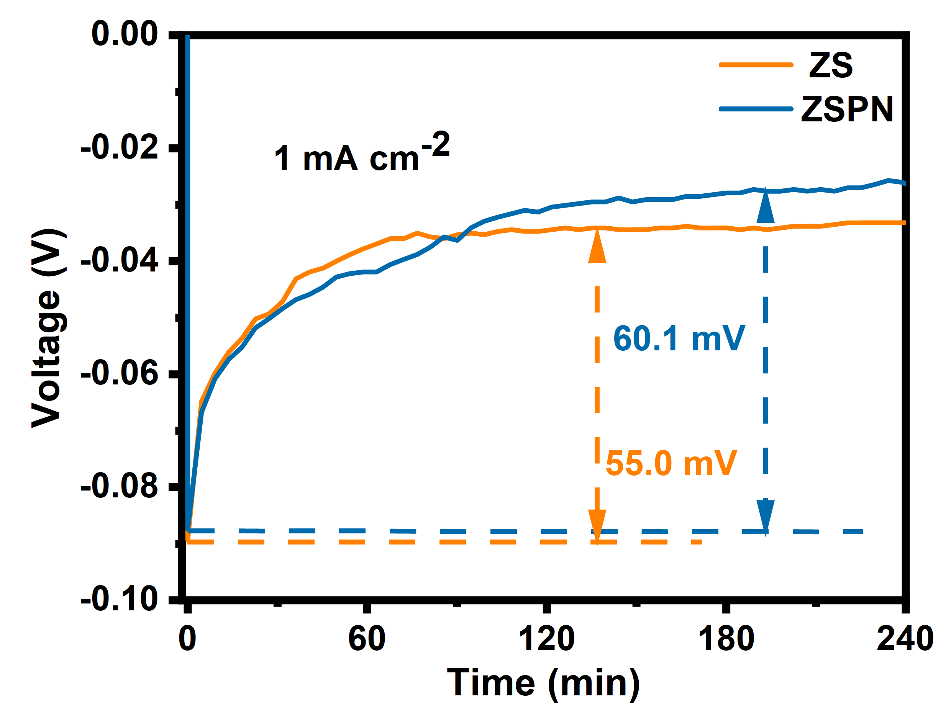
Supplementary Fig. 30 Nucleation overpotential of Zn||Zn symmetric batteries of ZS and ZSPN under 1mA cm⁻².

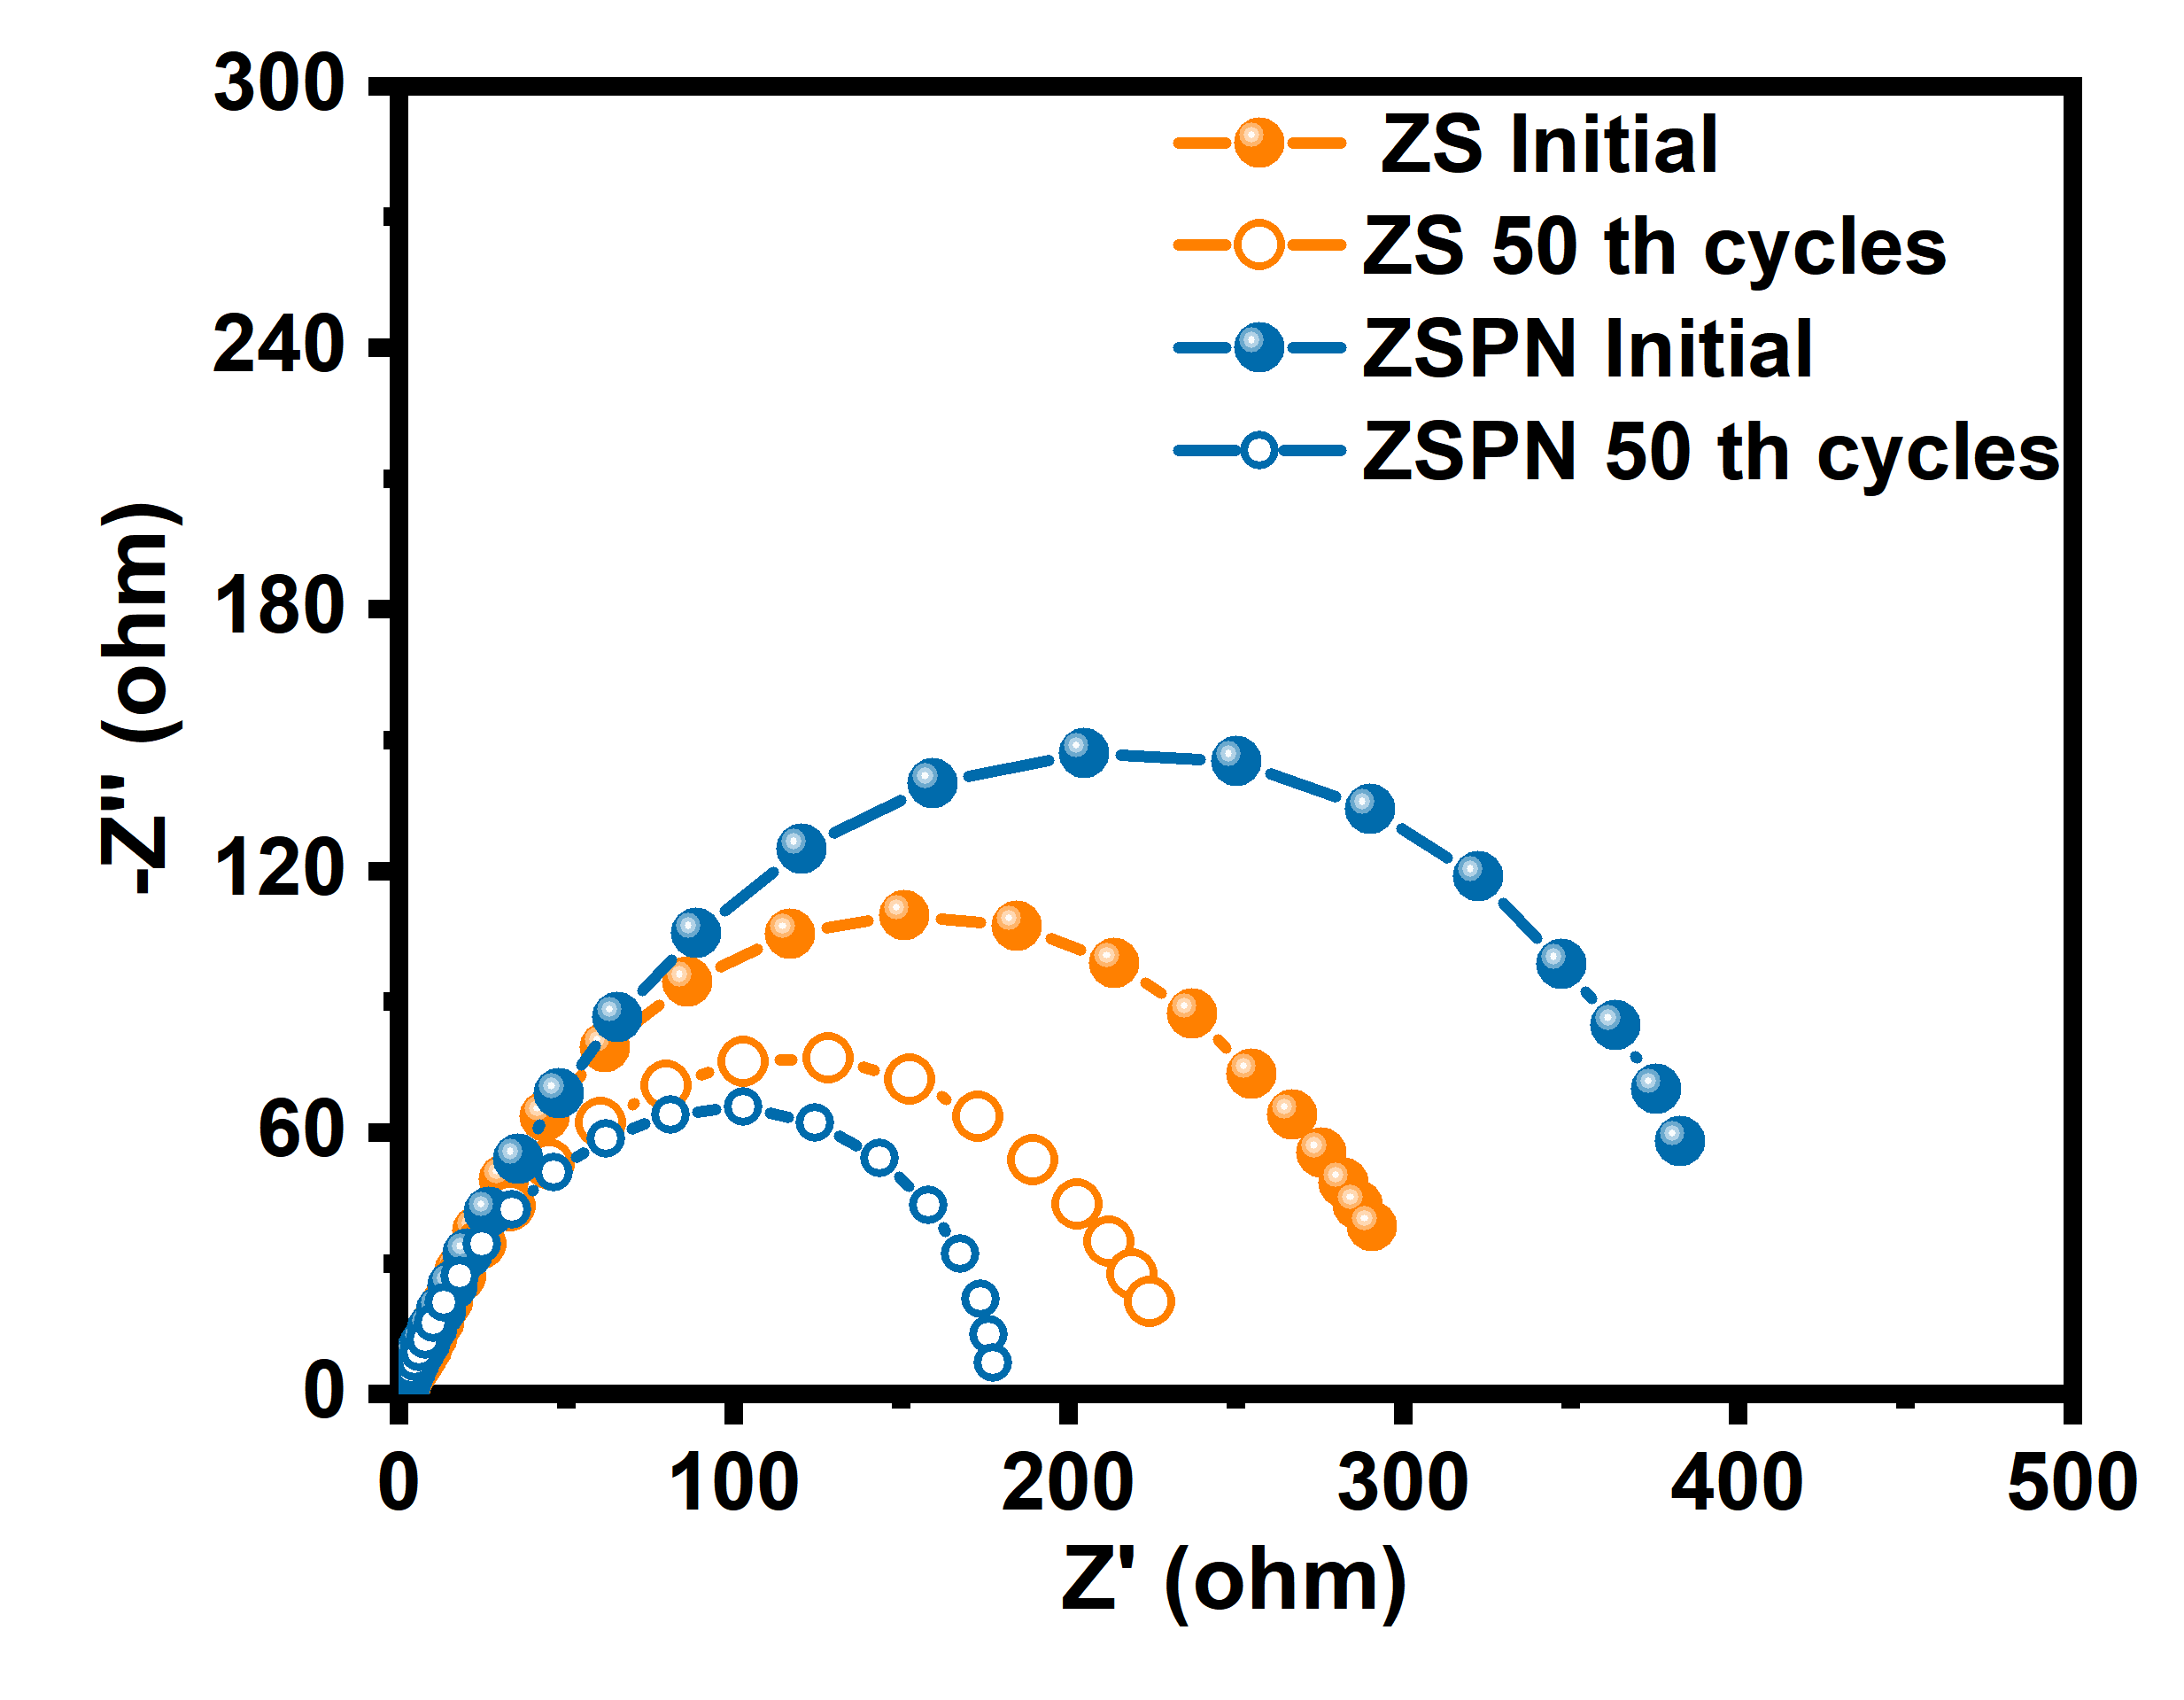
Supplementary Fig. 31 Nyquist plots of Zn||Zn symmetric cells of ZS and ZSPN in initial and after 50 cycles at 1 mA cm⁻², 1 mAh cm⁻².

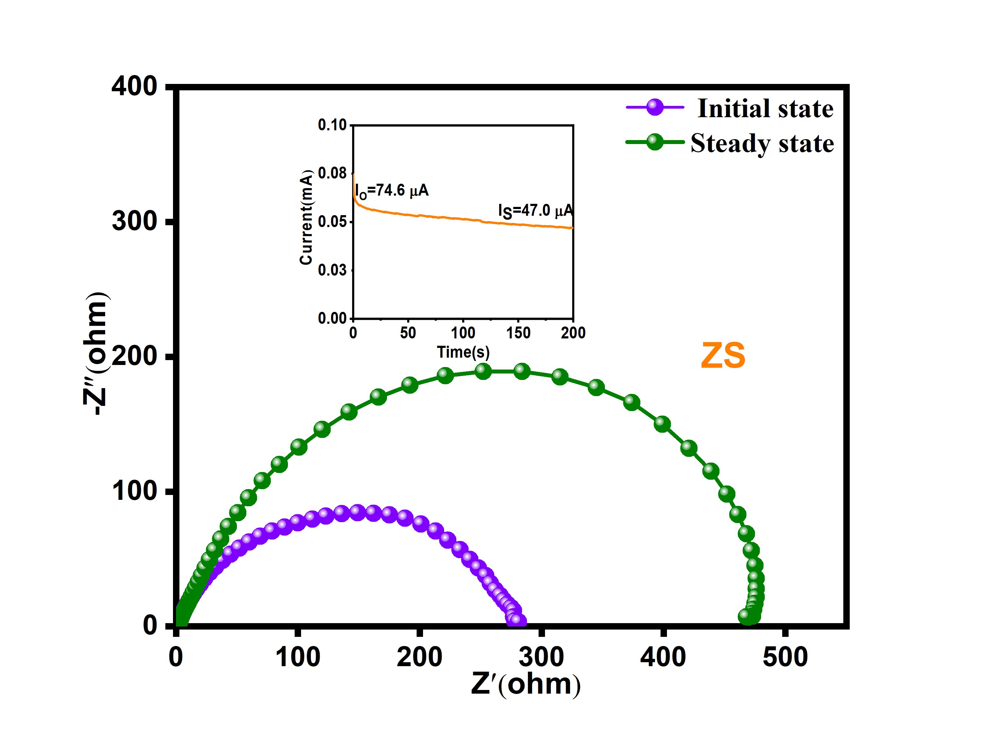
Supplementary Fig. 32 EIS of the Zn||Zn symmetric cells of ZS before and after polarization, inset: variation of current versus time during polarization at an applied voltage of 50 mV at room temperature.

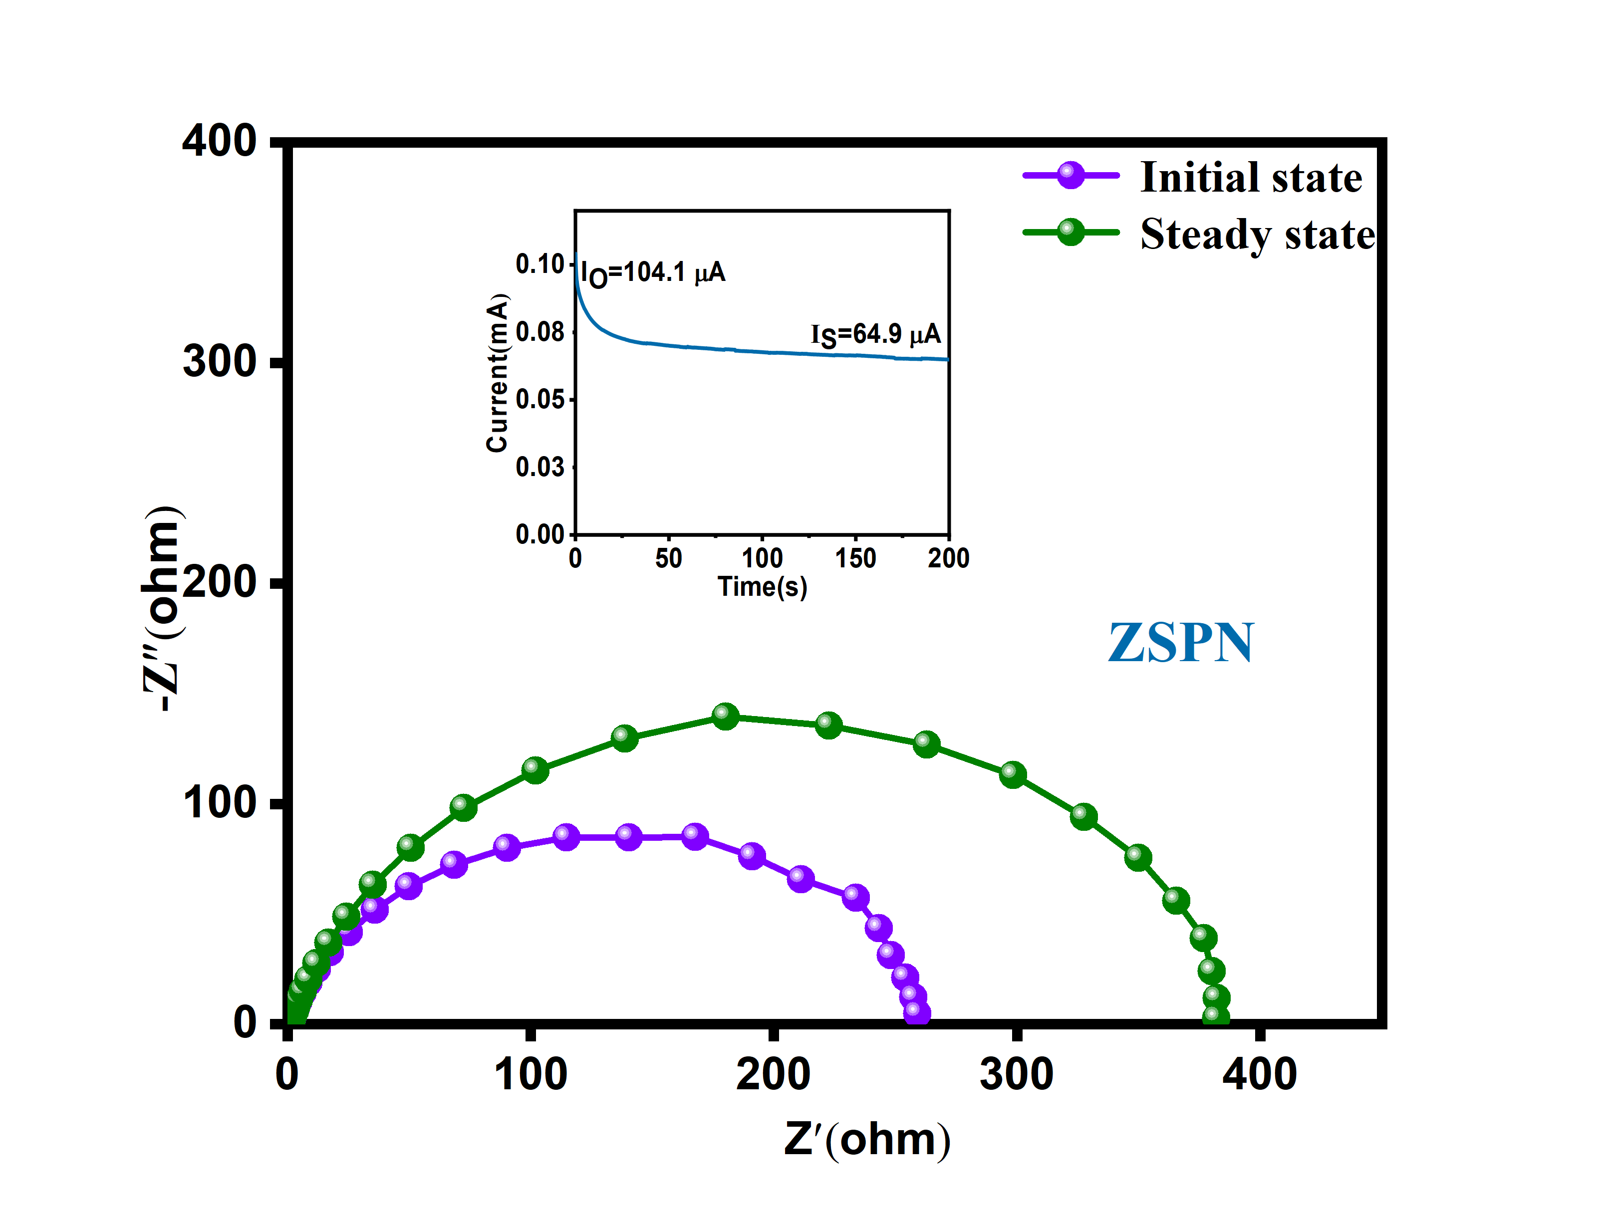
Supplementary Fig. 33 EIS of the Zn||Zn symmetric cells of ZSPN before and after polarization, inset: variation of current versus time during polarization at an applied voltage of 50 mV at room temperature.

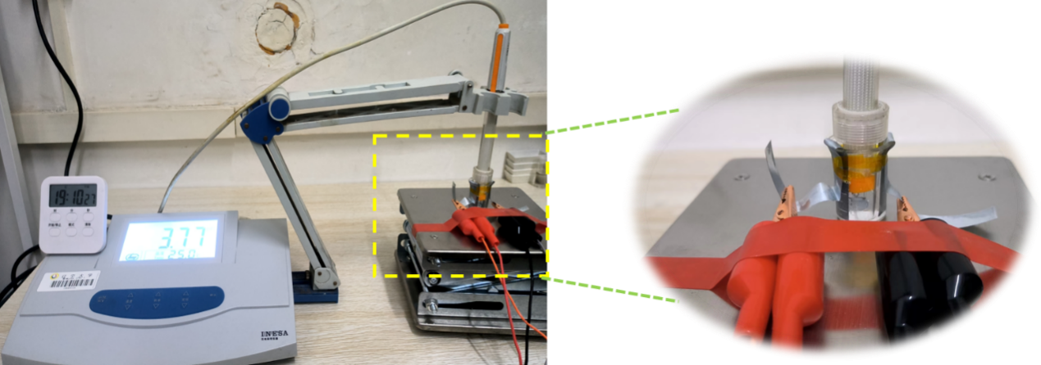
Supplementary Fig. 34 Self-made in situ pH measurement device and detailed images. Note: Here, we utilized a 5 ml breaker to hold the electrolyte and pH detector. Zinc sheets cut into strips with 1 cm width were adhered to the breaker side. Moreover, the volume of electrolyte was controlled in 3 ml strictly. PH value in the screen was recorded at every setting time.

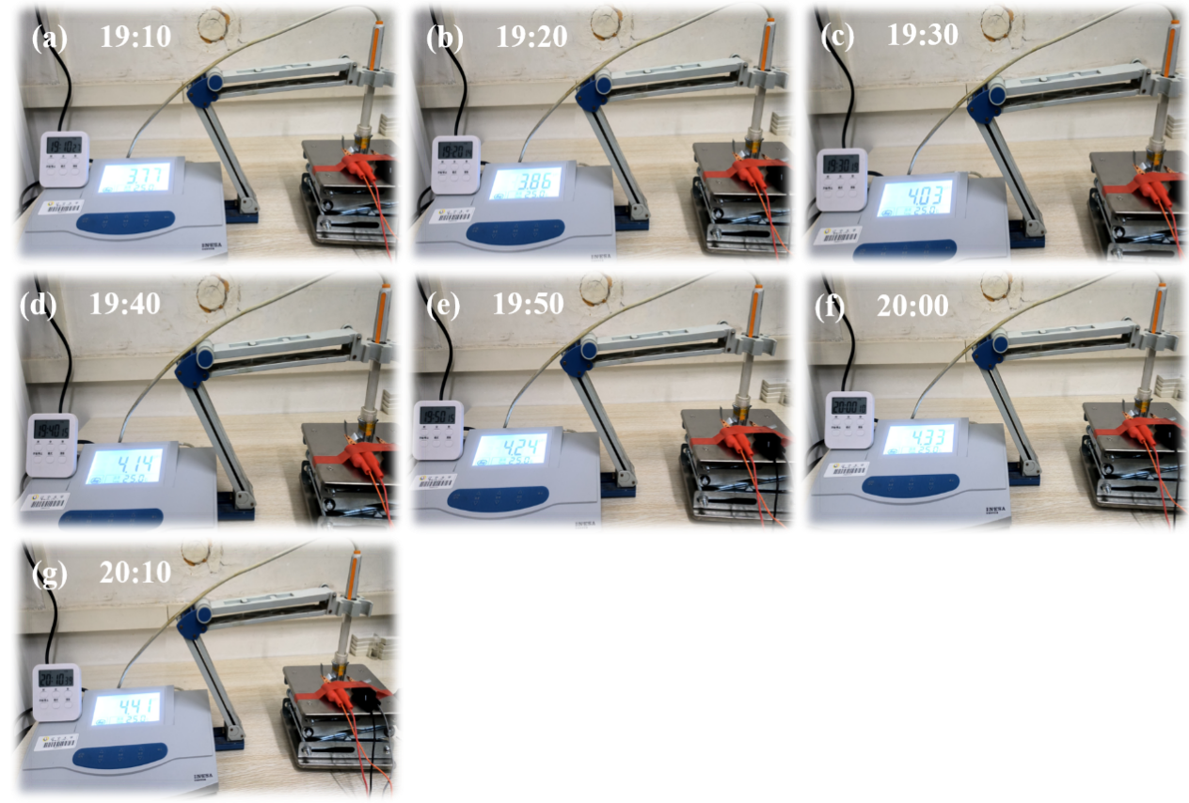
Supplementary Fig. 35 (a)-(g) PH value images in each 10 min of ZS.

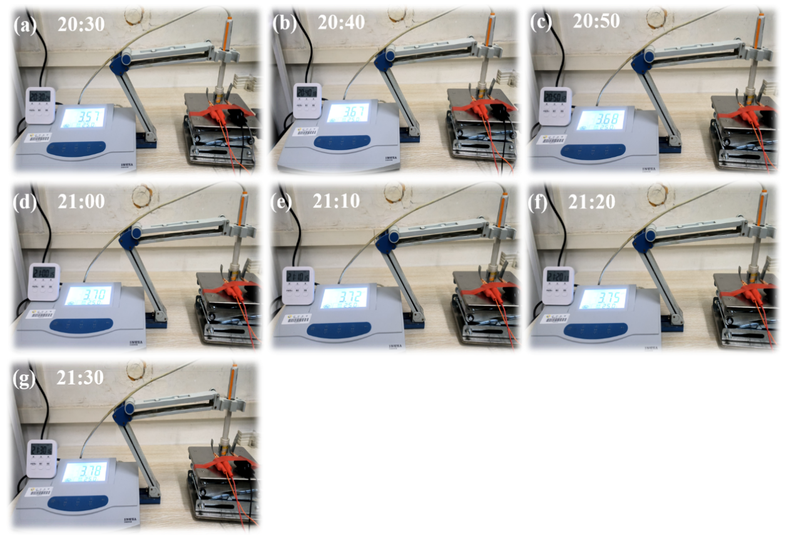
Supplementary Fig. 36 (a)-(g) PH value images in each 10 minutes of ZSPN.

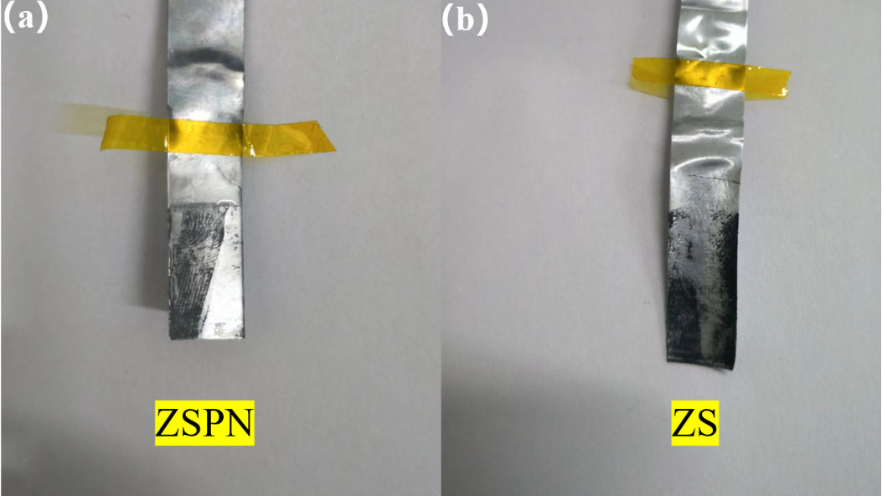
Supplementary Fig. 37 Detached zinc sheet from in situ pH devices of (a) ZSPN and (b) ZS.

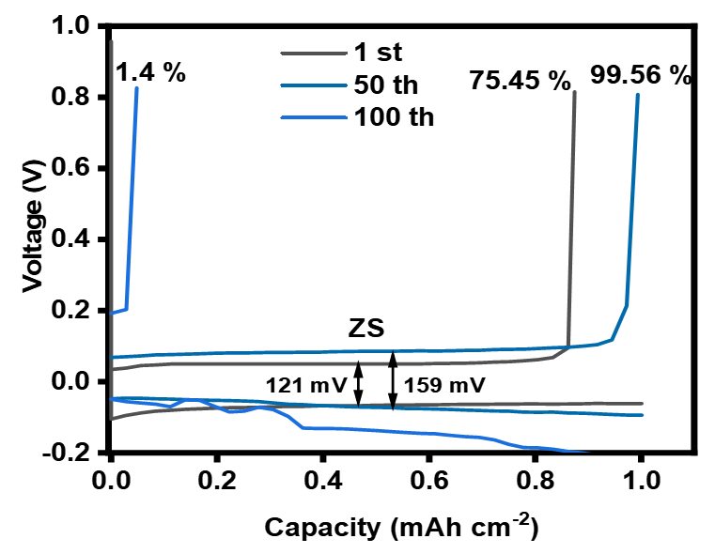
Supplementary Fig. 38 The voltage profiles in 1st,50th,100th,300th,600th cycle in ZS.

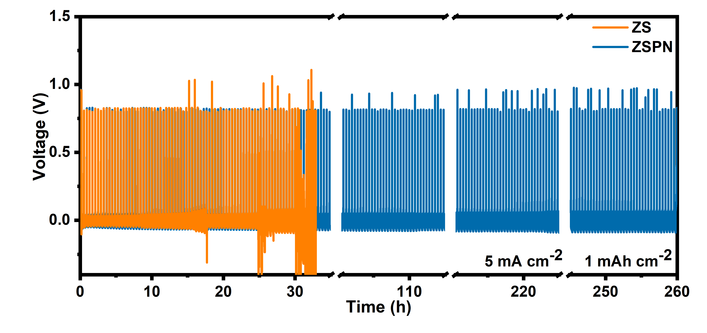
Supplementary Fig. 39 Corresponding voltage profiles of Zn||Cu half cells under 5 mA cm⁻², and 1 mAh cm⁻² in ZS and ZSPN, respectively.

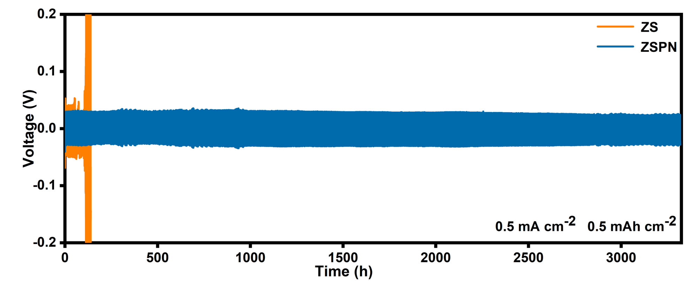
Supplementary Fig. 40 The cycling performance of Zn||Zn batteries with ZS and ZSPN under conditions of 0.5 mA cm⁻², and 0.5 mAh cm⁻².

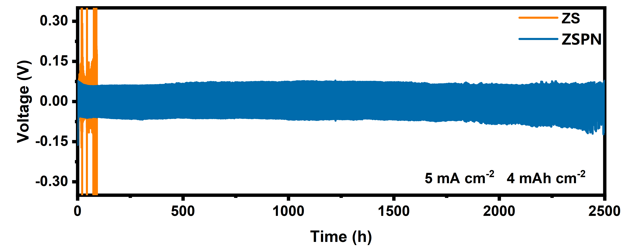
Supplementary Fig. 41 The cycling performance of Zn||Zn batteries with ZS and ZSPN under conditions of 5 mA cm⁻², and 4 mAh cm⁻².

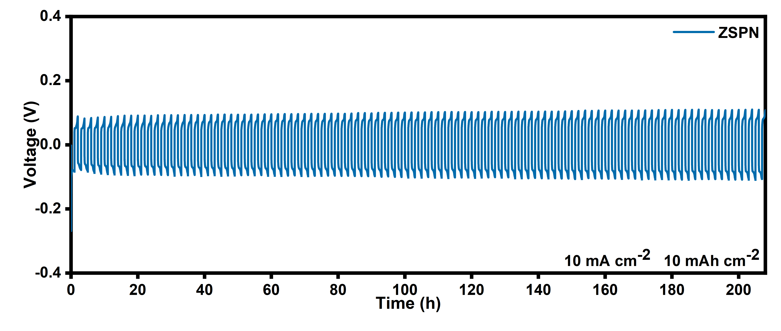
Supplementary Fig. 42 The cycling performance of Zn||Zn batteries with ZS and ZSPN under conditions of 10 mA cm⁻², and 10 mAh cm⁻².

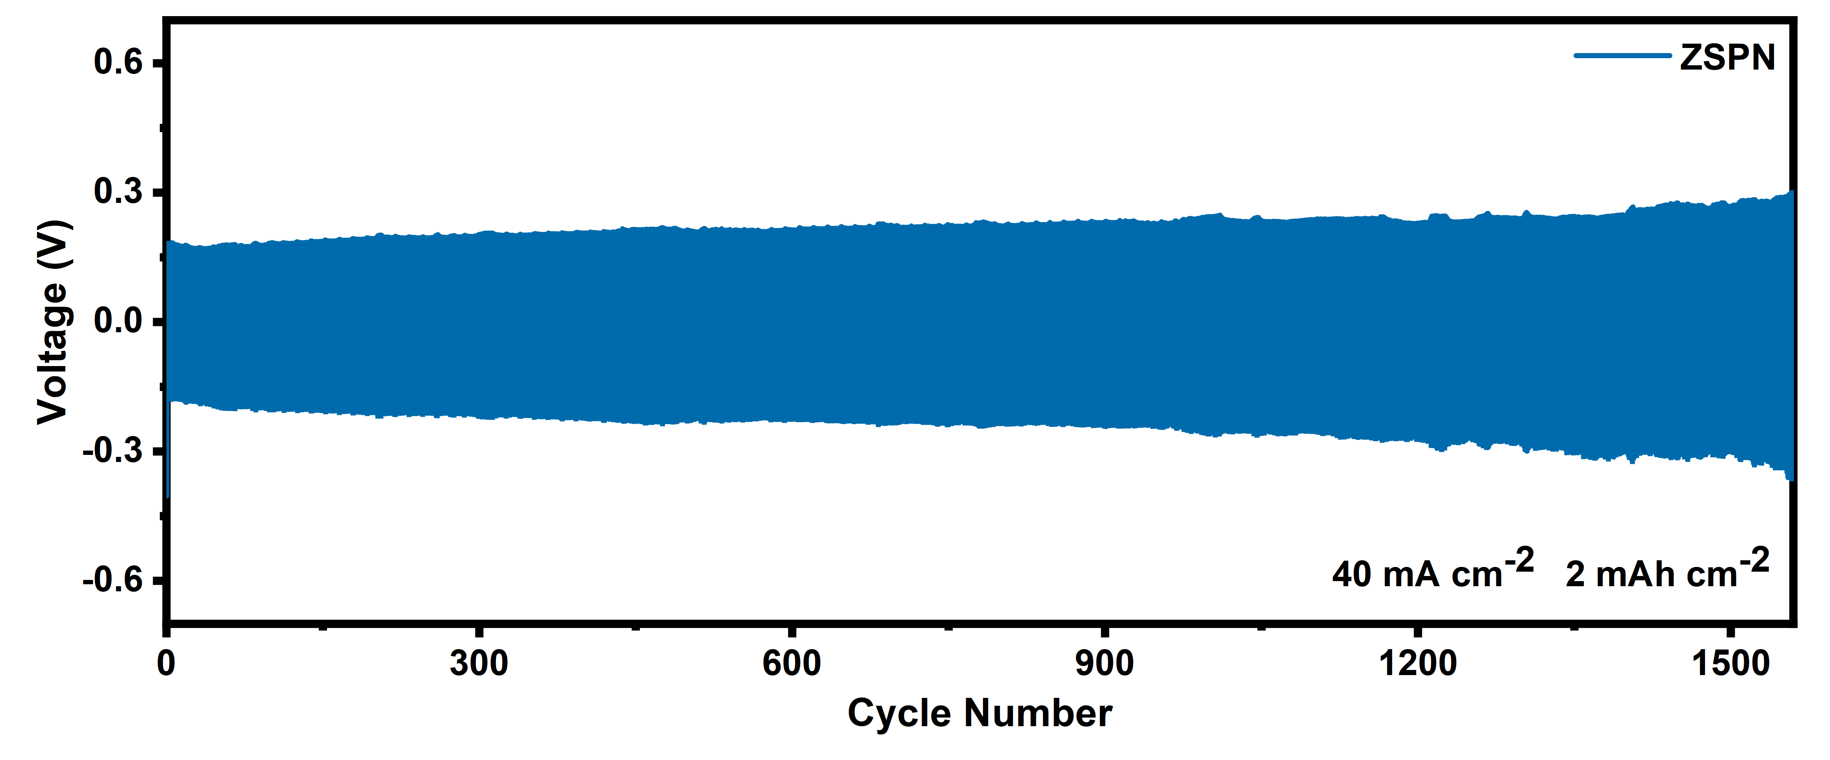
Supplementary Fig. 43 The cycling performance of Zn||Zn batteries with ZS and ZSPN under conditions of 40 mA cm⁻², and 2 mAh cm⁻².

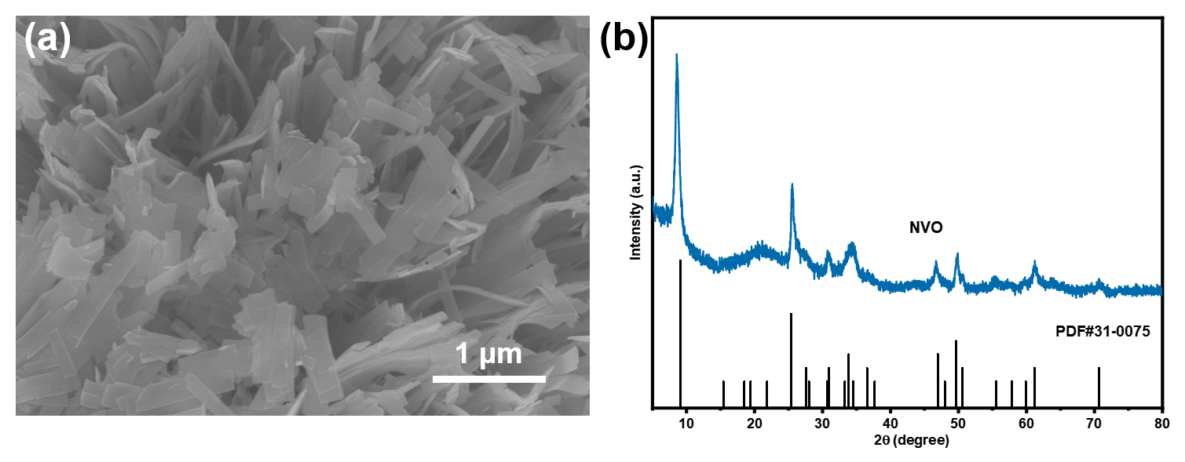
Supplementary Fig. 44 (a) SEM and (b) XRD images of the synthesized (NH₄V₄O₁₀) NVO⁶.

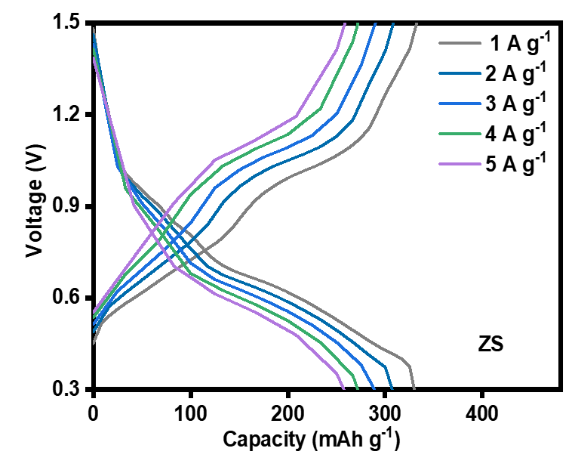
Supplementary Fig. 45 GCD curves of ZS in different current density.

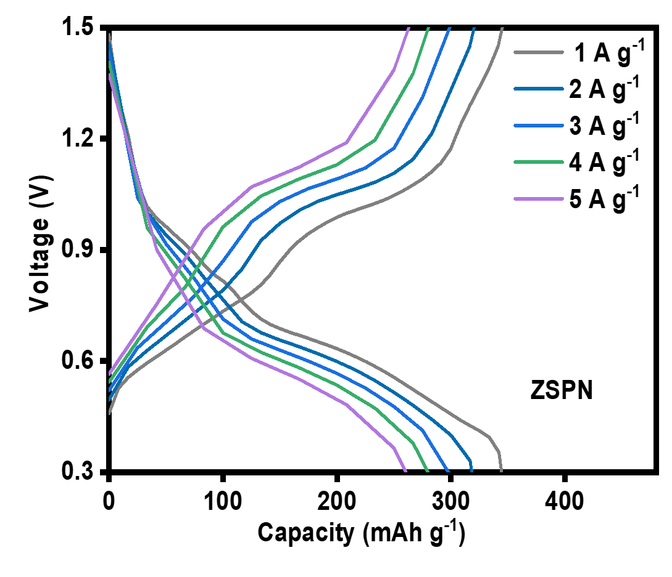
Supplementary Fig. 46 GCD curves of ZSPN in different current density.

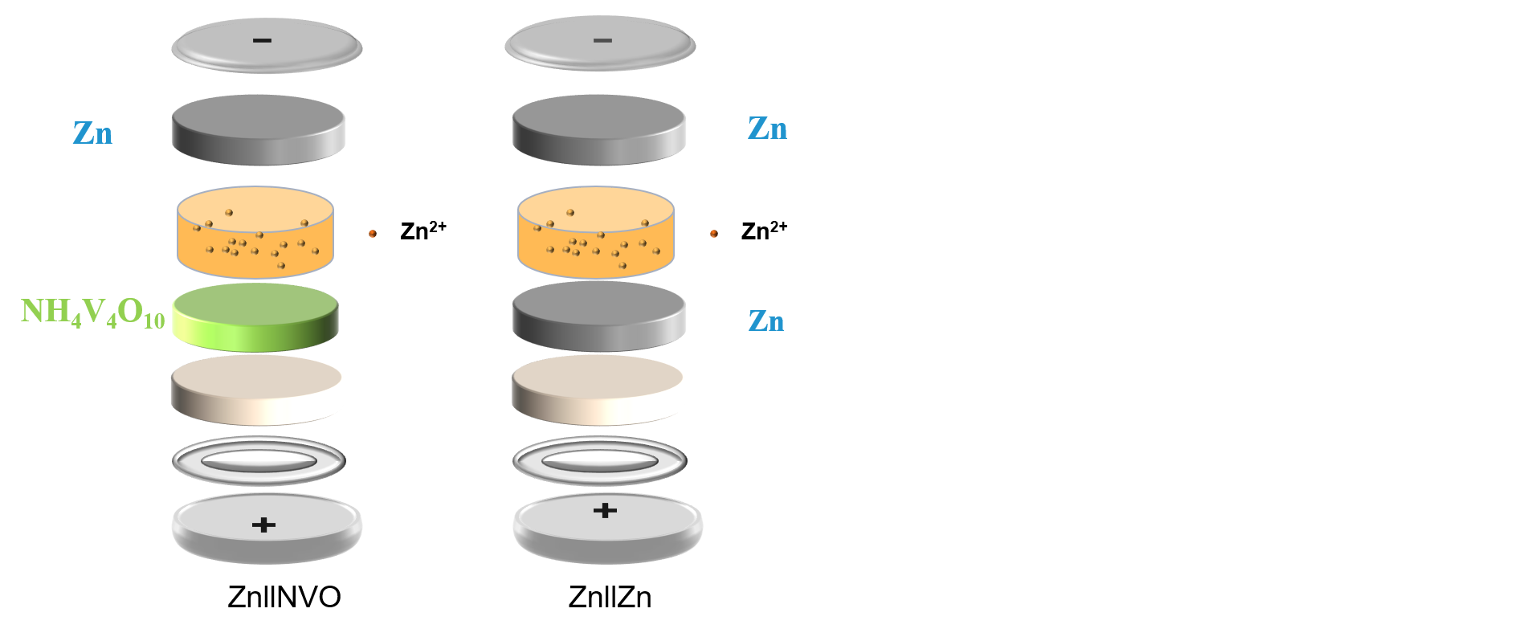
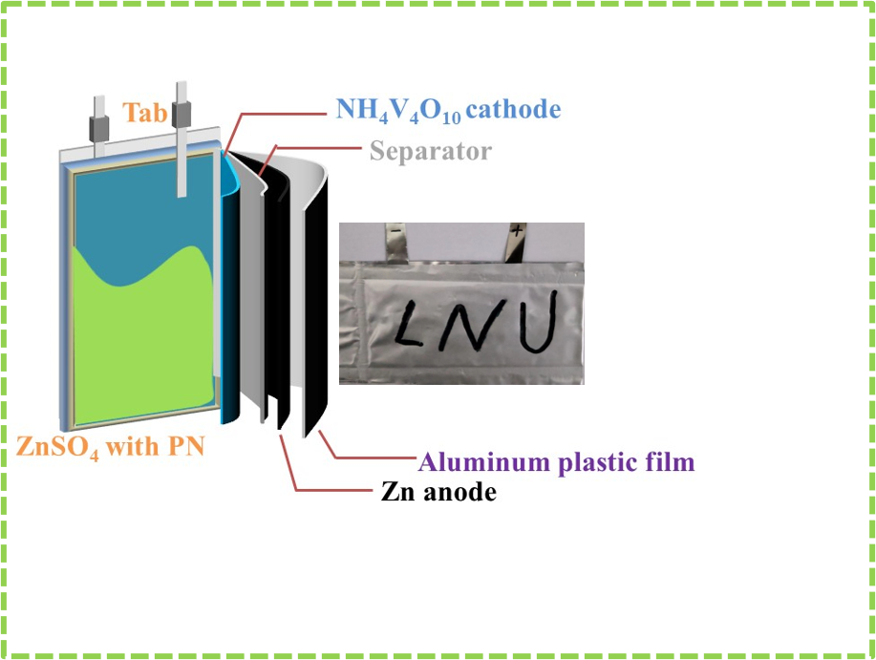
Supplementary Fig. 47 Assembly diagram of pouch cell of Zn Zn||NVO batteries and self-packed pouch cell utilized to power electrical appliances.

2 Supplementary Equations
The wetting free energy of different electrolytes was calculated by the equation based on Extrand’s simple model which is as follows¹.
∆G=$\frac{RT}{3}ln\frac{{\left(1-\cos{θ}\right)}^{2}(2+\cos{θ})}{4}$ (Equation 1 )
Where R, T, and θ stand for the ideal gas constant (8.314 J mol^{–1}K^{–1}), absolute temperature (K), and contact angle (°), respectively.
The formula for calculating the capacitance value of the electric double layer is as follows²:
$C_{s}=\frac{4\int{I\left(V\right)dV}}{Sv∆V}$(Equation 2)
Where Cs is the electric double layer capacitance (mF cm^{–1}), $\int{I(V)dV}$ is the CV curve integral area, S is the effective electrode area (cm^{–2}), v is the scanning rate (V S^{–1}), ∆V is the scanning voltage window (V).
Existing studies have shown that there is a correlation between the size, shape, and surface density of Zn nucleation and the current density, which is consistent with classical nucleation theory³. The Gibbs energy follows the equation 3:
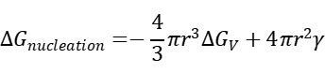
(Equation 3)

Where ΔG_{V} is the change in free energy per volume, γ is the surface energy at the electrode/electrolyte interface, and η is the nucleation overpotential, the relationship between ΔG_{V} and η follows the equation 4:
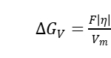
(Equation 4)

Where F is Faraday's constant and V_{m} is the molar volume of Zn atoms, therefore, the critical radius of Zn nucleation r_{crit} follows the equation 5:
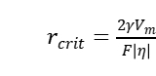
(Equation 5)
The equation shows that the relationship between Zn core size and surface density and nucleation overpotential follows r_{crit}∝η^{–1} and N∝η³ (N: zinc core areal density).
The Zn²⁺ transference number (𝑡_{𝑍𝑛}²⁺) was obtained according to following equation ⁴.
𝑡_{𝑍𝑛}²⁺ =$\frac{I_{s(∆V-I_{0}R_{0})}}{I_{0(∆V-I_{s}R_{s})}}$ (Equation 6)
Where ∆V was the applied voltage (50 mV) in the CA test, 𝐼₀, 𝐼_{𝑠} and𝑅₀, 𝑅_{𝑠} represented initial (steady) current density and charge transfer resistance before and after polarization test, respectively.

3 Supplementary Tables
Supplementary Table 1 PH values and ion conductivity (25 ℃) of electrolytes in different PN concentrations.
PN concentration  (g L⁻¹) | PH | Ion conductivity  (mS cm⁻¹)
0 | 3.39 | 53.2
0.5 | 3.15 | 53.5
1 | 3.12 | 53.4
1.5 | 3.06 | 53.7
2 | 3.04 | 53.4
Supplementary Table 2 Calculated wetting free energy according to contact angles of ZS and ZSPN.
Time  (min) | ZS | ZSPN
0 | 0.84446 | 1.74764
3 | 1.10249 | 2.06682
6 | 1.33802 | 2.46646
9 | 1.51146 | 2.76676
Supplementary Table 3 Surface roughness information of zinc sheet detached from Zn||Zn symmetrical batteries.
 | Sa(μm) | Sq(μm) | Sz(μm)
Fresh Zn | 0.459 | 0.574 | 4.688
ZS | 18.753 | 21.520 | 96.986
ZSPN | 3.354 | 4.701 | 56.583
Note: Sa represents the arithmetic average of the absolute value of the height of each point in the defined area, Sq represents the root mean square value of the height coordinate value in the defined area, and Sz is the sum of the maximum peak height and maximum valley depth in the defined area.
Supplementary Table 4 Real time pH values in different electrolytes.
Time  (min) | ZS | ZSPN
0 | 3.77 | 3.57
10 | 3.86 | 3.67
20 | 4.03 | 3.68
30 | 4.14 | 3.70
40 | 4.24 | 3.72
50 | 4.33 | 3.75
60 | 4.41 | 3.78
Supplementary Table 5 Electrochemical performance comparison of electrolyte additives in zinc-ion symmetric cell.
additives | Current density (mA cm⁻²) | Areal capacity (mAh cm⁻²) | Cycling life (h) | Cumulative capacity  (mAh cm⁻²) | Ref
PN | 1  5  40 | 1  4  2 | 7000  2500  156 | 3500  6250  3120 | This work.
TW20 | 1  5 | 1  5 | 2500  500 | 1250  1250 | ⁷
TPPS | 1 | 1 | 2300 | 1150 | ⁸
Py | 10 | 10 | 100 | 500 | ⁹
SDBS | 0.5 | 0.5 | 600 | 150 | ¹⁰
Zn(H₂PO₄)₂ | 1  1 | 1  5 | 1200  800 | 600  400 | ¹¹
DMSO | 0.5  10 | 0.5  0.5 | 1000  6 | 250  30 | ¹²
NMP | 1  5 | 1  5 | 540  195 | 270  487.5 | ¹³

References
1. Extrand, C. W. A Thermodynamic model for wetting free energies from contact angles. Langmuir 19, 646-649 (2003).
2. Wang, B. et al. Synergistic solvation and interface regulations of eco‐friendly silk peptide additive enabling stable aqueous zinc‐ion batteries. Adv. Funct. Mater. 32 (2022).
3. Pei, A., Zheng, G., Shi, F., Li, Y. & Cui, Y. Nanoscale nucleation and growth of electrodeposited lithium metal. Nano Letters 17, 1132-1139 (2017).
4. Li, D. et al. Self-assembled multilayers direct a buffer interphase for long-life aqueous zinc-ion batteries. Energy Environ. Sci. 16, 3381-3390 (2023).
5. Sohal, P., Banipal, T. S. & Banipal, P. K. Exploration of interactions between pyridoxine HCl (vitamin B6) and {hexadecyltrimethylammonium bromide + sodium cholate (trihydroxy bile salt)} mixtures at T = (298.15 to 318.15) K: physicochemical and spectroscopic approach. J. Chem. Eng. Data 66, 2991-3002 (2021).
6. Wang, P. et al. Spontaneous construction of nucleophilic carbonyl-containing interphase toward ultrastable zinc-metal anodes. Adv. Mater. 34, e2202733 (2022).
7. Deng, Q. et al. Polymer molecules adsorption-induced zincophilic-hydrophobic protective layer enables highly stable Zn metal anodes.Adv. Mater. 36, 2312924 (2024).
8. Zhao, X. et al. Tetraphenylporphyrin‐based chelating ligand additive as a molecular sieving interfacial barrier toward durable aqueous zinc metal batteries. Angew. Chem. Int. Ed. 62 (2023).
9. Luo, J. et al. Regulating the inner helmholtz plane with a high donor additive for efficient anode reversibility in aqueous Zn-ion batteries. Angew. Chem. Int. Ed. 62, e202302302 (2023).
10. Yang, X. et al. Anion additive integrated electric double layer and solvation shell for aqueous zinc ion battery. Small Methods (2023).
11. Zeng, X. et al. Electrolyte design for in situ construction of highly Zn²⁺ -conductive solid electrolyte interphase to enable high-performance aqueous Zn-ion batteries under practical conditions. Adv. Mater. 33, e2007416 (2021).
12. Cao, L. et al. Solvation structure dsign for aqueous Zn metal batteries. J. Am. Chem. Soc. 142, 21404-21409 (2020).
13. Li, T. C. et al. A universal additive strategy to reshape electrolyte solvation structure toward reversible Zn storage. Adv. Energy Mater. 12 (2022).

