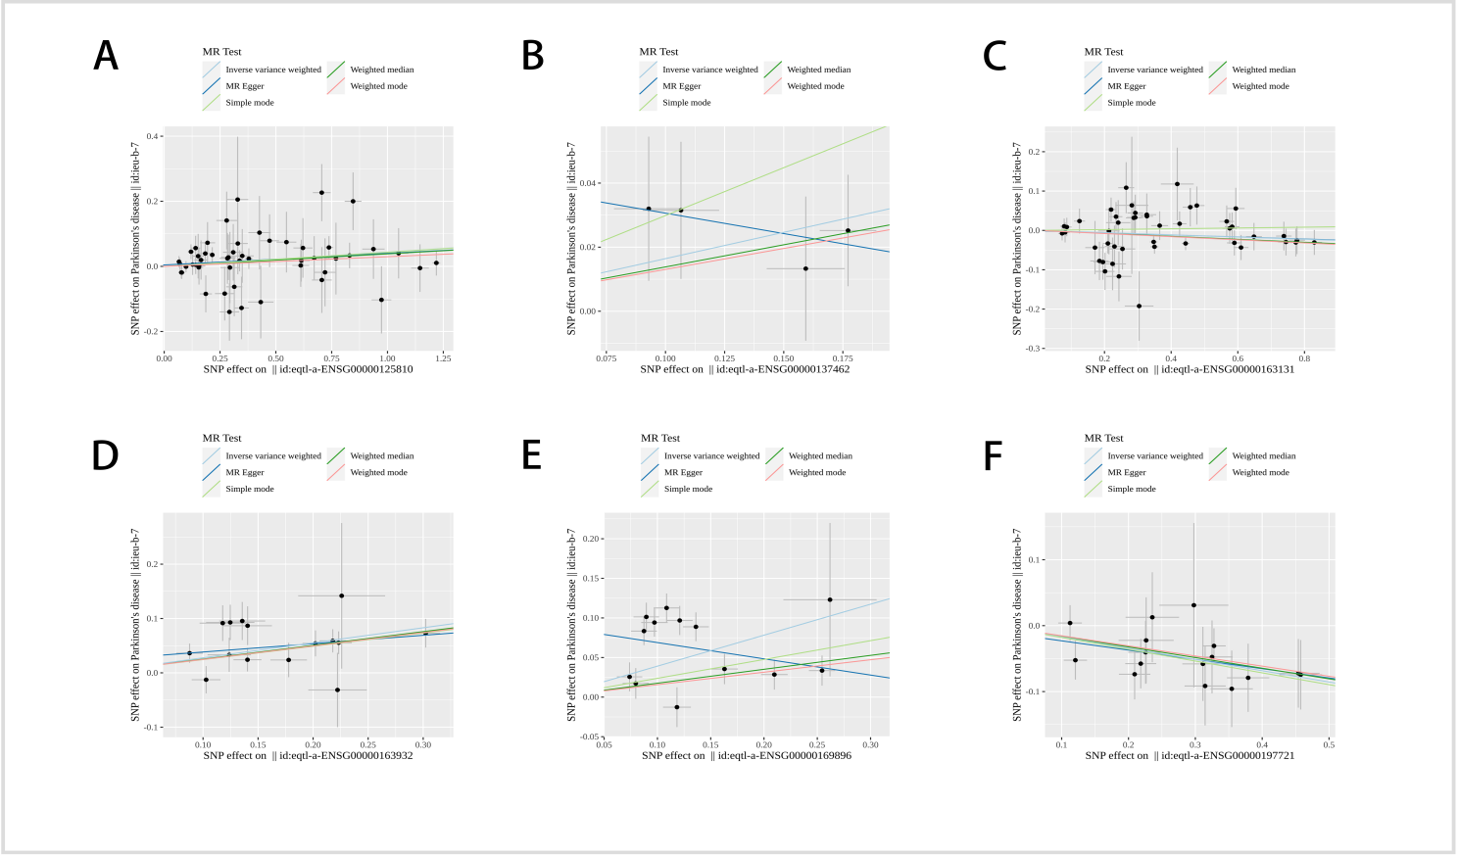
Supplementary Figures 1 Scatter plots of causality for six candidate exposure factors. A Scatter plot of MR analysis for CD93. B Scatter plot of MR analysis for TLR2. C Scatter plot of MR analysis for CTSS. D Scatter plot of MR analysis for PRKCD. E Scatter plot of MR analysis for ITGAM. F Scatter plot of MR analysis for CR1L.
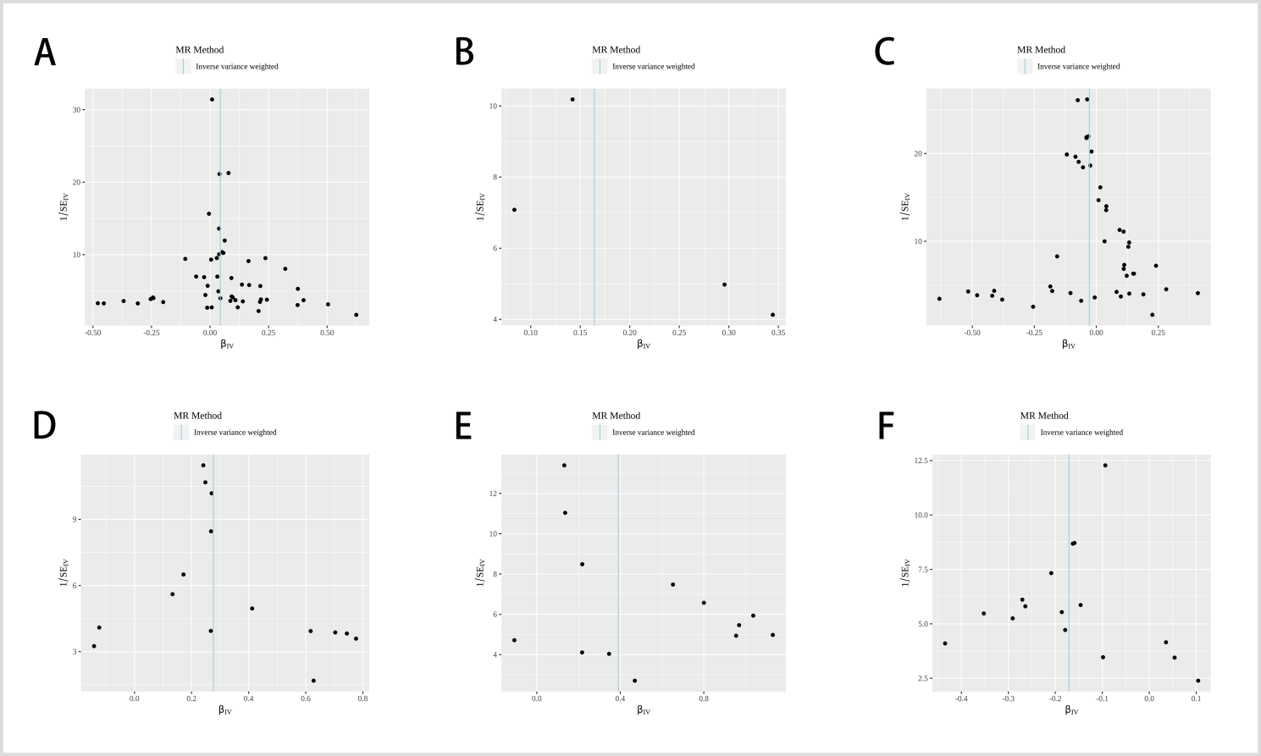
Supplementary Figures 2 Forest plots depicting the estimated MR effect of each IV in IVW models. A Funnel plot
of MR analysis for CD93. B Funnel plot of MR analysis for TLR2. C Funnel plot of MR analysis for CTSS. D
Scatter plot of MR analysis for PRKCD. E Scatter plot of MR analysis for ITGAM. F Funnel plot of MR analysis for
CR1L.
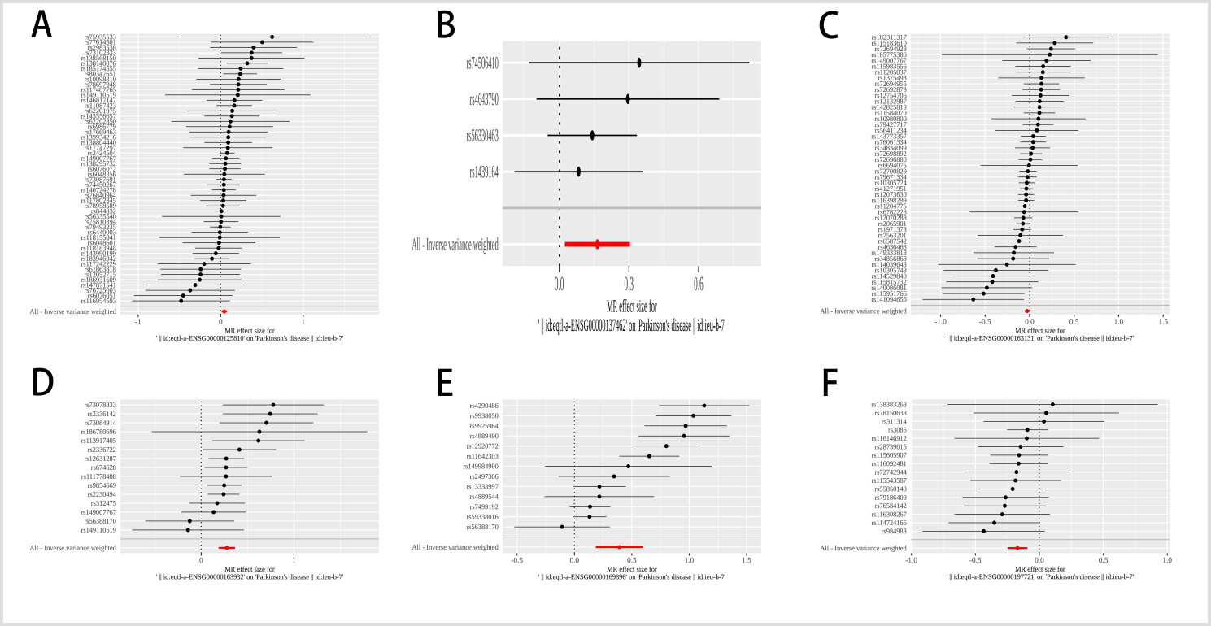
Supplementary Figures 3 Forest map of MR analysis for different exposure factors. A Forest map of MR
analysis for CD93. B Forest map of MR analysis for TLR2. C Forest map of MR analysis for CTSS. D Forest
map of MR analysis for PRKCD. E Forest map of MR analysis for ITGAM. F Forest map of MR analysis for
CR1L.
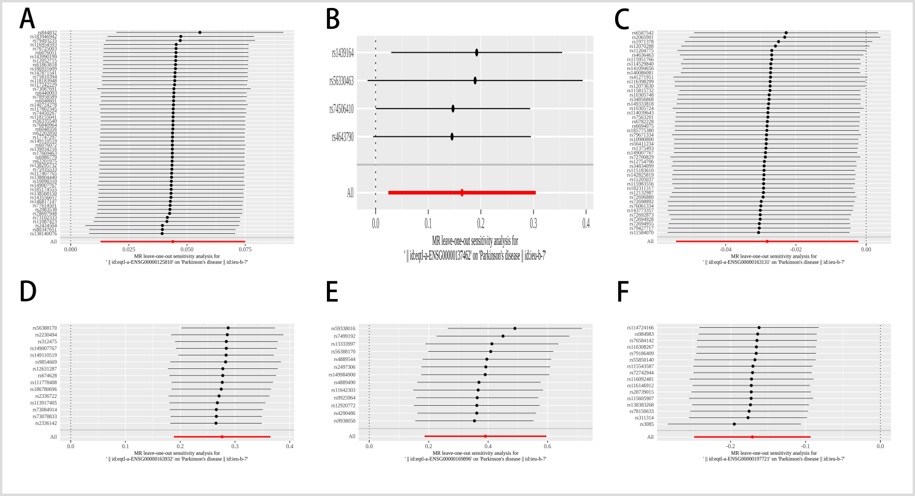
Supplementary Figure 4 MR leave-and-out sensitivity analysis. A Forest map of CD93. B Forest map of TLR2. C Forest map of CTSS. D Forest map of PRKCD. E Forest map of ITGAM. F Forest map of CR1L.

Supplementary Table 1 Information of the PD patients
 | Case 1 | Case 2 | Case 3 | Case 4 | Case 5
SeX | Female | Male | Female | Female | Male
Age | 63 | 65 | 61 | 63 | 63
Years of diagnosis | 3.5 | 3 | 3.5 | 4 | 4.5
Treatment of PD | Metoba; pramipexole | Metoba; pramipexole | Metoba; pramipexole | Metoba; pramipexole | Metoba; pramipexole
Comorbid diseases | No | No | No | No | No
Smoking | No | No | No | No | No
Alcoholism | No | No | No | No | No
Cognitive impairment | No | No | No | No | No

