Foraging flexibility in response to at-sea constraints in a deep diver, the king penguin (Aptenodytes patagonicus): an experimental study

Supplementary Material
S1. Treatment groups composition
Text S1.1
Breeding pairs were randomly assigned to the two treatment groups towards the end of the incubation period to ensure that all birds were captured at least once (marked and measured). The number of individual birds in each group (as well as the number of breeding pairs) is presented in Table S1.1. Some birds were assigned a group during incubation but could not be equipped during brooding because of breeding failure prior to equipment. Consistency in breeding adults’ conditions between the groups was verified using Structural size and Body condition of the birds at the first capture (incubation). Structural size is defined as the first principal component (PC1) of a PCA accounting for beak and culmen lengths and both flipper lengths (in mm). Body condition is defined as the residuals of the regression between body girth (in mm, considered a good proxy of adults' body weight; Viblanc et al., 2012) and structural size, it is therefore the value of body weight that is not explained by the size of the individual. Because body girth measurements showed great variation between the two years, regressions were performed on the two years separately (see Table S1.2).
Overall, there was no significant differences in terms of structural size or body condition between treatment groups in both years. However, males showed increased structural size but markedly decreased body condition at first capture (see Table S1.3 and S1.4). Males are known to be slightly taller than females (despite no marked sexual dimorphism in this species). Male poor body condition at first capture is explained by the breeding cycle of the species, as male take over the first incubation shift after about a month of courtship and mating while fasting, their body reserves are lower than females when they come back from see to take over the second incubation shift.
Table S1.1. Number of individuals (and of different pairs) in each treatment group (Control/Treated) in each year (2019/2022). “Assigned” designates the number of breeding adults (and pairs) that were monitored during incubation and assigned to a treatment group, “Equipped” the number of breeding adults (and pairs) that were successfully equipped with a logger according to their group and “Successful” the number of breeding adults (and pairs) for which foraging data were successfully recorded and integrated in the study.
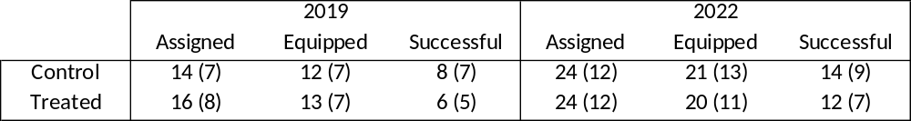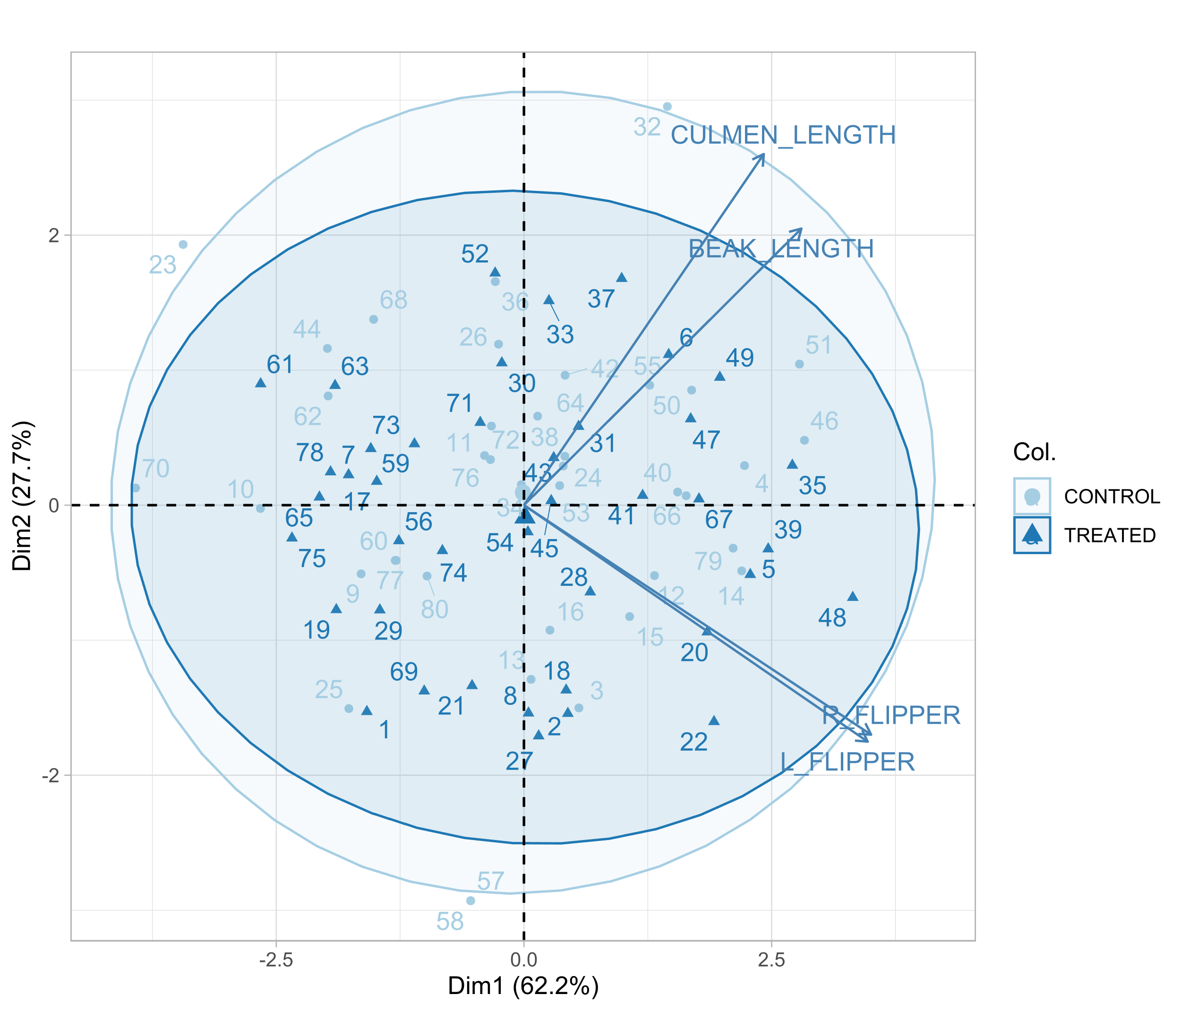
Figure S1. Principal Component Analysis for the structural size (PC1) of adult birds (male and female) of the two treatment groups. Structural size is computed via the measurement of beak and culmen and both flipper lengths (in mm).
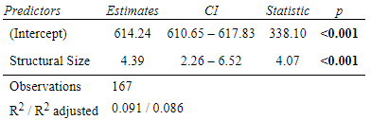
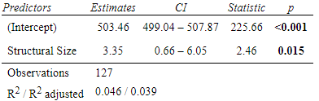
Table S1.2. Linear Model (LM) parameter estimates for the regression between body girth and structural size of breeding adults in 2019 (left) and 2022 (right).
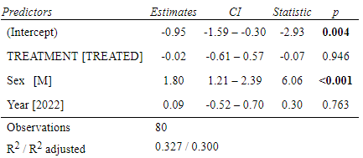
Table S1.3. Linear Model (LM) parameter estimates for the comparison of adults’ structural size between control and treatment groups. Reference groups are “control” for Treatment, “female” for Sex, and “2019” for Year.
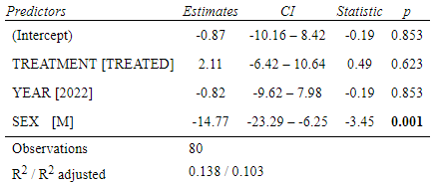
Table S1.4. Linear Model (LM) parameter estimates for the comparison of adults’ body condition between control and treatment groups. Reference groups are “control” for Treatment, “female” for Sex, and “2019” for Year.
S2. Monitoring and equipment period
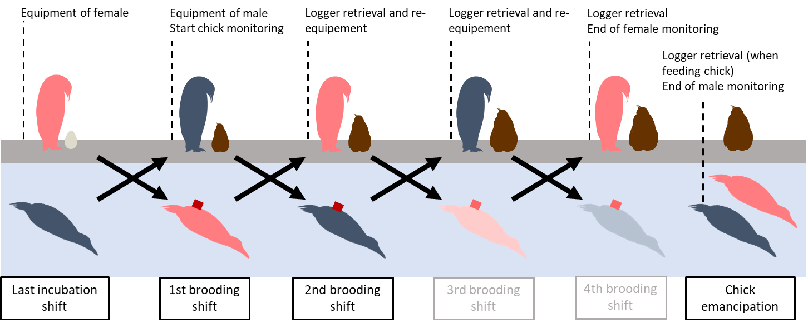
Figure S2. Schematic view of the equipment period (chick brooding). Both 3rd and 4th brooding shift were not presented in this study because of insufficient data retrieved from deployed loggers, parents were however equipped according to their group (treated/control) over the entire monitoring period. Last loggers (after emancipation) were opportunistically retrieved when parent was on land to feed the chick. For most of the monitored pairs, the last incubation shift was carried out by the female, but for some pairs the brooding shifts are inverted.

S3. Diving depth categorization
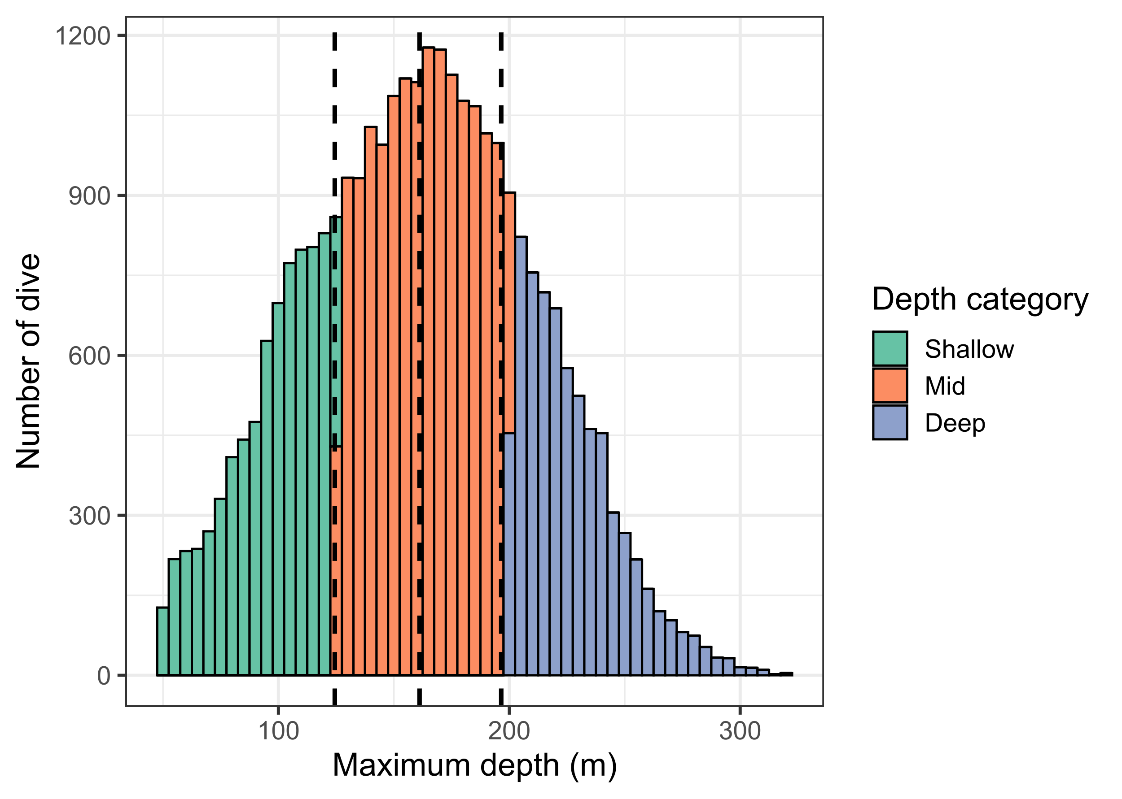
Figure S3 Distribution of the maximum depth reached when diving (for dives >50m). Dashed lines represent the 0.25, mean and 0.75 quantile respectively. The color represents in which depth category the dives are classified.

S4. Model summaries for diving parameters

Table S4.1. Model summaries for the diving parameters for Shallow foraging dives (<125m). Both fixed and random effects are presented. Statistics (t or z) depend on the type of model (Linear Mixed Model and Generalized Linear Mixed Model with Poisson distribution for post dive duration and number of wiggles). Reference groups are “control” for Treatment, “female” for Sex, and “2019” for Year.
 |  | est | se | df | t (or z) | p
Dive duration | Intercept | -0.24 | 0.12 | 35.11 | -2.00 | 0.053
Dive duration | Treatment [TREATED] | 0.09 | 0.12 | 24.02 | 0.73 | 0.474
Dive duration | Year [2022] | 0.15 | 0.12 | 25.76 | 1.23 | 0.232
Dive duration | Sexe [Male] | 0.48 | 0.08 | 12.35 | 6.21 | <0.001
Dive duration | Random | ID : Pair ID | 3.1%
Dive duration |  | Pair ID | 7.8%
Post dive duration | Intercept | 4.96 | 0.10 |  | 47.25 | <0.001
Post dive duration | Treatment [TREATED] | -0.21 | 0.09 |  | -2.43 | 0.015
Post dive duration | Year [2022] | 0.11 | 0.09 |  | 1.25 | 0.213
Post dive duration | Sexe [Male] | -0.19 | 0.09 |  | -2.14 | 0.032
Post dive duration | Random | ID | 87.5%
Bottom duration | Intercept | -0.01 | 0.10 | 31.80 | -0.07 | 0.946
Bottom duration | Treatment [TREATED] | -0.01 | 0.08 | 24.33 | -0.15 | 0.880
Bottom duration | Year [2022] | -0.03 | 0.09 | 29.27 | -0.39 | 0.703
Bottom duration | Sexe [Male] | 0.06 | 0.08 | 22.99 | 0.78 | 0.441
Bottom duration | Random | ID : Pair ID | 4.7%
Bottom duration |  | Pair ID | 0.7%
Diving efficiency | Intercept | -0.01 | 0.09 | 31.19 | -0.08 | 0.939
Diving efficiency | Treatment [TREATED] | 0.03 | 0.08 | 24.90 | 0.38 | 0.709
Diving efficiency | Year [2022] | -0.07 | 0.08 | 28.45 | -0.89 | 0.380
Diving efficiency | Sexe [Male] | 0.003 | 0.07 | 20.30 | 0.05 | 0.963
Diving efficiency | Random | ID : Pair ID | 3.2%
Diving efficiency |  | Pair ID | 1.5%
Number of Wiggles | Intercept | 1.34 | 0.09 |  | 14.87 | <0.001
Number of Wiggles | Treatment [TREATED] | -0.05 | 0.08 |  | -0.60 | 0.550
Number of Wiggles | Year [2022] | -0.16 | 0.08 |  | -1.98 | 0.048
Number of Wiggles | Sexe [Male] | -0.12 | 0.07 |  | -1.62 | 0.105
Number of Wiggles | Random | ID : Pair ID | 15.2%
Number of Wiggles |  | Pair ID | 3.0%
Descent rate | Intercept | 0.32 | 0.11 | 35.15 | 2.88 | 0.007
Descent rate | Treatment [TREATED] | -0.03 | 0.11 | 23.17 | -0.28 | 0.784
Descent rate | Year [2022] | -0.32 | 0.11 | 25.37 | -2.89 | 0.008
Descent rate | Sexe [Male] | -0.36 | 0.07 | 10.87 | -4.78 | <0.001
Descent rate | Random | ID : Pair ID | 2.8%
Descent rate |  | Pair ID | 5.9%
Ascent rate | Intercept | 0.34 | 0.13 | 35.69 | 2.57 | 0.014
Ascent rate | Treatment [TREATED] | -0.08 | 0.12 | 26.08 | -0.65 | 0.523
Ascent rate | Year [2022] | -0.37 | 0.13 | 29.39 | -2.99 | 0.006
Ascent rate | Sexe [Male] | -0.40 | 0.10 | 18.57 | -4.02 | <0.001
Ascent rate | Random | ID : Pair ID | 6.7%
Ascent rate |  | Pair ID | 5.3%

Table S4.2. Model summaries for the diving parameters for Mid foraging dives (between 125 and 200 m). Both fixed and random effects are presented. Statistics (t or z) depend on the type of model (Linear Mixed Model and Generalized Linear Mixed Model with Poisson distribution for post dive duration and number of wiggles). Reference groups are “control” for Treatment, “female” for Sex, and “2019” for Year.
 |  | est | se | df | t (or z) | p
Dive duration | Intercept | -0.45 | 0.13 | 35.63 | -3.47 | 0.001
Dive duration | Treatment [TREATED] | 0.09 | 0.13 | 27.84 | 0.66 | 0.515
Dive duration | Year [2022] | 0.22 | 0.13 | 28.94 | 1.63 | 0.114
Dive duration | Sexe [Male] | 0.54 | 0.08 | 16.01 | 6.69 | <0.001
Dive duration | Random | ID : Pair ID | 3.9%
Dive duration |  | Pair ID | 9.7%
Post dive duration | Intercept | 4.86 | 0.09 |  | 55.96 | <0.001
Post dive duration | Treatment [TREATED] | -0.08 | 0.07 |  | -1.09 | 0.274
Post dive duration | Year [2022] | 0.20 | 0.07 |  | 2.63 | 0.008
Post dive duration | Sexe [Male] | -0.15 | 0.07 |  | -2.11 | 0.035
Post dive duration | Random | ID | 83.3%
Bottom duration | Intercept | -0.09 | 0.10 | 35.29 | -0.84 | 0.406
Bottom duration | Treatment [TREATED] | -0.16 | 0.08 | 35.41 | -1.93 | 0.062
Bottom duration | Year [2022] | 0.13 | 0.09 | 35.59 | 1.48 | 0.148
Bottom duration | Sexe [Male] | 0.19 | 0.09 | 35.48 | 2.23 | 0.032
Bottom duration | Random | ID | 6.3%
Diving efficiency | Intercept | -0.01 | 0.09 | 35.60 | -0.07 | 0.944
Diving efficiency | Treatment [TREATED] | -0.14 | 0.07 | 35.75 | -1.89 | 0.066
Diving efficiency | Year [2022] | 0.02 | 0.08 | 35.98 | 0.30 | 0.766
Diving efficiency | Sexe [Male] | 0.12 | 0.07 | 35.83 | 1.66 | 0.106
Diving efficiency | Random | ID | 4.9%
Number of Wiggles | Intercept | 1.07 | 0.06 |  | 16.46 | <0.001
Number of Wiggles | Treatment [TREATED] | -0.16 | 0.05 |  | -2.95 | 0.003
Number of Wiggles | Year [2022] | 0.06 | 0.06 |  | 1.01 | 0.312
Number of Wiggles | Sexe [Male] | 0.02 | 0.05 |  | 0.30 | 0.768
Number of Wiggles | Random | ID | 9.1%
Descent rate | Intercept | 0.18 | 0.11 | 34.79 | 1.63 | 0.113
Descent rate | Treatment [TREATED] | -0.27 | 0.11 | 24.35 | -2.45 | 0.022
Descent rate | Year [2022] | 0.04 | 0.11 | 25.75 | 0.35 | 0.733
Descent rate | Sexe [Male] | -0.11 | 0.07 | 11.76 | -1.67 | 0.122
Descent rate | Random | ID : Pair ID | 2.6%
Descent rate |  | Pair ID | 6.4%
Ascent rate | Intercept | 0.22 | 0.11 | 35.68 | 2.01 | 0.052
Ascent rate | Treatment [TREATED] | -0.39 | 0.11 | 27.40 | -3.59 | 0.001
Ascent rate | Year [2022] | 0.06 | 0.11 | 29.17 | 0.54 | 0.591
Ascent rate | Sexe [Male] | -0.12 | 0.08 | 16.56 | -1.64 | 0.119
Ascent rate | Random | ID : Pair ID | 3.7%
Ascent rate |  | Pair ID | 5.7%
Table S4.3. Model summaries for the diving parameters at for Deep foraging dives (> 200 m). Both fixed and random effects are presented. Statistics (t or z) depend on the type of model (Linear Mixed Model and Generalized Linear Mixed Model with Poisson distribution for post dive duration and number of wiggles). Reference groups are “control” for Treatment, “female” for Sex, and “2019” for Year.
 |  | est | se | df | t (or z) | p
Dive duration | Intercept | -0.52 | 0.17 | 37.10 | -3.09 | 0.004
Dive duration | Treatment [TREATED] | 0.05 | 0.15 | 26.11 | 0.34 | 0.740
Dive duration | Year [2022] | 0.11 | 0.15 | 31.57 | 0.68 | 0.503
Dive duration | Sexe [Male] | 0.41 | 0.13 | 20.18 | 3.13 | 0.005
Dive duration | Random | ID : Pair ID | 11.9%
Dive duration |  | Pair ID | 5.8%
Post dive duration | Intercept | 4.92 | 0.09 |  | 57.62 | <0.001
Post dive duration | Treatment [TREATED] | -0.13 | 0.07 |  | -1.83 | 0.068
Post dive duration | Year [2022] | 0.30 | 0.07 |  | 4.09 | <0.001
Post dive duration | Sexe [Male] | -0.16 | 0.07 |  | -2.22 | 0.026
Post dive duration | Random | ID | 83.3%
Bottom duration | Intercept | -0.11 | 0.10 | 32.47 | -1.09 | 0.284
Bottom duration | Treatment [TREATED] | -0.16 | 0.08 | 29.94 | -2.14 | 0.041
Bottom duration | Year [2022] | 0.04 | 0.08 | 31.92 | 0.48 | 0.635
Bottom duration | Sexe [Male] | 0.16 | 0.08 | 30.00 | 2.01 | 0.053
Bottom duration | Random | ID | 4.5%
Diving efficiency | Intercept | -0.17 | 0.10 | 33.16 | -1.76 | 0.088
Diving efficiency | Treatment [TREATED] | -0.19 | 0.08 | 30.59 | -2.42 | 0.022
Diving efficiency | Year [2022] | 0.11 | 0.08 | 32.59 | 1.25 | 0.220
Diving efficiency | Sexe [Male] | 0.18 | 0.08 | 30.66 | 2.26 | 0.031
Diving efficiency | Random | ID | 4.7%
Number of Wiggles | Intercept | 0.65 | 0.09 |  | 7.33 | <0.001
Number of Wiggles | Treatment [TREATED] | -0.19 | 0.07 |  | -2.65 | 0.008
Number of Wiggles | Year [2022] | 0.15 | 0.08 |  | 2.03 | 0.042
Number of Wiggles | Sexe [Male] | 0.13 | 0.07 |  | 1.76 | 0.079
Number of Wiggles | Random | ID | 9.5%
Descent rate | Intercept | 0.22 | 0.16 | 37.46 | 1.36 | 0.182
Descent rate | Treatment [TREATED] | -0.36 | 0.15 | 26.94 | -2.33 | 0.028
Descent rate | Year [2022] | 0.07 | 0.16 | 30.81 | 0.44 | 0.662
Descent rate | Sexe [Male] | -0.16 | 0.12 | 16.18 | -1.35 | 0.195
Descent rate | Random | ID : Pair ID | 8.7%
Descent rate |  | Pair ID | 8.7%
Ascent rate | Intercept | 0.09 | 0.12 | 37.51 | 0.71 | 0.480
Ascent rate | Treatment [TREATED] | -0.54 | 0.12 | 29.48 | -4.64 | <0.001
Ascent rate | Year [2022] | 0.20 | 0.12 | 32.22 | 1.68 | 0.103
Ascent rate | Sexe [Male] | 0.03 | 0.08 | 16.99 | 0.34 | 0.740
Ascent rate | Random | ID : Pair ID | 3.7%
Ascent rate |  | Pair ID | 6.3%

S5. Model summaries for chick body mass and survival.
Table S5.1. Summary of the LMM for chick body mass throughout the chick brooding period (4, 10, 20 and 35 days). Both fixed, interaction and random effects are presented. Reference groups are “control” for Treatment, “day 4” for Stage, and “2019” for Year.
 | est ± se | df | t value | p
(Intercept) | -1.16 ± 0.08 | 88.02 | -15.33 | < 0.001
Year [2022] | -0.16 ± 0.06 | 33.02 | -2.66 | 0.012
Treatment [TREATED] | 0.03 ± 0.09 | 107.16 | 0.28 | 0.778
STAGE [10] | 0.73 ± 0.09 | 86.16 | 8.59 | < 0.001
STAGE [20] | 1.50 ± 0.09 | 87.49 | 17.34 | < 0.001
STAGE [35] | 1.90 ± 0.09 | 88.54 | 21.51 | < 0.001
Treatment [TREATED]:  STAGE [10] | -0.18 ± 0.12 | 86.12 | -1.44 | 0.153
Treatment [TREATED]:  STAGE [20] | -0.38 ± 0.13 | 88.76 | -2.98 | 0.004
Treatment [TREATED]:  STAGE [35] | -0.23 ± 0.14 | 91.68 | -1.70 | 0.093
Random: Chick ID | 15.9%

Table S5.2. Summary of the LMM for chick body mass gain throughout the chick brooding period (4 to 35 days). Reference groups are “control” for Treatment, and “2019” for Year and body mass at day 4 was used as a covariate.
 | est ± se | df | t value | p
Intercept | 47.57 | 18.33 | 2.60 | 0.015
Treatment [TREATED] | -17.05 | 5.40 | -3.16 | 0.004
Year [2022] | -5.60 | 5.62 | -0.99 | 0.327
Body mass at day 4 | 0.05 | 0.06 | 0.82 | 0.419

Table S5.3. Summaries of the COX hazard models for chick survival until the end of the chick brooding period (and experiment) at 35-days post-hatching and at fledging (~300 days). Reference groups are “control” for Treatment and “2019” for Year.
 |  | coef | se(coef) | odds ratio | z | p
35-days | Treatment [TREATED] | 1.11 | 0.84 | 3.05 | 1.33 | 0.184
35-days | Year [2022] | 0.52 | 0.84 | 1.69 | 0.63 | 0.531
Fledging  (~300 days) | Treatment [TREATED] | 0.89 | 0.39 | 2.43 | 2.25 | 0.024
Fledging  (~300 days) | Year [2022] | 0.68 | 0.41 | 1.97 | 1.67 | 0.096

