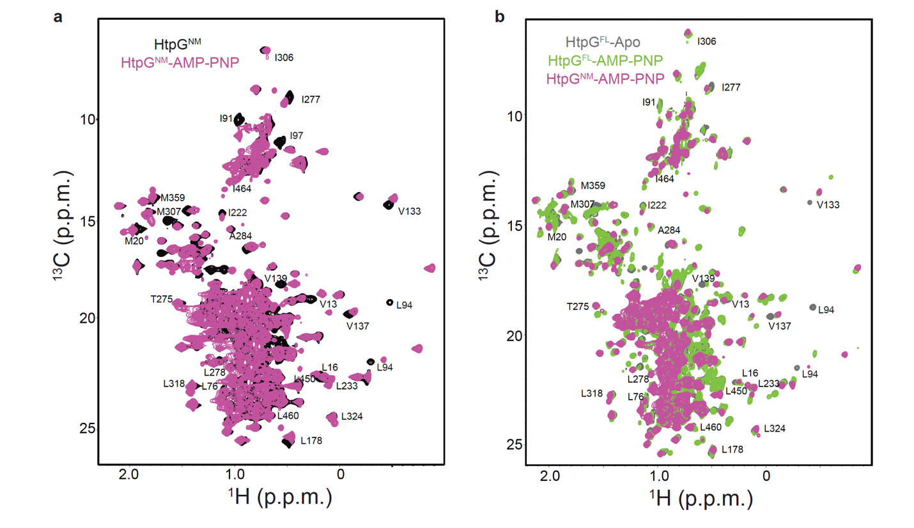
Extended Data Fig. 1: NMR characterizations of HtpG^{NM} and its response to AMPPNP binding.
a, Superimposed methyl-TROSY spectra showing HtpG^{NM} in its apo form (black) and when bound to AMPPNP (pink), highlighting residues with significant chemical shift perturbations upon ligand binding. b, Comparative methyl-TROSY spectra of nucleotide-free HtpG^{FL} (gray), AMPPNP-bound HtpG^{FL} (green), and AMPPNP-bound HtpG^{NM} (pink). Labels identify residues undergoing significant chemical shift perturbations upon AMPPNP binding. Notably, unlike HtpG^{FL}, AMPPNP binding to HtpG^{NM} does not result in signal splitting, underscoring a distinct conformational response in the mutant.

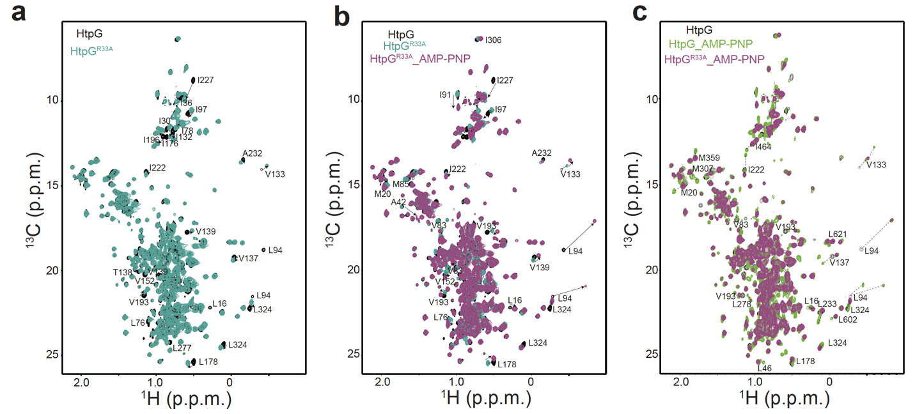
Extended Data Fig. 2: NMR analysis of the HtpG^{R33A} mutant.
a, Superimposed methyl-TROSY spectra comparing wild-type HtpG (black) with the HtpG^{R33A} mutant (greenish-blue), illustrating substantial CSPs induced by the mutation, which underscore its significant impact on HtpG's conformational modulation. b, Comparative methyl-TROSY spectra of wild-type HtpG (black), the HtpG^{R33A} mutant in its nucleotide-free state (greenish-blue), and the AMPPNP-bound HtpG^{R33A} mutant (pink), highlighting the mutation's effects on conformational states upon nucleotide binding. c, Overlaid methyl-TROSY spectra of wild-type HtpG (black), AMPPNP-bound wild-type HtpG (green), and AMPPNP-bound HtpG^{R33A} mutant (pink). Notably, for the arm-closure-impaired HtpG^{R33A} mutant, AMPPNP binding restricts NMR signals predominantly to an intermediate transitional state, demonstrating a stark contrast to the wild type.

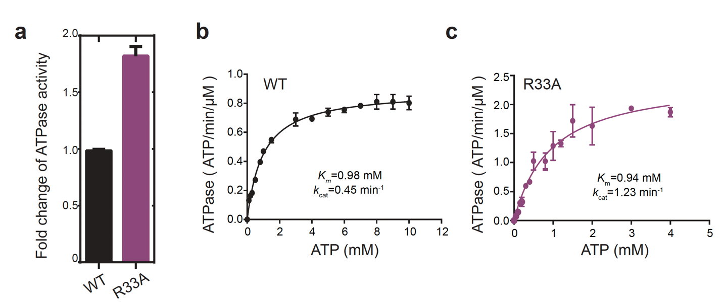
Extended Data Fig. 3: ATPase activity analysis of HtpG and its R33A mutant.
a, Comparative enzymatic activity of HtpG and the R33A mutant measured over a 60-minute reaction at 37 °C with 5 μM enzyme concentration and 0.5 mM ATP. b, Steady-state kinetic analysis of HtpG, conducted under the same assay conditions with 2 μM enzyme concentration and varying ATP concentrations. c, Steady-state kinetic analysis of the HtpG^{R33A} mutant, following the same protocol as panel (b), showcasing the enzymatic kinetics with varied ATP concentrations.

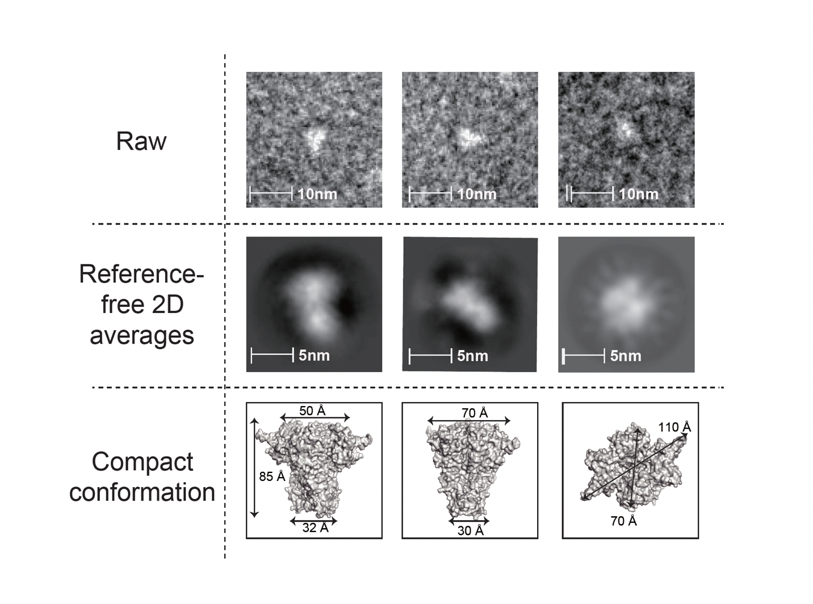
Extended Data Fig. 4: Structural analysis of ADP-Bound HtpG via negative-stain electron microscopy.
a, Representative raw images captured during the analysis. b, Reference-free 2D class averages highlighting the distinct conformations observed. c, Views of the compact conformation of ADP-bound HtpG, derived from EM data analysis¹⁰.

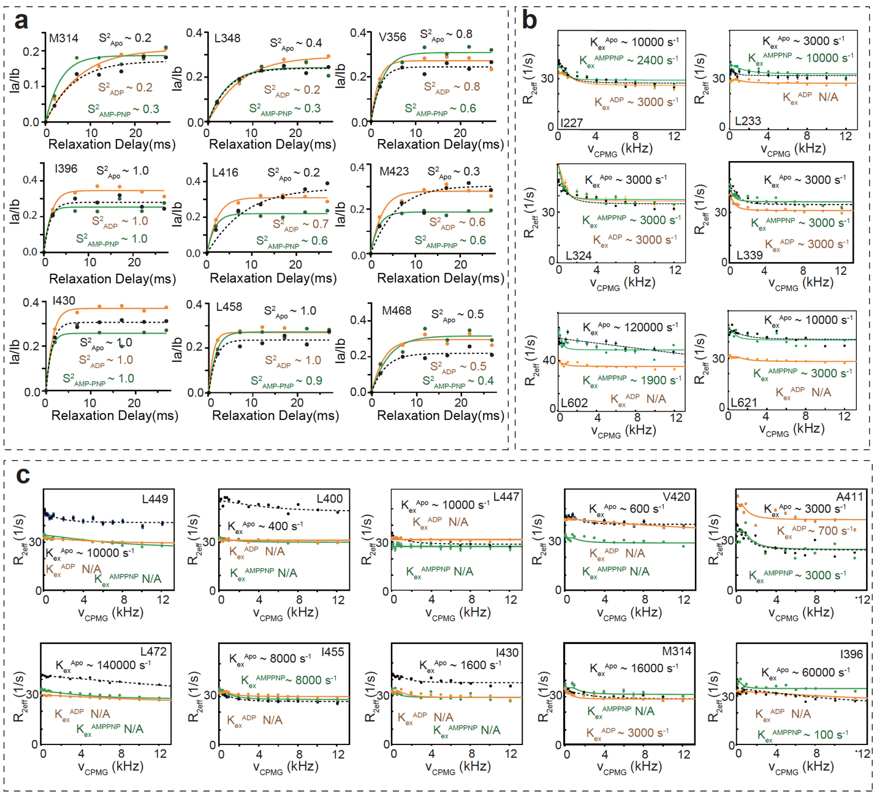
Extended Data Fig. 5. Dynamics of HtpG across different nucleotide states.
a, b, Comparative analysis of dynamic profiles: Order parameter profiles (a) and CPMG relaxation dispersion profiles (b) for selected residues across nucleotide states—nucleotide-free HtpG (black dashed line), ADP-bound HtpG (orange), and AMPPNP-bound HtpG (green). c, CPMG profiles specific to residues near the client-binding grooves in HtpG, across various nucleotide states, using the same color coding as in panels (a) and (b).

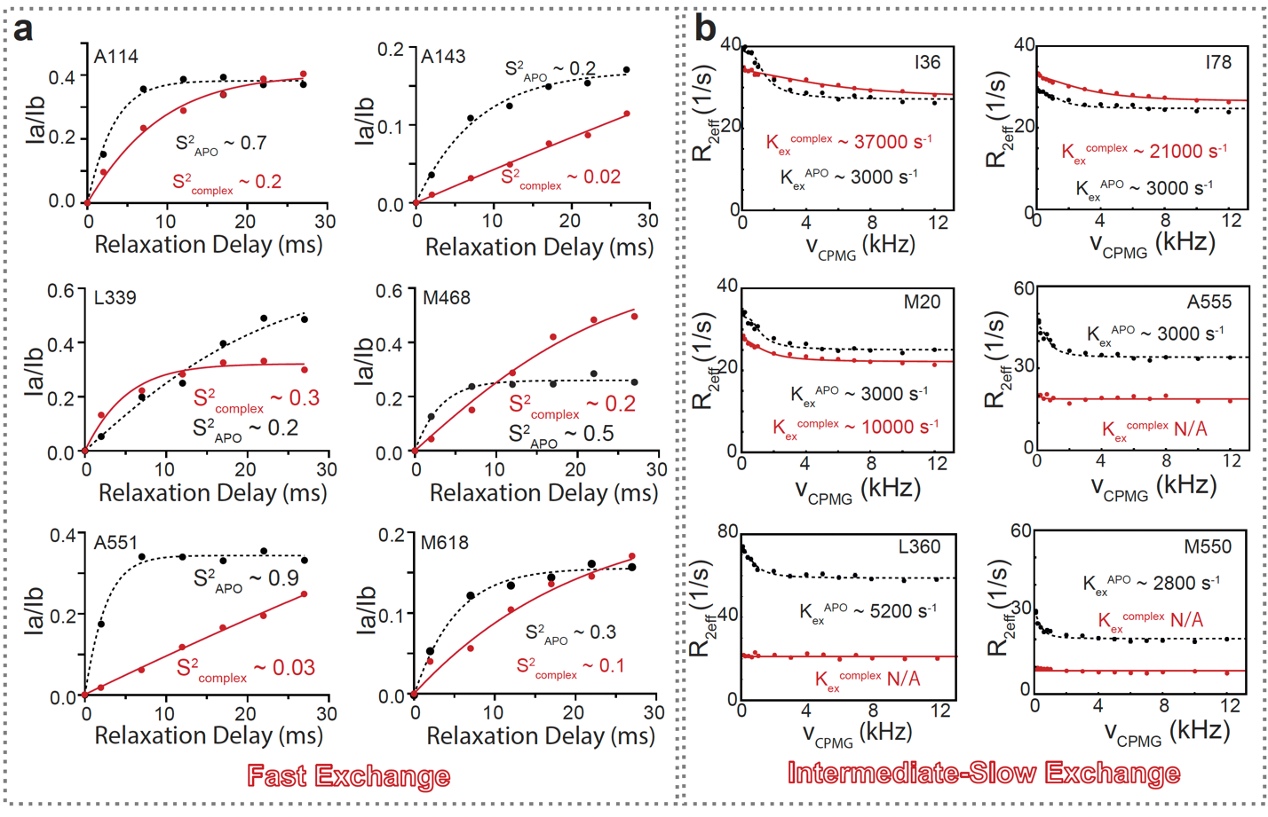
Extended Data Fig. 6. Changes of the dynamics of HtpG upon client binding.
Comparison profiles of order parameters (a) and μs-ms timescale K_{ex} (b) for unliganded HtpG (black dashed line) and HtpG-Δ131Δ complex (red).

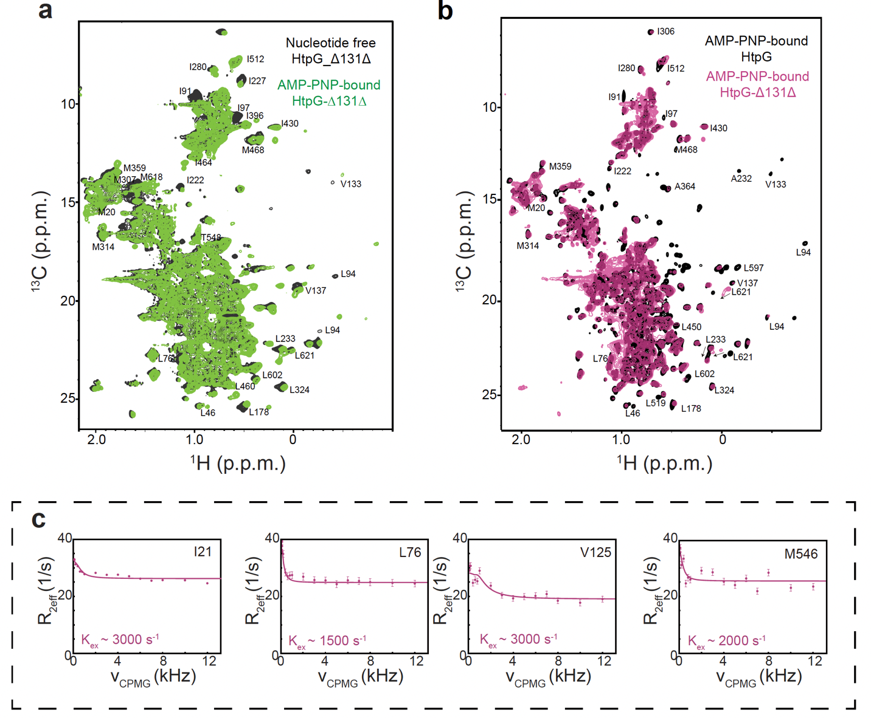
Extended Data Fig. 7. NMR Analysis of HtpG-Δ131Δ Complex with AMPPNP.
This figure presents detailed NMR characterizations comparing different states of the HtpG-Δ131Δ complex: a, Methyl-TROSY spectra overlay comparing the nucleotide-free (black) and AMPPNP-bound (green) states of the HtpG-Δ131Δ complex, illustrating significant chemical shift perturbations. b, Methyl-TROSY spectra comparison between the AMPPNP-bound state of unliganded HtpG (black) and the AMPPNP-bound HtpG-Δ131Δ complex (pink), highlighting differences induced by the presence of the client. c, Representative CPMG profiles for select residues within the HtpG-Δ131Δ complex, demonstrating the dynamics of interaction with the Δ131Δ client.

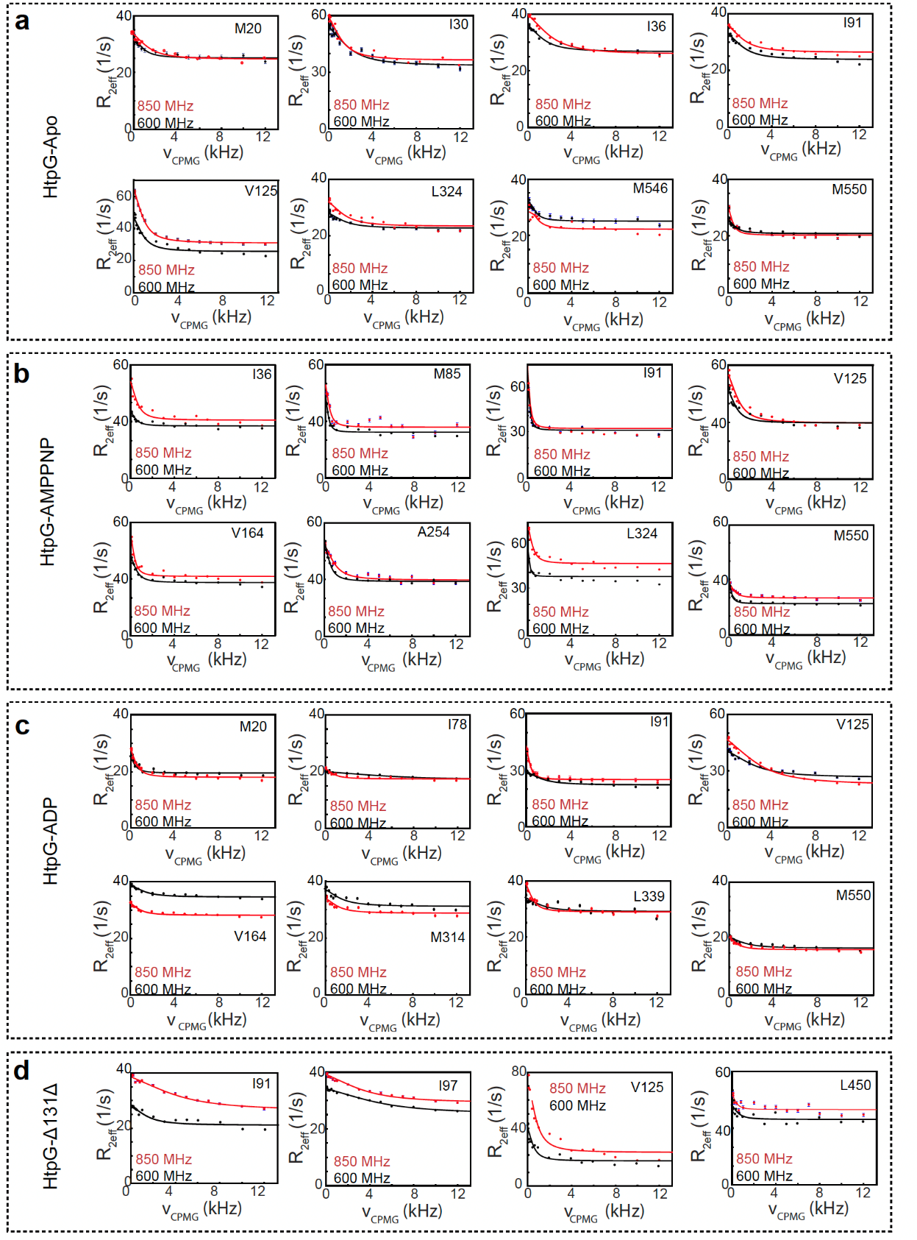
Extended Data Fig. 8 Slow Timescale Conformational Dynamics of HtpG Assessed at Various Magnetic Fields.
a-d, Examples of relaxation dispersion curves for residues exhibiting μs-ms timescale dynamics as measured by ¹³C CPMG relaxation dispersion experiments for the Apo (a), AMPPNP (b), ADP (c) and Δ131Δ (d) bound forms of HtpG.

