Supplementary Figures

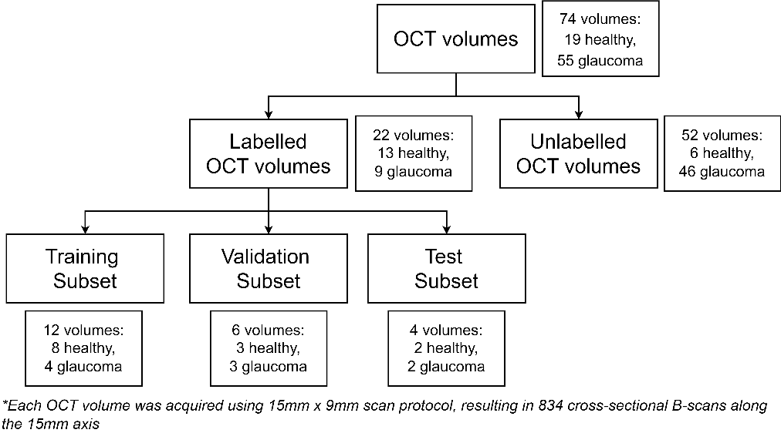
Figure S1: Distribution of the labelled and unlabelled OCT dataset.
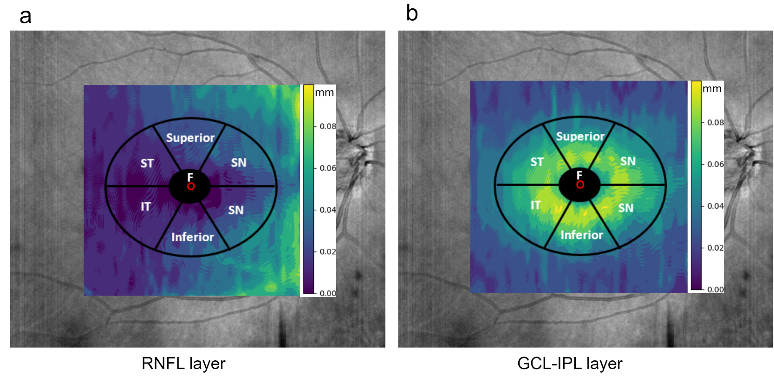
Figure S2: Overlaid thickness maps of the macula with elliptic annulus dimensions on OCT images. Measurements of six areas were performed around the fovea (F) on (a) RNFL and (b) GCL-IPL layers based on [50]. These areas include superior (I), superior-temporal (ST), inferior-temporal (IT), Inferior (II), Inferior-nasal (IN), and superior-nasal (SN).

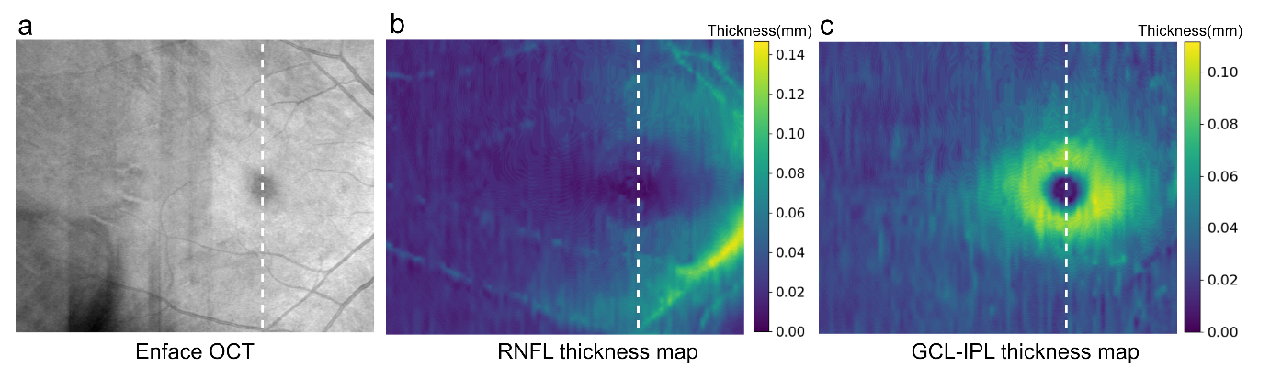
Figure S3: Examples of RNFL and GCL-IPL thickness maps derived from pixel intensity. These maps utilize a color-coding technique, where the intensity of each pixel indicates the thickness of the RNFL and GCL-IPL layers. (a) presents the widefield 15x9 OCT enface image with the optic nerve head region excluded; (b) and (c) depict the RNFL and GCL-IPL thickness maps, respectively. The white dotted line represents the cross-sectional image at the fovea in Figure 3.

