Increased drying threatens alpine pond biodiversity more than temperature increase in a changing climate
Lamouille-Hébert, M.^{1,2,4}, Arthaud, F. ^{3,4}, Besnard, A.⁵, Logez, M¹, Datry, T.¹
¹INRAE, UR RiverLy, Centre Lyon-Grenoble Auvergne-Rhône-Alpes, 5 rue de la Doua CS70077, 69626 Villeurbanne Cedex, France
²FNE Haute-Savoie, 84 route du Viéran, 74370 Pringy
³Univ. Savoie Mont Blanc, INRAE, CARRTEL, 74200, Thonon-les-Bains, France
⁴Pole R&D ECLA, OFB, Direction de la Recherche et de l'Appui Scientifique, Montfort, 01330, Birieux, France
⁵ CEFE, Univ Montpellier, CNRS, EPHE-PSL University, IRD, Montpellier, France

Supplemental material

Table of contents
S1. Specialist Vs Generalist species 2
Figure S2.1. Altitudinal distribution in Switzerland of a set of 16 species frequently observed at high altitude (above 1500m). 2
Figure S2.2. Altitudinal distribution in Auvergne Rhône-Alpes regional of a set of 22 species frequently observed at high altitude (above 1500m). 3
S2. List of the 104 models fitted to analyze the simple and quadratic relation between each scaled covariate and species occupancy probabilities 5
S3. MSOM used script 8
S3.1) Function 8
S3.2) Main script 9
S4. Relation between summer water warming and alpine ponds species (Amphibia, macrophytes and Odonata) occupancy probabilities 17
Figure S4. Relation between summer water warming and alpine ponds species (Amphibia, macrophytes and Odonata) occupancy probabilities (Med temp, Temp max). R 17
S5. Relation between pond network and alpine ponds species (Amphibia, macrophytes and Odonata) occupancy probabilities 18
S5.1 Number of wetlands in different buffers around sampled pond 18
Figure S5.1. Relation between the number of wetlands in different buffers around sampled pond and alpine ponds species (Amphibia, macrophytes and Odonata) occupancy probabilities. R 18
S5.2 Area of wetlands in different buffers around sampled pond 19
Figure S5.2. Relation between area of wetlands in different buffers around sampled pond and alpine ponds species (Amphibia, macrophytes and Odonata) occupancy probabilities. R 19
S5.3 Number and reliable river network and land cover index in different buffers around sampled pond and land cover in different buffers around sampled pond 20
Figure S5.3. Relation between number and reliable river network and land cover in different buffers around sampled pond and alpine ponds species (Amphibia, macrophytes and Odonata) occupancy probabilities.. 20

S1. Specialist Vs Generalist species

Alpine ponds’ specialist species are sensitive to high temperatures (Epele et al., 2022; Lindholm et al., 2015) and are geographically restricted to a small thermal range (Rosset & Oertli, 2011). For Odonata species, in Switzerland, neighboring our study area, their geographical distribution area was well documented by the databases of the Swiss Centre for Fauna Cartography (CSCF). Specialist species being predominant in the upper elevation area (>1500m), it allowed differentiating cold specialist species and generalist species (Oertli, 2010). Aeshna caerulea, Aeshna juncea, Aeshna subarctica, Coenagrion hastulatum, Leucorrhinia dubia, Somatochlora alpestris and Somatochlora arctica were identified like cold specialist species (Fig.S2.1a). The others were generalist (for example Aeshna cyanea and Libellula quadrimaculata) (Fig. S2.1b).
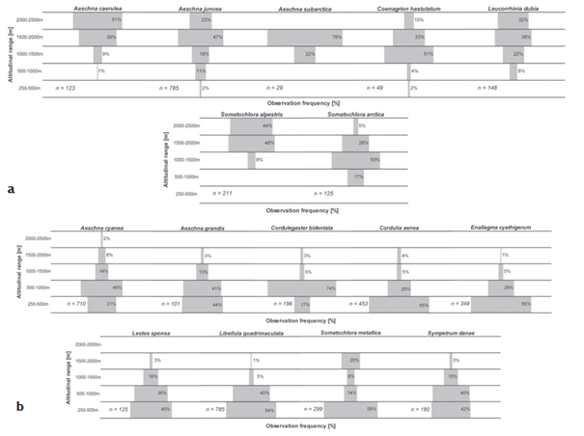
Figure S2.1. Altitudinal distribution in Switzerland of a set of 16 species frequently observed at high altitude (above 1500m). S2.1a The seven cold specialist species; S2.1b The nine generalist species. The data report observations of exuviae and subadults only, two life stages attesting the reproduction at the observed altitude. “n” indicates the number of observations. Data were gatered before 2003 (mainly between 1990 and 2002) by the Swiss Centre for Fauna Cartography. This figure is extracted from Oertli, 2010 (distributed under the terms of the Creative Commons Attribution License (CC BY 3.0)).
We did not find studies identifying local Amphibia and Flora specialist species. To determine specialist Amphibia and Flora species of our study area, we used the Auvergne Rhône-Alpes regional (the study area region) observatory of biodiversity (https://atlas.biodiversite-auvergne-rhone-alpes.fr) which documented geographical distribution of species by the regional databases. This platform provides representations of altitudinal distribution of species (Fig.S2.2).
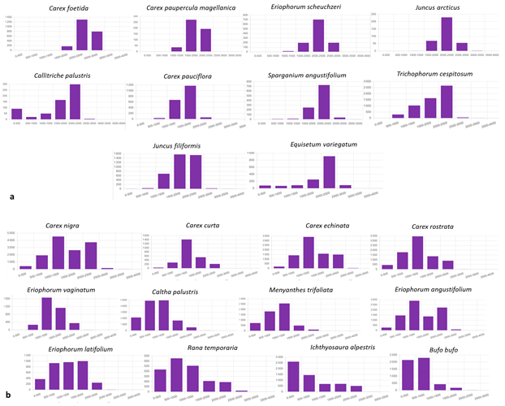
Figure S2.2. Altitudinal distribution in Auvergne Rhône-Alpes regional of a set of 22 species frequently observed at high altitude (above 1500m). S2.2a the ten cold specialist species; S2.2b the 12 generalist species. Histograms were extracted from the Auvergne Rhône-Alpes regional observatory of biodiversity (https://atlas.biodiversite-auvergne-rhone-alpes.fr) in December 2023.

Carex foetida, Carex paupercula magellanica, Eriophorum scheuzeri, Juncus arcticu, Callitriche palustris, Carex pauciflora, Sparganium angustifolium, Trichophorum cespitosum, Juncus filiformis and Equisetum variegatum were identified like cold specialist species (Fig.S2.2a). The others were generalist (for example all Amphibia, Carex nigra and Carex rostrata) (Fig.S2.2b).
References:
Epele, L. B., Grech, M. G., Williams-Subiza, E. A., Stenert, C., McLean, K., Greig, H. S., Maltchik, L., Pires, M. M., Bird, M. S., Boissezon, A., Boix, D., Demierre, E., García, P. E., Gascón, S., Jeffries, M., Kneitel, J. M., Loskutova, O., Manzo, L. M., Mataloni, G., … Batzer, D. P. (2022). Perils of life on the edge : Climatic threats to global diversity patterns of wetland macroinvertebrates. Science of The Total Environment, 820, 153052. https://doi.org/10.1016/j.scitotenv.2022.153052
Lindholm, M., Hessen, D. O., Færøvig, P. J., Rognerud, B., Andersen, T., & Stordal, F. (2015). Is distribution of cold stenotherms constrained by temperature? The case of the Arctic fairy shrimp (Branchinecta paludosa O.F. Müller 1788). Journal of Thermal Biology, 53, 46‑52. https://doi.org/10.1016/j.jtherbio.2015.08.005
Oertli, B. (2010). The local species richness of Dragonflies in mountain waterbodies : An indicator of climate warming ? In : Ott J (Ed) (2010)b Monitoring Climatic Change With Dragonflies. BioRisk, 85, 243‑251. https://doi.org/10.3897/biorisk. 5.853
Rosset, V., & Oertli, B. (2011). Freshwater biodiversity under climate warming pressure : Identifying the winners and losers in temperate standing waterbodies. Biological Conservation, 144(9), Article 9. https://doi.org/10.1016/j.biocon.2011.06.009

S2. List of the 104 models fitted to analyze the simple and quadratic relation between each scaled covariate and species occupancy probabilities

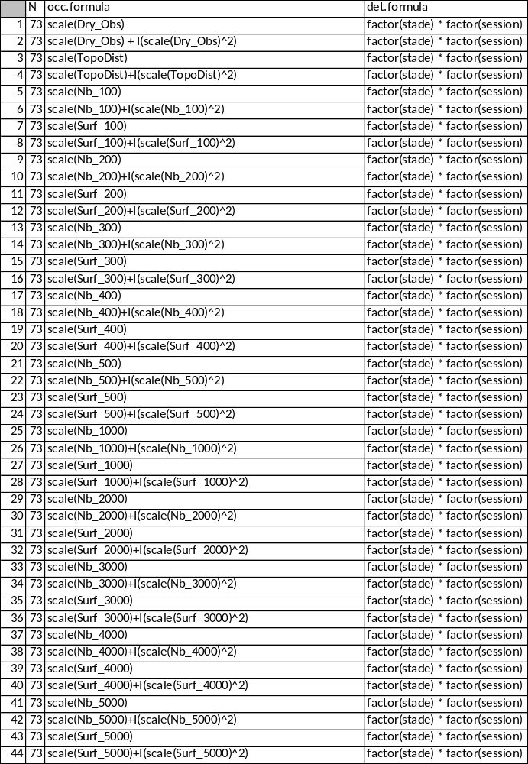

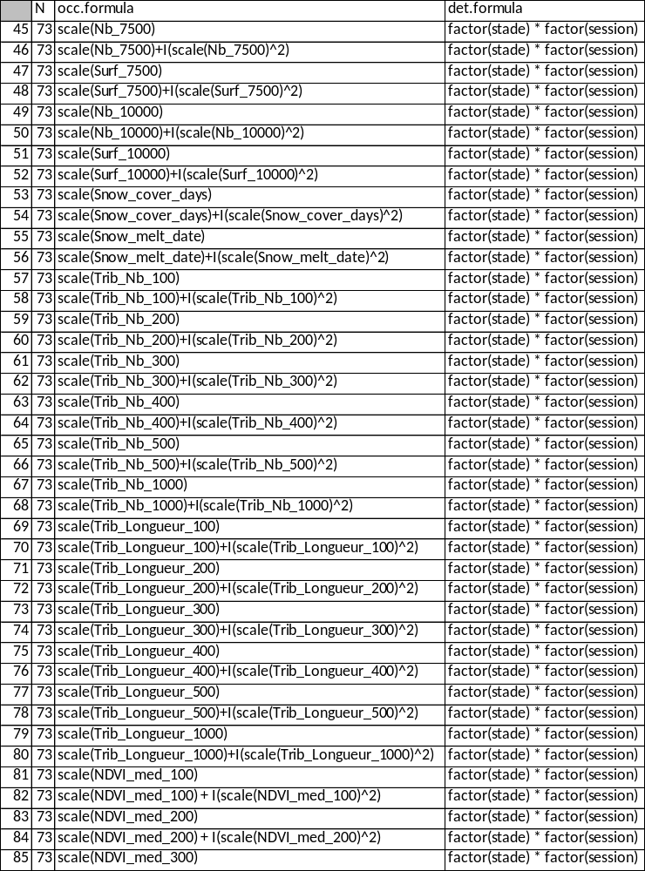
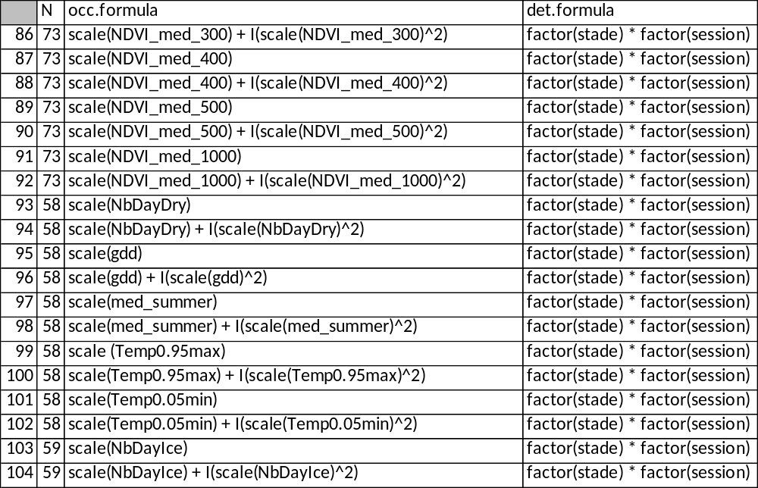

S3. MSOM used script

S3.1) Function

## Data list
create_data.list<-function(data,occ.covs_2,method4, session4,coords)
{
data2 <- data %>% pivot_longer(cols = 2:ncol(data), names_pattern="(.+)") %>% extract(name, c("stade", "espece", "session"), regex = "(.+)_(.+)_(.+)")
y <- xtabs(value ~ espece + Site + interaction(stade, session), data = data2)
class(y) <- "array"
y <- (y>0.5)*1

rownames(occ.covs_2) <- occ.covs_2$Site
occ.covs<-occ.covs_2[,c(2:54)]

rownames(method4) <- method4$Site
method4<-method4[,c(2:5)]
stade=method4
stade[,c(1:4)] <- lapply(stade, function(x) factor(x, levels = c("Sub_Adult","Adult","eDNA")))

rownames(session4) <- session4$Site
session4<-session4[,c(2:5)]
session=session4
session[,c(1:4)] <- lapply(session, function(x) factor(x, levels = c("Session1", "Session2")))

det.covs<-list(stade=as.list(stade),
session=as.list(session))

mytab=coords
coords=as.matrix(mytab[,2:3])
dimnames(coords)=list(mytab[,1],names(mytab)[2:3])

data.list <- list(y = y,
occ.covs = occ.covs,
det.covs = det.covs,
coords = coords)
return(data.list)
}

## Models

create_models<-function(EchNb, data.list, path_model="D:/MSOM/modeles/")

{
nl <- which(boucle$N==EchNb)
for (i in nl){

form1 <- sprintf("~ %s", boucle[i,4])
form1 <- as.formula(form1)
form2 <- sprintf("~ %s", boucle[i,6])
form2 <- as.formula(form2)

mod <- sfMsPGOcc(occ.formula = form1 ,
det.formula = form2,
data = data.list,
inits = inits.list,
n.batch = n.batch,
batch.length = batch.length,
accept.rate = 0.43,
priors = prior.list,
cov.model = "exponential",
tuning = tuning.list,
n.omp.threads = 1,
verbose = TRUE,
NNGP = TRUE,
n.neighbors = 15,
n.factors = n.factors,
search.type = 'cb',
n.report = 10,
n.burn = 2000,
n.thin = 4,
n.chains = 4
)
save(mod, file = sprintf("%s/modele_%03d_74.Rdata", path_model, i))
cat("Modele _ : " , i, "\n")
rm(mod)
}
}

S3.2) Main script

#references:
#https://www.jeffdoser.com/files/spoccupancy-web/reference/sfmspgocc
#https://cran.r-project.org/web/packages/spOccupancy/spOccupancy.pdf
#https://www.jeffdoser.com/files/spoccupancy-web/

source("C:/Users/marie.lamouille-hebe/Documents/R/ScriptsCIMaE/spOccupancyRNN74_all/MSOM/function.R")

## Packages
library(tidyverse)
library(spOccupancy)
library(coda)
library(stars)
library(ggplot2)
library(sf)
library(pals)
library(cowplot)
library(MCMCvis)
library(RColorBrewer)

## Data # modified in function of the three different data sets (73, 58, 59)
path_model <- "D:/MSOM/modeles/"
data=read.csv2("~/R/ScriptsCIMaE/spOccupancyRNN74_all/MSOM/data/Inter/TableAnalyse_RNN74_Odo_Amphi_Macrophytes_sitesOK.csv")
occ.covs_2<-read.csv2("~/R/ScriptsCIMaE/spOccupancyRNN74_all/MSOM/data/Inter/occ.cov_2.csv")
method4<-read.csv2("~/R/ScriptsCIMaE/spOccupancyRNN74_all/MSOM/data/Inter/method4.csv")
session4<-read.csv2("~/R/ScriptsCIMaE/spOccupancyRNN74_all/MSOM/data/Inter/session4.csv")
coords<-read.csv2("~/R/ScriptsCIMaE/spOccupancyRNN74_all/MSOM/data/Inter/coords.csv")
boucle<-read.csv(file="~/R/ScriptsCIMaE/spOccupancyRNN74_all/Results/Scenari.csv",header = TRUE,sep = ";")

## Data list
data.list<-create_data.list(data,occ.covs_2,method4,session4,coords)
save(data.list, file="5_Data_list.RData")
load("C:/Users/marie.lamouille-hebe/Documents/R/ScriptsCIMaE/spOccupancyRNN74_all/MSOM/73_Data_list.Rdata")

## Bayesian indices
prior.list <- list(beta.comm.normal = list(mean = 0, var = 2.72),
alpha.comm.normal = list(mean = 0, var = 2.72),
tau.sq.beta.ig = list(a = 0.1, b = 0.1),
tau.sq.alpha.ig = list(a = 0.1, b = 0.1),
phi.unif = list(a = 3/1, b = 3/.1))
n.factors=15
N=31
lambda.inits <- matrix(0, N, n.factors)
diag(lambda.inits) <- 1
lambda.inits[lower.tri(lambda.inits)] <- rnorm(sum(lower.tri(lambda.inits)))
inits.list <- list(alpha.comm = 0,
beta.comm = 0,
beta = 0,
alpha = 0,
tau.sq.beta = 1,
tau.sq.alpha = 1,
phi = 3 / .5,
lambda = lambda.inits,
z = apply(data.list$y, c(1, 2), max, na.rm = TRUE))
n.batch <- 500
batch.length <- 40
n.samples <- n.batch * batch.length
tuning.list <- list(phi = 1)

##Models
EchNb=73 # modified in function of the three different data sets (73, 58, 59)
path_model <- "D:/MSOM/modeles/"
create_models(EchNb,data.list, path_model)

##Model validations
path_model <- ("D:/MSOM/modeles")
path_figure<- ("D:/MSOM/figures")
path_table<-("D:/MSOM/tables")

nl <- which(boucle$N==EchNb)
WAIC <- numeric(length(nl))
u<-1
for (i in nl) {
load(file = sprintf("D:/MSOM/modeles/modele_%03d_74.Rdata",i))

png(file = sprintf("D:/MSOM/figures/Conv_Occ_%03d_74_Occ.png",i), width = 900, height = 1500)
plot(mod$beta.samples, density = FALSE) # Occupancy parameters.
dev.off()
png(file = sprintf("D:/MSOM/figures/Conv_Detect_%03d_74_Det.png",i), width = 900, height = 1500)
plot(mod$alpha.samples, density = FALSE) # Detection parameters.
dev.off()
bpval <- function(object) {
bpval_comm <- mean(object$fit.y.rep > object$fit.y)
N <- ncol(object$fit.y)
bpval_sp <- numeric(N)

for (i in 1:N) {
bpval_sp[i] <- mean(object$fit.y.rep[, i] > object$fit.y[,i])
}
out <- data.frame(Taxa = c("Comm", object$sp.names), p_val = c(bpval_comm, bpval_sp))
return(out)
}

test1 <- ppcOcc(mod, 'freeman-tukey', group = 2)
sum1<- bpval(test1)
write.table(sum1,
sprintf("D:/MSOM/tables/summary_test_1_%03d.csv", i),
row.names = FALSE, sep=";")

test2 <- ppcOcc(mod, 'freeman-tukey', group = 1)
sum2 <- bpval(test2)
write.table(sum2,
sprintf("D:/MSOM/tables/summary_test_2_%03d.csv", i),
row.names = FALSE, sep=";")

##Figures of the significant effect, or not, of the different occ.cov on occupancy probabilities of species
png(file = sprintf("D:/MSOM/figures/Sp_%03d.png",i), width = 900, height = 1500)
MCMCplot(mod$beta.samples, ref_ovl = TRUE, ci = c(50, 95))
dev.off()

WAIC[u]<-waicOcc(mod)[3]
u<-u+1

}

WAIC<-data.frame(nl=nl, WAIC=WAIC)

write.table(WAIC,sprintf("D:/MSOM/tables/WAIC_%d.csv", EchNb),
row.names = FALSE, sep = ";")

## Predict of the occupancy probabilities of species on the tested variable range (when its effect is significant)
##this part of the script is created by Maxime Logez (2024_01)

extract_names <- function(xnames, deep = TRUE) {
xnames <- gsub(" +", "", xnames)
if (any(grepl(":", xnames))){
xnames <- strsplit(xnames, ":")
xnames <- sapply(xnames, extract_names)
xnames <- unlist(xnames)
xnames <- unique(xnames)
}else{
if (any(grepl("^I\\(", xnames))) {
xnames <- gsub("(?:^I\\()(.+)(?:\\))", "\\1", xnames)
}
if (deep){
while(any(grepl("\\(", xnames))) {
xnames <- gsub("(?:.*\\()(.+)(?:\\).*)", "\\1", xnames)
}
xnames <- unique(xnames)
}
}
xnames
}

extract_intercept <- function(xnames) {
u <- grepl("Intercept", xnames)
if (any(u))
xnames <- xnames[!u]
xnames
}

simplify_modnames <- function(mod_names) {
mod_names <- gsub("I\\(scale\\(", "I\\(", mod_names)
mod_names <- gsub("\\)\\^2", "\\^2", mod_names)
mod_names <- strsplit(mod_names, ":")
mod_names <- lapply(mod_names, function(x) gsub("(scale\\()(.+)(\\))", "\\2", x))
mod_names <- lapply(mod_names, paste, collapse = ":")
mod_names <- unlist(mod_names)
mod_names <- sub("\\(Intercept\\)", "Intercept", mod_names)
mod_names
}

f_inter <- function(x.pred, x.fixed, xvars) {
inters <- logical(length(x.fixed))
for (i in 1:length(inters)) {
test1 <- any(grepl(sprintf("%s(.*)?:(.*)?%s", x.pred, x.fixed[i]), xvars))
test2 <- any(grepl(sprintf("%s(.*)?:(.*)?%s", x.fixed[i], x.pred), xvars))
inters[i] <- test1 | test2
}
if(all(!inters)){
inters <- NULL
}else{
inters <- x.fixed[inters]
}
inters
}

prep_data <- function(x.pred, x.fixed = NULL, inters = NULL, tab) {
quant_inter <- function(x) {
if (length(unique(x))<=5) {
res <- sort(unique(x))
}else{
res <- quantile(x, c(0.2, 0.5, 0.8), na.rm = TRUE)
}
res
}

x.fixed <- setdiff(x.fixed, inters)
if (is.matrix(tab))
tab <- as.data.frame(tab)
if (length(inters) > 0.5){
inters <- tab[, inters, drop = FALSE]
inters <- lapply(inters, quant_inter)
}
if (length(x.fixed)> 0.5){
x.fixed <- tab[, x.fixed, drop = FALSE]
x.fixed <- lapply(x.fixed, mean, na.rm = T)
}
x.pred <- tab[, x.pred, drop = FALSE]
x.pred <- lapply(x.pred,
function(x) seq(min(x, na.rm = TRUE),
max(x, na.rm = TRUE), le = 101))
tab <- c(x.pred, inters, x.fixed)
tab <- do.call(expand.grid, tab)
tab
}

prep_graph <- function(mod, xnames, x.pred, data = NULL){

xvars <- mod$x.names

xvars[grep("Intercept", xvars)] <- 1
form1 <- as.formula(sprintf("~ %s", paste(xvars, collapse = " + ")))

if (is.null(x.pred) || length(x.pred) < 0.5 || is.na(x.pred))
x.pred <- character()

x.fixed <- xnames[!xnames %in% x.pred]
if (length(x.fixed) < 0.5)
x.fixed <- NULL
if (any(auxi <- grepl("\\:", xvars))) {
inters <- f_inter(x.pred, x.fixed, xvars)
}else{
inters <- NULL
}
if (length(inters)> 1.5) {
stop("Seulement une interaction possible prévue entre\nla variable d'intérêt et les autres")
}

tab_pred <- prep_data(x.pred, x.fixed, inters, data)

tab_new <- model.matrix(form1, data = tab_pred)
if (nrow(tab_new) < 0.5) {
tab_new <- matrix(1L, 1 , 1)
colnames(tab_new) <- "Intercept"
}else{
colnames(tab_new) <- sub("\\(Intercept\\)", "Intercept", colnames(tab_new))
}

lsp <- colnames(mod$beta.samples)
lsp <- lsp[grep("Intercept", lsp)]
lsp <- gsub("\\(Intercept\\)-", "", lsp)

cnames <- colnames(mod$beta.samples)
linkinv <- binomial()$linkinv
res <- vector("list", length = length(lsp))
for (i in 1:length(lsp)) {
sp <- lsp[i]
cfs <- mod$beta.samples[, grep(sp, cnames), drop = FALSE]
cfs <- as.matrix(cfs)
colnames(cfs) <- gsub(sprintf("-%s", sp), "", colnames(cfs))
nint <- grep("Intercept", colnames(cfs))
cfs <- cfs[, c(nint, setdiff(1:ncol(cfs), nint)), drop = FALSE]
colnames(cfs) <- simplify_modnames(colnames(cfs))
colnames(cfs)[1] <- "Intercept"
cfs <- cfs[, colnames(tab_new), drop = FALSE]
cfs <- t(cfs)
ps <- tab_new[, , drop = FALSE] %*% cfs[, , drop = FALSE]
ps <- t(ps)
int_tot <- apply(ps, 2, quantile, c(0.025, 0.5, 0.975)) #HDI ?
int_tot <- t(int_tot)
colnames(int_tot) <- c("pocc_inf", "pocc", "pocc_sup")
int_tot <- int_tot[, c("pocc", "pocc_inf", "pocc_sup"), drop = FALSE]
ints <- linkinv(int_tot)
res[[i]] <- ints
}
names(res) <- lsp
res$tab_new <- tab_new
res$tab_pred <- tab_pred
res$lsp <- lsp
res$inters <- inters # n'existe pas si null
return(res)
}

graph_var_sp <- function(tab, var1, inter, sp, plot = TRUE) {
if (length(var1) < 0.5 || is.na(var1)){
p1 <- ggplot(tab, aes(x = factor(1), pocc)) +
geom_linerange(aes(ymin = pocc_inf, ymax = pocc_sup)) +
geom_point() +
xlab("Intercept") +
theme_bw() +
theme(axis.text.x = element_blank())
}else{
var1 <- sym(var1)
p1 <- ggplot(tab, aes(x = {{var1}}, pocc)) +
geom_path() +
geom_ribbon(aes(ymin = pocc_inf, ymax = pocc_sup), alpha = 0.5) +
theme_bw()
}
if (!is.null(inter)) {
if (is.numeric(tab[, inter]))
tab[, inter] <- factor(round(tab[, inter], 1))
p1 <- p1 + facet_wrap(inter, labeller = label_both)
}
p1 <- p1 +
labs(title = {{sp}}) +
ylab("Occupancy probability") +
labs(title = {{sp}}) +
ylim(0, 1) +
theme(plot.title = element_text(face = "italic"))
if (plot){
plot(p1)
}else{
return(p1)
}
}

graph_var_multi <- function(tab, var1, plot = TRUE, ncol = 3, nrow = round(length(lsp)/3)) {
auxi <- length(var1) < 0.5 | is.na(var1)
if (auxi){
p1 <- ggplot(tab, aes(x = factor(1), pocc)) +
geom_linerange(aes(ymin = pocc_inf, ymax = pocc_sup)) +
geom_point() +
xlab("Intercept")
}else{
var1 <- sym(var1)
p1 <- ggplot(tab, aes(x = {{var1}}, pocc)) +
geom_path() +
geom_ribbon(aes(ymin = pocc_inf, ymax = pocc_sup), alpha = 0.5)
}
p1 <- p1 +
facet_wrap(~sp, ncol = ncol) +
ylab("Occupancy probability") +
ylim(0, 1) +
theme_bw()+
theme(strip.background = element_rect(fill = "white", color = "transparent"),
strip.text.x.top = element_text(face = "italic"),
panel.grid.major = element_line(linewidth = 0.2),
panel.grid.minor = element_line(linewidth = 0.1)
)
if(auxi){
p1 <- p1 +
theme(axis.text.x = element_blank())
}
if (plot){
plot(p1)
}else{
return(p1)
}
}

effect_mod <- function(mod, data, path = getwd(), file.name,
tab = "init", gtype = "sp", lsp = NULL,
ncol = 3, width = 7, height = 7) {

sp_mod <- gsub("(^.+-)(.+$)", "\\2", colnames(mod$beta.samples))
sp_mod <- unique(sp_mod)
if (is.null(lsp)) {
lsp <- sp_mod
}else{
if (!inherits(lsp, "data.frame") || ncol(lsp)!=2) {
stop("lsp must be a two columns data.frame")
}
if (any(!sp_mod %in% lsp$sp_mod)) {
stop("The species code of lsp must those used in the model (beta.samples)")
}
lsp <- lsp$sp[match(sp_mod, lsp$sp_mod)]
}

mod_names <- mod$x.names
xnames <- extract_names(mod_names)
xnames <- extract_intercept(xnames)

if (length(xnames) > 0.5) {
scaled <- sapply(xnames, function(x) {
x <- grep(x, mod_names, value = TRUE)
x <- x[1]
res <- grepl("scale", x)
res
})
}else {
scaled <- FALSE
}

data_mod <- data
if (any(scaled)) {
mns <- colMeans(data[, xnames[scaled], drop = FALSE], na.rm = TRUE)
sds <- sapply(data[, xnames[scaled], drop = FALSE], sd, na.rm = TRUE)
for (i in xnames[scaled]) {
data_mod[, i] <- (data_mod[, i] - mns[i])/sds[i]
}
mod_names <- simplify_modnames(mod_names)
mod$x.names <- mod_names
}

auxi <- if (length(xnames) < 0.5) 1 else 1:length(xnames)
pdf(sprintf("%s/%s.pdf", path, file.name),
width = width, height = height)
for (i in auxi) { #pour toutes les variables du modèle
x.pred <- xnames[i]
tabs <- prep_graph(mod, xnames, x.pred, data_mod)
if (any(u <- scaled[colnames(tabs$tab_pred)])) {
tab2 <- tabs$tab_pred
for (j in colnames(tab2)[u]) {
tab2[, j] <- tab2[, j]*sds[j]+mns[j]
}
tabs$tab_pred <- tab2
rm(tab2)
}
inter <- tabs$inter # nom des variables en interaction avec x.pred
if (!tab %in% "init"){
tab1 <- tabs$tab_new
cn <- colnames(tab1)
cn <- extract_names(cn, deep = FALSE)
colnames(tab1) <- cn
xnames <- cn[grep(x.pred, cn)]
xnames <- xnames[1]
}else{
tab1 <- tabs$tab_pred
}
names(tabs)[match(sp_mod, names(tabs))] <- lsp
if (!is.null(inter) || gtype == "sp") { # graphique par espèce
for (j in lsp) {
graph_var_sp(if (nrow(tab1)>0.5) cbind(tab1, as.data.frame(tabs[[j]])) else as.data.frame(tabs[[j]]),
x.pred, inter, j, plot = TRUE)
}
}else {
for (j in lsp) {
if (nrow(tab1 > 0.5)){
tabs[[j]] <- cbind(tab1, sp = j, as.data.frame(tabs[[j]]))
}else{
tabs[[j]] <- cbind(sp = j, as.data.frame(tabs[[j]]))
}
}
tab_m <- do.call(rbind, tabs[lsp])
graph_var_multi(tab_m, x.pred, plot = TRUE, ncol = ncol)
}
}
dev.off()
}

## Example with a model
load("73_Data_list.Rdata")
d1 <- data.list
load("./graph_effect/modele_002_74.Rdata")
effect_mod(mod, data.list$occ.covs, file.name = "mod_002")
effect_mod(mod, data.list$occ.covs, file.name = "mod_002_m", gtype = "m", ncol = 5,
height = 10)

S4. Relation between summer water warming and alpine ponds species (Amphibia, macrophytes and Odonata) occupancy probabilities
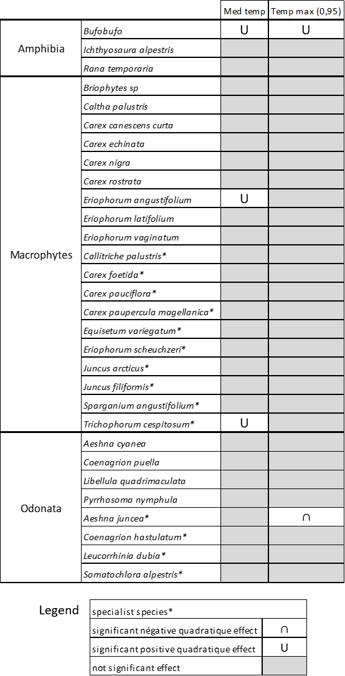
Figure S4. Relation between summer water warming and alpine ponds species (Amphibia, macrophytes and Odonata) occupancy probabilities (Med temp, Temp max). Relations were tested with different MSOM. For each species (listed by group: Amphibia, macrophytes and Odonata), we reported here the quadratic relation between the metric and their occupancy probability. The asterisk “*” identify specialist species. Med temp is the median of daily difference between the maximum and the minimum temperature; Temp max (0.95) is the summer maximal temperature.

S5. Relation between pond network and alpine ponds species (Amphibia, macrophytes and Odonata) occupancy probabilities

S5.1 Number of wetlands in different buffers around sampled pond

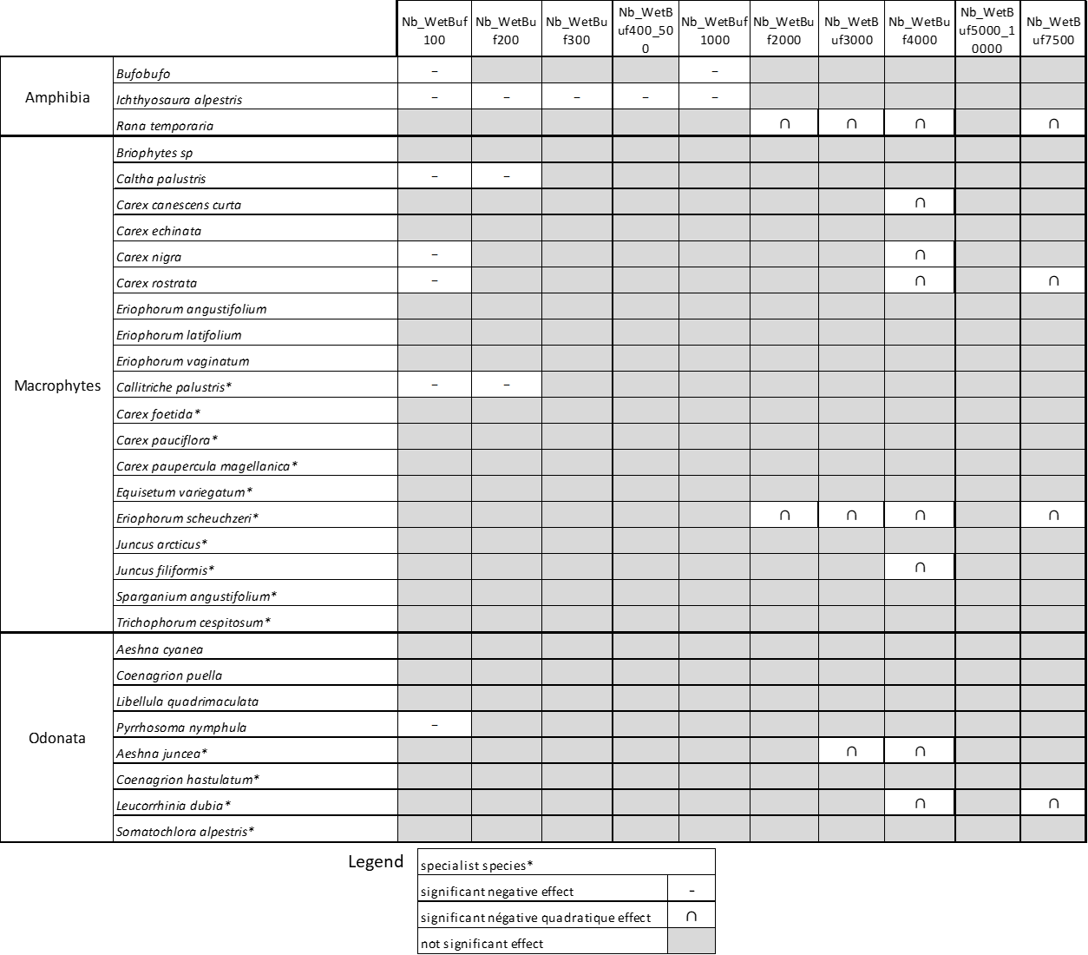
Figure S5.1. Relation between the number of wetlands in different buffers around sampled pond and alpine ponds species (Amphibia, macrophytes and Odonata) occupancy probabilities. Relations were tested with different MSOM. For each species (listed by group: Amphibia, macrophytes and Odonata), we reported here the significant relation between the metric and their occupancy probability. The asterisk “*” identify specialist species. Nb_WetBuf(100, 200, 300, 400, 500, 1000, 2000, 3000, 5000, 7500, 10000) is the number of wetlands on each buffer.

S5.2 Area of wetlands in different buffers around sampled pond

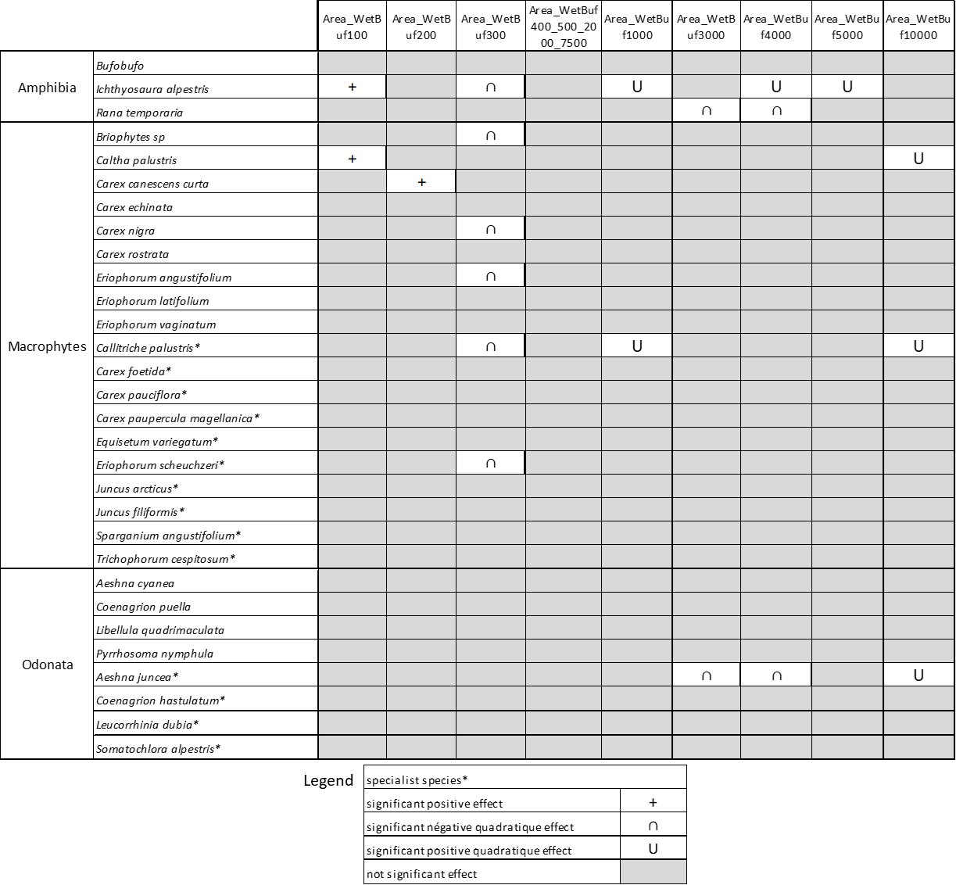
Figure S5.2. Relation between area of wetlands in different buffers around sampled pond and alpine ponds species (Amphibia, macrophytes and Odonata) occupancy probabilities. Relations were tested with different MSOM. For each species (listed by group: Amphibia, macrophytes and Odonata), we reported here the significant relation between the metric and their occupancy probability. The asterisk “*” identify specialist species. Area_WetBuf(100, 200, 300, 400, 500, 1000, 2000, 3000, 5000, 7500, 10000) is the number of wetlands on each buffer.

S5.3 Number and reliable river network and land cover index in different buffers around sampled pond and land cover in different buffers around sampled pond

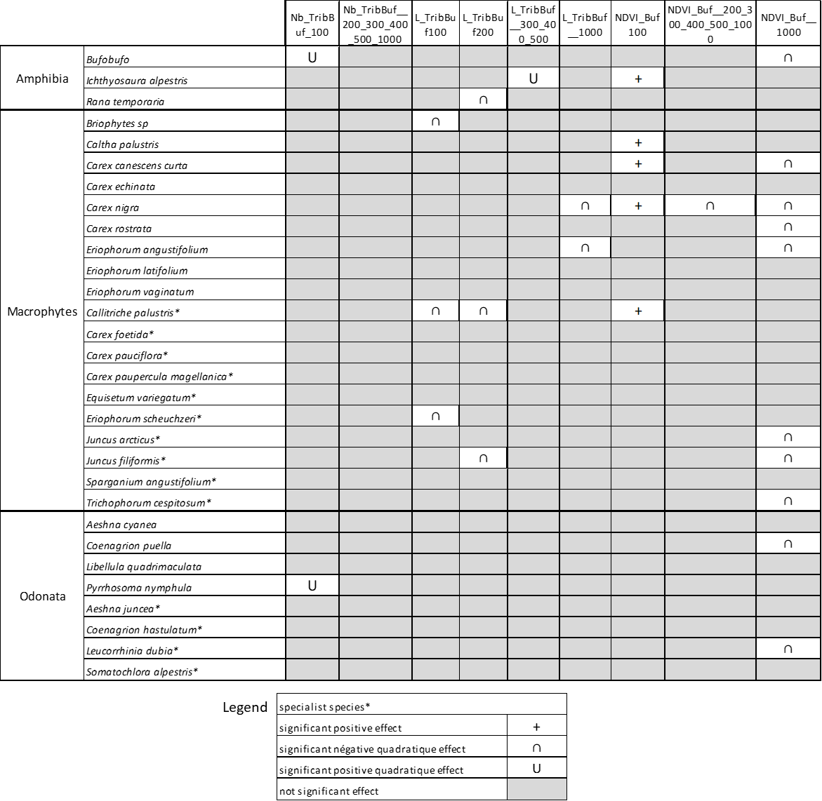
Figure S5.3. Relation between number and reliable river network and land cover in different buffers around sampled pond and alpine ponds species (Amphibia, macrophytes and Odonata) occupancy probabilities. Relations were tested with different MSOM. For each species (listed by group: Amphibia, macrophytes and Odonata), we reported here the relation between the metric and their occupancy probability. The asterisk “*” identify specialist species. Nb_TribBuf(100, 200, 300, 400, 500, 1000) is the number of tributaries on each buffer; L_TribBuf(100, 200, 300, 400, 500, 1000) is the length of the reliable river network in different buffers around sampled pond; NDVI_Buf(100, 200, 300, 400, 500, 1000) is the maximum of the median normalized difference vegetation index (NDVI) in different buffers.

