Supplementary Materials
Supplementary Figure 1
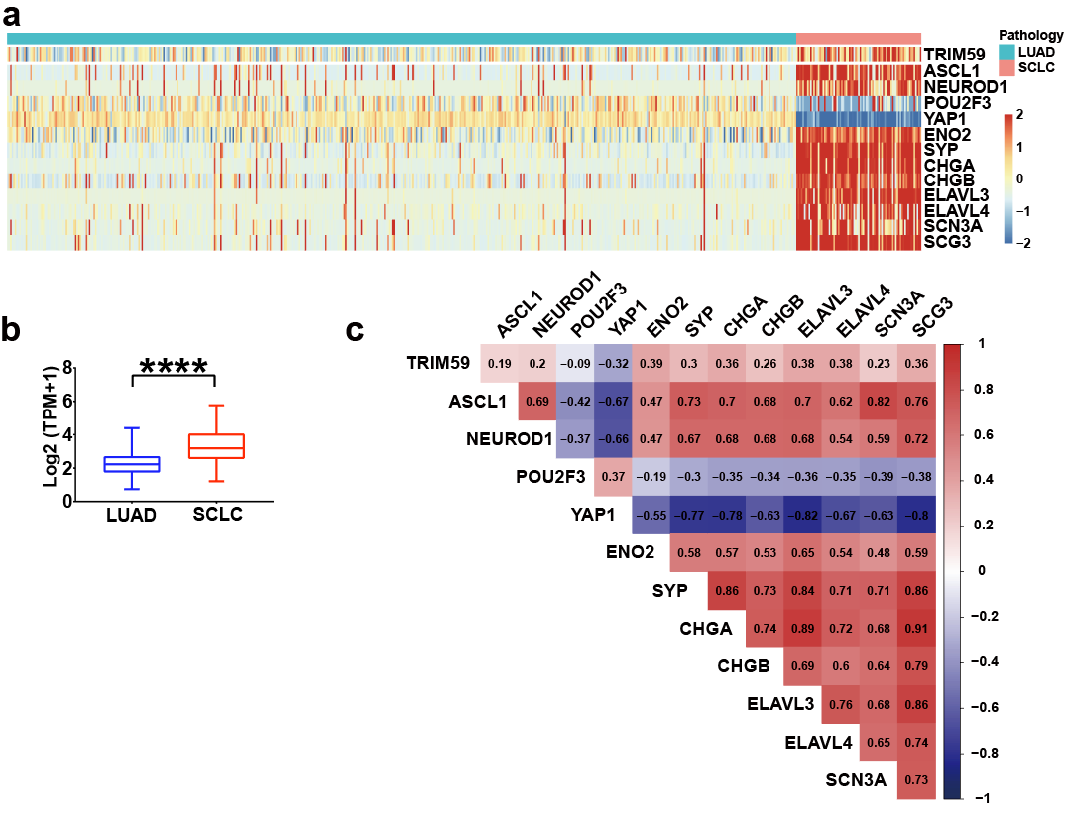
Supplementary Figure 1. TRIM59 is highly expressed in small cell lung cancer.
- Heatmap depicting TRIM59 and neuroendocrine markers in TCGA-LUAD(lung adenocarcinoma)（n=511）and small cell lung cancer (SCLC)¹ (n=81). The shade of pink represents mRNA expression values (log2 (TPM+1)). Limma was used to remove the batch effect.
- TRIM59 is upregulated in SCLC compared to LUAD. Student’s t test is used to compare the difference.
- Heatmap depicting the pearson correlation coefficients between TRIM59 and neuroendocrine genes in dataset described in (a).

Supplementary Figure 2
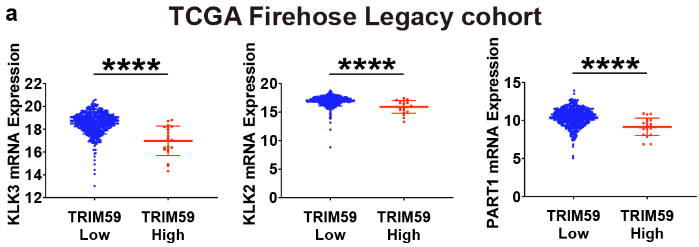
Supplementary Figure 2. Inverse correlation between AR targets and TRIM59
- AR targeted gene expression (KLK3, KLK2 and PART1) in TCGA Firehouse Legacy cohort stratified by TRIM59 expression

Supplementary Figure 3
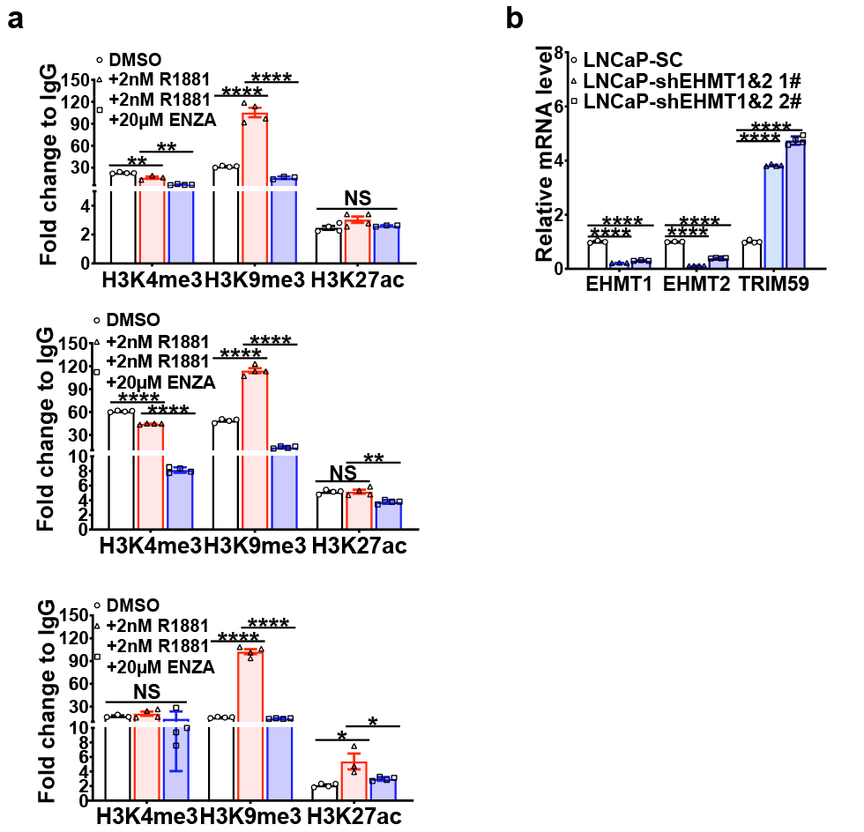
Supplementary Figure 3. The epigenetic program at TRIM59 promoter is modulated by AR signaling.
(a) ChIP-qPCR detecting changes of enrichment of H3 lysine 4 trimethylation (H3K4me3), H3 lysine 9 trimethylation (H3K9me3) and H3 lysine 27 acetylation (H3K27Ac) on the TRIM59 promoter in androgen R1881 (2nM) stimulated or enzalutamide (20µM) treated LNCaP cells.
(b) q-PCR analysis of EHMT1, EHMT2 and TRIM59 in shRNA mediated silencing of both EHMT1 and EHMT2 in LNCaP.
Means±SEM in (a-b). two-tailed unpaired Students t test is used in (a-b). * p < 0.05, **p < 0.01, ***p < 0.001, ****p < 0.0001, NS represents no significance.
Supplementary Figure 4
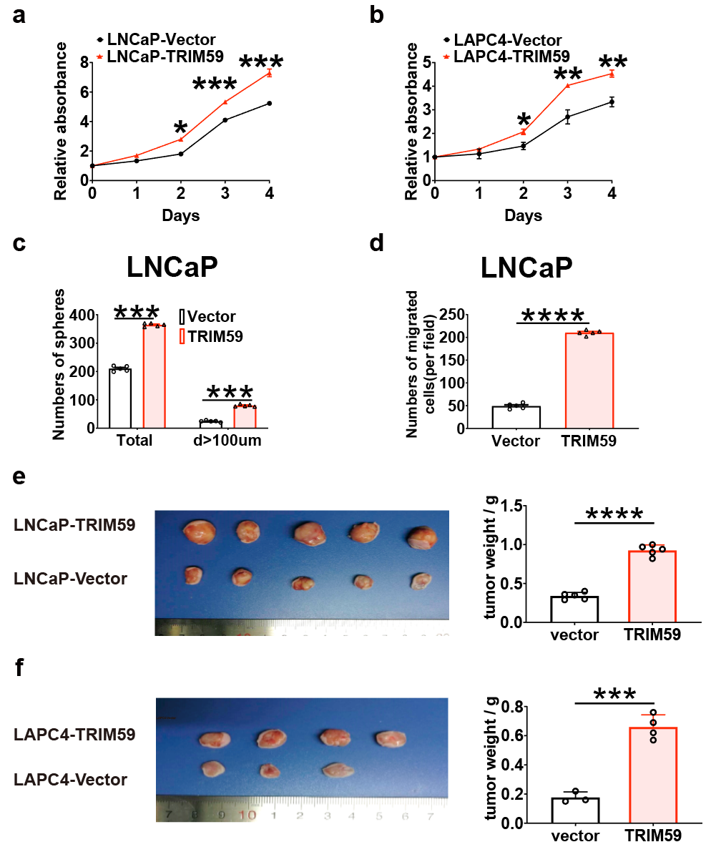

Supplementary Figure 4. TRIM59 promotes PCa cell proliferation, migration, xenograft tumor growth.
(a, b) Cell proliferation assay in stable TRIM59 expressing LNCaP (a), LAPC4 (b) and respectively control cells (n=3).
(c) Sphere formation assay in stable TRIM59 expressing LNCaP and respectively control cells (n=5)
(d) Cell migration assay in stable TRIM59 expressing LNCaP and respectively control cells (n=5)
(e, f) Subcutaneous xenograft assay using stable TRIM59 expressing (a, n=5), LAPC4 (b, n=4) and respectively control cells. Representative image (left panel) shows the tumor samples. Bar graph (right panel) shows the tumor weight in each group.
Means±SEM in (a-f). two-tailed unpaired Students t test is used in (a-f). * p < 0.05, **p < 0.01, ***p < 0.001, ****p < 0.0001.

Supplementary Figure 5
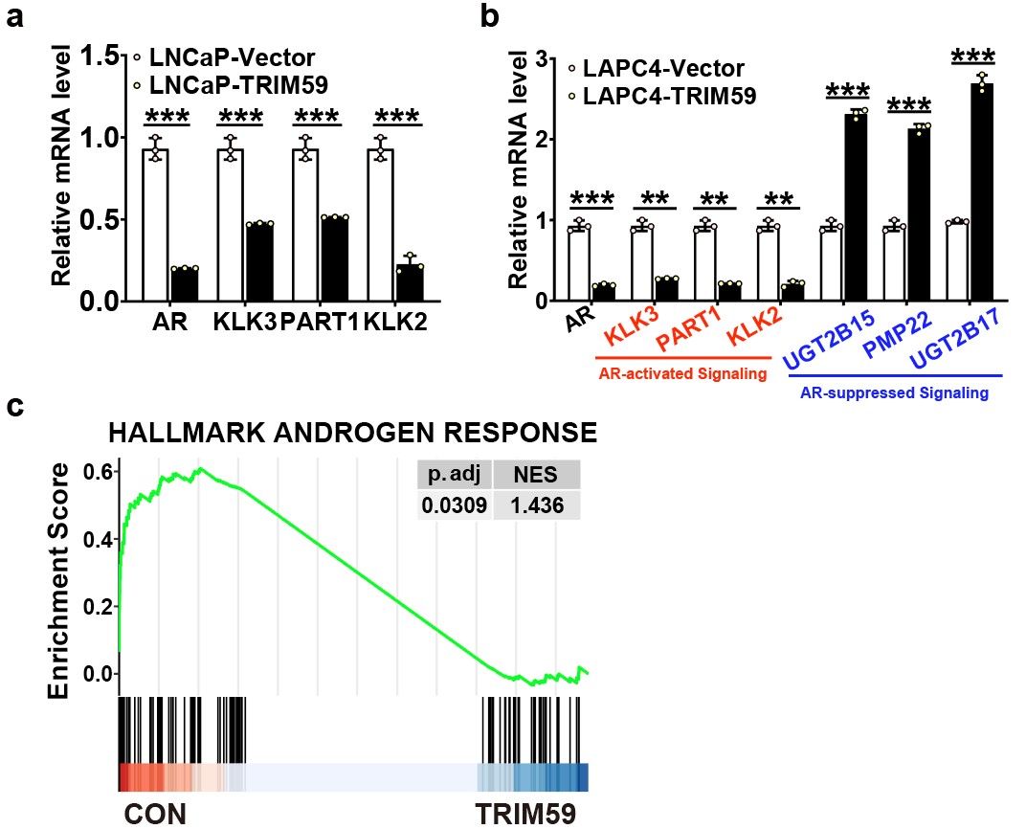
Supplementary Figure 5. TRIM59 downregulates the AR signaling.
(a) q-PCR analysis of AR, indicated AR-activated genes and AR-suppressed genes in stable TRIM59 expressing LAPC4 and control cells.
(b) q-PCR analysis of AR, indicated AR-activated genes and AR-suppressed genes in stable TRIM59 expressing LNCaP and control cells.
(c) GSEA analysis of “HALLMARK ANDROGEN RESPONSE” of RNA-seq data from stable TRIM59 expressing LNCaP and control cells.

Supplementary Table 1. clinical information for patient samples enrolled in the RENJI-CRPC cohort.
No. | pathology | Gleason | M stage | OS(mo) | event on death | PFS of ARPI treatment | event on progression of ARPI treatment | TRIM59 IHC score
RJ-001 | adeno | 5＋4＝9 | 1 | 9 | 1 | 1.2 | 1 | 9
RJ-002 | adeno | 5＋4＝9 | 1 | 9 | 1 | 1.2 | 1 | 9
RJ-003 | adeno | 4+5＝9 | 1 | 7 | 1 | 1.3 | 1 | 9
RJ-004 | adeno | 5＋5＝10 | 1 | 9 | 1 | 1.4 | 1 | 9
RJ-005 | adeno | 5＋4＝9 | 1 | 10 | 1 | 1.6 | 1 | 9
RJ-006 | adeno | 4+5=9 | 1 | 13 | 1 | 2 | 1 | 6
RJ-007 | adeno | / | 1 | 13 | 1 | 3.9 | 1 | 6
RJ-008 | adeno | 4+4＝8 | 1 | 12 | 1 | 4.3 | 1 | 6
RJ-009 | adeno | / | 1 | 19 | 1 | 4.8 | 1 | 4
RJ-010 | adeno | 4+5=9 | 1 | 16 | 1 | 5.7 | 1 | 6
RJ-011 | adeno | 4＋3＝7 | 1 | 26 | 1 | 6 | 1 | 3
RJ-012 | adeno | 5＋4＝9 | 1 | 19 | 1 | 7 | 1 | 6
RJ-013 | adeno | 4+4＝8 | 1 | 22 | 1 | 7 | 1 | 3
RJ-014 | adeno | 4+4=8 | 1 | 26 | 1 | 8 | 1 | 4
RJ-015 | adeno | 4＋5＝9 | 1 | 36 | 0 | 8 | 1 | 3
RJ-016 | adeno | 4+5=9 | 1 | 39 | 0 | 9 | 1 | 2
RJ-017 | adeno | 3+4=7 | 1 | 20 | 1 | 10 | 1 | 3
RJ-018 | adeno | 3+4=7 | 1 | 24 | 1 | 10 | 1 | 2
RJ-019 | adeno | 4＋3＝7 | 1 | 22 | 1 | 11 | 1 | 3
RJ-020 | adeno | 3+4＝7 | 1 | 22 | 1 | 12 | 1 | 3
RJ-021 | adeno | 4+5＝9 | 1 | 36 | 0 | 12 | 1 | 2
RJ-022 | adeno | 4+3=7 | 1 | 32 | 1 | 13 | 1 | 2
RJ-023 | adeno | 4+3=7 | 1 | 27 | 1 | 14 | 1 | 2
RJ-024 | adeno | / | 1 | 40 | 1 | 27 | 1 | 1
RJ-025 | adeno | / | 1 | 9 | 0 | / | / | 2
RJ-026 | adeno | 4＋5＝9 | 0 | 14 | 0 | / | / | 2
RJ-027 | adeno | 5＋4＝9 | 0 | 16 | 0 | / | / | 3
RJ-028 | adeno | 5＋4＝9 | 0 | 17 | 0 | / | / | 3
RJ-029 | adeno | 3＋4＝7 | 1 | 18 | 0 | / | / | 3
RJ-030 | adeno | 5＋4＝9 | 1 | 18 | 1 | / | / | 1
RJ-031 | adeno | 4+5=9 | 1 | 19 | 0 | / | / | 2
RJ-032 | adeno | 5+4=9 | 1 | 19 | 0 | / | / | 2
RJ-033 | adeno | 4＋5＝9 | 1 | 19 | 1 | / | / | 4
RJ-034 | adeno | 4＋5＝9 | 0 | 23 | 1 | / | / | 6
RJ-035 | adeno | 4+3=7 | 1 | 23 | 1 | / | / | 1
RJ-036 | adeno | 5+4=9 | 1 | 24 | 1 | / | / | 3
RJ-037 | adeno | 5+4＝9 | 0 | / | / | / | / | 2
RJ-038 | adeno | 5＋4＝9 | 0 | / | / | / | / | 2
RJ-039 | adeno | 4+5＝9 | 0 | / | / | / | / | 2
RJ-040 | NEPC | / | 1 | / | / | / | / | 9
RJ-041 | NEPC | / | 1 | / | / | / | / | 9
RJ-042 | NEPC | / | 1 | / | / | / | / | 9
RJ-043 | NEPC | / | 1 | / | / | / | / | 9
RJ-044 | NEPC | / | 1 | / | / | / | / | 9
RJ-045 | NEPC | / | 1 | / | / | / | / | 9
RJ-046 | NEPC | / | 1 | / | / | / | / | 6
RJ-047 | NEPC | / | 1 | / | / | / | / | 6
RJ-048 | NEPC | / | 1 | / | / | / | / | 6
RJ-049 | NEPC | / | 1 | / | / | / | / | 6
RJ-050 | NEPC | / | 1 | / | / | / | / | 6
RJ-051 | NEPC | / | 1 | / | / | / | / | 4
RJ-052 | NEPC | / | 1 | / | / | / | / | 9
RJ-053 | NEPC | / | 1 | / | / | / | / | 9
RJ-054 | NEPC | / | 1 | / | / | / | / | 9
RJ-055 | NEPC | / | 1 | / | / | / | / | 9
RJ-056 | NEPC | / | 1 | / | / | / | / | 9
RJ-057 | NEPC | / | 1 | / | / | / | / | 9
RJ-058 | NEPC | / | 1 | / | / | / | / | 4
RJ-059 | NEPC | / | 1 | / | / | / | / | 3
RJ-060 | NEPC | / | 1 | / | / | / | / | 4

Supplementary Table 2. TRIM59 IHC score in sequential samples in the RENJI-NEPC cohort.
Patient number | TRIM59 score in pre-ARPI treatment prostate adenocarcinoma | TRIM59 score in post-ARPI NEPC
RJ-040 | 4 | 9
RJ-045 | 4 | 6
RJ-046 | 4 | 6
RJ-049 | 4 | 6
RJ-050 | 3 | 6
RJ-051 | 2 | 4
RJ-052 | 4 | 9
RJ-057 | 3 | 9
RJ-058 | 6 | 4
RJ-060 | 4 | 4

Supplementary Table 3. primers for q-PCR in this study.
hGAPDH(F) | CTGGGCTACACTGAGCACC
hGAPDH(R) | AAGTGGTCGTTGAGGGCAATG
TRIM59(F) | CCTGTGTTTGAGATAGATTTAAGAGC
TRIM59(R) | GCAACAAGGTGAGACCCAGT
hARfull(F) | CAGCCTATTGCGAGAGAGCTG
hARfull(R) | GAAAGGATCTTGGGCACTTGC
bhPSA(F) | CACAGCCTGTTTCATCCTGA
bhPSA(R) | AGGTCCATGACCTTCACAGC
Nkx3.1(F) | CCCACACTCAGGTGATCGAG
Nkx3.1(R) | GAGCTGCTTTCGCTTAGTCTT
bNSE(F) | GAACTATCCTGTGGTCTCC
bNSE(R) | CGACATTGGCTGTGAACTTG
bSYP(F) | TCAGTTCCGGGTGGTCAAG
bSYP(R) | AAGACCCATTGCAGCACCTT
bCGA(F) | TCCAAGGCGCCAAGGA
bCGA(R) | CATCTTCAAAACCGCTGTGTTTC
hRB1(F) | CTCTCGTCAGGCTTGAGTTTG
hRB1(R) | GACATCTCATCTAGGTCAACTGC
hTP53(F) | GAGGTTGGCTCTGACTGTACC
hTP53(R) | TCCGTCCCAGTAGATTACCAC
bSOX2(F) | TGCGAGCGCTGCACA
bSOX2(R) | TCATGAGCGTCTTGGTTTTCC
KDM4A(F) | ATCCCAGTGCTAGGATAATGACC
KDM4A(R) | ACTCTTTTGGAGGAACAACCTTG

Supplementary Table 3. primers for ChIP-qPCR in this study.
ARE1(F) | GAACCTCTAAGCTGTACGTTGT
ARE1(R) | TTATGAAAGTATTGCCTAGAGATGA
ARE2(F) | CAAACAGCTGAGCGGCGGA
ARE2(R) | CGACGGCTTCTGAGGAATTAT
ARE3(F) | GAAGCCTCACTTTTGAGAGGTA
ARE3(R) | TAACTGCAAGACAAAAGCATCCAT

1 George, J. et al. Comprehensive genomic profiles of small cell lung cancer. Nature 524, 47-53, doi:10.1038/nature14664 (2015).

